SPRING SECURITY:

Spring Security is a framework which provides various security features like: authentication, authorization to create secure Java Enterprise Applications.

It is a sub-project of Spring framework which was started in 2003 by Ben Alex. Later on, in 2004, It was released under the Apache License as Spring Security 2.0.0.

It overcomes all the problems that come during creating non spring security applications and manage new server environment for the application.

This framework targets two major areas of application are authentication and authorization. Authentication is the process of knowing and identifying the user that wants to access.

**Authorization** is the process to allow authority to perform actions in the application.

We can apply authorization to authorize web request, methods and access to individual domain.

Technologies that support Spring Security Integration

Spring Security framework supports wide range of authentication models.

## What is Spring Boot

Spring Boot is a project that is built on the top of the Spring Framework. It provides an easier and faster way to set up, configure, and run both simple and web-based applications.

It is a Spring module that provides the **RAD (*Rapid Application Development*)** feature to the Spring Framework. It is used to create a stand-alone Spring-based application that you can just run because it needs minimal Spring configuration.

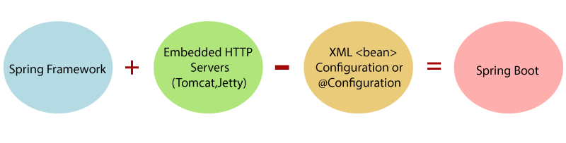

In short, Spring Boot is the combination of **Spring Framework** and **Embedded Servers**.

In Spring Boot, there is no requirement for XML configuration (deployment descriptor). It uses convention over configuration software design paradigm that means it decreases the effort of the developer.

We can use Spring **STS IDE** or **Spring Initializr** to develop Spring Boot Java applications.

# **Spring vs. Spring Boot vs. Spring MVC**

## Spring vs. Spring Boot

**Spring:** Spring Framework is the most popular application development framework of Java. The main feature of the Spring Framework is **dependency Injection** or **Inversion of Control** (IoC). With the help of Spring Framework, we can develop a **loosely** coupled application. It is better to use if application type or characteristics are purely defined.

**Spring Boot:** Spring Boot is a module of Spring Framework. It allows us to build a stand-alone application with minimal or zero configurations. It is better to use if we want to develop a simple Spring-based application or RESTful services.

The primary comparison between Spring and Spring Boot are discussed below:

|  |  |
| --- | --- |
| **Spring** | **Spring Boot** |
| **Spring Framework** is a widely used Java EE framework for building applications. | **Spring Boot Framework** is widely used to develop **REST APIs**. |
| It aims to simplify Java EE development that makes developers more productive. | It aims to shorten the code length and provide the easiest way to develop **Web Applications**. |
| The primary feature of the Spring Framework is **dependency injection**. | The primary feature of Spring Boot is **Autoconfiguration**. It automatically configures the classes based on the requirement. |
| It helps to make things simpler by allowing us to develop **loosely coupled** applications. | It helps to create a **stand-alone** application with less configuration. |
| The developer writes a lot of code (**boilerplate code**) to do the minimal task. | It **reduces** boilerplate code. |
| To test the Spring project, we need to set up the sever explicitly. | Spring Boot offers **embedded server** such as **Jetty** and **Tomcat**, etc. |
| It does not provide support for an in-memory database. | It offers several plugins for working with an embedded and **in-memory** database such as **H2**. |
| Developers manually define dependencies for the Spring project in **pom.xml**. | Spring Boot comes with the concept of **starter** in pom.xml file that internally takes care of downloading the dependencies **JARs** based on Spring Boot Requirement. |

## Spring Boot vs. Spring MVC

**Spring Boot:** Spring Boot makes it easy to quickly bootstrap and start developing a Spring-based application. It avoids a lot of boilerplate code. It hides a lot of complexity behind the scene so that the developer can quickly get started and develop Spring-based applications easily.

**Spring MVC:** Spring MVC is a Web MVC Framework for building web applications. It contains a lot of configuration files for various capabilities. It is an HTTP oriented web application development framework.

Spring Boot and Spring MVC exist for different purposes. The primary comparison between Spring Boot and Spring MVC are discussed below:

|  |  |
| --- | --- |
| **Spring Boot** | **Spring MVC** |
| **Spring Boot** is a module of Spring for packaging the Spring-based application with sensible defaults. | **Spring MVC** is a model view controller-based web framework under the Spring framework. |
| It provides default configurations to build **Spring-powered** framework. | It provides **ready to use** features for building a web application. |
| There is no need to build configuration manually. | It requires build configuration manually. |
| There is **no requirement** for a deployment descriptor. | A Deployment descriptor is **required**. |
| It avoids boilerplate code and wraps dependencies together in a single unit. | It specifies each dependency separately. |
| It **reduces** development time and increases productivity. | It takes **more** time to achieve the same. |