Vi Editor - Assignments
- Invoke the vi editor with a filename (which is to be created)
- Type a few lines(at least 10) in the editor. Let one or more lines contain the words given below.
delhi mumbai chennai Mumbai
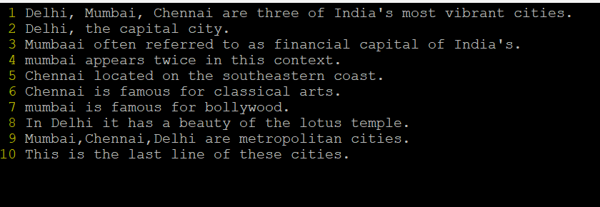
- Save the file without exiting the editor
To save the file in vi without exiting, press Esc to go to normal mode, then type:W
- Navigate quickly to the beginning & end of the file
- To move to the beginning of the file, press gg.
- To move to the end of the file, press G.
- Delete first two lines & copy it after the last line.
- To delete first two lines: go to first and then press ‘d2+down arrow’.
- To copy it after the last line: First copy by pressing ‘y+2’, go to last line by ‘G’ then, press ‘p’.
- Now Copy the last two lines & paste them before the first line.
- To copy the last 2 line: Press ‘y+2’, go to first line by ‘gg’ then, press ‘O’ it creates a new line above the line. Then, press ‘p’.
- Combine last two lines of the file in a single line.
- To combine last two lines of the file- in a single line : Press ‘J’ to combine the cursor in the last 2nd line.
- How will you insert a line before the first line? (Hint : Find such an option in the tutorial document)
To insert a line before the first line: Press ‘O’
- How will you paste a yanked buffer before the current line?
- First copy the yanked buffer by ‘y’ in normal mode.
- To paste before current line press ‘P’ in Esc mode.
- Search the document for a string “delhi”
- Type ‘/Delhi’ and then press ‘Enter’. This will start search for the string.
- The cursor will move to the first occurrence. You can press ‘n’ to go next occurrence or ‘N’ to go back to the previous occurrence.
- Replace a single occurrence of “delhi” with “Mumbai”
To replace a single occurrence of "delhi" with "Mumbai", place the cursor on the word and type: rMumbai
- Replace all occurrences of “delhi” on a particular line with “Mumbai” using one command
To replace all occurrences of "delhi" on a specific line (e.g., line 6), type: :6s/delhi/Mumbai/g
- Replace “delhi” with “mumbai” for the entire document using one command.
To replace "delhi" with "mumbai" throughout the entire document, type: :%s/delhi/mumbai/g
- Replace all occurrences of “delhi” with “mumbai” for part of a document (e.g. line number 13 to 37).
To replace "delhi" with "mumbai" only in the specified range of lines, type: :13,37s/delhi/mumbai/g
- Undo the above command
To undo the previous command, press u.
- Replace only the first occurrence of “delhi” with “mumbai” in each line, for part of a document (e.g. line number 13 to 37).
To replace only the first occurrence of "delhi" with "mumbai" in each line within the range, use: :13,37s/delhi/mumbai/
- Undo the above comment. Redo it. Undo it again.
- To undo, press u.
- To redo, press Ctrl + r.
- To undo it again, press u again.
- Replace all occurrences of “delhi” with “mumbai” for complete file interactively.
To replace all occurrences of "delhi" with "mumbai" interactively (it asks for confirmation), type: :%s/delhi/mumbai/gc
- Search for a word backwards. Loop through all matches.
To search for a word (e.g., " Mumbai ") backwards, type:? Mumbai
- Search for a word forwards. Loop through all matches
To search for a word (e.g., "Mumbai") forwards, type:/Mumbai
- Join two lines together.
To join the current line with the next line, use:J
- Enable line numbering and then disable it
To enable line numbers, type: :set number
To disable line numbers, type: :set nonumber
- Make the search case insensitive
To make the search case-insensitive, type: :set ignorecase
- Delete 4 lines (and then paste them somewhere else)
To delete 4 lines, type: :1,4d
To paste them, navigate to the desired location and press: p
- What is the command to delete part of the line starting from the current cursor position?
To delete from the cursor position to the end of the line, type: D
- What is the command to delete the current word?
To delete the current word under the cursor, type: dw

