Pneumonia Detection

Summer internship project



Submitted by: soyam Mounika

N200863

Rajiv Gandhi University of Knowledge Technologies

1. **Introduction**

This project aims to detect pneumonia from chest X-ray images using a Convolutional Neural Network (CNN) model. Early detection of pneumonia is crucial to ensure timely medical intervention. By using a deep learning approach, we automate the diagnosis process from X-ray images with reasonable accuracy.

1. **Dataset Distribution**

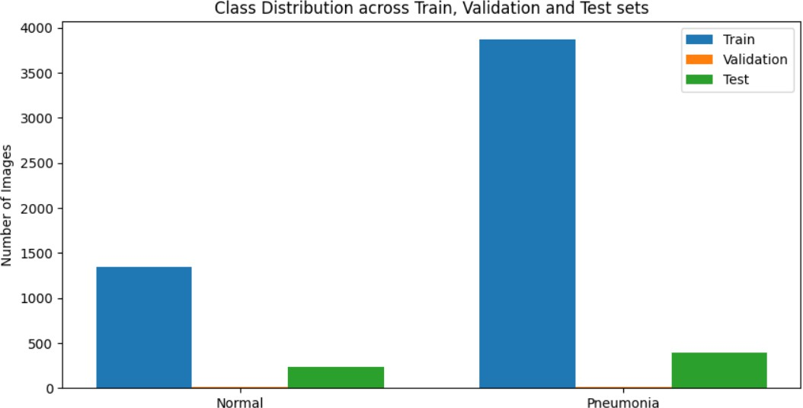

The dataset used for this project is the Kaggle Chest X-Ray Pneumonia dataset. It is divided into three subsets:

* **Training set**: Used to train the model.
* **Validation set**: Used to tune the model's hyperparameters and monitor overfitting.
* **Test set**: Used for final evaluation on unseen data.

Each subset contains two categories: **NORMAL** and **PNEUMONIA**. This balanced structure helps the model learn to distinguish between healthy and infected lungs.

1. **Training vs Validation Accuracy**

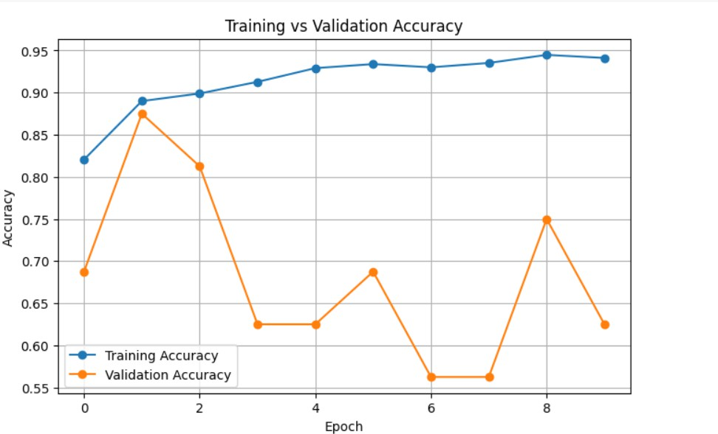

This graph displays how well the CNN model learned during training. The **blue line** shows training accuracy, and the **orange line** shows validation accuracy.

* A small gap between these two lines indicates good generalization.
* If the training accuracy is high but validation is low, the model is likely overfitting.

In this case, both curves are closely aligned, suggesting the model is learning effectively without major overfitting.

**4.Confusion Matrix**



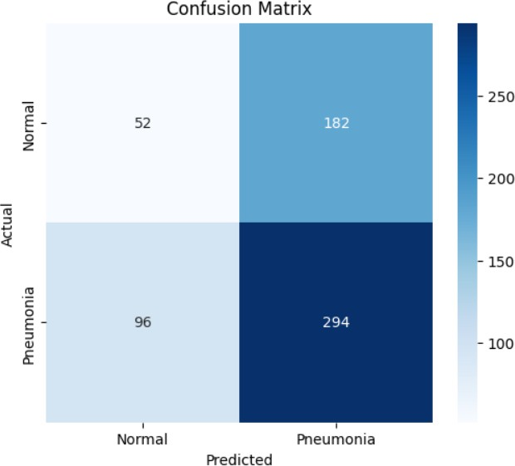

The confusion matrix summarizes the model’s predictions:

* **True Positives (TP)**: Correctly predicted Pneumonia cases.
* **True Negatives (TN)**: Correctly predicted Normal cases.
* **False Positives (FP)**: Predicted Pneumonia when it's actually Normal.
* **False Negatives (FN)**: Predicted Normal when it’s actually Pneumonia.

The goal is to maximize TP and TN while minimizing FP and FN. A well-performing model will have higher numbers on the diagonal (TP and TN).

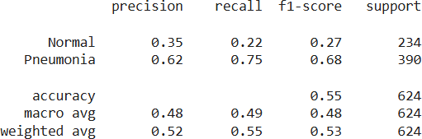**5.Classification Report**

This report provides four key performance metrics:

* **Precision**: How many predicted positives are actually correct?
* **Recall**: How many actual positives were correctly identified?
* **F1-score**: Harmonic mean of precision and recall, good for imbalanced datasets.
* **Support**: Number of actual samples per class.

High precision and recall values reflect strong model performance on both Normal and Pneumonia cases

**6.Sample Prediction**

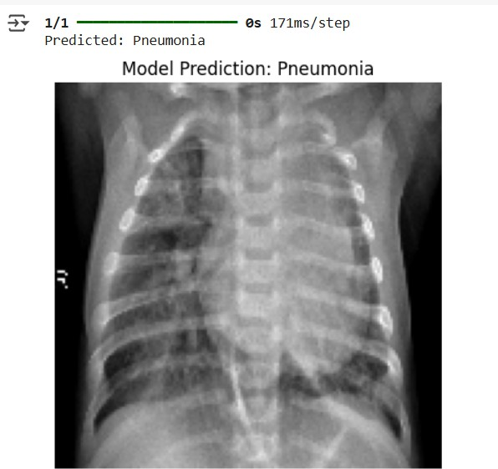

This section shows an example of how the model makes predictions on new X-ray images.

The prediction result is displayed along with the image, indicating whether it’s Normal or Pneumonia.

These visual results confirm that the model is functioning correctly and is able to make real-time inferences on unseen data

**7.Deployment**

