Day 1 – 16th May  
  
Doc name: Day 1 – mouniknc – Mounika  
  
1. SDLC – Software Development Life Cycle. It is process which is used by developers to build high quality software from production to deployment and Management.  
It helps to manage software development projects form taking a project from customer until delivering a project with high efficient and to reduce risk of bugs and to meet customer expectations.  
  
2. Why we use SDLC –

When we get a project, we’ll have a timeline. We need a proper plan to work on that project. So, to plan each and every task. To analyze and design how to develop the project and finally we’ll test the project. The software development life cycle gives a strategic and bug free results with in the given time.  
  
3. What are the stages of SDLC 2 lines about each.

There are 7 stages in SDLC.  
Planning: This is the initial phase where all things like, what is the objective and goal of the project, budget, team and timeline of the project will be decided.

Analysis: In Analysis phase, whatever the documents required for project will be gathered from user.   
  
Design: Based on the customer requirements, including Algorithm designing of the project will start.  
Coding: Here, we’ll develop a code and implement according to customer’s requirements.

Testing: Whatever we did coding part will be tested in this stage. To make sure project meets the requirement and also to find out bugs and to resolve it.

Deployment: After testing and zero bugs were detected then the code will be deployed. Here, we can’t change anything. Whatever changes should be there, it should be done before deployment.

Maintenance: Maintenance is that if project requirements change or added should be upgraded or maintain post deployment.

4. SDLC MODELS - List them, description - 4 lines min and with a image

Agile Model –   
In the middle of the development, if there is a need to make any changes to complete the project quickly. for this Agile Model was created. 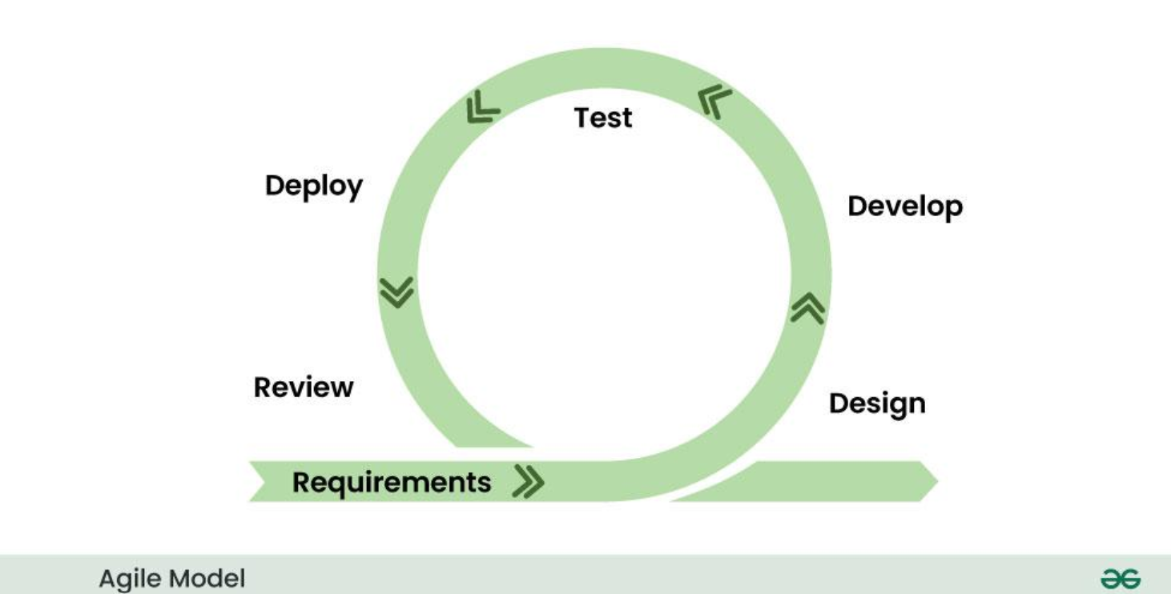

Advantages:  
 Customer will be included such that customer and the development, testing team is on the same page.

* Flexibility and Adaptability in Project Management

Disadvantages: If there are no clear goals, the overall progress is challenging.

Application: It is suitable for Mobile & Web applications as it adjusts based on Client requirements.

2. Waterfall Model

There are phases in this model. And each phase should be completed to go to next development phase. Basically, the result of one development phase will be the input of other phase.

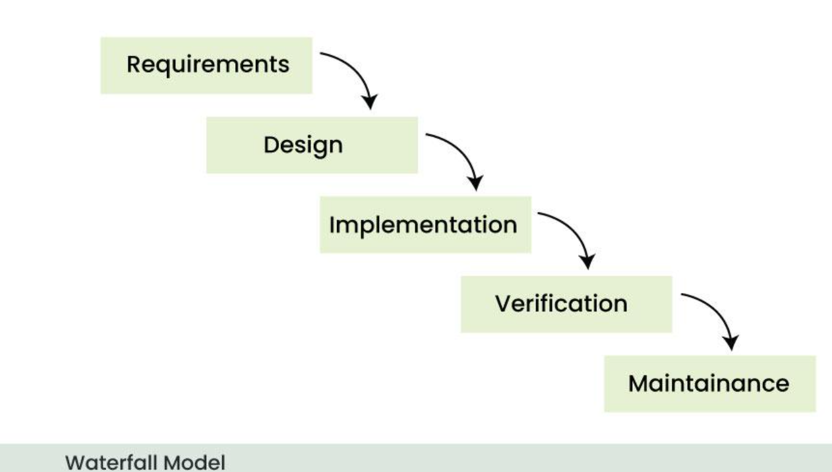

Advantages:   
Even before the software development starts, the design is given out in detail which makes the needs and the outcome clear to everyone. The documentation is clear.

Disadvantages:   
Lack of flexibility – As everything is predefined, it is difficult for changes.

3. V-Model

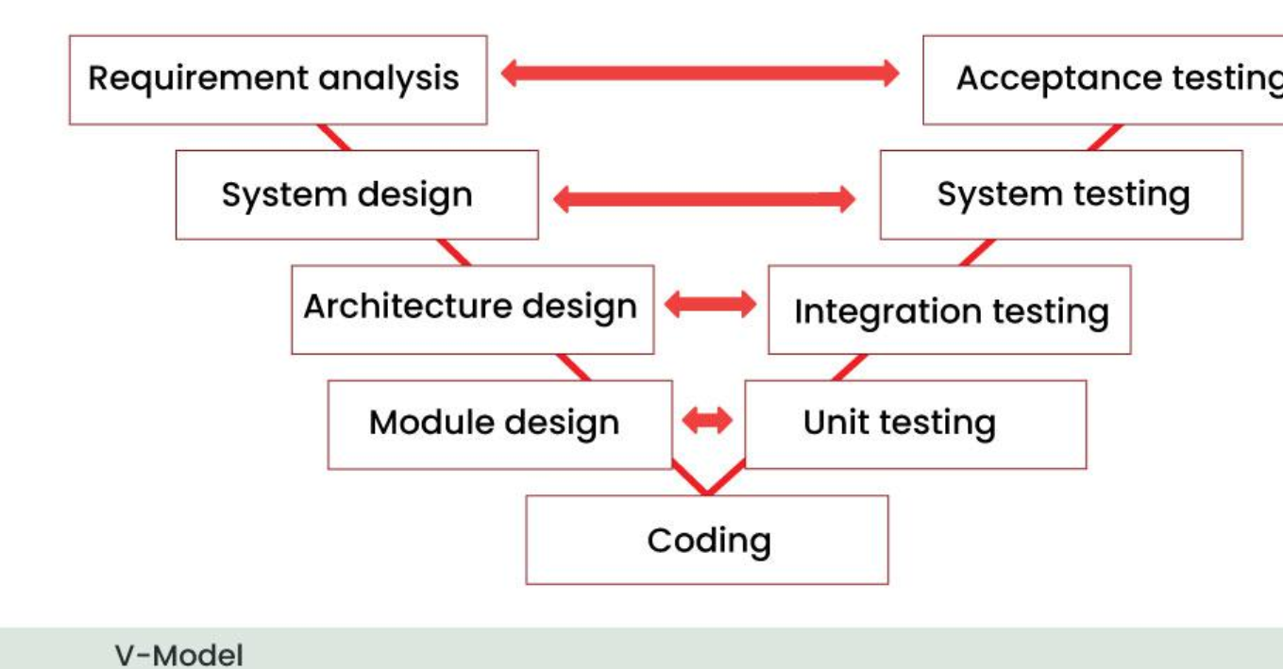

In V-Model, the execution of each process is sequential, that is, the new phase starts only after the previous phase ends.

* Advantages: Simple and easy to use. Works well for small projects where requirements are easily understood.
* Disadvantages: If any changes happen in midway, then the test documents along with requirement documents has to be updated.

The V-shaped model should be used for small to medium sized projects where requirements are clearly defined and fixed

4. Incremental Model –

It is used in for a project which requires many modules to work on, like a big project which needs more modules

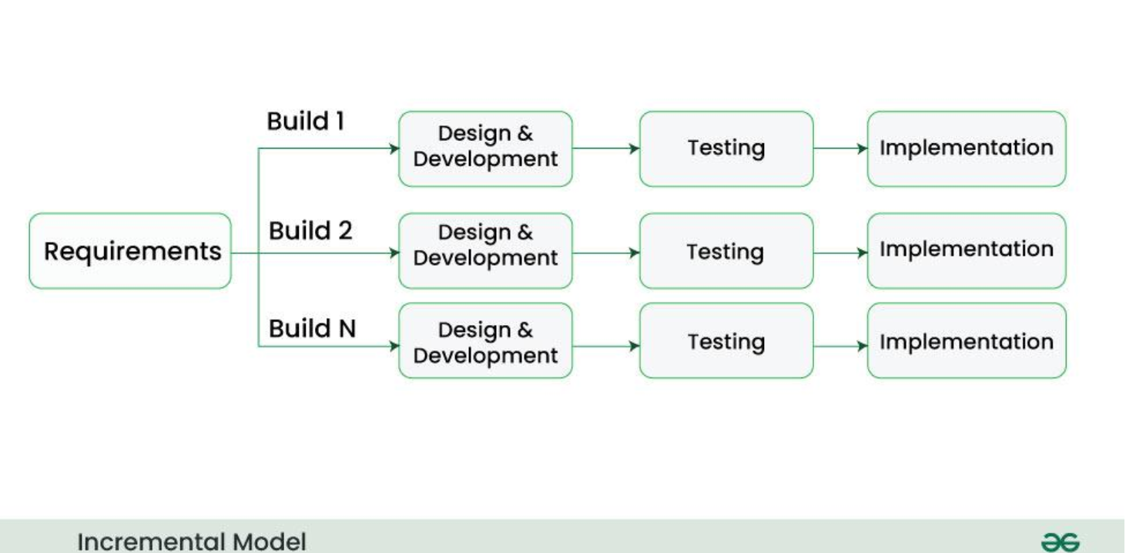

* Advantages: It is easier to test and debug during a smaller iteration.
* Easier to manage risk because risky pieces are identified and handled during it’d iteration.
* Disadvantage: Needs good planning and design to get rid of risk.  
  This model can be used when the requirements of the complete system are clearly defined and understood.

5. Iterative Model –

Based on the requirements, we start developing the software and it will be reviewed. Once, it is reviewed, To get a final product, there might be few changes or new features it will be developed again and will be reviewed until then.

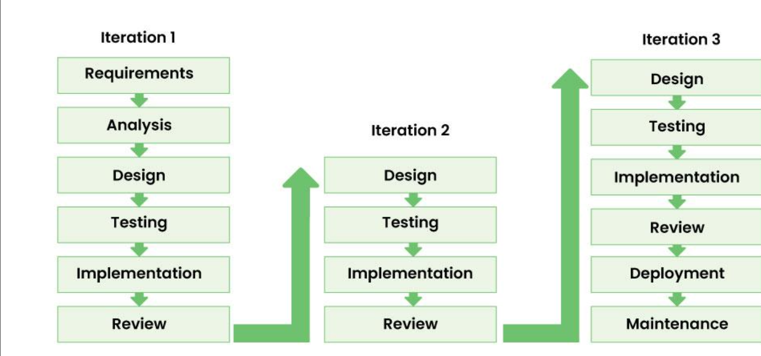

Advantages: This model is very flexible as new functionality can be added to it any time of the development. The bugs will be detected in the early stage.

Disadvantage: Problem in system architecture because of many changes or new requirements. The iterative model iterates planning, design, implementation, and testing stages again and again. This helps in ensuring that the final product built iteratively, is according to the standards required by the user.

6. RAD Model – It is smiliar to the incremental or water fall model. It is used for small projects. In RAD model the components or functions are developed in parallel as if they were mini projects. The developments are time boxed, delivered and then assembled into a working prototype.

* Advantages: Increases reusability of components
* Disadvantages: Need high skilled team
* RAD [SDLC model](https://tryqa.com/what-are-the-software-development-models/) should be chosen only if resources with high business knowledge are available and there is a need to produce the system in a short span of time (2-3 months).

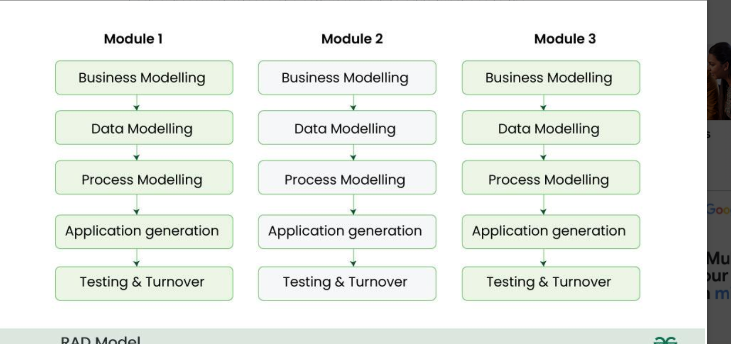

7. Spiral Model -   
This model has characteristics of both iterative and waterfall models. This model is used in projects which are large and complex. The spiral model has four phases. A software project repeatedly passes through these phases in iterations.

Advantage: Good for large and mission-critical projects.

Disadvantage: Doesn’t work well for smaller projects

This can be used when the Users are unsure of their needs and significant changes are expected.

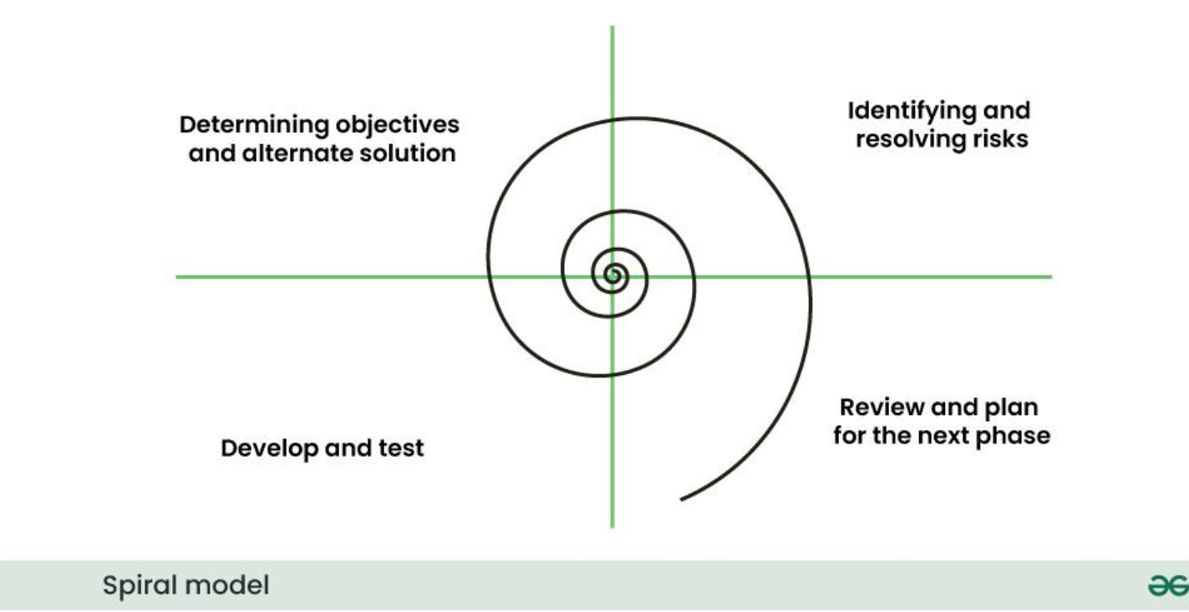

8. Prototype Model

It requires clear requirements. First a prototype is created and then the final product is manufactured based on that prototype. The basic idea is that instead of freezing the requirements before a design or coding can proceed, a throwaway prototype is built to understand the requirements. This prototype is developed based on the currently known requirements.

* Advantages: Users are actively involved in the development
* Errors can be detected much earlier

Disadvantages: Incomplete application may cause application not to be used inadequate problem analysis.

Prototype model should be used when the desired system needs to have a lot of interaction with the end users.

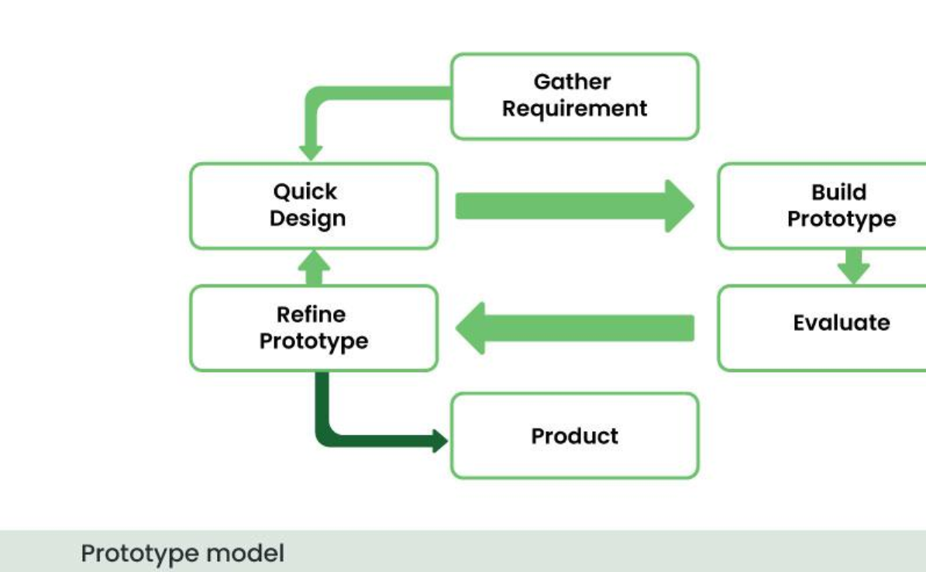

Applications Of SDLC MODELS

1. Agile -  
   It is suitable for Mobile & Web applications as it adjusts based on Client requirements.
2. Waterfall Model –

the Waterfall model ensures that all requirements are met, minimizing the risk of errors in critical systems like those in aerospace or medicine.

1. V-Model - It can be used for software projects of large / small size. Eg: Commerce, Military.
2. Incremental Model – It allows gradual improvements with feedback eg: Web, Mobile, Gaming
3. Iterative Model – It is used When the requirements of the complete system are clearly defined and understood by the development expertise.
4. RAD Model – When project requires adaptation to new requirements and need to deploy faster. Mobile app, customer support.
5. Spiral Model – It is suitable for early detection of risk like E-commerce, Health records.

What is SCRUM?

SCRUM is a systematic approach or a plan on initial stage of a project to delivering project by dividing into modules and there is a time line for every module given to all teams who are working on a project. SCRUM Master acts as a bridge between Client and the project developing team. Here, based on the progress of each team what do next i.e; next phase of each progress will be discussed.

What is SPRINT?

A sprint is a short set of time where a team works to finish specific task in which particular module / part of the project will be done.

DO’s & DON’T’S while working on a Sprint.

DO’s

* 1. Attend daily sprint.
  2. Make sure everyone on the project knows what we’re trying to achieve in this sprint.
  3. In a short time like 10 – 15 mins, explain What I did yesterday and what I will do today and also if I have any blockers.
  4. At the end of the day explain what task I did.  
       
     DON’T’s
  5. Never Over commit without any knowledge of how long will the task take to complete.
  6. Never skip updates. Not updating the status will cause confusions and hidden blockers. Never hide blockers.
  7. Don’t work in isolation – Going solo on big features risk misalignment; share progress often

What is Backlog / stories in Sprint?

Backlog – It is a list of all the work that needs to be done in a project.  
It can be: New features, fixing bugs, Tasks for Testing & Designing

Story – It is a small item in a Backlog. It describes one piece of work from the user’s point of view.

Scrum Artifacts

Product Backlog

* Sprint Backlog
* Burn-Down Chart
* Increment  
  Can you brief the above Artifacts.

Artifacts are just important items or documents that help the team plan, track and show progress during a project.

Product Backlog

It is a big list of everything the product needs.

It includes features, bug fixes, improvements,

Always changing as new ideas comes or there is a priority shift.

It is just like a master to-do list for the whole team.

Sprint Backlog –

A smaller list taken from the product backlog.

It includes only the work the team plans to do this sprint.

It is just like a short – term to-do list for the next 1-2 weeks.

Increment –

This is the working product at the end of the sprint.

It’s the finished and usable work -tested and ready. It could be a new feature, a fix or any improvement.

It’s what to show to the people after the sprint ends.

Burndown Chart –

It shows how much work is left to do and how much time is left in the sprint.

NETWORKING

What are Ports & Protocols?

Ports – Computer uses ports to handle different types of traffic. Each kind of a service uses different kind of port. A number used to identify different types of traffic like port 80 for website.

Protocols – It is a set of rules for how to send or receive data. It helps devices understand each other on a network.

TCP / IP – Core protocol of the internet. Basic rules of how data travels on the internet.

HTTP – For loading websites

HTTPS – Used for website

FTP – Used for File Transfers.

DNS- Turns website names into IP addresses

Different types of Network

LAN – Local Area Network – small area Eg: Office / University

WLAN – Just like LAN but Wireless –

WAN – Wide Area Network Country or world wide Eg: Internet

MAN – Metropolitan Network Eg: City

PAN – Personal Area Network eg: smart watch

SAN – Storage Are Network – Special network used to connect storage devices Eg: to hard drive

VPN – Virtual Private Network

It’s not a physical network but a secure connection over the internet. Keeps the data private and hides IP.

Types of VPN –

1. Remote Access VPN –

Used by employees to connect to office network from home.

1. Site – to – site VPN

Connects two office networks in different locations. Often used by large companies with multiple branches to securely link their offices.

1. Personal VPN / Commercial VPN

Used by by regular users to Hide IP address, stay private, Access blocked sites.  
  
Types of servers –

A server is a computer that gives service t oother computers over a network.

Types of Servers:

1. Web server –

Sends website to the browser when we type a web address

1. Mail server -  
   Sends and receives emails.
2. File Server –

Stores and shares files over the network.

1. Database Server –
2. Stores and manages data used by websites and apps.
3. DNS Server – Translate website names into IP address.

What do you know about DNS?

DNS – Domain Name System.

It is like the phonebook of the internet. Computers use numbers to remember. DNS translate names to Numbers. Whenever we type anything, DNS finds its IP address and browser connects to that IP address loads the site.

What are the different types of Network Topologies?

1. Bus Topology – All devices are connected to a single cable which is called the bus. If the main cable fails, the whole network goes down.

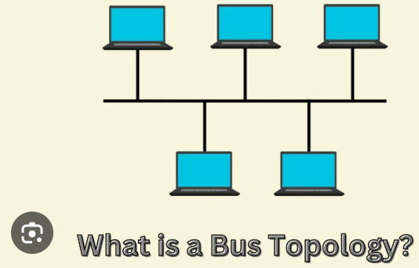

1. Star Topology – All devices connect to a central hub / switch.

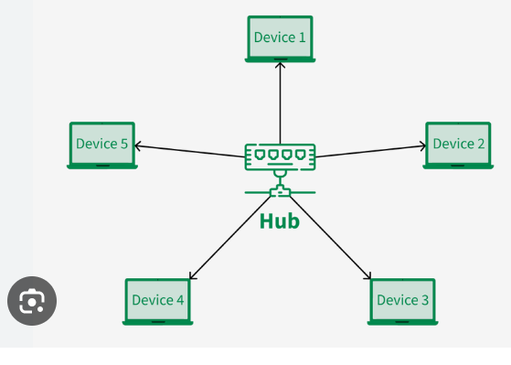

1. Ring Topology – devices are connected in a circle. Data travels in one direction.

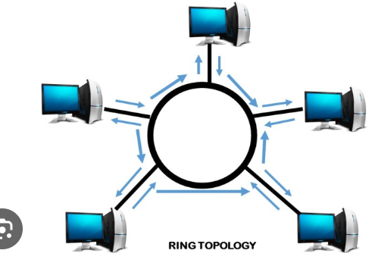

1. Mesh Topology – every device is connected to every other device.

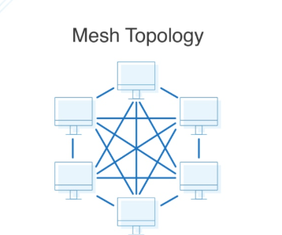

1. Tree Topology – A mix of star and bus topologies. Devices are grouped in branches.

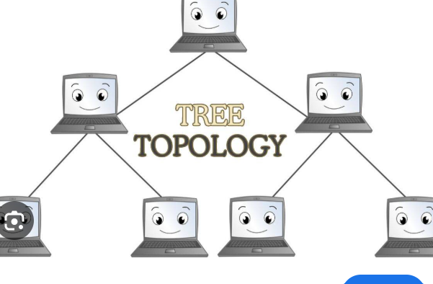

1. Hybrid Topology – A mix of two or more topologies like star + mesh or star + ring. It is common in Large organizations.

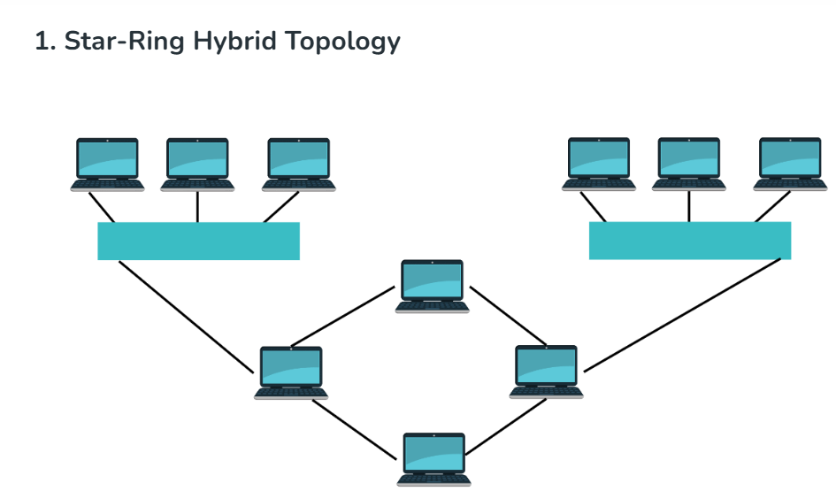

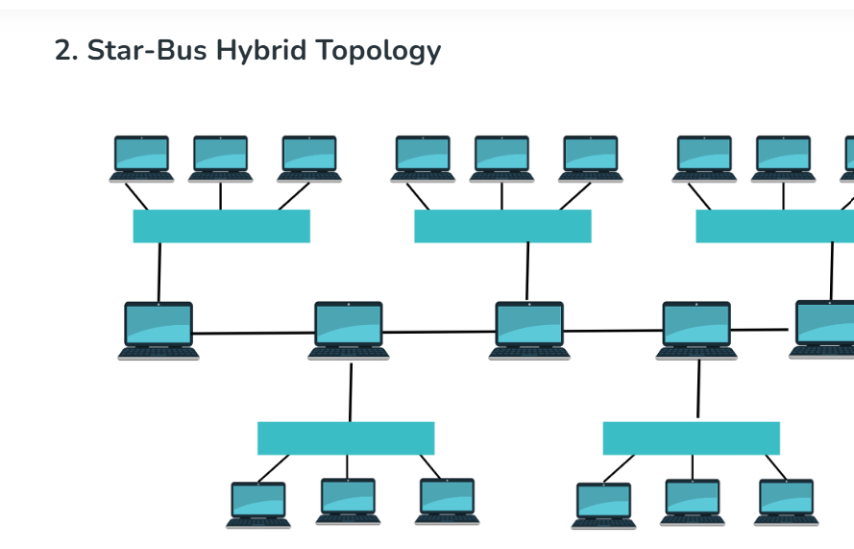

What is OSI Model and What are the Layers of OSI Model?

OSI – Open Systems Interconnection Model. It explains how data moves through a network from one computer to another.

It is a 7 – step delivery system. Every layer has a specific job. When sending data – Data moves from top to Bottom & When Receiving – Data moves from Bottom to Top.

Layer 1 – Physical Layer

It is hardware like switches, cables. Sends data as bits 0’s and 1’s through wires. It deals with Voltages, signals.

Eg: The internet cable plugged into your computer.

Layer 2 – Data Link Layer

Sends data between devices on the same network. It uses MAC addresses. Detects and may correct errors in the data.

Eg: Laptop send data to wifi Router.

Layer 3 – Network Layer

Finds the best path to send Data. Uses IP addresses to identify computers. It is responsible for routing & packet delivery.

Eg: Data going from one country to another country through many routers.

Layer 4 – Transport Layer –

It breaks data into small segments. It makes sure data is reliable.

Eg: Watching youtube video

Layer 5 – Session Layer –

It opens, manages and closes connections between devices. It keeps track of communication. It manages the conversation so both sides know when it starts & ends.

Eg: Logging into a website

Layer 6 – Presentation Layer

It prepares data so apps can understand it. It formats, compresses or encrypts data. It makes sure sender & receiver “Speak the same language”

Eg: Converting video to MP4.

Layer 7 – Application Layer

It is the closest to the user. It delas with software apps like web browsers, email. It’s where we interact with the network.

Eg: when we type any thing like [www.google.com](http://www.google.com) in chrome