Mounir Abderrahmani mounir1badi@gmail.com

ECE 551 Homework3 (Spring2016)
May 14th 2016

Professor: Hilal Kazan

- 1)
a) Single linkage
   | 6 | 8 | 10 | 20 | 26 | 30 | 32 | 33
  6 | - | 2 | 4 | 14 | 20 | 24 | 26 | 27
  8 | 2 | - | 2 | 12 | 18 | 22 | 23 | 24
  10 | 4 | 2 | - | 10 | 16 | 20 | 22 | 21
  20 | 14 | 12 | 10 | - | 6 | 10 | 12 | 13
  26 | 20 | 18 | 16 | 6 | - | 4 | 6 | 7
  30 | 24 | 22 | 20 | 10 | 4 | - | 2 | 3
  32 | 26 | 24 | 22 | 12 | 6 | 2 | - | 1
  33 | 27 | 25 | 23 | 13 | 7 | 3 | 1 | -
   | 6 | 8 | 10 | 20 | 26 | 30 | 32/33
  6 | - | 2 | 4 | 14 | 20 | 24 | 26
  8 | 2 | - | 2 | 12 | 18 | 22 | 23
  10 | 4 | 2 | - | 10 | 16 | 20 | 22
  20 | 14 | 12 | 10 | - | 6 | 10 | 12
  26 | 20 | 18 | 16 | 6 | - | 4 | 6
  30 | 24 | 22 | 20 | 10 | 4 | - | 2
  32/33 | 26 | 24 | 22 | 12 | 6 | 2 | -

   | 6/8/10 | 20 | 26 | 30/32/33
  6/8/10 | - | 10 | 16 | 20
  20 | 10 | - | 6 | 10
  26 | 16 | 6 | - | 4
  30/32/33 | 20 | 10 | 4 | -
   | 6/8/10 | 20 | 30/32/33/26
  6/8/10 | - | 10 | 16
  20 | 10 | - | 6
  30/32/33​/26 | 16 | 6 | -

8
6
33
10
32
30
26
20
2

1

2

4

2

6

10

 | 6/8/10 | 30/32/33/26/20
6/8/10 | - | 10
30/32/33​/26/20 | 10 | -

b) Complete linkage
   | 6 | 8 | 10 | 20 | 26 | 30 | 32 | 33
  6 | - | 2 | 4 | 14 | 20 | 24 | 26 | 27
  8 | 2 | - | 2 | 12 | 18 | 22 | 23 | 24
  10 | 4 | 2 | - | 10 | 16 | 20 | 22 | 21
  20 | 14 | 12 | 10 | - | 6 | 10 | 12 | 13
  26 | 20 | 18 | 16 | 6 | - | 4 | 6 | 7
  30 | 24 | 22 | 20 | 10 | 4 | - | 2 | 3
  32 | 26 | 24 | 22 | 12 | 6 | 2 | - | 1
  33 | 27 | 25 | 23 | 13 | 7 | 3 | 1 | -
   | 6 | 8 | 10 | 20 | 26 | 30 | 32/33
  6 | - | 2 | 4 | 14 | 20 | 24 | 27
  8 | 2 | - | 2 | 12 | 18 | 22 | 24
  10 | 4 | 2 | - | 10 | 16 | 20 | 23
  20 | 14 | 12 | 10 | - | 6 | 10 | 13
  26 | 20 | 18 | 16 | 6 | - | 4 | 7
  30 | 24 | 22 | 20 | 10 | 4 | - | 3
  32/33 | 26 | 24 | 22 | 12 | 6 | 3 | -

   | 6/8 | 10 | 20 | 26 | 30 | 32/33
  6/8 | - | 4 | 14 | 20 | 24 | 27
  10 | 4 | - | 10 | 16 | 20 | 23
  20 | 14 | 10 | - | 6 | 10 | 13
  26 | 20 | 16 | 6 | - | 4 | 7
  30 | 24 | 20 | 10 | 4 | - | 3
  32/33 | 27 | 23 | 13 | 7 | 3 | -
   | 6/8 | 10 | 20 | 26 | 30/32/33
  6/8 | - | 4 | 14 | 20 | 27
  10 | 4 | - | 10 | 16 | 23
  20 | 14 | 10 | - | 6 | 13
  26 | 20 | 16 | 6 | - | 7
  30/32/33​ | 27 | 23 | 13 | 7 | -

 | 6/8/10 | 20 | 26 | 30/32/33
6/8 | - | 14 | 20 | 27  8  6  33  10  32  30  26  20  2  1  3  4  13  27  6
20 | 14 | - | 6 | 13
26 | 20 | 6 | - | 7
30/32/33​ | 27 | 13 | 7 | -

 | 6/8/10 | 20/26 | 30/32/33
6/8 | - | 20 | 27
20/26 | 20 | - | 13
30/32/33​ | 27 | 13 | -

c) Average linkage
   | 6 | 8 | 10 | 20 | 26 | 30 | 32 | 33
  6 | - | 2 | 4 | 14 | 20 | 24 | 26 | 27
  8 | 2 | - | 2 | 12 | 18 | 22 | 23 | 24
  10 | 4 | 2 | - | 10 | 16 | 20 | 22 | 21
  20 | 14 | 12 | 10 | - | 6 | 10 | 12 | 13
  26 | 20 | 18 | 16 | 6 | - | 4 | 6 | 7
  30 | 24 | 22 | 20 | 10 | 4 | - | 2 | 3
  32 | 26 | 24 | 22 | 12 | 6 | 2 | - | 1
  33 | 27 | 25 | 23 | 13 | 7 | 3 | 1 | -
   | 6 | 8 | 10 | 20 | 26 | 30 | 32.5
  6 | - | 2 | 4 | 14 | 20 | 24 | 26.5
  8 | 2 | - | 2 | 12 | 18 | 22 | 24.5
  10 | 4 | 2 | - | 10 | 16 | 20 | 22.5
  20 | 14 | 12 | 10 | - | 6 | 10 | 12.5
  26 | 20 | 18 | 16 | 6 | - | 4 | 6.5
  30 | 24 | 22 | 20 | 10 | 4 | - | 2.5
  32.5 | 26.5 | 24.5 | 22.5 | 12.5 | 6.5 | 2.5 | -

   | 7 | 10 | 20 | 26 | 31.25
  7 | - | 3 | 13 | 19 | 24.25
  10 | 3 | - | 10 | 16 | 21.25
  20 | 13 | 10 | - | 6 | 11.25
  26 | 19 | 16 | 6 | - | 5.25
  31.25 | 24.25 | 21.25 | 11.25 | 5.25 | -
   | 8.5 | 20 | 26 | 31.25
  8.5 | - | 11.5 | 17.5 | 22.75
  20 | 11.5 | - | 6 | 11.25
  26 | 17.5 | 6 | - | 5.25
  31.25 | 22.75 | 11.25 | 5.25 | -

 | 8.5 | 20 | 28.625
8.5 | - | 11.5 | 20.125
20 | 11.5 | - | 8.625
28.625 | 20.125 | 8.625 | -

8
6
33
10
32
30
26
20
2

1

2.5

5.25

3

8.625

15.8125

 | 8.5 | 24.3125
8.5 | - | 15.8125
24.3125 | 15.8125 | -

2)
a) Clustering with Complete linkage in general is a little tricky to visualize or solve without a pencil and a paper, so It wouldn't be easy to follow and remember the distances between the clusters, and it is highly unlikely to be the same after actually computing and applying the clustering algorithm as follow

1.2
4
5.2
6
6.9
7.5
2

0.8

0.6

 | 1.2 | 4 | 5.2 | 6 | 6.9 | 7.5
1.2 | - | 2.8 | 4 | 4.8 | 5.7 | 6.3
4 | 2.8 | - | 1.2 | 2 | 2.9 | 3.5
5.2 | 4 | 1.2 | - | 0.8 | 1.7 | 2.3
6 | 4.8 | 2 | 0.8 | - | 0.9 | 1.5
6.9 | 5.7 | 2.9 | 1.7 | 0.9 | - | 0.6
7.5 | 6.3 | 3.5 | 2.3 | 1.5 | 0.6 | -

   | 1.2 | 4 | 5.2 | 6 | 6.9|7.5
  1.2 | - | 2.8 | 4 | 4.8 | 6.3
  4 | 2.8 | - | 1.2 | 2 | 3.5
  5.2 | 4 | 1.2 | - | 0.8 | 2.3
  6 | 4.8 | 2 | 0.8 | - | 1.5
  6.9|7.5 | 6.3 | 3.5 | 2.3 | 1.5 | -
   | 1.2 | 4 | 5.2|6 | 6.9|7.5
  1.2 | - | 2.8 | 4.8 | 6.3
  4 | 2.8 | - | 2 | 3.5
  5.2|6 | 4.8 | 2 | - | 2.3
  6.9|7.5 | 6.3 | 3.5 | 2.3 | -

   | 1.2 | 4|5.2 | 6.9|7.5
  1.2 | - | 4 | 6.3
  5.2|4 | 4 | - | 3.5
  6.9|7.5 | 6.3 | 3.5 | -
   | 1.2 | 4|5.2|6.9|7.5
  1.2 | - | 6.3
  4|5.2|6.9|7.5 | 6.3 | -

b)

clustering result using single linkage with k = 2
because of the that connected line (vertical right side) the first cluster connects both up and down part like in the picture (red) , and the second cluster the object that is relatively isolated (yellow).

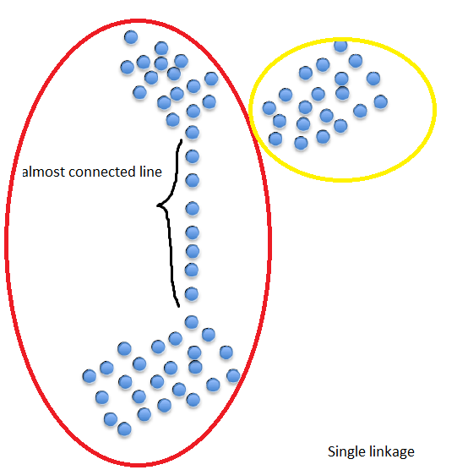
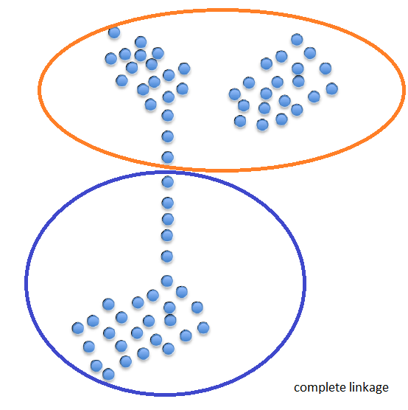

Clustering with K-Means takes place iteratively and involves two steps:
1) assignment of data samples to clusters on the basis of how far the data samples are from the cluster centers;
2) Recalculation of the cluster centers
for our analysis the numbers generated randomly with Gaussian distribution of number like more numbers ( pdf of the mean is the highest and degrading slowly with Gaussian variance)

creating 3 gaussian with same amount of numbers each, would result of making 3 clusters each with a different mean and variance.
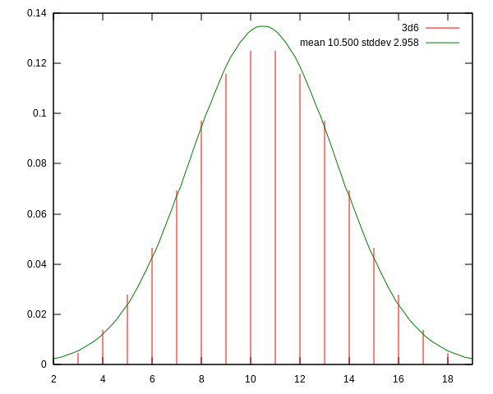

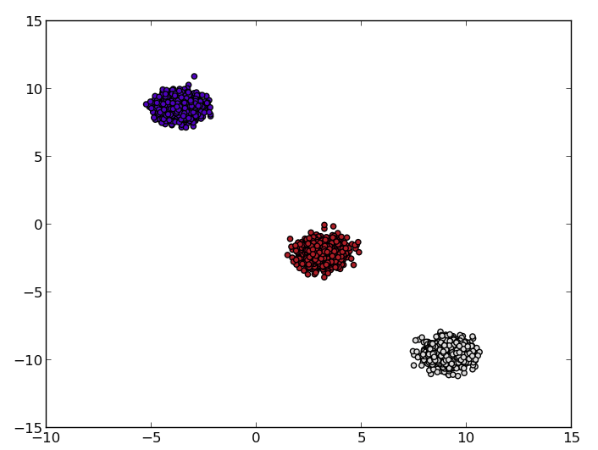
The code is here

