Performance enhanced VCO based ADC for Biomedical signal acquisition
¹Mounish V , ²Mohamed Thoufiq S , ³Muthukumaran S,
⁴Nareshkumar R P , ⁵Rithiv Krishna P
^{1,2,4,5} Student, ³ Professor,
^{1,2,3,4,5}Department of ECE, Sri Eshwar College of Engineering, Coimbatore, Tamil Nadu, India
Abstract — Wearable and implantable biomedical monitors are tightly constrained by battery capacity, which places power efficiency ahead of raw resolution when selecting an analog-to-digital converter (ADC) architecture. Voltage-controlled-oscillator (VCO) based ADCs address this constraint by moving quantization into the time domain, where a current-starved ring oscillator converts an input voltage into a proportional frequency that is subsequently digitized by a simple digital counter, avoiding power-hungry precision analog blocks such as comparators and resistor ladders. This work presents the design and functional simulation of a five-stage current-starved ring VCO paired with a six-bit reset-counter frequency-to-digital converter, implemented and simulated in a 180-nm CMOS process at a 1.5 V supply. The voltage-to-frequency tuning curve was characterized across a control-voltage range covering typical ECG/EMG signal amplitudes (0.4 V to 1.2 V) and found to be distinctly sigmoidal rather than linear, with measurably different gain in the lower and upper portions of the range. Using a sampling period fixed directly by the reset-counter testbench (Ts = 50.4 ns), the converter was verified to produce a monotonically increasing, non-overflowing six-bit digital code across the full input range without saturating the counter. Power consumption and signal-to-noise-and-distortion ratio (SNDR) characterization are part of ongoing work and are not reported in this paper.
Keywords — VCO-based ADC, current-starved ring oscillator, voltage-to-frequency conversion, 180-nm CMOS, biomedical signal acquisition, reset counter, frequency-to-digital converter.

I. INTRODUCTION
Portable and implantable biomedical devices — for electrocardiogram (ECG), electromyogram (EMG), and similar vital-sign monitoring — operate under strict battery-life constraints, which makes the power efficiency of every block in the signal chain a first-order design concern [1]. The analog-to-digital converter (ADC) is one of the most power-sensitive blocks in this chain, since it must run continuously to digitize the incoming physiological waveform [2].
Conventional ADC architectures such as flash, successive-approximation-register (SAR), and delta-sigma converters each trade off speed, resolution, and power differently [3]. Flash converters offer high speed at the cost of area and power; delta-sigma converters achieve high resolution but at the expense of latency and complex analog circuitry; SAR converters are popular for low-power design but remain dependent on precision analog components such as comparators and capacitor arrays [3]. Recent SAR-ADC implementations for biomedical applications have continued to push resolution and energy efficiency at deeply scaled nodes [4, 5], but remain reliant on precision analog blocks that scale less favorably than digital logic. As CMOS technology scales, digital logic continues to improve in speed and power efficiency at a rate that precision analog circuitry cannot match, motivating a shift toward architectures that push more of the signal path into the time or digital domain [6].
Voltage-controlled-oscillator (VCO) based ADCs are one such time-domain approach. An input voltage is first converted into a proportional oscillation frequency by a VCO, and a digital counter then quantizes that frequency into a code over a fixed sampling window [7]. Because the second stage consists entirely of digital logic, this architecture benefits directly from process scaling and largely avoids the precision analog components that limit conventional ADCs [7]. Biomedical-specific VCO-ADC implementations have recently been reported for applications ranging from neural recording to multi-channel physiological monitoring [8, 9]. A current-starved ring oscillator is a common and efficient choice of VCO for this purpose, and prior work has demonstrated such designs at a range of CMOS nodes, most notably a five-stage current-starved VCO with a four-bit reset-counter back end implemented at 130 nm [1]. A related implementation at 180 nm for positron emission tomography timing has also been reported [10], but full nonlinearity characterization of the voltage-to-frequency tuning curve at this node — and its direct consequence on the resulting digital transfer function — is less commonly documented in the literature.
The nonlinearity of current-starved ring oscillators is itself a recognized limitation: because the bias current that starves each inverter stage depends on the square of the control-voltage overdrive rather than on the control voltage directly, the resulting frequency-versus-voltage curve is not linear, and this has motivated dedicated linearization techniques in prior work [11], as well as systematic studies of stage-count trade-offs in current-starved ring VCOs [12]. Rather than attempting to correct this nonlinearity, the present work characterizes it directly and shows that a suitably sized counter can still yield a fully monotonic, non-overflowing digital output across a clinically relevant input range despite the underlying nonlinearity, an approach consistent with other ring-VCO linearity studies aimed at low-energy sensing applications [13].
A. Contribution of this work
The contributions of this paper are summarized as follows:
- Design and functional simulation of a five-stage current-starved ring VCO and a six-bit reset-counter frequency-to-digital converter (FDC), ported to and verified in a 180-nm CMOS process at 1.5 V supply.
- Full characterization of the voltage-to-frequency tuning curve across the 0.4 V to 1.2 V range relevant to ECG/EMG acquisition, showing a distinctly sigmoidal rather than linear response.
- A six-bit counter sizing decision, verified against the measured tuning curve and a fixed, testbench-derived sampling period, that yields a monotonic and non-overflowing digital transfer function across the full targeted input range without following the fixed fmax = 2^n × fmin sizing rule used in prior work.
II. SYSTEM ARCHITECTURE
The overall converter follows the two-stage indirect ADC structure common to VCO-based designs [1, 7]: a voltage-to-frequency converter (VFC) built from a current-starved ring oscillator, followed by a frequency-to-digital converter (FDC) built from a reset counter and output register, as shown in Fig. 1. An analog front-end conditioning stage for raw ECG/EMG sensor signals is anticipated as part of a complete acquisition chain but is treated as future scope and was not implemented or simulated as part of this work; the VFC and FDC blocks were driven directly by a controlled input voltage source for characterization purposes.
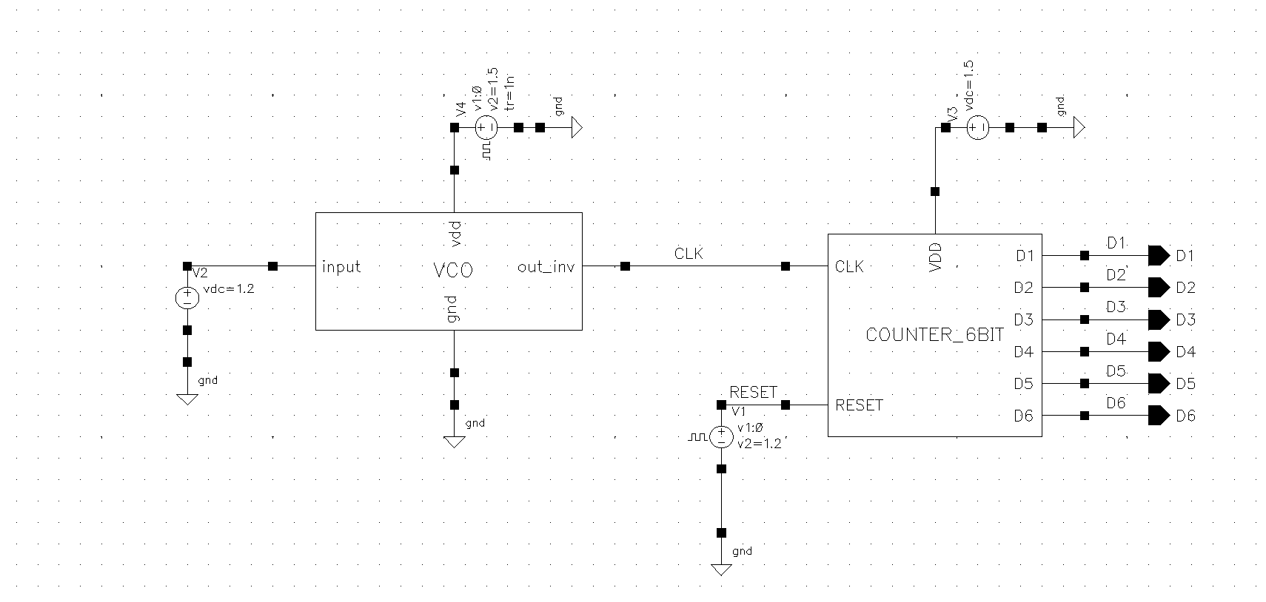
Fig. 1. Top-level schematic of the implemented VCO-based ADC, showing the VCO block driving the six-bit reset counter through an inverting output stage.
III. PROPOSED DESIGN AND IMPLEMENTATION
A. Voltage-to-Frequency Converter
The VFC consists of a five-stage current-starved ring oscillator followed by an inverter that squares the oscillator's output into clean digital pulses. Each delay stage limits its own charge/discharge current using a control-voltage-gated transistor in series with the stage's main inverter, so that the propagation delay — and hence the oscillation frequency — is set by the applied input voltage rather than by the inverter's unrestricted switching speed [1]. The implemented five-stage schematic is shown in Fig. 2, realized in 180-nm CMOS with a 1.5 V supply.
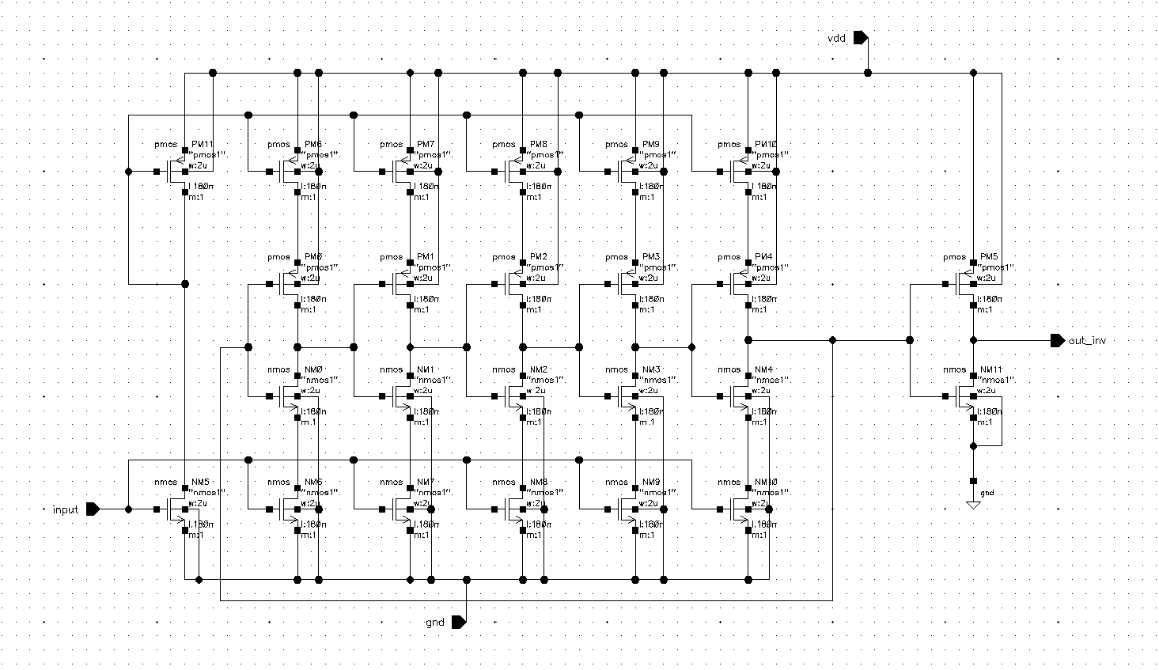
Fig. 2. Transistor-level schematic of the implemented five-stage current-starved ring VCO.
The transient response of the VCO output, before and after the output inverter, is shown in Fig. 3 for several fixed control-voltage levels, confirming that the oscillator produces a clean, frequency-modulated square wave suitable for digital counting across the tested range.
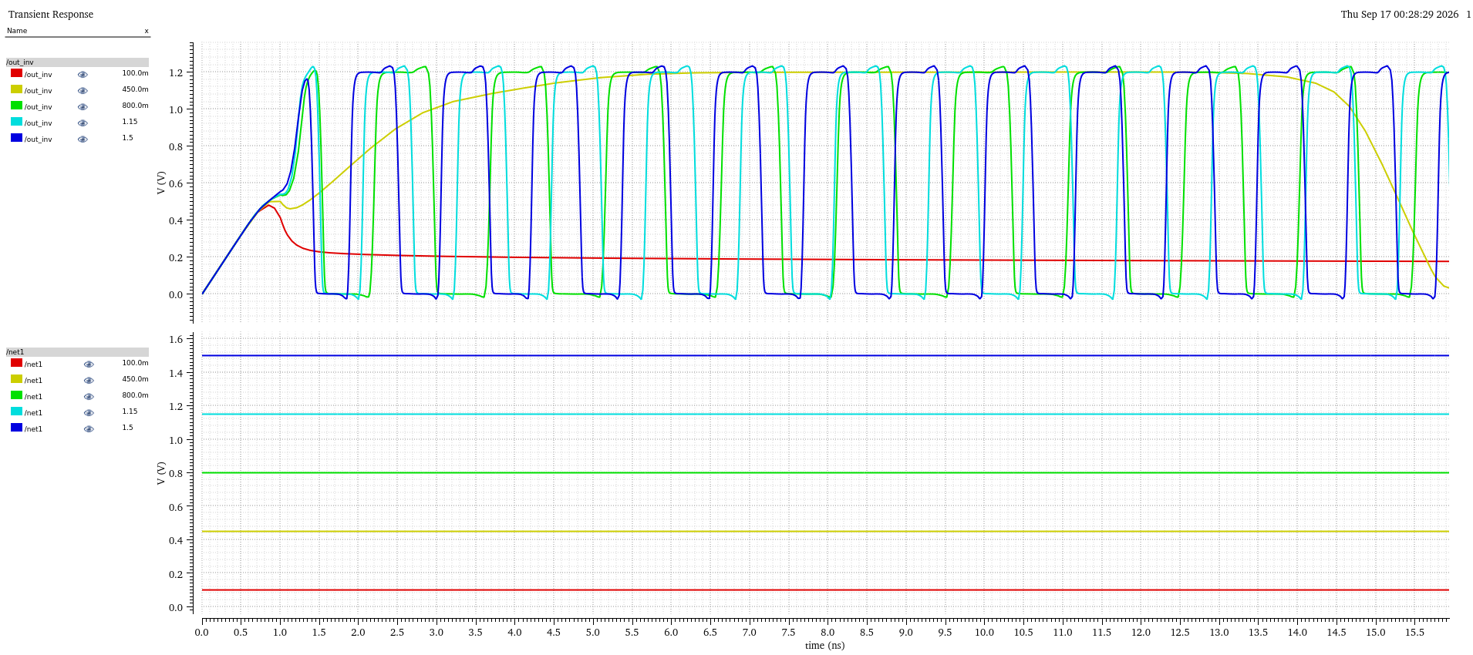
Fig. 3. Transient response of the current-starved VCO output at several control-voltage levels, before and after the output inverter.
B. Tuning Curve Characterization
The voltage-to-frequency tuning curve was obtained by sweeping the control voltage and recording the resulting oscillation frequency at the inverter output, focused on the 0.4 V to 1.2 V range relevant to ECG/EMG acquisition. The result, shown in Fig. 4, is distinctly sigmoidal rather than linear: the frequency rises steeply between roughly 0.4 V and 0.8 V, then continues to increase but with visibly reduced slope between 0.8 V and 1.2 V. This behavior is consistent with the square-law dependence of the starving transistors' drain current on control-voltage overdrive, and matches the nonlinear tuning behavior reported for current-starved ring oscillators elsewhere in the literature [11, 13]. Rather than treating this nonlinearity as a defect to be corrected, it is characterized directly here and its effect on the resulting digital code spacing is examined quantitatively in Section IV.
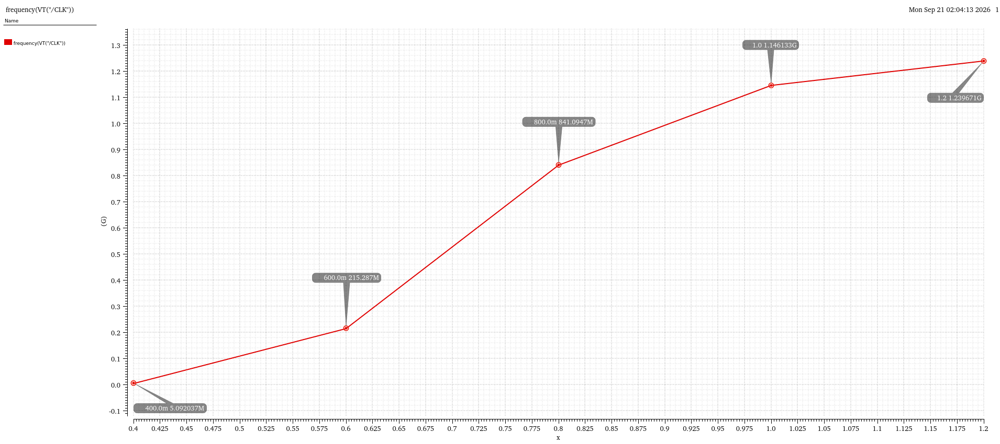
Fig. 4. Measured voltage-to-frequency tuning curve of the integrated VCO-based ADC across the 0.4 V to 1.2 V input range.
C. Frequency-to-Digital Converter
The FDC consists of six cascaded D-flip-flops (D-FFs) forming a ripple counter with an asynchronous, active-low reset, followed by an output register, shown in Fig. 5. Each D-FF is a single-stage, edge-triggered structure built from NAND gates, with the clock of each successive stage driven by the Q_BAR output of the preceding stage, giving a standard binary ripple-counting sequence from 000000 to 111111 (0 to 63) before reset. A six-bit counter was chosen — rather than the four-bit counter conventionally used in narrower-range prior designs [1] — specifically to accommodate the wide frequency excursion produced by the VCO across the full ECG/EMG input range without the counter overflowing, as quantified in Section IV.
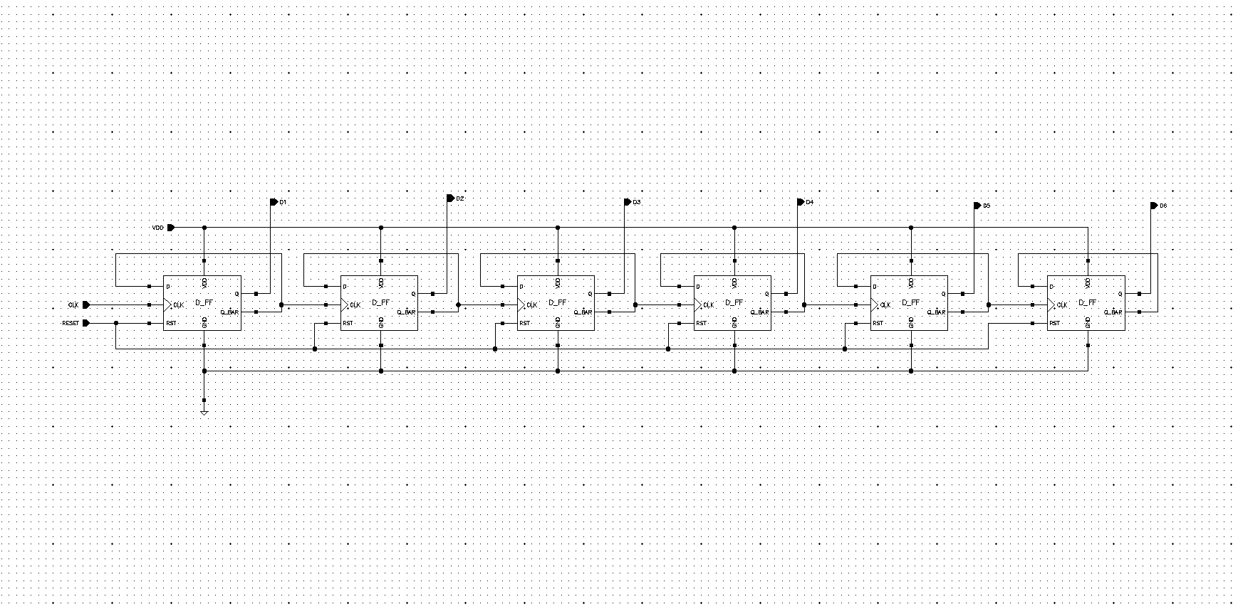
Fig. 5. Schematic of the six-bit ripple counter, implemented as six cascaded edge-triggered D-flip-flops with asynchronous reset.
The counter's functional timing is shown in Fig. 6, where each output bit D1 through D6 is observed to toggle at half the rate of the preceding bit, correctly producing the full binary counting sequence and resetting cleanly once the maximum count is reached.
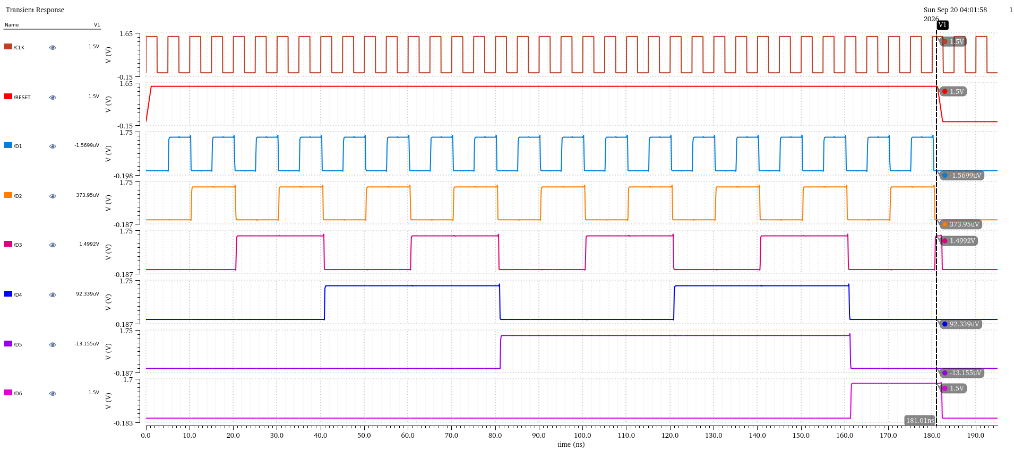
Fig. 6. Timing diagram of the six-bit ripple counter, showing the correct binary counting sequence D1 through D6 and asynchronous reset behavior.
IV. RESULTS AND DISCUSSION
The complete VCO-based ADC was simulated for five fixed input voltages spanning the ECG/EMG-relevant range: 0.4 V, 0.6 V, 0.8 V, 1.0 V, and 1.2 V. In each case, the reset-counter testbench fixed the sampling period at Ts = 50.4 ns (fs ≈ 19.84 MHz), read directly from the simulation rather than derived from the fmin = fs, fmax = 2^n × fs convention used in narrower-range four-bit designs [1]. The resulting oscillation frequency and corresponding six-bit digital output for each input voltage are summarized in Table I.

Vin (V) | fosc (MHz) | Digital Code (D6–D1) | Decimal Count
0.4 | 5.09 | 000000 | 0
0.6 | 218.29 | 001011 | 11
0.8 | 841.09 | 101010 | 42
1.0 | 1146.13 | 111001 | 57
1.2 | 1239.67 | 111101 | 61
TABLE I. VOLTAGE-TO-DIGITAL-CODE MAPPING OVER THE ECG/EMG INPUT RANGE
The digital output increases monotonically across the full input range and reaches 61 out of a maximum possible 63 at 1.2 V, meaning the six-bit counter uses nearly its entire code space without overflowing at any tested point. This confirms that the six-bit sizing decision — made to match this specific ECG/EMG voltage span rather than following a fixed fmax/fmin ratio rule — was appropriate for this design. The unequal spacing between successive codes is a direct, visible consequence of the sigmoidal tuning curve characterized in Fig. 4: the jump from 0 to 11 counts occurs over the 0.4 V to 0.6 V interval, a further 31 counts (11 to 42) occur over the next 0.2 V, while only 19 additional counts (42 to 61) occur over the remaining 0.4 V of input range. This compression at the upper end of the range is the digital-domain signature of the VCO's reduced high-voltage gain, and represents a nonuniform effective LSB size across the input range rather than a fault in the counter or register design.
Individual transient responses of the complete ADC for each of the five tested input voltages are shown in Fig. 7 through Fig. 11, each confirming correct reset timing and a stable digital code at the end of the sampling window.
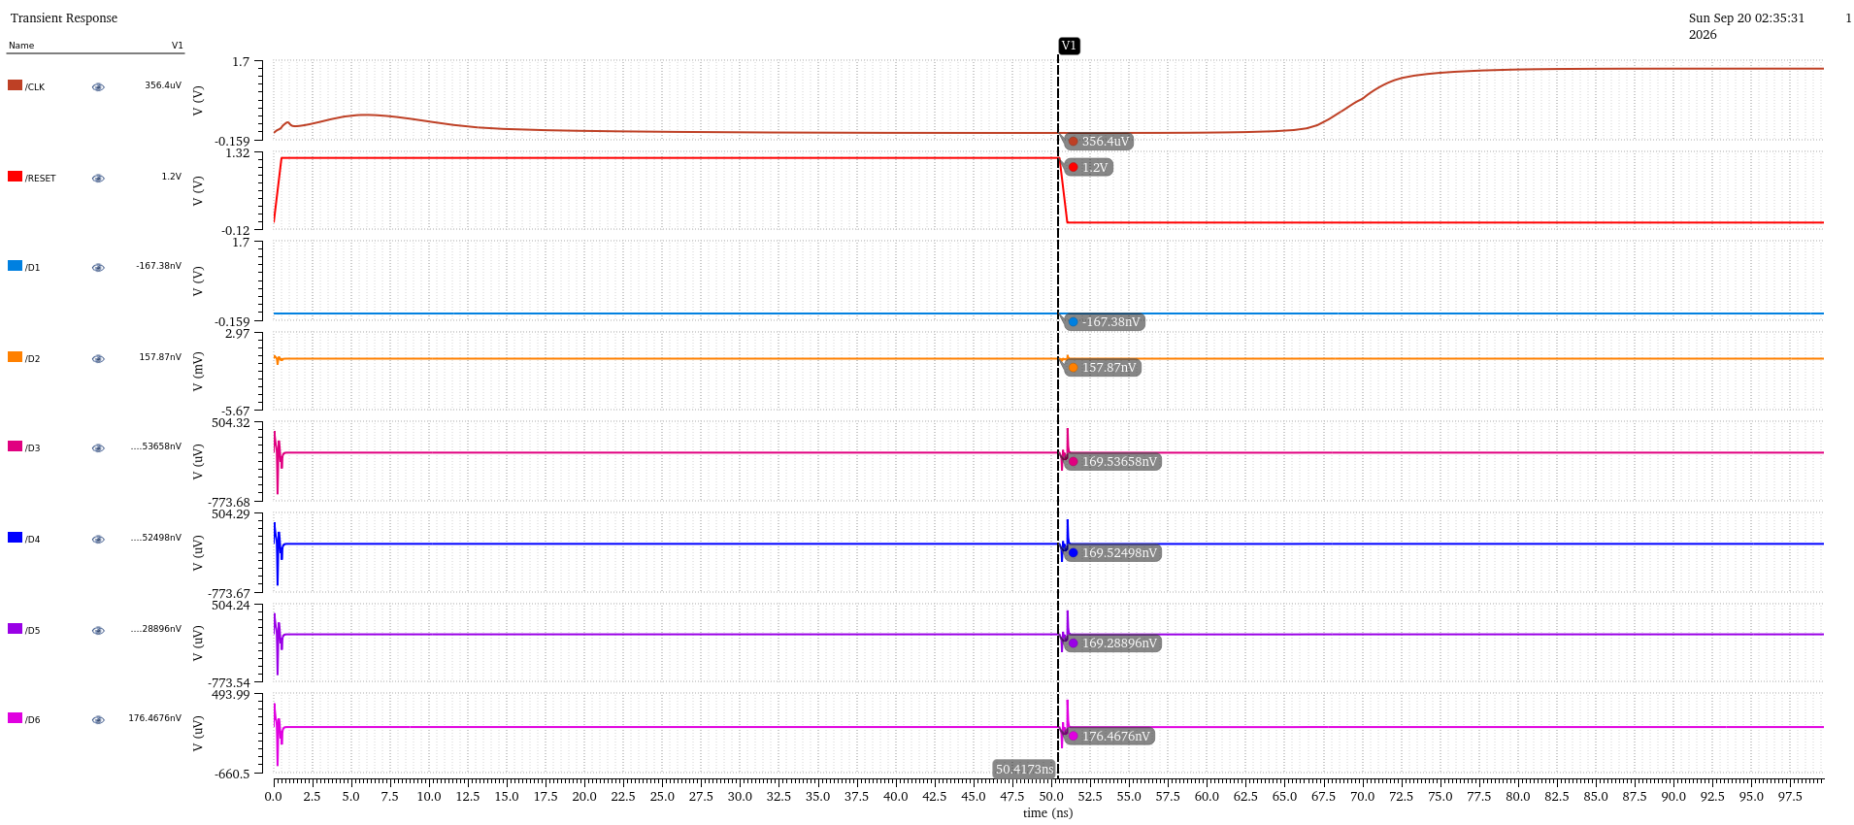
Fig. 7. Transient response of the complete VCO-based ADC for a 0.4 V input voltage.
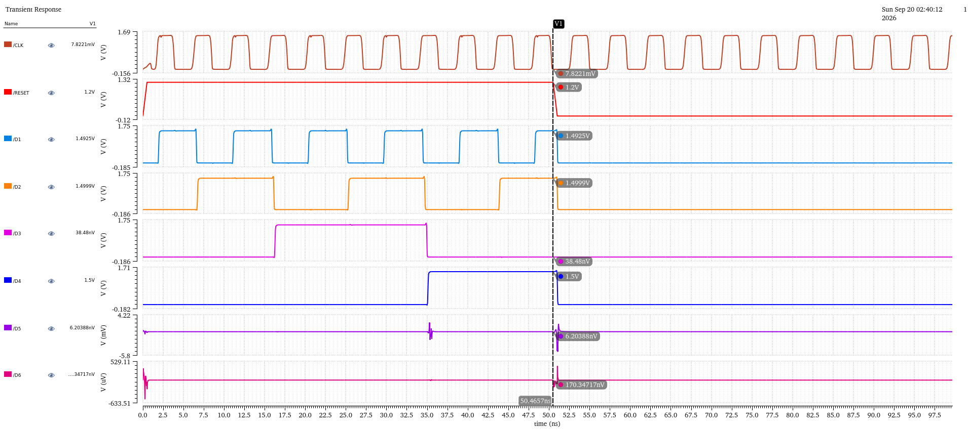
Fig. 8. Transient response of the complete VCO-based ADC for a 0.6 V input voltage.
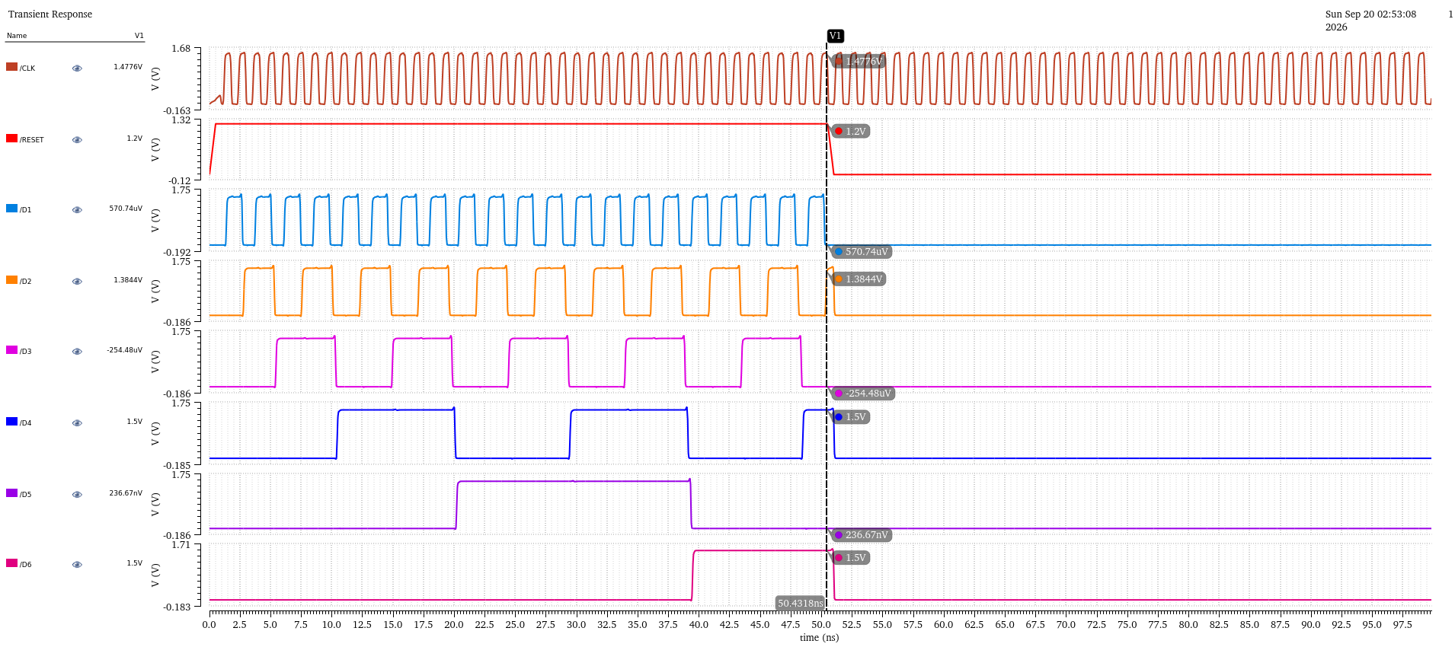
Fig. 9. Transient response of the complete VCO-based ADC for a 0.8 V input voltage.
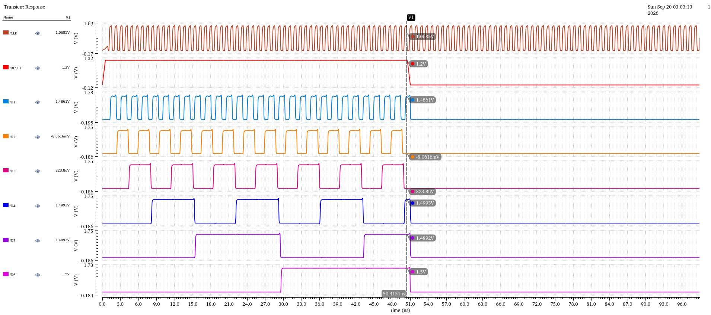
Fig. 10. Transient response of the complete VCO-based ADC for a 1.0 V input voltage.
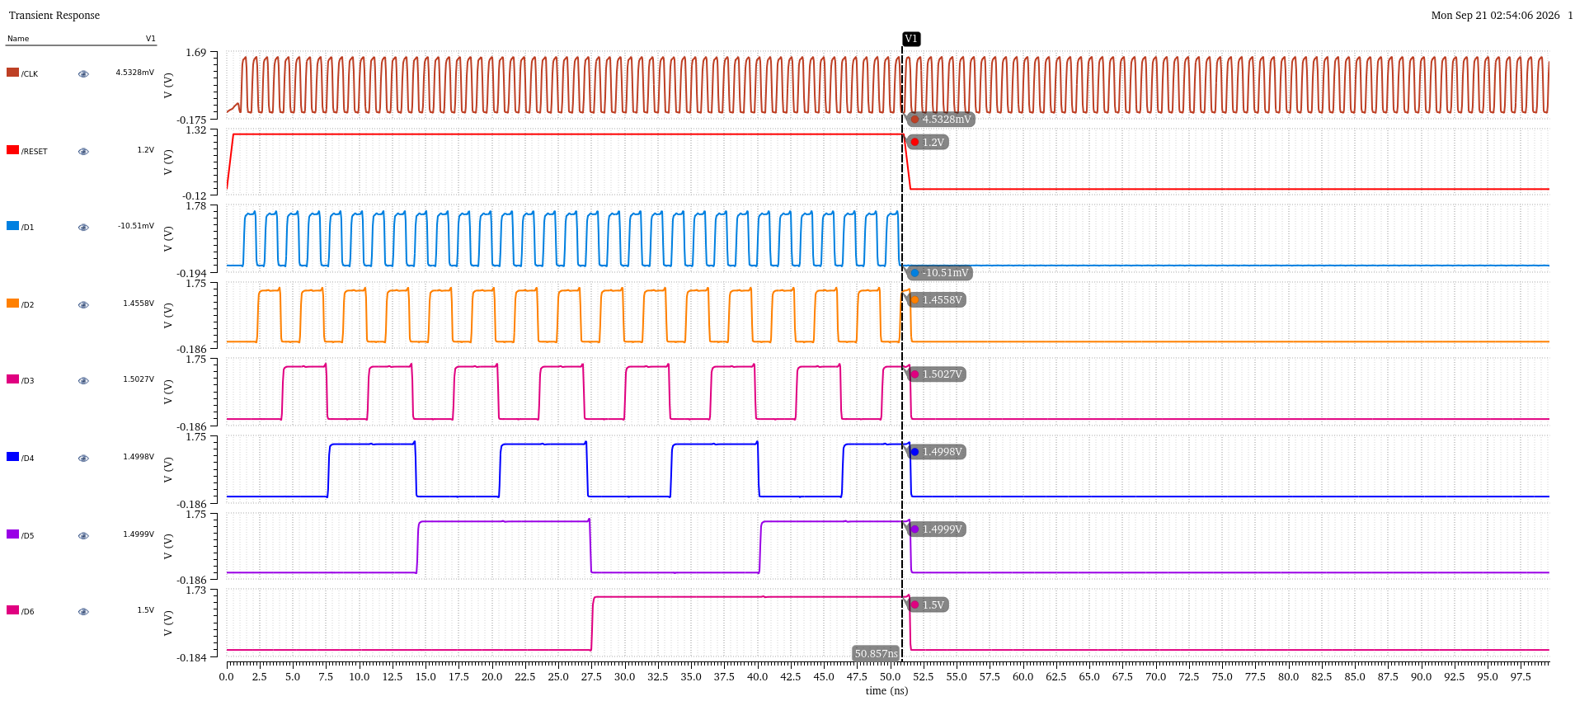
Fig. 11. Transient response of the complete VCO-based ADC for a 1.2 V input voltage.
Table II situates this work relative to previously reported VCO-based ADCs. Power consumption and SNDR-derived figures of merit for the present design are marked as in progress, as these require a sinusoidal-input, FFT-based characterization that had not been completed at the time of writing and is planned as a direct extension of this work.
Ref. | Proc.  (nm) | VDD  (V) | Fs  (MHz) | BW  (MHz) | SNDR  (dB) | Pwr  (mW) | FoM  (fJ/st)
[14] | 130 | 1.8 | 20 | 0.02 | 69.6 | 0.28 | 148
[15] | 65 | 1.2 | 205 | 2.5 | 64.2 | 1 | 150.9
[16] | 180 | 1.8 | 400 | 10 | 72.6 | 24 | 360
[1] | 130 | 1.2 | 100 | 1 | 62 | 0.257 | 125
This  work | 180 | 1.5 | 19.84 | — | TBD* | TBD* | TBD*
TABLE II. COMPARISON WITH PREVIOUSLY REPORTED VCO-BASED ADCs
*Pending sinusoidal-input, FFT-based characterization; see Section V.
V. CONCLUSION AND FUTURE WORK
This work presented the design and functional simulation of a five-stage current-starved ring VCO and a six-bit reset-counter FDC, ported to a 180-nm CMOS process at 1.5 V supply and targeted at ECG/EMG-range biomedical signal acquisition. The voltage-to-frequency tuning curve was shown to be sigmoidal rather than linear across the 0.4 V to 1.2 V input range, and this nonlinearity was shown to translate directly into nonuniform digital code spacing at the ADC output. A six-bit counter, sized specifically for this input range and verified against a testbench-derived sampling period rather than the fixed fmax/fmin ratio convention used in prior four-bit designs, was shown to produce a fully monotonic, non-overflowing digital transfer function across the entire tested range. As future work, this design will proceed to physical layout, DRC/LVS verification, and parasitic extraction, followed by post-layout re-simulation to confirm that the functional behavior characterized here holds once real interconnect and device parasitics are included, culminating in tapeout of the complete VCO-based ADC.
REFERENCES
[1] D. M. Ellaithy, "Voltage-controlled oscillator based analog-to-digital converter in 130-nm CMOS for biomedical applications," Journal of Electrical Systems and Information Technology, vol. 10, no. 38, 2023.
[2] D. Chen, X. Cui, Q. Zhang, D. Li, W. Cheng, C. Fei, and Y. Yang, "A survey on analog-to-digital converter integrated circuits for miniaturized high-resolution ultrasonic imaging systems," Micromachines, vol. 13, no. 1, p. 114, 2022.
[3] K. I. Arafa, D. M. Ellaithy, A. Zekry, M. Abouelatta, and H. Shawkey, "Successive approximation register analog-to-digital converter (SAR ADC) for biomedical applications," Active and Passive Electronic Components, vol. 2023, art. no. 3669255, 2023.
[4] K. I. Arafa, D. M. Ellaithy, et al., "A 1.2-V 7.76-ENOB 1-MS/s single-ended SAR ADC in 65-nm CMOS for biomedical applications," Scientific Reports, 2025.
[5] D. M. Ellaithy et al., "A low-power 8-bit 1-MS/s single-ended SAR ADC in 130-nm CMOS for medical devices," Journal of Electrical Systems and Information Technology, 2024.
[6] Z. Zhu and S. Liu, "Digitalized analog integrated circuits," Fundamental Research, 2023.
[7] Y. Zhong and N. Sun, "A survey of voltage-controlled-oscillator-based ΔΣ ADCs," Tsinghua Science and Technology, vol. 27, no. 3, pp. 472–480, 2021.
[8] R. Shokri, Y. Koolivand, O. Shoaei, D. D. Caviglia, and O. Aiello, "A reconfigurable, nonlinear, low-power VCO-based ADC for neural recording applications," Sensors, vol. 24, no. 19, art. no. 6161, 2024.
[9] J. Kim and S.-Y. Park, "An energy-efficient 12-bit VCO-based incremental zoom ADC with fast phase-alignment scheme for multi-channel biomedical applications," Electronics, vol. 13, no. 9, art. no. 1754, 2024.
[10] J. Bergs, "Design of a VCO based ADC in a 180 nm CMOS process for use in positron emission tomography," M.S. thesis, Luleå Univ. Technology, Luleå, Sweden, 2010.
[11] L. M. Alvero-Gonzalez, V. Medina, V. Kampus, S. Paton, L. Hernandez, and E. Gutierrez, "Ring-oscillator with multiple transconductors for linear analog-to-digital conversion," Electronics, vol. 10, no. 12, p. 1408, 2021.
[12] N. Anjum, V. K. S. Yadav, and V. Nath, "Design and analysis of a low power current starved VCO for ISM band application," International Journal of Microsystems and IoT, vol. 1, no. 2, pp. 82–98, 2023.
[13] P. Srikram, "Ring-VCO-based ADC design for low-energy smart sensing devices," Ph.D. dissertation, Hokkaido Univ., Sapporo, Japan, 2023.
[14] F. Cardes, E. Gutierrez, A. Quintero, C. Buffa, A. Wiesbauer, and L. Hernandez, "0.04-mm2 103-dB-A dynamic range second-order VCO-based audio ΣΔ ADC in 0.13-μm CMOS," IEEE Journal of Solid-State Circuits, vol. 53, no. 6, pp. 1731–1742, 2018.
[15] A. Jayaraj, M. Danesh, S. T. Chandrasekaran, and A. Sanyal, "Highly digital second-order VCO ADC," IEEE Transactions on Circuits and Systems I, vol. 66, no. 7, pp. 2415–2425, 2019.
[16] M. Hu, Y. Guo, and J. Jin, "A VCO-based continuous time delta-sigma ADC with an alternative feedforward scheme VCO," in Proc. IEEE 15th Int. Conf. Solid-State and Integrated Circuit Technology (ICSICT), 2020, pp. 1–3.

