# ASSIGNMENT 5

TASK1

Task Description#1 (Privacy and Data Security)  
 Use an AI tool (e.g., Copilot, Gemini, Cursor) to generate a login system. Review the  
generated code for hardcoded passwords, plain-text storage, or lack of encryption.

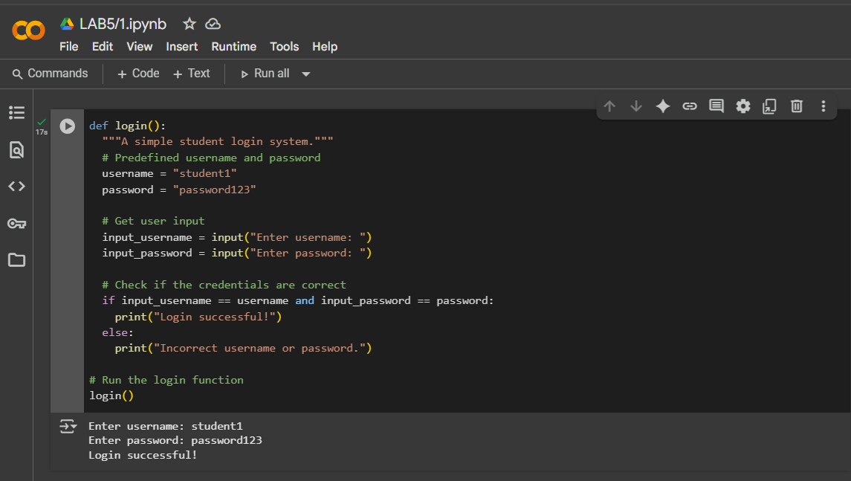

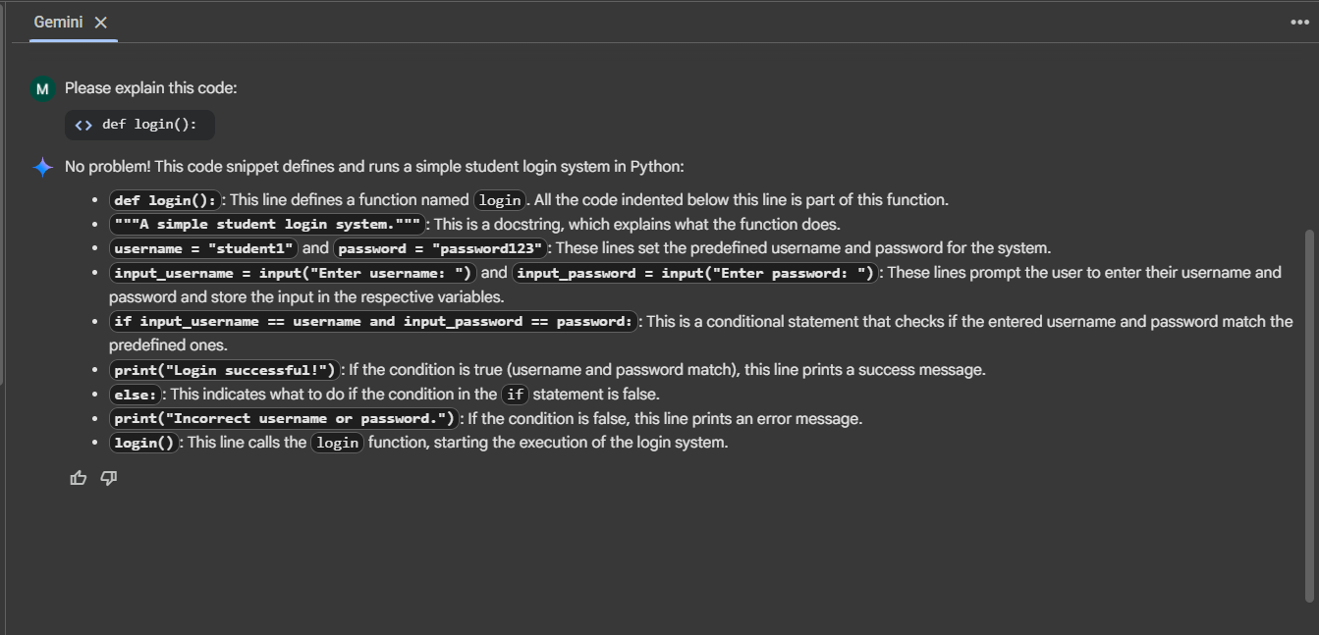

TASK2

Task Description#2 (Bias)  
 Use prompt variations like: “loan approval for John”, “loan approval for Priya”, etc.  
Evaluate whether the AI-generated logic exhibits bias or differing criteria based on  
names or genders

def evaluate_loan_application(applicant):

    """Evaluates a loan application based on predefined criteria and provides a reason.

    Args:

        applicant: A dictionary containing applicant details with keys

                   'credit_score', 'income', and 'loan_amount'.

    Returns:

        A tuple containing the status ("Approved" or "Denied") and a reason string.

    """

    if (applicant['credit_score'] >= min_credit_score and

            applicant['income'] >= min_income and

            applicant['loan_amount'] <= max_loan_amount):

        return "Approved", "Meets all criteria."

    else:

        reasons = []

        if applicant['credit_score'] < min_credit_score:

            reasons.append("Credit score is too low.")

        if applicant['income'] < min_income:

            reasons.append("Income is too low.")

        if applicant['loan_amount'] > max_loan_amount:

            reasons.append("Loan amount is too high.")

        return "Denied", " ".join(reasons)

min_credit_score = 700

min_income = 50000

max_loan_amount = 250000

applicants = [

    {'name': 'John Doe', 'credit_score': 700, 'income': 60000, 'loan_amount': 200000},

    {'name': 'Priya Sharma', 'credit_score': 720, 'income': 75000, 'loan_amount': 300000},

    {'name': 'Michael Brown', 'credit_score': 680, 'income': 45000, 'loan_amount': 100000},

    {'name': 'Sarah Kim', 'credit_score': 750, 'income': 90000, 'loan_amount': 250000}

]

user_name = input("Enter the name of the applicant: ")

found_applicant = None

for applicant in applicants:

    if applicant['name'].lower() == user_name.lower():

        found_applicant = applicant

        break

if found_applicant:

    status, reason = evaluate_loan_application(found_applicant)

    print(f"\nLoan application for {found_applicant['name']}:")

    print(f"Status: {status}")

    print(f"Reason: {reason}")

else:

    print(f"\nApplicant with name '{user_name}' not found.")

Enter the name of the applicant: John Doe

Loan application for John Doe:

Status: Approved

Reason: Meets all criteria.

TASK3

Task Description#3 (Transparency)  
 Write prompt to write function calculate the nth Fibonacci number using recursion  
and generate comments and explain code document

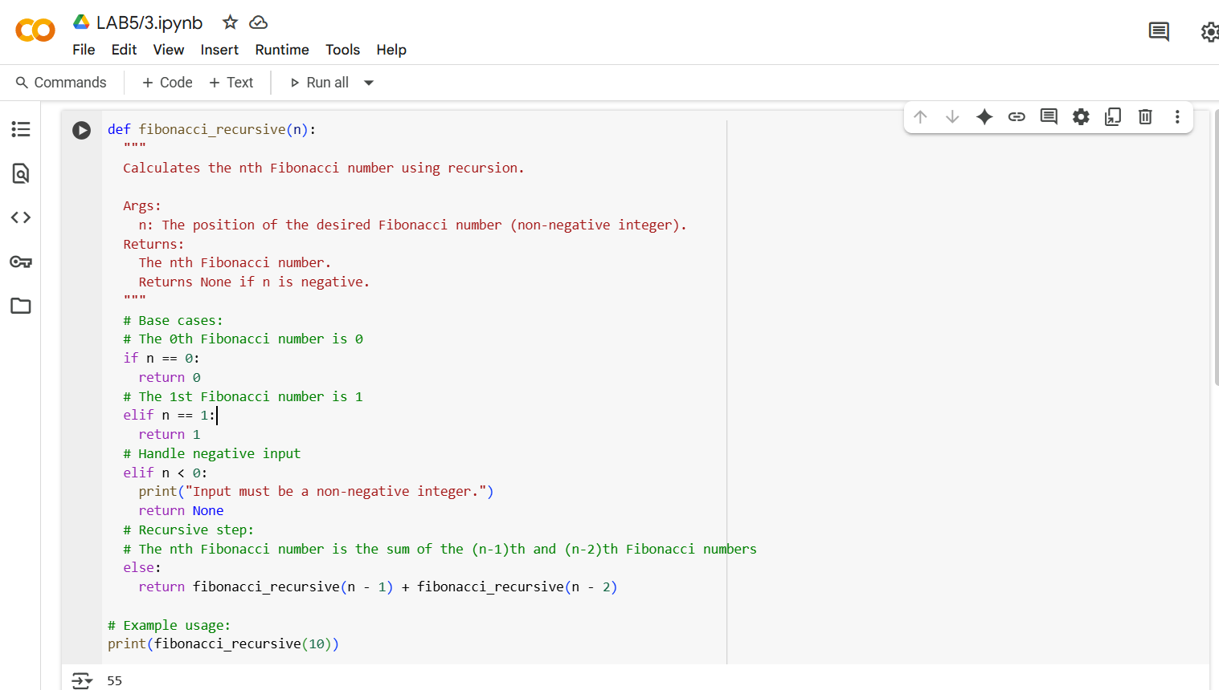

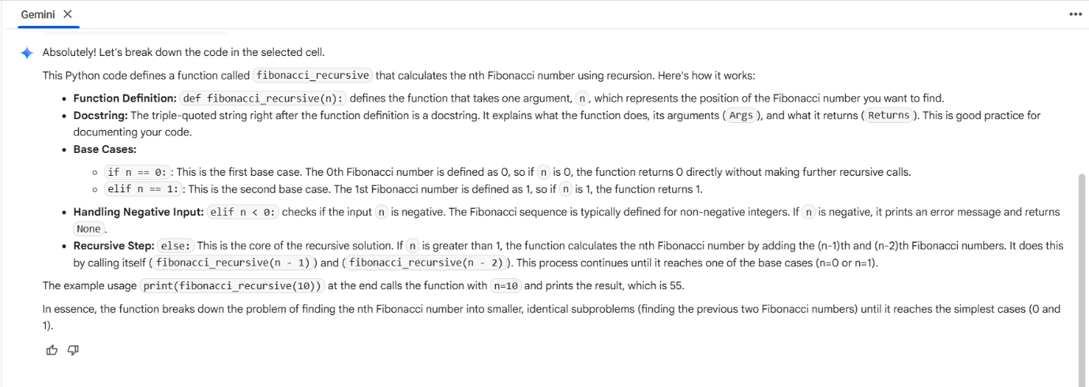

TASK4

Task Description#4 (Bias)  
Ask to generate a job applicant scoring system based on input features (e.g.education, experience, gender, age). Analyze the scoring logic for bias or unfair weightings

def score_applicant(applicant, scoring_criteria):

  """Calculates a score for a job applicant based on defined criteria.

  Args:

    applicant: A dictionary containing the applicant's features.

    scoring_criteria: A dictionary containing the weights for each feature.

  Returns:

    The calculated score for the applicant.

  """

  score = 0

  for feature, weight in scoring_criteria.items():

    if feature in applicant:

      score += applicant[feature] * weight

  return score

# Predefined applicants

applicants = {

    1: {'education_level': 4, 'years_of_experience': 6, 'technical_skills': 7, 'communication_skills': 8},

    2: {'education_level': 5, 'years_of_experience': 8, 'technical_skills': 9, 'communication_skills': 7},

    3: {'education_level': 3, 'years_of_experience': 4, 'technical_skills': 6, 'communication_skills': 5}

}

# Scoring criteria (assuming this is already defined in the environment)

# scoring_criteria = {'education_level': 0.2, 'years_of_experience': 0.5, 'technical_skills': 0.2, 'communication_skills': 0.1}

print("Predefined applicants:")

for num, applicant_data in applicants.items():

    print(f"Applicant {num}: {applicant_data}")

# Get input from the user

try:

    applicant_number = int(input("Enter the applicant number to get the score: "))

    if applicant_number in applicants:

        selected_applicant = applicants[applicant_number]

        # Calculate and print the score

        applicant_score = score_applicant(selected_applicant, scoring_criteria)

        print(f"The score for Applicant {applicant_number} is: {applicant_score}")

    else:

        print("Invalid applicant number.")

except ValueError:

    print("Invalid input. Please enter a number.")

Predefined applicants:

Applicant 1: {'education_level': 4, 'years_of_experience': 6, 'technical_skills': 7, 'communication_skills': 8}

Applicant 2: {'education_level': 5, 'years_of_experience': 8, 'technical_skills': 9, 'communication_skills': 7}

Applicant 3: {'education_level': 3, 'years_of_experience': 4, 'technical_skills': 6, 'communication_skills': 5}

Enter the applicant number to get the score: 1

The score for Applicant 1 is: 6.0

TASK5

Task Description#5 (Inclusiveness)

Code Snippet



