2320030010 Section 4  
K Mounisha sri sai saranya

**Client Report on the YouTube Transcriber LLM App Using Google Gemini Pro**

**Introduction**

This report documents the meetings and feedback gathered from Mrs. Gayathri Devi K, Academic Dean of Narayana e-Techno School, Nizampet, regarding the development of the YouTube Transcriber LLM App. The app leverages the Google Gemini Pro model to automatically transcribe and summarize YouTube videos, making it easier for educators to review and prepare lesson materials.

The tool is built using the Streamlit interface and Python framework, designed for simplicity and functionality. Its primary purpose is to generate concise summaries of educational videos, which can help teachers like Mrs. Gayathri Devi K. in their daily lesson planning. Mrs. Devi often uses YouTube videos as supplemental teaching resources and requires this tool to save time on video review and preparation by summarizing the key points of a video, particularly focusing on complex concepts, definitions, and examples that she plans to explain further in class.

**Day 1: Meeting Summary**

**MCQs:**

1. **What types of YouTube videos do you primarily use for teaching?**
   * **o Educational lectures**
   * **o Tutorials**
   * **o Documentaries**
   * **o Other: ___________**
2. **How often do you use YouTube videos as part of your lessons?**
   * **o Daily**
   * **o Weekly**
   * **o Occasionally**
   * **o Rarely**
3. **How long are the YouTube videos you typically use?**
   * **o Less than 5 minutes**
   * **o 5–10 minutes**
   * **o 10–30 minutes**
   * **o More than 30 minutes**
4. **How important is it for the summary to include timestamps?**
   * **o Very important**
   * **o Somewhat important**
   * **o Not important**
5. **Do you prefer bullet-point summaries or paragraph summaries?**
   * **o Bullet points**
   * **o Paragraphs**

**Q&A:**

1. **What are the key points you expect the summary to cover from a video?**
   * **"I expect it to highlight the main concepts and examples discussed."**
2. **How would you describe the ideal length of a summary for your teaching materials?**
   * **"A concise but comprehensive 250-word summary would be ideal."**
3. **What challenges do you face when manually summarizing videos?**
   * **"It takes too much time, especially with longer videos."**
4. **What specific features would make this tool more helpful for you?**
   * **"The ability to add my own notes to the generated summary."**
5. **How important is transcript accuracy for your workflow?**
   * **"Accuracy should be the top priority, especially when dealing with complex topics."**

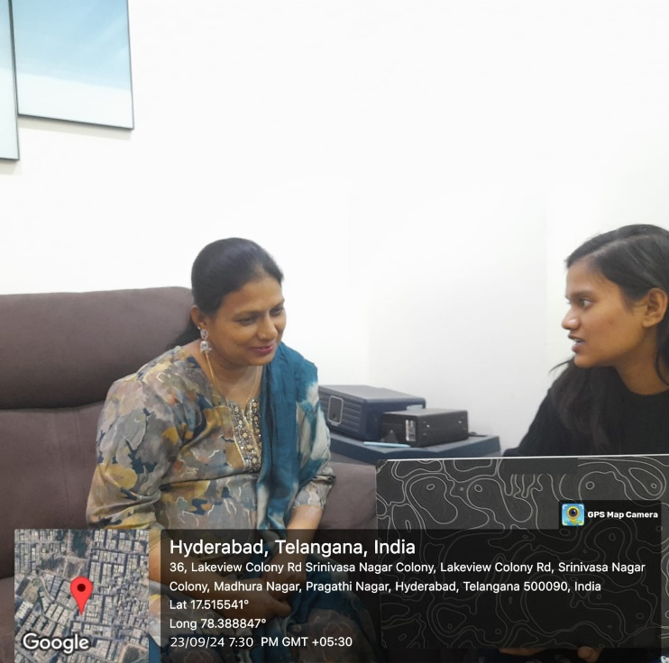

**Day 2: Meeting Summary**

**MCQs:**

1. **Should the tool allow editing or modifying the generated summaries before finalizing them?**
   * **o Yes**
   * **o No**
2. **How likely are you to use a feature that allows you to save video summaries for future reference?**
   * **o Very likely**
   * **o Somewhat likely**
   * **o Unlikely**
3. **Should the tool generate quizzes or discussion questions based on the summarized content?**
   * **o Yes**
   * **o No**
4. **How important is it for the tool to categorize or organize summaries by subject or topic?**
   * **o Very important**
   * **o Somewhat important**
   * **o Not important**
5. **Should the tool support summarization of live-streamed YouTube videos as well?**
   * **o Yes**
   * **o No**

**Q&A:**

1. **How would you prioritize the following: transcript accuracy, speed, formatting options, language support?**
   * **"Transcript accuracy should come first, then formatting options."**
2. **Can you provide examples of situations where summarizing a video would save you time?**
   * **"For lesson planning, it helps to have quick summaries of lengthy educational videos."**
3. **Are there any features you think would be unnecessary?**
   * **"I don’t think we need timestamps for short videos."**
4. **Do you prefer video summaries to focus on detailed analysis or just key points?**
   * **"Just the key points, because I’ll expand on the details in class."**
5. **Would you trust AI-generated summaries for educational purposes?**
   * **"I trust AI for general points, but I’ll still review them before sharing with students."**

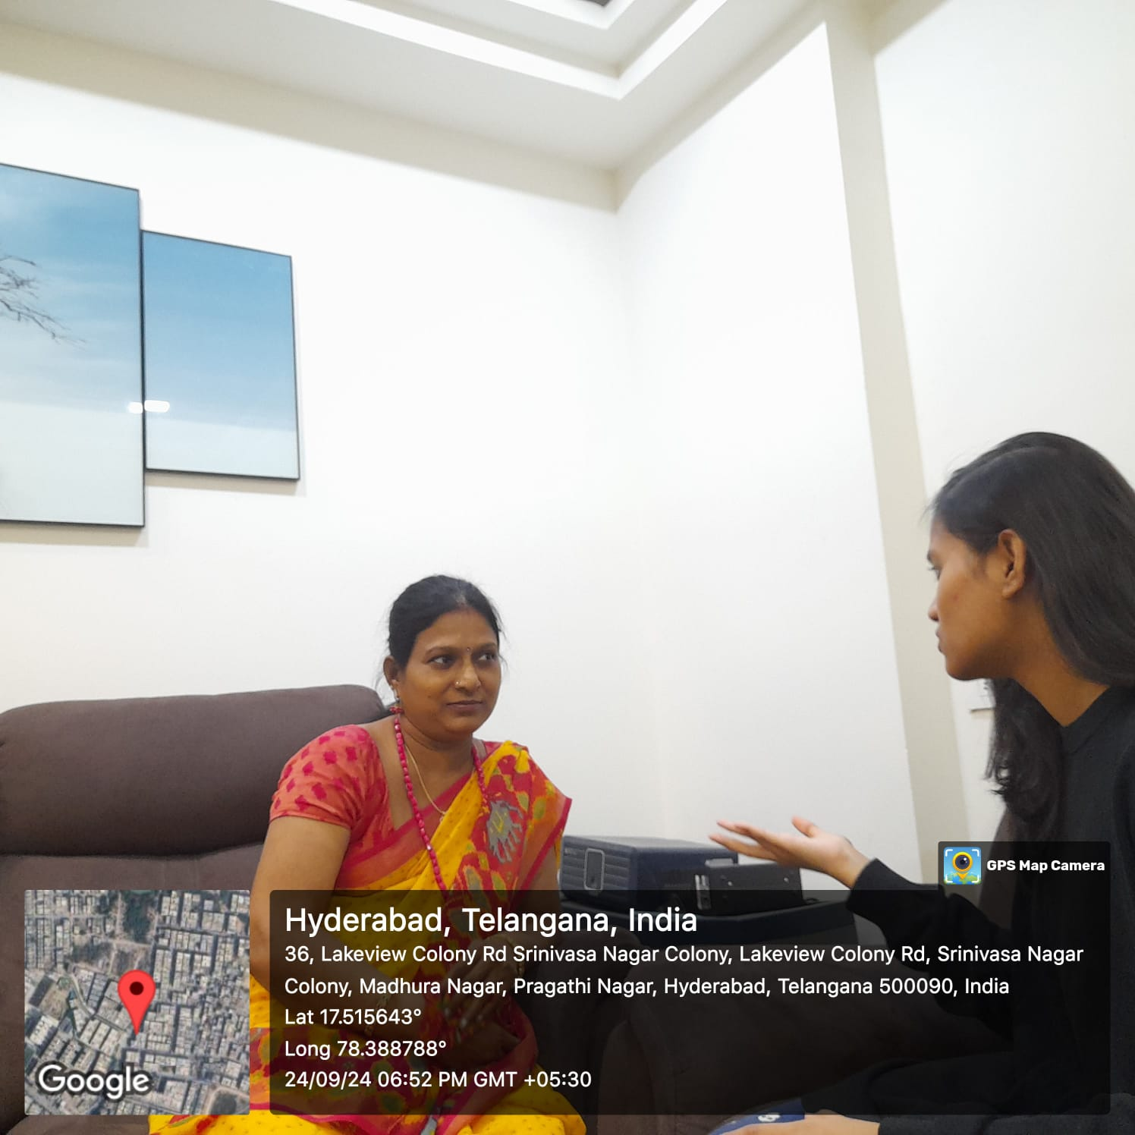

**Day 3: Meeting Summary**

**MCQs:**

1. **How important is the speed of transcript generation for your workflow?**
   * **o Extremely important**
   * **o Somewhat important**
   * **o Not important**
2. **Would you prefer to have automatic summaries generated as you watch the video?**
   * **o Yes, it would be convenient**
   * **o No, I prefer summaries after watching**
   * **o I’m indifferent**
3. **Would you like an option to compare different versions of the transcript (e.g., edited, automated)?**
   * **o Yes**
   * **o No**
   * **o Maybe**
4. **How often do you summarize non-educational videos for other purposes?**
   * **o Frequently**
   * **o Occasionally**
   * **o Rarely**
   * **o Never**
5. **Do you need the tool to summarize videos from platforms other than YouTube (e.g., Vimeo, Dailymotion)?**
   * **o Yes**
   * **o No**

**Q&A:**

1. **How would you customize the output of the summaries to suit your teaching style?**
   * **"I would include more visuals or diagrams alongside text summaries."**
2. **What challenges do you face with existing tools when summarizing or transcribing YouTube videos?**
   * **"Current tools don’t summarize videos well; they tend to lose important context."**
3. **What feedback do you usually receive from students regarding the video summaries?**
   * **"Students find summaries helpful for revision."**
4. **Would you prefer a feature that generates video annotations instead of just summaries?**
   * **"Yes, annotations would be more interactive for class discussions."**
5. **What key frustrations have you experienced when using YouTube videos in your lessons?**
   * **"The lack of good-quality captions and transcripts makes it harder to follow along."**

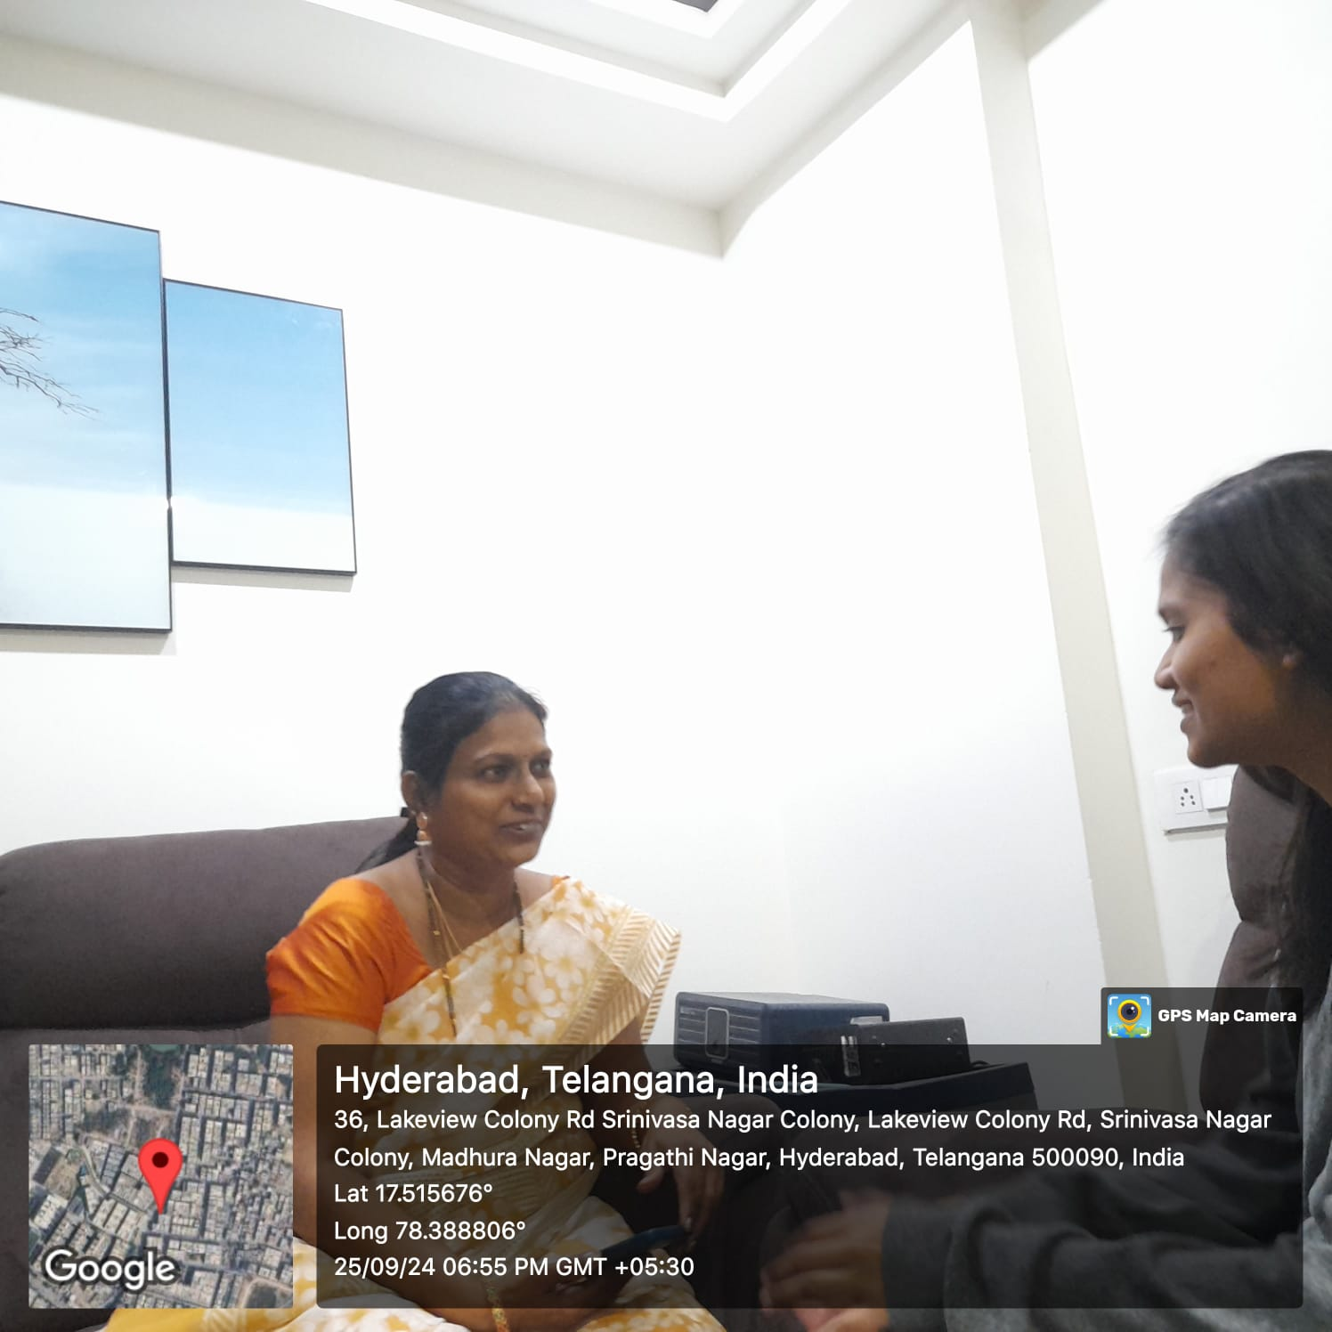

**Day 4: Meeting Summary**

**MCQs:**

1. **Would you use the tool to convert video transcripts into other formats (e.g., presentations, lesson plans)?**
   * **o Yes, I’d use it frequently**
   * **o Maybe, in some cases**
   * **o No, I only need plain summaries**
2. **How often do you use captions or subtitles when watching YouTube videos for teaching?**
   * **o Always**
   * **o Sometimes**
   * **o Rarely**
   * **o Never**
3. **Would you like the tool to offer an option to exclude certain sections (e.g., introductions, advertisements) from the summary?**
   * **o Yes, it would be helpful**
   * **o No, I prefer the full transcript**
4. **How frequently would you like the tool to update or check for changes in the summarized video?**
   * **o Every time the video is edited**
   * **o Monthly**
   * **o Never**
   * **o Other: ___________**
5. **Do you think a feature that summarizes video comments would be useful for teaching?**
   * **o Yes**
   * **o No**

**Q&A:**

1. **How do you currently use YouTube videos to engage students, and how could this tool improve that process?**
   * **"I use videos as supplemental material, and summaries could make it easier to review."**
2. **How would this tool fit into your daily teaching workflow?**
   * **"It would save me time by automatically generating notes after I select the videos."**
3. **What additional educational tools would enhance your teaching experience using this tool?**
   * **"A feature to auto-generate diagrams or mind maps from summaries would be helpful."**
4. **If the tool had a collaboration feature for sharing summaries, how would that help?**
   * **"It would be great for collaborating with other teachers on lesson planning."**
5. **What expectations do you have for AI-generated summaries for educational purposes?**
   * **"I expect them to be accurate and capture the main ideas without needing too much revision."**



**Conclusion**

Mrs. Gayathri Devi K’s feedback has been invaluable in shaping the development of the YouTube Transcriber LLM App. Her insights on accuracy, flexibility, and ease of use will help refine the tool to better meet the needs of educators, ensuring it serves as a valuable resource for lesson planning and content review.