1.Draw a graph with overall_score as the Y axis and parental_level_of_education as the X axis.

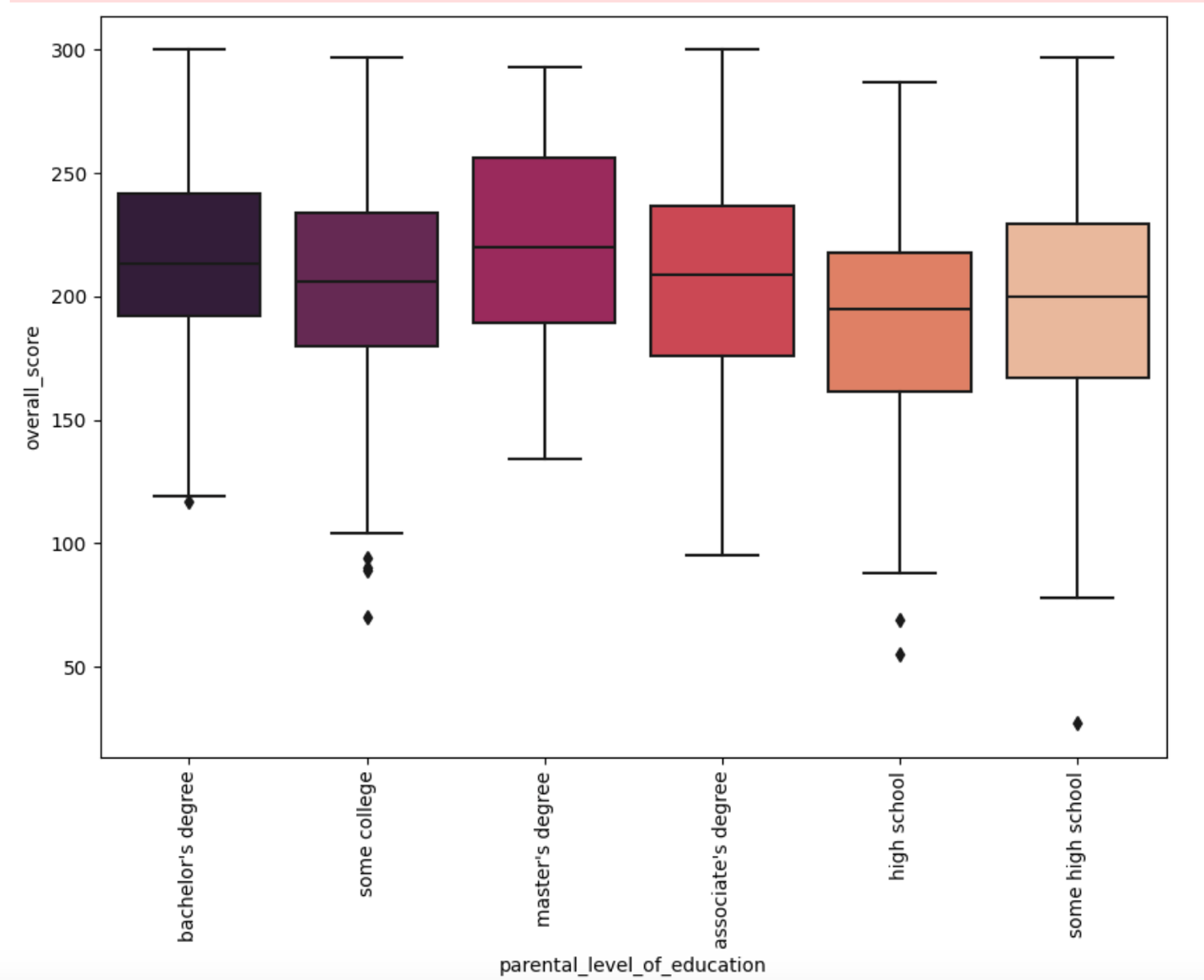

conclusion: We might assume that a master's degree is of greater value in comparison to other degrees of education.

1. Let us plot a graph between count in Y – axis and score type in X- axis.

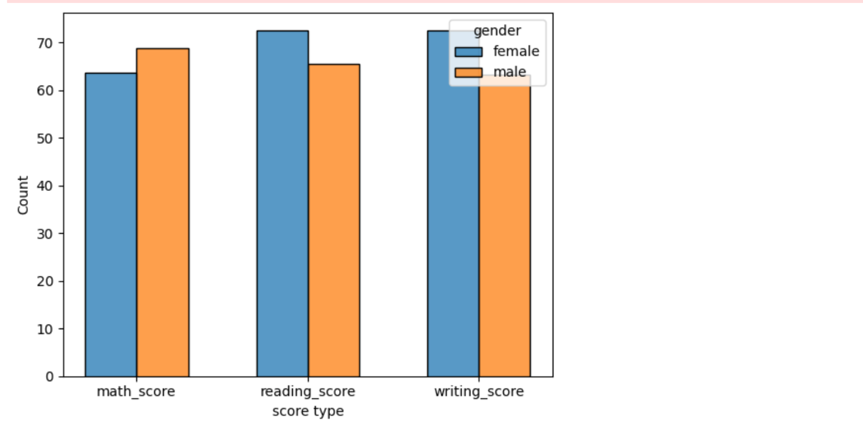

Conclusion: We can assume that males have greater arithmetic scores than females, while females have greater reading and writing scores than males.