Top of Form

Bottom of Form

Top of Form

Bottom of Form

**Introduction**

A scientific calculator is a calculator designed to help calculate science, engineering, and mathematics problems. It has way more buttons than your standard calculator that just lets you do your four basic arithmetic operations of addition, subtraction, multiplication, and division.we can now use calculator to solve trigonometry problems involving sine, cosine, tangent, their inverses, and their hyperbolic functions. When working with trigonometric values, we can change the calculations between degrees, radians, and grads. Also, aslo we now have access to a button for π and Euler's constant, e. There are also buttons that allow you to easily calculate exponents to the second, third, or any other power.

**Features**

This system supports following types of data conversions (For positive integers): 1.Substraction(-),2.Addition(+),3.multiplication,4.divison,5.Power of a number, 5.logarithim 6.square root,7.sine 8.cosine 9.tangent 10.secant

**Swot Analysis**

_______________+++++[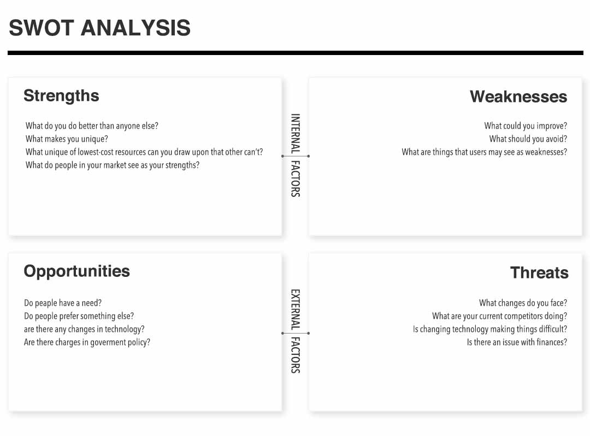](https://user-images.githubusercontent.com/89597549/132383860-d152b5be-cff1-496a-aa88-c396f57b000e.jpg)

**Examples**

| **Input** | **output** |
| --- | --- |
| 7+4 | 11 |
| 8-5 | 3 |
| log(2) | 0.301 |
| sqrt(16) | 4 |
| sin((30) | 0.5 |
| cos(60) | 0.5 |
| tan(45) | 1 |

**4W's and 1'H**

**Who:**

1. all engineering students
2. commers students

**What:**

A person can easly calculate the problems,this can help to so many students.

**When:**

1. youcan crossVerify your manualy done work by this calculator.

**Where:**

This project can be used by students as well as shop owners where such calculations are needed.

**How:**

This project can perform various calculations at the same and make user's task smooth and effortless.

**Detail requirements**

**High Level Requirements:**

| **ID** | **Description** | **Status (Implemented/Future)** |
| --- | --- | --- |
| HLR-1 | User shall be able to do division easly | Implemented |
| HLR-2 | System output must display data without any error | Implemented |
| HLR-3 | User shall be able to dispaly the data in colour screen | Future |
| HLR-4 | User shall be able to charge it like mobile | Future |

**Low level Requirements:**

| **ID** | **Description** | **Status (Implemented/Future)** |
| --- | --- | --- |
| LLR-1 | User shall be able to make almost all calculations output data | Implemented |