Smart Energy Consumption Analysis and Prediction using Machine Learning with Device-Level Insights

1. Introduction
This project focuses on building a system that tracks energy consumption of different home appliances and predicts future usage using machine learning techniques. In most households, electricity bills provide only total consumption without appliance-level insights. This system provides device-level analysis along with next-hour energy prediction through a web dashboard. The primary objective is to help users understand their consumption patterns and reduce electricity waste.

2. Dataset Used
Dataset Name: SmartHome Energy Monitoring Dataset
File Used: smart_home.csv
Columns Included:
-HomeID
- Date
- Time
- Appliance Type
- Energy Consumption (kWh)
- Outdoor Temperature (C)
- Season
Total Appliances: 10 (Air Conditioning, Computer, Dishwasher, Fridge, Heater, Microwave, Oven, TV, Washing Machine, Light)

3. Work Done - Module Wise
Week 1-2: Data Collection and Preprocessing
- Data loading and structure validation
- Missing value handling and duplicate removal
- Time series transformation
- Resampling to hourly and daily formats
- Normalization using MinMaxScaler
- Train-test split (80%-20%)
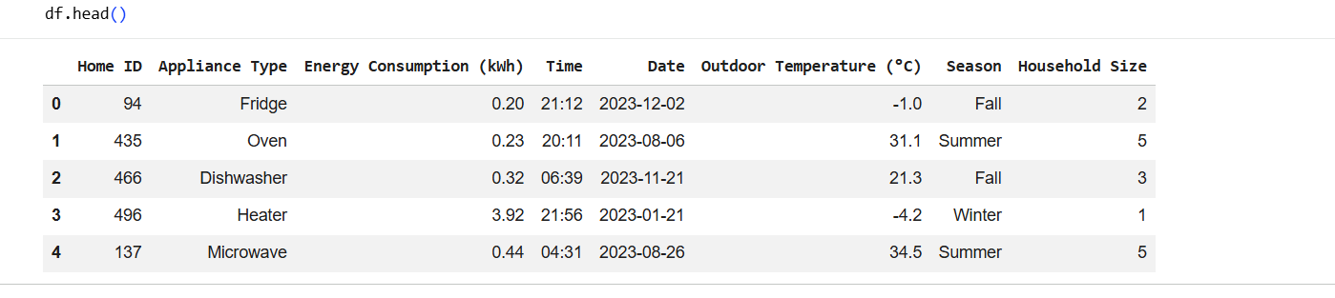
Week 3-4: Feature Engineering and Baseline Model
- Extracted time-based features (hour, day, weekday, month)
- Created lag and rolling mean features
- Built Linear Regression models per appliance
- Evaluated using MAE and RMSE
- Saved models as .pkl files
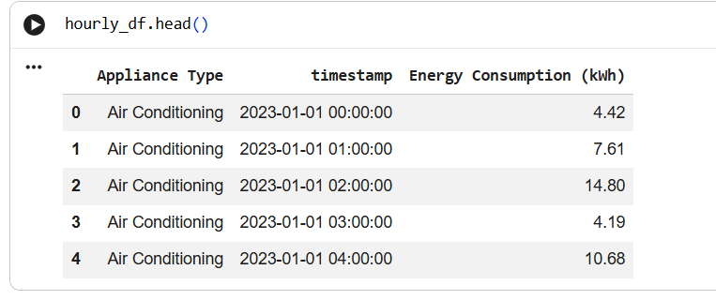
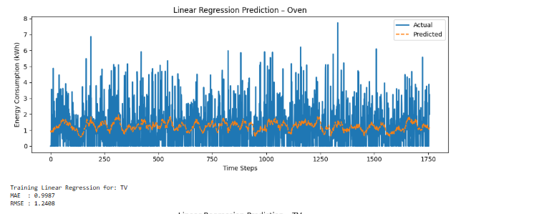
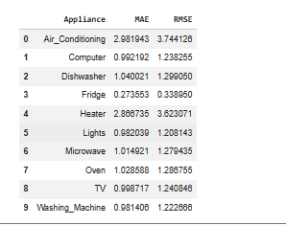
Week 5-6: LSTM Model Development
- Built LSTM architecture with Dropout layers
- Used Adam optimizer and MSE loss
- Applied EarlyStopping
- Trained separate LSTM model per appliance
- Saved models (.h5) and scalers (.pkl)
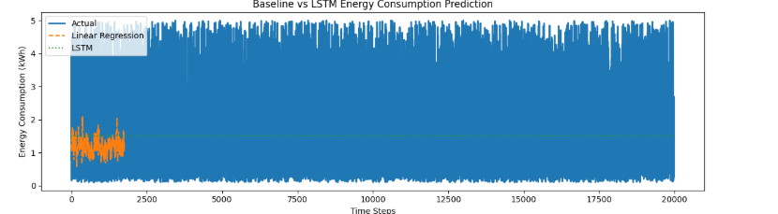
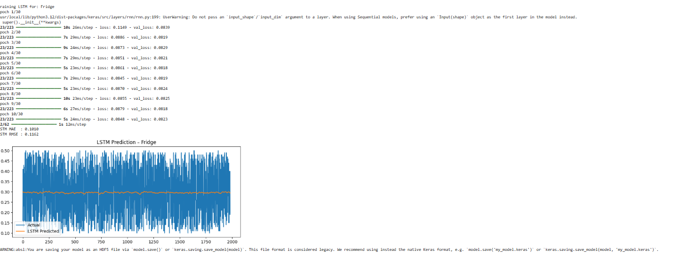
Week 7-8: Dashboard and Web Application
- Developed Flask backend (app.py)
- Created REST API endpoints
- Designed frontend using HTML, CSS, and JavaScript
- Built interactive dashboard with charts and predictions
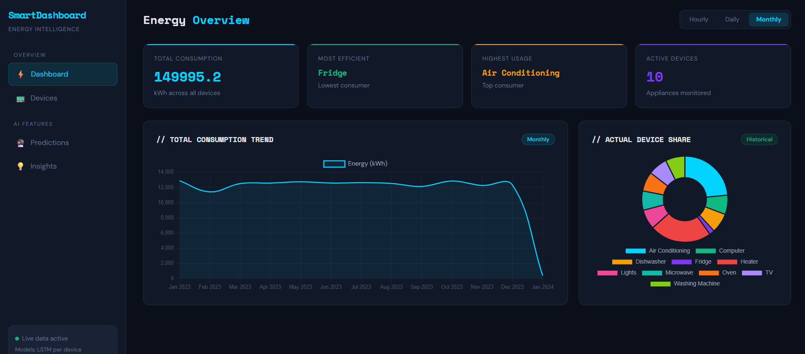
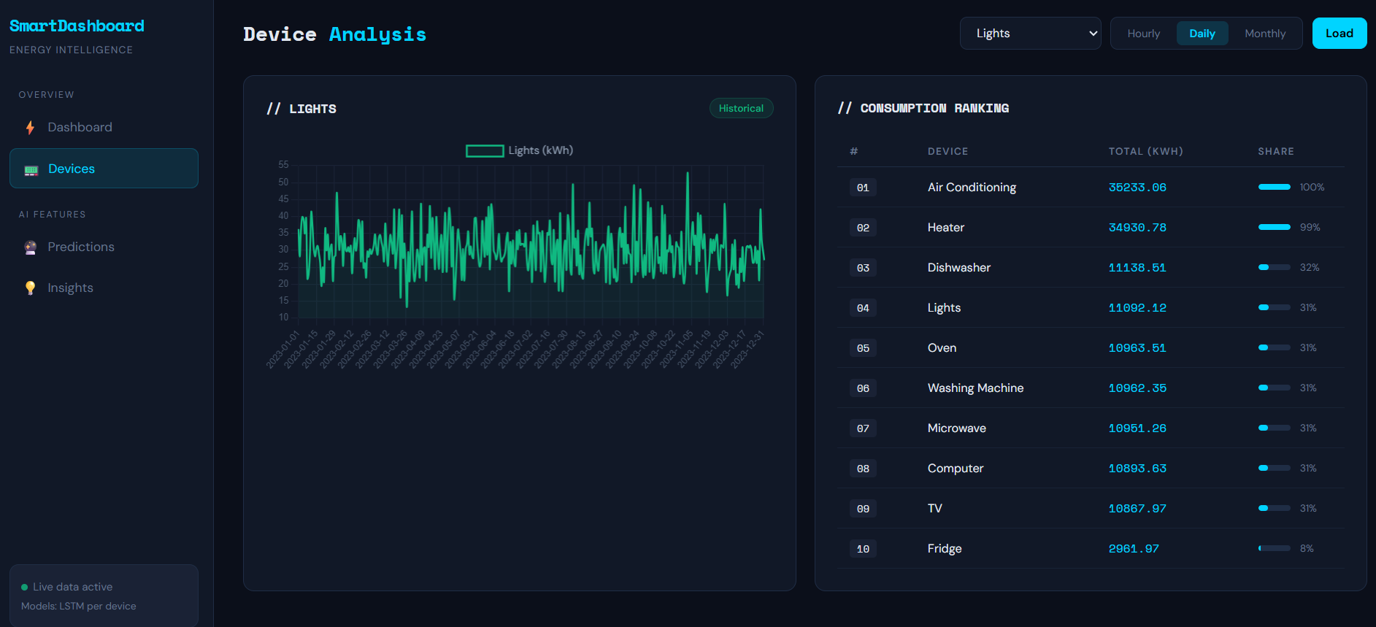
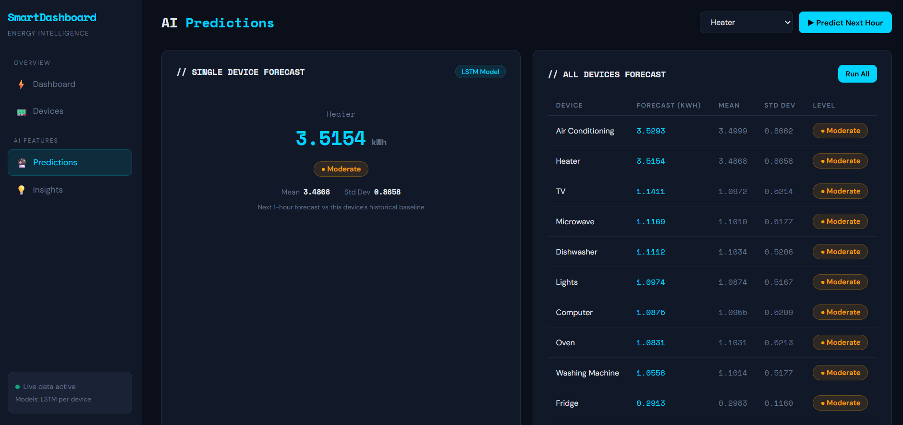
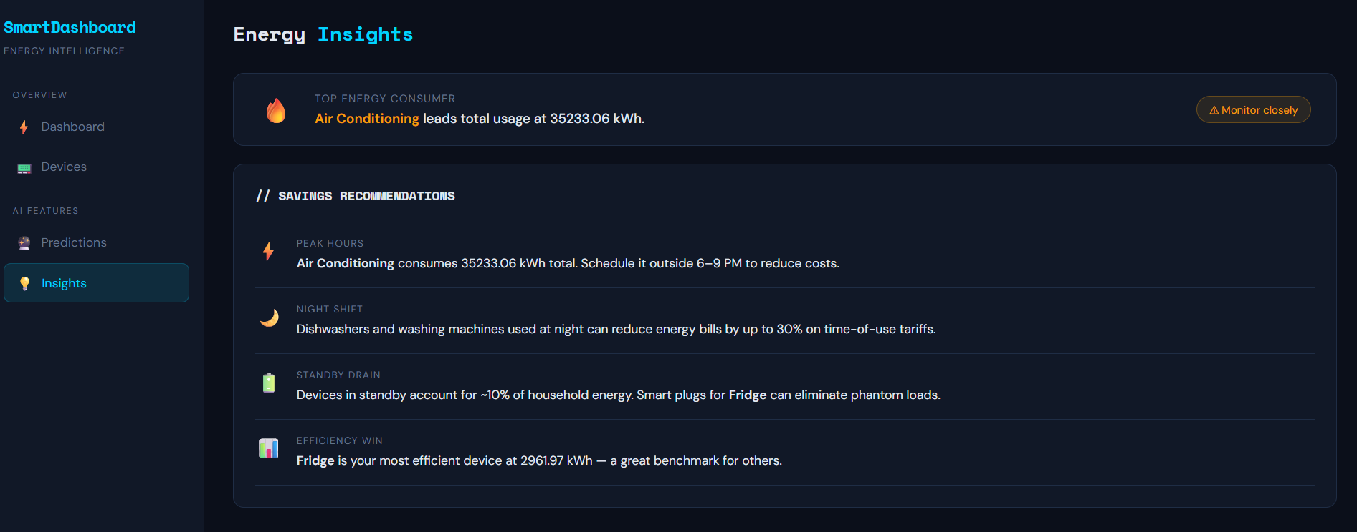

4. API Endpoints
GET /api/appliances
GET /api/overall
GET /api/device
GET /api/device_totals
GET /api/device_stats
GET /api/predict_all
POST /api/predict
GET /api/insights

5. Prediction Level Logic
Prediction levels are classified using mean and standard deviation of each appliance:
- High: Above (mean + std deviation)
- Moderate: Within mean ± std deviation
- Low: Below (mean - std deviation)
If standard deviation is near zero, a 10% band of mean is used instead.

6. Result Summary
Total Tests Conducted: 41
Tests Passed: 41
Tests Failed: 0
LSTM model performed better than Linear Regression across all appliances, especially for non-linear energy usage patterns.

7. Learning Outcomes
- Time series analysis using pandas
- LSTM model building using Keras
- Model saving and loading
- Flask REST API development
- Frontend-backend integration
- Dashboard visualization
- Git version control

8. Limitations
- Works on static CSV data
- No live sensor integration
- Manual retraining required
- No authentication system

