**TASK:1**

**execute the following networking commands like -**

**1)ipconfig  
2)tracert  
3)telnet  
4) Ip brief  
5)ping  
6)nslookup**

**PROCEDURE:**

**Step1: Launch Cisco packet tracer**  
->Double click the cisco packet tracer icon on your desktop or find it in your applications list and open the program

**Step2: Create a simple network topology  
1)Add devices** – Routers, switches and PC’s  
 ->Drag and drop a router and a switch from the device list on to the workspace.   
 ->Drag and drop two PC’s on to the workspace.  
**2)Connection**- Use the connection tool to connect the devices   
->connect one PC to the switch using the copper straight through cable.  
->connect the switch to the router using another copper straight through cable  
->connect the second PC to the switch using copper straight through cable.

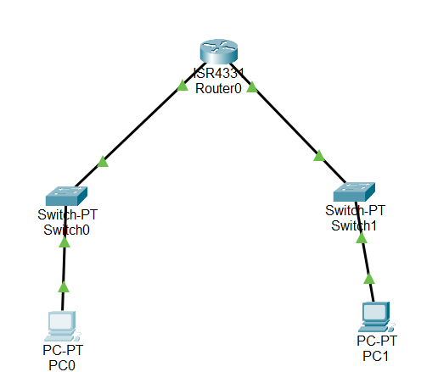

**Step3:Configure the devices   
1)Router-**Click on the router and go to the config tab and assign the IP address to the router   
Example : interface G0/0:ip address 192.168.1.1, subnet mask:255.255.255.0 and ON

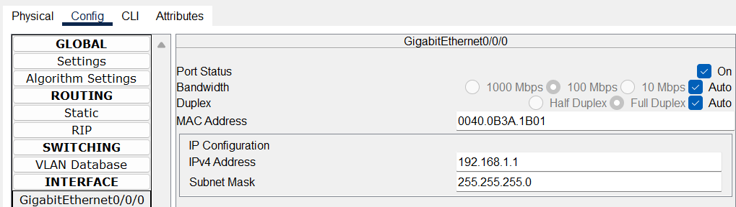  
->Repeat the same step again for connecting the right side. But this time give the IP address as interface G0/0:ip address 192.168.2.1

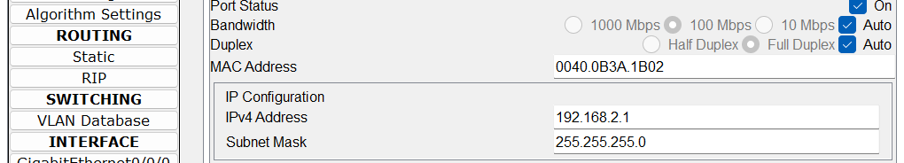

**2)PC-0-** Click on the PC and go to the config and go to IP config and assign the IP confirguration to each PC.  
Example: PCO-IP address 192.168.1.2  
 Subnet mask:255.255.255.0  
 Default address: 192.168.1.1

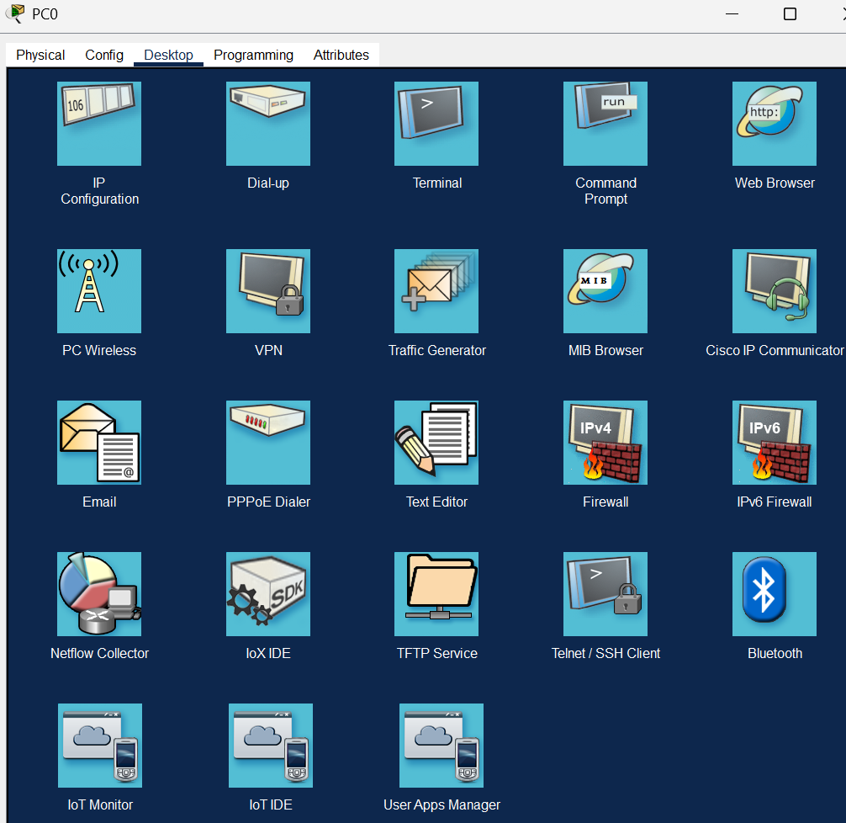

**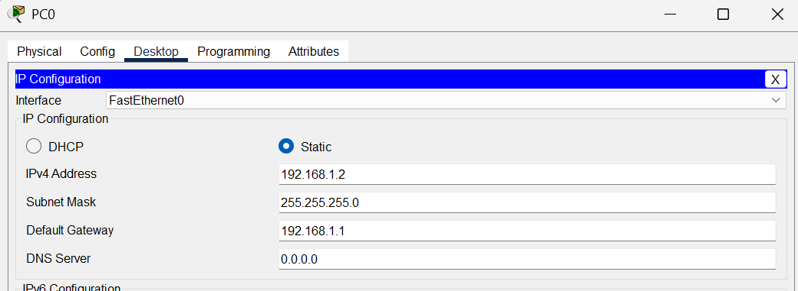  
 ->PC-1--** Click on the PC and go to the config and go to IP config and assign the IP confirguration to each PC.  
Example: PCO-IP address 192.168.2.2  
 Subnet mask:255.255.255.0  
 Default address: 192.168.2.1

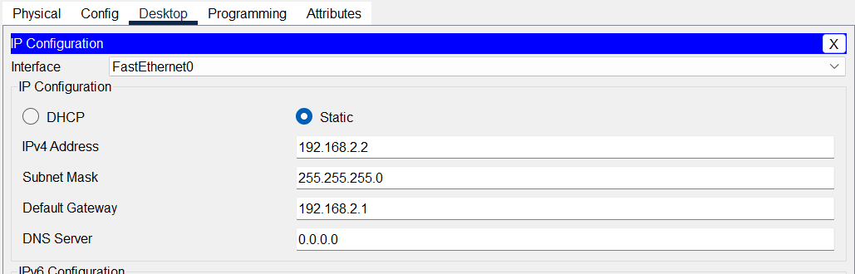

**Step-4)Executes the commands**->Click on the PC-0 and go to the desktop tab and open the **command prompt  
1)ipconfig-**This command displays all correct tcp ip network configurations values and all DSCP and DNS settings.

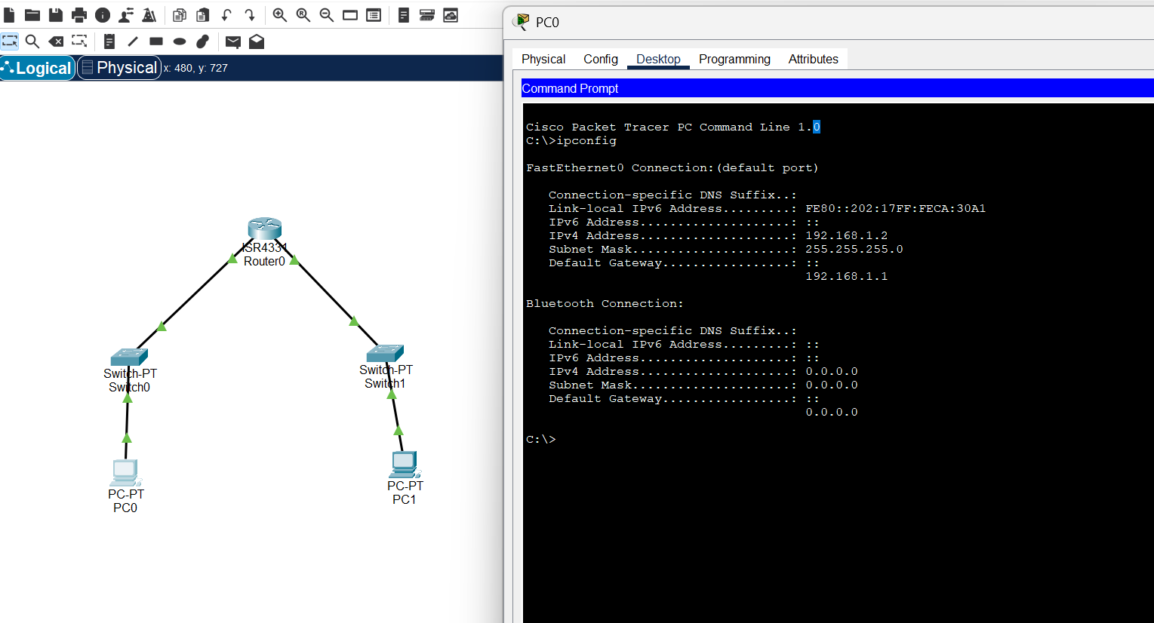

**2) Tracert-**This command traces the path taken to a destination by sending icmp echo request messages.

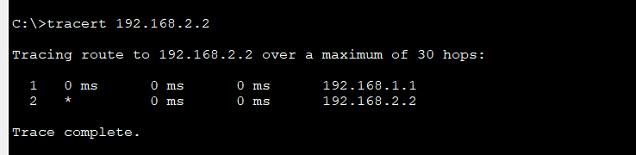

**3)telnet-**

Step1) Go to Router and click on CLI and write this code.

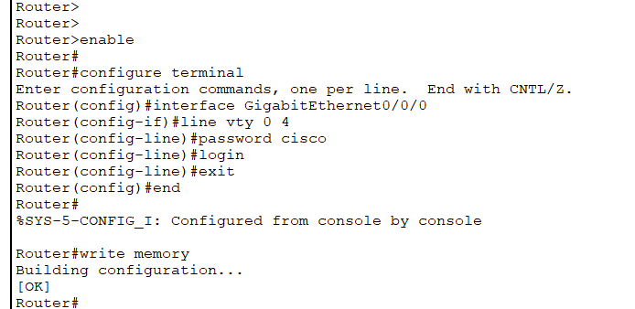

Step-2) Go to PC0->Desktop->Command prompt->telnet 192.168.1.1 23

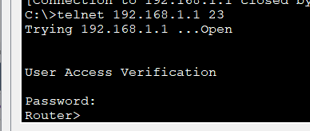

**4)Ip brief-**

Step1)Click on server and and click on CLI and type these commands to display

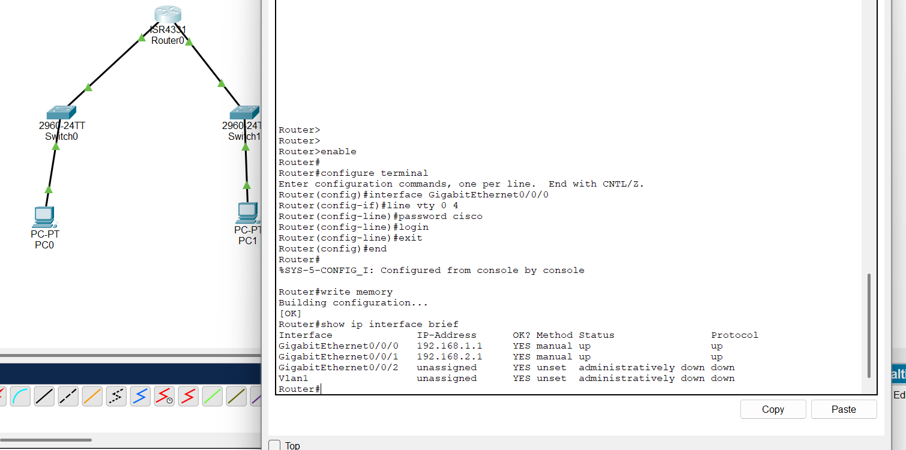

**5)Ping-**

Step1)Go to command prompt in desktop in PCO or PC1

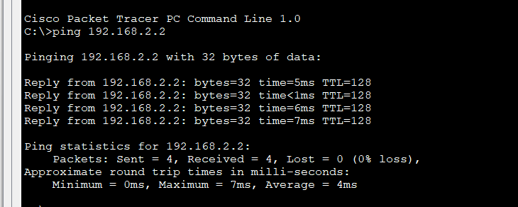

**6)nslookup-**

Step1)Take an Server and do the connections according to the picture and use copper-straight-wire.

Step2)-Click on the server and go to config->INTERFACE->FastEthernet0->Give the IP address and ON.

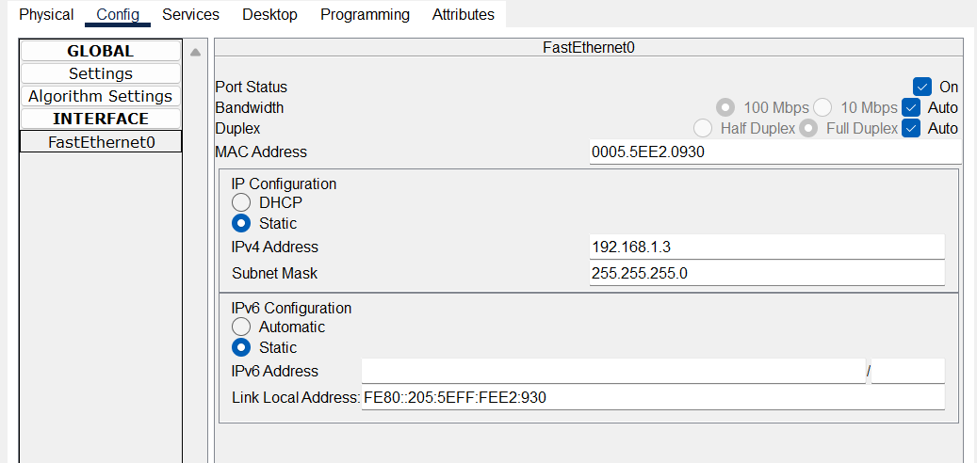

Step3)-Go to DNS and click on ON and then type this near name and Address and click on add

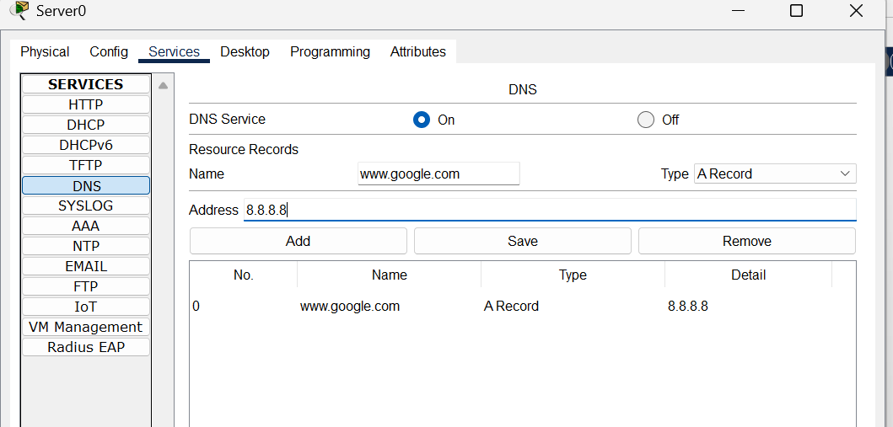

Step4) Now click PC0 and go to command prompt and type the command.

