**WEEK-4**

**Aim:-** Construction of Different VLANS and TRUNKING using Cisco packet tracer.

**Procedure:-**Step-1:-Setting up the Network Topology.  
1)Open Cisco packet tracer and select  
->Switch-2950T-24 and take 2  
->Take from PC-1 to PC-8  
->Connect the wire (Copper-Cross-wire) and select -Fa0/24 for both the switches.  
->Connect the wire (Copper-Straight-wire) and select from Fa0/23-20.

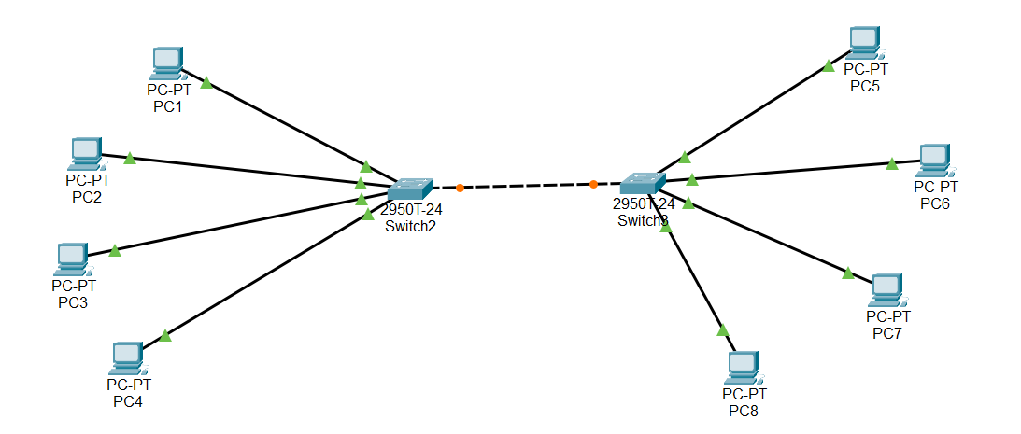

Step-2:- Select Switch-0 and open CLI and write the following code.

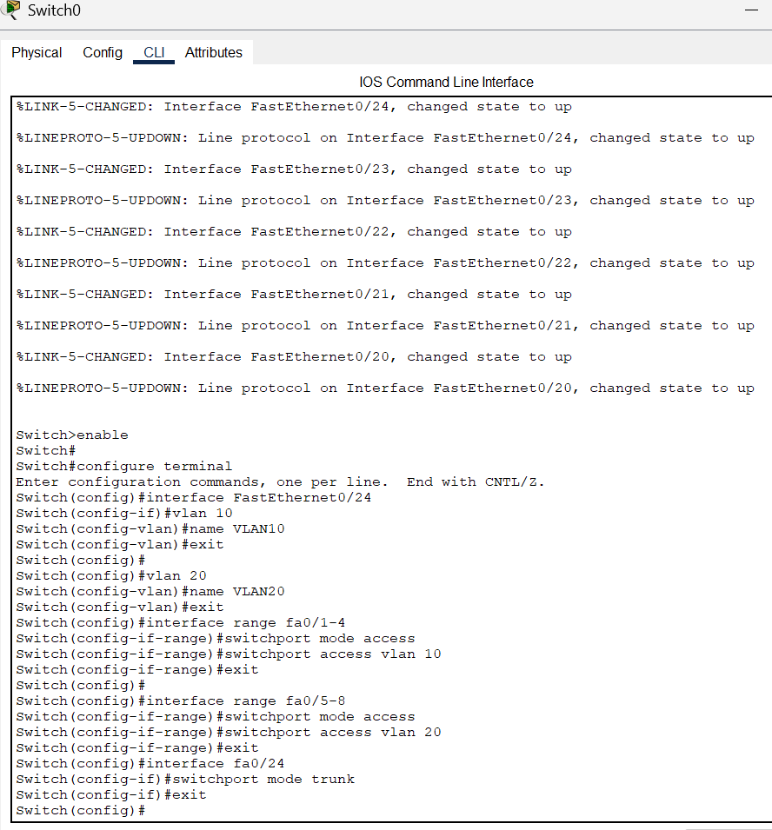  
 Step-3:-Select Switch-1 and open CLI and write the following code. After that click on enter when more is displayed till you get this.

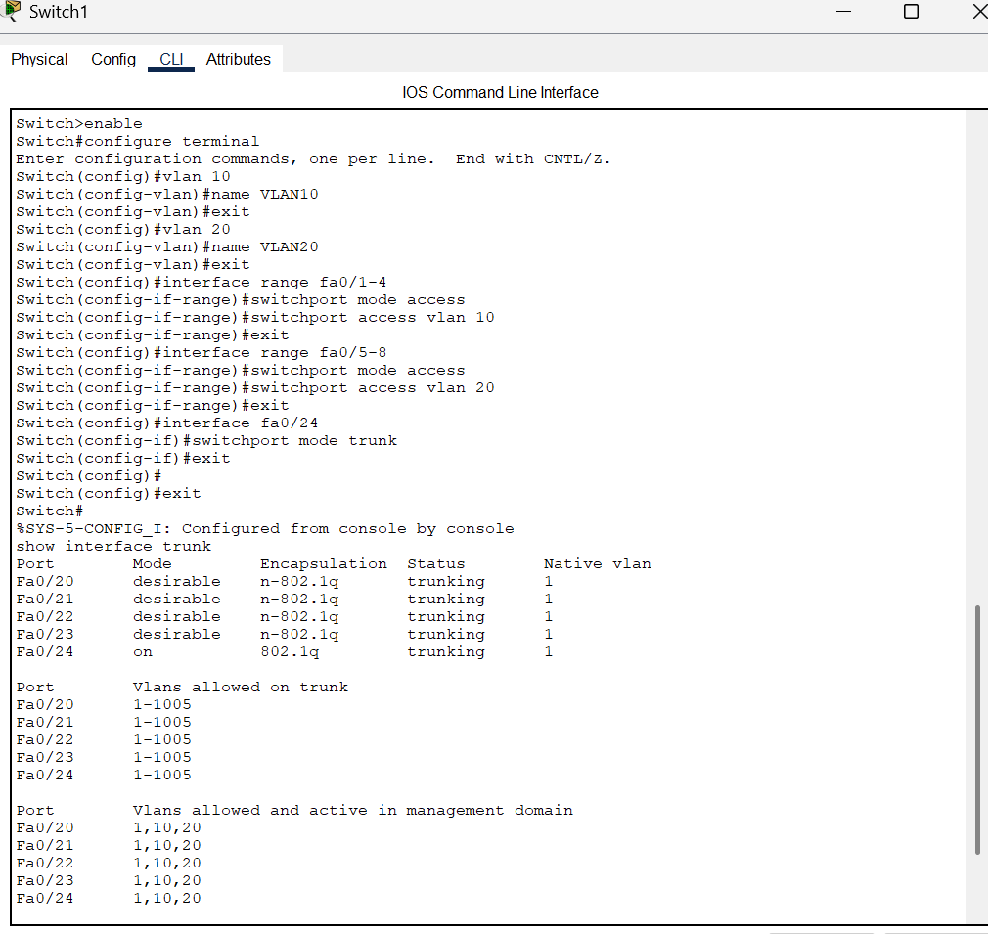

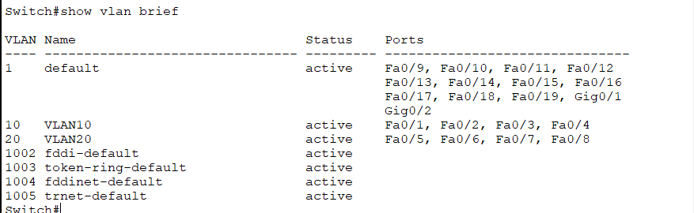

Step-4:- Now Config the PCs- Go to config Fa0 and give the following Ip-address’s.

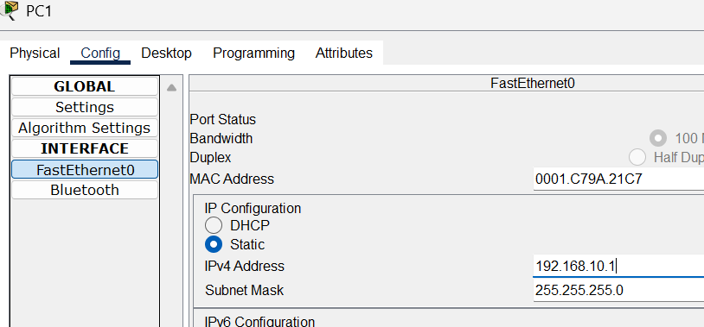

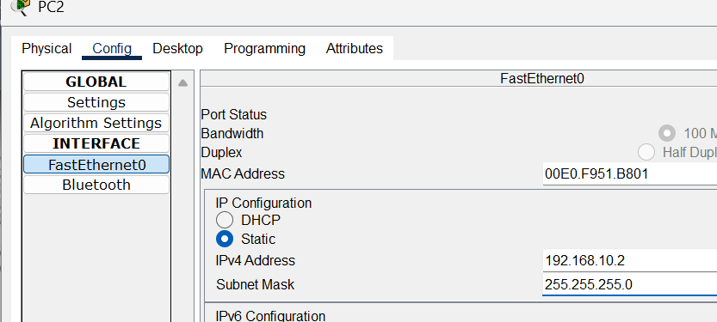

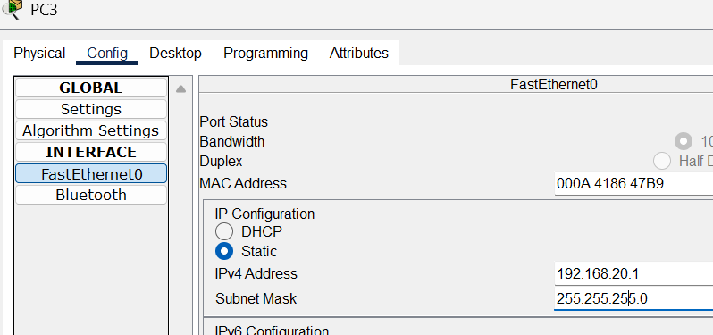

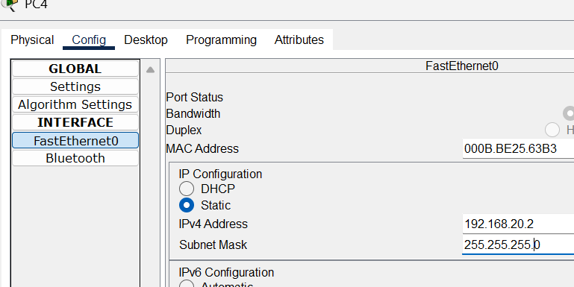

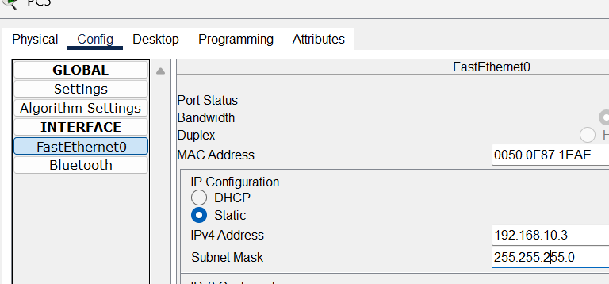

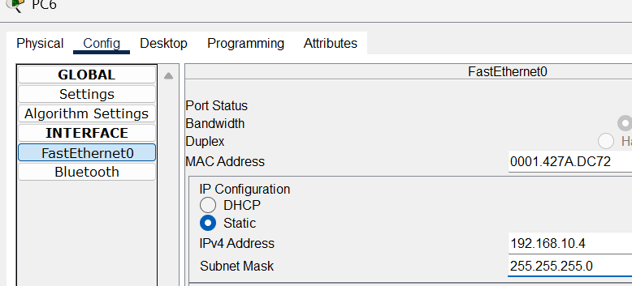

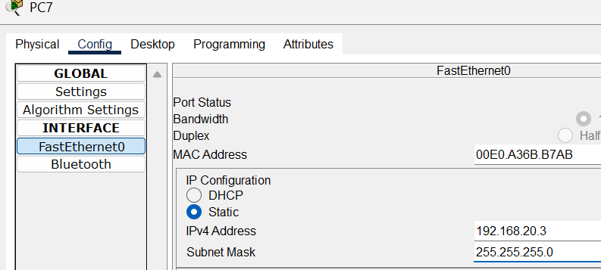

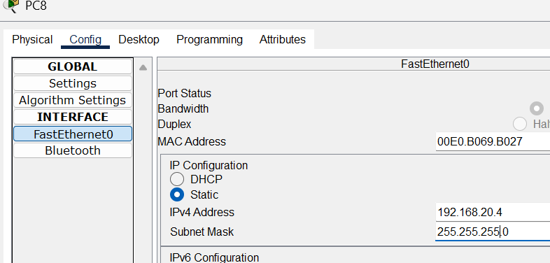

Step-5:-Go to PC-1 and desktop and command prompt and check if the vlan10 are all connected by using the following command.  
ping 192.168.10.2 or so on   
If you can access the config of other vlan PCs then you code is right and now check with vlan20 config using the same command and if you get request-timed out then your config is correct.

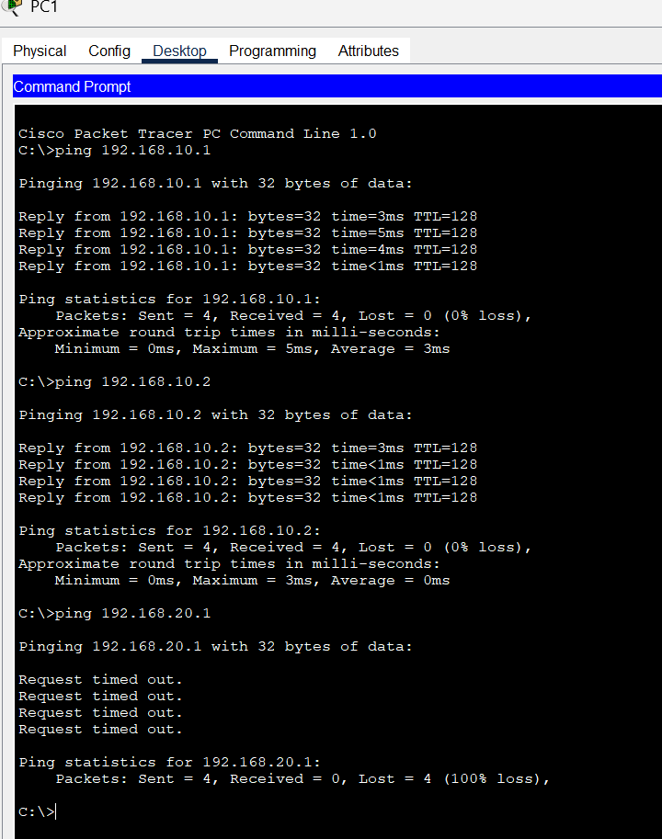

EXPLANATION-  
Your PC is in the **192.168.10.x network**, so it can communicate with devices in the same network (192.168.10.1 and 192.168.10.2).  
But **192.168.20.1 is in a different network**, and there is **no routing configured** between the two networks (or the router interface is down).  
That’s why the ping request times out.

**Concept of VLAN (Virtual Local Area Network)**

**Definition:**  
A VLAN is a **logical** (virtual) separation of a physical network into multiple smaller networks, created using switches.

**Main Points:**

* Devices in the **same VLAN** can communicate directly.
* Devices in **different VLANs** cannot communicate unless a router or Layer 3 switch is used (**Inter-VLAN Routing**).
* VLANs improve **security** and **reduce broadcast traffic** by keeping broadcast domains smaller.
* VLANs are configured by assigning ports on a switch to specific VLAN IDs.

**Example:**

* VLAN 10 → Department A (IPs: 192.168.10.x)
* VLAN 20 → Department B (IPs: 192.168.20.x)

If a PC in VLAN 10 pings a PC in VLAN 20, it **fails** unless there is a router in between — exactly like in screenshot.

Important Definitions:-

**Ping**

* A command to test if two devices can talk to each other on a network.

**IP Address**

* A unique number given to a device so it can be found on a network.

**Subnet Mask**

* Tells which part of an IP is the network and which part is the device.

**Default Gateway**

* The device (usually a router) that lets you reach other networks.

**VLAN (Virtual LAN)**

* A way to split one network into smaller groups for security and control.

**Routing**

* Moving data from one network to another through a router.