

DEPARTMENT OF CSE

PROJECT ABSTRACT SUBMISSION
COURSE: Adaptive Software Engineering – (24CI3201)

A.Y. 2026 - 2027
TITLE OF THE PROJECT | AI-Based Smart Food Redistribution and Waste Reduction System
S. No. | University ID | Name
1 | 2420030284 | Shalini . Ch
2 | 2420030330 | Thirumala Reddy Sagar Mounitha
3 | 2420030441 | S.Tejasree
4 | 2420030484 | Kongara Deepthi
Name of the Guide |  | Dr.Archana Kalidindi

Abstract
The AI-Based Smart Food Redistribution and Waste Reduction System is an intelligent platform developed to reduce food waste and ensure surplus food reaches people in need. It connects food donors such as restaurants, hotels, supermarkets, and households with NGOs, food banks, and charitable organizations through a centralized digital platform. The system uses Artificial Intelligence (AI) to analyze food availability, predict demand, prioritize donations based on freshness and expiry time, and recommend the most efficient distribution routes. It also provides real-time inventory management, donation tracking, automated notifications, and secure user authentication to improve transparency and efficiency. The platform enables quick coordination between donors, receivers, and delivery partners, ensuring timely food redistribution while minimizing spoilage. By reducing unnecessary food waste, the system supports environmental sustainability, lowers carbon emissions, and promotes social welfare by addressing food insecurity. The application is built using modern technologies such as React.js for the frontend, Python (FastAPI) for the backend, PostgreSQL for database management, TensorFlow for AI-based prediction, REST APIs for communication, JWT Authentication for security, and Google Maps API for route optimization. The system also uses Docker for containerization, Kubernetes for container orchestration, and cloud technologies for scalable deployment and service management. It follows Adaptive Software Engineering, AI, Cloud-Native, and Service-Oriented Architecture concepts to support flexible development, intelligent processing, and modular services. This solution offers a scalable, secure, and technology-driven approach to sustainable food management.

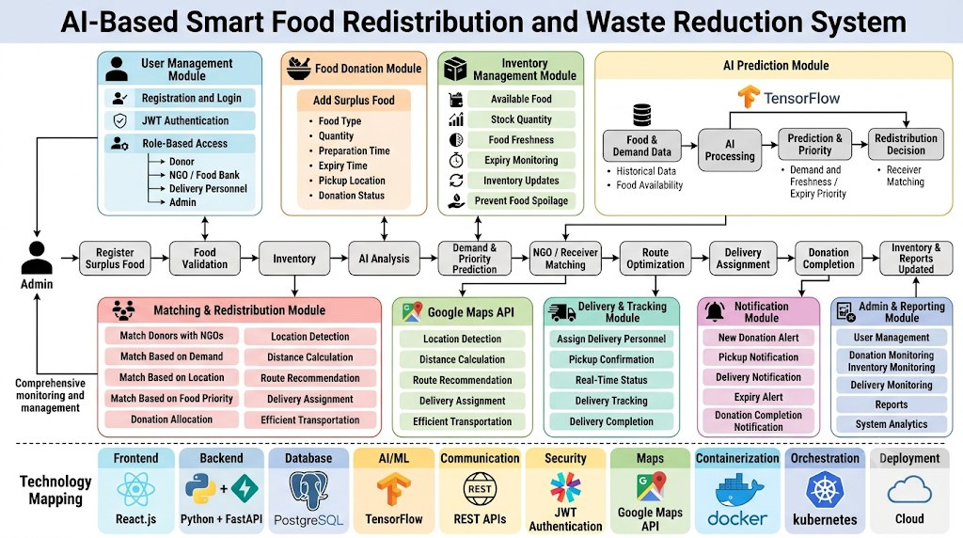
Project Design
User Management
Handles registration, login, JWT authentication and role-based access for donors, NGOs, delivery personnel and administrators.
Food Donation & Inventory Management
Allows donors to register surplus food and maintains information about quantity, freshness, expiry and availability.
AI Prediction and Matching
Uses TensorFlow to predict food demand, prioritize donations based on freshness and expiry, and support donor–receiver matching.
Route Optimization and Delivery
Uses Google Maps API to calculate efficient routes and assists in assigning delivery personnel and tracking donations.
Notification and Administration
Provides automated alerts for donations, pickups, expiry and delivery completion. Administrators can monitor users, donations, inventory and reports.

Signature of the Guide HOD

