Autonomy calculation :

Given the components in my system, a Nucleo-32 L011K4 board, a MQ-4 sensor and a SIM7080G communication module, let's calculate the total current consumption and estimate the battery life of the whole system. We assume that the system captures and transmits data during one minute each hour.

Current consumption of components :

1. STM32L011K4 on Nucleo-32 board:
- Deep sleep : 0.34 µA
- Active mode : 5.7 mA (assuming 32 MHz clock speed)

2. MQ-4 Sensor:
- Heating consumption = 750 mW
- Typical consumption: 750 mW / 5V = 150 mA

3. SIM7080G NB-IoT Module:
- Power saving mode: 3 µA
- Active mode : 200 mA (assuming peak current during transmission)

Time in each mode :

Assume the system transmits data once every hour:
- Deep sleep: 59 minutes
- Active mode (STM32, MQ-4 sensor and SIM7080G transmission): 1 minute

Average current consumption :

1. STM32L011K4:
- Deep sleep: 0.34 µA * 59 / 60 = 0.33 µA
- Active: 5.7 mA * 1 / 60 = 95 µA

2. MQ-4 Sensor:
- Active (for 1 minute/hour): 150mA * 1 / 60 = 2.5 mA

3. SIM7080G:
- Sleep mode: 3 µA * 59 / 60 = 2.95 µA
- Active transmission: 200 mA * 1 / 60 = 3.33 mA

Total average current consumption:

0.33 µA + 95 µA + 2.5 mA + 2.95 µA + 3.33 mA = 5.93 mA

Battery life calculation
Using two 1800mAh batteries in parallel (total 3600mAh):

3600 mAh / 5.93 mA = 605 hours = 25 days

References for STM32L011K4 :

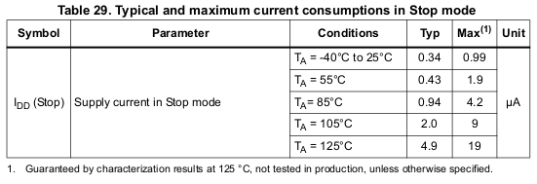
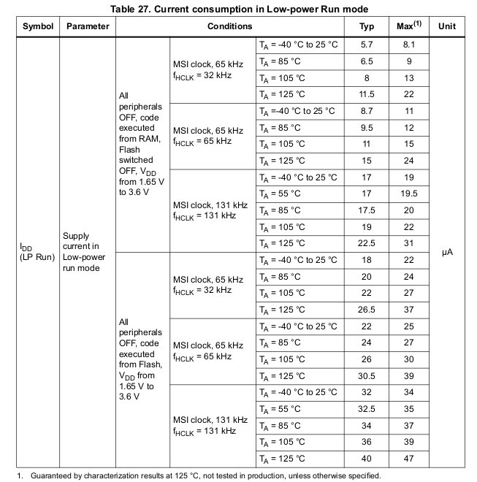

References for MQ4 Sensor :

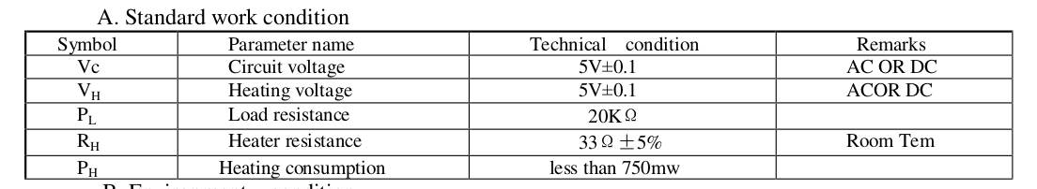

References for SIM7080G NB-IoT Module :

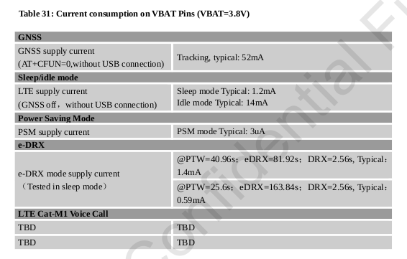
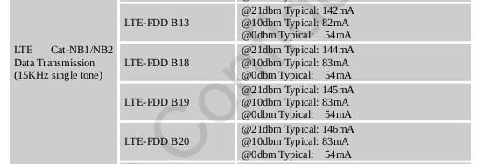
Typical consumption for NB IoT transmission

