Mounsef BOUHAR

SEOC
2024

Hanoi University of Science and Technology
School of Electrical and Electronic Engineering, Smart Sensor Lab
1 Đ. Đại Cồ Việt, Bách Khoa, Hai Bà Trưng, Hà Nội

Design of a Mobile IoT Device

for Real-time CH4 Monitoring
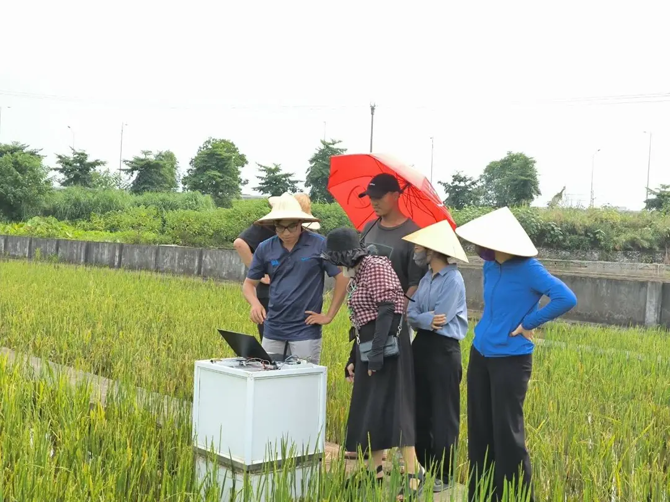

from 05/13/2024 to 08/27/2024

Under the supervision of :

- Company supervisor :
Associate Professor Le Minh Thuy, thuy.leminh@hust.edu.vn

- Phelma Tutor :------------------------------------------------------------

Confidentiality : no

Summary

Glossary ..............................................................................................................................…...3
List of Figures ...........................................................................................…......................…...4
List of Tables ..................................................................................................…...............…….4
Introduction ...................................................................................................…...............…......5
I. Project Organization ………………………………………………………...……………....6
1. Project Structure……………………………………………………………………...6
2. Prevision ……………………………………………………………………………..8
II. Design of the on-site board…………………………………………………..……………..9
1. Methane Sensor……………………………………………………………………….9
2. Communication Module………………………………………………...…………....12
3. Micro-controller…………………………………………………………………...….14
4. Power Supply……………………………………………………………………..…..15
5. Charger and Solar Cell……………………………………………………………….18
6. Final Schematic and Block Diagram………………………………………………....21
III. Implemention of a user-friendly mobile application for data visualization…….………….22
1. Communication Method………………………………………………….…………...22
2. Communication Routine…………………………………………………....………...24
3. ThingsBoard……………………………………………………………….….……...26
a. User Dashboard………………………………………………………...………26
b. Administrator Dashboard………………………………………………...…….27
IV. On site tests and results………………………………………………...…………………..27
1. Environmental conditions…………………………………………………………….27
2. Equipment…………………………………………………………………………….28
3. Calibration and measurements………………………………………………………..28
Conclusion………………………………………………………………...……………………29

Glossary
CH₄ : chemical formula for methane
IoT : internet of things
CO₂ : carbon dioxyde
GSM : Global System for Mobile
UI/UX : User interface / User experience
PPM : parts per million
PPB : parts per billion
LoRa : long range
TCP/IP : Transmission Control Protocol/Internet Protocol
GPRS : General packet radio service
LPWA : Low-power wide-area network
PSM : Power Saving Mode
GNSS : Global Navigation Satellite Systems
GSM : Global System for Mobile
MPPT : Maximum Power Point Tracking
NB IoT : Narrowband IoT
HTTP : Hypertext Transfer Protocol
CoAP : Constrained Application Protocol
MQTT : Message Queuing Telemetry Transport
MCU : Microcontroller Unit
VNUA : Vietnam National University of Agriculture

List of figures
Figure 1 : Gantt diagram for CH4 monitoring IoT device……………….8
Figure 2 : Schematic diagram of split/splitless injection of a GC inlet….9
Figure 3 : Results of study on low-cost detection of methane…………..10
Figure 4 : SIM7080G Module…………………………………………...13
Figure 5 : STM32L031K6 Microcontroller…………………………….14
Figure 6 : NUCLEO-L031K6 Board………………………………..….15
Figure 7 : Power Supply Schematic…………………………………….17
Figure 8 : STEVAL-ISV012V1……………………………………..….18
Figure 9 : Current-Voltage Curve of a solar panel to explain MPPT…...18
Figure 10 : Block diagram and final schematic of the IoT device…..…..21
Figure 11 : Structure of a MQTT packet……………………………..…23
Figure 12 : Connection routine and architecture of a MQTT network.....23
Figure 13 : Example of a MQTT transmission………………………….23
Figure 14 : User Interface………………………………………………..26
Figure 15 : Admin Interface……………………………………………..26
Figure 16 : Equipment and above sight of the box……………………...28
Figure 17 : Isolation box………………………………………………...28
Figure 18 : Collected data……………………………………………….28
List of table
Table 1 : Comparative table of sensors found on the market……………11
Table 2 : Comparative table of NB IoT modules found on the market….13
Table 3 : Comparative table of micro-controllers found on the market…14
Table 4 : Comparative table of SIM7080G communication protocol…...22

Introduction
Methane (CH₄) is a potent greenhouse gas that significantly impacts global warming. It is naturally present in soil, water, and the atmosphere, but human activities such as agriculture, particularly rice paddies, significantly increase its levels. Methane is a major component of natural gas, constituting about 60% of fossil deposits. It is also produced by forced anaerobic fermentation, a process used to intentionally decompose organic matter to generate methane, which can be utilized for electricity, heating, and as automotive fuel. However, methane's highly flammable and explosive nature in air necessitates careful monitoring and management.

Methane contributes to global warming by absorbing infrared radiation emitted by the Earth, thereby preventing heat from escaping into space. It is the second most important greenhouse gas after water vapor. Significant sources of methane emissions include anaerobic fermentation in natural or artificial wetlands, rice paddies, hydroelectric dams, and fossil fuel extraction and use.

Methane levels are measured using variable techniques and devices such as satellite technology, drones or on-site sensors. Reducing methane emissions is more cost-effective and efficient for mitigating global warming than reducing CO₂ emissions. Several strategies are employed to mitigate methane emissions, including the use of sensors for monitoring, burning or distillation purification to convert CH₄ emissions into less potent CO₂, modifying cattle diets, and optimizing rice cultivation practices to reduce fertilizer use and methanogenic sediment production.

The ongoing research project focuses on developing a robust and cost-effective methane sensor system. The project aims to integrate various types of sensors with a microcontroler system to monitor methane levels efficiently. Key components include low-budget methane sensors, a microcontroller, and a communication module to connect the board to the cloud for real-time data retrieval and processing via a mobile application. The system is designed to be autonomous and resistant to environmental constraints such as temperature fluctuations and high humidity, ensuring reliable operation in diverse field conditions.

By developing effective methane detection and mitigation technologies, this project contributes to global efforts in reducing greenhouse gas emissions and combating climate change. The implementation of such technologies in agricultural and industrial settings can significantly lower methane emissions, providing both environmental and economic benefits.

I . Project Organization
The project aims to develop an advanced mobile Internet of Things (IoT) device for accurate and real-time monitoring of methane (CH₄) gas levels. This initiative addresses critical needs in environmental monitoring, industrial safety, and agricultural applications by providing a portable solution capable of measuring methane concentrations and transmitting the data to a remote server or mobile application for continuous analysis and monitoring.

1. Project structure
The primary objective of this project is to design and develop a mobile IoT device specifically tailored for CH₄ monitoring. The scope includes the integration of various components such as sensors, data acquisition systems, and wireless data transmission modules. The end goal is to create a user-friendly mobile application that allows for real-time data visualization.
The project focuses on the following key tasks:
- Design of the Portable IoT Device:

Create a compact and portable device equipped with high-precision CH₄ sensors for real-time gas concentration monitoring.
Steps to follow :
- Sensor selection: Identify and select high-precision methane sensors (e.g., MQ-4 or similar) suitable for real-time monitoring and capable of operating under various environmental conditions.
- Circuit design: Design the electronic circuit that integrates the selected sensors with other necessary components like microcontrollers (e.g., Arduino or ESP8266/ESP32), power supply units, and wireless communication modules.
- Prototyping: Develop a prototype using breadboards and jumper wires to test the initial design and make necessary adjustments.
- Enclosure design: Design a portable and durable enclosure that houses all the components. Ensure the enclosure is compact, easy to carry, and provides adequate protection against environmental factors.
- Testing: Conduct initial testing of the device to ensure all components are functioning correctly and make any required modifications to the design
- Development of Firmware:

Write and implement firmware that facilitates data acquisition from the sensors and supports wireless data transmission, enabling remote monitoring capabilities.
Steps to follow :
- Sensor interface programming: Write code to interface with the methane sensors, ensuring accurate data reading and processing. This includes calibration routines and error handling.
- Data acquisition: Develop routines for continuous data acquisition from the sensors. Implement algorithms to filter and preprocess the sensor data for accuracy.
- Wireless communication: Program the microcontroller to handle wireless communication using technologies like Wi-Fi or GSM/4G. Ensure reliable data transmission to remote servers or mobile applications.
- Energy management: Implement power-saving features to extend the device's battery life. This includes efficient power management coding and utilizing low-power modes of the microcontroller.

- Mobile Application Implementation:

Develop a user-friendly mobile application that provides real-time visualization of the collected methane data, enhancing accessibility and usability.
Steps to follow :
- Platform selection: Choose a platform for mobile application development (e.g., Android, iOS, or cross-platform frameworks like Flutter or React Native).
- UI/UX design: Design an intuitive user interface that allows users to easily view real-time data, set alerts for high methane levels, and access historical data.
- Backend development: Develop the backend infrastructure to receive, store, and process data from the IoT device. This includes setting up servers and databases.
- Data visualization: Implement features for real-time data visualization using graphs, charts, and maps. Ensure the application can handle dynamic updates and provide meaningful insights.
- Testing and debugging: Thoroughly test the application for bugs and performance issues. Conduct user testing to gather feedback and improve the application.

- Power Efficiency and Wireless Connectivity:

Ensure the device operates efficiently with minimal power consumption and supports reliable wireless connectivity for seamless data transfer.
Steps to follow:
- Power supply design: Choose and design an efficient power supply system, considering battery life and the power requirements of all components.
- Optimization: Optimize the firmware and hardware for low power consumption. Use sleep modes, efficient coding practices, and low-power components.
- Integration testing: Conduct thorough testing to ensure that the power supply, sensors, microcontroller, and wireless modules work seamlessly together.

- System evaluation:

Assess the system's performance, accuracy, and reliability across various CH₄ monitoring scenarios to ensure it meets the required standards.
Steps to follow:
- Field testing: Deploy the device in different real-world scenarios such as industrial sites, agricultural fields, and environmental monitoring locations to collect data.
- Performance analysis: Analyze the collected data to evaluate the device's accuracy and reliability. Compare the readings with standard methane measurement equipment to validate the results.
- Stress testing: Test the device under extreme conditions (e.g., high humidity, temperature variations) to ensure it performs reliably.
- Feedback loop: Gather feedback from users and stakeholders to identify areas for improvement. Make necessary adjustments to the hardware, firmware, or application based on this feedback.
- Documentation: Document the entire process, including design choices, testing methodologies, and performance results. This will be crucial for future development and deployment.
By following these detailed steps, the project aims to deliver a robust, reliable, and user-friendly mobile IoT device for real-time CH₄ monitoring, contributing significantly to environmental safety, industrial applications, and agricultural efficiency.

2. Project prevision :
To ensure the successful completion of the project within a 4-month timeframe, the following detailed schedule is proposed. This plan includes research, design, development, testing, and report writing phases.
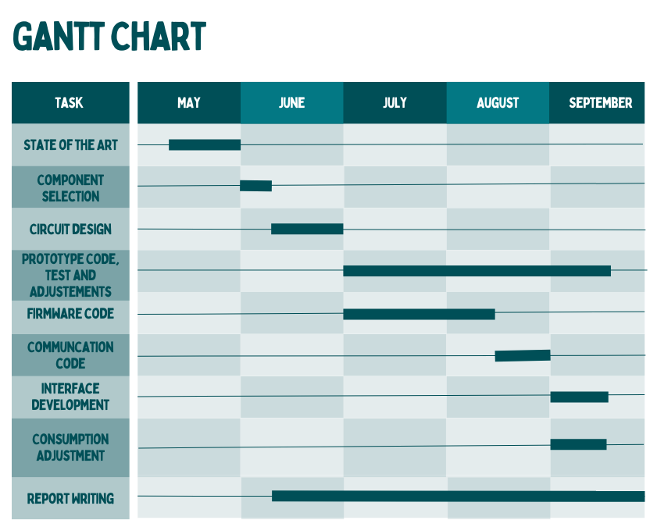

Figure 1 : Gantt diagram for CH4 monitoring IoT device
By adhering to this detailed planning schedule, the project will be systematically developed, thoroughly tested, and comprehensively documented within the 4-month internship period. This plan ensures that each phase builds upon the previous work, leading to a successful and timely project completion.

II . Design of the on-site board
To design a mobile, autonomous methane sensing device that can operate effectively in various field conditions, I need to carefully select and integrate several components. These include a methane sensor, a communication module, a battery, an autonomous battery charger, and a microcontroller. The design must account for technical and environmental constraints to ensure proper operation and mobility. Indeed, fields are subject to numerous environmental constraints which the components of our application must be resistant to. Temperatures can range from very low to very high. The device must withstand temperature variations ranging from 0°C (for winter seasons) to 50°C (for summer seasons) including a 5°C margin. The circuit must also be resistant to humidity and rain to avoid circuit malfunctions such as short-circuiting or corrosion. I would need a device that can withstand more up to 95% humidity for the most humid regions of Vietnam. Finally, the card placed in a field must be autonomous, with no need for recurrent handling, and must be self-sufficient in terms of energy supply. It is therefore impossible to consider a power supply via rechargeable batteries that have to be changed manually. One solution would be to use renewable energies, such as solar power via solar panels or wind power.

1. Methane Sensor
The research conducted on methane sensors involved both market-available sensors and non-commercialized research findings. The aim was to identify sensors with the required precision and sensitivity for methane detection in environmental monitoring applications.

Before delving into the specifics of the commercially available methane sensors, it's essential to first explore the highly sensitive and innovative sensors identified through academic and scientific research. These research-driven sensors demonstrate advanced detection capabilities and offer insights into the latest technological advancements in methane detection, providing a valuable benchmark against which to compare market-available options. The following paragraphs will present a detailed overview of these cutting-edge research findings.
Low-Cost Detection of Methane Gas in Rice Cultivation:
The article from the National Center for Biotechnology Information (NCBI) describes a study that utilized a Gas Chromatography-Flame Ionization Detector (GC-FID) based on manual injection and a split pattern technique to measure methane levels.
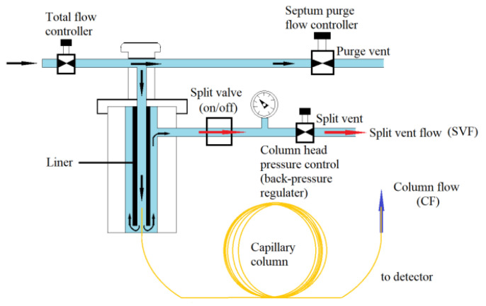

Figure 2 : Schematic diagram of split/splitless injection of a GC inlet
This method is capable of detecting methane concentrations down to a few parts per million (ppm). Tests conducted on methane samples collected from low-emission rice fields yielded conclusive results, demonstrating the method's effectiveness in accurately measuring low levels of methane emissions in agricultural settings.
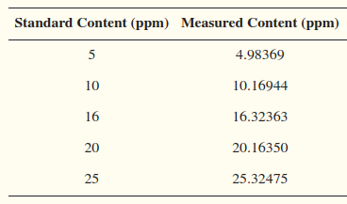

Figure 3 : Results of study on low-cost detection of methane
More details can be found in the NCBI article.
Highly Sensitive Sensor Detection in Parts-per-Billion:
An article by Schulich researchers from the University of Calgary focused on the development of a novel sensor technology that achieves high sensitivity through advanced material and detection techniques. This sensor is capable of detecting methane concentrations down to parts-per-billion (ppb) levels. The research demonstrated the sensor's ability to detect extremely low levels of methane with high accuracy, making it suitable for applications requiring precise methane monitoring. For more information, you can read the Schulich research article.
Another study published in ACS Sensors utilized advanced sensor fabrication and material science techniques to achieve high sensitivity in methane detection. This sensor can detect methane at parts-per-billion (ppb) levels. The results confirmed the sensor's high sensitivity and reliability in detecting very low methane concentrations, highlighting its potential for environmental monitoring and industrial applications. More details are available in the ACS Sensors article.
In conclusion, while these research-driven methane detection systems are highly appealing due to their exceptional precision and sensitivity, they remain non-commercialized solutions. As such, their practical applicability in real-world scenarios may be limited by factors such as availability, cost, and scalability. Despite their potential, the transition from research prototypes to market-ready products can often be a challenging and time-consuming process.
Having examined the advanced sensors resulting from academic research, I will now turn our attention to commercially available methane sensors. These market-ready solutions offer varying levels of performance, affordability, and practicality, making them essential considerations for immediate implementation in methane detection projects. The following sections will provide an in-depth overview of these commercially available options. The list of sensors will be presented in a table format, summarizing their component part, manufacturer part, distribution part, sensitivity, detection range, link, and price.

Component | Manufacturer / Distributor | Pros / Cons | Sensitivity - Accuracy | Detection range | Price | Article link  (Hyperlinks)
MQ family | DFRobot | Low price  Widely used  Market entry device | No info | 200-10000 ppm | $5 | DFRobot
SEN0565 | DFRobot / Mouser Electronics | Need often calibration,  Need a known sample of CH4 | Low | 1-10000ppm | $4.38 | Mouser
DFRobot Gravity: I2C Digital Gas Sensor (CH4) | DFRobot / DFRobot | Need often calibration,  Need a known sample of CH4 | Low | 200-10000ppm | $7 | DFRobot
SGX Sensortech MICS-4514 | Amphenol SGX Sensortech / Mouser Electronics | Datasheet with no info | No info | >1000ppm | $11.5 | Mouser
Adafruit MiCS5524 | Adafruit / Adafruit | Can't tell you which gas it has detected | Low | ~ 1,000++ ppm | $15 | Adafruit
CH-A3 Combustible Gas Pellistor | AlphaSense / GasLab | High quality, low power | Sensivity  (mV / % methane):  15 to 22 = 0.00015 mV/ppm | 0 to 100% LEL methane | $159 | Gaslab
Winsen MH-440D | Winsen/Winsen | Expensive | 0.05%VOL | 0~100%vol | $235 | Winsen Sensor
MUL13442-Safety-CH4-5%vol | eLichens / DigiKey | Expensive  Auto-calibration  Ultra Low Power  (Peak current < 4.0 mA) | Accuracy  ±0.1% vol.  Or ±5% of reading | 0…5% vol. | $273.00 | Digikey
MPS Methane Gas Sensor | NevadaNano / CO2meter | Factory calibrated  Detection of gas type  Low Power | Resolution 1 ppm | 500 - 1,500ppm | $608.85 | CO2meter

Table 1 : Comparative table of sensors found on the market
The sensors currently available in the market, such as the MQ family, are not precise enough for low methane concentration detection and require frequent calibration. More advanced sensors like the MPS Methane Gas Sensor and Winsen MH-440D are expensive but offer better performance. Non-commercialized research indicates that highly sensitive methane detection methods exist, such as Gas Chromatography-Flame Ionization and parts-per-billion level sensors developed by research institutions. These findings highlight the need for a balance between cost, sensitivity, and precision when selecting a methane sensor for environmental monitoring applications.
The final choice was made for MQ6 sensor due to his low price, high available documentation and convenience in use.

2. Communication Module
Once the data has been collected, it needs to be accessed remotely. One solution is to transmit the data to a cloud server and then retrieve it from another remote device. Several devices can be used for this purpose, including a WiFi device like ESP8266 or ESP32, a low-energy Bluetooth device such as Nordic nRF52, a LoRa device like RFM95, or a cellular device. The first three devices are frequently used for sensor networks; however, to connect to the cloud, they require a gateway, which can complicate a single sensor system. A cellular device seems more relevant in this case as it is self-sufficient, but this solution may not be viable on a large scale.

Considering a cellular device with a SIM card, a low-cost and highly functional solution is the SIM module family (e.g., SIM800, SIM900). These modules are optimized for low-power operation and can be battery-powered. They connect to the Internet via an integrated TCP/IP protocol, thanks to a GPRS module. However, the peak current required for data transmission via the GPRS module is around 2 A, which a microcontroller cannot deliver. A separate regulator or a Li-Ion battery must be used. For instance, a 3.7 V battery delivering up to 2 A can be used, but it needs recharging, which isn't optimal due to the need to recharge multiple batteries to power the board. A DC/DC regulator is a better option, providing an input voltage for the GPRS module of between 3.4 V and 4.4 V, and allowing the module to draw up to 2 A.

However, after reviewing my work, a 3G module doesn't seem to be the best option. 3G and 2G technologies are slowly becoming obsolete due to governmental decisions to phase them out. Although 4G modules were considered, their prices are too high. NB-IoT (Narrowband Internet of Things) was suggested as a better alternative. Unlike other solutions requiring a gateway, NB-IoT is an all-in-one device that balances the high price of 4G while meeting the requirements of a mobile IoT device.

NB-IoT (Narrowband Internet of Things) is a wireless communication technology specifically designed for low power, wide area (LPWA) networks, optimized for IoT devices that require efficient data transfer over long distances with minimal power consumption. It operates on a licensed spectrum, ensuring reliable and secure connectivity.
NB-IoT is specifically designed for low power consumption, making it ideal for battery-powered devices in remote locations, such as methane sensing in rice fields, where devices need to operate for long periods without frequent battery replacements or recharging. It provides extensive coverage, even in challenging environments like underground or rural areas, ensuring reliable data transmission from fields with poor connectivity. NB-IoT modules and services are often more cost-effective compared to traditional GSM modules due to their optimized design for IoT applications, leading to reduced module costs and lower data transmission expenses. It can support a massive number of devices per cell, which is beneficial for large-scale agricultural deployments where multiple sensors need to communicate simultaneously. Moreover, NB-IoT uses cellular security mechanisms, offering better protection against hacking and data breaches compared to some traditional IoT communication methods.

In summary, NB-IoT seems to be a superior solution for my project due to its wide coverage, massive connection capability, low power consumption, simplified mobility, and reliable data transfer. These advantages make it an ideal choice over GSM modules, which are becoming obsolete and are less suited for the specific needs of mobile IoT devices.

When comparing various NB-IoT modules available on the market, it is essential to evaluate key aspects such as current consumption, power supply requirements, coverage, data rates, and additional features. Current consumption is a critical factor, especially for battery-operated devices, as it determines the module's efficiency and longevity in the field. Power supply requirements, including operating voltage and peak current, influence the module's compatibility with different power sources and its overall energy efficiency. Coverage and data rates are crucial for ensuring reliable connectivity and efficient data transmission, particularly in remote or rural areas. Additional features, such as built-in GNSS for location tracking, integrated security protocols, and ease of integration with existing systems, further distinguish the suitability of these modules for specific IoT applications. By systematically comparing these parameters, one can identify the most appropriate NB-IoT module to meet the specific needs of a project, ensuring optimal performance and reliability.
The following sections will provide an in-depth overview of these commercially available options. The list of NB IoT communication devices will be presented in a table format, summarizing their current consumption, power supply requirements, coverage, data rates, and additional features.
Module Name | Current Consumption | Power Supply Req | Coverage | Data Rates | Additional  Features | Price
SIM7080G | PSM mode : 3 uA  Sleep mode :  1.2 mA  Idle mode :  14 mA  Data transmission :  ~91-121mA | 2.7 V  to 4.8 V,  typical  3.8 V | LTE CAT-NB1/NB2  across mutliple bands | Download :  136 kbps  Upload :  150 kbps | Integrated GNSS, HTTP, FTP, and MQTT | $32.99
Quectel BC95 | PSM mode : 3.6 uA  Idle mode :  2 mA  Data transmission :  ~65-250mA | 3.1 V  to 4.2 V,  typical  3.6 V | Multiple Frequency Bands  700-800-850-...-2100MHz | Download :  25.2kbps  Uplink :  15.625kbps | Supports CoAP, LWM2M | $20
u-blox  SARA-N2 | Deep-sleep mode:  < 3 μA  Active mode:  < 6 mA  Rx mode: < 46 mA Tx mode: < 220 mA | 2.75 V to 4.2 V  typical  3.6 V | Multiple Frequency Bands but none available for SEA | Uplink :  31.25 kbps  Downlink :  27.2 kbps | IPv4, Embedded UDP/IP, Generic Constrained Application Protocol | $25

Table 2 : Comparative table of NB IoT modules found on the market

Considering the data, the SIM7080G demonstrates the lowest current consumption in PSM mode at 3 µA, closely followed by the Huawei Boudica 120 at 2.5 µA. The u-blox SARA-N2 also performs well with 4 µA. All modules operate within similar voltage ranges, with the u-blox SARA-N2 supporting a slightly lower minimum voltage. The SIM7080G supports the widest range of frequency bands, making it more versatile for global applications, and it boasts the highest data rates with an upload speed of 150 kbps and a download speed of 136 kbps. Additionally, both the SIM7080G and Huawei Boudica 120 offer a rich set of features, including integrated GNSS and support for multiple protocols. In terms of pricing, the Huawei Boudica 120 is the most cost-effective, followed by the Quectel BC95 and the SIM7080G. Therefore, despite being slightly more expensive at $32.99, the SIM7080G appears to be the best choice for balancing low power consumption, wide coverage, high data rates, and comprehensive additional features.
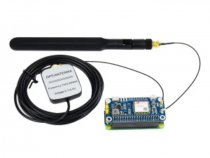

Figure 4 : SIM7080G Module
3. Micro-controller
Now that I have chosen the sensors and communication module, it is crucial to select the right microcontroller to ensure optimal performance and efficiency. The objectives of the microcontroller in this project include managing data acquisition from the sensors, handling communication with the SIM7080G module, and ensuring overall system stability and efficiency. Key criteria for the microcontroller selection include power consumption, portability, resistance to environmental conditions, and board autonomy. Given these requirements, I focus on two categories of STM microcontrollers: STM32L0 and STM32L4, known for their ultra-low power consumption and robust performance.

The selected models, STM32L011K4, STM32L031K6, and STM32L476RG, all belong to the ultra-low power series, offering low current requirements and a wide supply voltage range. This ensures that both the microcontroller board and the GSM module can be efficiently powered from a single source, enhancing portability and reducing the overall power footprint. These microcontrollers are available on NUCLEO boards (e.g., NUCLEO-L011K4), providing ease of integration and development. By carefully aligning the characteristics of the microcontroller with those of the chosen sensors and communication module, I can achieve a reliable and energy-efficient solution for monitoring methane levels in rice fields.
Each of these microcontrollers comes with its unique set of features and specifications. The comparison below covers key aspects such as power consumption, memory, peripherals, and other critical parameters to help justify the choice for a methane monitoring project in rice fields.
Parameters | STM32L011K4 | STM32L031K6 | STM32L476RG
Core | Arm® Cortex®-M0+ | Arm® Cortex®-M0+ | Arm® Cortex®-M4
Flash Memory | 16 KB | 32 KB | 1 MB
RAM | 2 KB | 8 KB | 128 KB
EEPROM | None | 1 KB | None
Max CPU Frequency | 32 MHz | 32 MHz | 80 MHz
Power Supply Voltage | 1.65 V to 3.6 V | 1.65 V to 3.6 V | 1.71 V to 3.6 V
Operating Temperature | -40 to 85 °C | -40 to 125 °C | -40 to 85 °C
Power Consumption in Stop Mode | 0.34 µA | 0.6 µA | 450 nA
Timers | 2 x 16-bit | 3 x 16-bit | 2 x 32-bit, 10 x 16-bit
Communication Interfaces | 1x I2C, 1x SPI, 1x USART | 1x I2C, 1x SPI, 1x USART | 3x I2C, 4x SPI, 6x USART, 3x CAN
ADC | 12-bit, 5 channels | 12-bit, 10 channels | 12-bit, 16 channels
Packages | UFQFPN32, UFQFPN28, TSSOP20 | UFQFPN32, UFQFPN28, TSSOP20 | LQFP48, UFBGA64, UFBGA100

Table 3 : Comparative table of micro-controllers found on the market
Based on the comparison, the STM32L031K6 offers a balanced mix of ultra-low power consumption, sufficient memory, and robust peripheral interfaces. Its capability to operate in a wide temperature range and slightly higher memory compared to the STM32L011K4 makes it more suitable for the methane monitoring project in rice fields. The STM32L476RG, while powerful, might be overkill for this application due to its higher power consumption and excessive features not necessarily required for this project.
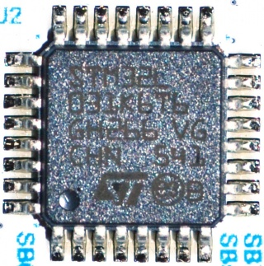

Figure 5 : STM32L031K6 Microcontroller
Hence, STM32L031K6 is recommended for this project to ensure optimal performance, power efficiency, and reliability in environmental conditions. I will use the NUCLEO-L031K6 board, which integrates the STM32L031K6 microcontroller, to take full advantage of its low power consumption and robust features, ensuring efficient and reliable operation in the field.

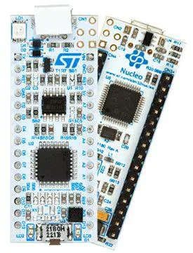

Figure 6 : NUCLEO-L031K6 Board

4. Power Supply
For the CH4 monitoring device, the power supply is a critical component, ensuring the system's portability and autonomy. The design leverages a combination of a battery-powered system and a solar-powered charging mechanism to achieve sustained operation in the field. Below is a detailed breakdown of the power supply setup based on current consumption calculations and the specific components used in the project.

Components and Current Consumption
- STM32L031K6 Microcontroller on Nucleo-32 Board:
Deep Sleep Mode: 0.34 µA
Active Mode: 5.7 mA at 32 MHz clock speed
- MQ-4 Methane Sensor :
Heating Consumption: 750 mW
Typical Consumption: 750 mW / 5V = 150 mA
- SIM7080G Module :
Power Saving Mode: 3 µA
Active Mode: 200 mA (peak current during transmission)

Operational Modes and Time Distribution
The system is designed to capture and transmit data once every hour, distributing its operational time across different modes as follows:
Deep Sleep Mode: 59 minutes per hour
Active Mode (including data capture and transmission): 1 minute per hour

Average Current Consumption Calculation
To determine the average current consumption of the entire system, I calculate the contribution of each component in its respective operational mode:
- STM32L031K6 Microcontroller:
Deep Sleep Mode: 0.34μA×59/60≈0.33μA
Active Mode: 5.7mA×1/60≈95μA
- MQ-4 Methane Sensor:
Active Mode: 150mA×1/60≈2.5mA
- SIM7080G Module:
Sleep Mode: 3μA×59/60≈2.95μA
Active Transmission Mode: 200mA×1/60≈3.33mA
Summing these contributions, the total average current consumption is: 0.33μA+95μA+2.5mA+2.95μA+3.33mA≈5.93mA

Battery and Autonomy
The power supply consists of two 1800 mAh Li-Ion batteries connected in parallel, providing a total capacity of 3600 mAh. Using the calculated average current consumption, I estimate the system's battery life:
3600mAh/5.93mA≈605hours≈25days

Solar-Powered Charging System
The autonomous methane sensing device utilizes a power supply system designed to ensure continuous operation through the integration of Li-Ion batteries and solar energy. This system incorporates a dual-battery relay module and a solar charger to manage power distribution effectively.

The component of the system are :
- Li-Ion batteries:
Voltage: 3.7V
Capacity: 2000mAh
High energy density, low self-discharge, and reliable performance.
- Solar charger and solar cell:
The solar cell provides renewable energy, charging the batteries during daylight.
The charger module ensures efficient charging while protecting against overcharge and deep discharge.
- Relays:
Four controlled relays act as switches to manage the charging and discharging cycles of the two batteries.
- Microcontroller:
STM32 microcontroller to control the relay switches and manage power distribution based on battery charge levels.

The system operates by alternating the charging and discharging cycles of two batteries using controlled relays. This ensures that one battery is always supplying power to the microcontroller while the other is being charged by the solar panel.

- Normal operation:
Battery 1 supplies power to the microcontroller board.
Battery 2 is connected to the solar charger.
- When battery 1 is low:
The microcontroller detects the low charge of Battery 1.
Relays switch roles: Battery 2 begins supplying power to the microcontroller, and Battery 1 connects to the solar charger for recharging.
This relay system ensures that the microcontroller board always has a power source, thereby maintaining continuous operation of the methane sensing device.
There is a schematic to visualize the design :

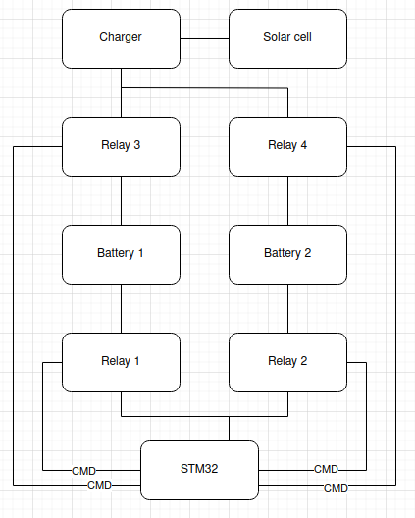

Figure 7 : Power Supply Schematic

5. Charger and Solar Cell
The charging system utilizes a solar cell paired with an autonomous battery charger module, specifically the STEVAL-ISV012V1.
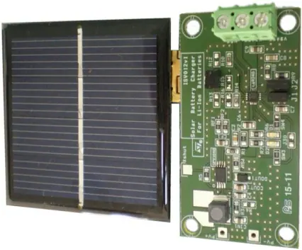

Figure 8: STEVAL-ISV012V1

The STEVAL-ISV012V1 is an ideal choice for the autonomous methane sensing device due to its advanced features and suitability for low-power applications. Below is a detailed justification based on the device's capabilities and the power consumption requirements of the methane sensing device.
This module is mainly composed of two parts: the SPV1040 Solar Boost Converter and the L6924D Linear Charger. The SPV1040 features Maximum Power Point Tracking (MPPT) with an embedded "perturb & observe" algorithm.
Maximum Power Point Tracking (MPPT) is an essential algorithm used in solar power systems to maximize the efficiency of the energy conversion process. The core objective of MPPT is to ensure that the solar panel operates at its Maximum Power Point (MPP), the point at which it produces the highest possible power output.

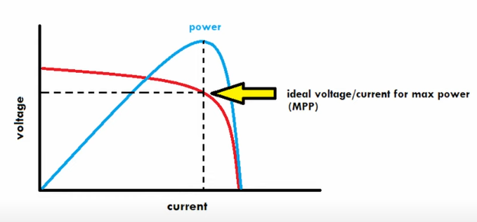

Figure 9 : Current-Voltage Curve of a solar panel to explain MPPT
Solar panels have a unique power-voltage (P-V) curve, which is influenced by environmental conditions such as sunlight intensity and temperature. The Maximum Power Point is the specific point on this curve where the product of current (I) and voltage (V) is highest, resulting in maximum power output. The location of the MPP can change dynamically due to variations in sunlight and temperature throughout the day. MPPT algorithms are employed to continuously track this point and adjust the operating parameters to ensure the solar panel consistently operates at or near the MPP.
MPPT algorithms work by adjusting the electrical operating point of the solar panel to find and maintain the MPP. There are several types of MPPT algorithms, but one commonly used method is the "perturb and observe" (P&O) algorithm, which is implemented in the SPV1040 Solar Boost Converter used in the STEVAL-ISV012V1 module.

The Perturb and Observe (P&O) algorithm works as follows :
- Perturbation: The algorithm periodically perturbs (adjusts) the operating voltage or current of the solar panel by a small amount.
- Observation: It then observes the change in power output resulting from this perturbation.
- Decision:
  - If the perturbation leads to an increase in power output, the perturbation is continued in the same direction.
  - If the perturbation results in a decrease in power output, the perturbation direction is reversed.
- Iteration: This process is repeated continuously, ensuring that the operating point converges towards the MPP. The algorithm keeps oscillating around the MPP, making small adjustments to maintain optimal power output.

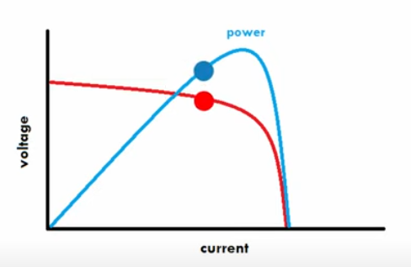
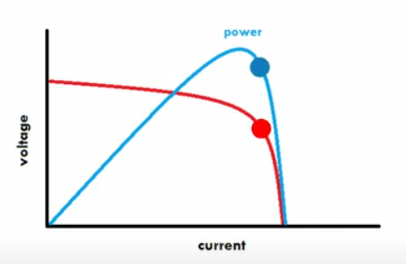
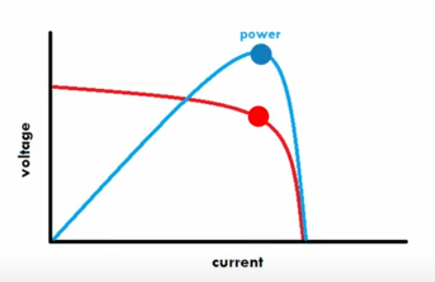

The P&O algorithm is relatively simple to implement, making it a popular choice for many MPPT applications and it performs well under most environmental conditions, ensuring reliable tracking of the MPP.
However, the P&O algorithm has some limitations, such as oscillations around the MPP and potential inaccuracies under rapidly changing environmental conditions.
In the SPV1040 Solar Boost Converter, the P&O MPPT algorithm is embedded to optimize the power harvested from the solar panel. The converter continuously adjusts the input voltage to the MPP by perturbing and observing the power output. This ensures that even under varying conditions like changes in sunlight intensity or temperature, the solar panel operates at its peak efficiency. The high efficiency of up to 95% achieved by the SPV1040 is a testament to the effectiveness of its MPPT implementation.
In summary, the MPPT algorithm is crucial for maximizing the power output of solar panels by dynamically adjusting the operating point to the MPP. The P&O algorithm, used in the SPV1040, offers a simple yet effective means to achieve this, ensuring optimal performance of solar-powered systems like the STEVAL-ISV012V1.
The SPV1040 is also capable of operating with very low input voltages (down to 0.3 V), making it suitable for maximizing energy capture from small solar cells. Additionally, it includes protection features such as input reverse polarity protection, thermal shut-down, and overcurrent protection, which enhance the reliability and safety of the system.

The L6924D Linear Charger integrates multiple functionalities into a single chip to provide efficient and safe battery charging, especially in solar-powered applications. It combines a power MOSFET, which acts as a switch to control the charging current, a reverse blocking diode that prevents the battery from discharging back into the charger, and battery thermal control that monitors the temperature during charging and adjusts or halts the process to prevent overheating and potential damage.

The L6924D employs a quasi-pulse charging mode, which is particularly effective in solar-powered applications. This mode maximizes the charge rate by delivering current in pulses rather than a continuous flow, allowing the battery to absorb charge more efficiently, especially when solar power fluctuates. It also minimizes power dissipation by reducing heat generation, as the system cools down between pulses, leading to improved overall efficiency.

One of the strengths of the L6924D is its programmability, allowing for customization to suit various battery types and charging requirements. The charge current can be adjusted to optimize charging speed and ensure compatibility with different battery capacities. The pre-charge voltage threshold, the point at which the transition from low current pre-charge to main charging occurs, is also customizable. Additionally, the termination current, the level at which charging stops to ensure full charge without overcharging, can be set according to the needs of the battery.

These programmable features provide significant flexibility for different battery capacities and charging scenarios. The integrated safety features, such as thermal control and reverse blocking, ensure the longevity and reliability of both the battery and the charging system by protecting against overheating, reverse current flow, and overcharging. This makes the L6924D a robust choice for efficient and safe battery charging in solar-powered applications.

The methane sensing device has a total power consumption of approximately 450mA. The STEVAL-ISV012V1 is well-suited for this application due to the following reasons:
- The L6924D can deliver up to 1A of charge current with high accuracy, which is sufficient to recharge the 2000mAh batteries used in the device.
- The high efficiency of the SPV1040 ensures that the maximum amount of energy from the solar panel is utilized, reducing the need for frequent battery replacements or external charging.
- The MPPT algorithm in the SPV1040 adjusts to varying sunlight conditions, ensuring consistent energy harvesting, which is crucial for autonomous operation in outdoor environments.

The combination of a dual battery setup and a solar-powered charging system ensures that the methane monitoring device remains operational and autonomous in various environmental conditions. By optimizing power consumption and leveraging renewable energy, the device can efficiently monitor CH4 levels in the field for extended periods, significantly contributing to the project's environmental monitoring objectives.

6. Final schematic and block diagram
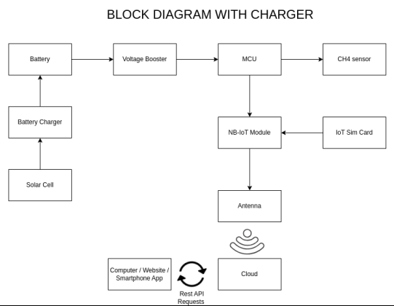

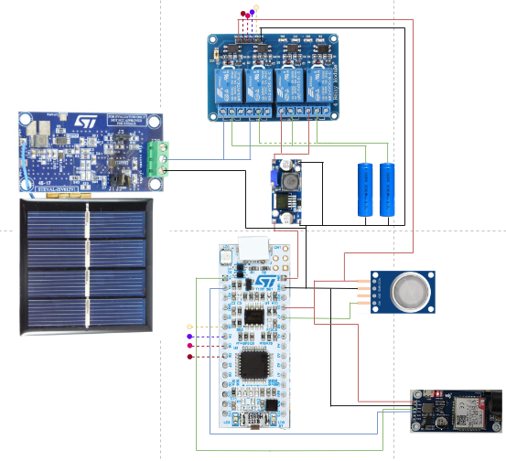

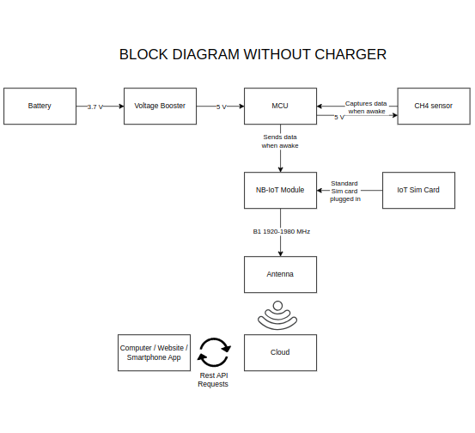

Figure 10 : Block diagram and final schematic of the IoT device

The block diagrams illustrate the design and functionality of the methane monitoring system, both with and without a charging mechanism. In the diagram labeled "BLOCK DIAGRAM WITHOUT CHARGER," the system is powered by a battery that supplies 3.7V. A voltage booster increases this to 5V to power the microcontroller unit (MCU), which is responsible for managing data acquisition from the CH4 sensor and handling communication with the NB-IoT module. The MCU captures data from the sensor, which also operates at 5V, and sends it to the NB-IoT module, which requires a step-down voltage to 3.3V. This module transmits the data via an antenna to the cloud, where it can be accessed through a computer, website, or smartphone app via REST API requests.

In the "BLOCK DIAGRAM WITH CHARGER," the setup is enhanced with a battery charger and solar cell, providing a sustainable power source for the battery. The voltage booster again steps up the battery output to 5V for the MCU and CH4 sensor. The rest of the system functions similarly, with the MCU processing the sensor data and the NB-IoT module handling data transmission to the cloud.

The addition of the charging mechanism ensures continuous operation and reliability in field conditions, making it particularly suitable for long-term environmental monitoring projects. The use of a solar cell to charge the battery supports sustainability and reduces maintenance, aligning with the project's goals of power efficiency and robustness in environmental conditions. By selecting the NUCLEO-L031K6 board with the STM32L031K6 microcontroller, the design balances power consumption, processing capability, and operational efficiency, ensuring the system meets the project's specific requirements.
III . Implemention of a user-friendly mobile application for real-time data visualization

In collaboration with the Vietnam National University of Agriculture (VNUA), our project was developed based on their specific requirements and demands. VNUA emphasized the need for a real-time feed of methane levels, along with environmental temperature, humidity and geolocation data, to monitor agricultural environments effectively. This collaboration was pivotal in shaping the design and functionality of our interface, ensuring it met the exact needs of our partners at VNUA.
In this section, I will discuss the implementation of a mobile application designed to provide real-time visualization of methane levels monitored by our device. The first sub-part will focus on the communication method employed, specifically the MQTT protocol used in conjunction with the SIM7080G communication module. I will explore why MQTT was chosen over other protocols, highlighting its efficiency and reliability for real-time data transmission. Then, I will delve into the communication routine used. Following this, I will introduce ThingsBoard software, a powerful IoT platform that serves as the backbone for our data management and visualization. I will delve into its purpose, key features, and the advantages it offers for our project. Finally, I will present two distinct dashboards created using ThingsBoard: one for end-users to monitor methane levels and another for administrators to manage and analyze the system's performance.

1. Communication Method

When selecting the communication method for the SIM7080G module, several protocols were considered, including HTTP (Hypertext Transfer Protocol), CoAP (Constrained Application Protocol), and MQTT (Message Queuing Telemetry Transport). After careful evaluation, MQTT was chosen as the most suitable protocol for our methane monitoring project.
Protocol Name | HTTP | CoAP | MQTT
Minimum Packet Size | 32 bytes (request case)  Byte 1-14 : request line  Byte 15-30 : host header  Byte 31-32 : empty line | 4 bytes  Byte 1: 2 bits for version,  2 bits for type,  and 4 bits for token length.  Byte 2 : 8 bits for the code  Bytes 3 and 4 : 16 bits for the message ID. | 2 bytes  Byte 1 : Control packet type and flags  Byte 2 : Remaining length
Model | Full-duplex, Bidirectional | Request/Response | Publish/Subscribe
Transport Mechanism | TCP | UDP | TCP, UDP
Messaging Mode | Asynchronous | Synchronous | Asynchronous
Pros | Widely used, easy to implement, supports large payloads. | Lightweight, designed for resource-constrained devices, low overhead. | Very low latency, minimal overhead, optimized for small data packets, supports reliable message delivery with QoS (Quality of Service) levels, widely supported with numerous libraries and tools.
Cons | Higher latency, more overhead, less efficient for small data packets, not optimized for frequent data transmission. | Less mature compared to MQTT, fewer libraries and tools available, might have higher latency in certain network conditions. | Requires a broker for message handling, which adds a layer of complexity.

Table 4 : Comparative table of SIM7080G communication protocol
The SIM7080G module will transmit data to the server using the MQTT protocol, which is well-suited for low-bandwidth, high-latency, or unreliable networks. The data is organized into a structured data frame before transmission. A typical MQTT data frame consists of a 2-byte fixed header, followed by variable header fields and the payload, which contains the actual sensor data. The size of the data frame varies based on the payload length and additional fields required by the MQTT message type, but it is designed to be lightweight to minimize power consumption and bandwidth usage.
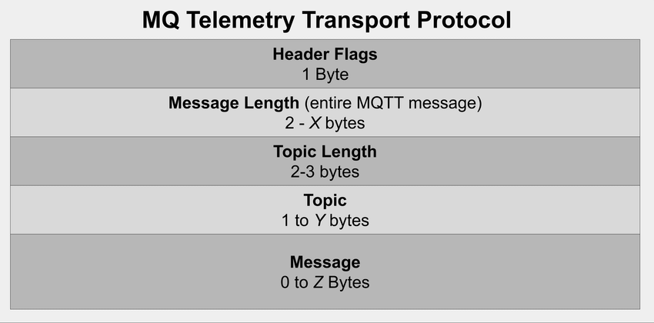

Figure 11 : Structure of a MQTT packet
To display the measured data on an application, the MQTT messages are sent to a broker after a connection routine, which then forwards them to the application server. The application interprets the incoming data and visualizes it through user-configurable dashboards. Users can create widgets to display data in various formats, such as charts, gauges, or tables, making it easy to monitor methane levels in real-time.
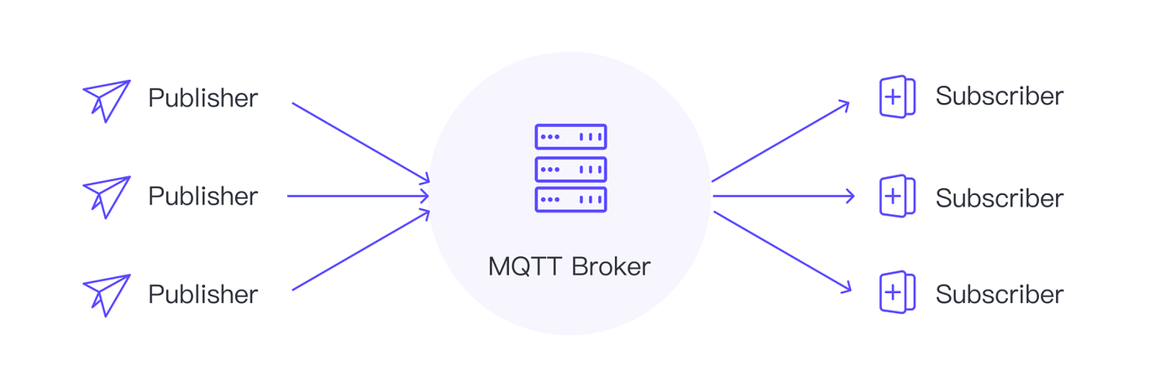
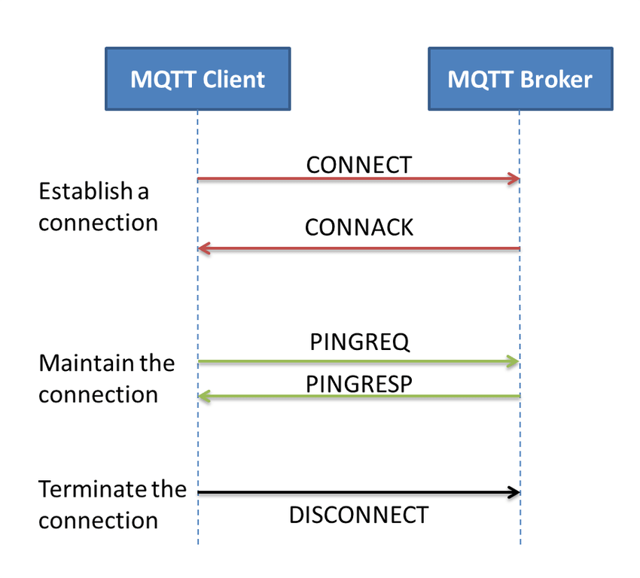

Figure 12 : Connection routine and architecture of a MQTT network
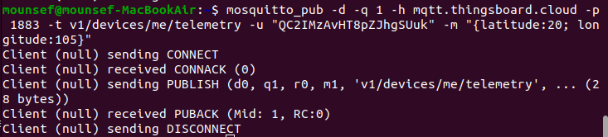

Figure 13 : Example of a MQTT transmission

Controlling the measurement interval of the device from the ThingsBoard dashboard involves sending MQTT commands back to the SIM7080G module. This is achieved by subscribing to a control topic on the device, where commands can be published from the application interface. The commands are then interpreted by the device to adjust its measurement and transmission intervals, ensuring flexible and dynamic data collection based on user requirements.

2. Communication routine

A communication routine refers to a structured sequence of operations or commands designed to facilitate the exchange of data between devices, particularly in IoT (Internet of Things) systems. This routine is essential because it ensures that data is transmitted reliably and efficiently, allowing devices to communicate with one another or with a central server in a consistent manner. In the context of real-time monitoring systems, such as those used to track methane levels, a well-designed communication routine is crucial for maintaining the accuracy and timeliness of the data being transmitted. Without an effective communication routine, data loss, delays, or corruption could occur, leading to unreliable system performance and potentially critical gaps in monitoring. Therefore, implementing a robust communication routine is key to ensuring that the system operates smoothly and meets the necessary requirements for real-time data transmission and monitoring.

The Vietnam National University of Agriculture (VNUA) required a system that could provide real-time analytic data from the field every 5 seconds, specifically tracking temperature, humidity, and methane levels. Additionally, the system needed to transmit positioning data, but with less frequency—every 10 cycles of data transmission.

To meet these requirements, our system collects data from the temperature, humidity, and methane sensors every 3 seconds. The collection process for these three parameters takes approximately 1 second per sensor, ensuring that all necessary data is gathered within the required timeframe. Once the data is collected, it is sent to the server, a process that takes about 1 second, allowing the system to repeat the data collection and transmission in the next second.

This routine is essential for maintaining the real-time aspect of the monitoring system, ensuring that VNUA receives up-to-date information from the field at the intervals they specified. The positioning data, which is less critical for immediate analysis, is collected and transmitted after every 10 cycles, aligning with the system's need to prioritize environmental data while still providing regular updates on location. This structured approach ensures that all data is transmitted reliably and within the necessary timeframes, enabling accurate and timely monitoring.

Here is a schematic to explain the process :
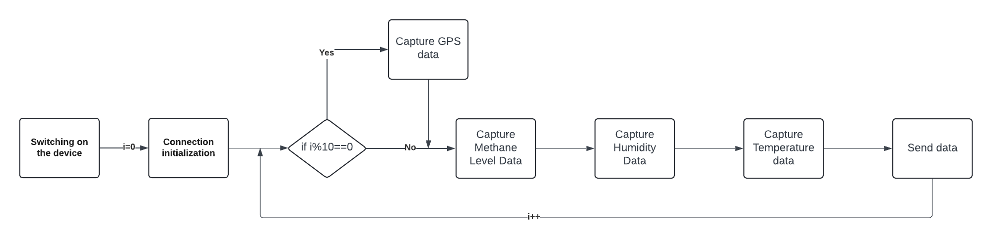

But, how can we make it work between a STM32 microcontroller and all devices connected into a server interface such as ThingsBoard ? How to use MQTT protocols between those two ?

AT commands (Attention commands) are a set of instructions used to control modems and other communication modules, including IoT devices like the SIM7080G. These commands enable you to perform various tasks, such as establishing network connections, sending data, receiving data, and configuring the device. AT commands are widely used because they offer a simple, text-based interface to interact with the hardware, making them accessible and versatile for a range of applications. In this project, AT commands play a crucial role in enabling real-time data transmission from our IoT devices.

Here's a quick overview of the main commands used folllowing the previous steps of the communication routine:

1. Connecting to the MQTT Broker: AT+SMCONN
This command initiates the connection to the MQTT broker, enabling the device to start sending and receiving data.

2. Setting Up the MQTT Connection: AT+SMCONF="URL","mqtt.thingsboard.cloud",1883
This command configures the MQTT connection by specifying the server URL and port. It's essential for establishing communication with the MQTT broker.

3. Publishing Data to the MQTT Broker: AT+SMPUB="v1/devices/me/telemetry",17,1,1
This command publishes data to the specified MQTT topic. The data, such as temperature, humidity, and methane levels, is sent to the ThingsBoard platform for real-time monitoring.

4. Enabling the GNSS (GPS) Functionality: AT+CGNSPWR=1
This command powers on the GNSS (Global Navigation Satellite System) engine, enabling the device to start receiving GPS data such as location, altitude, and speed.

5. Checking the GNSS Status: AT+CGNSSTATUS?
This command allows us to check the current status of the GNSS. It helps us determine whether the device has acquired a GPS fix, which is necessary for obtaining accurate location data.

6. Retrieving GPS Information: AT+CGNSINF
This command retrieves the current GPS data from the GNSS engine. The response includes key information such as UTC time, latitude, longitude, altitude, speed, and the fix status.

7. Retrieving and Parsing the GNSS Data:
After receiving the response from the AT+CGNSINF command, the latitude and longitude are extracted from the string using string parsing techniques in C.

These AT commands provide a robust framework for controlling the SIM7080G module and ensuring that data is transmitted efficiently and reliably from the field to the server. Through this setup, we meet the specific requirements of the VNUA by delivering accurate, real-time environmental data for analysis and monitoring.

3. ThingsBoard

For this project, the data display needs to include real-time methane concentration, temperature and concentrations levels, historical data trends, and alert notifications for threshold breaches. The user dashboard on ThingsBoard provides a simplified view for end-users, while the admin dashboard offers more detailed control and configuration options. MQTT's efficient message handling, minimal overhead, and reliable delivery make it an ideal choice for transmitting sensor data and receiving control commands in an IoT setup like this one.
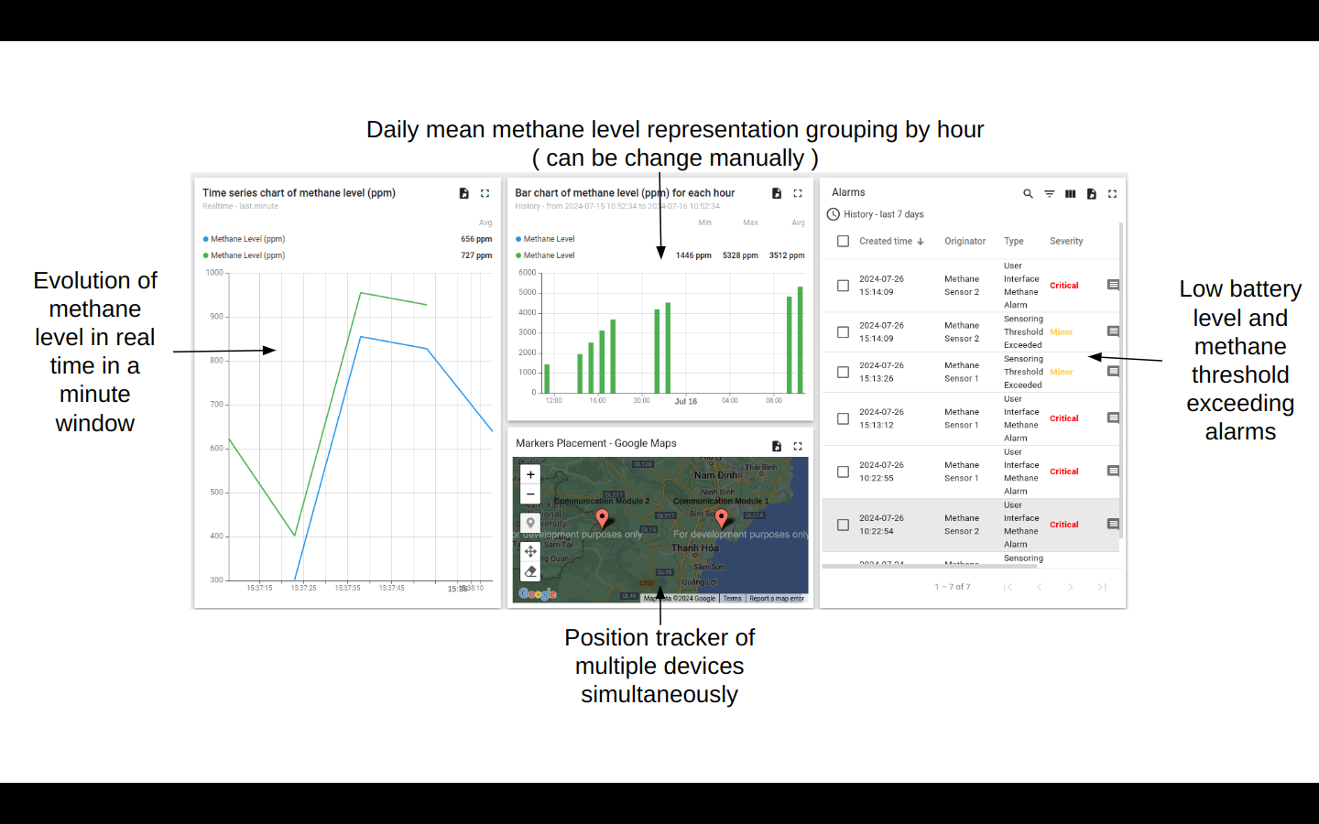

Figure 14 : User Interface
The user interface is designed to be user-friendly, which means used easily with no much features to understand and everything sight reachable. To make it as easy as possible and following requirements of VNUA, I only gave user access to two different data figures. The first one is a time series chart which shows the evolution of methane level in real time in a minute row and the second one shows a daily mean of methane level grouping by hour. Additionally, a position tracker is displayed to show the real time position of every device registered. Finally, a table recap all alarms occurred during lifetime of each device. Only two types of alarms were created : low battery level ( less than 5% ) and methane threshold exceeding ( more than 500ppm ).
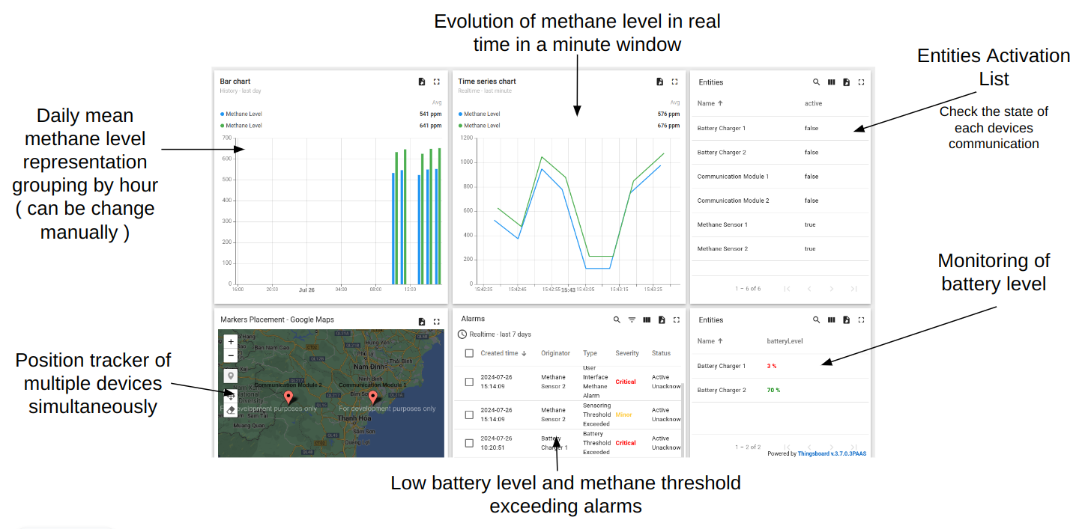
Figure 15 : Admin Interface
The admin interface is designed to be a little more detailed and modular, which means same basic features as the user interface but with a little more details and a way larger modification capacity. It follows the same requirements as the user interface. The only differences is the possibility of acknowledge and clear alarms, when the administrator thinks the issue is resolved. Additionally, the administrator has access to the devices current battery level and to a comprehensive table displaying real time activity of each part of these devices. It can help the administrator to resolve alarms issue.
of the box

IV. On-site tests and results
In this section, we will delve into the testing phase of our project, which involved conducting on-site measurements at the Vietnam National University of Agriculture (VNUA). We directly engaged with the agricultural fields at VNUA to gather real-time data using our monitoring system. The equipment featured in the following pictures and diagrams was provided by another student conducting the same project, and although it is not part of my personal toolkit, it was perfectly suited to meet the objectives of our project. The field tests, while essential, presented several environmental and technical challenges that impacted the measurement process.
The equipment used during these tests included advanced sensors for monitoring methane levels, temperature, and humidity. These devices were integral to collecting the environmental data required for our analysis. Despite being externally sourced, the equipment's compatibility with our system ensured accurate and reliable data collection, which was crucial for validating the project's outcomes. The subsequent images and descriptions will provide a detailed overview of the tools employed and the specific challenges encountered during the measurements at VNUA.
1. Environmental conditions

The environmental conditions during our testing phase in the rice fields at VNUA presented significant challenges due to the outdoor nature of the fields and the climate of Hanoi, particularly during the flood season. The hot temperatures, combined with extremely high humidity levels, created a challenging environment for both the equipment and the testing process. Additionally, the frequent and heavy rainfall characteristic of this period led to waterlogged conditions, making it difficult to maintain stable measurements and placing additional strain on the electronic components used in the field. These factors collectively contributed to the complexity of the testing environment, necessitating careful planning and adaptation to ensure the reliability and accuracy of the data collected. Despite these challenges, the tests provided valuable insights into the system's performance under real-world conditions, which were crucial for assessing the overall viability of the project.

In addition to the challenging environmental conditions, the remote location of the rice fields and surrounding countryside posed significant connectivity issues, which became apparent upon our arrival at the faculty. The low network access in these rural areas created obstacles for maintaining a stable connection, which is crucial for real-time data transmission in our monitoring system. This lack of reliable connectivity hindered our ability to efficiently communicate with the server, adding another layer of complexity to the testing process. These difficulties highlighted the importance of considering connectivity challenges when deploying IoT systems in remote agricultural settings, as it directly impacts the system's ability to provide timely and accurate data. Despite these setbacks, the tests were successfully conducted, offering valuable insights into the system's resilience and adaptability in less-than-ideal conditions.

2. Equipment
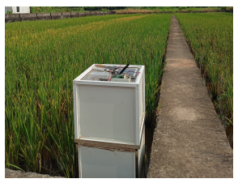
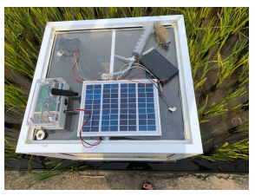

Figure 16 : Equipment and above sight Figure 17 : Isolation box
of the box

The equipment used during our on-site tests closely mirrors the device I designed, with almost identical components. The core of the system, including the board, communication module, and power supply, is housed within a protective enclosure to shield it from the harsh environmental conditions in the field. Meanwhile, the solar cell and sensors, crucial for gathering real-time environmental data such as temperature, humidity, and methane levels, are mounted externally to ensure optimal exposure and functionality. The equipment's design ensures that it can operate efficiently even in the challenging conditions of the rice fields.
Additionally, the setup includes a syringe, visible in the accompanying picture, which is used for the calibration process. This syringe is essential for ensuring that the sensors provide accurate readings by allowing precise calibration with known gas concentrations. The presence of these components highlights the practicality and robustness of the system, ensuring it meets the demands of real-time monitoring in an agricultural setting. The similarity between this setup and my own design demonstrates the adaptability and relevance of the system we’ve developed.

3. Measurements

The data collected are gathered on the MCU, formatted and sent to the Thingsboard dashboard illustrated below:

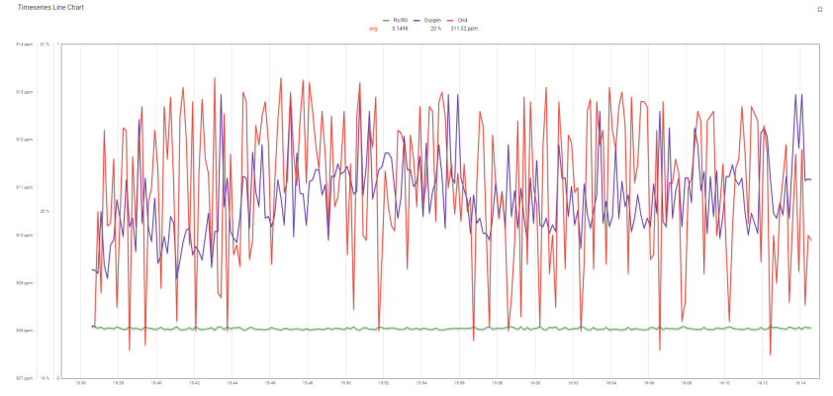

Figure 18 : Collected data

Temperature, humidity and methane level are represented in real time in this time series chart.
Even if the methane level seems really stable and low, results seems accurate for the season.

Conclusion

This internship has been an invaluable experience, both in terms of the technical knowledge I have gained and the personal growth I have experienced. The project centered around the design and implementation of a real-time environmental monitoring system, specifically focused on tracking methane levels, temperature, and humidity in agricultural fields. Throughout this process, I deepened my understanding of IoT systems, particularly in the areas of sensor integration, data communication, and the use of platforms like ThingsBoard for data visualization and management.

One of the most significant aspects of this internship was the hands-on application of theoretical concepts. Working directly in the fields at the Vietnam National University of Agriculture (VNUA) exposed me to the real-world challenges of deploying IoT systems in remote and environmentally demanding conditions. This experience underscored the importance of robust design and adaptability, as well as the need to consider factors such as connectivity issues and environmental impacts on electronic components.

On a personal level, I learned the importance of collaboration and adaptability. The close cooperation with VNUA allowed me to see the value of aligning technical solutions with the specific needs of end-users. I also developed problem-solving skills as I navigated the technical and environmental challenges that arose during the project. Overall, this internship has significantly enhanced my technical expertise and provided me with practical skills that will be invaluable in my future career.

Social and ecological impact
I. Personal carbon footprint during the internship :

During my internship at Hanoi University of Science and Technology, my carbon footprint was largely influenced by transportation, both internationally and locally, and the equipment and infrastructure used during the internship.
Transportation: The international travel included a bus from Tours to Paris, followed by a flight from Paris to Xiamen, and then another to Hanoi. For the return, I traveled by air from Hanoi to Shanghai, from Shanghai to Paris, and then completed the trip by car from Paris to Tours.
Daily commuting: During my stay in Hanoi, I opted to walk to the lab, minimizing emissions from local transport.
Here is a detailed calculation of total personal carbon emission :
We'll use average emission factors (in kg of CO₂ per passenger kilometer) for each transport mode.
Bus: ~0.05 kg CO₂ per km
Flights:
Short-haul flights (up to 1500 km): ~0.15 kg CO₂ per km
Long-haul flights (over 1500 km): ~0.11 kg CO₂ per km
Car: ~0.21 kg CO₂ per km (assuming a medium-sized car)
Below is an outline of the trips and their approximate distances:
Bus from Tours to Paris: ~240 km
Flight from Paris to Xiamen: ~9,700 km
Flight from Xiamen to Hanoi: ~1,700 km
Flight from Hanoi to Shanghai: ~1,900 km
Flight from Shanghai to Paris: ~9,300 km
Car travel from Paris to Tours: ~240 km

Calculations
Bus:
Tours to Paris: 240km×0.05 kg CO₂/km = 12 kg CO₂
Flights:
Paris to Xiamen (long-haul): 9,700 km×0.11 kg CO₂/km=1,067 kg CO₂
Xiamen to Hanoi (short-haul): 1,700 km×0.15 kg CO₂/km=255 kg CO₂
Hanoi to Shanghai (short-haul): 1,900 km×0.15 kg CO₂/km=285 kg CO₂
Shanghai to Paris (long-haul): 9,300 km×0.11 kg CO₂/km=1,023 kg CO₂
Car:
Paris to Tours: 240 km×0.21 kg CO₂/km=50.4 kg CO₂

So,
Bus: 12 kg CO₂
Flights: 1,067+255+285+1,023=2,630 kg CO₂
Car: 50.4 kg CO₂

Total Carbon Footprint = 12+2,630+50.4=2,692.4 kg CO₂

Equipment use: The project involved using IoT equipment for methane monitoring, including microcontrollers, sensors, and a solar-powered battery setup. The energy used in operating this equipment, as well as powering personal devices such as laptops, contributed to my overall footprint.

Server usage: The infrastructure involved data storage and real-time monitoring using the ThingsBoard platform. Running servers and maintaining data connections also contributed to the carbon footprint.

II. Measures taken to reduce environmental footprint :

In line with the goal of reducing carbon footprints and promoting sustainability, several initiatives were taken to minimize the environmental impact of this project:

Daily commute: Walking to the lab instead of using motorized transport helped eliminate emissions associated with local travel in Hanoi.
Solar power: A solar-powered system was used for the methane monitoring device, ensuring a renewable energy source that significantly reduced the carbon impact of powering the equipment.
Efficient communication protocols: To minimize energy consumption, we used MQTT as the communication protocol, known for its low overhead, which helped reduce the energy required for transmitting data.

These measures were implemented to align the project with sustainable practices and to reduce its environmental footprint while maintaining efficiency.

III. Broader environmental and societal impact :

The methane monitoring device was developed specifically to track emissions from rice paddies, which are known to be significant contributors to greenhouse gases. By providing real-time monitoring capabilities, this project aims to help farmers adopt more sustainable practices, thereby reducing methane emissions and contributing to global efforts against climate change.
Also, the device’s utility extends to local farmers, who can benefit from better monitoring of methane levels. This enables the adoption of practices that are both environmentally friendly and economically efficient, fostering sustainability in local communities. It also raises awareness of methane emissions and their impact, promoting responsible agricultural practices among stakeholders.

IV. Challenges and areas for improvement :
The project involved various electronic components, including microcontrollers and sensors, which, if not properly disposed of, could contribute to electronic waste. Ensuring a recycling plan for these components at the end of their lifecycle is crucial.
And while the project utilized renewable energy, optimizing the manufacturing and disposal process of components like the battery and sensors can further reduce environmental impact. Considerations like extending the device’s operational life through design improvements can help enhance sustainability.This impact analysis highlights both the proactive measures taken to mitigate environmental impacts and areas for future improvement, ensuring that the project aligns with broader sustainability goals.

Compétence 1 : Concevoir ou réaliser des solutions techniques, théoriques ou expérimentales, permettant de répondre à un cahier des charges
Elève-ingénieur : Auto-évaluation Niveau 1  Contexte :  Lors de mon stage à HUST, j'ai développé un module IoT pour mesurer le méthane dans des rizières, en respectant un cahier des charges strict.  Argumentaire :  J'ai suivi un protocole précis, en passant par plusieurs étapes intermédiaires, et rédigé des rapports techniques pour documenter les tests et difficultés rencontrées.  Conclusion :  Ce stage m'a permis d'appliquer des méthodologies de validation tout en mettant en œuvre des solutions fonctionnelles, consolidant ainsi mes compétences. | 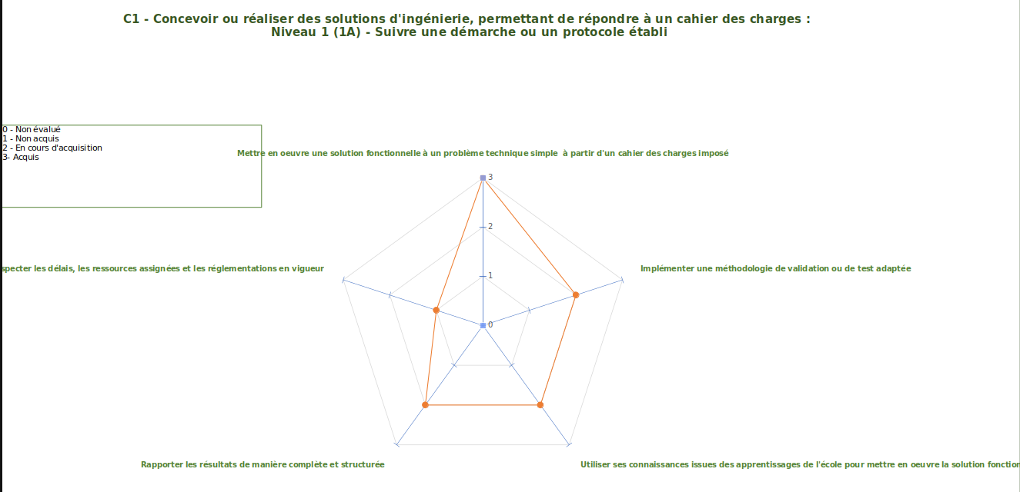  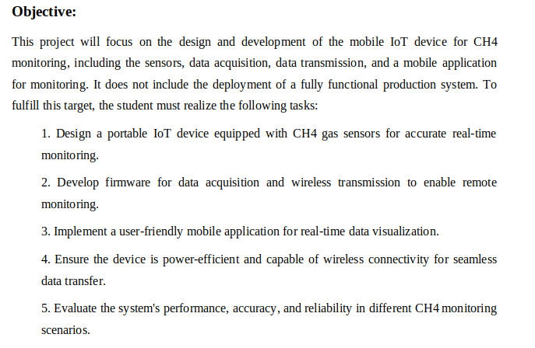  Le rapport précedent est la version finale de mes rapports intermédiaires.
Elève-ingénieur : Auto-évaluation Niveau 2  Contexte :  Durant mon stage, j'ai proposé et développé une solution répondant aux besoins du projet tout en tenant compte des ressources disponibles dans le laboratoire et des délais de livraison importants.  Argumentaire :  J'ai utilisé mes acquis et recherché des informations externes pour résoudre les problèmes techniques à travers la phase d’état de l’art et tout au long du stage. J'ai conçu une solution en intégrant les contraintes de temps et de matériel disponible au laboratoire. J'ai réalisé des tests sur site au sien de l’université d’agriculture d’Hanoï et proposé des améliorations sur la base des résultats obtenus.  Conclusion :  Cette expérience m'a permis d'apprendre à proposer des solutions tout en suivant une démarche structurée et à anticiper leur réutilisation par d'autres. | 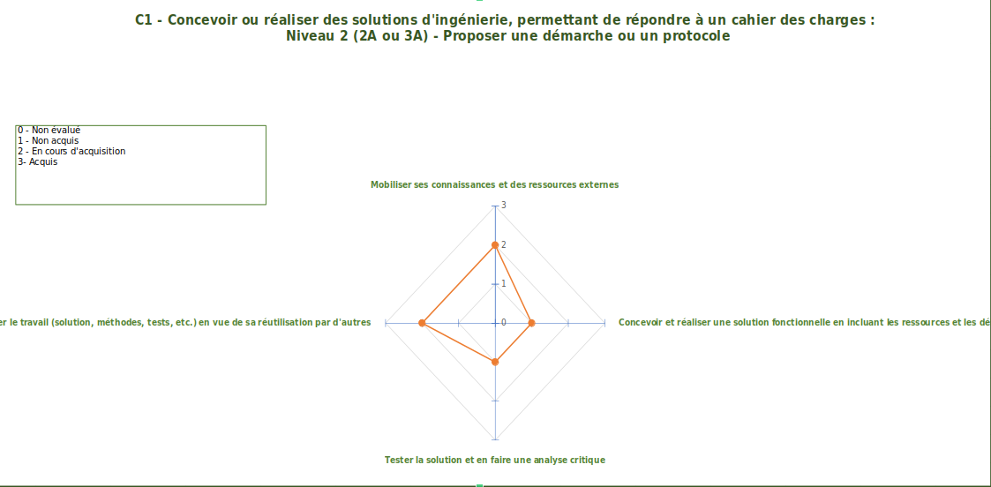
Compétence 2 : Mettre en œuvre une démarche de recherche fondamentale ou appliquée à des fins d'innovation
Elève-ingénieur : Mettre en œuvre une démarche de recherche ou d’innovation (Niveau 1)  Contexte :  Lors de mon stage 2A, j’ai occupé le poste de stagiaire chercheur qui consistait à avoir les mêmes tâches et suivre la même démarche de recherche qu’un chercheur lambda en laboratoire sous la supervision d’un chercheur.  Argumentaire :  J'ai analysé le contexte et les articles scientifiques pertinents, ce qu’on appelle “faire l’état de l’art”.  Par la suite, j’ai identifié des ressources fiables pour éclairer le problème à travers une liste non exhaustive d’artciles scientifiques qui s’approchaient de proche ou de loin à mon sujet .  J’ai alors évalué les solutions existantes comme par exemple, la detection par drone ou satellite et ensuite les différents modules déjà développés. J’ai mis en évidence leurs limites et les obstacles théoriques et techniques.  Pour enfin formalisé une démarche innovante pour répondre au problème à travers un rapport transmis et validé par le maître de stage.  Conclusion :  Ce travail m’a permis de développer une approche méthodique en recherche et innovation, consolidant ainsi mes compétences analytiques. | 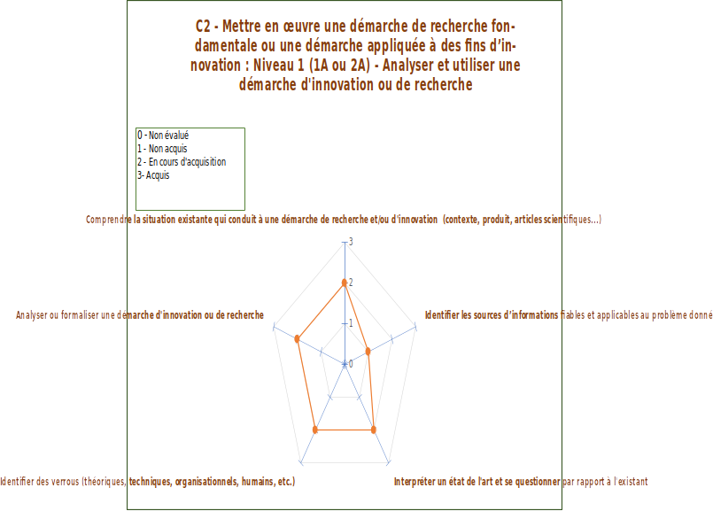

Compétence 3 : Coopérer dans une équipe ou en mode projet
Elève-ingénieur : Coopérer dans une équipe et en mode projet (Niveau 1)  Contexte :  Au cours de mon stage 1A au sein de l’entreprise Sunrise Medical, j'ai intégré une équipe pour participer à la gestion d’un entrepôt et à la réparation de fauteuils roulants  Argumentaire :  J’ai été affilié au poste de préparateur de commandes où les tâches quotidiennes étaient prédéfinies.  J’ai respecté l’organisation du reste de l’équipe car certains fauteuils étaient livrés à une certaines heures et devaient être libérés à un certain oment.  J’ai intégré les retours et critiques de l’équipe pour améliorer la gestion de l’entrepôt.  Nous avions un planning d’équipe.  Conclusion :  Cette expérience m'a permis de développer des compétences en gestion de projet dans un cadre collaboratif. | 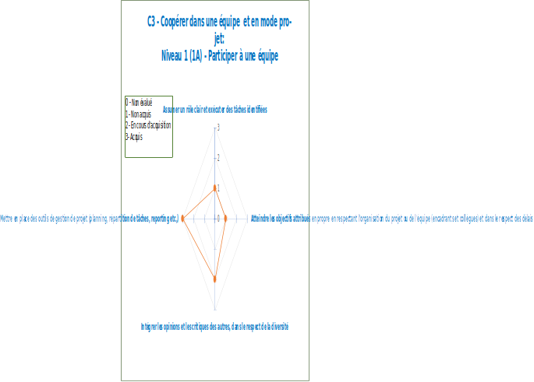
Elève-ingénieur : Coopérer dans une équipe et en mode projet (Niveau 2)  Contexte :  Durant mon stage 2A, au sein d’une équipe, j’ai structuré et coordonné des actions en interaction avec des professionnels.  Argumentaire :  J’ai découpé le projet en sous-tâches et planifié les ressources avec un diagramm de Gantt. J’ai pris des initiatives dans un environnement nécessitant autonomie et organisation en me mettant en contact avec des collaborateurs dans d’autres université.  J’ai géré les avancées et résolu les conflits en trouvant au sein de l’équipe des solutions pour atteindre les objectifs.  J’ai communiqué les résultats de façon claire au maître de stage à travers un rapport hebdomadaire.  Conclusion :  Ce projet m'a permis de renforcer mes compétences en gestion d’équipe et en communication avec des professionnels externes. | 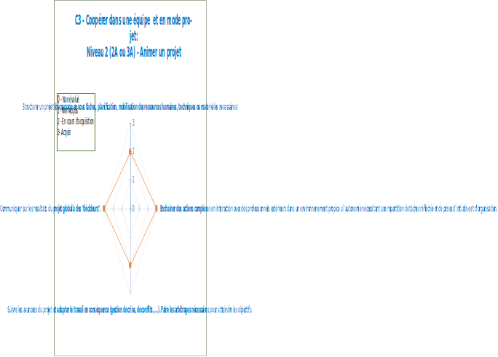

Compétence 5 : Piloter les transitions technologiques, environnementales, sociétales
Elève-ingénieur : Tenir compte des transitions technologiques, environnementales, sociétales (Niveau 1)  Contexte :  Durant mon stage à l’étranger, au Vietnam, en collaboration avec l’Université d’Agriculture de Hanoi, j'ai travaillé sur le design et le développement d'un dispositif IoT permettant de mesurer en temps réel le niveau de méthane dans les rizières. Le méthane est un gaz à effet de serre majeur, et la gestion de ses émissions est cruciale dans le contexte de la transition environnementale et de la lutte contre le réchauffement climatique.  Argumentaire :  Analyse des aspects RSE (Niveau 3) :  Mon stage s’inscrivait dans un contexte international où l’éthique de l’innovation et la gestion de la diversité étaient primordiales. Travailler dans une équipe multiculturelle, avec des experts de l’Université d’Agriculture de Hanoi, m'a permis de renforcer mes compétences en collaboration interculturelle. De plus, le projet visait à contribuer à des solutions écologiques pour réduire l’impact des gaz à effet de serre, notamment le méthane. Le dispositif IoT, conçu pour mesurer ces émissions, s’inscrivait dans une démarche de responsabilité environnementale et sociétale, visant à apporter des solutions aux défis climatiques tout en prenant en compte la réalité des agriculteurs locaux.  Évaluation de l'impact carbone d'un projet (Niveau 3) :  Le dispositif IoT développé avait pour objectif de surveiller en temps réel les émissions de méthane des rizières, une source significative de gaz à effet de serre. J’ai participé à l’évaluation de l’empreinte carbone du projet, en optimisant les capteurs pour minimiser leur consommation énergétique. L’implémentation de protocoles de transmission de données efficaces a également permis de réduire la consommation d’énergie liée à la communication des données, contribuant ainsi à diminuer l’empreinte carbone globale du dispositif. Ce projet était aligné avec les objectifs globaux de réduction des émissions de gaz à effet de serre.  Analyse des impacts sociétaux d'un projet (Niveau 3) :  Ce projet avait un impact sociétal direct sur les communautés locales au Vietnam, notamment les agriculteurs qui dépendent de la riziculture. En permettant une surveillance précise des émissions de méthane, le dispositif pourrait aider à mettre en place des pratiques agricoles plus durables et respectueuses de l'environnement. En outre, l'outil permettrait de sensibiliser les communautés locales sur leur impact environnemental, tout en fournissant des données cruciales pour les politiques agricoles. Le projet visait donc à améliorer à la fois la productivité agricole et la durabilité environnementale.  Analyse de l'impact systémique (Niveau 2) :  J’ai également contribué à l’évaluation de l’impact systémique du dispositif IoT. L'intégration de cette technologie dans les systèmes agricoles locaux a nécessité une analyse approfondie des infrastructures existantes et de leur capacité à absorber cette innovation. L’utilisation des données générées par le dispositif pourrait influencer les politiques agricoles locales et nationales, ainsi que les pratiques globales de gestion des cultures pour réduire les émissions de méthane. Cela nécessite une approche systémique pour assurer la cohérence des nouvelles technologies avec les objectifs environnementaux à long terme.  Conclusion :  Ce stage m’a permis de comprendre en profondeur l’impact environnemental des technologies IoT dans l’agriculture. En travaillant sur ce projet, j’ai non seulement acquis des compétences techniques, mais aussi une conscience accrue des défis environnementaux et sociétaux liés à la transition écologique. J'ai appris à évaluer et à améliorer l'empreinte carbone, tout en tenant compte des impacts sociétaux et systémiques dans un contexte international. | 