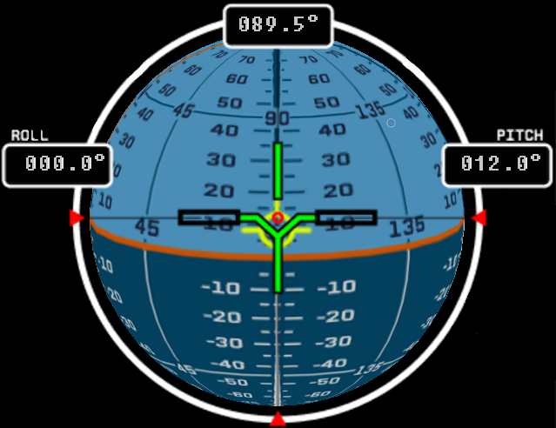
ROCKET

APO:435,578,678 km
ALT: 888,129 km
PER: 77,239 km

ttA: 23:22:67

SPD: 76,023 m/s
(orbit)

