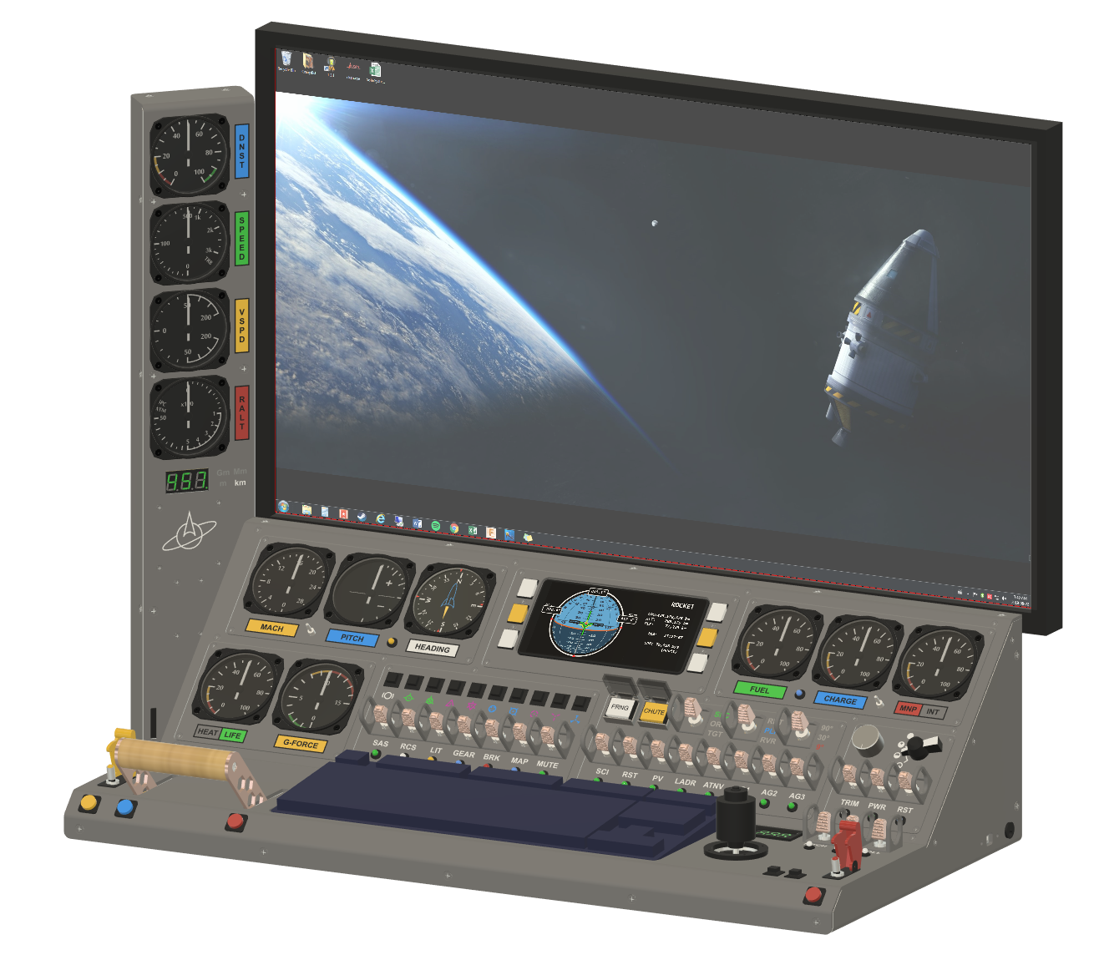
Gauge Tower
Panel Casing

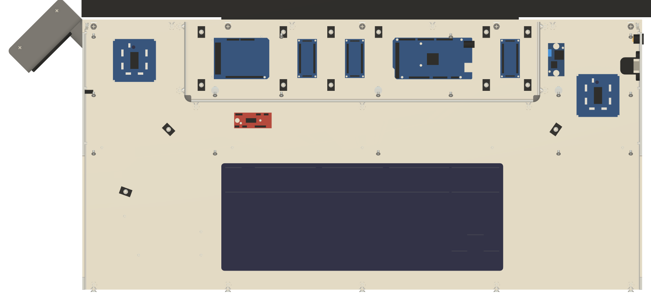
Arduino Mega
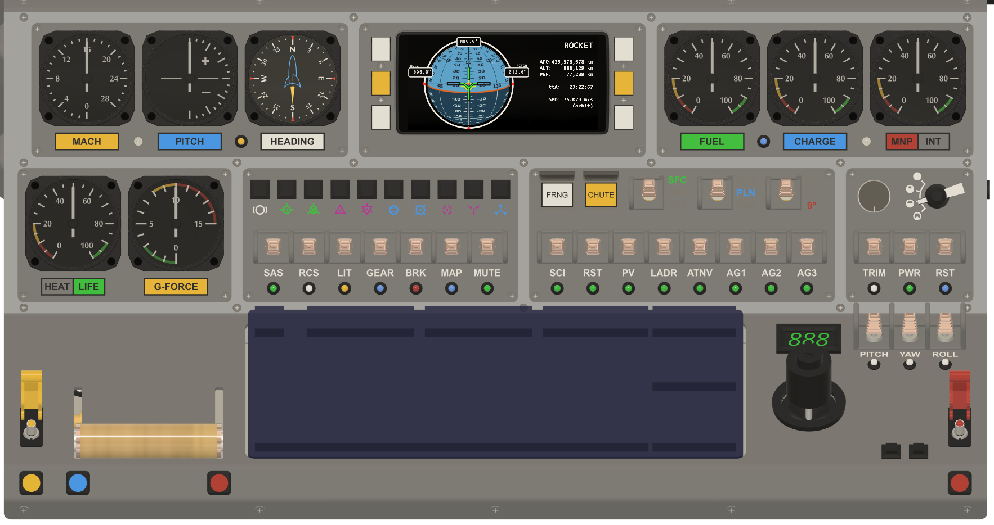
Module F
Module E
Module D
Module C
Module B
Module A
Module G
Module H
Module I

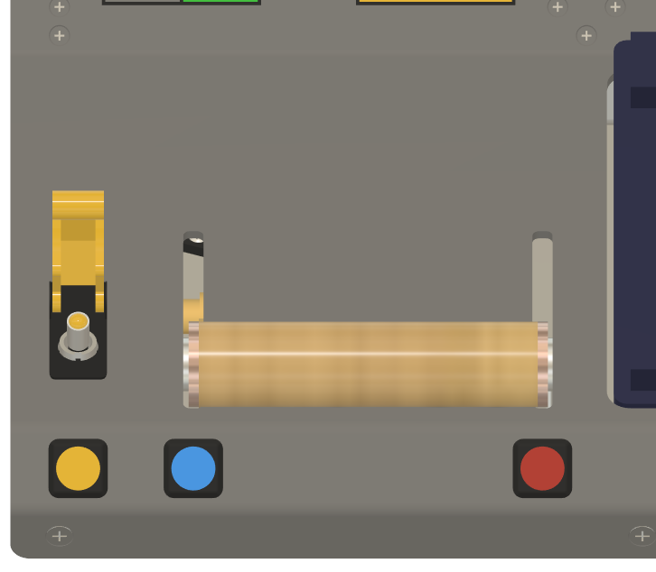
Brake Momentary Pushbutton
Throttle Toggle Pushbutton
Staging Momentary Pushbutton
Throttle Handlebar
Staging Missile Switch
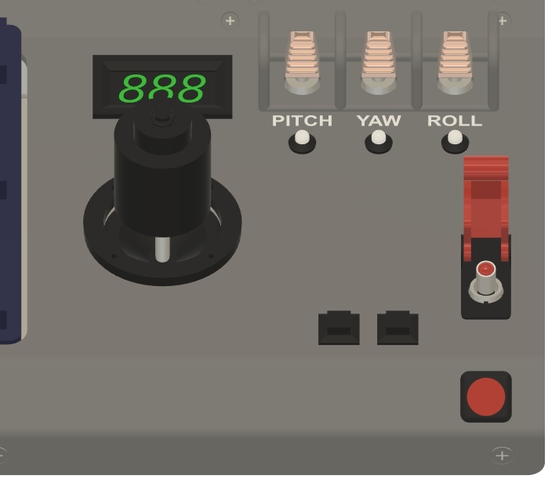
Trim Controls
(toggle switches)
Abort Missile Switch
Abort Momentary Pushbutton
Time Warp >>
Voltmeter
Time Warp <<
Joystick
(3 axis
+ button)
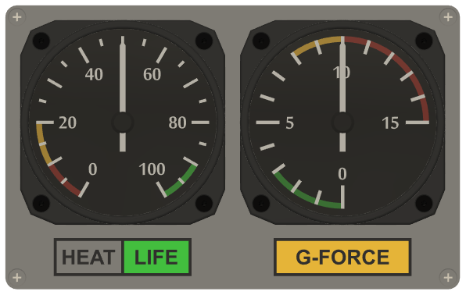
Geared Analog Stepper Gauges (315° range)
Backlit Lightboxes
(Life Support)
(Max Heat)
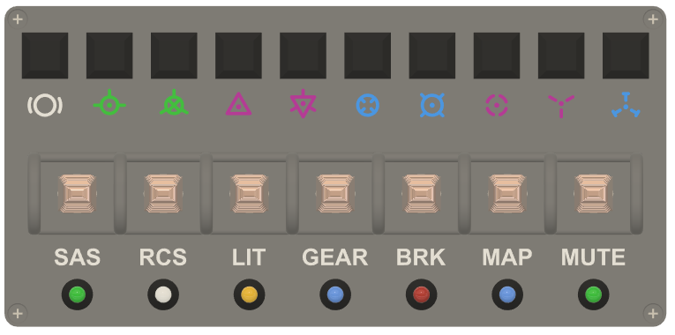
Backlit
(Hold) (Retrograde) (Anti-normal) (Radial Out) (Anti-Target)
(Prograde) (Normal) (Radial In) (Target) (Maneuver)
Auto-pilot
Toggle Switches
(Stability (Reaction (Lights) (Landing (Brake) (Ship/Map (Phone
Assist Control Gear) view) Speaker)
System) System)
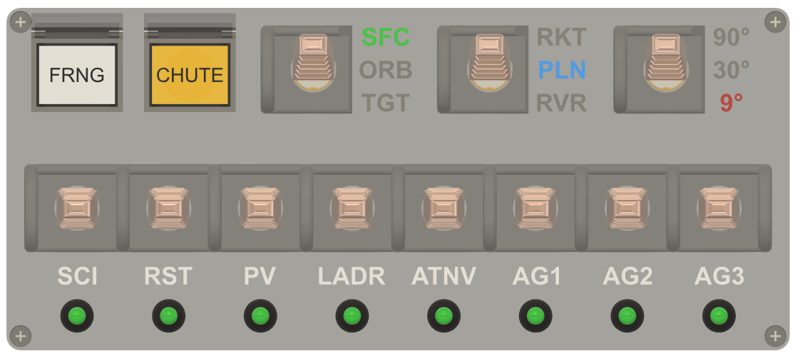
Covered
Push
Buttons
(Science (Reset (Solar (Ladder) (Auto- (Action (Action (Action
Experiments) Sci.) Panels) Navigation) Group1) Group2) Group3)
Momentary Toggle Switches
3-position Toggle Switches
Speed Reference Maneuver Mode
(Surface) (Rocket)
(Orbit) (Plane)
(Target) (Rover) Pitch Precision
Fairing
Parachute
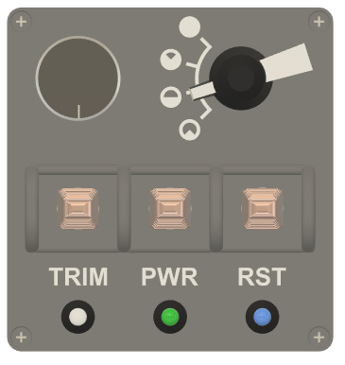
Trim
Master
Control
Control Panel Master Power
Switch
Arduino Mega Reset
Control Sensitivity
(4-position)
Multi-purpose Potentiometer
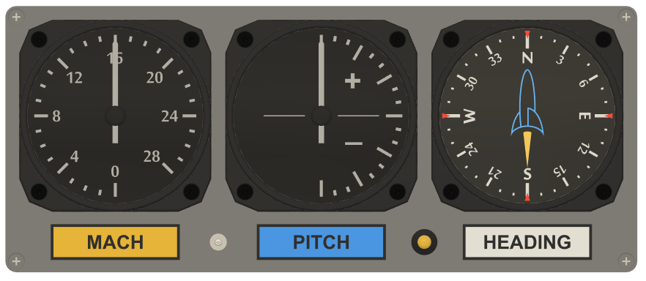
HEAT/LIFE Toggle Switch
Vehicle Pitch
(90°/30°/9°)
Vehicle Compass Heading
Panel-Computer Communications LED
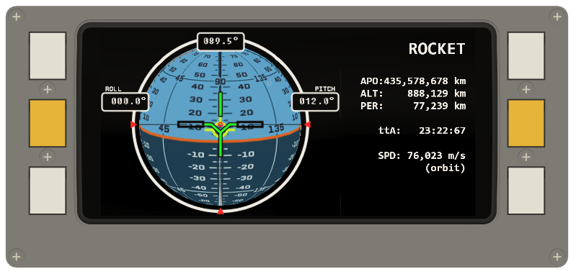
TR: Top Right

CR: Center Right

BR: Bottom Right
TL: Top Left

CL: Center Left

BL: Bottom Left
Glass Cockpit Momentary Pushbuttons
Phone
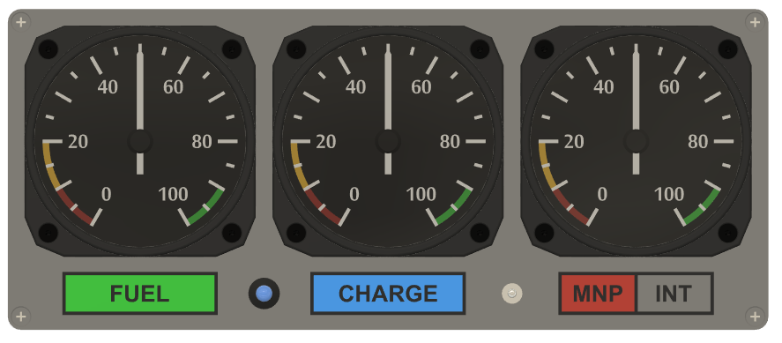
MNP/INT
Toggle Switch
Intake Air
Monopropellant
Electricity Reserve
Charge
Rate-Of-Change RGB LED
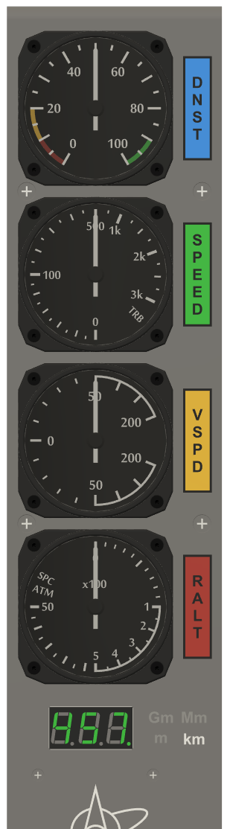
Altitude
Vehicle Radar Altitude (m)
Vehicle Vertical Speed (m/s)
Vehicle Speed (m/s)
Air
Density

