**Site Purpose**:

Bountiful foods is a small business that sells organic, locally grown foods. They are located Carlsbad, California. This site is a place where people in the Carlsbad area can see what is fresh and what Bountiful Foods offers to the people who want locally grown foods.

Our mission at Bountiful foods is to provide fresh and healthy food options to the coastal areas of California.

**Target Audience**:

**Audience**

People in the Carlsbad area looking for fresh food. People who want local food choices. Mnaybe day cares who what better food options for they day cares.

### **Personas**

Phil a 20-year-old navy seal who is looking for better food option so he can have a healthier life style.

Travis a 47-year-old chiropractor who wants to show his clients that they can help their body by eating better food and there is option out there.

#### **Scenarios**

* People who what better food options
* People with food allergy and food sensitivity
* Anyone who what’s better food options

**Site Map**:

Home

* Summary
* Call to action
* Weather cards

Fresh

* First name
* Email
* Phone
* 3 inputs

About us

* Historical info
* contact
* google map

**Color Scheme**:

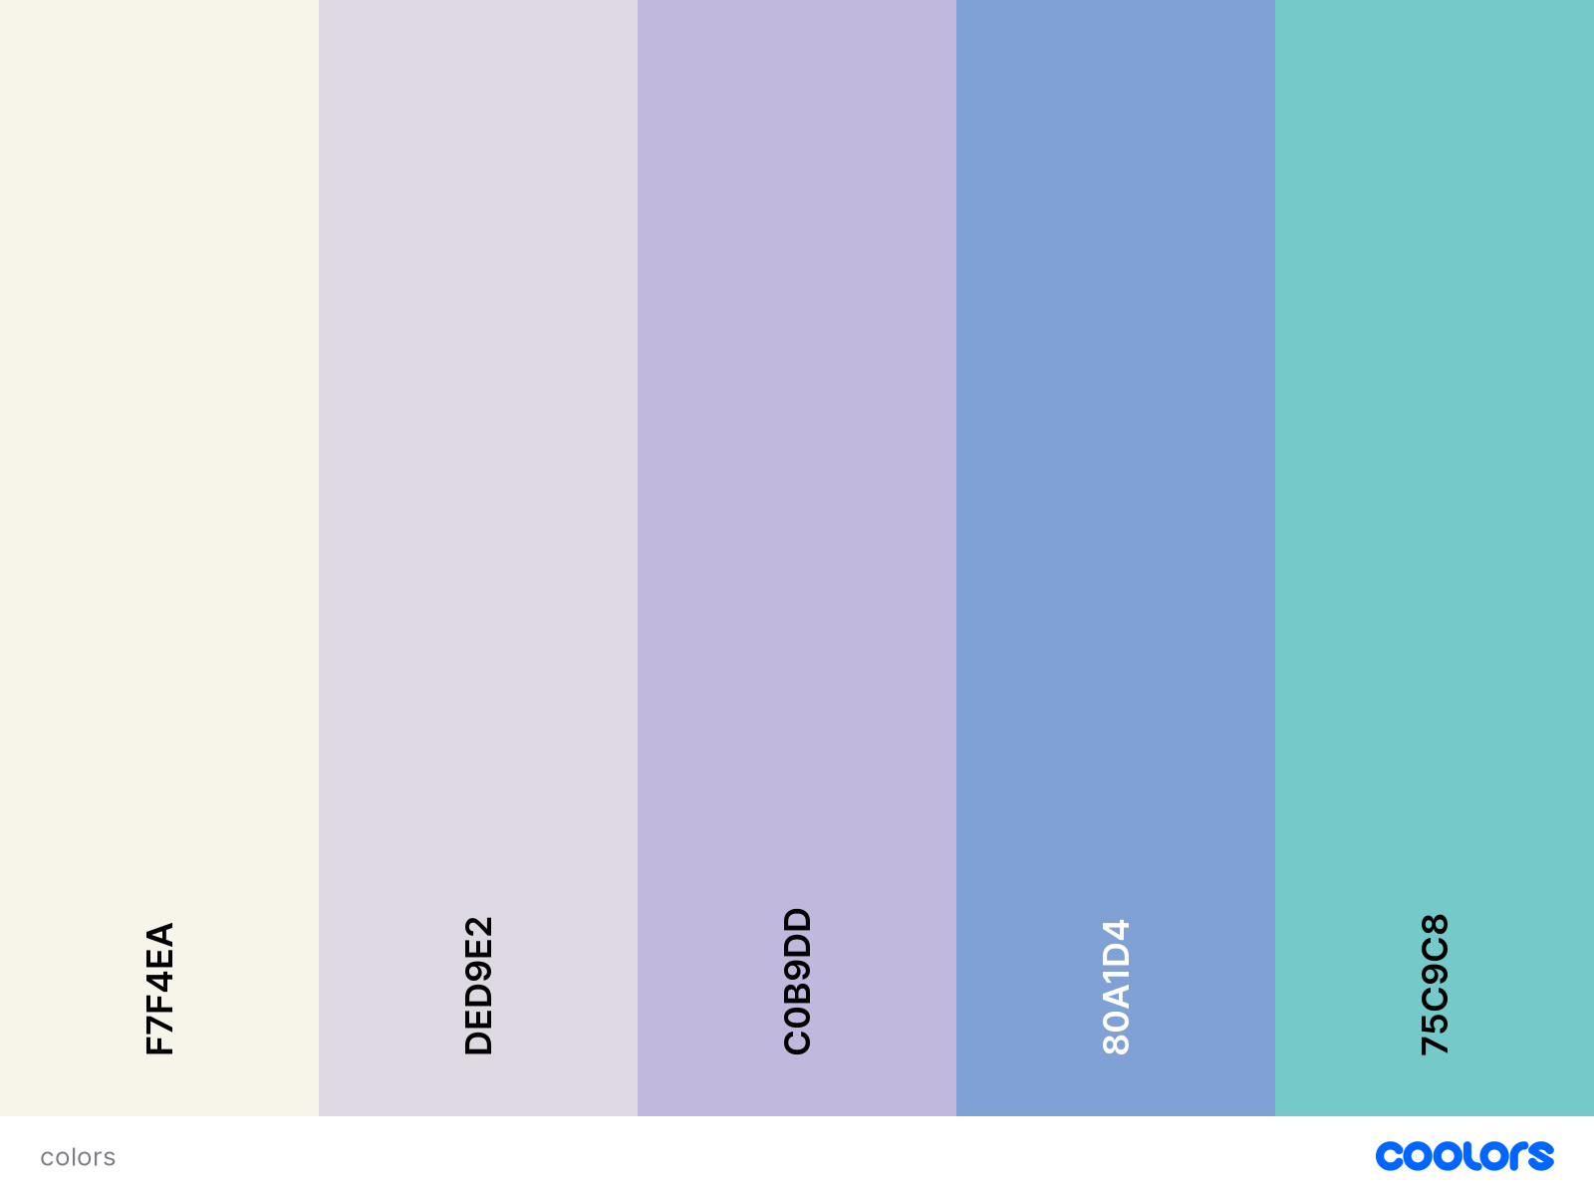

**Typography:**

font-family: 'Sofia Sans', sans-serif;

<link rel="preconnect" href="https://fonts.googleapis.com">

<link rel="preconnect" href="https://fonts.gstatic.com" crossorigin>

<link href="https://fonts.googleapis.com/css2?family=Sofia+Sans:ital,wght@1,100&display=swap" rel="stylesheet">

**Wireframe Sketches:**

