

Rationalisation Model

Date: 2024-09-17

# Summary of the analysis performed

This document contains the results of the rationalisation model for the Rabobank with scope being SSIS. The goal of this analysis is to uncover the complexity within the system in-scope and provide useful insights of its functionalities.

## Overview of the nodes in the control flow

|  |  |
| --- | --- |
| Node task | Number of occurences |
| Execute SQL Task | 5 |
| Foreach Loop Container | 1 |
| Expression Task | 1 |
| Data Flow Task | 1 |

<Placeholder for manual input>

## External table connection to the control nodes

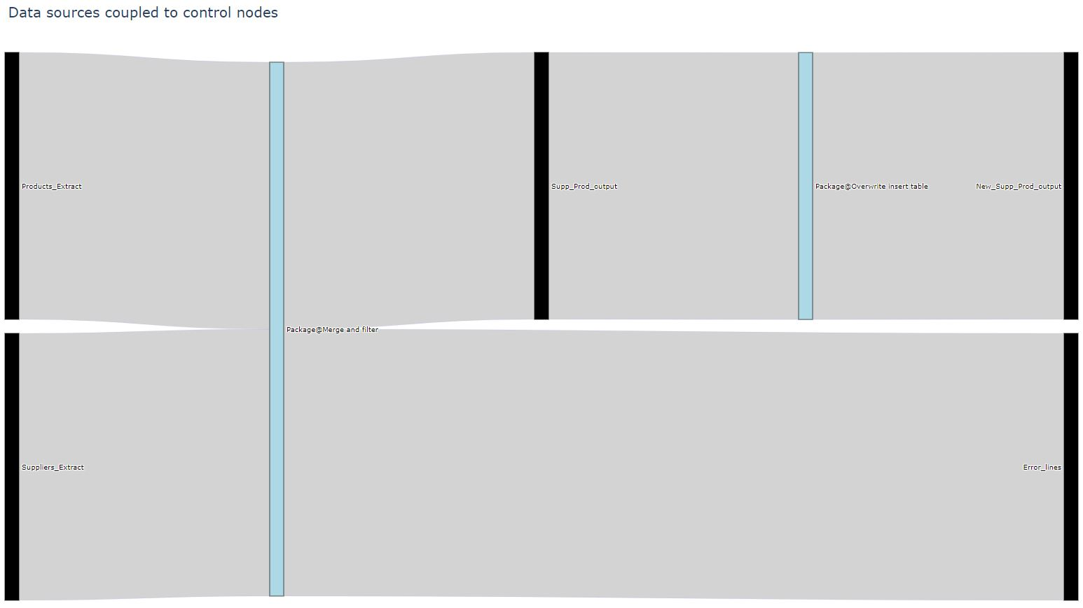

### Legend:

|  |  |
| --- | --- |
|  | - External table |
|  |  |
|  | - Control flow node |
|  |  |

# Details of the data flow Merge and filter

This section zooms in on the critical observations derived from the analysis, with a specific emphasis on the data flow.

## Overview of the nodes in the data flow

|  |  |
| --- | --- |
| Node task | Number of occurences |
| DataSources | 3 |
| Variable | 2 |
| DerivedColumn | 2 |
| RowCount | 2 |
| SSISODBCDst | 2 |
| DataDestinations | 1 |
| SSISODBCSrc | 1 |
| Lookup | 1 |
| ConditionalSplit | 1 |
| UnionAll | 1 |

<Placeholder for manual input>

## Overview of utilised source tables in the data flow

|  |  |
| --- | --- |
| Source table | Occurrences |
| Suppliers_Extract | 1 |
| Products_Extract | 1 |

<Placeholder for manual input>

## Overview of utilised target tables in the data flow

|  |  |
| --- | --- |
| Target table | Occurrences |
| Error_lines | 1 |

<Placeholder for manual input>

## Overview of transformations in the data flow

|  |  |  |
| --- | --- | --- |
| Node | Column | Transformation |
| Merge and filter@Alter name pref | CompanyName | "PREF_" + CompanyName |
| Merge and filter@Error_match_column | Match_lookup | "No_match" |

<Placeholder for manual input>

## Overview of split arguments in the data flow

|  |  |  |
| --- | --- | --- |
| Node | Node task | Split argument |
| Merge and filter@Split preferences | ConditionalSplit | Discount > 0 |

<Placeholder for manual input>

## Overview of join arguments in the data flow

|  |  |  |
| --- | --- | --- |
| Node | Node task | Join argument |
| Merge and filter@Match with products | Lookup | SupplierID = SupplierID2 |

<Placeholder for manual input>

# Sankey Diagrams

This section contains the Merge and filter data flow in a sankey Diagram, giving you insights into the overall lineage and the transformations as well as model-identified focus points of the view.

## Lineage within the Merge and filter data flow

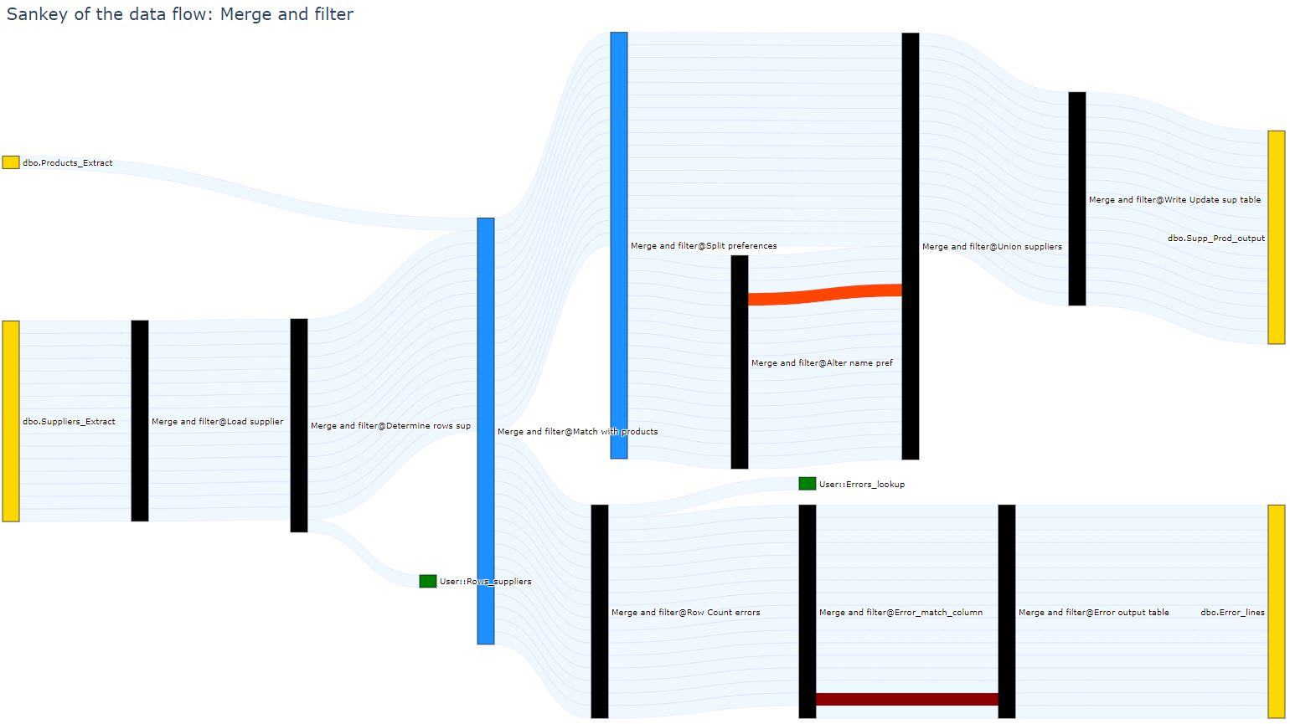

### Legend:

|  |  |
| --- | --- |
|  | - Node |
|  |  |
|  | - External table |
|  |  |
|  | - Join or split node |
|  |  |
|  | - Variable |
|  |  |
|  | - Data transmission |
|  |  |
|  | - Transformation (existing column) |
|  |  |
|  | - Transformation (new column) |
|  |  |