GenSRT — User Guide
Generate subtitles for any video, in any language, using a desktop app. No command line required.
This guide covers the GUI app. For batch processing, CLI flags, and the full set of tuning knobs, see README.md.

What you can do with it
Drop a video onto the app, click Generate SRT, and a few minutes later you have a subtitle file sitting next to your video. The subtitles can be in the original language of the audio or translated into your choice of target language.
Here's what the result looks like, played back in PotPlayer:
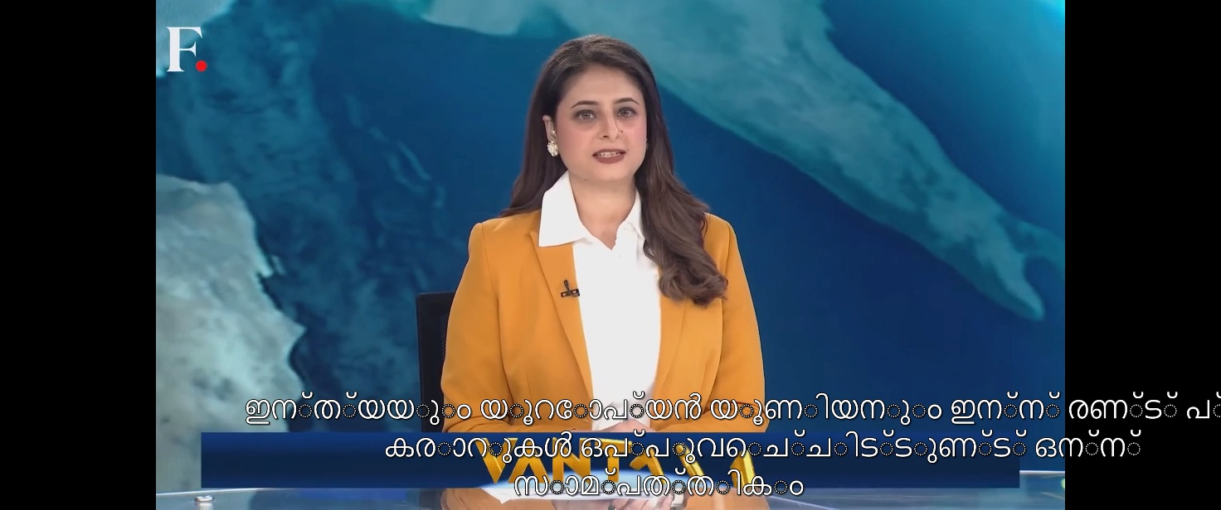
That's a Firstpost news clip (English/Hindi audio), transcribed and translated to Malayalam by GenSRT, then loaded as a subtitle track in PotPlayer.
The same .srt file works in VLC, Jellyfin, Kodi, web browsers, and just about anything else that plays video.

Installation
Two options:
Option 1 — Use the standalone build. If your friend who sent you here also sent you a gensrt.exe (or a zipped folder containing it), just run that. No Python required. The first run will take a few minutes to download Whisper model weights (~800 MB) — subsequent launches are instant.
Option 2 — Install from source. See README.md. You'll need Python 3.10+, CUDA 12.8, and FFmpeg.
Either way, you also need:
- An NVIDIA GPU with CUDA 12.8 installed (CPU works but is much slower)
- FFmpeg on your system PATH
- An internet connection (for Google Translate; the Whisper model also downloads on first run)

The interface
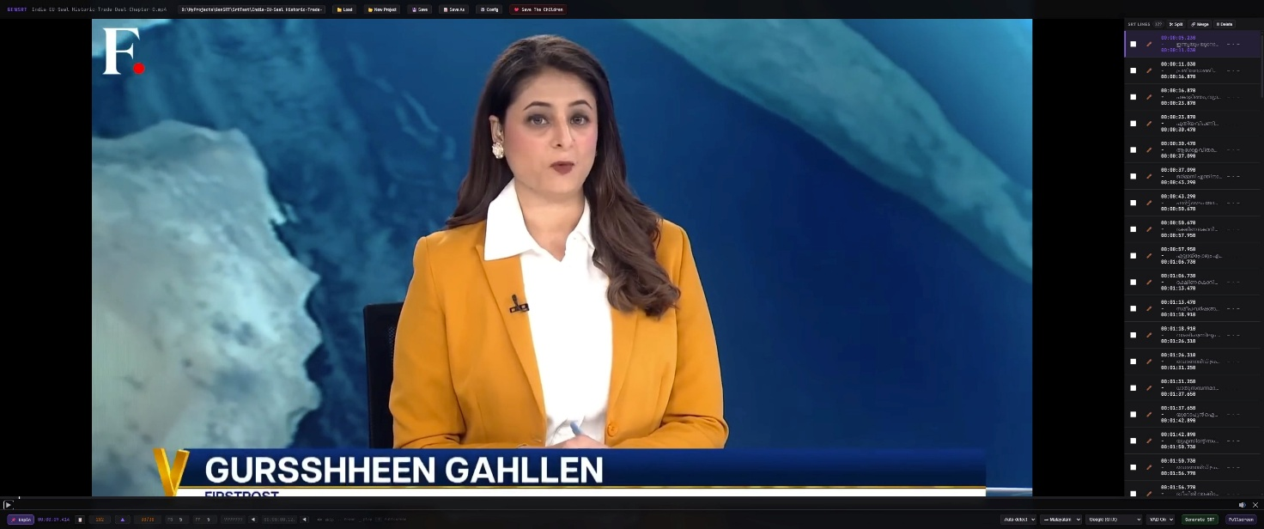
The window has four areas:
Top bar — filename, full path of the currently loaded video, and project buttons (Load, New Project, Save, Save As, Config). The "Save The Children" link is a donation prompt; the rest of the app works without clicking it.
Video player (left) — drag a video here or use the Load button. Standard playback controls.
SRT lines (right) — each subtitle line shows its start time, the text, and its end time. Click a row to seek the video to that point. Each row has a checkbox (for Split) and a pencil icon (for Edit).
Footer (bottom) — selectors that control how the next Generate SRT run will work:
Control | What it does
Source language | What language the audio is in (Auto-detect lets Whisper figure it out)
Target language | What language to translate the subtitles into
Translation engine | Which service does the translation (Google is the default, recommended for non-English targets)
VAD On/Off | Voice Activity Detection — filters out silence before transcription. Usually leave on.
Generate SRT | The big button. Starts the transcription job.

These are per-job overrides. To change your defaults permanently, click the Config button in the top bar.

Generate your first SRT
- Drag a video file onto the player area. Or click Load and pick one from a file dialog. Supported formats: mp4, mkv, ts, m2ts, mts, m4v, mov, avi, webm.
- Set the languages in the footer if needed.
  - For Korean audio → Malayalam subtitles: source = Korean, target = Malayalam, engine = Google (GTX)
  - For English audio → English subtitles (transcription only): source = Auto-detect, target = English
  - For "keep it in the original language, don't translate": set source and target to the same language
- Click Generate SRT. A progress bar appears. The first run loads the Whisper model into your GPU's memory (takes a few seconds), then processes the audio. For a 20-minute video on an RTX 3060 Ti, expect ~1-2 minutes total.
- The SRT lines appear in the right pane once it's done. They're also written to disk next to your video. See File naming below.
- Review the result. Click any row to seek the video to that line. You can fix anything that looks wrong (see Editing below) or just hit Save and move on.

Watching with subtitles
GenSRT writes a plain .srt file next to your video. Open the video in any player that supports SRT subtitles:
- PotPlayer — auto-detects sidecar SRTs
- VLC — auto-detects, or Subtitle menu → Add Subtitle File
- Jellyfin / Plex / Kodi — server-side; subtitles appear as a selectable track
- Web browsers via HTML5 — works if you wrap the video and SRT in a webpage with a <track> element (or convert to .vtt, see Roadmap in README.md)
If you generate multiple language SRTs for the same video, media servers like Jellyfin will surface each as a separate track that you can switch between in the player.

Editing subtitles
GenSRT is fast and accurate, but transcription is never perfect. The SRT lines panel is a built-in editor for fixing things up before you commit the final file.
Click a row → seeks the video to that line and pauses, so you can hear what was actually said.
Edit a line — click the pencil icon on the right of the row. A modal opens with the text, start time, and end time, all editable.
Split a line — when one SRT line covers too much speech, you can split it into two. Check the row's checkbox, then click Split at the top of the right pane. A modal opens with two halves you can fine-tune.
Delete lines — check one or more row checkboxes, click Delete, confirm. Subtitle indices renumber automatically on save.
Save — writes back to the loaded .srt file.
Save As — writes to a different filename / location. Next Save goes to the new path.

Languages and Engines
GenSRT supports any source language Whisper recognizes (~100 languages). For translation:
- Google Translate is the default and supports any → any translation. This is what you want for Malayalam, Tamil, Telugu, Bengali, Hindi, etc. Requires an internet connection.
- NLLB-200 (Meta) and MarianMT (Helsinki-NLP) are offline engines, but they only translate to English. They're useful if you're transcribing Korean / Japanese / etc. into English and don't want to depend on Google.
- None (passthrough) — keeps subtitles in the source language with no translation.
If you pick Marian or NLLB with a non-English target, the app will refuse with a clear message ("Target language 'ml' is only supported by the 'google' translation engine…"). Switch to Google or change the target to English.

File naming
Subtitles land next to the video with this naming convention:
Target language | File written
English | MyVideo.srt
Malayalam | MyVideo.ml.srt
Korean | MyVideo.ko.srt
Hindi | MyVideo.hi.srt
(any other) | MyVideo.<lang>.srt

English stays unsuffixed for compatibility with files you already have. All other languages get an ISO 639-1 code suffix. This matches the convention used by Plex, Jellyfin, and Kodi — so multiple language tracks for the same video coexist cleanly.
When you drop a video that already has a sidecar SRT, GenSRT loads it into the right pane automatically. If both MyVideo.srt and MyVideo.ml.srt exist, the unsuffixed one wins by default — drag the language-suffixed file directly if you want to edit that one instead.

Tips
- Whisper model choice matters for accuracy. The default large-v3-turbo is a good balance. For Korean (and other languages with subtle phonetic distinctions), large-v3 produces noticeably better results at the cost of being ~3x slower. Change this in Config → Transcription → model.
- VAD off if VAD is eating speech. Voice Activity Detection occasionally filters out real dialogue (especially soft-spoken or accented audio). The footer toggle is the quickest way to try a run without it.
- Auto-detect is usually fine, but explicit is faster. If you know the source language, setting it in the footer skips the detection step and saves a few seconds per file.
- Save As is your "make a copy before editing" button. Hit it before you start editing if you want to preserve the original Generate output.
- Config changes propagate live. When you save settings in the Config modal, the footer selectors update immediately — no need to relaunch.

Troubleshooting
"CUDA not available" or transcription is very slow. The CPU fallback works but is much slower than GPU. Confirm CUDA 12.8 is installed (nvidia-smi should show your GPU). If you don't have an NVIDIA GPU, CPU mode is expected to be slow — a 20-minute video might take ~30 minutes instead of ~1 minute.
Video won't load (file with Korean / non-ASCII characters in the name). Known issue with the embedded video player. Workaround: rename the file to use ASCII characters in the filename. The transcription itself handles all languages fine — it's just the player widget that's picky about filenames.
The SRT file appears next to the video, but the right pane is empty. Check the engine selector in the footer. If you picked Marian or NLLB with a non-English target, the job fails silently in some setups. Switch to Google.
Subtitles appear slightly before the speaker actually starts speaking. Lower vad_speech_pad_ms in Config → VAD & Subtitle Timing. Default is 200 ms; try 100 ms.
Whisper hallucinated text in silent sections. Raise vad_threshold in Config → VAD & Subtitle Timing. Default is 0.5; try 0.6 or 0.7.

Getting help
For deeper tuning and CLI usage, see README.md.
For issues, send a screenshot or copy of the log output to whoever sent you the app.

