Q1.

Given the screen space coordinates of a triangle in counter clockwise order, how would you determine if the triangle is front or back facing?
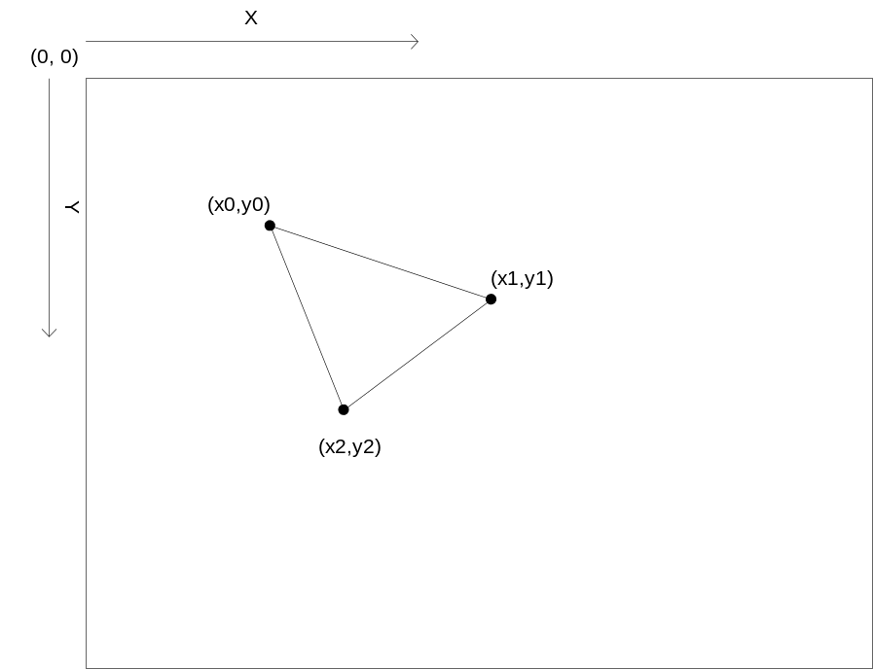

Q2.
Unlike most modern OS’s, console video game systems have no virtual memory. Describe some memory-saving techniques for fitting a large video game into a fixed amount of memory.

Q3.
Describe the following data structures and describe their use. Also, give examples of where they might be used in a program, and what performance we might expect from them.
- Linked List
- Queue
- Stack
- Array

Q4.

Write an optimized C program to convert a base 16 number to its base 10 equivalent, without using the standard C libraries, i.e. don’t use scanf(“%x”). The program should allow the user to input the number. State any assumptions you made when writing the program. Use 23DA as a test number.

Q5.

Write one or two paragraphs answering the following questions:

- Describe the common uses for the break, nop, and cop instructions on many of the current processors.
- What are the advantages and disadvantages of using a handle-based memory allocation system over a pointer-based allocation system?
- How would you approach optimizing a large application such as a video game?
- How would you attempt to understand the design of a large code base in a short period of time?

Q6.
Here are several different ways to declare constants. What are the pros and cons of each?

A.
#define INDEX_1 0
#define INDEX_2 1
#define INDEX_3 2
#define MAX_INDEX 3

B.
enum
{
INDEX_1 = 0,
INDEX_2,
INDEX_3,
MAX_INDEX
};

C.
typedef enum
{
INDEX_1 = 0,
INDEX_2,
INDEX_3,
MAX_INDEX
} INDEX_TYPE;

D.
static const int
INDEX_1 = 0,
INDEX_2 = 1,
INDEX_3 = 2,
MAX_INDEX = 3;

E.
int
INDEX_1 = 0,
INDEX_2 = 1,
INDEX_3 = 2,
MAX_INDEX = 3;

Q7.

Write an optimized program in C to multiply two linear matrices. This program should take as input the dimensions of each matrix, as well as the components of each matrix. State any assumptions you made when writing this program. Use the following matrices as a test:

1 0
-2 3 0 6 1
5 4 3 8 -2
0 1

Q8.
Why would someone program in assembly language - what are the pluses and minuses? Are there better ways to deal with these situations than resorting to assembly?

