AI-Powered Behavioral Anomaly Detection for Cybersecurity

Technical Report
Dataset: 108,986 sessions across 330 entities, 2.006% injected anomaly rate
Alert queue: 1,971 alerts generated from the full dataset
Train/test split: 76,290 train / 32,696 test rows (chronological split at 2026-06-10 16:17:15)

1. Executive Summary
The system detects behavioral anomalies in access logs using an unsupervised Isolation Forest detector (supplemented with a targeted rule for device-fingerprint mismatches), classifies flagged events into one of 7 attack categories with a Random Forest, and explains each alert using both statistical deviation analysis and exact SHAP-based feature attribution.
On a held-out chronological test split, the detector achieves 99.7% precision and 58.2% recall (ROC-AUC 0.974, PR-AUC 0.826), with a false positive rate of 0.0%. At a realistic 1% analyst alert budget, precision reaches 99.7%, capturing 59.3% of all true anomalies.
Across the full dataset’s alert queue, 1,554 of 2,186 (71.1%) true attack sessions were actually flagged and are visible to an analyst - see Section 5 for the important caveat that this varies sharply by attack type.

2. Dataset
Synthetic access-log data generated per the required schema, with all 7 specified attack patterns injected at controlled rates plus an 8th ambiguous edge case (insider drift) for false-positive tuning. Full behavioral assumptions and the attack taxonomy are documented in generator/ASSUMPTIONS.md.
Label | Count
normal | 106,800
brute force | 1,163
credential stuffing | 379
low and slow exfiltration | 308
lateral movement | 177
insider drift | 88
impossible travel | 46
device spoofing | 25

3. System Architecture
Synthetic Data Generator (Phase 1)
|
Backend API + Database (Phase 2) -- FastAPI + SQLite
|
ML Pipeline (Phase 3)
Baseline Profiler (rolling per-entity window, learned from logs)
-> Feature Engineering (15 signals)
-> Isolation Forest Detector (unsupervised)
-> Random Forest Classifier (attack-type)
|
Alert Population (Phase 4) -- hybrid statistical + rule-based flagging
|
Explainability (Phase 5) -- z-score reasoning + SHAP classification attribution
|
Analyst Dashboard (Phase 4) -- Alert Queue, Live Feed, Entity Explorer,
Device Trust, World Map, Model Evaluation

4. Model Performance (Held-Out Test Split)

4.1 Binary Detection
Metric | Value
Precision | 0.997
Recall | 0.582
F1 | 0.735
ROC-AUC | 0.974
PR-AUC | 0.826
False Positive Rate | 0.0%
Precision @ top 1pct alert budget | 0.997 (captures 59.3% of anomalies)
Precision @ top 2pct alert budget | 0.639 (captures 76.0% of anomalies)
Precision @ top 5pct alert budget | 0.309 (captures 91.8% of anomalies)
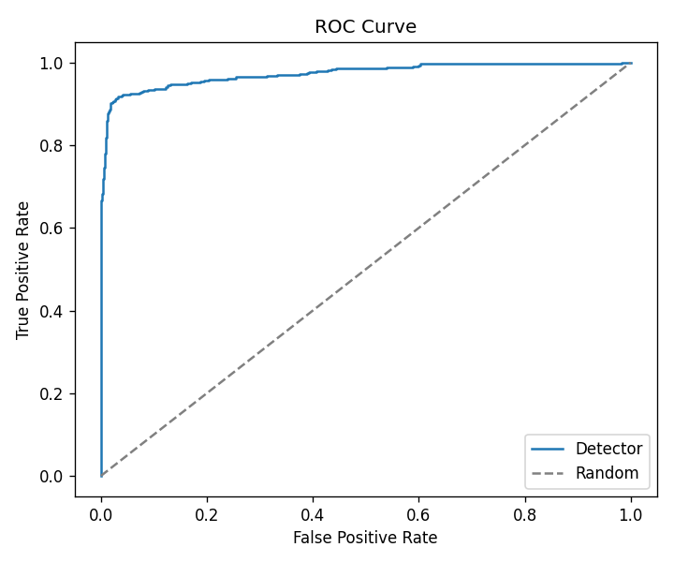
ROC Curve
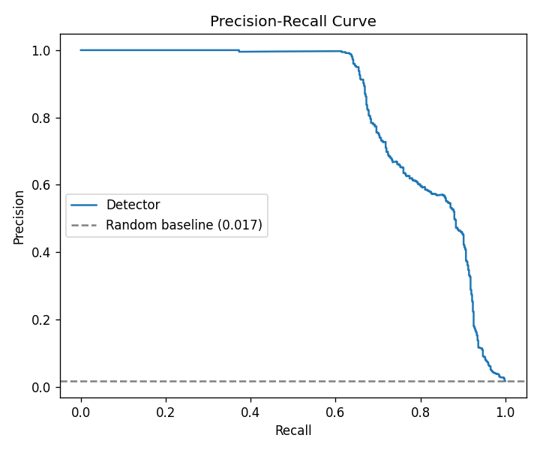
Precision-Recall Curve
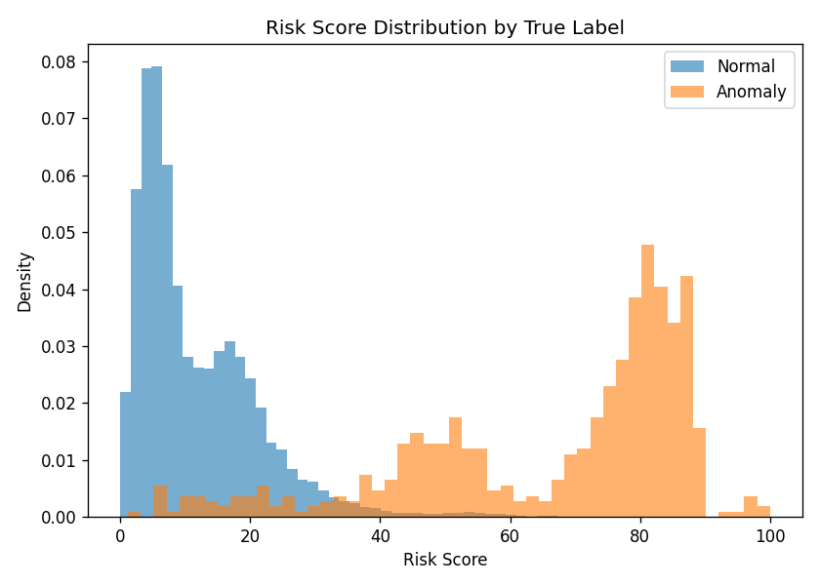
Risk Score Distribution
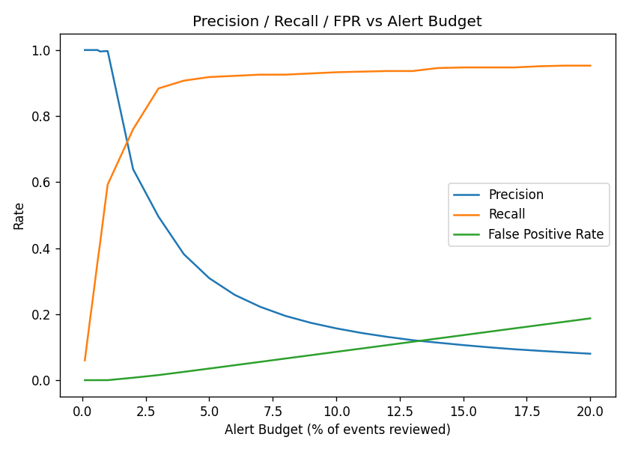
Alert Budget Curve

4.2 Attack-Type Classification (oracle setting - evaluated on true anomalies)
Attack Type | Precision | Recall | F1 | Support
brute force | 1.00 | 1.00 | 1.00 | 221
credential stuffing | 0.99 | 1.00 | 1.00 | 118
device spoofing | 1.00 | 1.00 | 1.00 | 8
impossible travel | 1.00 | 0.57 | 0.73 | 14
insider drift | 0.56 | 0.70 | 0.62 | 27
lateral movement | 0.96 | 0.83 | 0.89 | 65
low and slow exfiltration | 0.82 | 0.89 | 0.85 | 97
Overall accuracy |  |  | 0.933 | 550
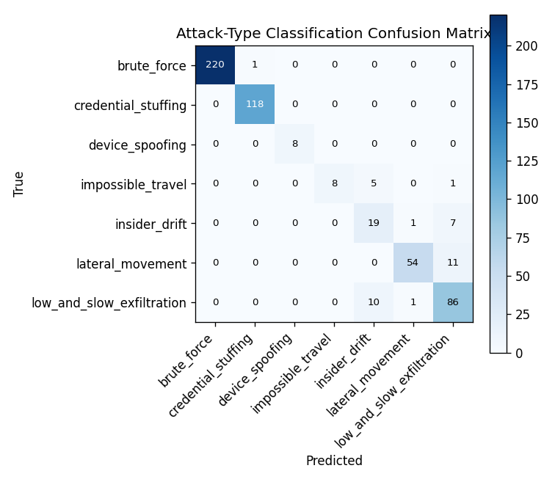
Attack-Type Confusion Matrix

4.3 Top Classifier Feature Importances
Feature | Importance
log_implied_speed_kmh | 0.166
new_device_flag | 0.116
log_time_gap_seconds | 0.116
new_resource_flag | 0.087
duration_zscore | 0.083
log_prior_session_count | 0.078
hour_zscore | 0.076
log_ip_recent_distinct_entities | 0.067

5. End-to-End Attack Coverage (Full Dataset Alert Queue)
Distinct from the held-out test metrics above: this measures, for the FULL dataset, how many true attack sessions of each type actually produced a visible alert an analyst could act on. This is a stricter, more operationally relevant check.
Attack Type | Injected | Flagged | Flag Rate | Correctly Typed
brute force | 1163 | 1105 | 95.0% | 1104
credential stuffing | 379 | 379 | 100.0% | 379
device spoofing | 25 | 25 | 100.0% | 25
impossible travel | 46 | 24 | 52.2% | 24
insider drift | 88 | 1 | 1.1% | 0
lateral movement | 177 | 8 | 4.5% | 5
low and slow exfiltration | 308 | 12 | 3.9% | 12
Honest finding: loud, structurally distinctive patterns (brute force, credential stuffing, device spoofing) are flagged at 95-100%. Quiet, gradual patterns (lateral movement, low-and-slow exfiltration, insider drift) are flagged far less often in practice - as low as 1.1% for insider drift, which was deliberately designed as an ambiguous edge case. This reflects a genuine, well-understood limitation of threshold-based unsupervised detection tuned to an overall base rate: subtler patterns don’t clear the same bar as louder ones. See Section 7 for discussion.

6. Explainability
Every alert carries two independent explanation layers:
- Detection-level (why flagged at all) - features ranked by standardized deviation from normal-row statistics.
- Classification-level (why this specific attack type) - exact SHAP (shap.TreeExplainer) feature attributions from the trained Random Forest, computed per predicted class.
Both layers were spot-checked for coherence: for impossible_travel alerts, SHAP correctly identifies implied travel speed as the dominant factor, matching that feature’s #1 ranking in the classifier’s global feature importances (Section 4.3) - independent confirmation that the model learned genuine signal.

7. Known Limitations & Assumptions
- Risk-score scaling is min-max normalized relative to whatever batch is being scored; a live streaming deployment should pin this to a fixed reference range computed at training time rather than recomputing per call.
- Attack-type flag-rate imbalance (Section 5): subtler patterns are caught far less often than loud ones in the full alert queue. A per-pattern-type contamination/threshold tuning pass, traded deliberately against false-positive rate, is the natural next step.
- Classification is evaluated in an oracle setting (given the true anomalies) to isolate classifier quality from detector recall; an end-to-end number restricted to the detector’s actual flagged set is a reasonable further check.
- Synthetic data: geo-coordinates jitter around 12 fixed reference cities rather than a full geocoding service; command_sequence uses a small templated action vocabulary per resource type. Both are adequate for the modeling task but not a substitute for real telemetry. Full assumptions in generator/ASSUMPTIONS.md.
- Cold-start handling: entities with fewer than 5 prior sessions in their rolling window fall back to peer-group (same entity_type) statistics rather than individual baselines. Verified: 1.5% of all sessions used this fallback with non-degenerate feature values.

8. Deliverables Checklist
# | Deliverable | Status
1 | Synthetic data generator + documented taxonomy | Done - generator/, generator/ASSUMPTIONS.md
2 | Baseline profiling model | Done - ml/profiler.py, ml/ip_features.py
3 | Detection model (sequence-aware, flags deviations) | Done - ml/detector.py (Isolation Forest)
4 | Anomaly classification (attack category) | Done - ml/classifier.py (Random Forest)
5 | Explainability layer | Done - ml/explain.py (z-score + SHAP)
6 | Analyst-facing dashboard | Done - frontend/dashboard.html
7 | Report (this document) | Done - auto-generated from live model output

This report was generated automatically from live evaluation data and the current database state - every number above reflects the actual current model run, not a hand-typed snapshot.

