NAME: MOUNVI PODAPATI

REG NO: 19BCE0396

COURSE CODE: CSE1007

FACULTY: DR. LOKESH KUMAR

# LAB ASSIGNMENT-1

QUESTION 1:

CODE:

**import** java.io.*;

**import** java.util.Scanner;

**class** Sales {

**public** **static** **void** main(String[] args) {

Scanner sc=**new** Scanner(System.***in***);

**int** i=0,j=0,row_total=0;

**int**[][] sales=**new** **int** [8][9]; /* EID DAY1 DAY2 DAY3 DAY4 DAY5 DAY6 DAY7 TOTAL */

//For inputing the entries and calculating the total sales for each employee

**for**(i=0;i<8;i++) {

System.***out***.print((i+1) + ". Enter the employee ID: ");

j=0; row_total=0;

sales[i][j]=Integer.*parseInt*(sc.next());

**for**(j=1;j<8;j++) {

System.***out***.print("Enter the sales of the day "+ (j) + " of the first week: ");

sales[i][j]=Integer.*parseInt*(sc.next());

row_total += sales[i][j];

}

sales[i][8]=row_total;

}

//Displaying the data employee-wise

**for**(i=0;i<8;i++) {

System.***out***.println("Employee ID: " + sales[i][0]);

System.***out***.print("Sales of the week- [ ");

**for**(j=1;j<8;j++) {

System.***out***.print(" " + sales[i][j] + " ");

}

System.***out***.println(" ]");

}//Calculating the minimum and maximum sales

**int** max_sales=0,max_index=0;

**int** min_sales=sales[0][8],min_index=0;

**for**(i=0;i<8;i++) {

**if**(sales[i][8]>max_sales) {

max_sales=sales[i][8];

max_index=i;

}

**if**(sales[i][8]<min_sales) {

min_sales=sales[i][8];

min_index=i;

}

}

System.***out***.println("Max sales are "+ max_sales +" by employee ID: "+ sales[max_index][0]);

System.***out***.println("Min sales are "+ min_sales +" by employee ID: "+ sales[min_index][0]);

}

}

Console:

1. Enter the employee ID: 345

Enter the sales of the day 1 of the first week: 4

Enter the sales of the day 2 of the first week: 3

Enter the sales of the day 3 of the first week: 2

Enter the sales of the day 4 of the first week: 4

Enter the sales of the day 5 of the first week: 5

Enter the sales of the day 6 of the first week: 6

Enter the sales of the day 7 of the first week: 7

2. Enter the employee ID: 234

Enter the sales of the day 1 of the first week: 1

Enter the sales of the day 2 of the first week: 4

Enter the sales of the day 3 of the first week: 6

Enter the sales of the day 4 of the first week: 2

Enter the sales of the day 5 of the first week: 3

Enter the sales of the day 6 of the first week: 4

Enter the sales of the day 7 of the first week: 6

3. Enter the employee ID: 246

Enter the sales of the day 1 of the first week: 1

Enter the sales of the day 2 of the first week: 2

Enter the sales of the day 3 of the first week: 2

Enter the sales of the day 4 of the first week: 2

Enter the sales of the day 5 of the first week: 3

Enter the sales of the day 6 of the first week: 4

Enter the sales of the day 7 of the first week: 3

4. Enter the employee ID: 564

Enter the sales of the day 1 of the first week: 2

Enter the sales of the day 2 of the first week: 3

Enter the sales of the day 3 of the first week: 4

Enter the sales of the day 4 of the first week: 5

Enter the sales of the day 5 of the first week: 3

Enter the sales of the day 6 of the first week: 3

Enter the sales of the day 7 of the first week: 3

5. Enter the employee ID: 237

Enter the sales of the day 1 of the first week: 1

Enter the sales of the day 2 of the first week: 2

Enter the sales of the day 3 of the first week: 8

Enter the sales of the day 4 of the first week: 9

Enter the sales of the day 5 of the first week: 4

Enter the sales of the day 6 of the first week: 5

Enter the sales of the day 7 of the first week: 4

6. Enter the employee ID: 214

Enter the sales of the day 1 of the first week: 3

Enter the sales of the day 2 of the first week: 5

Enter the sales of the day 3 of the first week: 2

Enter the sales of the day 4 of the first week: 8

Enter the sales of the day 5 of the first week: 6

Enter the sales of the day 6 of the first week: 4

Enter the sales of the day 7 of the first week: 4

7. Enter the employee ID: 278

Enter the sales of the day 1 of the first week: 3

Enter the sales of the day 2 of the first week: 3

Enter the sales of the day 3 of the first week: 4

Enter the sales of the day 4 of the first week: 5

Enter the sales of the day 5 of the first week: 6

Enter the sales of the day 6 of the first week: 4

Enter the sales of the day 7 of the first week: 4

8. Enter the employee ID: 345

Enter the sales of the day 1 of the first week: 3

Enter the sales of the day 2 of the first week: 3

Enter the sales of the day 3 of the first week: 2

Enter the sales of the day 4 of the first week: 1

Enter the sales of the day 5 of the first week: 2

Enter the sales of the day 6 of the first week: 2

Enter the sales of the day 7 of the first week: 2

Employee ID: 345

Sales of the week- [ 4 3 2 4 5 6 7 ]

Employee ID: 234

Sales of the week- [ 1 4 6 2 3 4 6 ]

Employee ID: 246

Sales of the week- [ 1 2 2 2 3 4 3 ]

Employee ID: 564

Sales of the week- [ 2 3 4 5 3 3 3 ]

Employee ID: 237

Sales of the week- [ 1 2 8 9 4 5 4 ]

Employee ID: 214

Sales of the week- [ 3 5 2 8 6 4 4 ]

Employee ID: 278

Sales of the week- [ 3 3 4 5 6 4 4 ]

Employee ID: 345

Sales of the week- [ 3 3 2 1 2 2 2 ]

Max sales are 33 by employee ID: 237

Min sales are 15 by employee ID: 345

SNAPSHOTS:

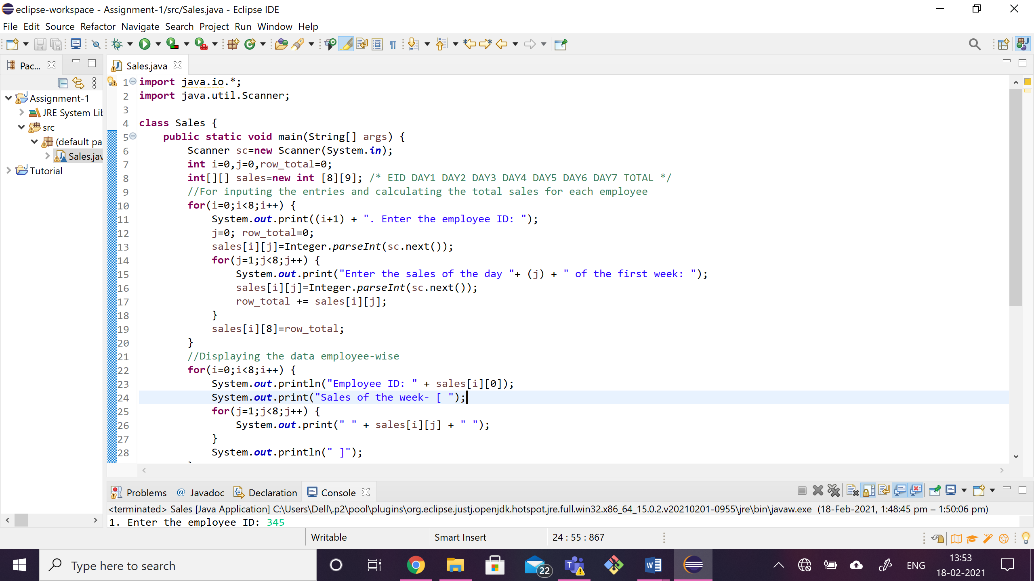

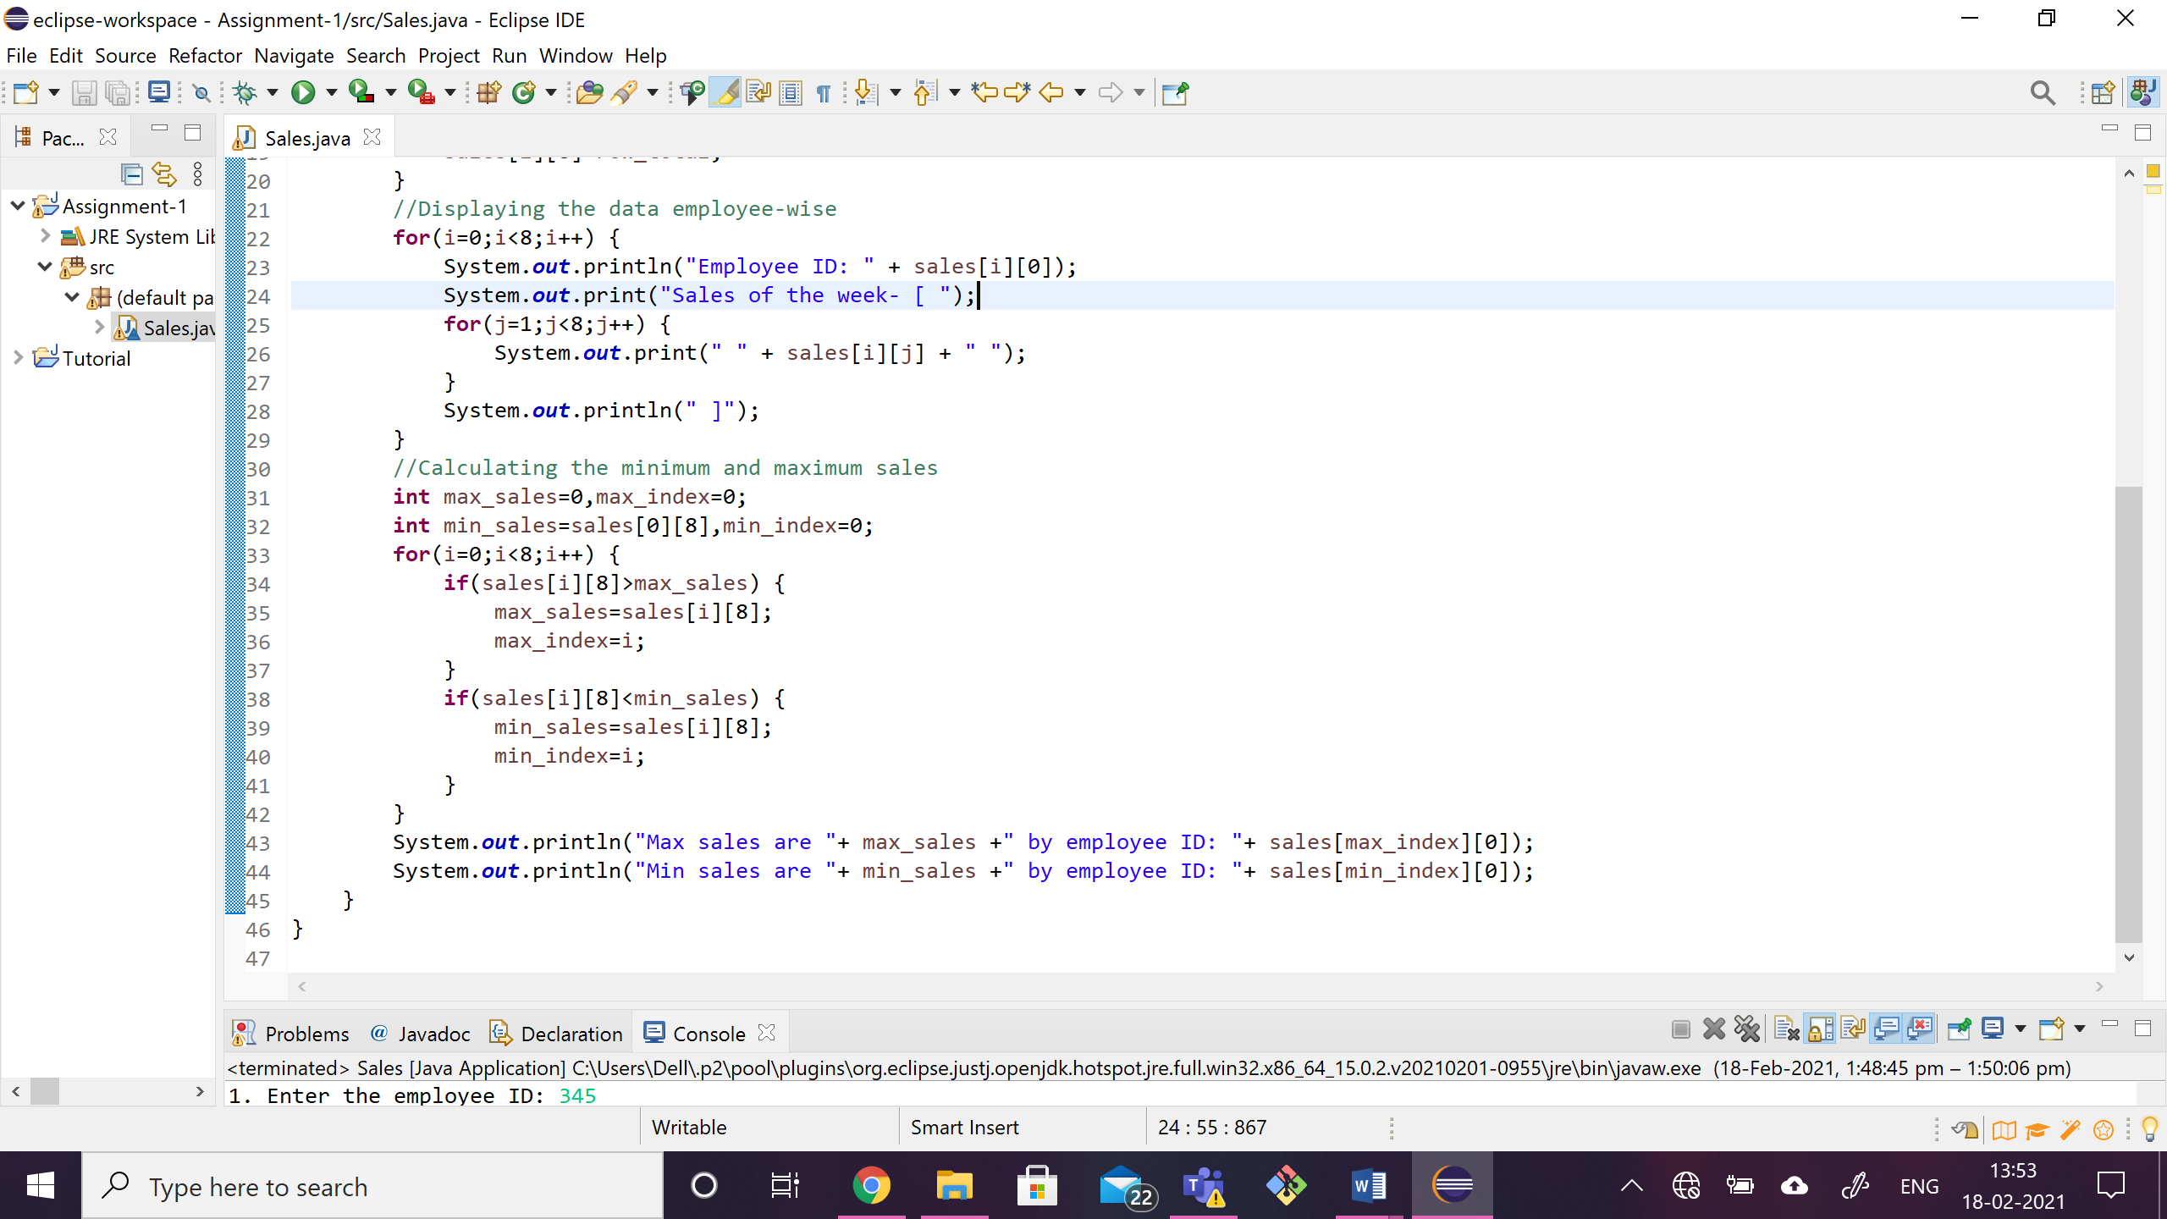

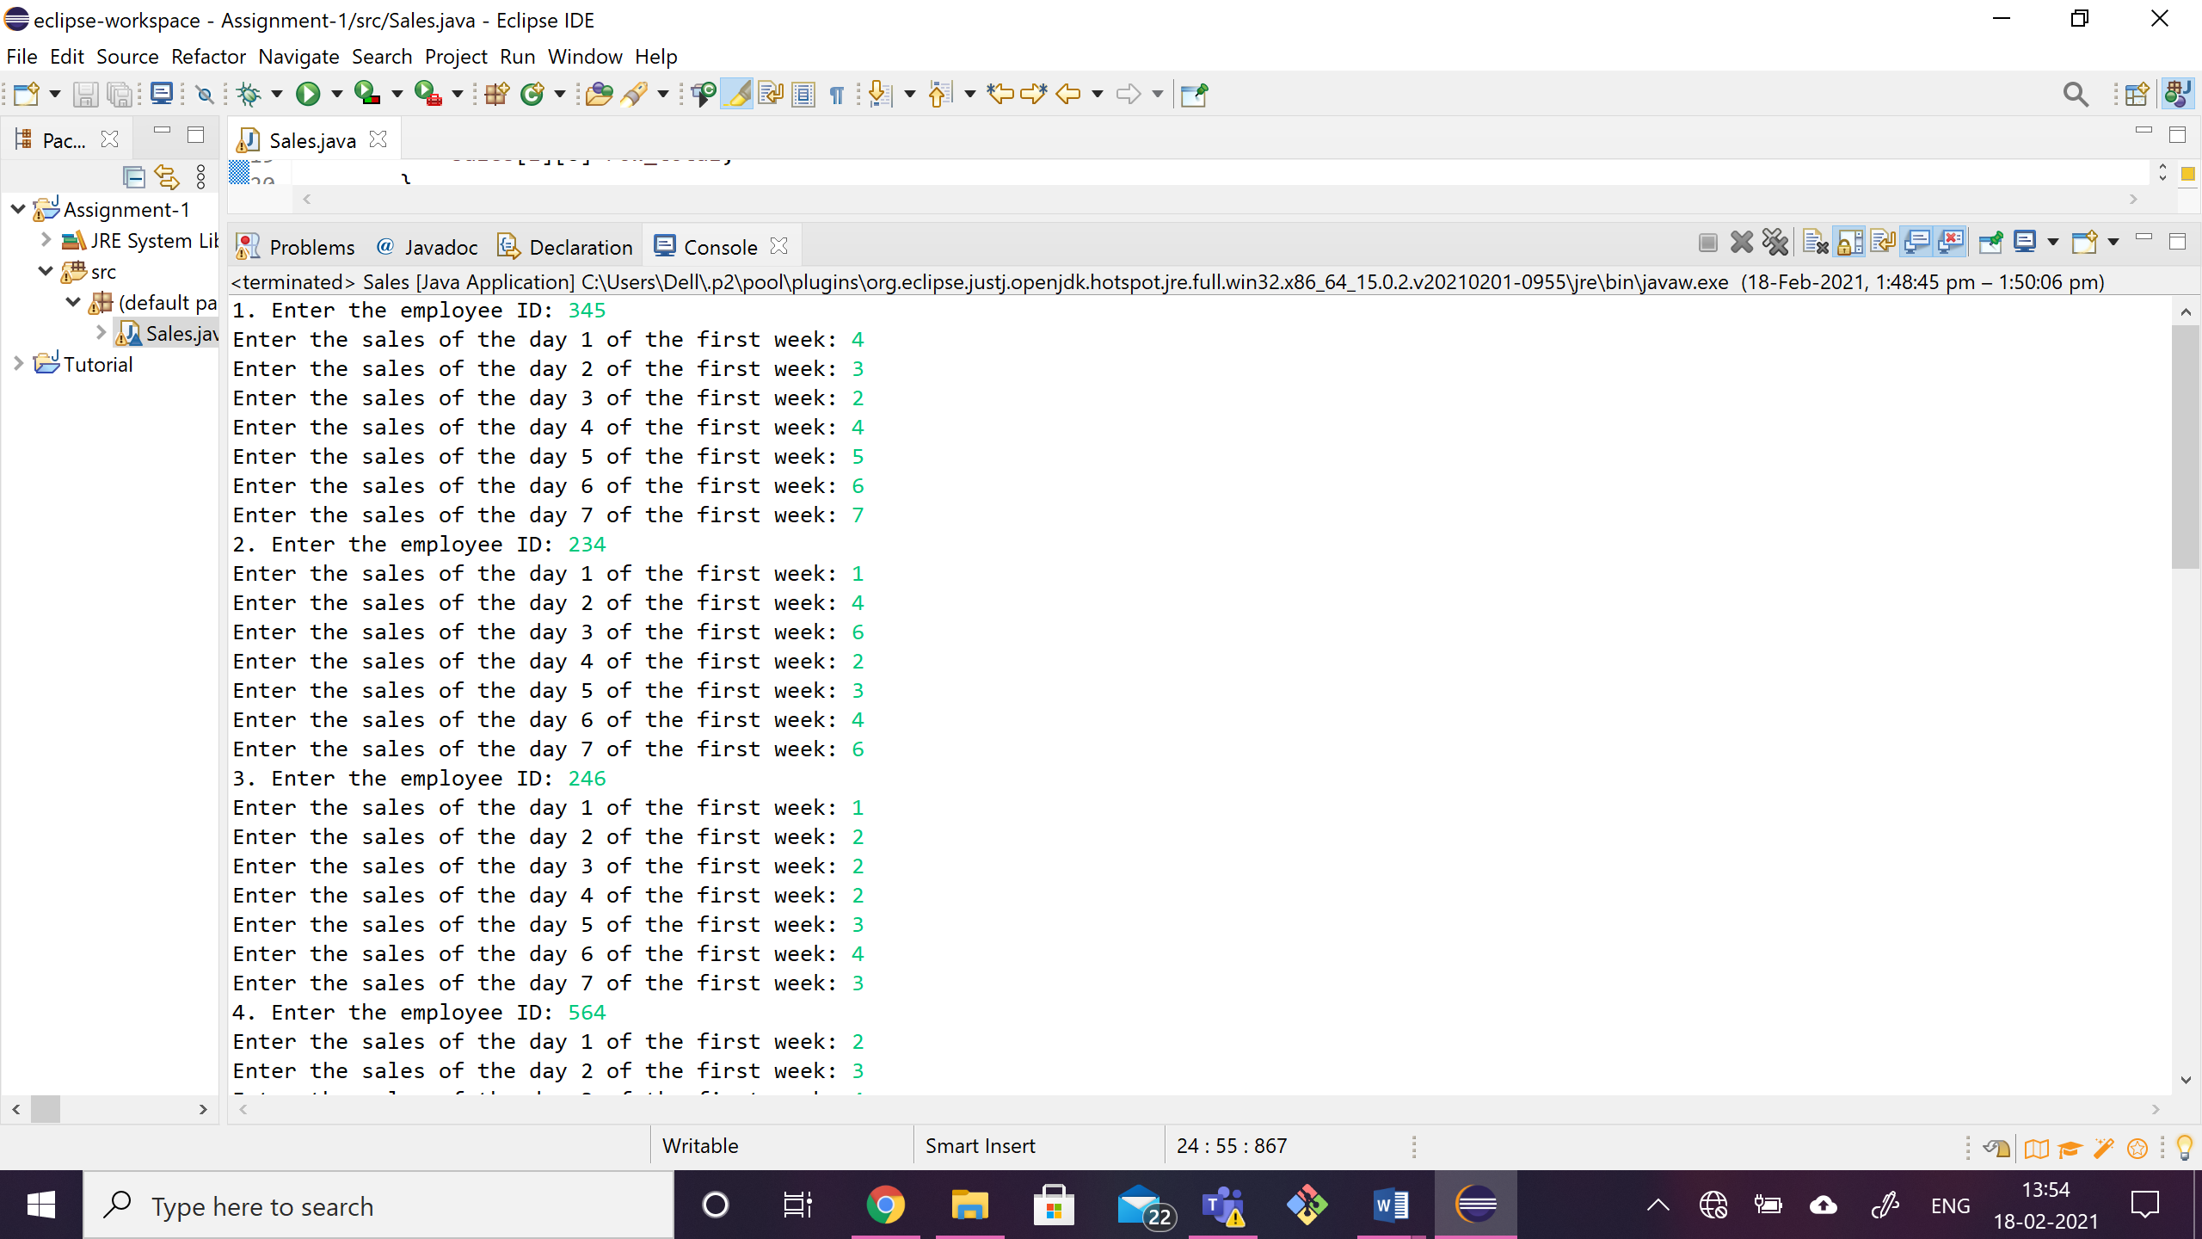

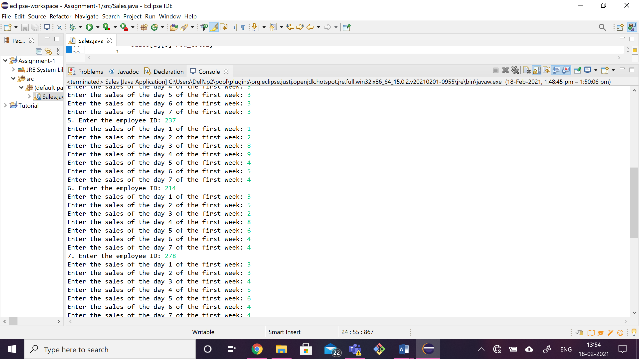

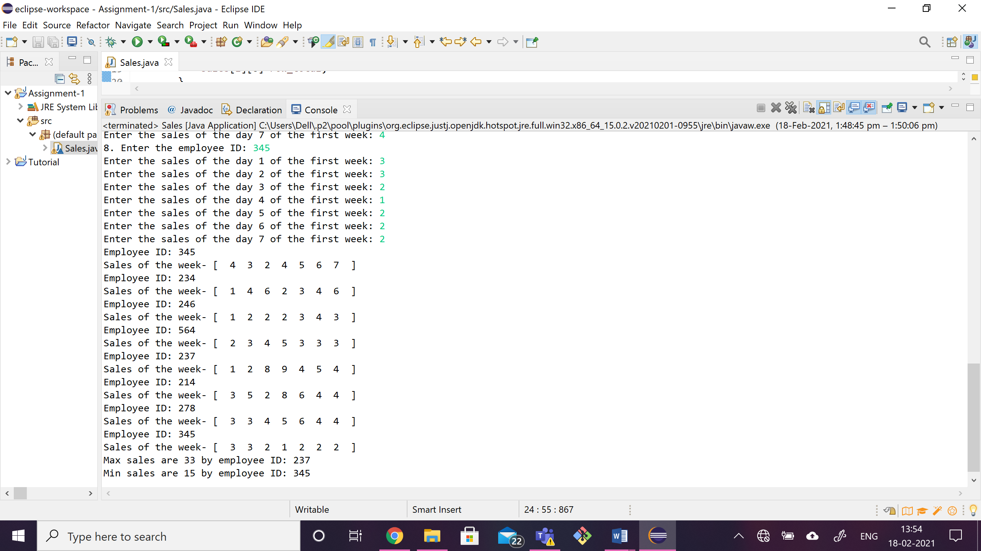

**QUESTION 2:**

**CODE:**

**class** Cricket {

**static** **double** addscore() {

**int** min=0,max=110;

**return** (Math.*random*() * (max - min + 1)) + min;

}

**public** **static** **void** main(String[] args) {

**int**[] score_arr=**new** **int**[11];

**int** i=0;

String j="";

**for**(i=0;i<11;i++) {

score_arr[i] = (**int**)*addscore*();

}

**for**(i=0;i<11;i++) {

j=(score_arr[i]<=9) ? "bad" :

(score_arr[i]<=99) ? "good" :

"very good";

System.***out***.println("a["+i+"]: "+ j);

}

}

}

Console:

a[0]: bad

a[1]: good

a[2]: good

a[3]: good

a[4]: very good

a[5]: good

a[6]: good

a[7]: good

a[8]: good

a[9]: good

a[10]: bad

SNAPSHOT:

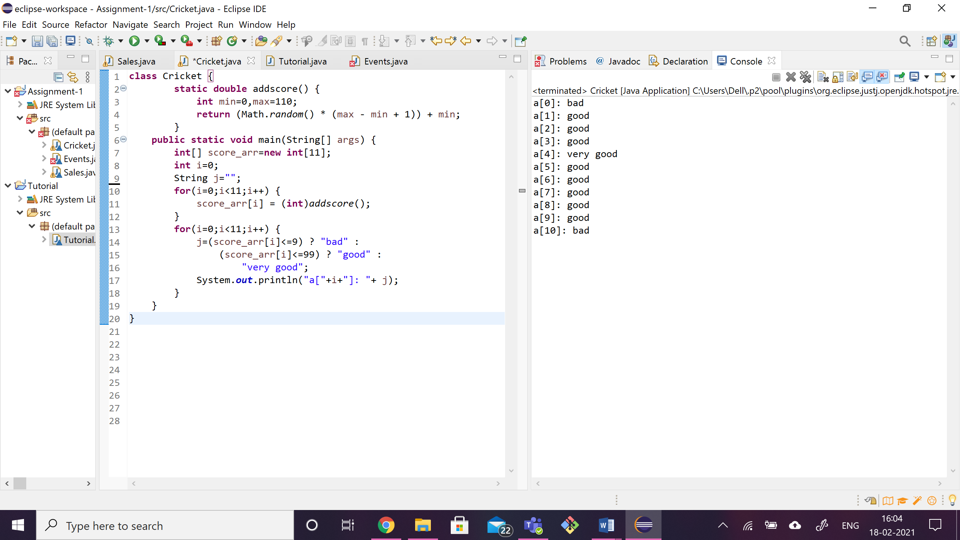

QUESTION 3:

CODE:

**import** java.util.Scanner;

**class** Events{

**static** **int** *i*=0,*count*=0;

**static** String[] *event_1*=**new** String [5];

**static** String[] *event_2*=**new** String [5];

**static** String[] *event_3*=**new** String [5];

**static** **int** search_1(String regno) {

**int** c=0;

**for**(*i*=0;*i*<5;*i*++) {

**if**(regno.equalsIgnoreCase(*event_1*[*i*])) {

c=1;

}

} **return** c;

}

**static** **int** search_2(String regno) {

**int** c=0;

**for**(*i*=0;*i*<5;*i*++) {

**if**(regno.equalsIgnoreCase(*event_2*[*i*])) {

c=1;

}

}

**return** c;

}

**static** **int** search_3(String regno) {

**int** c=0;

**for**(*i*=0;*i*<5;*i*++) {

**if**(regno.equalsIgnoreCase(*event_3*[*i*])) {

c=1;

}

}

**return** c;

}

**static** **void** display() {

**for**(*i*=0;*i*<5;*i*++) {

System.***out***.println("Reg.No: "+ *event_1*[*i*]);

}

System.***out***.println();

**for**(*i*=0;*i*<5;*i*++) {

System.***out***.println("Reg.No: "+ *event_2*[*i*]);

}

System.***out***.println();

**for**(*i*=0;*i*<5;*i*++) {

System.***out***.println("Reg.No: "+ *event_3*[*i*]);

}

}

**public** **static** **void** main(String[] args) {

String ch,regno;

**int** e_1=0,e_2=0,e_3=0;

Scanner sc=**new** Scanner(System.***in***);

**do** {

System.***out***.println("Enter your choice");

System.***out***.println("\t 1.Robo vars \t 2.Pro-shows \t 3.Silent Disco \t 4.Exit");

ch=sc.next();

**switch**(ch) {

**case** "1":

System.***out***.print("Enter reg no : ");

regno=sc.next();

**if**((*search_2*(regno)+*search_3*(regno)<2)&&e_1<5) {

*event_1*[e_1++]=regno;

} **else** System.***out***.println("Sorry!"+regno+" can't register for more than 2 events");

**break**;

**case** "2":

System.***out***.print("Enter reg no : ");

regno=sc.next();

**if**((*search_1*(regno)+*search_3*(regno)<2)&&e_2<5) {

*event_2*[e_2++]=regno;

} **else** System.***out***.println("Sorry! "+regno+ " can't register for more than 2 events");

**break**;

**case** "3":

System.***out***.print("Enter reg no : ");

regno=sc.next();

**if**((*search_1*(regno)+*search_2*(regno)<2)&&e_3<5) {

*event_3*[e_3++]=regno;

} **else** System.***out***.println("Sorry! "+regno+ " can't register for more than 2 events");

**break**;

**case** "4":

*display*();

System.*exit*(0);

**break**;

**default**:

System.***out***.println("Only 3 events.Choose only among them!");

}

} **while** (**true**);

}

}

CONSOLE:

Enter your choice

1.Robo vars 2.Pro-shows 3.Silent Disco 4.Exit

1

Enter reg no : 19BCE0396

Enter your choice

1.Robo vars 2.Pro-shows 3.Silent Disco 4.Exit

2

Enter reg no : 19BCE0396

Enter your choice

1.Robo vars 2.Pro-shows 3.Silent Disco 4.Exit

3

Enter reg no : 19BCE0396

Sorry! 19BCE0396 can't register for more than 2 events

Enter your choice

1.Robo vars 2.Pro-shows 3.Silent Disco 4.Exit

1

Enter reg no : 19BCE0416

Enter your choice

1.Robo vars 2.Pro-shows 3.Silent Disco 4.Exit

3

Enter reg no : 19BCE0416

Enter your choice

1.Robo vars 2.Pro-shows 3.Silent Disco 4.Exit

2

Enter reg no : 19BCE0990

Enter your choice

1.Robo vars 2.Pro-shows 3.Silent Disco 4.Exit

1

Enter reg no : 19BCE0990

Enter your choice

1.Robo vars 2.Pro-shows 3.Silent Disco 4.Exit

3

Enter reg no : 19BCE0111

Enter your choice

1.Robo vars 2.Pro-shows 3.Silent Disco 4.Exit

2

Enter reg no : 19BCE0345

Enter your choice

1.Robo vars 2.Pro-shows 3.Silent Disco 4.Exit

1

Enter reg no : 19BCE0345

Enter your choice

1.Robo vars 2.Pro-shows 3.Silent Disco 4.Exit

2

Enter reg no : 19BCE0312

Enter your choice

1.Robo vars 2.Pro-shows 3.Silent Disco 4.Exit

3

Enter reg no : 19BCE0321

Enter your choice

1.Robo vars 2.Pro-shows 3.Silent Disco 4.Exit

2

Enter reg no : 19BCE0111

Enter your choice

1.Robo vars 2.Pro-shows 3.Silent Disco 4.Exit

1

Enter reg no : 19BCE0111

Sorry!19BCE0111 can't register for more than 2 events

Enter your choice

1.Robo vars 2.Pro-shows 3.Silent Disco 4.Exit

3

Enter reg no : 19BCE0998

Enter your choice

1.Robo vars 2.Pro-shows 3.Silent Disco 4.Exit

1

Enter reg no : 19BCE0333

Enter your choice

1.Robo vars 2.Pro-shows 3.Silent Disco 4.Exit

4

Reg.No: 19BCE0396

Reg.No: 19BCE0416

Reg.No: 19BCE0990

Reg.No: 19BCE0345

Reg.No: 19BCE0333

Reg.No: 19BCE0396

Reg.No: 19BCE0990

Reg.No: 19BCE0345

Reg.No: 19BCE0312

Reg.No: 19BCE0111

Reg.No: 19BCE0416

Reg.No: 19BCE0111

Reg.No: 19BCE0321

Reg.No: 19BCE0998

Reg.No: null

SNAPSHOTS:

