NAME: MOUNVI PODAPATI

REG.NO: 19BCE0396

COURSE CODE: CSE1007

FACULTY: DR.LOKESH KUMAR

TUTORIAL EXERCISE _ 12-02-2021

1. Write an application that declares a class named Person. It should have instance variable to record Name, Age and Salary. These should be of types String, int and double/Float. Use the new operator to create a Person object. Set and display its instances for 5 persons in the main class by invoking the method called persondisplay( ).

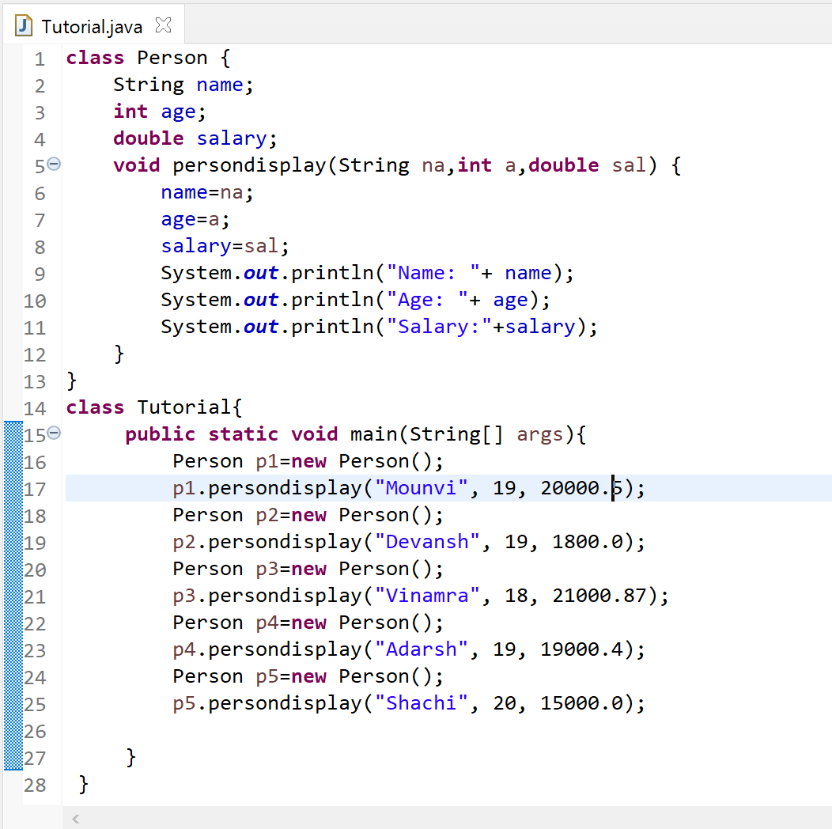

OUTPUT:

