**WEEK - 5**

**Microservices**

**Creating Microservices for account and loan.**

**Package name: com.cognizant.account.model**

**File name: Account.java**

package com.cognizant.account.model;

public class Account {

private String number;

private String type;

private double balance;

public Account() {}

public Account(String number, String type, double balance) {

this.number = number;

this.type = type;

this.balance = balance;

}

public String getNumber() {

return number;

}

public void setNumber(String number) {

this.number = number;

}

public String getType() {

return type;

}

public void setType(String type) {

this.type = type;

}

public double getBalance() {

return balance;

}

public void setBalance(double balance) {

this.balance = balance;

}

}

**Package name: com.cognizant.account.controller**

**File name: AccountController.java**

package com.cognizant.account.controller;

import org.springframework.web.bind.annotation.GetMapping;

import org.springframework.web.bind.annotation.PathVariable;

import org.springframework.web.bind.annotation.RestController;

import com.cognizant.account.model.Account;

@RestController

public class AccountController {

@GetMapping("/accounts/{number}")

public Account getAccountDetails(@PathVariable String number) {

return new Account(number, "savings", 234343.0);

}

}

**Package name: com.cognizant.account**

**File name: AccountApplication.java**

package com.cognizant.account;

import org.springframework.boot.SpringApplication;

import org.springframework.boot.autoconfigure.SpringBootApplication;

@SpringBootApplication

public class AccountApplication {

public static void main(String[] args) {

System.out.println("Starting Account Microservice ");

SpringApplication.run(AccountApplication.class, args);

System.out.println("Account Service Ready on Port 8080 ");

}

}

**Package name: com.cognizant.account**

**File name: application.properties**

server.port=8080

spring.application.name=account-service

**Package name: com.cognizant.loan.model**

**File name: Loan.java**

package com.cognizant.loan.model;

public class Loan {

private String number;

private String type;

private double loan;

private double emi;

private int tenure;

public Loan() {}

public Loan(String number, String type, double loan, double emi, int tenure) {

this.number = number;

this.type = type;

this.loan = loan;

this.emi = emi;

this.tenure = tenure;

}

public String getNumber() {

return number;

}

public void setNumber(String number) {

this.number = number;

}

public String getType() {

return type;

}

public void setType(String type) {

this.type = type;

}

public double getLoan() {

return loan;

}

public void setLoan(double loan) {

this.loan = loan;

}

public double getEmi() {

return emi;

}

public void setEmi(double emi) {

this.emi = emi;

}

public int getTenure() {

return tenure;

}

public void setTenure(int tenure) {

this.tenure = tenure;

}

}

**Package name: com.cognizant.loan.controller**

**File name: LoanController.java**

package com.cognizant.loan.controller;

import org.springframework.web.bind.annotation.GetMapping;

import org.springframework.web.bind.annotation.PathVariable;

import org.springframework.web.bind.annotation.RestController;

import com.cognizant.loan.model.Loan;

@RestController

public class LoanController {

@GetMapping("/loans/{number}")

public Loan getLoanDetails(@PathVariable String number) {

return new Loan(number, "car", 400000.0, 3258.0, 18);

}

}

**Package name: com.cognizant.loan**

**File name: LoanApplication.java**

package com.cognizant.loan;

import org.springframework.boot.SpringApplication;

import org.springframework.boot.autoconfigure.SpringBootApplication;

@SpringBootApplication

public class LoanApplication {

public static void main(String[] args) {

System.out.println("Starting Loan Microservice");

SpringApplication.run(LoanApplication.class, args);

System.out.println("Loan Service Ready on Port 8081");

}

}

**Package name: com.cognizant.loan**

**File name: application.properties**

server.port=8081

spring.application.name=loan-service

**OUTPUT:**

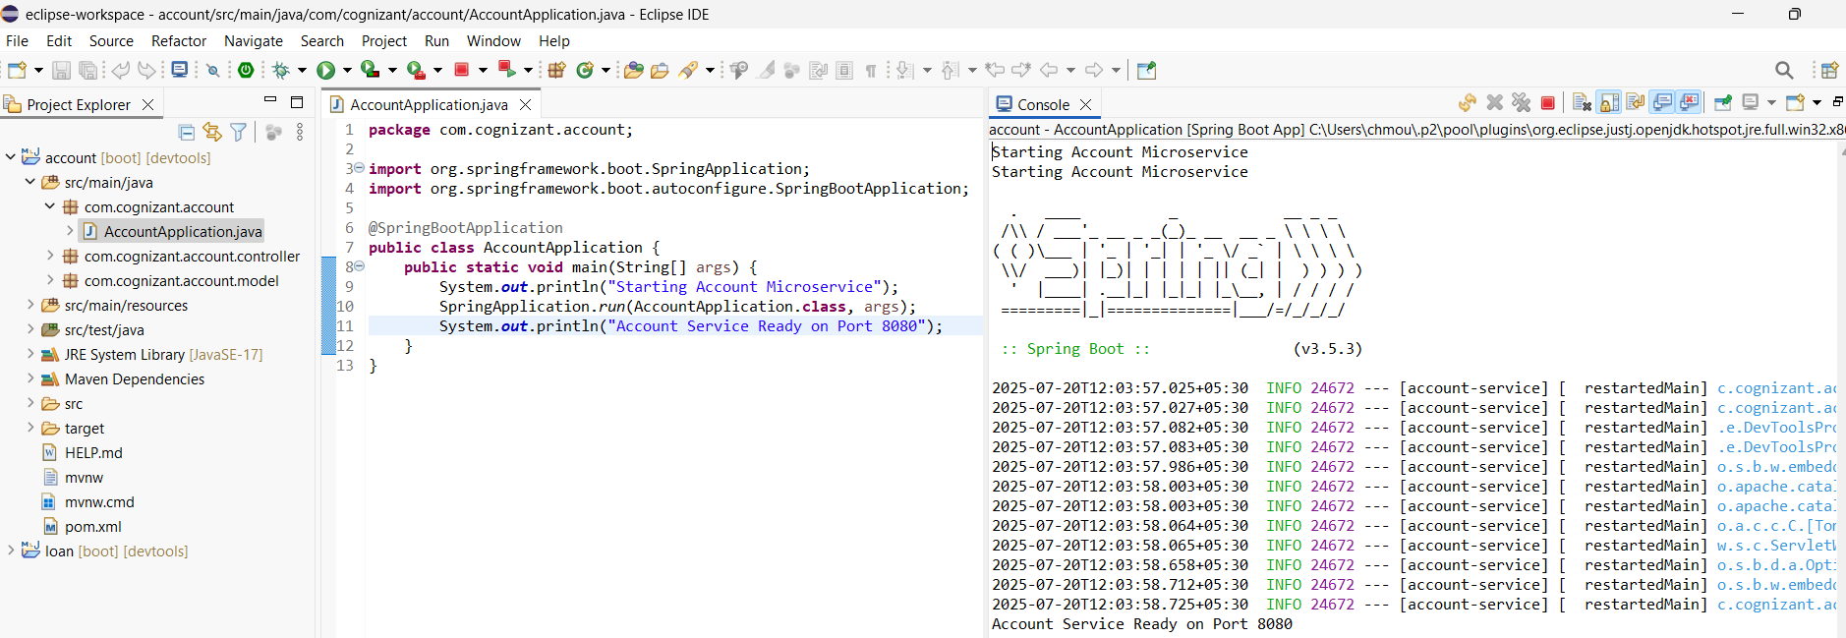

**In postman:**

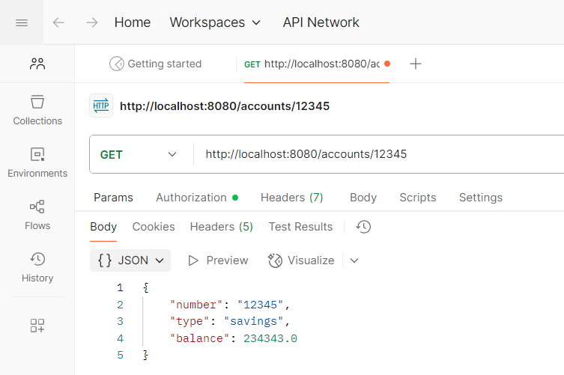

**In Browser:**

