**WEEK- 6**

**REACT**

1. **Create a new React Application with the name “myfirstreact”, Run the application to print “welcome to the first session of React” as heading of that page.**

**File name: App.js**

export default function App() {

return <h1>Welcome the first session of react</h1>;

}

**File name:index.js**

import React from 'react';

import ReactDOM from 'react-dom/client';

import './index.css';

import App from './App';

const root = ReactDOM.createRoot(document.getElementById('root'));

root.render(

<React.StrictMode>

<App />

</React.StrictMode>

);

**OUTPUT:**

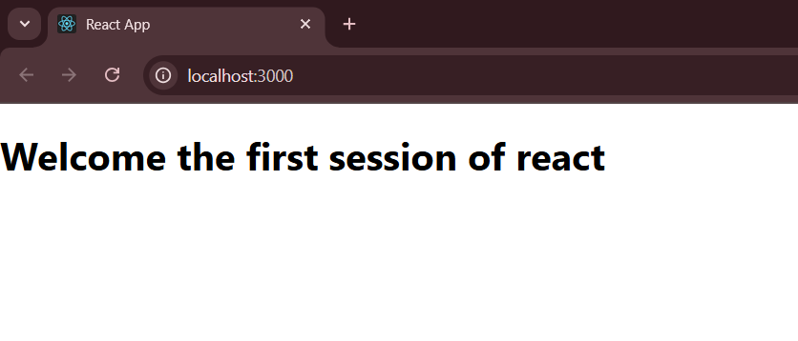

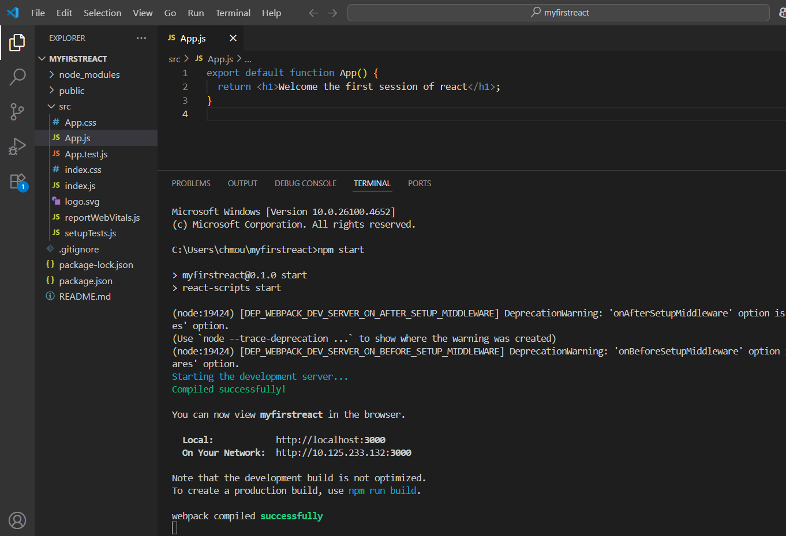

1. **Create a react app for Student Management Portal named StudentApp and create a component named Home which will display the Message “Welcome to the Home page of Student Management Portal”. Create another component named About and display the Message “Welcome to the About page of the Student Management Portal”. Create a third component named Contact and display the Message “Welcome to the Contact page of the Student Management Portal”. Call all the three components.**

**File name:src/Components/Home.js**

import React, { Component } from "react";

class Home extends Component {

render() {

return (

<div>

<h3>Welcome to the Home Page of Student Management Portal</h3>

</div>

);

}

}

export default Home;

**File name:src/Contact.js**

import React, { Component } from "react";

class Contact extends Component {

render() {

return (

<div>

<h3>Welcome to the Contact Page of Student Management Portal</h3>

</div>

);

}

}

export default Contact;

**File name:src/About.js**

import React, { Component } from "react";

class About extends Component {

render() {

return (

<div>

<h3>Welcome to the About Page of Student Management Portal</h3>

</div>

);

}

}

export default About;

**File name:src/App.js**

import logo from "./logo.svg";

import "./App.css";

import Home from "./Components/Home";

import About from "./About";

import Contact from "./Contact";

function App() {

return (

<div className="container">

<Home />

<About />

<Contact />

</div>

);

}

export default App;

**File name:src/index.js**

import React from 'react';

import ReactDOM from 'react-dom/client';

import './index.css';

import App from './App';

const root = ReactDOM.createRoot(document.getElementById('root'));

root.render(

<React.StrictMode>

<App />

</React.StrictMode>

);

**OUTPUT:**

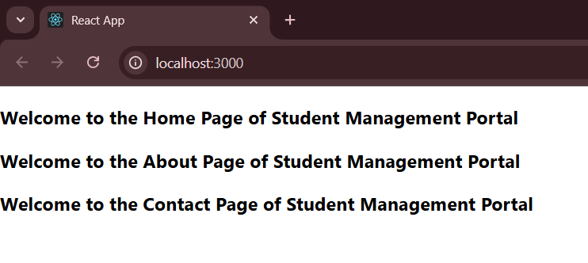

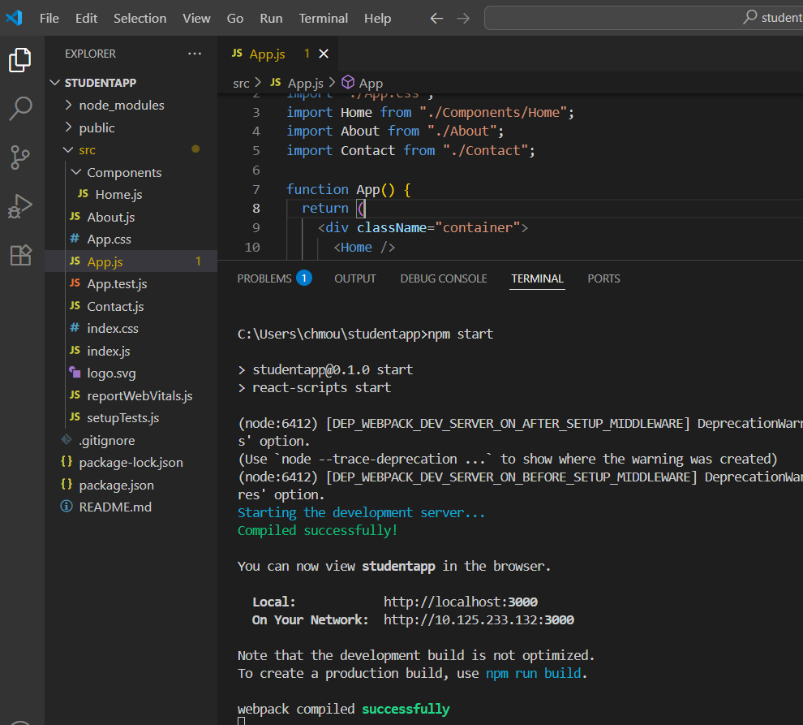

1. **Create a react app for Student Management Portal named scorecalculatorapp and create a function component named “CalculateScore” which will accept Name, School, Total and goal in order to calculate the average score of a student and display the same.**

**File name:src/components/CalculateScore.js**

import React from "react";

import "../stylesheets/mystyle.css";

const percentToDecimal = (decimal) => {

return decimal.toFixed(2) + "%";

};

const calcScore = (total, goal) => {

return percentToDecimal(total / goal);

};

export const CalculateScore = ({ Name, School, total, goal }) => {

return (

<div className="formstyle">

<h1>

<font color="brown">Student Details:</font>

</h1>

<div className="Name">

<b>

<span>Name: </span>

</b>

<span>{Name}</span>

</div>

<div className="School">

<b>

<span>School: </span>

</b>

<span>{School}</span>

</div>

<div className="Total">

<b>

<span>Total: </span>

</b>

<span>{total}</span>

<span>Marks</span>

</div>

<div className="Score">

<b>Score:</b>

<span>{calcScore(total, goal)}</span>

</div>

</div>

);

};

**File name:src/stylesheets/mystyle.css**

.Name {

font-weight: 300;

color: blue;

}

.School {

color: crimson;

}

.Total {

color: darkmagenta;

}

.formstyle {

text-align: center;

font-size: large;

}

.Score {

color: forestgreen;

}

**File name:src/App.js**

import { CalculateScore } from "./components/CalculateScore";

function App() {

return (

<div>

<CalculateScore

Name={"Steeve"}

School={"DNV Public School"}

total={284}

goal={3}

/>

</div>

);

}

export default App;

**OUTPUT:**

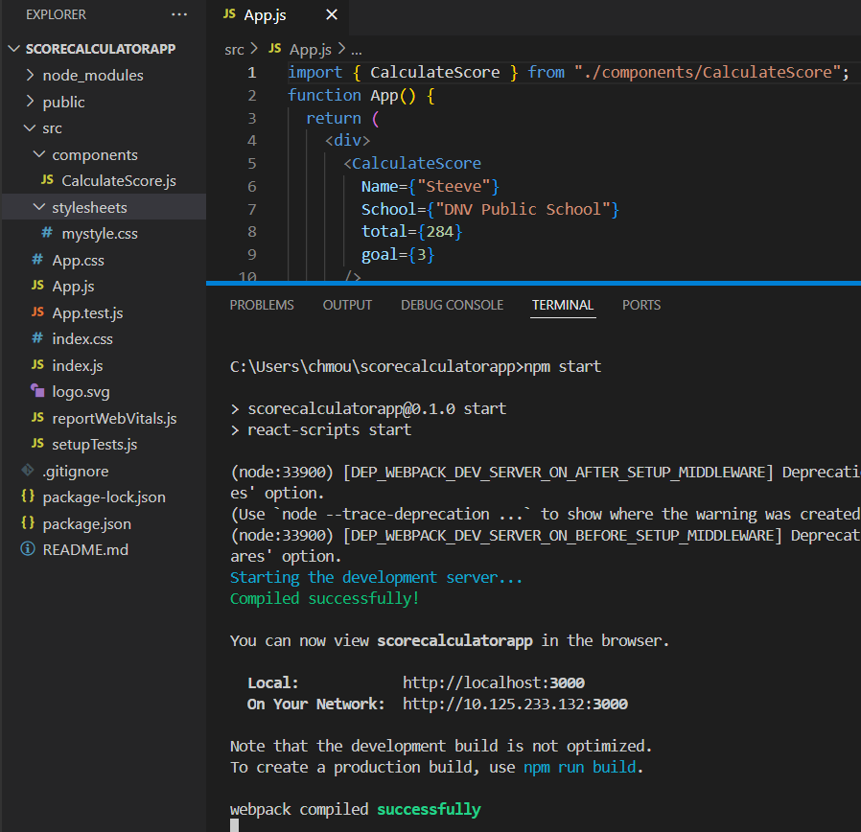

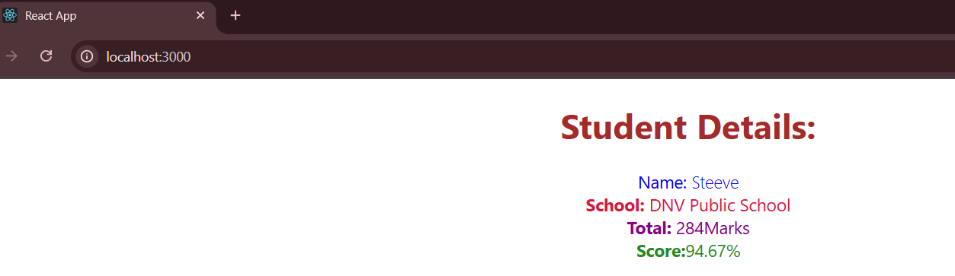

1. **Create a new react application using *create-react-app* tool with the name as “blogapp”.**

**File name:src/Post.js**

class Post {

constructor(id, title, body) {

this.id = id;

this.title = title;

this.body = body;

}

}

export default Post;

**File name:src/Posts.js**

import React from "react";

class Posts extends React.Component {

constructor(props) {

super(props);

this.state = {

posts: [],

};

}

loadPosts() {

fetch("https://jsonplaceholder.typicode.com/posts")

.then((response) => response.json())

.then((data) => {

this.setState({ posts: data });

})

.catch((error) => {

console.error("Error fetching posts:", error);

});

}

componentDidMount() {

this.loadPosts();

}

render() {

return (

<div>

<h1>Posts</h1>

{this.state.posts.map((post) => (

<div

key={post.id}

style={{

marginBottom: "20px",

padding: "10px",

border: "1px solid #ddd",

}}

>

<h2>{post.title}</h2>

<p>{post.body}</p>

</div>

))}

</div>

);

}

componentDidCatch(error, info) {

console.error("Component caught an error:", error, info);

alert("An error occurred in the Posts component");

}

}

export default Posts;

**File name:src/App.js**

import React from "react";

import Posts from "./Posts";

import "./App.css";

function App() {

return (

<div className="App">

<Posts />

</div>

);

}export default App;

**OUTPUT:**

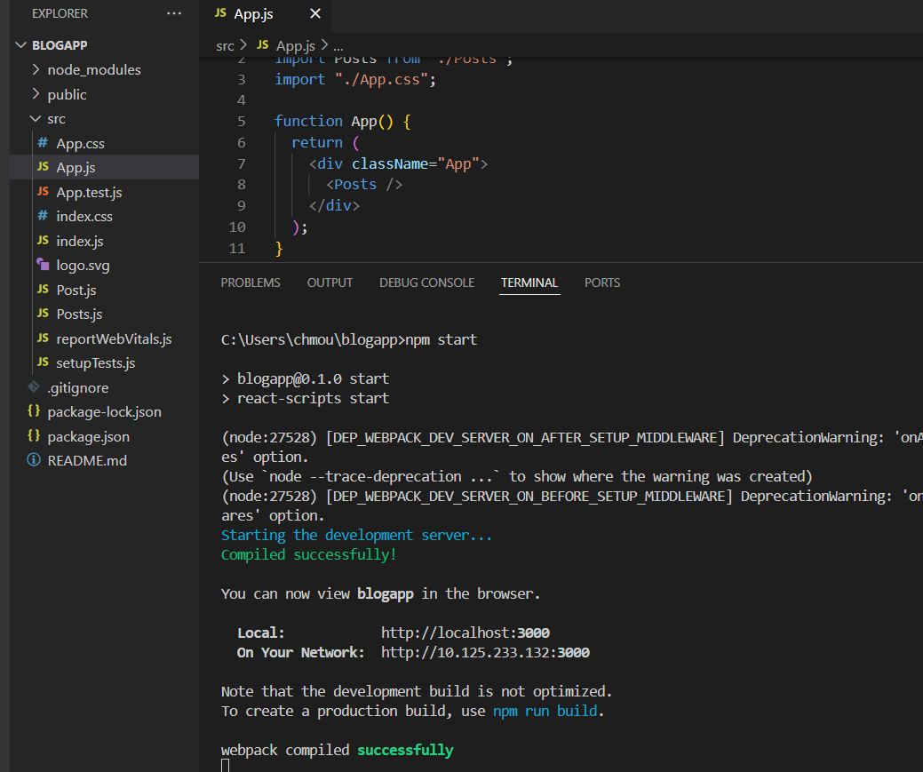

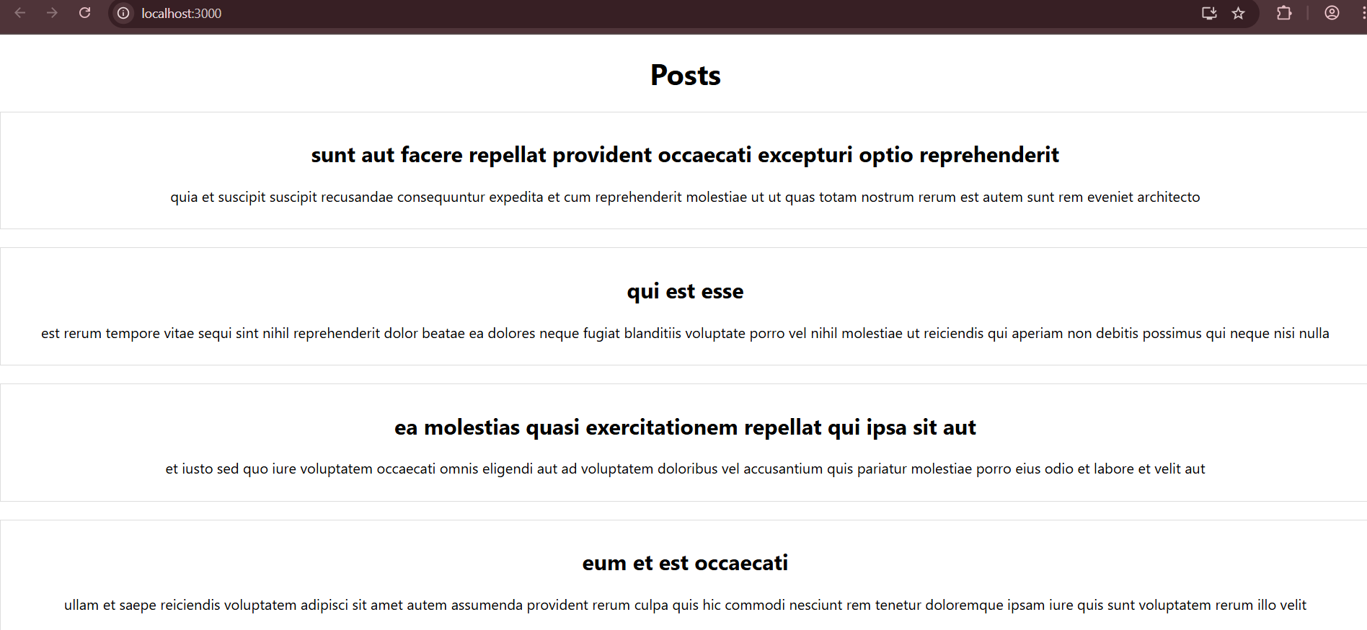

1. **My Academy team at Cognizant want to create a dashboard containing the details of ongoing and completed cohorts. A react application is created which displays the detail of the cohorts using react component. You are assigned the task of styling these react components.**

**File name:CohortDeatils.js**

import React from "react";

import styles from "./CohortDetails.module.css";

function CohortDetails(props) {

const { name, startedOn, status, coach, trainer } = props;

return (

<div className={styles.box}>

<h3 className={status === "Ongoing" ? styles.green : styles.blue}>

{name}

</h3>

<dl>

<dt>Started On</dt>

<dd>{startedOn}</dd>

<dt>Current Status</dt>

<dd>{status}</dd>

<dt>Coach</dt>

<dd>{coach}</dd>

<dt>Trainer</dt>

<dd>{trainer}</dd>

</dl>

</div>

);

}

export default CohortDetails;

**File name:CohortDetails.module.css**

.box {

width: 300px;

display: inline-block;

margin: 10px;

padding: 10px 20px;

border: 1px solid black;

border-radius: 10px;

}

dt {

font-weight: 500;

}

.green {

color: green;

}

.blue {

color: blue;

}

**File name: App.js**

import React from "react";

import CohortDetails from "./CohortDetails";

function App() {

return (

<div>

<CohortDetails

name="INTADMD F10 - .NET FSD"

startedOn="22-Feb-2022"

status="Scheduled"

coach="Aathma"

trainer="Jojo Jose"

/>

<CohortDetails

name="ADM21JF014 - Java FSD"

startedOn="10-Sep-2021"

status="Ongoing"

coach="Apoorv"

trainer="Eliza Smith"

/>

<CohortDetails

name="CDBJF21025 - Java FSD"

startedOn="24-Dec-2021"

status="Ongoing"

coach="Aathma"

trainer="John Doe"

/>

</div>

);

}

export default App;

