AssistX-AI Powered Voice and Gesture Controlled Cursor
K. Durga Kalyani¹, Chidurala Mounya Sai², Pulimamidi Navya², Boddepalli Sravan Kumar²

¹ Assistant Professor of CSE, Geethanjali College of Engineering & Technology, Hyderabad, TS, India.
² Students, Department of CSE, Geethanjali College of Engineering & Technology, Hyderabad, TS, India

ABSTRACT
Human–computer interaction has evolved rapidly with the advancement of artificial intelligence and computer vision technologies. Conventional computer interaction mainly relies on hardware devices such as a keyboard and mouse, which may not always be convenient, especially for elderly users or people with physical limitations. Because of these challenges, researchers have been exploring alternative interaction methods that allow users to communicate with computers in a more natural and flexible way.
In this work, we present AssistX, a multimodal human–computer interaction system that combines hand gesture recognition and voice commands to control a computer interface. The system uses a standard webcam to detect hand gestures and a microphone to receive voice instructions, eliminating the need for specialized or expensive hardware. By integrating computer vision with speech recognition techniques, the proposed system offers a simple, touch-free, and user-friendly approach for interacting with computers.
Keywords
Human–Computer Interaction, Gesture Recognition, Voice Commands, Computer Vision, Speech Recognition, Multimodal Interface, Virtual Mouse.
- INTRODUCTION
Human–Computer Interaction (HCI) plays a key role in modern computing systems. Most computers are still controlled using traditional devices such as keyboards, mice, and touchpads. However, these devices may not always be convenient, especially for elderly users, people with physical disabilities, or in situations where touching hardware is not practical. With the development of artificial intelligence and computer vision, new interaction methods have emerged that allow users to control computers in a more natural way. One such method is gesture recognition, where hand movements captured by a camera are interpreted as commands to perform actions on the computer [7][8].
Many researchers have worked on virtual mouse systems that use cameras to detect hand gestures and convert them into operations such as clicking, scrolling, and dragging. Although these systems improve user interaction, some of them require special hardware like depth-sensing cameras, which increases the overall cost and makes the system more complex to implement [1][3][4][5].
Another important development in HCI is voice-based interaction using intelligent assistants. Voice commands allow users to operate computers using simple spoken instructions, which can be very useful for elderly users and individuals with disabilities. Recent research therefore focuses on multimodal interaction, where different input methods such as gestures and voice are combined to improve usability and flexibility. Based on this concept, the proposed system AssistX integrates both gesture recognition and voice commands to create an easy, touch-free way of controlling a computer using commonly available devices like a webcam and microphone [2][6][7][8].
- RELATED WORK
Table 1: Recent Research Papers on Gesture and Voice-Based Cursor Control Technique
Year | Authors | Title | Methodology | Limitations
2025 | Chunling Yu | Gesture Recognition with YOLOv5 | Deep learning object detection | High computational requirements
2024 | Bokolo Anthony | AI Voice Assistants for Mobility | Voice interaction systems | Limited gesture integration
2024 | Birkeland et al | Thermal Gesture Recognition using CNN | Thermal camera and CNN model | Thermal cameras are costly
2023 | Todericiu | Virtual Assistants Review | Overview of voice-based AI assistants | Limited multimodal capability
2020 | Vojtech et al | Head-Tilt and EMG Cursor Control | Head movement and EMG signals | Needs specialized sensors
2020 | Tran et al | Real-Time Virtual Mouse System Using RGB-D Images | Fingertip detection using depth cameras | Requires expensive RGB-D sensors

- PROPOSED METHOD
The proposed system introduces a multimodal human–computer interaction approach that allows users to control a computer using hand gestures and voice commands. Traditional input devices such as a mouse and keyboard are commonly used, but they may not always be suitable for everyone, especially for people with mobility difficulties or in situations where touch-free interaction is preferred. To overcome these limitations, the system combines computer vision and speech recognition technologies to create a more natural and convenient way of interacting with a computer.In this system, a webcam is used to capture and detect hand gestures, while a microphone records voice commands given by the user. Image processing techniques analyze the hand movements and translate them into cursor actions such as movement, clicking, and scrolling. At the same time, speech recognition processes the spoken instructions and converts them into system commands. By integrating both gesture and voice inputs, the system enables users to perform tasks like moving the cursor, clicking, scrolling, and opening applications
without relying on traditional hardware devices, thereby improving accessibility and overall user experience.
3.1 System Workflow
3.1.1 User Input
The system starts when the user interacts with the computer using hand gestures or voice commands. A webcam captures the user's hand movements in real time, while a microphone records spoken commands such as “click”, “scroll”, or “open”. These inputs are then sent to the system for further processing.
3.1.2 Pre-Processing
Before recognizing the commands, the captured data is prepared for analysis. For visual input, the webcam continuously collects image frames, which are resized and filtered to remove noise and improve clarity. The system then detects the hand region to focus on gesture recognition. For audio input, the microphone captures voice signals, reduces background noise, and extracts important speech features required for identifying commands.
3.1.3 Gesture Recognition
The system analyzes hand movements using computer vision techniques. Hand landmarks are detected using models such as MediaPipe, which identify key points on the hand. By tracking fingertip positions and movement patterns, the system recognizes different gestures and converts them into actions like cursor movement, left click, right click, and scrolling.
3.1.4 Voice Command Recognition
Voice commands are processed using speech recognition technology. The recorded audio is converted into text, and the system identifies specific instructions such as click, scroll, open browser, or close window. Each recognized command is then linked to the appropriate system operation.
3.1.5 Multimodal Integration
The system combines both gesture and voice inputs into a single control mechanism. Hand gestures mainly control cursor movement and basic mouse actions, while voice commands are used for higher-level operations such as opening applications. The system also checks and manages inputs carefully to prevent conflicts between gesture and voice commands.
3.1.6 Cursor Control and System Action
Once the inputs are interpreted, the system performs the corresponding operations. It updates the cursor position, executes mouse actions like clicking, dragging, and scrolling, and performs tasks such as opening applications or executing commands based on the user’s voice input.
3.1.7 Continuous Learning and Improvement
The system is designed to improve over time. Using machine learning techniques, it adapts to different users and environments. Feedback from users also helps the system improve the accuracy of gesture recognition and voice command detection, making the interaction smoother and more reliable.
3.2 Testing and Evaluation
The system is tested under different users and environmental conditions to evaluate its performance. Key metrics include detection accuracy, which measures how correctly the system recognizes gestures and voice commands, response time, which indicates how quickly the system detects and executes commands, and user experience, which evaluates how easy and convenient the system is for users. The proposed system is also compared with existing approaches such as gesture-only systems, which rely only on camera-based hand gestures, and voice-only systems, which depend solely on speech commands. This comparison helps demonstrate the advantages of the multimodal approach in improving usability and interaction efficiency.
3.3 Challenges
During system testing, a few limitations were identified. Lighting conditions play an important role in gesture recognition, and poor or uneven lighting can reduce the accuracy of detecting hand movements. Background noise in the environment may interfere with the speech recognition process, making it harder for the system to correctly understand voice commands. Additionally, variations among users, such as differences in hand size, gesture style, accents, or speaking patterns, can also affect the overall performance of the system.

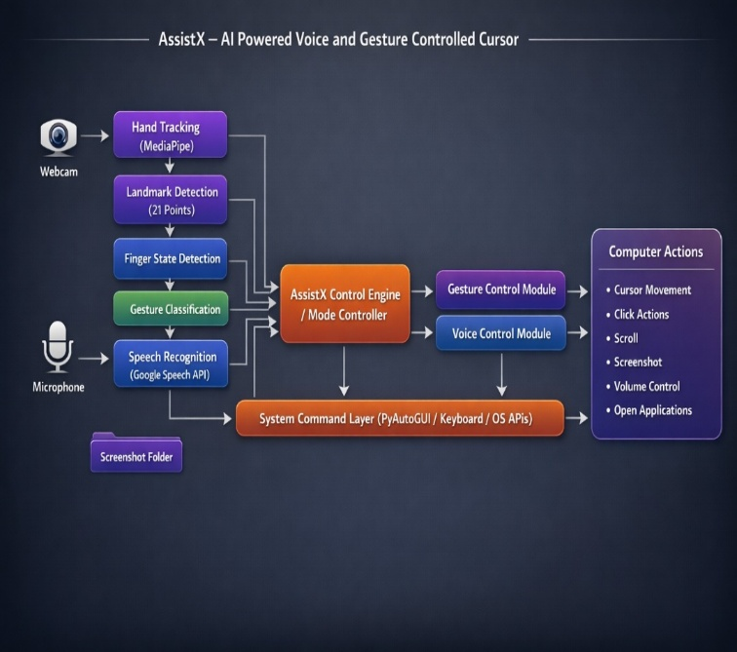
Figure 1: System Architecture
SpeechRecognition | Library | Voice command processing | SpeechRecognition converts spoken voice commands into text so the system can understand and execute actions.
Python | Programming Language | System development | Python is used to develop the system and integrate libraries for gesture and voice-based cursor
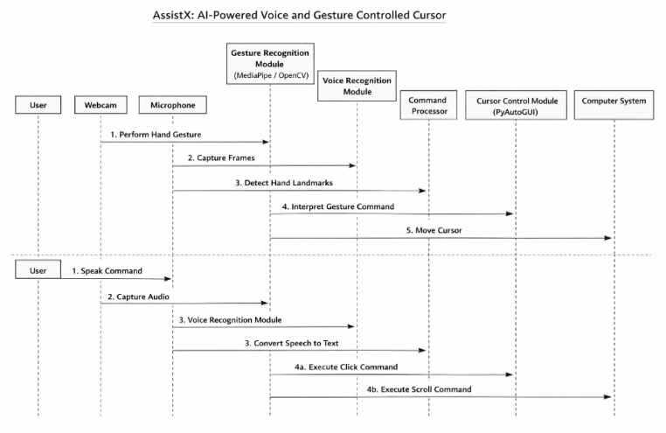

Figure 2: Process Sequence
- IMPLEMENTATION

Table 2: Proposed Work Using Libraries and Models
Component | Type | Purpose | Description
OpenCV | Library | Image processing and video capture | OpenCV is used to capture webcam video and process image frames for detecting and tracking hand gestures used to control the cursor.
MediaPipe | Framework | Hand landmark detection | MediaPipe uses pre-trained models to detect and track hand landmarks, helping recognize gestures for cursor control and actions.
PyAutoGUI | Library | Cursor control and automation | PyAutoGUI is used to control the mouse cursor and perform clicks based on gestures or voice commands.

Table 3: Module Analysis
MODULES | PURPOSE | DESCRIPTION
Gesture Detection | Identifies hand landmarks using MediaPipe | This module captures webcam frames and uses MediaPipe to detect hand landmarks, enabling real-time gesture recognition.
Cursor Control | Maps finger movements to cursor movement | After detecting hand landmarks, the index finger position is mapped to screen coordinates to move the cursor without touching the mouse.
Click Detection | Recognizes finger gestures for mouse clicks | Pinching the thumb and index finger is detected as a gesture and translated into mouse actions such as left-click / right-click.
Voice Command Recognition | Converts speech to commands | The microphone captures voice input, and the speech recognition module converts spoken words into text commands for system execution.

Command Execution | Performs system actions | Recognized gestures or voice commands are executed by the system using PyAutoGUI to perform actions like clicking, scrolling, and cursor control.
Table 4: Output Analysis
MODULES | PURPOSE | DESCRIPTION
Gesture Detection | Detects and tracks hand landmarks using MediaPipe and webcam input. | Hand landmark coordinates and gesture patterns identified from the video frames.
Cursor Control | Converts detected finger movements into cursor movement on the computer screen. | Smooth cursor movement that follows the user’s finger position.
Click Detection | Identifies specific finger gestures that represent mouse actions. | Mouse click events such as left click, right click, or double click executed on the system.
Voice Command Recognition | Captures and converts spoken commands into machine-readable text. | Recognized text commands such as “click”, “scroll”, or “open”.
Command Execution | Processes the recognized gesture or voice command and performs the required system action. | System operations performed such as cursor movement, clicking, scrolling, or executing commands.

- RESULTS AND DISCUSSION
The AssistX system showed effective performance in controlling the computer cursor using hand gestures when tested under normal lighting conditions. The gesture recognition module was able to track hand movements through the webcam and convert them into cursor actions. At the same time, the voice recognition module successfully interpreted spoken commands and executed the corresponding system operations. Because of this, users were able to interact with the computer without using traditional devices such as a mouse or keyboard.
Another important advantage of AssistX is its accessibility and flexibility. Users can control the system either through gestures or voice commands depending on their convenience. This multimodal interaction improves usability compared to systems that rely on only one method of input. The system also works with common hardware such as webcams and microphones, which reduces the cost and complexity of implementation. However, the system performance may slightly decrease in situations with poor lighting or high background noise. In the future, more advanced deep learning models can be used to improve gesture recognition accuracy and strengthen speech recognition in noisy environments.
- CONCLUSION
This research introduces AssistX, a multimodal human–computer interaction system that combines hand gesture recognition and voice commands to create a more natural way of interacting with computers. The system demonstrates how technologies such as artificial intelligence and computer vision can enable touch-free computer control, allowing users to perform actions using simple hand movements and spoken instructions.
Unlike many existing systems that require specialized sensors or expensive hardware, AssistX operates using commonly available devices like webcams and microphones. This makes the system practical, accessible, and cost-effective for everyday users. In future work, the system can be enhanced by using advanced deep learning techniques to improve gesture detection accuracy. Additional interaction methods such as facial expression recognition or eye-tracking could also be integrated to further expand the capabilities of the system.
7. REFERENCES
[1] D.-S. Tran, N.-H. Ho, H.-J. Yang, S.-H. Kim, and G.-S. Lee, “Real-Time Virtual Mouse System Using RGB-D Images and Fingertip Detection,” Multimedia Tools and Applications, 2020.
[2] J. M. Vojtech, S. Hablani, G. J. Cler, and C. E. Stepp, “Integrated Head-Tilt and Electromyographic Cursor Control,” Boston University, 2020.
[3] A. A. Argyros and M. I. A. Lourakis, “Vision-Based Interpretation of Hand Gestures for Remote Control of a Computer Mouse,” Springer, 2006.
[4] S. Birkeland, L. J. Fjeldvik, N. Noori, S. R. Yeduri, and L. R. Cenkeramaddi, “Thermal Video-Based Hand Gesture Recognition Using Lightweight CNN,” Journal of Ambient Intelligence and Humanized Computing, 2024.
[5] C. Yu, “Computer Interactive Gesture Recognition Model Based on Improved YOLOv5 Algorithm,” Springer, 2025.
[6] B. Anthony Jnr., “User-Centered AI-Based Voice Assistants for Safe Mobility of Older People in Urban Context,” AI & Society, 2024.
[7] I. A. Todericiu, “Virtual Assistants: A Review of the Next Frontier in AI Interaction,” Universal Access in the Information Society, 2023.
[8] I. A. Todericiu, “Multimodal Human–Computer Interaction Systems: Recent Trends and Challenges,” Springer, 2024.
[9] D. Afchar, V. Nozick, J. Yamagishi, and I. Echizen, “MesoNet: A Compact Facial Video Forgery Detection Network,” IEEE, 2019.
[10] B. Dolhansky et al., “The DeepFake Detection Challenge Dataset,” NeurIPS, 2020.
[11] P. Korshunov and S. Marcel, “DeepFake Detection Using Audio Visual Information,” IEEE Biometrics Conference, 2019.
[12] Z. Liu and W. Xu, “Audio Visual DeepFake Detection Using Multimodal Learning,” IEEE Transactions on Multimedia, 2021.
[13] H. Nguyen, F. Fang, J. Yamagishi, and I. Echizen, “Multi Task Learning for Detecting and Segmenting Manipulated Facial Images and Videos,” IEEE, 2019.
[14] Y. Li and S. Lyu, “Exposing DeepFake Videos by Detecting Face Warping Artifacts,” IEEE CVPR Workshop, 2018.
[15] T. Jung, S. Kim, and K. Kim, “DeepVision: Deepfake Detection Using Deep Learning Techniques,” IEEE Access, 2022.

