**CASE STUDY: HIRA GUEST HOUSE**

**Present state**

[Hira](http://hiraguesthouse.com/) is guest house in a beautiful, antique, 300 year old traditional Newari building in Patan, Lalitpur (Kathmandu) Nepal. We offer an authentic traditional Newari experience for our guests with western comforts and services. The business generates approximately 10 to 50 customers per month. The number is reasonable, but still not enough. The business is facing increased competition in its area without being able to boost its SEO on booking platforms. Hira would therefore like to see an increase in bookings in the next 90 days as a result of its marketing strategy in order to generate $5000-$10000 per month.

**Hira 90 Days Goals**

After 90 days, Hira would like to see an increase in bookings.

Our goal is what will define our marketing strategy. It should be SMART.

Hira needs to refine its goal as the current one is not tangible and measurable!

Similarly, we cannot clearly talk about an increase in bookings without knowing at which stage our business is at.

**Diagnosis**

**Business Stage**

Each business that exists is within one of the 4 stages mentioned below:

**Stage 1: Idea:-** At this stage the business is still an idea, might or might not have a product. It generally has little or no sales or customers.

**Stage 2: Product Market Fit:** At this stage the business has a reasonable number of customers that have bought and provided feedback about the product or service. The earnings per customer may be low, and so the business might not be very profitable.

**Stage 3: Scale:** At this stage the business has a more than reasonable earnings per customer that can justify further investment in marketing, like in pay per click marketing. It also would have a validated client journey.

**Stage 4: Expansion:** Should we be talking about this stage now?

**What is Hira Guest House Business Stage?**

According to the form that Hira Guest House filled out, we know that Hira already serves quite a few guests. The fact that many of them come back and use our services again and if we stick to the analysis of the feedback and reviews we get from these clients, we can deduce that Hira is no longer at stage 1 with its business. Stage 1: idea is therefore already discarded

“we get on average 10-50 guests per month”

Now we still need to determine at what stage Hira is among the remaining 3.  To do this, we will have to calculate Hira's earnings per customer.

**What is Hira earnings per customer?**

**Formula: EPC = Total Revenue / Total Number of Customers**

**Is our EPC low or high?**

Our EPC is high enough when the following conditions are met:

* We have at least two months of business expenses saved before investing in marketing.
* Our total marketing or lead-generation expenses should not exceed 10-15% of your total sales

From the list of clients we got from Hira Guest House, we know that from July to December 2019, Hira Guest House received 166 guests and obtained a total revenue of 7734.55.  From these data we can deduce that the earnings per customer of Hira Guest House is of:

**EPC=** 7734.55/166 = 46.5936747

Our Earnings per Customer is therefore 46.5936747.  Is this enough to justify further investments in marketing? Is this enough for us to scale our business and make it profitable?

Before answering these questions and finally being able to establish the stage in which Hira Guest House is positioned, we will analyze the expenses of Hira Guest House.  Hira Guest House did not provide us with any information about its current expenses. However, based on our personal investigations, we realize [that the variable commission rate of booking.com is 15% per booking](https://partner.booking.com/en-gb/help/commission-invoices-tax/how-much-commission-do-i-pay) we get on the website.  We will therefore use this rate as the basis for our Hira Guest House expenses calculation.

If we carry out a [monthly analysis of our expenses](https://docs.google.com/spreadsheets/d/1_H_i2cclKr_S-lMOvxL5OckEwHZUgOeDnG3JgF3SbN0/edit?usp=sharing), for example, we can conclude:

In July for example we got 4 customers from Booking.com for a revenue of $768.4. If we take 15% of each booking, the booking commission for July is $115.26.

Our revenue is therefore 768.4 - 115.26= 653.14

If 653.4 indeed covers the expense generated by our booking listing, is it enough to justify more investment in marketing and advertising?

If we keep 2 months of our July revenue via booking, our current amount is $345.78. This leaves us with $307.62 in revenue.

It is within this $307.62 that we have to pay wages, operating costs and other expenses. The expenses are more than 15% of our total revenue.

**Conclusion:** Our earnings per customer are low and can not justify further investments in Marketing. We need to improve it.  Hira Guest House is therefore positioning itself as per stage 2.

**STRATEGIES**

Following our diagnosis, we find out that our current challenge is our low earnings per customer. Our strategy will therefore be focused on increasing our earnings per customers

**Increase our earnings per customer**

**Step 1: Sell more**

In order for Hira to sell more, we're going to have to follow 3 steps:

-**Study and map out and make an analysis and review the complete client journey (funnel)**

**-Identify leaks and what's causing the leak**

**-Use 80/20 analysis to decide on which leaks to fix**

1. **Customer journey map**

If your earnings per lead are low, you are going to find it difficult to find the money you will use to pay for the ads.

**i) Study and optimize your sales journey (e.g., copy, offer, design etc)**

By analyzing the client list we got from Hira Guest House, we realize that the business has clients from several channels. The three most popular are:

OTA: Hira Guest House gets the most clients from its Booking.com listing.

Walk-in Guest: These are customers that come to Hira without a prior booking.

Direct Booking: these are people who have either called or sent an email to book or who have gone through our [website](http://hiraguesthouse.com/) to make a reservation.

**OTA Funnel**

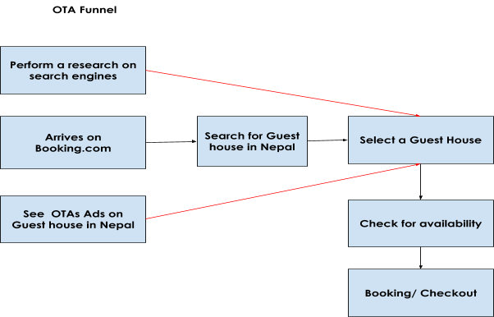

Here is how the OTA funnel looks like, a user can either perform a query on search engines and from there click on their offer. He or she will then have to select a house among different proposals, make sure the house is available before being able to make a reservation later on.

Alternatively, the guest can decide to go directly to the booking website or app and search for a guest house on the app or see an Ad from the OTAs and decide to click on it to make a booking.

These are the different channels that customers who book with us via booking, use. However, this funnel is static and we cannot control it as we are not the major players here. Everything is controlled by booking. So we can't optimize it.  That is why we have to go through the other two funnels through which we get customers.

**Walk-in Guest and direct Booking Funnel**

The challenge here is that we can't clearly identify how Hira gets these customers. Hira cannot identify the customer journey from the moment they decide they are looking for a Guest House to the moment they book from us. It is therefore impossible to retrieve a customer journey from these channels. However, we do get a large number of customers from these channels, so these funnels deserve to be considered and taken into account.

**ii) Identify Leaks and use 80/20 analysis**

Every business should go through 3 steps before it can sell:

* Traffic
* Conversion
* Close

If one of these points is lacking, the business growth potential is 0. We have to apply the 80/20 rule. 20 percent of our efforts produce 80 percent of our results. So we need to find where we will put our 20 percent effort.

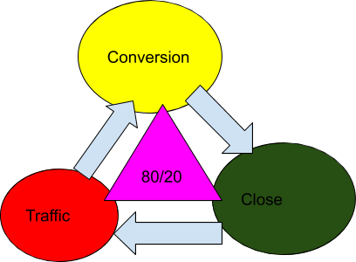

To apply this, we need to choose which part of our customer journey will provide the biggest impact with the highest ease of implementation.

The channel with our industry is that OTAs have already paid for most of the keywords and rank first for those. It therefore becomes difficult to generate direct traffic to our website.

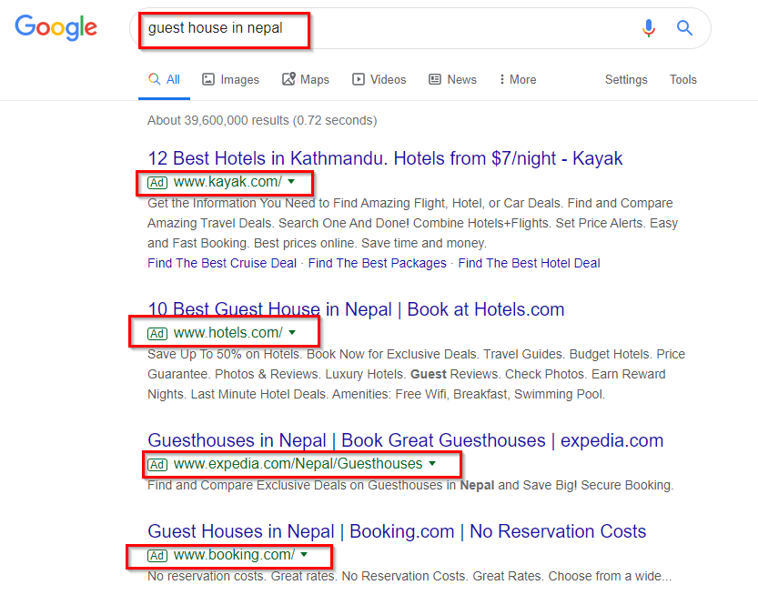

Investing 20% of our efforts to generate traffic would therefore not bring us 80% of the results we expect. Therefore, we should consider conversion and Close. The challenge with the conversion stage is that, Hira Guest House does not yet have a community to rely on and just needs to be encouraged. So we're left with the Close stage: is there an affordable way to reach our target customers?  Yes

[**Customer list**](https://docs.google.com/spreadsheets/d/1EvDNCs0eD68wxHFGg-5Lupcw_1VlcLzXR0rsDDnLRoA/edit?usp=sharing)

Those people have already spent money with us and the likelihood of them doing it again is high. The impact and ease of implementation is great and is between 3 and 5.

**Strategy: Use Omnipresence strategy to sell to clients:**

Step 1: Study, provide data and graphs on the present clients (Location, Age Range, Sex, traffic channel what did they buy? Why did they buy?)

Step 2: From what they bought what else can we offer them? Create the upsell.

Step 3: Create  an Omnichannel sales funnel, which re-engages them and then sells to them

Step 4: Promote the funnel on various channels where customers are. Social media and email can be the channels we use to drive traffic and conversion.

**Other funnels we can take advantages of**

We noticed that the Walk-in Guest and Direct Booking strategy works, so it would be interesting to find new similar channels. We can therefore optimize the direct booking funnel.

**Strategy 1: Increase direct bookings**

**Use Social Media**

Our analysis revealed that our industry is saturated by OTA, which leads to search engine overload. Therefore, we cannot use this channel to increase the number of direct bookings. However, we can use social media to generate direct traffic to our website. To do so, we need to proceed in steps.

Step 1: Build an organic audience engaging in Facebook groups (1-3 months)

Step 2: Create our Facebook group and start inviting people in the groups we are engaging to join it organically

Step 3: Run a lead generation campaign targeting people in the groups we are currently engaging in.

Step 4: Offer discounts to those who book directly through our website.

**Step 2: Earn more**

How can we deliver maximum value to each new customer that comes into your sales process so that we can extract maximum revenue out of that exchange.

i) upsells

ii) Cross sells  all in an effort to increase the average order value and the lifetime value of the customer

iii) Increase the price of our offer

**Step 3: Serve more**

You might have a low earnings per lead because your customers are not getting the type of transformation they need to be willing to pay or pay you more money. So look at your delivery and find places where you can serve more and better, so you can give them the transformation they need to buy or buy more from you.

NB: If your earnings per lead is small, ads will only amplify the effect. SO Work hard on increasing it before you run ads.