REACT:

Q1)
Create a new React Application with the name “myfirstreact”, Run the application to print “welcome to the first session of React” as heading of that page.

Step 1: Install Node.js and npm
Go to: https://nodejs.org/en/download
Download and install the LTS version for your OS.
After installation check version :-
node -v
npm -v

Step 2: Install Create React App
In your terminal or command prompt, run:
npm install -g create-react-app

Step 3: Create the React App
Run the following command:
npx create-react-app myfirstreact

Step 4: Navigate to the App Folder
cd myfirstreact

Step 5: Open the Project in VS Code

Step 6: Edit App.js
import React from 'react';

function App() {
return (
<div>
<h1>welcome to the first session of React</h1>
</div>
);
}

export default App;

Step 7: Run the React Application
In the terminal inside VS Code, run:
npm start

Step 8: View in Browser
http://localhost:3000
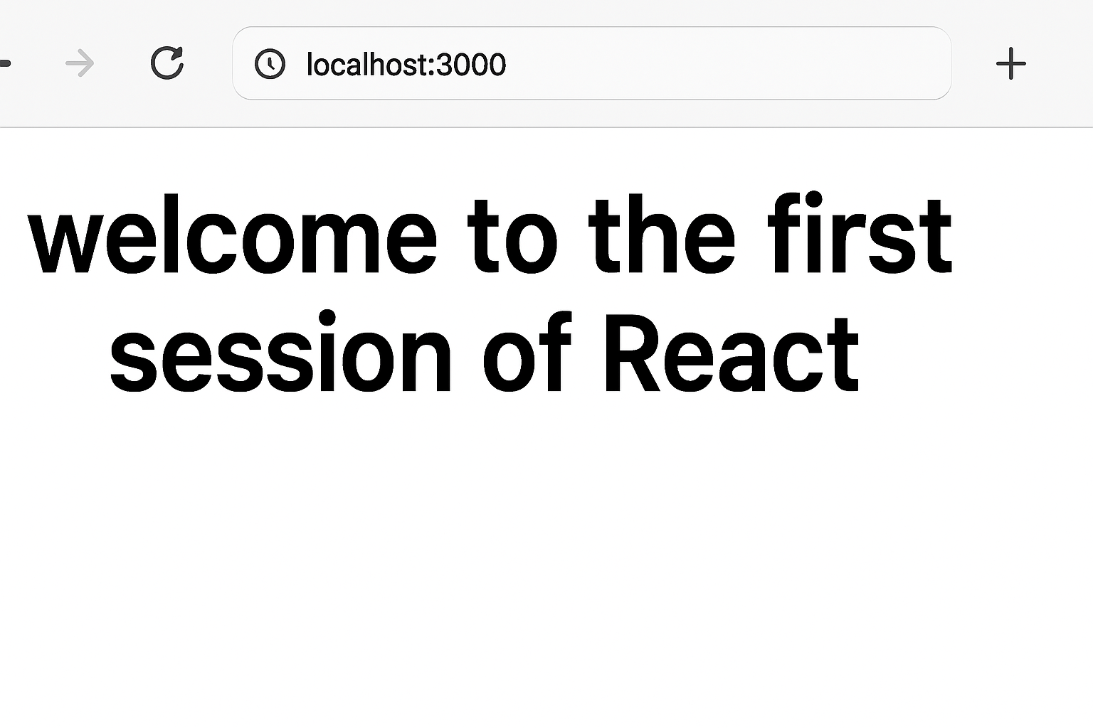
Q2)Create a react app for Student Management Portal named StudentApp and create a component named Home which will display the Message “Welcome to the Home page of Student Management Portal”. Create another component named About and display the Message “Welcome to the About page of the Student Management Portal”. Create a third component named Contact and display the Message “Welcome to the Contact page of the Student Management Portal”. Call all the three components.

1. Create React App named StudentApp
In Visual Studio Code terminal (or any terminal), run:
npx create-react-app StudentApp
cd StudentApp

2. Create Components Folder
Inside src/, create a folder called Components.

3. Create Home.js inside Components
src/Components/Home.js:
import React from 'react';

function Home() {
return (
<div>
<h2>Welcome to the Home page of Student Management Portal</h2>
</div>
);
}

export default Home;

4. Create About.js
src/Components/About.js:
import React from 'react';

function About() {
return (
<div>
<h2>Welcome to the About page of the Student Management Portal</h2>
</div>
);
}

export default About;

5. Create Contact.js
src/Components/Contact.js:
import React from 'react';

function Contact() {
return (
<div>
<h2>Welcome to the Contact page of the Student Management Portal</h2>
</div>
);
}

export default Contact;

6. Modify App.js to Call All Components
src/App.js:
import React from 'react';
import Home from './Components/Home';
import About from './Components/About';
import Contact from './Components/Contact';

function App() {
return (
<div className="App">
<h1>Student Management Portal</h1>
<Home />
<About />
<Contact />
</div>
);
}

export default App;

7. Run the App
In terminal:
npm start

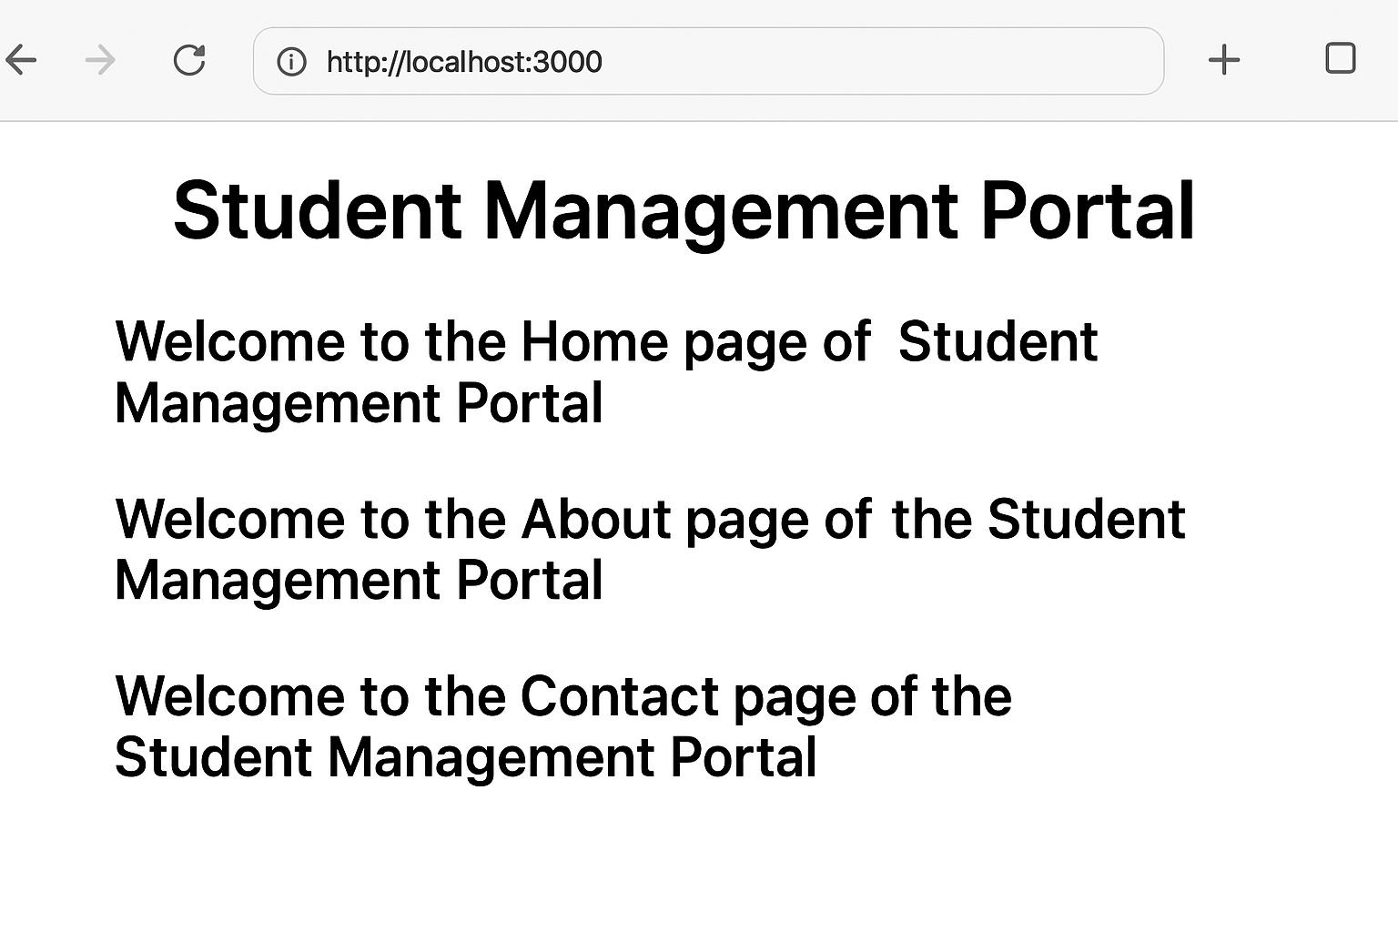

Q3)Create a react app for Student Management Portal named scorecalculatorapp and create a function component named “CalculateScore” which will accept Name, School, Total and goal in order to calculate the average score of a student and display the same.
Here’s the full implementation for your Score Calculator App based on the given steps:

1. Create React App named scorecalculatorapp
In terminal:
npx create-react-app scorecalculatorapp
cd scorecalculatorapp

2. Create Components Folder
Inside src/, create a folder named Components and add a file CalculateScore.js.

3. Code for CalculateScore.js
src/Components/CalculateScore.js:
import React, { useState } from 'react';
import '../Stylesheets/mystyle.css';

function CalculateScore() {
const [name, setName] = useState('');
const [school, setSchool] = useState('');
const [total, setTotal] = useState('');
const [goal, setGoal] = useState('');
const [average, setAverage] = useState(null);

const calculateAverage = () => {
if (total && goal) {
const avg = (parseFloat(total) / parseFloat(goal)).toFixed(2);
setAverage(avg);
}
};

return (
<div className="container">
<h2>Student Score Calculator</h2>
<input
type="text"
placeholder="Enter Student Name"
value={name}
onChange={(e) => setName(e.target.value)}
/>
<input
type="text"
placeholder="Enter School Name"
value={school}
onChange={(e) => setSchool(e.target.value)}
/>
<input
type="number"
placeholder="Enter Total Score"
value={total}
onChange={(e) => setTotal(e.target.value)}
/>
<input
type="number"
placeholder="Enter Goal Score"
value={goal}
onChange={(e) => setGoal(e.target.value)}
/>
<button onClick={calculateAverage}>Calculate Average</button>

{average && (
<div className="result">
<h3>Student Details:</h3>
<p>Name: {name}</p>
<p>School: {school}</p>
<p>Total: {total}</p>
<p>Goal: {goal}</p>
<p>Average Score: {average}</p>
</div>
)}
</div>
);
}

export default CalculateScore;

4. Create Stylesheet
Create folder src/Stylesheets and add mystyle.css:
src/Stylesheets/mystyle.css:
.container {
width: 400px;
margin: 50px auto;
padding: 20px;
border: 2px solid #333;
border-radius: 10px;
background-color: #f9f9f9;
text-align: center;
font-family: Arial, sans-serif;
}

input {
display: block;
width: 90%;
padding: 8px;
margin: 10px auto;
border-radius: 5px;
border: 1px solid #ccc;
}

button {
padding: 10px 20px;
background-color: #007bff;
color: white;
border: none;
border-radius: 5px;
cursor: pointer;
}

button:hover {
background-color: #0056b3;
}

.result {
margin-top: 20px;
text-align: left;
}

5. Edit App.js to Invoke Component
Replace src/App.js with:
import React from 'react';
import CalculateScore from './Components/CalculateScore';

function App() {
return (
<div className="App">
<h1>Score Calculator App</h1>
<CalculateScore />
</div>
);
}

export default App;

6. Run the App
In terminal:
npm start
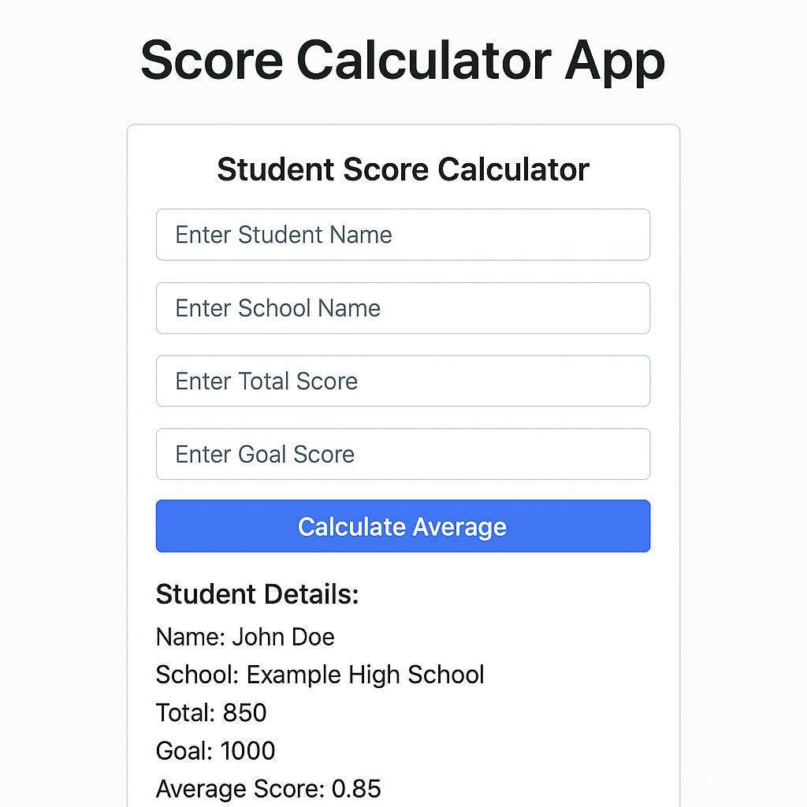
Q4)Create a new react application using create-react-app tool with the name as “blogapp”

1. Create a React Application
Open the terminal and run:
npx create-react-app blogapp
cd blogapp

2. Open in VS Code
Open the folder blogapp in Visual Studio Code:
code .

3. Create Post.js in src Folder
This will represent a single post entity as a class:
src/Post.js:
class Post {
constructor(id, title, body) {
this.id = id;
this.title = title;
this.body = body;
}
}

export default Post;

4. Create Posts.js Class-Based Component
Inside src/, create Posts.js:
import React, { Component } from 'react';
import Post from './Post';

class Posts extends Component {
constructor(props) {
super(props);
this.state = {
posts: [],
error: null
};
}

// 6. loadPosts method using Fetch API
loadPosts() {
fetch('https://jsonplaceholder.typicode.com/posts')
.then(response => response.json())
.then(data => {
const postsList = data.map(item => new Post(item.id, item.title, item.body));
this.setState({ posts: postsList });
})
.catch(error => {
this.setState({ error });
});
}

// 7. componentDidMount hook to load posts
componentDidMount() {
this.loadPosts();
}

// 9. componentDidCatch for error handling
componentDidCatch(error, info) {
alert('Error occurred: ' + error);
}

// 8. render posts in HTML
render() {
const { posts } = this.state;

return (
<div>
<h1>Blog Posts</h1>
{posts.length > 0 ? (
posts.map(post => (
<div key={post.id}>
<h3>{post.title}</h3>
<p>{post.body}</p>
<hr />
</div>
))
) : (
<p>Loading posts...</p>
)}
</div>
);
}
}

export default Posts;

10. Add Posts Component to App.js
src/App.js:
import React from 'react';
import Posts from './Posts';

function App() {
return (
<div className="App">
<Posts />
</div>
);
}

export default App;

11. Run the Application
In the terminal:
npm start

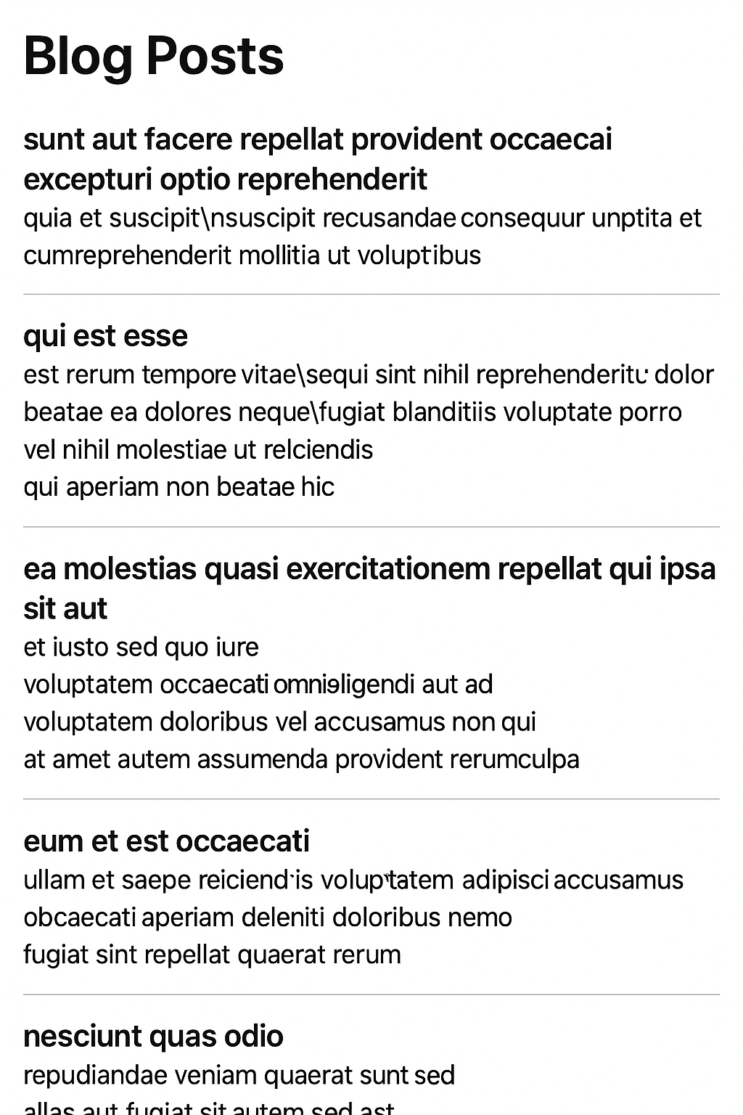

Q5)

1. Unzip & Open Application
Unzip the provided React app into a folder.
Open a Command Prompt or terminal, navigate to the project folder:
cd your-app-folder

2. Restore Node Packages
Run:
npm install

3. Open in VS Code
Open the app:
code .

4. Create CSS Module CohortDetails.module.css
In src/ (or inside the components folder where CohortDetails exists), create:
CohortDetails.module.css:
.box {
width: 300px;
display: inline-block;
margin: 10px;
padding: 10px 20px;
border: 1px solid black;
border-radius: 10px;
}

dt {
font-weight: 500;
}

5. Open CohortDetails.js Component and Import CSS
Inside CohortDetails.js:
import React from 'react';
import styles from './CohortDetails.module.css';

function CohortDetails({ name, status, startDate, endDate }) {
const headingColor = status === 'ongoing' ? 'green' : 'blue';

return (
<div className={styles.box}>
<h3 style={{ color: headingColor }}>{name}</h3>
<dl>
<dt>Status:</dt>
<dd>{status}</dd>
<dt>Start Date:</dt>
<dd>{startDate}</dd>
<dt>End Date:</dt>
<dd>{endDate}</dd>
</dl>
</div>
);
}

export default CohortDetails;

6. Apply box class
The div wrapping the content now uses:
<div className={styles.box}>
This applies the styles from CSS module.

7. Dynamic Heading Color
Condition:
const headingColor = status === 'ongoing' ? 'green' : 'blue';
Applied in:
<h3 style={{ color: headingColor }}>{name}</h3>

8. Run the Application
npm start
