**Vmware创建共享磁盘详细步骤**

1，在将vmware安装的文件夹下创建sharedisks文件夹：

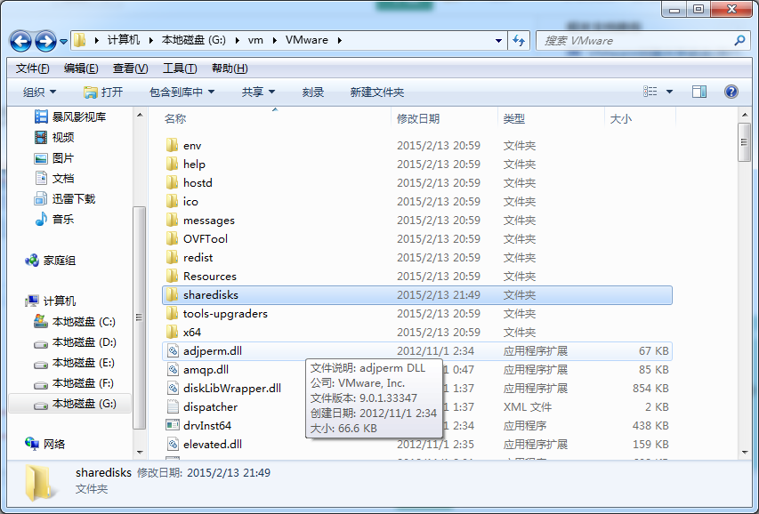

2,运行—cmd，打开DOS窗口，切换至Vmware安装的目录，然后执行

vmware-vdiskmanager.exe -c -s 20480M -a lslogic -t 2 G:\vm\VMware\sharedisks\sharedisk-1.vmdk

如果是win7系统会提示没有权限，解决办法很简单，将VMware以管理员身份运行就OK

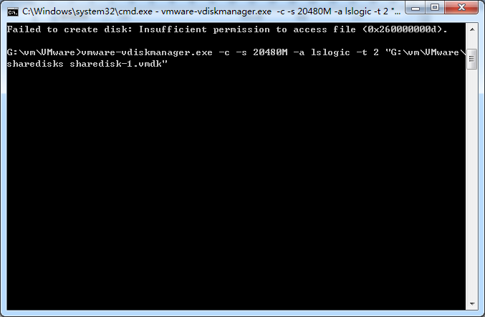

正在创建：

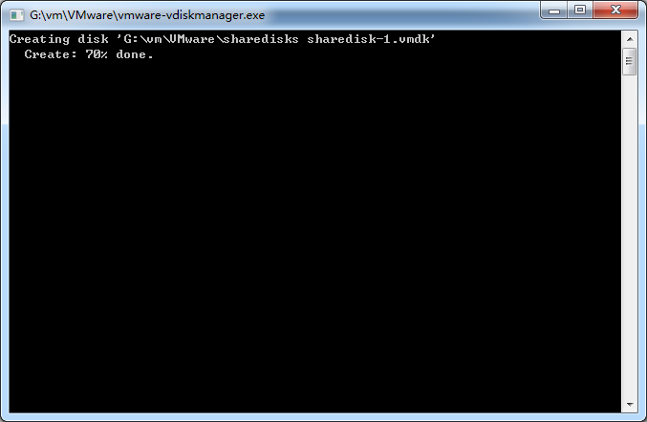

3，在我们之前新建的目录sharedisks可看到新生成的两个文件

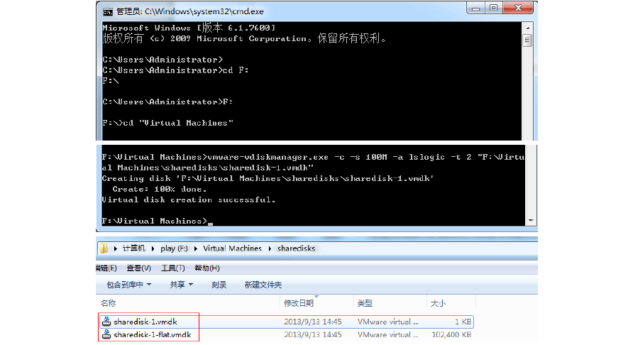

 4，配置虚拟机

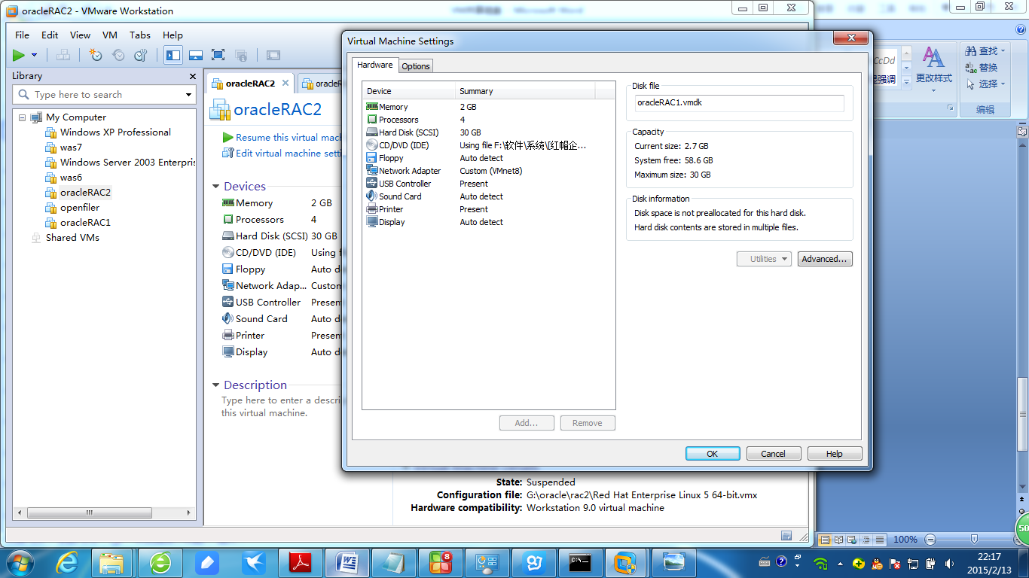

选择 Hard Disk,然后选择 Add..

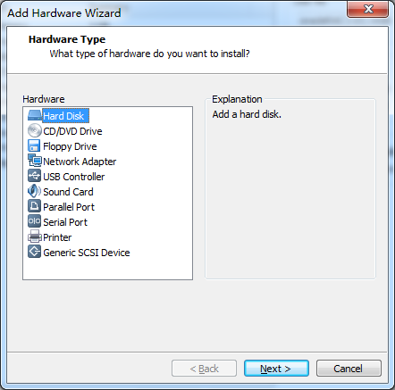

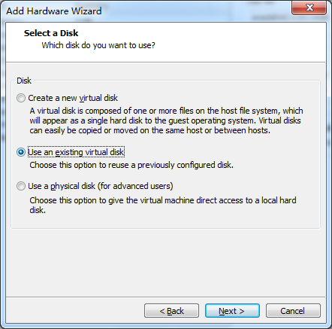

选择 Use an exiting virtual disk,然后点击 Next

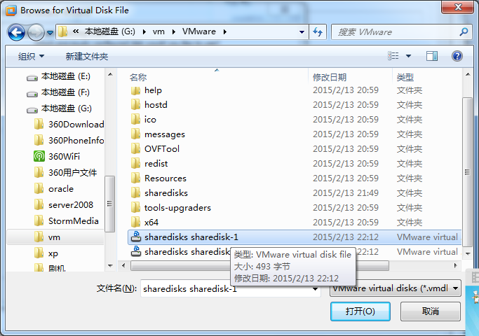

点击 Browse …,选择我们设置好的共享磁盘

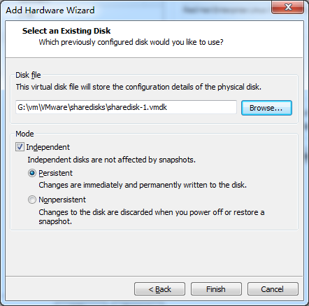

点击 Finish

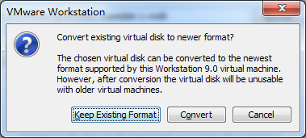

这里我们选择 Keep Exiting Format ,如果有需要，可以选择 Convert 进行格式转换

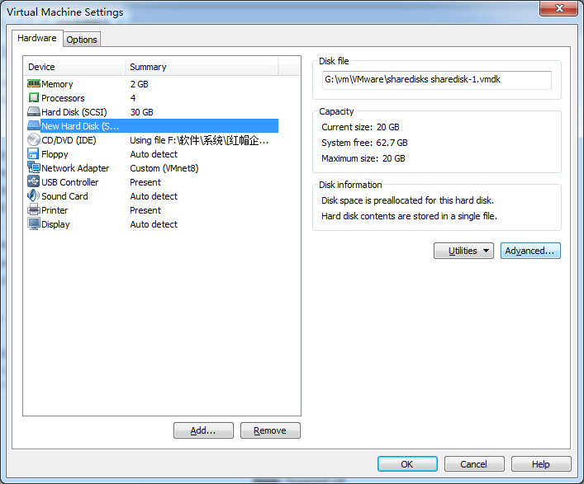选中我们刚建好的磁盘，然后点击 Advanced…

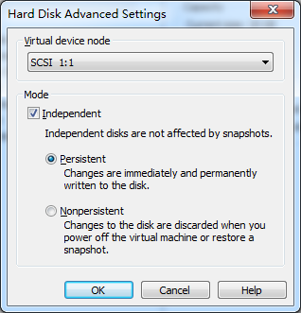

选择 SCSI 1：1 不和系统磁盘在一个通道上面

点击 OK 即可完成本台设备win2003-1的磁盘添加。

5,配置虚拟机文件，两个节点都要配置

找到虚拟机的目录，用记事本打开VMX文件

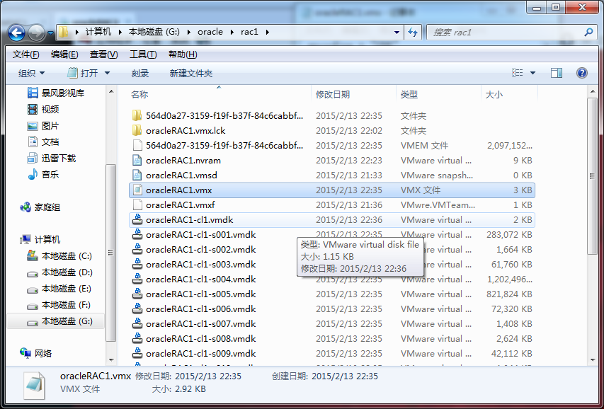

在下方添加

diskLib.dataCacheMaxSize = "0"

diskLib.dataCacheMaxReadAheadSize = "0"

diskLib.DataCacheMinReadAheadSize = "0"

diskLib.dataCachePageSize = "4096"

diskLib.maxUnsyncedWrites = "0"

disk.locking = "false"

scsi0:1.deviceType = "disk"

scsi0:1.SharedBus = "Virtual"

scsi0:1.shared = "true"

然后重启两个虚拟机，fdisk -l 查看，是否都已挂载该共享磁盘。

D:\Program Files (x86)\VMware\VMware Workstation>vmware-vdiskmanager.exe -help

vmware-vdiskmanager.exe: unrecognized option 'help'

VMware Virtual Disk Manager - build 2985596.

Usage: vmware-vdiskmanager.exe OPTIONS <disk-name> | <mount-point>

Offline disk manipulation utility

Operations, only one may be specified at a time:

-c : create disk. Additional creation options must

be specified. Only local virtual disks can be

created.

-d : defragment the specified virtual disk. Only

local virtual disks may be defragmented.

-k : shrink the specified virtual disk. Only local

virtual disks may be shrunk.

-n <source-disk> : rename the specified virtual disk; need to

specify destination disk-name. Only local virtual

disks may be renamed.

-p : prepare the mounted virtual disk specified by

the mount point for shrinking.

-r <source-disk> : convert the specified disk; need to specify

destination disk-type. For local destination disks

the disk type must be specified.

-x <new-capacity> : expand the disk to the specified capacity. Only

local virtual disks may be expanded.

-R : check a sparse virtual disk for consistency and attempt

to repair any errors.

-e : check for disk chain consistency.

-D : make disk deletable. This should only be used on disks

that have been copied from another product.

Other Options:

-q : do not log messages

Additional options for create and convert:

-a <adapter> : (for use with -c only) adapter type

(ide, buslogic, lsilogic). Pass lsilogic for other adapter types.

-s <size> : capacity of the virtual disk

-t <disk-type> : disk type id

Disk types:

0 : single growable virtual disk

1 : growable virtual disk split in 2GB files

2 : preallocated virtual disk

3 : preallocated virtual disk split in 2GB files

4 : preallocated ESX-type virtual disk

5 : compressed disk optimized for streaming

6 : thin provisioned virtual disk - ESX 3.x and above

The capacity can be specified in sectors, KB, MB or GB.

The acceptable ranges:

ide/scsi adapter : [1MB, 8192.0GB]

buslogic adapter : [1MB, 2040.0GB]

ex 1: vmware-vdiskmanager.exe -c -s 850MB -a ide -t 0 myIdeDisk.vmdk

ex 2: vmware-vdiskmanager.exe -d myDisk.vmdk

ex 3: vmware-vdiskmanager.exe -r sourceDisk.vmdk -t 0 destinationDisk.vmdk

ex 4: vmware-vdiskmanager.exe -x 36GB myDisk.vmdk

ex 5: vmware-vdiskmanager.exe -n sourceName.vmdk destinationName.vmdk

ex 6: vmware-vdiskmanager.exe -r sourceDisk.vmdk -t 4 -h esx-name.mycompany.com \

-u username -f passwordfile "[storage1]/path/to/targetDisk.vmdk"

ex 7: vmware-vdiskmanager.exe -k myDisk.vmdk

ex 8: vmware-vdiskmanager.exe -p <mount-point>

(A virtual disk first needs to be mounted at <mount-point>)

cd /d D:\Program Files (x86)\VMware\VMware Workstation

griddata最少6G，这里分配8G。其他所有磁盘也必须选择立即分配，执行命令：

vmware-vdiskmanager.exe -c -s 8GB -a lslogic -t 2 F:\VirtualMware\VirtualMachines\CentOS6.5-Oracle12c-RAC\share-disk\griddata.vmdk

vmware-vdiskmanager.exe -c -s 30GB -a lslogic -t 2 F:\VirtualMware\VirtualMachines\CentOS6.5-Oracle12c-RAC\share-disk\racdata.vmdk

vmware-vdiskmanager.exe -c -s 20GB -a lslogic -t 2 F:\VirtualMware\VirtualMachines\CentOS6.5-Oracle12c-RAC\share-disk\racfra.vmdk