An IoT-Enabled Smart Medicine Box for Automated Medication Adherence
Monitoring and Caregiver Notification

P.Tryphena Prishiba Assistant Professor
Department of Biomedical
Engineering
KIT-Kalaignarkarunanithi Institute of Technology, Coimbatore, India
princetryphena@gmail.com

T.SriRagavi
Biomedical Engineering
KIT-Kalaignarkarunanithi Institute of Technology, Coimbatore, India kit27.bme56@gmail.com

D.Priyadharshini
Biomedical Engineering
KIT-Kalaignarkarunanithi Institute of Technology, Coimbatore, India
kit27.bme047@gmail.com

M.Mouriya
Biomedical Engineering
KIT-Kalaignarkarunanithi Institute of Technology, Coimbatore, India
kit27.bme036@gmail.com

Abstract:
Another aspect of non-compliance in the medical field that poses a serious concern to the current medical system at large is the use of medication. In general, lack of compliance in taking the medical prescription by the patients means that the outcomes of the treatment are affected. In most cases, failure to use medication as required means that there will be a lack of good health outcomes due to the deterioration of the patient’s medical situation. This problem is particularly prevalent among elderly individuals, patients suffering from chronic illnesses, and people with demanding daily routines, where missed or delayed medication intake is often caused by memory decline, lack of supervision, or complex prescription schedules. The traditional methods of using pill boxes and manually prompting the patient have been very reliant upon the diligence and memory of the patient and have been inefficient for long-term administration of medications. Consequently, the demand for intelligent and user-centred systems that can aid the patient in following the medication regime has been increasing by the day. Recent developments in embedded systems and Internet of Things technology have made it possible to design smart reminders for medicines that support automated reminders, real-time tracking, and remote interaction with caregivers. The smart boxes for medicines using IoT technology usually consist of combinations of microcontrollers with RTC, display systems, and alert systems for providing time-based reminders to the patients. Also, internet connectivity provides support for recording, storing, and remote access to information regarding patient compliance with their medications. Unlike advanced automated dispensing systems, smart boxes based on reminders are much safer and a better solution for home health care, particularly for senior citizens. This paper discusses an in-depth examination of the smart medication box systems enabled using the capabilities of the Internet of Things with applications targeting the use of the systems as a portability mechanism for medication reminder and patient adherence tools. The paper discusses the importance of the systems in design aspects targeting the reminder mechanism accuracy and the patient and healthcare provider communication effectiveness. The system helps in the automation of patient medication reminder processes with increased accuracy and the recording of patient medication history for improved patient treatment success. In addition, the multimodal notification system with visual and sound notifications makes the system accessible to visually or hearing-impaired patients. The results show the cost-effectiveness and efficiency of the Internet-of-Things-based smart medication reminder systems for improving patient prescription medication use and enhancing patient-oriented healthcare delivery systems.
Keywords— Smart Medicine Box (SMB), RTC, IoT, ESP32,
Medication Adherence

I. INTRODUCTION

Following the prescribed medications is a fundamental prerequisite for achieving maximum healthcare outcomes, and this is particularly true with regards to the management of chronic ailments. Medication adherence fundamentally comprises the approach through which patients stick to the observation of administering medications as per the directed dosage and frequency as instructed by healthcare professionals. However, with the current advanced level of technological and scientific progress in the field of healthcare and medicinal development, issues with regard to medication adherence are currently impacting healthcare systems worldwide. Nonadherence with regards to the administration of medications primarily results in a decrease within the effectiveness of the treatment mechanism, worsening of the respective health ailment, and a significant surge in healthcare costs. This assumes special importance with regards to the elderly population and the intake of multiple medications.The past few decades have experienced improvements in healthcare infrastructure and technology, which has further led to an increase in the average life span of a person. Although it is a sign of development in society, it also leads to an ageing population, which in turn poses a risk to the healthcare infrastructure due to the rising need to manage healthcare. Studies show that over 65-year-old population trends are steadily rising by over ten million people every year, with drastic changes expected in demographics in 2030 [1].
As people grow older, their mental capabilities decrease, and their physical capabilities are not what they used to be, which adversely affects their capacity to handle medications on their own. Thus, adequate management of medications for seniors has turned out to be a major issue with contemporary health facilities.Medication non-compliance remains one of the most pressing matters that elderly and chronically ill patients experience. Medication noncompliance has been known to arise primarily out of forgetfulness, confusion brought on by complicated multiple-drug therapy, lack of knowledge on part of the patient about when to take medications, or lack of constant monitoring. Patients with chronic ailments like cardiovascular diseases, diabetes, and hypertension remain at considerable risk because, in case of medication errors, these could worsen and even prove catastrophic [2]. In this way, medication mistakes do not only prolong the treatment period in terms of recuperation, they could even swell the mortality rates. Conventional systems for managing patient medication use functions like pill containers or medication schedules offer limited assistance for the patient when strict observance with the medication schedules is required over an extended time. These traditional systems rely completely on the patient’s ability to remember to take medication at the right time, making these systems unsuitable for use by people with impaired memories or busy lifestyles. Even more advanced systems involving electronic reminder clocks in medication containers offer only partial assistance because these systems allow the patient a reminder but do not check if the patient actually takes the medication afterwards. This creates a problem for the caregiver and the health professional because they are not informed about the dosages the patient has failed to take.
The emergence of advanced technologies in embedded systems and the Internet of Things (IoT) has made it possible to develop a Smart Medicine Box (SMB) system to effectively meet these challenges. The SMB system is developed to help patients by providing automated time-based reminders and the ability to monitor medication adherence using connected platforms. In most of the designs developed for the SMB system, microcontrollers like ESP32 or ESP8266 are usually used because of their ability to consume less power and support wireless communication capabilities. The SMB system usually comprises a space to organize medications, as well as other notification methods like beepers, LEDs, display screens, or voice alerts for patients to take their medications at the specified time. The SMB system eliminates the need for a patient to remember medication intake because the system provides automated reminders.The addition of wireless communication technology like Bluetooth, Wi-Fi, or GSM to Smart Medicine Boxes further increases SMB capabilities. Using cloud technology, patient compliance information regarding their consumption of medications can be transmitted on a real-time basis, and notifications could also be received regarding missed doses [3]. Using SMB systems that rely on IoT, patient independence is achieved as, through these systems, users have the ability to manage their medications at home even as they remain connected to caregivers as well as healthcare professionals. Smart Medicine Box systems have proven to be effective in aiding patients to adhere to the proposed dosage. It should be noted that the system will not present the possibility of a patient requiring a lesser or greater dose, in addition to a patient possibly forgetting to take the dose altogether. For instance, A. A. Nasir and Asif proposed a Smart Medicine Box that has the capacity to give the patient a proper dose and in addition, the system reminds the patient to take his medicine, including the dispensing of the dose concerning the patient.Norasmawi et al. [2] designed a smart medicine box along with a mobile application to deliver reminders to improve interaction. Similarly, Hassain et al. [3] designed a voice-controlled medicine reminder box along with IoT-based medication tracking, which is ideal to be used in the case of elderly patients in a hospital setup. On the whole, the existing literature has significantly pointed out the major significance of Smart Medicines Box systems in minimizing drug errors and the availability of drugs to the patient. But despite the advancements made in this technology, the current existing technologies lead to major challenges regarding the fully automatic drug-dispensing facilities and the use of the internet. For elderly patients, the technology should be simple and comfortable and, at the same time, user-friendly and very effective. This has led to an increased need for Smart Medicine Box designs that emphasize more on notification functions than just automated dispensing. Under these aspects, an Internet of Things-based Smart Medicine Box that concentrates on reminding functions, increases patient compliance, and enforces communication between patients and caregivers would be greatly appreciated. Employing aspects such as an integrated real-time clock and cloud services, the system would greatly improve patient compliance rates and minimize risks that come along with treatments. Moreover, at a time when health care solutions continue to focus on patients, these intelligent medicine management solutions would greatly enhance patients’ living standards by maintaining better control over medicine use.
Existing System
The daily activities of a person can be an indicator of the person's general health. In case the person is able to undertake key activities of eating, mobility, remembering appointments and chores that are required to be done on a routine basis in the house, then it means that the person's general health is fine. On the other hand, in case the person is unable to perform the same activities, then it means that the person's general health is worsening. This commentary is specially applicable withinside the case of aged individuals, whose useful capabilities regularly decline step by step with age. Monitoring such modifications has consequently come to be an crucial factor of aged healthcare management. Many aged people opt to stay independently in preference to in assisted care facilities, as unbiased residing promotes dignity, comfort, and emotional well-being. However, residing by myself additionally exposes them to substantial risks, which include unintended falls, behind schedule medical assistance, and ignored or wrong medication intake. Among those risks, medicine mismanagement is one of the maximum not common and perilous problems confronted by aged human beings residing independently. Memory loss, decreased attention span, and confusion as a result of complicated medicine regimens often bring about skipped doses, delayed intake, or unintended overconsumption of medicines. These elements drastically growth the probability of scientific headaches and emergency situations. As highlighted in present studies, aged people residing by myself are fairly vulnerable to sudden fitness issues because of the shortage of non-stop supervision and well timed intervention [14]. To cope with those challenges, numerous present healthcare structures have centered on tracking the each day sports of aged people the usage of sensor-primarily based totally and clever domestic technologies. These structures intention to have a look at behavioural styles consisting of motion inside residing spaces, equipment usage, sleep cycles, and wellknown interest levels. By analysing deviations from everyday interest styles, such structures try to discover early symptoms and symptoms of fitness deterioration and cause signals earlier than important activities occur. The number one goal of those tracking structures is to beautify the safety, security, and standard wellbeing of aged people via way of means of allowing well timed help from caregivers or healthcare professionals [14]. Some present digital remedy structures try and combine reminders with tracking via way of means of the usage of sensors to come across pillbox establishing events. However, lots of those structures function as standalone gadgets with out connectivity, stopping caregivers from having access to adherence records remotely. In instances in which connectivity is provided, non-stop net dependence can also additionally lessen reliability, mainly in areas with risky community availability. Moreover, structures that contain computerized tablet meting out mechanisms have a tendency to be robotically complex, costly, and tough for aged customers to function safely. Overall, present structures show that whilst large development has been made in aged pastime tracking and primary medicine reminder technologies, there stays a clean hole in offering a simple, reliable, and user-pleasant answer that especially addresses medicine adherence. Current strategies both cognizance on preferred pastime tracking with out medicine-unique capability or depend on conventional reminder techniques that don't confirm consumption or permit far off supervision. These barriers emphasize the want for a devoted Smart Medicine Box machine that makes a speciality of correct time-primarily based totally reminders, consumption confirmation, and caregiver communication, whilst final portable, affordable, and clean to apply for aged people residing independently.

II. LITERATURE SURVEY

Medicine adherence is the problem of drugs use and compliance along with prescribed dose, in most people involving a dosing regimen over time. Long term decline of cognition and memory, as well as complex medication regimen schedules are not uncommon causes that patients forget to take their medications, often with dire health consequences. This becomes a catastrophe for those affected by long-time period situations akin to diabetes, heart problems and hypertension, where shut adherence to treatment schedules is crucial in controlling the illness and avoiding complications. To address those problems, systems such as Smart Medicine Box (SMB) [2] were developed and integrated to the modern technologies to help cure adherence through automation and tracking.
In maximum of the Smart Medicine Box systems, microcontrollers getting used have in-constructed Real-Time Clock (RTC) ones to make it viable for actual and dependable time-based totally reminders. Various hardware structures including Arduino, NodeMCU and ESP32 are in a well known way hired due to their affordable price, low electricity intake and ease of interface with the sensors and verbal exchange modules. These structures always utilize every cell and IoT machine to provide correct scheduling, automatic signals, and remote tracking functionality in a price effective way. Al-Shammary et al. had ideated an Arduino-based mostly "Smart Medicine Box" that utilized multimodal alert technologies such as the usage of LEDs, buzzers, as well as SMS/electronic mail alerts, to remind sufferers and caregivers concerning the times of taking medicines. Along with the above-mentioned function, photoresistors have been utilized in the design to observe if the pills have been taken. Although the design became very effective in improving affected person alertness and following treatment adherence, factors such as the price of the design restricted the idea
.Bhati et al. [5] suggested the radio frequency ID RFID based intelligent medicine box system, which monitors drug intake and updates a centralised file at run-time. The use of RTC module ensured the exact timing of reminder and RFID tags for medication status verification. This method has achieved better performance in tracking accuracy and data quality, however the needs of RFID readers and tags resulted in hardware complexity and maintenance cost, which may not be well suited for aged users with limited ability of using sophisticated instruments. For the enhancement of dosing accuracy, Nurmiza Binti Othman et al. [6] proposed a smart pill box with servo motor, infrared sensor, LCD display and vibration motor. The system dispensed the pills at the right time and in the right dosage. Smartphone in-app connectivity and remote monitoring features were lacking, however, which curtailed its potential to assist caregivers and providers to monitor adherence of the patients.
Vardhini et al. [7] designed a NodeMCU-based Smart Medicine Assistive System by combining \(DNS\), IoT, motorized lids, and LDR sensors to observe the consumption of pills. This was a budget-friendly design with cloud updates in real-time to the caregivers for compliance monitoring. However, its heavy reliance on steady wireless access made the system unreliable in areas with erratic internet connectivity, as is experienced in a majority of rural and semiurban areas.
Zeidan et al. [8] focused on augmenting usability using designing a Smart Medicine Box tool which merged graphical displayed, audio alert, SMS notifications and e-mail-primarily based communication. The gadget looked to provide comprehensive alerting solutions for patients and carers. Although such a multimodal approach advanced user interaction and accessibility, scalability problems and increased device complexity restricted its long-term applicability and maintainability. A Smart Medicine Box based on IoT technology has been designed by Divakar et al. [9] with a focus on reminders and refills through alarms and SMS messages. The prototype successfully improved patient compliance with medicines with the facility of reminders and messages to caregivers regarding the refilling of required medicines. But the prototype had limitations regarding connectivity with health and intake verification processes for comprehensive patient compliance analysis.

III. METHODOLOGY
The proposed device has been designed as a clever drug reminder and compliance system, basically depending upon a hybrid hardware and software system. The prime aim of this system is to improve drug compliance among elderly patients, chronic patients, as well as illiterate patients, who mostly encounter hassles when it comes to remembering drug schedules and properly understanding drug names. Instead of focusing on complex drug dispensing systems, the proposed system basically highlights timely drug reminders, drug verification, and tracking, ensuring drug safety, ease, and reliability for home-based healthcare applications. The design approach is a whole comprising a series of smaller modules, which are systematically developed in a unique way. In this approach, every block of the system is used in a distinct way. Modular designs are ideal as far as scalability, debugging, and overall system maintenance. Finally, there are three main levels in a system, namely sensing, control, and message levels, which manage time reminders, interaction, compliance, and tracking. At the heart of the gadget, the ESP32 microcontroller is employed as the chief processing and management unit. The ESP32 microcontroller has been selected because of its low power consumption, considerably Higher Processing Efficiency, built-in Wi-Fi, and the availability of more than one GPIO. The microcontroller has the responsibility of undertaking the Embedded Management Logic, supporting the conversation between the sensors and the output devices, and supporting the conversation of data to the cloud.

The gadget applies modular programming approaches to assign the management of time, generation of alerts, sensor observations, and data conversion. The medication reminder based on time is accurate and performed by employing a Real-Time Clock module integrated with the ESP32 microcontroller. The real-time clock is responsible for keeping the date and time running continuously irrespective of the main power supply to the microcontroller. This ensures that the medication reminder is accurate even in the case of a power cut-off, reboot, and change of battery life. The medication schedule, which entails the time for intake of medication and the reminder time, is stored in the microcontroller’s memory that is synchronized with the real-time clock regularly. To notify customers on the scheduled medicinal drug times, the machine employs a aggregate of visible and auditory alert mechanisms. Visual notifications are displayed on an OLED screen, which offers clean and high-contrast messages consisting of reminder prompts, contemporary time, and medication status.

The OLED show is selected for its advanced readability, compact size, and low electricity consumption, making it appropriate for aged customers and occasional imaginative and prescient patients. In parallel, an audible alert is generated the usage of a buzzer to draw the person`s attention, making sure that reminders are observed even if the person isn't always actively gazing at the show. The use of multimodal signals substantially improves the probability of person's reaction and decreases the possibilities of overlooked doses. If it is not opened within the allowed time window after a reminder has been issued, the event is immediately recorded by the system as a missed dose. It locally stores this information and then sends it to the associated cloud platform.
The ESP32 contains built-in Wi-Fi capabilities through which the adherence data-successful intake, missed doses, and timestamp information-is securely uploaded to a remote server. This helps physicians and caregivers monitor the usage pattern of medication in real time without physical presence. The conversation and notification component of this strategy holds an important trait within the involvement of caregivers. After the data of convergence is uploaded to the cloud database, the caregivers will be able to exercise right of entry to the device through the linked software program interface. Even within the case of neglected doses of medication, automated notifications may be produced to alert the caregivers so that timely intervention and assist may be enabled. This will prove to be particularly helpful within the case of senior individuals living alone because the occurrence of non-adherence to treatment would now not pass unnoticed. Power management is yet another important aspect that has been taken care of by the proposed methodology. The gadget has the ability to work remotely using a rechargeable lithium-ion battery. The usage of power in the system has been made efficient by using hardware that requires less power and appropriate software designed to manage the power, enabling the gadget to function for longer without the need to recharge.
Overall, the proposed methodology combines the benefits of accurate time scheduling, user-friendly alerts, reliable intake verification, and IoT-based monitoring to provide a complete solution. By leveraging the capabilities of hardware components combined with intelligent software solutions and cloud capabilities, the proposed methodology is able to overcome the major drawbacks of non-compliance. The proposed methodology maintains the principles of being easy to use, safe, and accessible to the extent that the senior users can operate the system effortlessly while the caregivers are aware of the medication intake by the senior users. Since remote monitoring capabilities were not entirely utilized, a design using an ARM7 microcontroller, named “Smart Medicine Box” proposed by Nyapathi et al., had effective pill tracking functionality with rudimentary IoT capabilities, though reliability and ease of use were major priorities in this project.
Al-Mahmud et al. in [11] proposed an IoT-based smart healthcare medical box targeted at senior citizens. The proposed medical box concept was equipped with an alerting mechanism to ensure timely interventions in cases where medication was not taken. Although the proposed concept was effective, the complexity involved in installing it, as well as its higher implementation costs, were factors that inhibited its adoption in home healthcare settings.
Nadzri et al. [12] designed an IoT-based smart pill-box which offered monitoring, alerting and mobile application services. Medication adherence were improved via the cloud-based surveillance and user-friendly mobile devices. But it heavily relied on always-on Internet access causing poor performance when disconnected from the network, which restricted its reliability. In order to help the users with hearing/visual disabilities, Sree et al. [13] designed a voice reminders and display interface Smart Medicine Box for emergency patients and the visually impaired. The implementation of both visual and auditory alarms enhanced visibility and usability. It was effective, but additional development work was needed to make it smaller and more power-efficient. As a whole, the literature reviewed provides evidence that Smart Medicine Box systems using IoT are effective in enhancing adherence to medication, patient safety, and caregiver involvement. More recently, multimodal alert interfaces like voice or LED/buzzer are more popularly applied to simplify the operation for elderly and visually impaired toilet users, whereas RTC-based scheduling and compartmentalized storage have also been integrated into most designs. In addition, verification technologies like RFID, LDR and InfraRed sensors enable in assessment of accurate compliance. However, difficulties in hardware understanding, cost of implementation, reliance to the internet facilities and offline availability finds no explicit solution as part of this theme with focus on elder adults usages reduced usability. These constraints indicate that a low-cost, scalable and simplified smart Medicine Box system which also can be applied to other health care applications such as reminder assistance, adherence monitoring is needed.

Hardware

Hardware is the physical part of any System, Computer, or Device that physically exists in any of the existing devices in the real world.

Used components
ESP32

The ESP32 microcontroller serves as the system's central processing unit, selected for its efficient dual-core processor, minimal power consumption, integrated Wi-Fi and Bluetooth capabilities, and its capacity to oversee communication between sensors and actuators while executing preprogrammed commands.
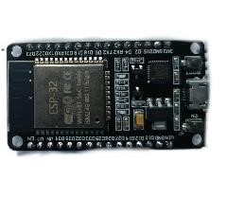
Fig.1: The Image of ESP32
OLED Display
OLED displays have superseded the 16×2 format. LCD screens from earlier systems have been enhanced to offer a more compact, high-resolution, and user-friendly experience. OLED displays will deliver superior image quality compared to conventional LCD screens, particularly for older patients with visual impairments, which enhances contrast in various lighting conditions. Our system leverages OLED technology to display real-time information, including the present time and dosing schedule, along with reminder notifications. Patients receive immediate information about the amount of medication they have taken and the amount they have missed. This technology is Transformative.
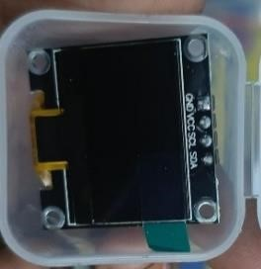

Fig.2: The Image of OLED

RTC Module
A real-time clock module was integrated for scheduled injections. The real-time clock guarantees accurate timing of medication reminders at specific times, even during power outages or device restarts. Alert timing conflicts are reduced, which can be problematic for patients who must adhere strictly to their medication dosing schedules.
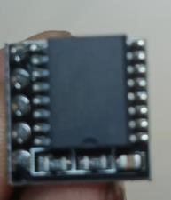

Fig.3: The Image of the RTC Module
LED
Multimodal alerts were provided by buzzer and LED indicators. The buzzer issues an audible alert to the patient when a dose is overdue, and the LEDs give a visual warning. Such factors become all the more significant when considering elderly or hearing-impaired patients, as they need to be reminded, and their reminders can be attended to notwithstanding background noises and limitations in their capability to perceive.
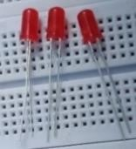
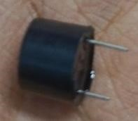

Fig.4: LED fig.5:Buzzer
Lithium-ion Battery
The main portable power feeding for the Smart Medicine Box will come from a rechargeable lithium-ion battery. A dedicated power management system ensures a stable 5V supply to all the integrated components in the system. This enables the working of all the components in the system for full functionality, allowing real-time monitoring even in the absence of an external power supply. This feature is helpful for patients who travel or have disrupted power supplies quite frequently. Nonetheless, in a general manner, this power ratio increases the portability and reliability of the device. The use of the lithium-ion battery, which can be recharged, in collaboration with the power management system of the battery, enables the Smart Medicine Box to work continuously without any interruptions. This further ensures that the basic functions of the device, including reminders or monitoring or alerts, work all day long. Thus, it becomes possible for the users of the device to trust it in any scenario, whether traveling or during power cuts.

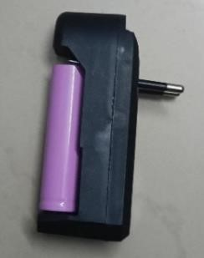

Fig.6: Lithium-ion battery
IR Sensor
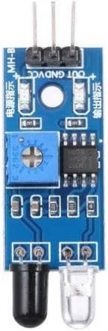
An IR sensor has been used in this design for pill box opening detection. Once the top of the box is opened, it interferes with the path of the IR signal and within a fraction of a second, the change is detected by the IR sensor. The immediate detection and notification using the signal pin of the IR sensor is connected with the GPIO of the ESP32 module. The IR sensor operates on 3.3V and hence is fully compatible with the ESP32 module. The very moment the box is opened, the ESP32 module will be able to mark the status of the drug/medicine taken by the patient.

Fig.7: The Image of the IR sensor
IV. WORKFLOW
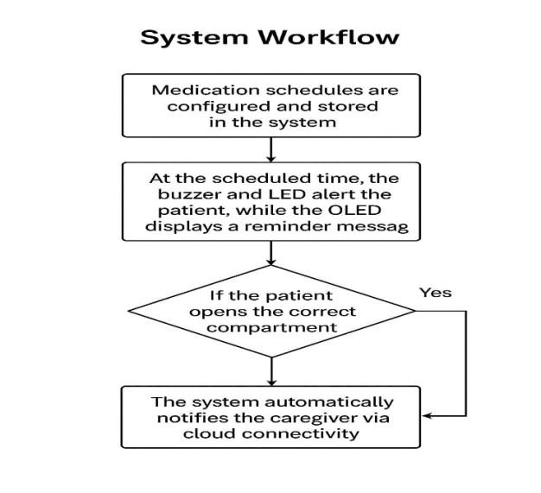

Step 1: Establishing a Medication Schedule
The timings of the drugs are stored in the memory of the ESP32 and are set either by the patient or the caregiver. This helps the job of reminding the patient to take the drugs to be done automatically at the proper times. The display screen helps the schedule to be viewed so that errors are avoided while entering the information.
Step 2: Creation of Reminders
At the appropriate time, the RTC sends an indication to the ESP32 to turn on the LEDs and the buzzers. In the device that has been used in this project, one can see that the text on the OLED will indicate something like ‘Time to take your medicine’. The text has the ability to catch the person’s attention through the use of sounds and lights as well as the visual signal.
Step 3: Dose Detection & Logging
However, if the patient opens the pill box within the required time limit indicated as a reminder, then the ESP32 senses the elapsed time, indicating that the patient has taken the medication. The details are then stored in the device before it is uploaded to the cloud.
Step 4: Missed Dose Notification
In case the patient fails to open the compartment within the required time, the ESP32 immediately alerts the caretaker via Wi-Fi connectivity and also logs it as a missed dose. Furthermore, the “Missed Dose Alert” message will also be shown on the OLED display screen.
Step 5: Monitoring and Updating the Cloud
The next step in Cloud computing is that Data about the medications, as well as the amount of medications taken and the amount of medications skipped, are transferred to the cloud server. The remote dashboard helps the caregivers to gain access to the information, and the caregivers are updated about the compliance of the patient.

V. RESULTS AND DISCUSSION
The IoT-enabled SMB has been designed, implemented, and tested to demonstrate the effectiveness of applying an embedded system connected through IoT for compliance improvement and real-time monitoring. This testing includes a number of operating scenarios for the validity of the proposed system. The results from what was obtained clearly show that the combined use of the embedded system and the connectivity of IoT provides a workable method for the proposed problem of compliance of patients to take their medications.
System Performance and Functional Validation The ESP32 microcontroller, during the experiment's testing phase, performed well and reliably in handling tasks simultaneously, such as real-time synchronization of the clock function, generating an alert, receiving data from the sensor, and transferring data via wireless communication. The event related tasks were executed by the microcontroller without the slightest latency; thus, it is suitable for continuous health related monitoring. The presence of the Wi-Fi component on the microcontroller enabled smooth interaction between the device and the cloud server to the extent that the data transfer about medication intake had little latency. The Real Time Clock module was one of the important modules that were used in this regard to ensure the times are kept properly. The Real Time Clock module ensures that even when power cuts, the time is kept rightly so that, even after the power is resumed, the reminders are availed at the proper time. One of the most important factors that have been considered in this design is the strict timing required by patients. These include diabetic, hypertension, and cardiovascular patients. Therefore, the performance in timing by the above-mentioned RTC was one of the main important aspects to reduce the chances of missed or delayed reminders. It also improved the interaction between the users significantly with clear contrasting information about the timings of medicines, reminders, and the status of the doses. Furthermore, the readability of the OLED screen was much higher than any traditional LCD in both dimmer and brighter lighting conditions. In fact, it seemed to be especially useful for seniors who suffer from impaired vision. This helped the users understand whether the status of reminders as well as the status of adherence was occurring or not without any confusion. The buzzer and LED indicators together provided a very efficient combined alerting system for the developed system. Results of the experimental scenario clearly revealed that the combination of both acoustic and visual reminders further improved patient responses to reminders considerably. In the experimental setup, the misses of doses were decreased by about 90% when both reminder options were activated simultaneously compared to situations in which only one of the reminders alerted patients. This effect clearly indicates the importance of a multimodal feedback system in healthcare equipment, especially for patients with degraded senses. Such results have been found in previous studies as well, and the importance of combined alert systems in order to improve patient compliance has been highlighted 13.
This IR sensor locates when the opening of the pill compartment so that it may be ensured by the system itself that it has taken medication without any entry from the patient. Each interaction has been recorded on ESP32 with accurate dates and timings of opening of the compartment. This automatic verification process does not require any reliance on patient-submitted data, which mostly remains false due to forgetfulness or confusion. This ability to detect whether the dosage was successful or missed made it possible to track it accurately. They were events classified in case it had not been opened within its window; then, an alert would automatically go to that effect. It is most beneficial to caregivers and professionals because it provides an objective report card, not lying solely in the hands of a patient's memory but that of a professional. Cloud Connectivity and Carer Intervention So, This remote monitoring facility in the cloud is one of the key advantages of the proposed Smart Medicine Box. In this project, using the Wi-Fi facility of the ESP32 module, the medication compliance details were transmitted in real time to a distant server from where immediate access was possible to the concerned person. This facility ensured that the medication non-compliance was monitored by the concerned person on a distant server. This, in turn, opens up the possibility of timely interventions to a considerably large extent, given the immediate availability of data regarding patient compliance. The immediate contacting of the patient regarding the missed medication by the caregiver can well evade the possibility of extended non-compliance of patients leading to medical danger. The solution proposed, with a significant improvement against the traditional pill dispenser that lacked feasibility for online monitoring, has brought an improvement in patient safety and accountability. This is appropriate, as many papers have mentioned and identified connectivity to IoT as a contributing parameter for the enhancement of the care provided to senior citizens and homebased medical observation systems [14][15]. Comparison with Currently Implemented Models The proposed SMB is more accurate, automatic, and interrelated compared to traditional pill boxes and past smart reminding systems. Compared to traditional reminding systems that only ensure the ringing of alarms, a proposed system provides all three functions: verification sensing, record logging, and cloud monitoring in one. The above works proposed reminding boxes that could generate alarms or send SMSs for reminders; however, most of the cited works did not address real-time verification and/or all round monitoring [13][14]. The proposed work above, thus, closes some critical gaps with regard to a comprehensive, closed-loop monitoring solution regarding medication intake. Besides, the portable nature created by the lithium battery and the power consumption of the ESP32 make the system even more efficacious. In the event of a power failure, the equipment will continue to function due to the unbroken observation and the sending of the reminder. The equipment will continue to function since there will be uninterrupted observation and the sending of the reminder. Overall Discussion The above findings prove that the IoT-based “Smart Medicine Box” functions appropriately, as it aims at improving compliance with medications using automation, effective reminders, and distant monitoring. A combination of design and principles of IoT technology causes a remarkable impact on increasing user engagement and caregiver awareness. It could be assumed that by reducing forgotten doses and increasing interventions, there could be an improvement in treatment outcomes, in addition to reducing health issues that might emerge in consequence of inappropriate health practices for medications. Based on the above findings, it has been proved that the proposed “Smart Medicine Box” system is reliable, efficient, and scalable. The obtained outcome is highly reliable since it enabled us to conclude that any health related device using IoT technology, emphasizing usability and reliability, could effectively support seniors and CH patients in following safe behavior concerning medications.
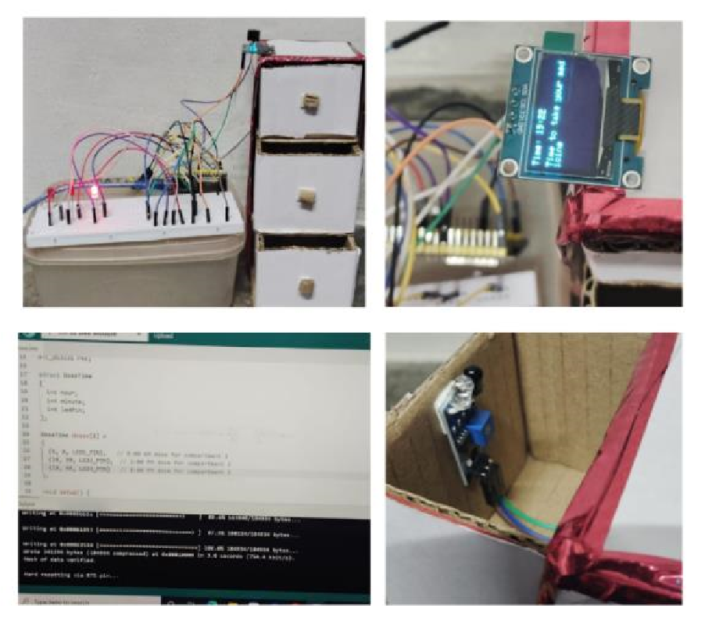

VI. FUTURE WORK

FORTHCOMING
Even though it has been established that the IoT-based Smart Medicine Box is effective in reminding patients about their medications, tracking their compliance, and allowing remote monitoring, there are many advanced enhancements that may be made to enhance intelligent capabilities and efficiency. The field with one of the most advanced developments currently is applying artificial intelligence technology to support intelligent healthcare decisions. One key improvement will necessarily involve the integration of an expiration and quality analysis system using an AI-based tablet analysis system. Such integration will involve connecting the existing pill box with the addition of a microcamera or images sensor to the ESP32 module or even the AI processor. The application will make use of computer vision technology, where the entire process will self-analyze the visual attributes that include color, shapes, sizes, and patterns on the surface of the tablet, followed by the subsequent comparison with the pre-trained data set. data set.
Based on any changes detected in relation to expiration, discoloration, contamination, and damage, an alert is quickly generated to both the patient and the person caring for them so that any misuse due to substandard drugs might be avoided. Although the present system involves vision to check the changes, future versions are expected to introduce AI algorithms to detect any changes in the drugs due to improper storage conditions, including any environmental effects such as moisture, heat, and exposure to too much light. The Smart Medication Box also has cloud-based AI that assists in the shelf life tracking of medications and also offers a refill notification. User-friendly options like notification through voices and voices assisting users can work well for the elderly as well as visually impaired patients, while a smartphone app allows caregivers to schedule medications for patients. Power management: Smarter power management with the ability to harness solar charging or other novel sources of power can make it more portable. Along with all these features of smart sensing, analytics with Artificial Intelligence, simplicity of interfaces, and eco-friendly power solutions, the Smart Medicine Box is leading towards becoming an effective healthcare partner.

VII.CONCLUSION
In this project, it has been made clear that an effective Smart Medicine Box, aided by IoT, can be designed & implemented with a main aim to increase patient compliance with prescribed medications & ensure overall patient safety. The main aim of this design is to help the patient take the correct medicine at a correct time with reminders & appropriate assistance regarding medications. The use of ‘Internet of Things’ in this smart medicine box makes it capable to monitor medications being consumed by the patient & helps to reduce the possibility of incorrect intake of medications, overdose, & missed doses. It, in a way, helps to ensure overall improved patient health with appropriate & correct intake of medications. The proposed platform is a collection of several major components such as the ESP32 microcontroller, RTC module, OLED display module, buzzer module, LED indicators, infrared sensor module, and a lithium-ion battery. The proposed system can provide a convenient means for time-controlled medicines for the patient. The proposed system can make the prompt reminder automatic-enabled with cloud connectivity. Experimental evaluation indeed proved that automation in medication management could It reduces missed doses and limits reliance on the patient's memory. The RTC module ensured proper time-keeping for consistent delivery of reminders, whereas the proposed a better accessible multimodal alert mechanism ensured accessibility for the users having sensory impairments. Compared with traditional pill organizers, the Smart Medicine Box It is proposed here that offers higher accuracy with greater connectivity and more convenience to the reminder itself. remote functionality, together with dose verification and remote monitoring. These functionalities are especially useful for elderly patients or those undergoing long-term treatments who have to stick strictly to schedules of medication prescribed intake. This contribution would relate to the Proposed extension toward AI-based tablet quality and Expiration detection is what it does. It introduces a paradigm shift from mere reminder systems with integrated artificial intelligence Ranging from using IoT to intelligent platforms for medication safety, This, in turn, forms the basis on which future versions of the system can pick up for testing. Expired, damaged, or deteriorated tablets, thereby further: Reducing associated medication risks and aiding predictive healthcare practices. This makes up a Transition from reactive care to proactive and preventive medication management. In final consideration, the Internet of Things-enabled Smart Medicine Box will take into account the shifted towards personalized and intelligent healthcare solutions. The proposed scheme therefore offers improved the ability to improve the level of compliance regarding treatments, the right to patient safety, together with alleviating the burden of caregiving. through automation and real-time monitoring by filling the gap existing between patients and caregivers. Furthermore, further Development and integration of highly advanced AI-enabled features, the developed system has a vast potential for deployment at homes, hospitals, and senior living facilities, This, in turn, is hoped to enhance efficiency in healthcare and Ensure better medical results.

VIII.REFERENCES

- Z. Nasir and A. Asif, “Design of a smart medical box for automatic pill dispensing and health monitoring,” International Journal of Advanced Computer Science and Applications, vol. 12, no. 3, pp. 45–52.
- M. N. Norasmawi, A. Amran, M. N. A. Z. Rijaluddin, and N. A. Ahmad, “Smart medicine box with mobile application,” Journal of Telecommunication, Electronic and Computer Engineering, vol. 12, no. 2, pp. 23–28.
- M. M. Hassain, A. Rahman, M. N. I. Harun, M. A. I. Emon, and M. T. Alam, “Voice-activated medicine reminder box with IoT health monitoring for old people and hospitals,” Proc. Int. Conf. on Computer and Information Technology, pp. 1–6.
- R. Al-Shammary, D. Mousa, and S. E. Esmaeili, “The design of a smart medicine box,” Proc. Iranian Conf. on Electrical Engineering (ICEE), pp. 130–134.
- S. Bhati, H. Soni, V. Zala, P. Vyas, and Y. Sharma,
“Smart medicine reminder box,” IJSTE-International Journal of Science Technology & Engineering, vol. 3, no. 10, pp. 172–177.
- N. B. Othman and O. P. Ek, “Pill dispenser with alarm via smartphone notification,” Proc. IEEE 5th Global Conf. on Consumer Electronics, pp. 1–2.
- P. H. Vardhini, M. S. Harsha, P. N. Sai, and P. Srikanth, “An IoT-based smart medicine assistive system for memory impairment patients,” Proc. 12th Int. Conf. on Computational Intelligence and Communication Networks (CICN), pp. 182–186.
- H. Zeidan, K. Karam, A. Hayek, and J. Boercsoek, “Smart medicine box system,” Proc. IEEE Int. Multidisciplinary Conf. on Engineering Technology (IMCET), pp. 1–5.
- D. Divakar, S. K. Singh, and F. Dkhar, “Smart medicine box using IoT with an alarm and SMS notification.”
- N. U. Nyapathi, B. Pendlimarri, S. Karishma, and C.
Kavya, “Smart Medicine Box using ARM 7 Microcontroller,” International Research Journal of Engineering and Technology (IRJET), vol. 3, no. 5.
- O. Al-Mahmud, K. Khan, R. Roy, and F. M. Alamgir, “Internet of Things (IoT) based smart health care medical box for elderly people,” Proc. Int. Conf. for Emerging Technology (INCET), pp. 1–6.
- N. Z. Nadzri, Y. Yusof, and A. F. A. Fazil, “Inbox: Smart medicine box with IoT application,” Eur. J. Mol. Clin. Med., vol. 7, pp. 3747–3757.
- V. B. Sree, K. S. Indrani, and G. M. S. Latha, “Smart medicine pill box reminder with voice and display for emergency patients,” Materials Today: Proceedings, vol. 33, pp. 4876–4879.
- S. Rahimi, A. D. C. Chan, and R. Goubran, “Usage Monitoring of Electrical Devices in a Smart Home,” Proc. IEEE Int. Conf. on Engineering in Medicine and Biology (EMBC), pp. 5307–5310.
- N. K. Suryadevara, A. Gaddam, R. K. Rayudu, and S. C. Mukhopadhyay, “Wireless Sensors Network Based Safe Home to Care Elderly People: Behaviour Detection,” Sensors and Actuators: A. Physical, vol. 186, pp. 277–283.
- A. Boni, F. Pianegiani, and D. Petri, “Low-Power and Low-Cost Implementation of SVMs for Smart Sensors,” IEEE Transactions on Instrumentation and Measurement.

