# **Key-Value (KV) database**

## Name: Ioanna Mourtzaki cs22200021

## Course: Big Data Management (M111)

## Professor: Alexandros Ntoulas

## Semester: Fall 2022

In this project we have created a simple version of a distributed, fault-tolerant, Key-Value (KV) database (or store), with a few tweaks. This database implementation was fully coded in Python and was run and tested on a Python environment using the Visual Code IDE. The “Mourtzaki_Ioanna_Project.zip” file also contains the source code, the input/output files (.txt) that are part of the project ana a README.md file with running details.

### **Data Creation (genData.py)**

In this of the project, we generate data that will be loaded to the key value store.

The assumptions made at this part of the project are the following:

* In the “keyFile” file there are different keys (name, age, height etc.), while the supported types are string, int and float.
* The output data are stored in a file called “dataToIndex” and their format is similar to the JSON format, as shown in the example below. Every key (high-level and the other ones) and also every value (string, int, float) are enclosed in ‘..’.
  + *'key0':{'name': {'age': '76', 'address': 'VM'}}*
* The high-level keys are named keyX, where X is an increasing number from 0 to n (number of lines input given from the user). So, in the “dataToIndex” file the high-level keys are key0, key1,.., keyN.
* In order to create the payload with the key-values data, we have used recursion. Specifically, we randomly decide the nesting level we will apply, based on the maximum level of nesting given from the user. In addition, we randomly decide the insides key number of the high-level key, based on the maximum number of keys given from the user. Then, for every inside key we apply recursion, as many times as the nesting level.
* We use the maximum string length given from the user to create the randomly created string value. All string variables consist of ASCII letters (both lower and upper case). Also, the maximum integer value is 100 and the maximum float value is 200 (with two decimal digits). These limits have been set based on the logic of the keys identified in the “keyFile” file.
* When the output data is successfully created, a “Data was successfully generated” message will be shown to the user.
* When an argument is missing from the user’s input, a message “Some arguments are missing. Please provide the required info in this order:….” will be shown to the user.

### **Key Value store**

In this part of the project, we create a KV Client that will be accepting queries and will be redirecting requests to the KV servers, collecting the results, and presenting them to the user and a KV Server that will be storing the actual data and will be handling the queries coming from the client.

### KV Client (kvClient.py)

The assumptions made at this part of the project are the following:

* The “serverFile” is a file containing server IPs and their respective ports that will be listening for queries and indexing commands. For example, “123.123.12.12 8000”. The k value is the replication factor, i.e., how many different servers will have the same replicated data. First, we check if the servers provided are less than the 'k' number. If so, the program must exit.
* We establish connection with the server using the socket connection, providing the IP address and the port given.
* We inform the user with suitable messages when the index of the servers is started and finished.
* Every time we check if the servers are down before answering the user query.
* When user is providing a new query, if their input is empty, then a suitable message is shown, and the user has to provide another query. The same happens when user provides only a command without key specified, for example just “GET”, or a command that is not supported. The supported ones are : GET, QUERY, COMPUTE, DELETE, EXIT.
* The “EXIT” command is used in order to exit the program.
* The commands given from the user can be either capitalize or not. For example, both “GET” and “get” formats are acceptable.
* After server indexing with the data, the user cannot perform any “PUT” requests. So, if they try so, a “PUT requests are not supported after server indexing” message will be shown.
* The user is not able to perform “DELETE” actions, if at least one server is down, because this will lead to differences between the servers. So, if this happens, a “DELETE request cannot be executed because at least one server is down” message will be shown.
* The “socket.recv” parameter has been set to 4098, so the socket will be able to read at most 4098 bytes of the incoming data.
* Every time the client communicates with the server from any reason (first indexing or responding to requests), the server response will be shown to the user. This response would be “OK” with some data, or “ERROR” with the error message. It is depended on each case.
* When an argument is missing from the user’s input, a message “Some arguments are missing. Please provide the required info in this order:….” will be shown to the user.

### KV Server (kvServer.py)

At this part of the project, we can run from different terminals the “connection” command, in order to set up multiple servers simultaneously.

The assumptions made at this part of the project are the following:

* We establish a server connection based on the IP address and port given from the user. We inform the user for this process, with messages like "Socket successfully created!" and "The socket is waiting..(for requests)".
* When the indexing of the server is done, a message like “OK” or “ERROR” will be shown to the user, based on the indexing status.
* The “socket.recv” parameter has been set to 4098, so the socket will be able to read at most 4098 bytes of the incoming data.
* The “socket.listen” parameter has been set to 5.
* When run, the server will create an instance of an empty Trie object, which will be filled with the data received by the client (server indexing). If the specific key already exists in the Trie structure, it will not be overwritten, and a suitable message will be shown to the user.
* The “GET” and “DELETE” requests can only be performed in high-level keys. So, we check if the key provided is high-key, and otherwise we inform the user that “No high-level key specified”.
* In “GET”, “QUERY” and “COMPUTE” requests the response follows this format:
  + *GET key1 : 'key1':{'name': {'age': '76', 'address': 'VM'}}*
* In all types of requests, if the (high-level) key provided is not found in the Trie, a message "KeyX was not found - is not a (high-level) key” will be shown.
* If the user provides an unsupported request, the message "This request is not available. Supported requests: GET, QUERY, COMPUTE, DELETE, EXIT." is shown.
* When an argument is missing from the user’s input, a message “Some arguments are missing. Please provide the required info in this order:….” will be shown to the user.

### Trie (trie.py)

At this part of the project, we implement the Trie structure. Generally, trie is a tree-like data structure made up of nodes. Nodes can be used to store data. In our implementation,  each node is used to store a character, and consequently each "branch" of the trie represents a unique word. The following figure shows a trie with five words (was, wax, what, word, work) stored in it.

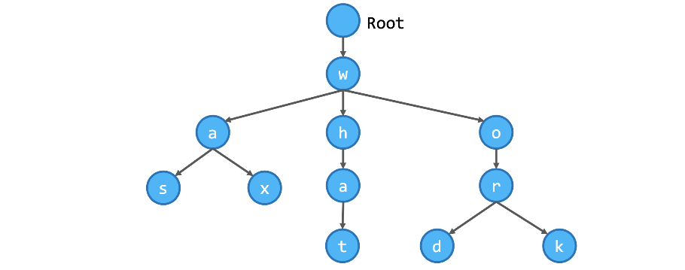

The assumptions made at this part of the project are the following:

* In order to insert a new word into the trie, we need to first check whether any prefix of the word is already in the trie. So, our program is based on the below logic:
  + Traverse the trie from the root node
  + Set the current node to be the root node
  + Check if the current character is a child of the current node
    - If no, we will create new nodes and insert them into the trie
    - If yes, set the current node to be this child node, set the current character to the next character in the input word, and perform this step again
* The search function is used in both “GET” and “QUERY” requests.
* In order to search for a word in the trie, we follow the below logic in our program:
  + For example, we are searching for the word “XYZ”
  + Start from the root node, we are able to find the node X and Y
  + From the node Y, we can go on to traverse the trie to retrieve all words starting with the prefix XY
  + When we arrive at the node Y, we check whether it is the end of a word, and if so, the word XYZ is returned as answer to the client
* The “COMPUTE” function supports the following math functions:
  + Addition
  + Subtraction
  + Division
  + Multiplication
  + Power
  + Trigonometric functions (sin, cos, tan)
  + Logarithmic functions (base 10)
* The above math functions are supported for up to 3 variables. In the case of:
  + one variable, this should be called X (or x)
  + two variables, these should be called X (or x) and Y (or y), following this specific order
  + three variables, these should be called X (or x) and Y (or y) and Z (or z), following this specific order

For example, the below query follows the above rules, as the first variable is X, the second is Y and the third is Z.

* *COMPUTE 2/(X+3*(Y+Z)) WHERE X = QUERY key2.address.number AND Y = QUERY key1.age AND Z = QUERY key3.height*
* In the “COMPUTE” function, in the case that the query contains trigonometric/logarithmic functions, we instantly replace it with the actual math function in Python. For example, if the string from the query is log(X), we will replace it with math.log(X), in order for the “eval” Python method to execute the math function immediately.
* Exactly the same happens in the case of the power (^) and we instantly replace it with the actual math function (math.pow) in Python. In order to find the base and the exponent of the power, we have implemented some additional complex logic:
  + For example, we have the “X^2” query and we should remake it to “math.pow(X,2)”
  + Find the power “^” symbol in the query
  + The base is the number at the left of this symbol (X)
  + The exponent is the number at the right of this symbol (X)
  + In the case that the exponent is not just a number, and is for example X^(Y+2), we follow some logic, in order to contain the whole parenthesis index in the exponent value
  + The same applies if the base is not just a number, and is for example (X+Y)^2
  + So, the following power formats are supported: X^2, 2^X, X^Y, (X+Y)^2, X^(Y+2), (X+2)^(Y+2)
  + This way we create the “math.pow(X,2)” and the “eval” Python method will execute it immediately
* The variables can be expressed in lower or upper case, e.g., X or x. But in the same query, the variable should be either X or x. That means:
  + *COMPUTE 2*X WHERE X = QUERY key1.age Supported*
  + *COMPUTE 2*x WHERE x = QUERY key1.age Supported*
  + *COMPUTE 2\*****X*** *WHERE* ***x*** *= QUERY key1.age Not Supported*
* In the case that anything goes wrong in the “COMPUTE” function, a “An error occurred with this operation” message will be shown to the user.
* The “GET/QUERY (search)” and “COMPUTE” functions return two variables: one that determines if the key was found and one with the actual return value of the request.