REGISTERS SET:
=> RISC is having 32 registers set,each of 32 bit
=> ‘S’ series registers and ‘T’ series registers are used for storing variables (s0 to s11(8-9,18-27),
t0 to t6(5-7,28-31)) → 19 registers
=> ‘ra’(return address,reg 1) and a0 to a7 (reg 10 to 17) have special uses during function calls → 9 registers
=> sp(stack pointer),gp(global pointer),tp(thread pointer) (reg 2 to 4) → 3 registers
=> Total = zero reg + 19 + 9 + 3 = 32 registers .

CONSTANTS/IMMEDIATES:
=> Risc V instructions can use constant or immediate operands and these constants are called immediates because their values are immediately available from the instruction and do not require a register or memory access .

=>For immediate instructions ,the instruction ends with ‘I’, for example addi

=> Immediates are 12 bit two’s compliment numbers ,so they are sign-extended to 32 bits

=> ‘addi’ instruction is a useful way to initialize register values with small constants

=> addi s5,x0,0x60 ,this instruction is nothing but initializing register s5 with 0x60

=> To create larger constants ,use a load upper immediate(lui) instruction followed by an add immediate instruction(addi)

=> The ‘lui’ instruction loads a 20-bit immediate into the most significant 20 bits of the instruction and places zero in the least significant bits .

=> eg: int a = 0xABCDE123; => lui s2,0xABCDE #s2 = 0x ABCDE000
addi s2,s2,0x123 #s2 = 0x ABCDE123

=> When creating large immediates,if the 12-bit immediate in addi is negative (I.e bit 11 is 1),the upper immediate in the lui must be incremented by one as the addi sign-extends the 12-bit immediate ,so a negative immediate will have all 1’s in it’s upper 20 bits .Because all 1’s is -1 in two’s compliment ,adding all 1’s to the upper immediate results in subtracting 1 from the upper immediate .

=> eg : int a = 0xFEEDA987; => lui S2,0XFEEDB #s2 = 0xFEEDB000
addi S2,S2,0X987 #s2 = 0xFEEDA987

MEMORY:
=> In the RISC-V architecture ,instructions operate exclusively on registers ,so data stored in memory must be moved to a register before it can be processed .

=>The RV32I RISC-V architecture uses 32-bit memory addresses and 32-bit data words .RISC-V uses a byte-addressable memory .

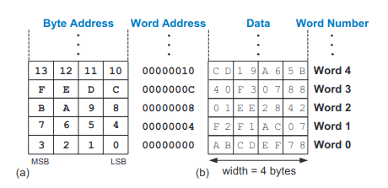

=> The load word instruction(lw) reads a data word from memory into a register .

=> The lw instruction specifies the memory address using an offset added to a base register .

Eg: lw rd, imm(rs1)
R[rd] = mem[R[rs1] + signex(imm)]

a=mem[2]; => #s7 = a, lw s7,8(zero) => #s7 = data at memory address(zero + 8)

The above example loads memory word 2 located at address 8 into a

address 0 => mem[0] ; addr 0 => 1st byte,addr 1 => 2nd byte,addr 2 => 3rd byte,addr 3 => 4th byte
address 4 => mem[1] ; addr 4 => 1st byte,addr 5 => 2nd byte,addr 6 => 3rd byte,addr 7 => 4th byte
address 8 => mem[2] ;

The Program Counter – also called the PC keeps track of the current instruction .The PC holds the memory address of the current instruction and increments by four after each instruction completes so that the processor can read or fetch the next instruction from the memory .

Logical instructions :
Logical operations include and,or,and xor .These each operate bitwise on two source registers and write the result to a destination register . Immediate version of these logical operations ,andi,ori, and xori, use one source register and a 12-bit sign-extended immediate .

Sign-extended logical immediates are somewhat unusual .Many other architectures ,such as MIPS and ARM,zero-extend the immediate for logical operations.

A logical NOT operation can be performed with xori s8,s1,-1. Remember that -1 (0xFFF) is sign-extended to 0xFFFFFFFF(all 1’s).XOR with all 1’s invert all the bits ,so s8 will get the one’s complement of s1.

Shift Instructions:
shift instructions shift the value in a register left or right,dropping bits off the end .RISC-V shift operations are sll(shift left logical),srl(shift right logical),and sra(shift right arithmetic).

=> Shift left always fill the least significant bits with zeros. However ,right shifts can be either logical(zeros shift into the most significant bits) or arithmetic (the ign bit shifts into the most significant bits ).These shifts specify the shift amount in the second source register.

=>Immediate versions of each instructions are also available (slli,srli,and srai),where the amount to shift is specified by a 5-bit unsigned immediate (2^5 = 32 ).

=>Shifting a value left by N is equivalent to multiply it by 2^N and divide by 2^N when logical right shift is performed.

=>Arithmetic right shifts divides two’s complement numbers,while logical right shifts divide unsigned numbers .

Branching:

=> An advantage of a computer over a calculator is its ability to make decisions .
=> Branch instructions modify the flow of the program so that the processor can fetch instructions that are not in sequential order in memory .They modify the PC to skip over sections of code or to repeat previous code .

=>Conditional branch instructions perform a test and branch only if the test is TRUE .Unconditional branch instructions ,called jumps ,always branch .

Conditional Branches:
beq(branch if equal) => Branches when rs1 == rs2
bne(branch if not equal) => Branches when rs1 != rs2
blt(branch if less than) => Branch if rs1 < rs2 ,this consider rs1 and rs2 as signed numbers
bltu(branch if less than) => Branch if rs1 < rs2 ,this consider rs1 and rs2 as unsigned numbers)
bge(branch if greater than or equal ) => Branch if rs1 > rs2 ,this consider rs1 and rs2 as signed numbers)
bgeu(branch if greater than or equal ) => Branch if rs1 > rs2 ,this consider rs1 and rs2 as unsigned numbers)

Jumps:
A program can jump—that is ,unconditionally branch-- using one of three instructions :
jump(j),jump and link(jal) and jump register(jr).

=> j jumps directly to the instruction at the specified label .

Function calls:
High – level languages support functions (also called procedures or sub-routines) to reuse common code and to make a program more modular and readable .Functions may have inputs,called arguments ,and an output called the return value.

Functions should calculate the return value and cause no other uintended side effects .

When one function calls another ,the calling function ,the caller ,and the called function ,the callee,must agree on where to put the arguments and the return value .

In RISC-V programs ,the caller conventionally places upto eight arguments in registers a0 to a7 before making the function call ,and the callee places the return value in registers a0 before finishing .

By following this convention ,both functions know where to find the arguments and return value ,even if the caller and callee were written by different people

The callee must not interfer with the behavior of the caller .This means that the callee must know where to return to after it completes and it must not trample on any register or memory needed by the caller .

The caller stores the return address in the return address register ‘ra’ at the same time it jumps to the callee using the jump and link instruction(jal).

The callee must not overwrite any architectural state or memory that the caller is depending on .specifically ,the callee must leave the saved registers (S0-S11),the return address(ra),and the stack .

RISC-V uses the jump and link instruction ‘jal’ to call a function and the jump register ‘jr’ to return from a function .

R-Type instructions:
These instructions use three registers as operands :two as sources and one as destination

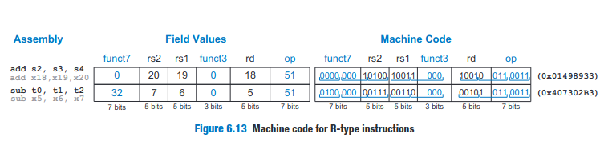
The operation the instruction performs is encoded in the three fields highlighted in blue :7 bit op,7 bit funct7 and 3 bit funct3 (also called the function fields).

These bits together are called the control bits because they control what operation to perform .

I-type Instructions:(loads – lw,lh,lb,lhu,lbu reg jumps – jalr ,regular – addi,andi,ori,xori)
These instructions use two register operands and one immediate operand. I-type is similar to R-type but includes a 12-bit immediate field imm instead of the funct7 and rs2 .rs1 and imm are the source operands ,and rd is the destination register .

The immediate field represents a 12-bit signed (two’s compliment).

I-type instructions have a 12-bit immediate field ,but the immediates are used in 32-bit operations using sign extension
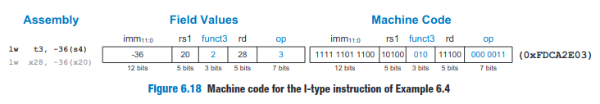

S/B-type Instructions:(Store or Branch type)
Like I-type instructions ,S/B-type instructions use two register operands and one immediate operand .However,both of the register operands are source registers (rs1 and rs2) in S/B-type,whereas I-type instructions use one source register (rs1) and one destination register(rd).

These type of instructions replace the funct7 and rd fields of R-type instructions with the 12-bit immediate imm. Thus this immediate field split across two bit ranges,bits 31:25 and bits 11:7,of the instruction .

S-type instructions encode a 12-bit signed(two’s complement) immediate ,with the top seven bits (imm[11:5]) in bits 31:25 of the instruction and the lower five bits (imm[4:0]) in bits 11:7 of the instruction .

B-type instructions encode a 13-bit signed immediate representing the branch offset,but only 12 of the bits are encoded in the instruction .The least significant bit is always 0,because branch amounts are always an even number of bytes .

The immediate of the B-type instruction is a somewhat strange bit swizzling of the immediate .

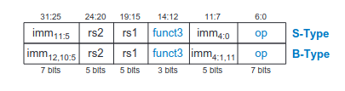

As the o th bit is always 0 for B-type instruction ,it is not included in the instruction .

For 32-bit instructions,bits 1:0 of the 13-bit branch offset(imm[12:0]) are always zero because 32-bit instructions occupy 4 bytes of memory .Thus,instruction addresses are always divisible by four and neither bits 1 nor 0 of the branch offset need to be encoded in the instruction .However RV32I only omits bit 0 .

For B-type instruction,rs1 and rs2 are the two source registers,and the 13-bit immediate branch offset ,imm[12:0],gives the number of bytes between the branch instruction and the BTA.

So,we have to multiply the immediate value with 2 or left shift by 1

U/J-type instructions: (upper immediate/jump)
These instructions have one destination register operand rd and a 20-bit immediate field.

Like other formats,U/J-type instructions have a 7-bit opcode .In U-type instructions,the remaining bits specify the most significant 20 bits of a 32-bit immediate

In J-type instructions ,the remaining 20 bits specify the most significant 20 bits of a 21-bit immediate jump offset .

As with B-type instructions,the least significant bit of the immediate is always 0 and is not encoded in the J-type instruction.

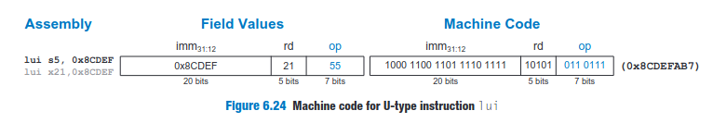

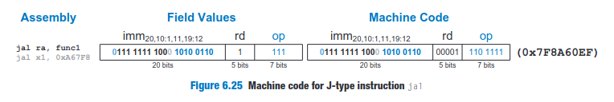
If a destination register , rd,is not specified by a ‘jal’ assembly instruction,that defaults to ra(X1).

For example,the instruction ‘jal L1’ is equivalent to ‘jal ra,L1’ and has ‘rd = 1’.

Ordinary jump(j) is encoded as jal with rd = 0.

Summary On Immediate Encoding:
RISC-V uses 32-bit signed immediates. Only 12 to 21 bits of the immediate are encoded in the instruction .

I-type and S-type instructions encode 12-bit signed immediates.

J- and B-type instructions use 21- and 13-bit signed immediate,where the least significant bit is always 0.

U-type instructions encode the top 20 bits of a 32-bit immediate.

Across instruction formats,RV32I attempts to keep immediate bits in the same instruction bits with the aim of simplifying hardware design .It is shown in the below picture .

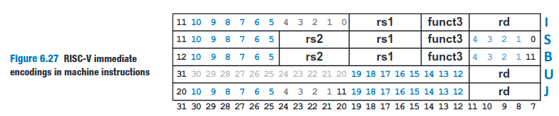
Addressing Modes:
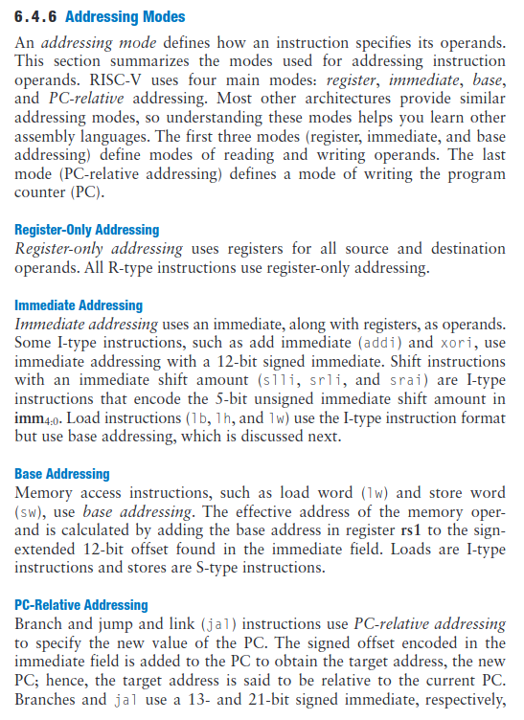

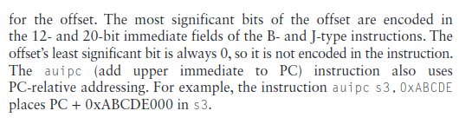

The Memory Map:
With 32-bit addresses,the RISC-V address space spans 2^32 bytes (4 GB).Word addresses are multiples of 4 and range from 0 to 0xFFFFFFFC.

Memory map divides the address space into five parts or segments :the text ,global data ,and dynamic data segments ,and segments for exception handlers and the operating system(OS),which includes dedicated to I/O.

The text segment:
The text segment stores the machine language user program. In addition to code ,it may include literals(constants) and read-only data.

The Global Data Segment:
The global data segment stores global variables that ,in constrant to local variables ,can be accessed by all functions in a program .Local variables are typically located in registers or on the stack.

Global variables are allocated in memory before the program begins executing ,and they are typically accessed using the global pointer register gp(register x3).

The Dynamic Data Segment:
The dynamic data segment holds the stack and the heap .The data in this segment is not known at start-up but is dynamically allocated and de-allocated throughout the execution of the program.

Upon start-up,the OS sets up the stack pointer to point to the top of the stack .Stack typically grows downward. The stack includes temporary storage and local variables,such as arrays ,that do not fit in the registers. Functions also use the stack to save and restore registers.

The heap stores data that is allocated by the program during run-time .In C,memory allocations are made by the malloc function .

Assembler Directives:
Assembler directives guide the assembler in allocating and initializing global variables ,defining constants ,and differentiating between code and data .

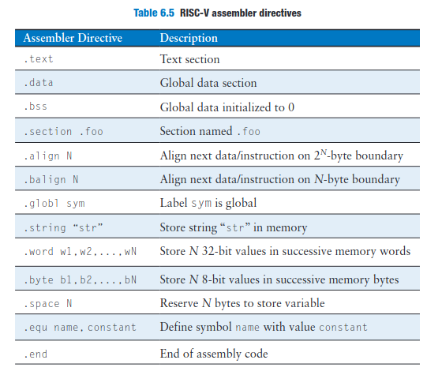

Compiler:
A compiler translates high-level code into assembly language ,and an assembler then translates that assembly code into machine code.

Gcc -O1 -g prog.c -o prog => This command produces an executable output file called prog .

-O1 => ask the compiler to perform basic optimizations .
-g => tells the compiler to include debugging information

To see the intermediate steps,we can use GCC’s -S flag to compile but not assemble or link

gcc -O1 -S prog.c -o prog.s

Assembling:
An assembler turns the assembly language code into an object file containing machine language code .Gcc can create the object file from either .s or directly from .c file .

gcc -c prog.s -o prog.o

gcc -O1 -g -c prog.c -o prog.o

we can disassemble the object file using the objdump command to see the assembly language code beside the machine language code .

Objdump -S prog.o

