1. COUNT PLOT FOR GOOD BAD AND NEUTRAL TWEETS -
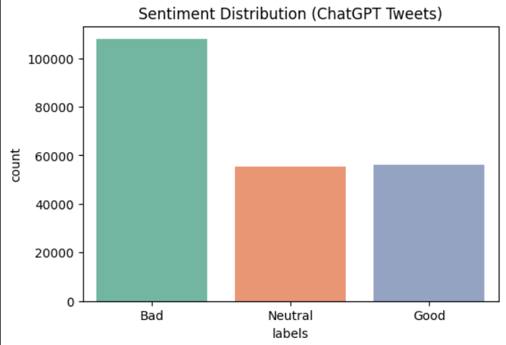

2. WORDCLOUD FOR BAD TWEETS –
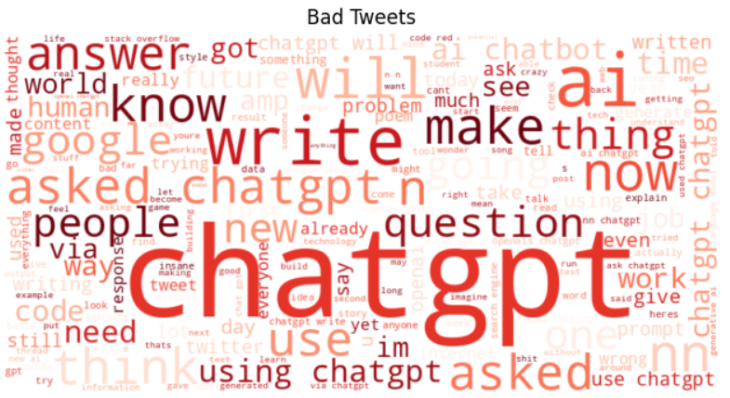

3. WORDCLOUD FOR NEUTRAL TWEETS –
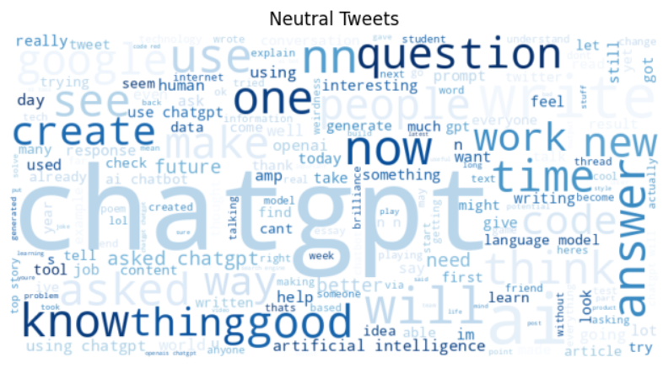

4. WORDCLOUD FOR GOOD TWEETS
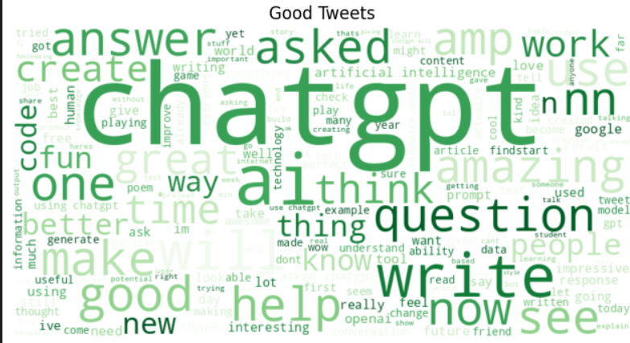

5. CONFUSION MATRIX FOR LOGISTIC REGRESSION –
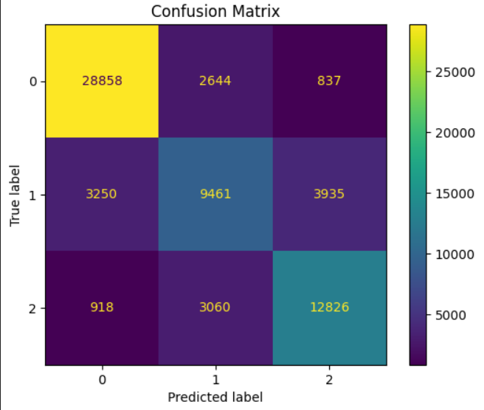

6. ROC CURVE FOR LOGISTIC REGRESSION –
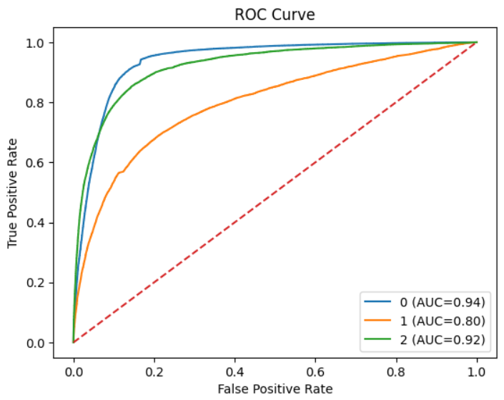
7. PRECISION RECALL CURVE FOR LOGISTIC REGRESSION –
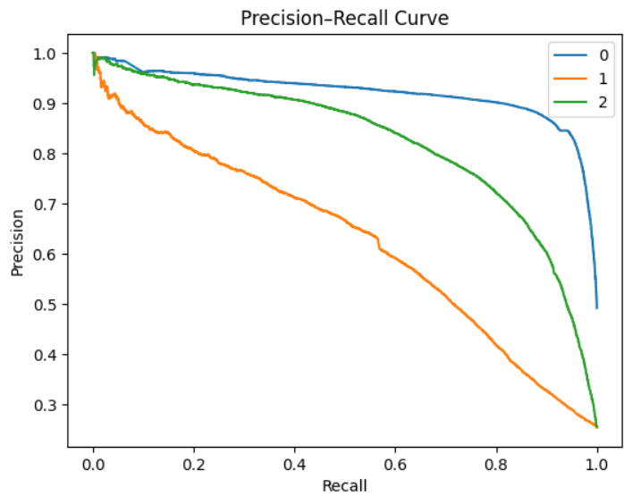

8. TRAINNING VS VALIDATION LOSS FOR DISTILBERT MODEL(TRANSFORMERS) –
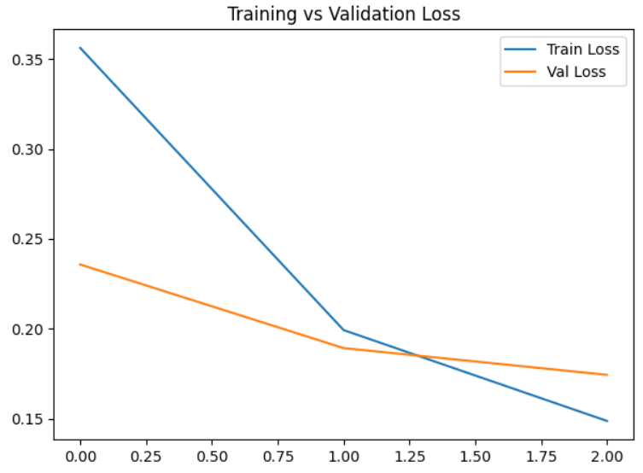
9. CONFUSION MATRIX FOR DISTILBERT MODEL –
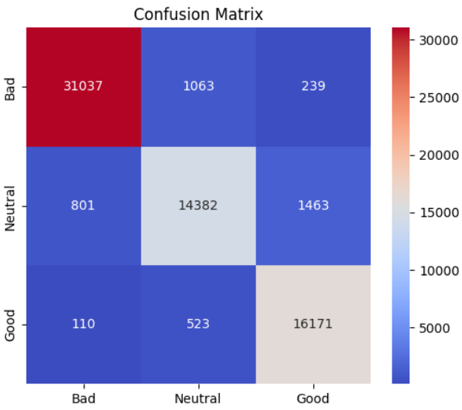

10 . SENTIMENT PROBABILITY FOR NEW TWEET PREDICTION USING DISTILBERT –

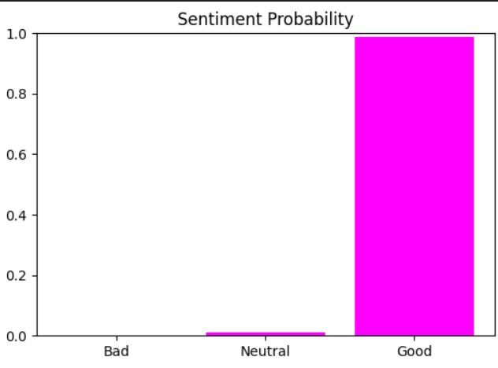
11. ATTENTION HEATMAP FOR NEW TWEET PREDICTION USING DISTILBERT MODEL –
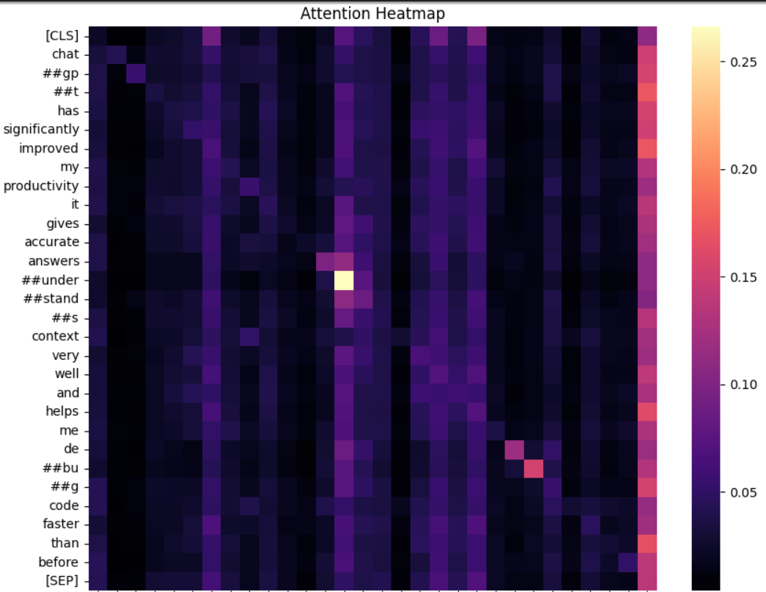

12 . ERROR COMPARISION (LOGISTIC VS DISTILBERT)
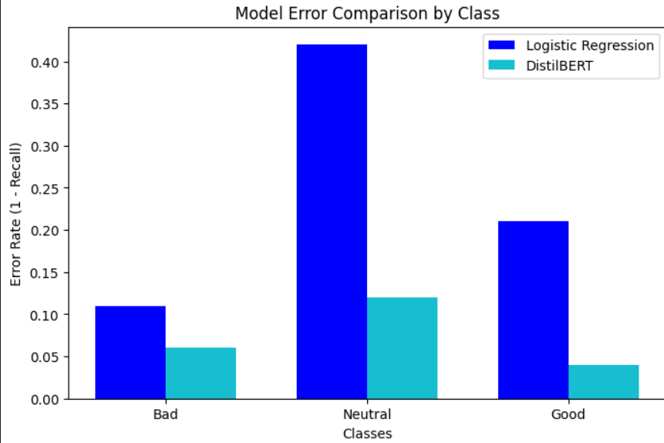
13. F1 SCORE COMPARISION
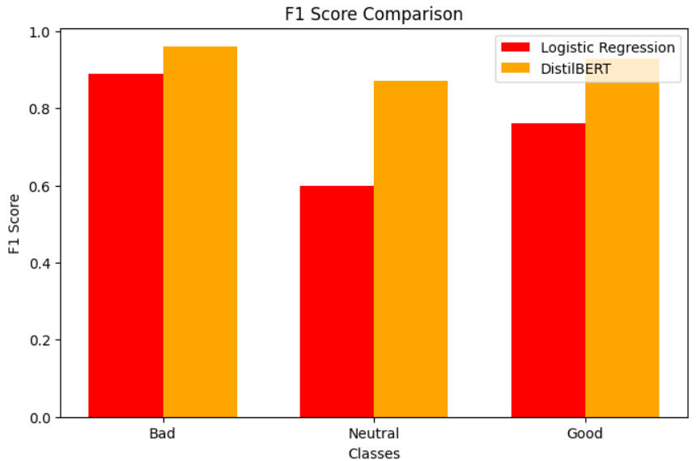

14. OVERALL ERROR COMPARISION (LOGISTIC VS DISTILBERT)
