**INNER JOIN**

select *

from temp_address inner join per_address

on temp_address.Cust_ID=per_address.Cust_ID

where temp_address.House_no=per_address.House_no and temp_address.street=per_address.street

and temp_address.city=per_address.city ;

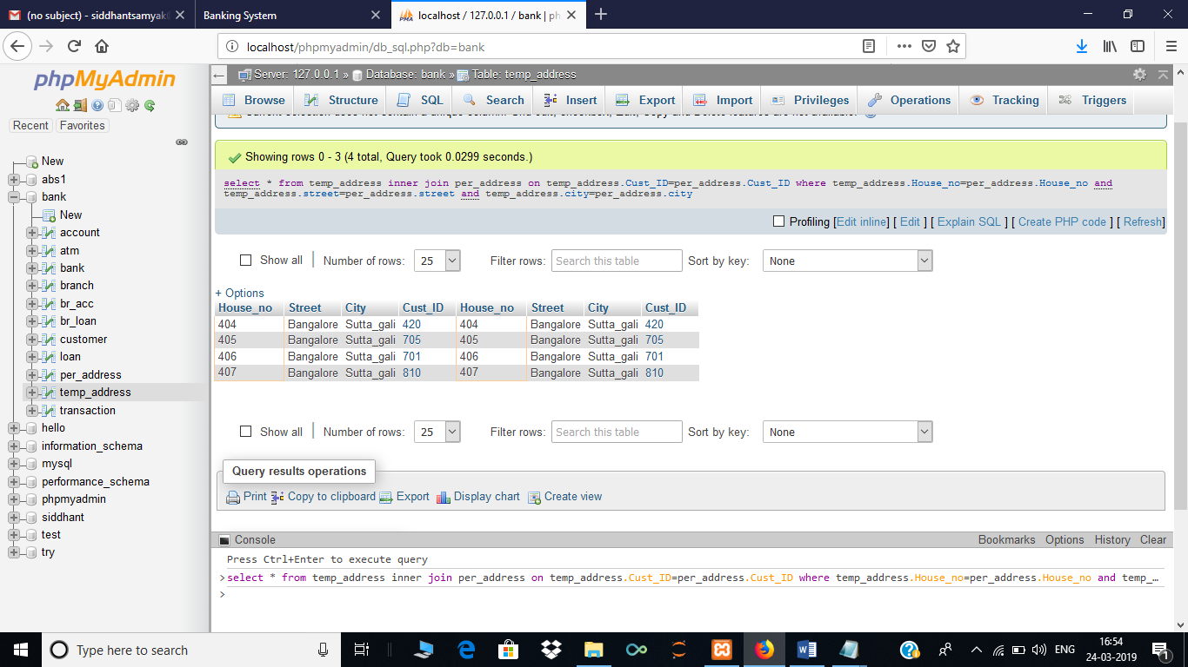

**NATURAL JOIN**

select *

from customer natural join

(select CHQ_DEP as CHQ_DEP,CSH_DEP as CSH_DEP,CSH_WID as CSH_WID,Cust_ID as ID,ATM_NO as ATM_NO from transaction)

as transac;

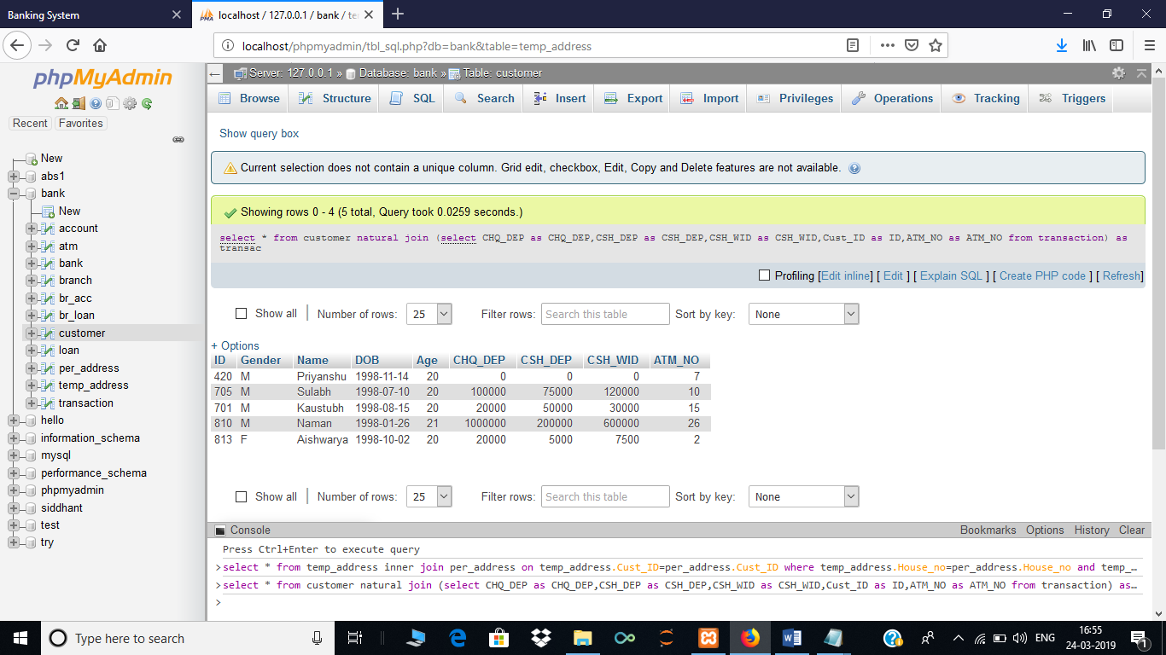

**LEFT JOIN**

select *

from customer left outer join loan

on customer.ID=loan.Cust_ID

where loan.amount>150000;

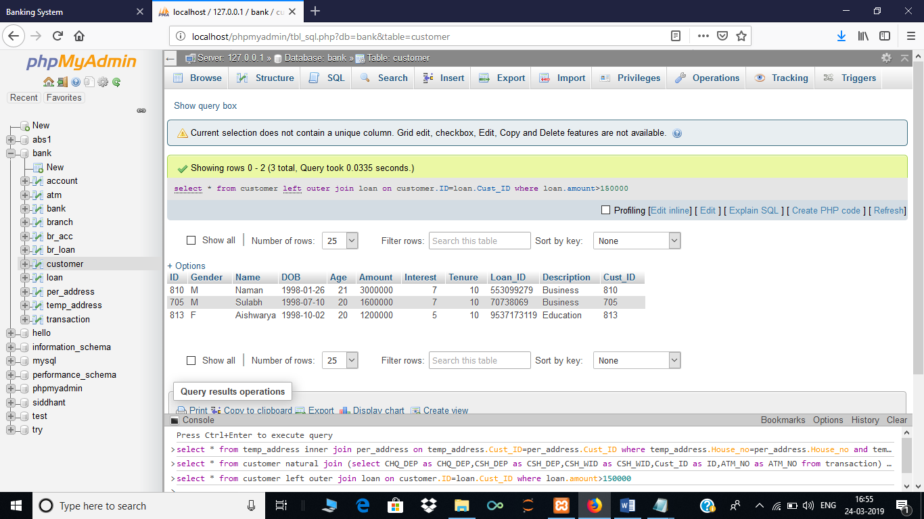

**RIGHT JOIN**

select customer.name,transaction.*

from customer right outer join transaction

on customer.id=transaction.Cust_ID;

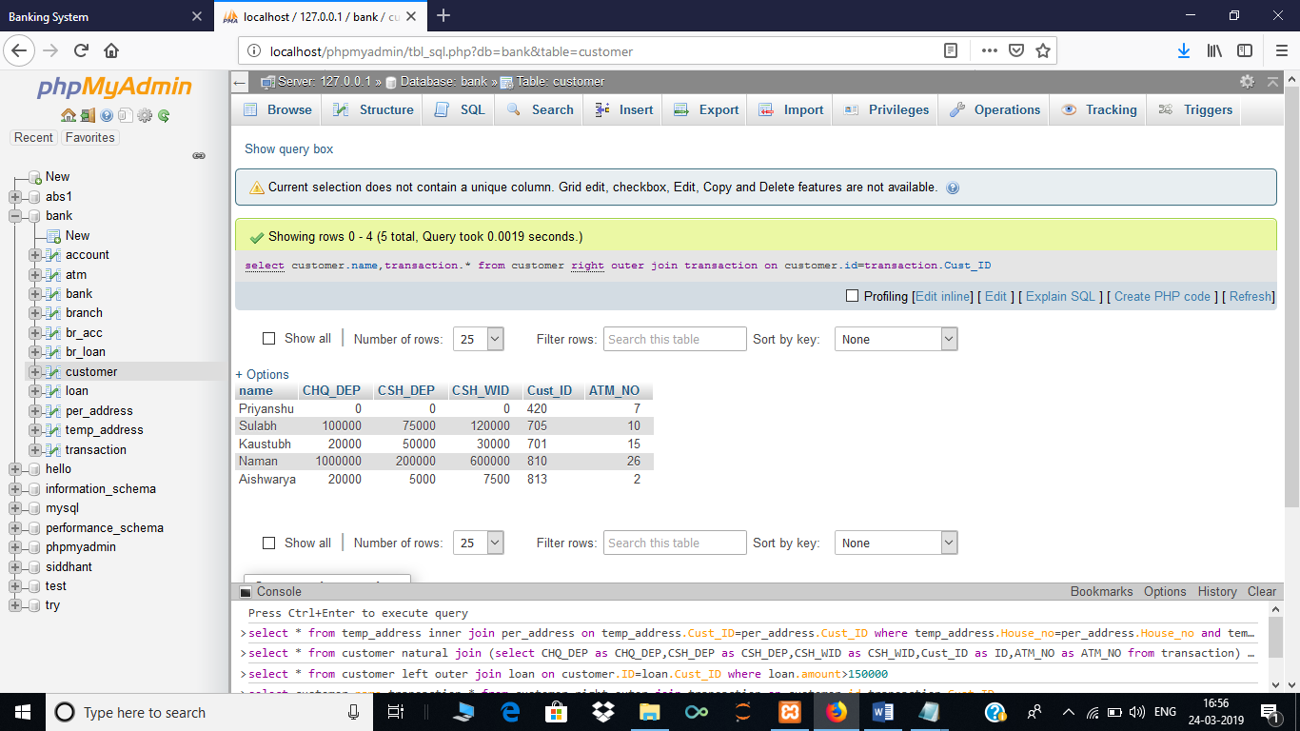

**AGGREGATE FUNCTIONS**

select sum(amount),avg(amount),min(amount),max(amount)

from loan;

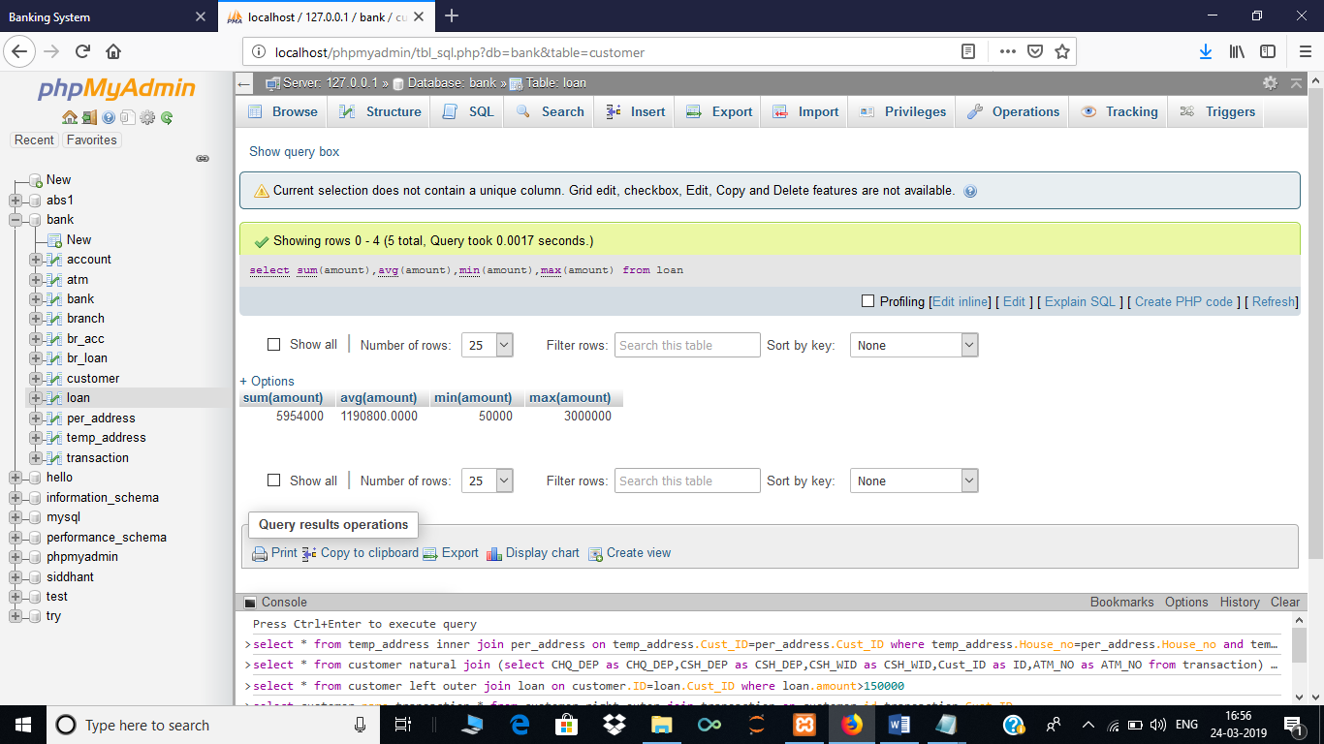

**GROUP HAVING**

select sum(amount),avg(amount),min(amount),max(amount)

from customer join loan

on customer.id=loan.Cust_ID

group by gender

having gender='M';

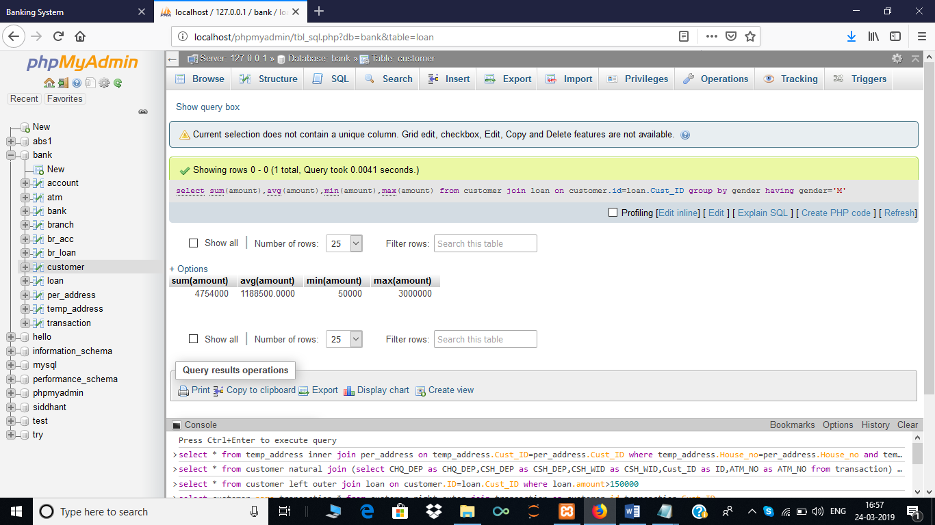

**USE OF COUNT**

select count(*)

from customer;

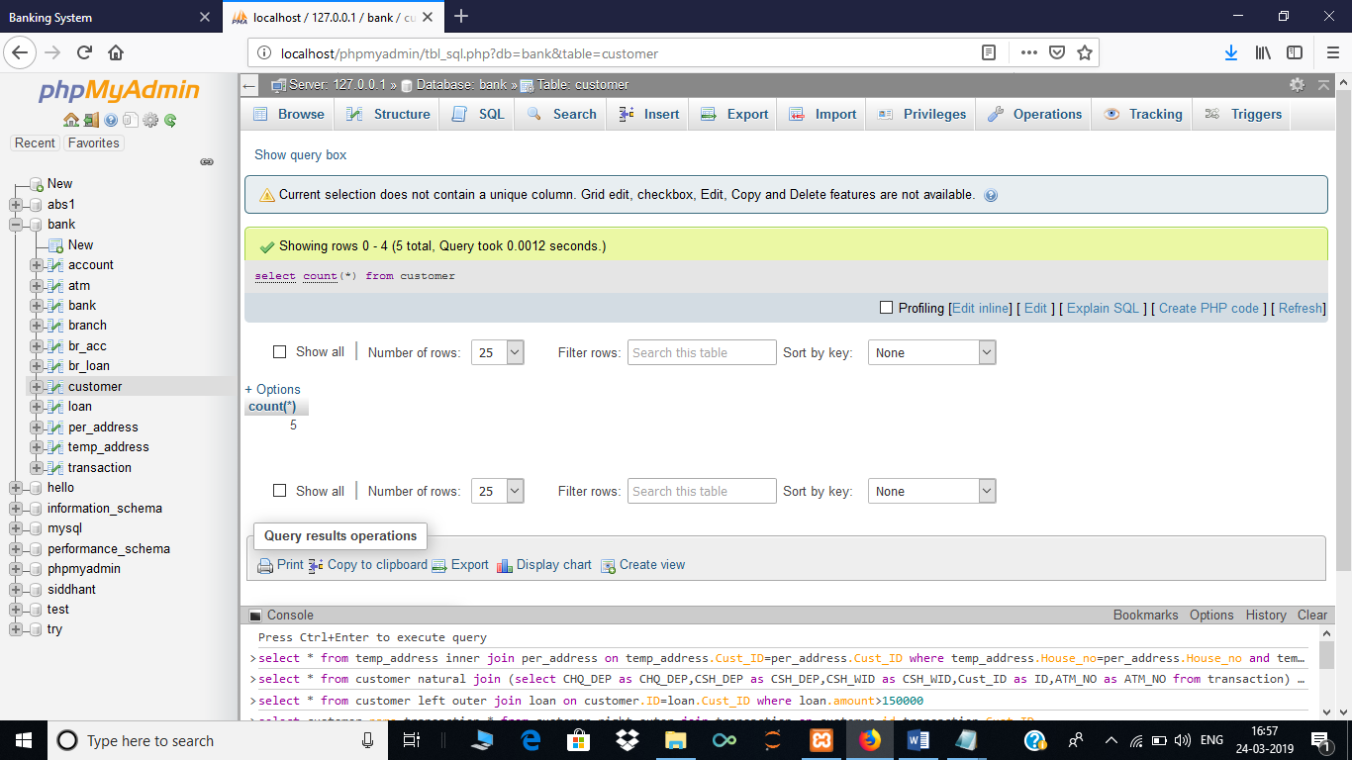

**EXISTS (EDUCATION LOAN)**

select *

from customer

where exists(select *

from loan

where loan.Description='Education' and loan.Cust_ID=customer.id);

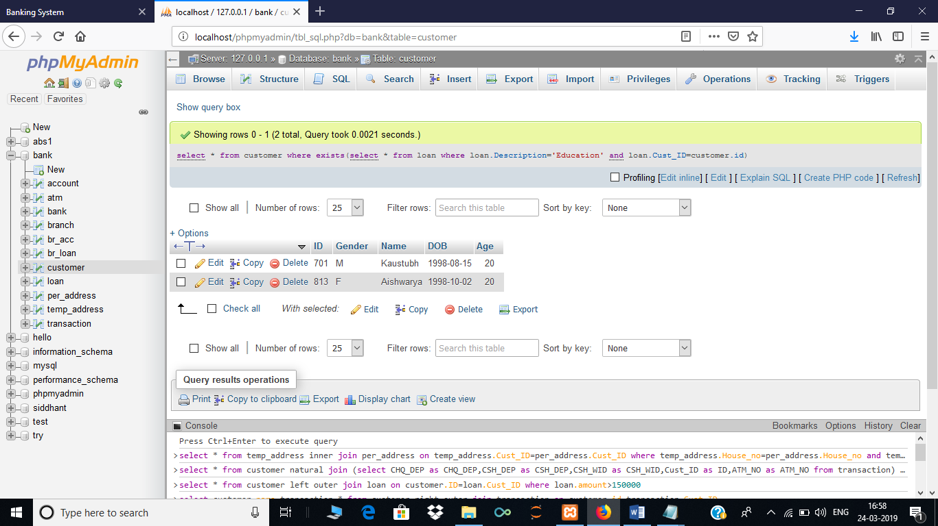

**LOAN PAYMENT**

select customer.name as name,(loan.amount+(loan.amount*loan.interest*loan.tenure/100)) as amount_payable

from customer,loan

where customer.ID=loan.Cust_ID;

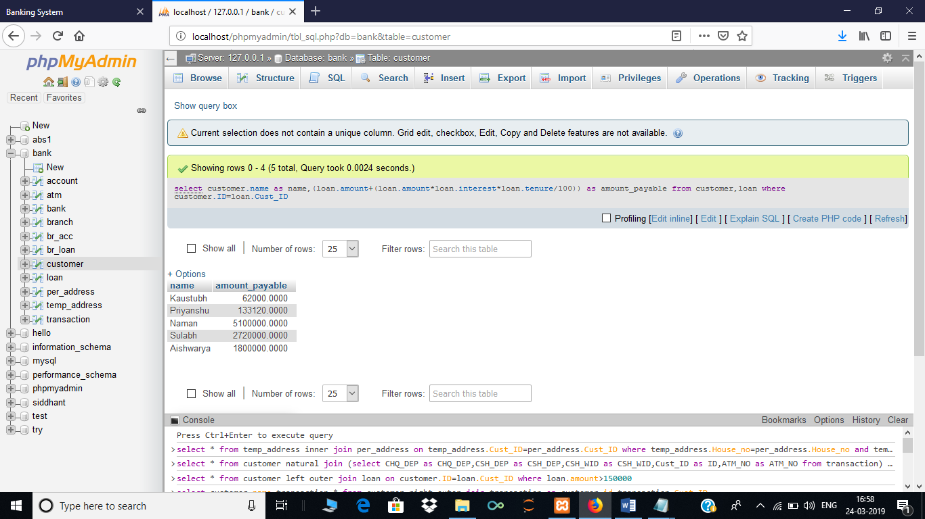

**TABLES**

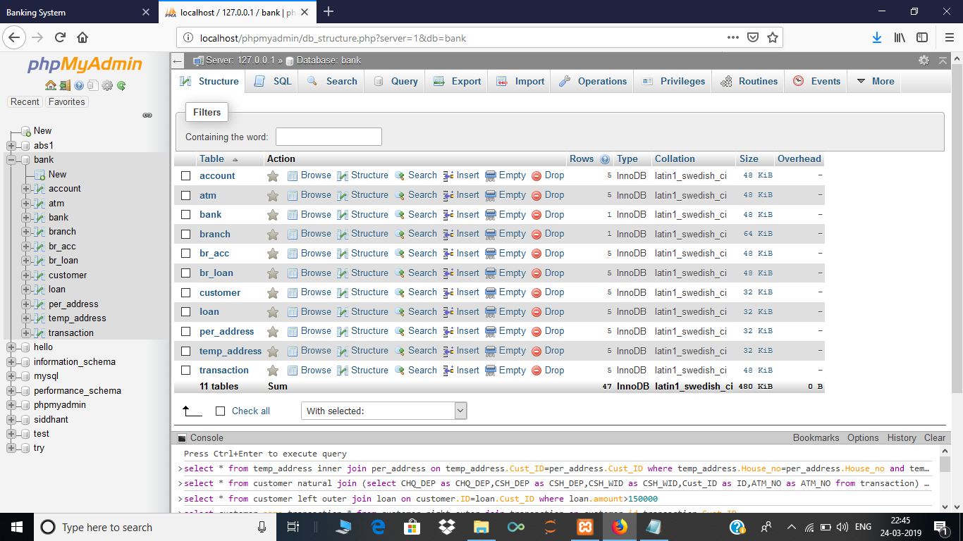

**INSERT STATEMENTS**

insert into customer values(705,'M','Sulabh','1998-07-10',20);

insert into account values(30000,9608370700,'Savings',705);

insert into temp_address values(405,'Bangalore','Sutta_gali',705);

insert into per_address values(405,'Bangalore','Sutta_gali',705);

insert into br_acc values('svs12345',9608370700);

insert into loan values(1600000,6.78,10,0070738069,'Business',705);

insert into br_loan values(0070738069,'svs12345');

insert into atm values (10,10000,705);

insert into transaction values (100000,75000,120000,705,10);

insert into customer values(701,'M','Kaustubh','1998-08-15',20);

insert into account values(25000.34,9971121532,'Savings',701);

insert into temp_address values(406,'Bangalore','Sutta_gali',701);

insert into per_address values(406,'Bangalore','Sutta_gali',701);

insert into br_acc values('svs12345',9971121532);

insert into loan values(50000,5.50,4,2351211799,'Education',701);

insert into br_loan values(2351211799,'svs12345');

insert into atm values (15,10000,701);

insert into transaction values (20000,50000,30000,701,15);

insert into customer values(810,'M','Naman','1998-01-26',21);

insert into account values(50000,9729903550,'Savings',810);

insert into temp_address values(407,'Bangalore','Sutta_gali',810);

insert into per_address values(407,'Bangalore','Sutta_gali',810);

insert into br_acc values('svs12345',9729903550);

insert into loan values(3000000,6.78,10,0553099279,'Business',810);

insert into br_loan values(0553099279,'svs12345');

insert into atm values (26,10000,810);

insert into transaction values (1000000,200000,600000,810,26);

insert into customer values(813,'F','Aishwarya','1998-10-02',20);

insert into account values(7000,9113717359,'Savings',813);

insert into temp_address values(408,'Bangalore','Sutta_gali',813);

insert into per_address values(40,'Delhi','Sarojni_Nagar',813);

insert into br_acc values('svs12345',9113717359);

insert into loan values(1200000,5,10,9537173119,'Education',813);

insert into br_loan values(9537173119,'svs12345');

insert into atm values (02,10000,813);

insert into transaction values (20000,5000,7500,813,02);

insert into customer values(420,'M','Priyanshu','1998-10-02',20);

insert into account values(20459.60,8235444823,'Savings',420);

insert into temp_address values(404,'Bangalore','Sutta_gali',420);

insert into per_address values(404,'Bangalore','Sutta_gali',420);

insert into br_acc values('svs12345',8235444823);

insert into loan values(104000.40,6.78,4,3284445328,'House',420);

insert into br_loan values(3284445328,'svs12345');

insert into atm values (7,10000,420);

insert into transaction values (0,0,0,420,7);

**USER INTERFACE**

