Wave Model Analysis of COARE Gas Transfer Parameters from HIWINGS

The COAREG algorithm gives a simple form for the transfer velocity
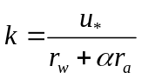 (1)
We can separate the oceanic and atmospheric components as follows
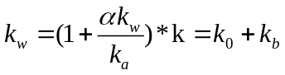 (2)
So from measurements of k, we can compute the oceanside value, which is made up of a turbulent-molecular term, k₀, and a bubble-mediated term, k_{b}. For DMS the correction factor multiplying k is an average of 1.054 for HIWINGS while for CO2 the factor is 1.008. Following Appendix A of Fairall et al. (2011), we can convert to k₆₆₀ and write (2) as
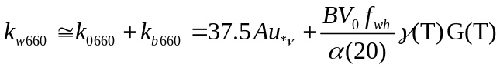 (3)
where the gas-dependent factors are
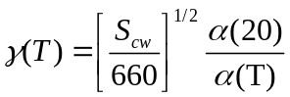 (4a)
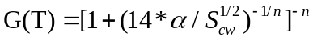 (4b)
with n=1.2. In (3) we have neglected buoyancy effects on the first term, which occur at wind speeds less than 5 m/s.
We can now consider the form of (3) for both CO₂ and DMS,
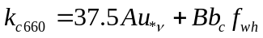 (5a)
(5b)
If k values are expressed in cm/h, then the factor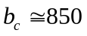, while 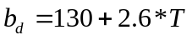; thus, the ratio 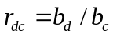 in (5b) varies from 0.16 to 0.22 with an average of 0.18 for HIWINGS. The relationships in (5) can be combined with observations of k for CO₂ and DMS to estimate the constants A and B:
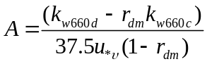 (6a)
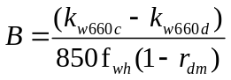 (6b)
If (6) is applied to k values computed with the COAREG algorithm, then for U_{10n}>5 m/s, the values for A and B assumed in the algorithm will be recovered within 10%. If the model and the measurements are consistent, then the values of A and B should be independent of wind speed.
Fig. 1 shows values of A and B extracted from HIWINGS observations averaged in wind speed bins. Two retrievals have been done: (1) with bin-averaged measured k_{w660} and (2) using fits of k₆₆₀ fit to power law in wind speed in the form
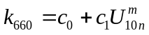 (7)
We have used c0=6.0, c1= 0.41, and m=1.9 for CO₂; c0=0.6, c1= 1.09, and m=1.2 for DMS. Both retrievals used bin-averaged estimates of whitecap fraction computed from Blomquist et al. (2017)
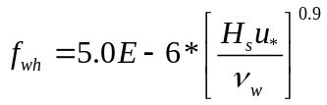 (8)
Averaging both retrieval methods yields A=1.2 and B=2.5. We have also used bin-averaged values of observed f_{wh}; that yields noisier results but does not significantly change the final estimates of A and B.
In Fig. 2 we show a comparison of the wind-speed bin averaged transfer velocities from the three calculation methods: linear+bubble, Eq. 5, power law, Eq. (7), and COAREG36. A summary of the mean and RMS statistics is given in Table 1. Since the power law is fit directly to the mean observations, it gives the best overall fit.

Table 1. Summary of mean k₆₆₀ (cm/h) and RMS difference from mean HIWINGS measurements.
 | CO₂ |  | DMS
 | Mean | RMS | Mean | RMS
Observation | 73.9 | 0 | 24.7 | 0
Interface + Whitecap | 80.6 | 6.2 | 28.2 | 3.3
Power-law | 74.4 | 6.5 | 25.3 | 2.2
COAREG36 | 75.2 | 10.1 | 24.8 | 2.8

One final amusing exercise is to evaluate the correlation of the bubble-mediated transfer component with whitecap coverages. We have done this by comparing the bubble-mediated forcing variable
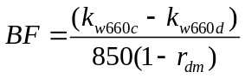 (9)
with f_{wh} (see Fig. 3). The linear correlation coefficients are 0.988 using f_{wh} from (8) and 0.9221 using bin-averaged observed f_{wh}.

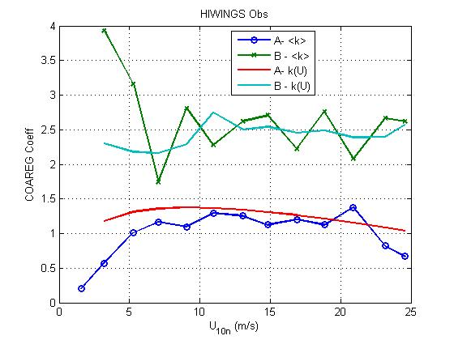
Figure 1. Retrieved values of COAREG constants, A and B, as a function of wind speed. Retrievals are based on mean values of observed k_{w660} averaged in wind speed bins (denoted <k>) plus values of k_{w660} computed from wind-speed power law fits. The bin-averaged f_{wh} are obtained from the Blomquist et al (2017) wave-Reynolds number relationship.
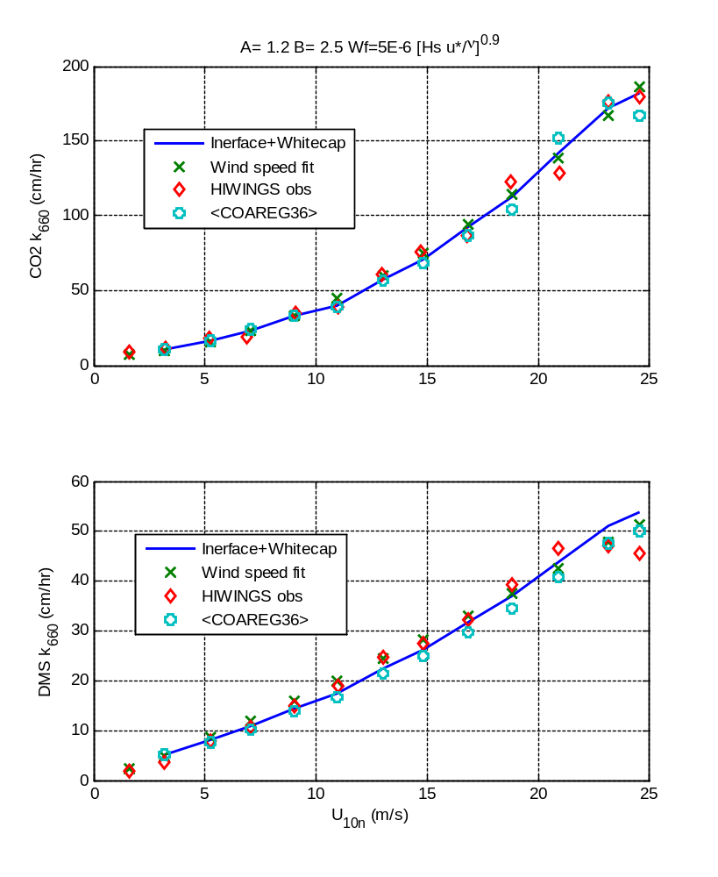
Figure 2. Values of k₆₆₀ (upper panel, CO₂; lower panel, DMS) averaged in wind speed bins vs 10-m neutral wind speed. The red diamonds are mean observed values, the x’s are from the wind speed power-law fits (7), the blue line is from (5) using A=1.2 and B=2.5, and the circles are means of values computed using COAREG36.

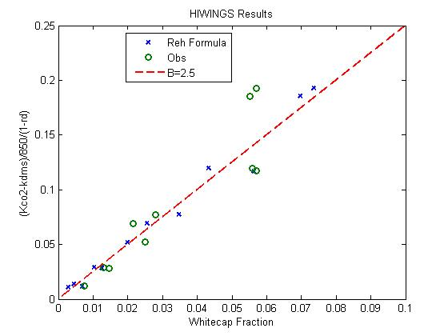
Figure 3. Bubble-mediated forcing vs f_{wh} for HIWINGS. The x’s use (8) for f_{wh}; the o’s used bin-averaged observed f_{wh}. The red dotted line is the expected slope using B=2.5.

