A scaling model of wave energy dissipation and whitecap production

C. W. Fairall, NOAA/ESRL/PSD, 325 Broadway, Boulder, CO 80305, USA

M. L. Banner, and R. P. Morison, UNSW, Sydney 2052, Australia

July 2016

This write up describes application of the wave breaking statistical approach to relating energy dissipation and whitecap fraction as a function of wind-wave conditions. The development is based on the Phillips mean length of wave breaking per unit area, Λ(c), and follows the approach described in Anguelova and Hwang (2016). Three basic properties of wind-wave transfer (transfer of wave momentum to near-surface currents by wave breaking, dissipation of wave KE by breaking, and whitecap fraction) are described by Λ

 (1a)

 (1b)

 (1c)

Here c is a wave phase speed, g acceleration of gravity, b(c) spectrally resolved breaking strength parameter on the order of 1E-3, T(c) the timescale of active breaking persistence on the surface, and ρw the density of water. The integration limits are from a minimum cn to a maximum cx; in the case of whitecaps the minimum is different because we include only the breakers that entrain air and produce an optically visible surface signature.

We use a scaling representation of Λ(c) from Sutherland and Melville (2013)

 (2)

where

 (3)

In a later paper Sutherland and Melville (2015) use cr instead of cp in the Lambda equation. Also, Banner et al. (2016) argue that the treatment of breaking velocity in the Sutherland and Melville papers has problems that changes Λ(c) somewhat. Sutherland and Melville used a1=0.05 and a2=1/10; for the purposes here we have chosen a1=0.05/3 and a2=1/12.

Combining the last two equations yields

 (4)

The nifty unification of powers occurs because we chose a2=1/12, which seems close enough to 1/10 it should not land us in jail.

We can do the first integral (2a)

 (5)

To determine be we match the UNSW wave model dissipation values to this expression. The UNSW model output includes 251 values for Hs, u\*, cp, and Ed at selected wind speeds. An example for the deduced be is shown for u10=12 m/s in Fig. 1. In this case we have chosen cx=2cp and cn=0.15cr. Fixing the value of cn at 1 m/s or fixing the ratio cx/cn=25 does not change the result much.

The whitecap integral is evaluated by assuming the timescale is proportion to the period of the breaking wave`

 (6)

Which yields

 (7)

Note, because we are matching to wave model dissipation the value of be we end up with depends on the value of a1 we pick. This doesn’t affect the dissipation results because they are based on the UNSW wave model (i.e., the product a1\*be is fixed). It does affect the whitecap fraction, because only a1 appears in that formula. Sutherland and Melville (2013) suggest that the limit of whitcapping is given by c/cr=0.8, or cnw=0.8\*cr. At a wind speed of 12 m/s this runs from 1 to 5 m/s in the UNSW model (cnw/cp about 0.5) or a whitecapping c-bandwidth of about 4 (ranging from .5\*cp to 2\*cp – see Fig. 2). The whitecap fraction for the case of u10=12 m/s is shown in Fig. 3a. Note whitecap faction is greatest for young waves. If you fix the lower bound (e.g., cnw=2 m/s), then the result is given in Fig. 3b. Now whitecap fraction increases with wave age, because the factor

 (8)

has a fairly strong wave age dependence.

Ratioing eqs (7) and (5) gives

 (9)

Which is similar to Eq (4) in Anguelova and Hwang (2016).

In Fig. 4 we compare the application of the two candidate whitecap minimum cnw conditions with some observations of whitecaps. Ship and tower-based observations are noisy with considerable bias possible due to analysis thresholds, variable lighting, field and angle of view, poor sampling statistics, etc. It is also insufficient to characterize whitecap fraction just by mean wind speed or friction velocity. Figs. 3 indicate considerable uncertainty in wave-age effects. Often wave properties are not included in historic white cap data sets. In order to plot a white cap estimate from (9) as a function of wind speed, we need to specify wave age. To do this, we have used the mean inverse wave age as a function of u10 from the large database of Edson et al. (2015) – see their Fig. 9b – that covers the wind speed range from 0 – 25 m/s. We have used the UNSW wave model at wind speeds of 12, 18, 24, and 30 m/s. At each wind speed a value of u\*/cp was eyeballed from Edson et al. (0.035, 0.061, 0.080, 0.09) and converted to a cp/u10 value from the model (1.1, 0.75, 0.60, 0.58). The Wf computed using cnw=2 m/s falls in the middle of the observations; the other approach is not a good comparison. For example, at u10=24 m/s the 0.8\*cr condition would mean breaking waves slower than 6.5 m/s were not entraining air.

The main conclusion here is that the model-generated whitecap fractions are very sensitive to the specification of the lower limit, cnw. This issue needs to be examined more critically now that both visible and IR observations methods are available. The new paper from Banner and Morison (2016) suggests that the scaling of Λ(c) with an emphasis on the c-6 behavior at higher values of c does not fit the observations in a useful manner. The B&M figs. 9 and 10 show the form of Λ(c)c5 and b(c)Λ(c)c5; we have reproduced the dissipation spectra here in Fig. 5. Also shown is (4) where the value maxes out at a nominal value taken from Fig. 4 in Sutherland et al. From Fig. 6 it is clear that Λ(c) is well-fit by a log-Gaussian. We have chosen to fit the fifth moment in the form

 (10)

Here c0 and σl are parameters of the Gaussian fit and *a* is a normalization constant that follows from the condition that the integral from -∞ to + ∞ in log(c) of G(c)=1.0 .

 (11)

The mth moment of the distribution follow from the moment properties of the log-Gaussian

 (12)

For the young seas in Fig. 5 c0=2.5 m/s and σl =0.5. From (1b) and (12) it follows that

 (13)

From (1a) the stress can be computed

 (14)

Or

 (15)

Note that c0 will be significantly less than cp, on the order of 0.25 cp.

We can follow this same approach using (1c) to compute whitecap fraction. If we assume the integrals are from -∞ to + ∞ in log(c), then

 (16)

Which can be compared to (9). However, we expect that the lower limit of the whitecap integration is important, so we make use of the error function, erf(x), which is the integral of a Gaussian. Using the Matlab definition of erf

 (17)

it follows that

 (18)

Where

 (19)

If cnw is very small then erf(-∞)=-1 and (19) reduces to (16). The factor 2σl2 accounts for the shift to lower frequency of the peak of the whitecap spectrum vs LC5 (i.e., the -3 moment of LC5 which is the -2 moment of with G(c)). In this case from 2.5 m/s to 1.5 m/s. If cnw is at the peak of the whitecap spectrum, then y=0 and erf(0)=0, and whitecap fraction is reduced a factor of 2 from (16). Once cnw exceeds this value, the whitecap fraction drops very rapidly. Using nominal values from Fig. 5, it turns out a 1% active fraction at u10=18 m/s requires y=1.0, or cnw=4 m/s.

The Banner-Morrison wave model uses a parameterization of breaking based on the wave slope in k-space to compute spectrally resolved values for Λ(c) and b(c). Whitecap fraction can also be computed; an early result is shown in Fig. 7. At a given wind speed, whitecap cover increases modestly as waves become older. Also, as wind speed increases, whitecap cover increases up to u10=25 m/s and then it begins to decrease.



Fig. 1. Values of b~~e~~ for u10=12 m/s. The blue line is from the UNSW model, the red dashed line from Zappa et al. 2016.



Fig. 2. Estimate of the ratio of the whitecap integral limits at u10=12 m/s from Sutherland and Melville (2013).





Fig. 3. Illustration of sensitivity of whitecap fraction to choice of integral lower boundary. Upper panel uses the Sutherland and Melville (2013) criterion; lower panel uses a fixed lower limit on the breaking velocity.



Fig. 4. Stage A whitecap fraction (%) as a function of 10-m wind speed. Observations are Anguelova and Hwang (their Fig. 7b), Hanson and Phillips (1999), and HIWINGS video analysis\*. Model results are Eq (9) using different specifications of the minimum wave phase speed. Wave age is estimated from average u\*/cp vs u10 in Fig. 9b Edson et al. (2015). \*HIWINGS values are ‘total white cap fraction’ which may be Stage B, so these are likely overestimates by as much as a factor of 10.

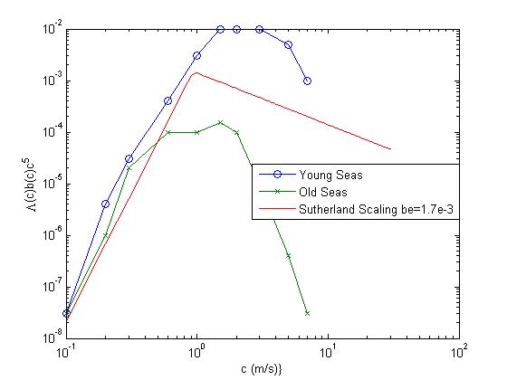

Fig. 5. The dissipation C-spectra from Banner and Morison (2016) for old (cp/u\*=40) and young (cp/u\*=15) seas. The Sutherland scaling fit is the red line.

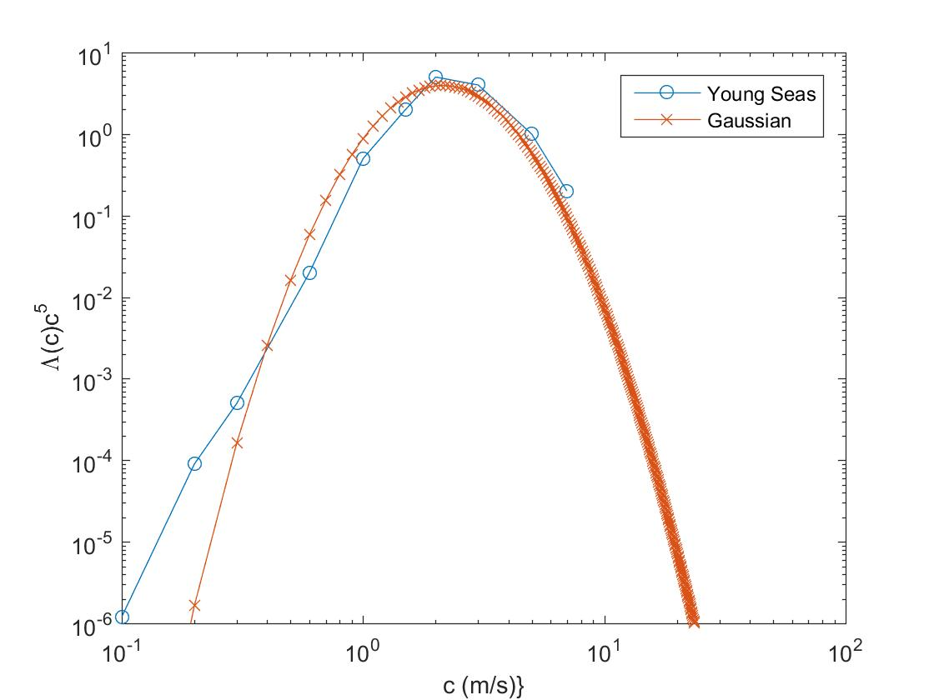

Fig. 6. Sample fit of breaking distribution from Banner and Morison (2016) with a log(c)-Gaussian fit.

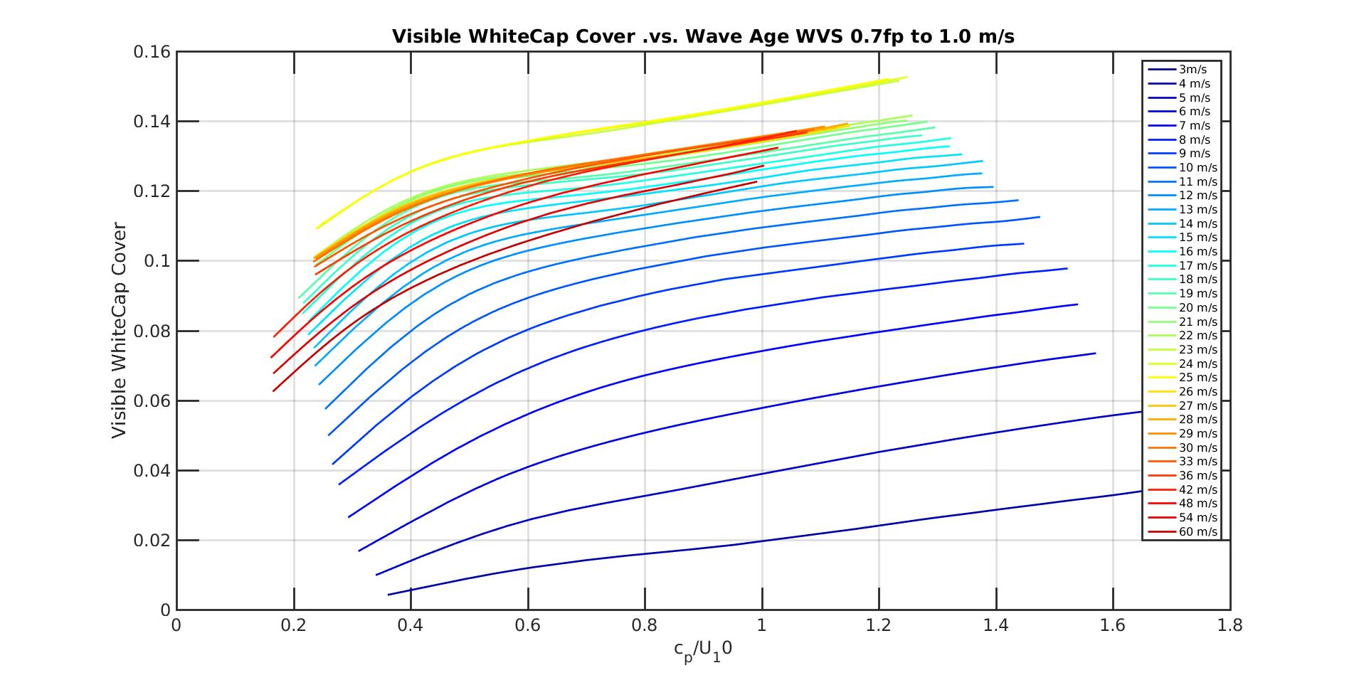

Fig. 7. Computations of whitecap fraction vs cp/u10 for different wind speeds (colors) from the Banner –Morison model.