**Summary of Scaling of USNW Wave Model Outputs**

**C. Fairall, M. Banner, R. Morison, J. Edson, B. Blomquis**

**20 Mar 2017**

The UNSW (Banner and Morison, 2010) have produced output of simulations of their wave model. Each simulation is run at a fixed 10-m wind speed and the wave field evolves from an initial state. They have provided the output of various variables (see list) for 701 time steps. At each wind speed this provides 701 realizations of different wave phase speed, C, and the associated wave conditions including significant wave height, Hs, peak of the spectrum, Cp, friction velocity, u*, and whitecap fraction. Spectral variables are given at 72 values of wavenumber, k (or C).

We have done two things with the outputs: 1) attempted to summarize the results with simple parameterizations in terms of wind speed and key wave variables, 2) compared some of the results with recent observations. The observations are from Jim Edson’s compilation of his work (Edson et al., 2013) and the HIWINGS field program south of Greenland in Oct-Nov 2013 (Yang et al. 2014). The observations cover the wind speed range from 0-25 m/s with direct measurements of fluxes, bulk meteorology, and wave parameters. HIWINGS also has whitecap measurements. For this analysis, we will emphasize wind speeds greater than 10 m/s. Note, the parameterizations here are simple mathematical fits and are not scaling laws that follow from some first principle considerations.

Comparison of data with the model is complicated by the fact that the model resolves a lot of Wa=Cp/U10 data space whereas field data are acquired in actual field conditions where most wave parameters are correlated with wind speed. To do the comparison, we take the mean relationship of Cp vs U10 from the data (see Fig. 1), match the values of Cp in each U10 model output, and select those model values for various wave parameters. Another approach is to take the ensemble of model outputs as a function of U10 and Cp/U10 and find scaling relationships that collapse all the data. For example, Fig. 2 shows the surface roughness parameterized as

 (1)

This formula approximately describes the wind-stress relationship from the Edson data and fits the model independently of wind speed. Given a value of U10, Cp, and Hs then (1) can be used to compute z0 and u* via the surface-layer drag relation

 (2)

We have done similar fits to the wave model to obtain approximate scaling formulae for Hs, whitecap fraction (Wf), and energy dissipated by wave breaking, ε.

 (3a)

 (3b)

 (3c)

Examples of these relationships are shown in Fig. 4-6. It is common in the literature to see Hs parameterized as hs=ah*U10^2 where the coefficient *ah* is on the order of 0.015-0.02. In (3a) *ah* is then a function of wave age. Historically whitecap fraction has been given a U10^3 wind speed scaling. Recent observations have shown this scaling breaks down at high wind speeds; (3b) indicates that whitecap fraction is higher for younger waves (consistent with observations).

Banner, M. and R. Morison, 2010: Refined source terms in wind wave models with explicit wve breaking prediction. Part I: Model framework and validatioin against field data. *Ocean Model.,* **33**, 177-189.

Edson, J.B., J. V. S. Raju, R.A. Welle**r**, S. Bigorre**,** A. Plueddemann, C.W. Fairall, S. Miller, L. Mahrt, Dean Vickers, andHans Hersbach, 2013: On the Exchange of momentum over the open ocean. *J. Phys. Oceanogr.*, **43**, 1589–1610. doi: <http://dx.doi.org/10.1175/JPO-D-12-0173.1>

Yang, M., B. W. Blomquist, and P. D. Nightingale (2014), Air-sea exchange of methanol and acetone during HiWinGS: Estimation of air phase, water phase gas transfer velocities, *J. Geophys. Res. Ocean*s, **119,** 7308–7323, doi:10.1002/2014JC010227.

**UNSW Wave Model Files**

**To bring to units in our paper multiply the dissipations by gravity (9.81)**

**Lamr is Lambda(c)/g**

The file contains the following:  
U10           701x1               4144  double      10m wind speed              (nt)  
 ZZ0           701x1               4144  double      Z0 (roughness length)    (nt)       
 cp            701x1               4144  double        peak wave speed    (nt)  
 hsig          701x1               4144  double        significant wave height  (nt)  
 k              72x1                576  double           wave number of grid   (nf)  
 kp            701x1               4144  double         peak wave number at each time step (nt)  
 nf              1x1                  8  double              number of frequencies / wavenumbers in grid  
 nt              1x1                  8  double              number of timesteps   
 sdse0d        701x1               4144  double       integrated total dissipation source term  (nt)  
 sdse0dl       701x1               4144  double       integrated breaking dissipation source term (nt)  
 sdse_1d       701x72            298368  double    total dissipation source term (nt,nf)  
**sdse_1dl      701x72            298368  double    breaking dissipation source term (nt,nf)**  
 ustar         701x1               4144  double         friction velocity (nt)  
 wage          701x1               4144  double        wave age (U10/cp)  (nt)

lamr (nt,nf)  this is the breaking crest length per unit area  
bk(nt,nf) this is the breaking strength parameter/g  
wc(nt) this is the total whitecap.

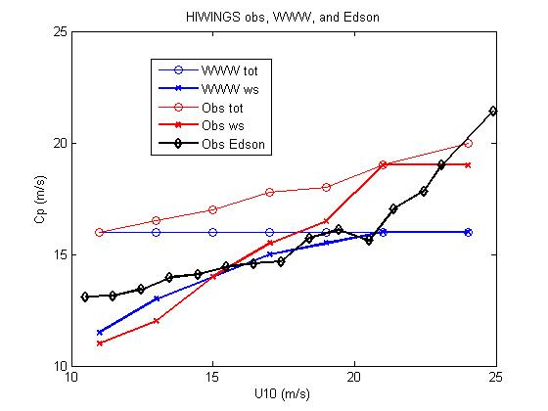

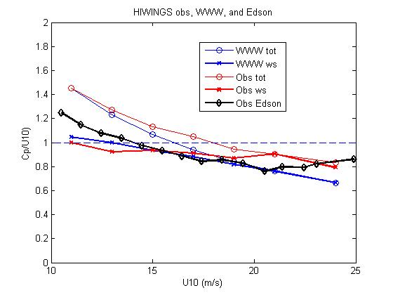

Figure 1. Upper panel: Comparison of Cp vs wind speed from HIWINGS (WWW is Wave Watch III; obs are from a buoy) and Edson with the UNSW model. The total wave spectrum (tot) and the wind sea component (ws) are shown. Lower panel: wave age Cp/U10 vs U10.

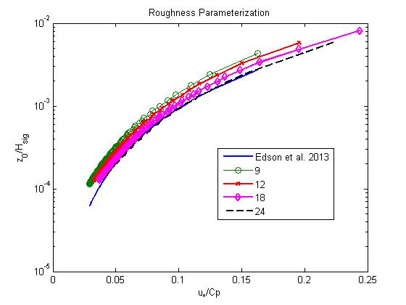

Figure 2. Surface roughness normalized by significant wave height vs inverse wave age.

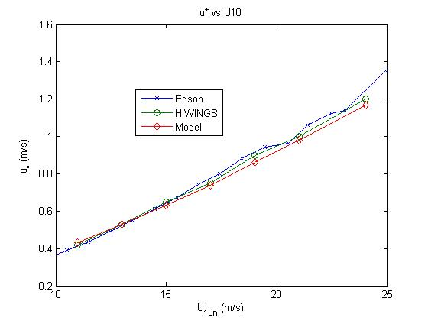

Figure 3. Friction velocity vs 10-m wind speed. Edson and HIWINGS are mean u* vs wind speed from covariance observations. The model results are computed using (1) and the mean Cp and Hs vs U10 from the observations.

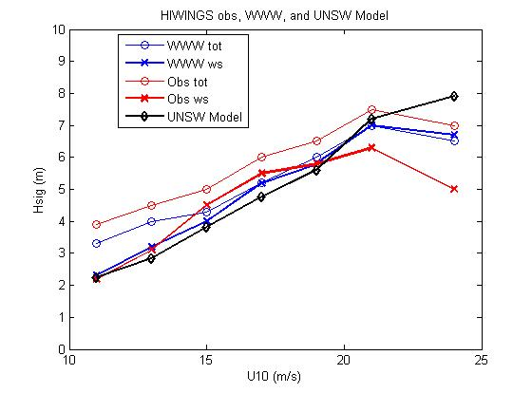

Figure 4. Significant wave height vs 10-m wind speed from HIWINGS.

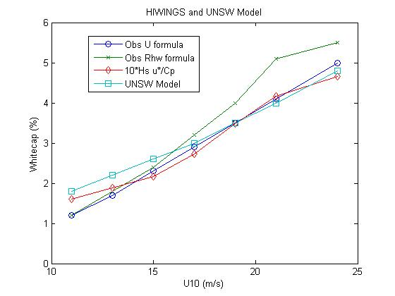

Figure 5. Mean whitecap (%) in wind speed bins from HIWINGS. The obs values are computed from regressions of observed Wf on wind speed and wave-breaking Reynolds number.

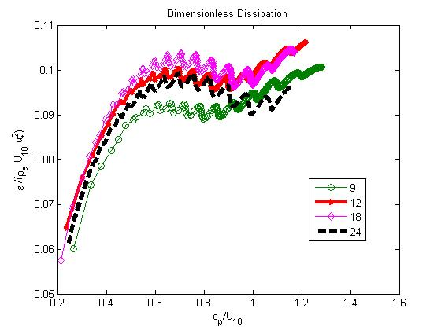

Figure 6. Dissipation rate made dimensionless using (3c) vs wave age at 4 different wind speeds from the UNSW model. In the region 0.5 <Wa <1.3 the formula collapses the dissipation rate fairly well.