**Steps:**

1. Create schema in MySQL: **smartwall_test_schema**
2. Create connection pool: **SmartWallPool**

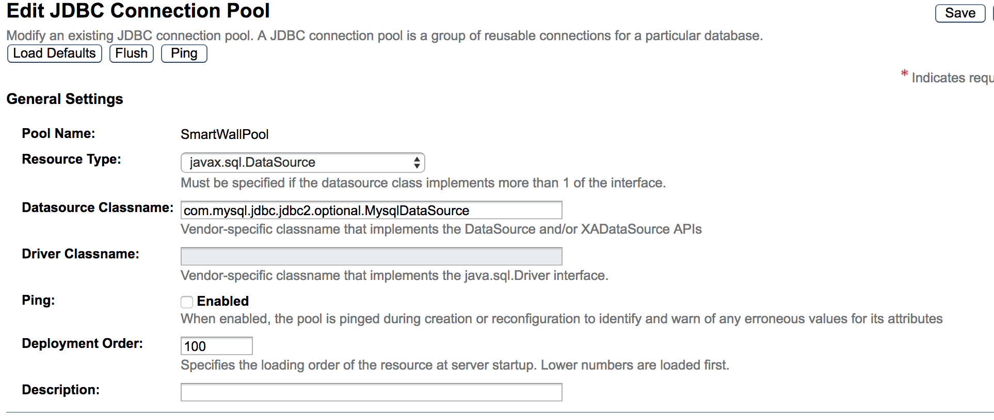

Set additional properties:

* URL: jdbc:mysql://localhost:3306/smartwall_test_schema
* User: <MySQL username>
* Password: <MySQL password>

1. Create JDBC Resource: **jdbc/smartwall**

