🖥️
NexGen Solutions
Chatbot Admin Panel — Complete Setup Guide
Step-by-step instructions with exact values to enter
Company | NexGen Solutions Pvt. Ltd.
Industry | IT / Software
Chatbot URL | /nexgen/chat
AI Provider | Groq (llama-3.1-8b-instant)
Flows | 3 (Demo Request, Support Ticket, Quick FAQ)
Prepared | March 2026

📖 How to Use This Guide
Follow the sections in order — top to bottom

This document contains every single value you need to type into the Admin Panel to set up the NexGen Solutions chatbot from scratch. Open each section of the Admin Panel and copy the values exactly as shown.
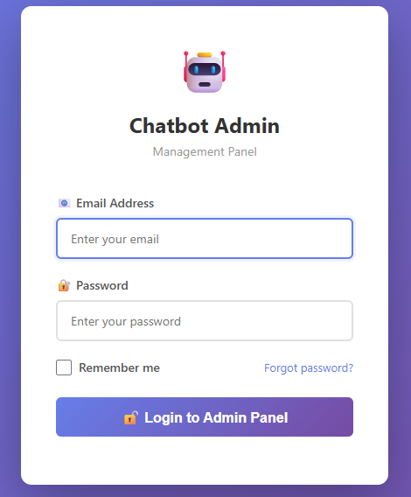

Admin Panel Navigation
After logging in, you will see the sidebar with two items: Dashboard and Companies.
Where to go | What it is
Companies | Lists all companies. Click 'Setup Wizard' button next to your company to open the chatbot setup.
Setup Wizard | The main place for all chatbot setup — has 6 tabs: Messages, Flows, Buttons, Products, Integrations, Services.
Edit (pencil icon) | Edit the company profile — name, AI settings, contact info.
Settings button | SMTP mail config and API keys.

Setup Order
Complete the steps in this exact order:
- Step 1 — Company Profile (Companies → Edit)
- Step 2 — Company Settings (Companies → Settings)
- Step 3 — Chatbot Wizard → Messages tab
- Step 4 — Chatbot Wizard → Flows tab
- Step 5 — Chatbot Wizard → Buttons tab
- Step 6 — Chatbot Wizard → Products tab
- Step 7 — Chatbot Wizard → Services tab
Step 8 — Chatbot Wizard → Integrations tab

⚠ Note: Complete each step fully before moving to the next.
Step 1 — Company Profile
Admin Panel → Companies → Edit

Go to Companies in the sidebar and click Edit on NexGen Solutions (or Create if not yet added).
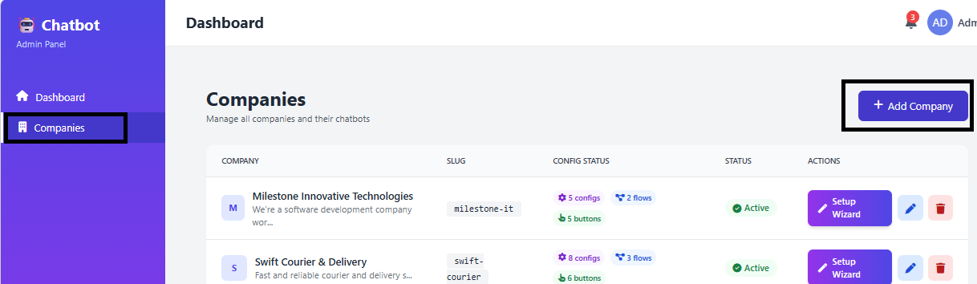
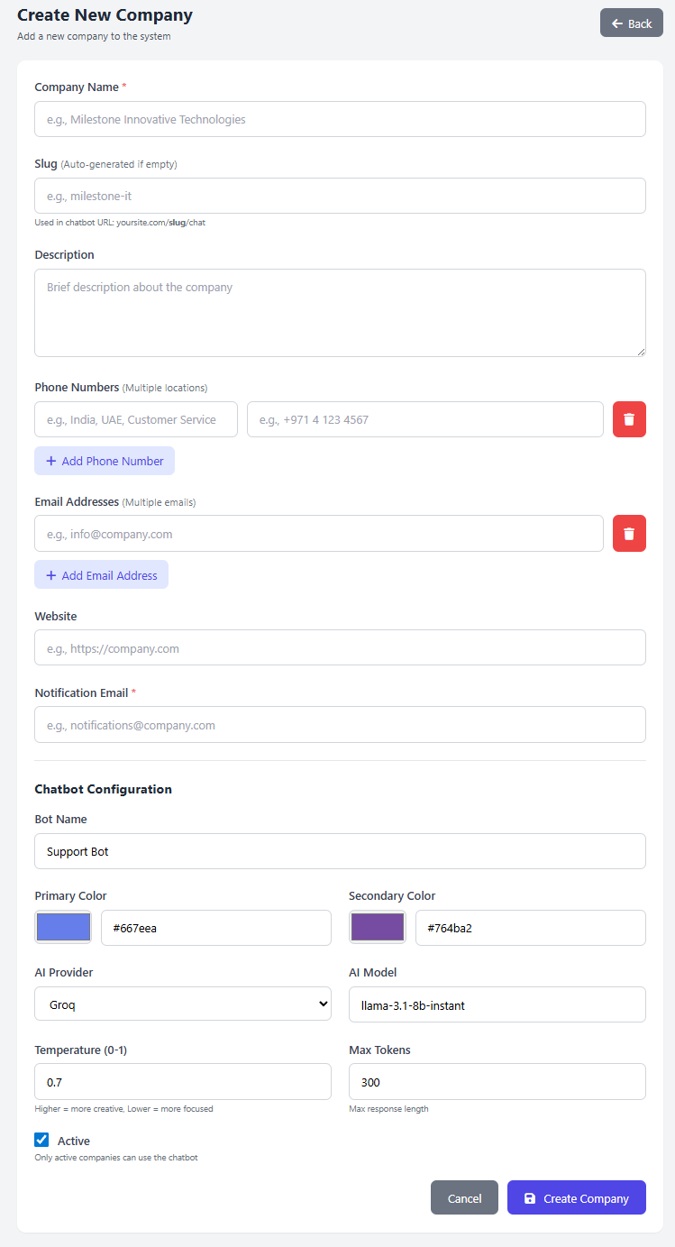

Field | Value to Enter
Name | NexGen Solutions Pvt. Ltd.
Slug | nexgen
Description | NexGen Solutions is a Kerala-based IT company specializing in custom software development, mobile apps, ERP systems, and cloud solutions. We serve SMEs across India with cutting-edge technology and dedicated support.
Phone Numbers | Head Office: +91 98765 43210 | Support: +91 98765 43211
Email Addresses | info@nexgensolutions.in, support@nexgensolutions.in
Website | https://www.nexgensolutions.in
Notification Email | leads@nexgensolutions.in
AI Provider | groq
AI Model | llama-3.1-8b-instant
AI Temperature | 0.7
AI Max Tokens | 300
Is Active | ✅ Checked

Tip: The Description is used by the AI when answering general questions. Make it accurate and informative — 2-4 sentences is ideal.

⚙ Step 2 — Company Settings
Admin Panel → Companies → Settings button

2a Mail / SMTP Settings
These allow the chatbot to email you when a customer submits a form.
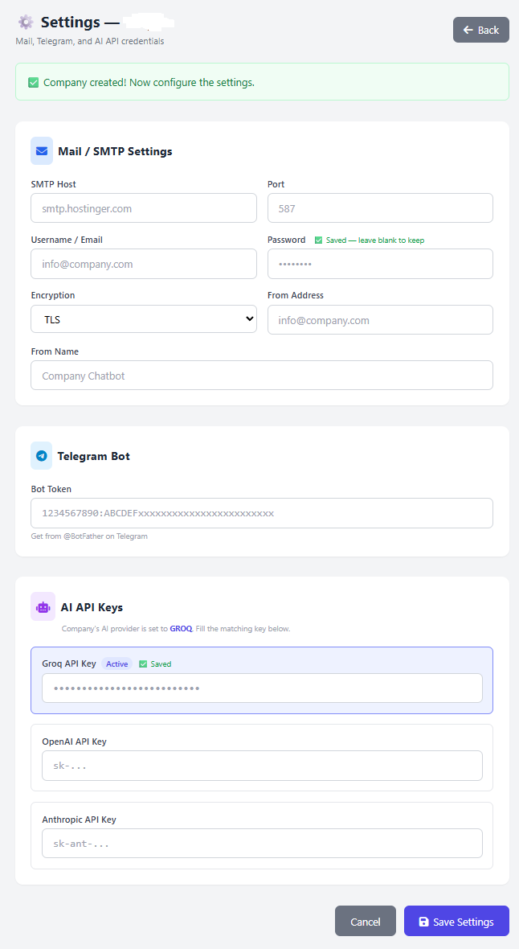

Field | Value to Enter
SMTP Host | smtp.hostinger.com (or your mail provider's host)
Port | 587
Username | info@nexgensolutions.in
Password | (your email password)
Encryption | TLS
From Address | info@nexgensolutions.in
From Name | NexGen Chatbot

2b AI API Key
Field | Value to Enter
Groq API Key | (paste your key from https://console.groq.com)

Tip: Groq is free to use and very fast. Create a free account at console.groq.com and copy your API key from the dashboard.

Step 3 — Chatbot Messages
Admin Panel → Chatbot Wizard → Messages tab → Add Message

Add each of the 3 messages below. Click 'Add Message', fill in the fields, and Save. Then repeat for the next one.
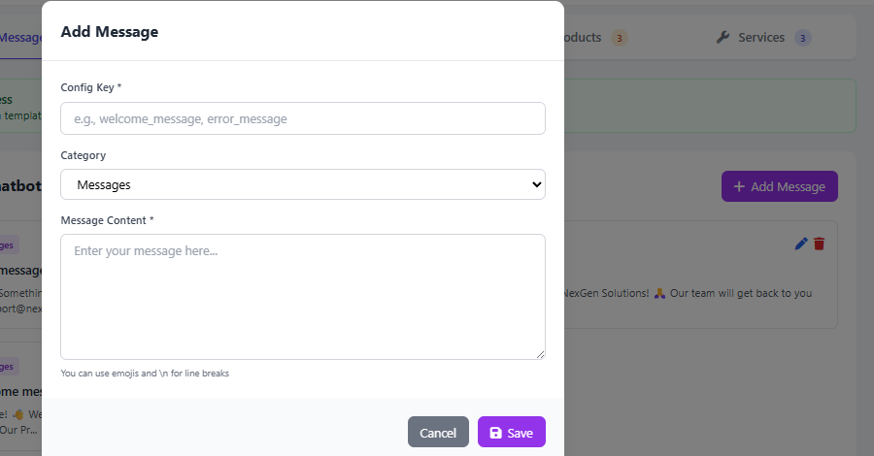
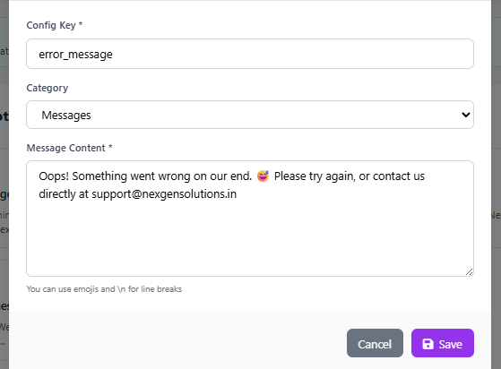

Message 1 — Welcome Message
Field | Value
Config Key | welcome_message
Category | messages
Value | Hi there! 👋 Welcome to NexGen Solutions. I'm your virtual assistant. I can help you with: • Our Products & Services • Requesting a Demo • Raising a Support Ticket • Contacting our team What can I help you with today?

Message 2 — Goodbye Message
Field | Value
Config Key | goodbye_message
Category | messages
Value | Thank you for reaching out to NexGen Solutions! 🙏 Our team will get back to you soon. Have a great day! 😊

Message 3 — Error Message
Field | Value
Config Key | error_message
Category | messages
Value | Oops! Something went wrong on our end. 😅 Please try again, or contact us directly at support@nexgensolutions.in

Step 4 — Flows
Admin Panel → Chatbot Wizard → Flows tab → Add Flow

There are 3 flows to create. Each flow is a complete automated conversation. Follow each sub-section carefully.

How the Flow Form Works
When you click 'Add Flow', a form page opens with these sections:
Section | What to do
Flow Name | Type the flow name (lowercase, underscores only)
Flow Type | Select from dropdown: Form Collection / Data Query / Quick Reply
Priority | Type a number — higher number = matched first
Triggers | Type a keyword, then click '+ Add Trigger' to add more
Steps | Each step = one question. Click '+ Add Step' to add more steps.
Data Configuration | Paste the JSON config block in this text area
Active checkbox | Make sure this is ticked before saving

Each Step has 3 fields:
Step Field | What to Enter | Example
Message | The question the chatbot will ask the customer | What is your full name?
Cache Key | Short code name for this answer (lowercase, underscores) | demo_name
Field Name | The database column where the answer is saved | customer_name

⚠️ Note: Cache Key and Field Name must be lowercase with underscores only — no spaces. Each step must have all 3 fields filled.
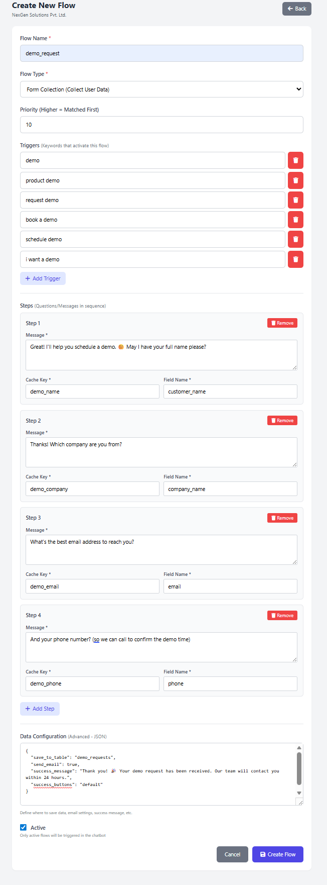

Flow 1 — Demo Request
When a customer wants to book a product demo, this flow collects their details and saves them to the database. An email notification is sent to your team automatically.

Basic Details
Field | Value
Flow Name | demo_request
Flow Type | Form Collection
Priority | 10
Is Active | ✅ Checked

Triggers
In the Triggers field, type each keyword and click '+ Add Trigger' to add the next one.
# | Trigger Keyword to Add
1 | demo
2 | request demo
3 | book a demo
4 | schedule demo
5 | i want a demo
6 | product demo

Steps (add in this exact order)

1 | What is your name?  Message: "Great! I'll help you schedule a demo. 😊 May I have your full name please?" | Cache Key: demo_name | Field Name: customer_name

2 | What is your company?  Message: "Thanks! Which company are you from?" | Cache Key: demo_company | Field Name: company_name

3 | Email address?  Message: "What's the best email address to reach you?" | Cache Key: demo_email | Field Name: email

4 | Phone number?  Message: "And your phone number? (so we can call to confirm the demo time)" | Cache Key: demo_phone | Field Name: phone

Data Configuration (copy exactly)
{
"save_to_table": "demo_requests",
"send_email": true,
"success_message": "Thank you! 🎉 Your demo request has been received. Our team will contact you within 24 hours.",
"success_buttons": "default"
}

Note: The value in save_to_table must exactly match the database table name. Ask your developer to confirm it is 'demo_requests'.

Flow 2 — Support Ticket
When an existing customer has a technical issue, this flow collects their details and the problem description. The team gets an email and the ticket is saved in the database.

Basic Details
Field | Value
Flow Name | support_ticket
Flow Type | Form Collection
Priority | 10
Is Active | ✅ Checked

Triggers
In the Triggers field, type each keyword and click '+ Add Trigger' to add the next one.
# | Trigger Keyword to Add
1 | support
2 | raise ticket
3 | ticket
4 | technical issue
5 | help
6 | problem
7 | issue
8 | bug

Steps (add in this exact order)

1 | Customer name?  Message: "I'll help you raise a support ticket. 🎫 What is your name?" | Cache Key: support_name | Field Name: customer_name

2 | Registered email?  Message: "What is your registered email address with us?" | Cache Key: support_email | Field Name: email

3 | Product/Service?  Message: "Which product or service is this about? (e.g. ERP Suite Pro, MobileApp, CloudConnect)" | Cache Key: support_product | Field Name: product_name

4 | Describe the issue?  Message: "Please describe the issue you're facing in as much detail as possible." | Cache Key: support_issue | Field Name: issue_description

Data Configuration (copy exactly)
{
"save_to_table": "service_enquiries",
"send_email": true,
"success_message": "Your support ticket has been raised! ✅ Ticket Reference will be emailed shortly. Response time: Within 4 business hours.",
"success_buttons": "default"
}

Flow 3 — FAQ (Quick Reply)
This flow answers common questions instantly without collecting any data. It's a Quick Reply flow — one message is sent and control returns to the menu.

Basic Details
Field | Value
Flow Name | faq
Flow Type | Quick Reply
Priority | 5
Is Active | ✅ Checked

Triggers
In the Triggers field, type each keyword and click '+ Add Trigger' to add the next one.
# | Trigger Keyword to Add
1 | faq
2 | frequently asked
3 | common questions
4 | how does it work
5 | what do you offer
6 | about you

Steps (only 1 step needed for Quick Reply)

1 | FAQ Message  Message: (copy the full text below) | Cache Key: faq_msg | Field Name: faq_msg

Step 1 Message — copy this exactly:
❓ Frequently Asked Questions — NexGen Solutions

Q: Where are you located?
A: Our head office is in Thrissur, Kerala. We serve clients pan-India.

Q: What technologies do you work with?
A: Laravel, React, Flutter, .NET, AWS, Azure, and more.

Q: How long does a project take?
A: Simple websites: 1-2 weeks. Mobile apps: 4-8 weeks. ERP: 2-4 months.

Q: Do you offer support after delivery?
A: Yes! We offer Annual Maintenance Contracts (AMC) with guaranteed SLA.

Q: How do I get a quote?
A: Request a free demo and our team will discuss your requirements.

Need more help? Type 'menu' to return to the main menu.

Data Configuration for Quick Reply
{
"success_buttons": "default"
}

Button Template 1 — Main Menu (default)
Fill in these fields in the Add Button Template popup:
Field | Value to Enter
Template Name | Main Menu Buttons
Context | default
Priority | 10
Active | ✅ Checked

Buttons (JSON) field — copy and paste this entire block into the Buttons (JSON) field:
[
{"label": "🛍️ Our Products", "value": "products", "order": 1},
{"label": "⚙️ Our Services", "value": "services", "order": 2},
{"label": "📞 Contact Us", "value": "contact", "order": 3},
{"label": "🎯 Request a Demo", "value": "demo", "order": 4},
{"label": "🎫 Raise Support Ticket", "value": "support", "order": 5},
{"label": "❓ FAQ", "value": "faq", "order": 6}
]

⚠️ Note: Paste the JSON exactly as shown — including all [ ] brackets and { } braces. Do not add or remove any commas.

What each JSON key means:
Key | Meaning | Example
label | Text shown on the button — what the customer sees | 🛍️ Our Products
value | Message sent when customer clicks the button | products
order | Display order (1 = leftmost/first) | 1
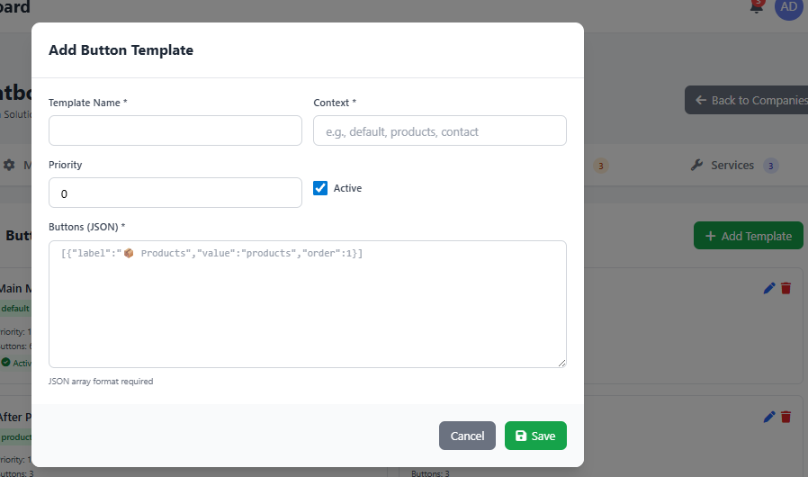
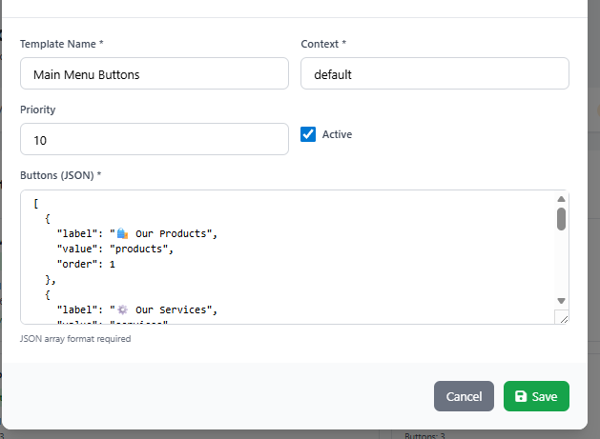

Button Template 2 — During Forms (navigation)
Fill in these fields in the Add Button Template popup:
Field | Value to Enter
Template Name | Form Navigation
Context | navigation
Priority | 10
Active | ✅ Checked

Buttons (JSON) field — copy and paste this:
[
{"label": "🏠 Main Menu", "value": "menu", "order": 1},
{"label": "❌ Cancel", "value": "back", "order": 2}
]

💡 Tip: These 2 buttons appear while a customer is filling in a form — so they can cancel and return to the main menu at any time.

Button Template 3 — After Products List (products)
Fill in these fields in the Add Button Template popup:
Field | Value to Enter
Template Name | After Products
Context | products
Priority | 10
Active | ✅ Checked

Buttons (JSON) field — copy and paste this:
[
{"label": "🎯 Request a Demo", "value": "demo", "order": 1},
{"label": "⚙️ Our Services", "value": "services", "order": 2},
{"label": "🏠 Main Menu", "value": "menu", "order": 3}
]

Button Template 4 — After Services List (services)
Fill in these fields in the Add Button Template popup:
Field | Value to Enter
Template Name | After Services
Context | services
Priority | 10
Active | ✅ Checked

Buttons (JSON) field — copy and paste this:
[
{"label": "🎫 Raise Support Ticket", "value": "support", "order": 1},
{"label": "🎯 Request a Demo", "value": "demo", "order": 2},
{"label": "🏠 Main Menu", "value": "menu", "order": 3}
]

Button Template 5 — After Contact Info (contact)
Fill in these fields in the Add Button Template popup:
Field | Value to Enter
Template Name | After Contact
Context | contact
Priority | 10
Active | ✅ Checked

Buttons (JSON) field — copy and paste this:
[
{"label": "🎯 Request a Demo", "value": "demo", "order": 1},
{"label": "🛍️ Our Products", "value": "products", "order": 2},
{"label": "🏠 Main Menu", "value": "menu", "order": 3}
]

💡 Tip: Each context shows relevant next-action buttons. 'products' context shows Demo and Services. 'services' context shows Support and Demo. 'contact' context shows Demo and Products.

📦 Step 6 — Products
Admin Panel → Chatbot Wizard → Products tab → Add Product

Add each product below. These will appear when a customer clicks 'Our Products' or types 'products'.
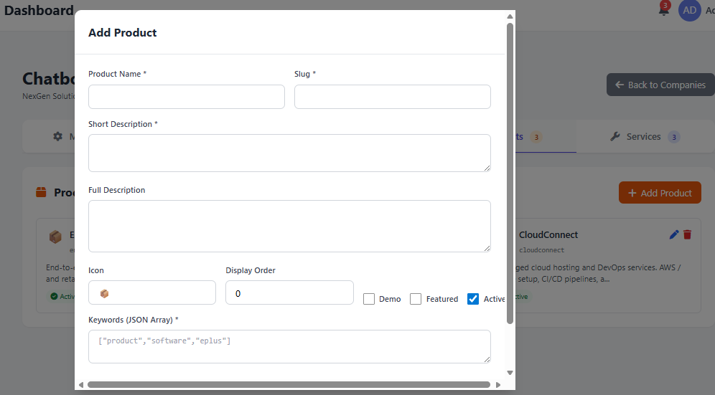

Product 1 — ERP Suite Pro
Field | Value to Enter
Product Name | ERP Suite Pro
Slug | erp_suite_pro
Short Description | End-to-end ERP solution for manufacturing, trading, and retail businesses. Includes inventory, billing, HR, and CRM modules.
Full Description | (Optional) Longer description for detailed product pages. Can be left blank.
Icon | 🏭
Display Order | 1
Demo | ☐ Leave unchecked
Featured | ☐ Leave unchecked
Active | ✅ Checked

Keywords (JSON Array) — copy and paste this:
["erp", "enterprise", "inventory", "billing", "hrm", "crm"]

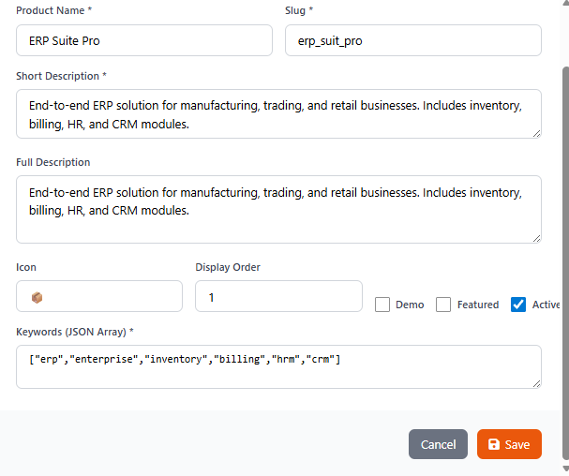

Product 2 — MobileApp Builder
Field | Value to Enter
Product Name | MobileApp Builder
Slug | mobileapp_builder
Short Description | Custom Android & iOS app development with React Native. Rapid delivery within 4-6 weeks for standard requirements.
Full Description | (Optional) Leave blank.
Icon | 📱
Display Order | 2
Demo | ☐ Leave unchecked
Featured | ☐ Leave unchecked
Active | ✅ Checked

Keywords (JSON Array) — copy and paste this:
["mobile", "app", "android", "ios", "react native", "flutter"]

Product 3 — CloudConnect
Field | Value to Enter
Product Name | CloudConnect
Slug | cloudconnect
Short Description | Managed cloud hosting and DevOps services. AWS / Azure setup, CI/CD pipelines, and 24x7 monitoring.
Full Description | (Optional) Leave blank.
Icon | ☁️
Display Order | 3
Demo | ☐ Leave unchecked
Featured | ☐ Leave unchecked
Active | ✅ Checked

Keywords (JSON Array) — copy and paste this:
["cloud", "hosting", "aws", "azure", "devops", "server"]

⚠ Note: Slug must be unique and lowercase with underscores only — no spaces or special characters.

Service 1 — Custom Software Development

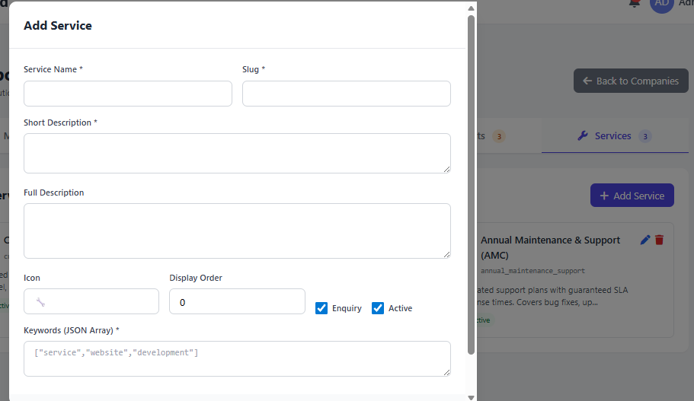
Field | Value to Enter
Service Name | Custom Software Development
Slug | customesoftwaredevelopment
Short Description | Tailored web and desktop applications built with Laravel, React, and .NET. From idea to deployment.
Full Description | (Optional) Leave blank.
Icon | 💻
Display Order | 1
Enquiry | ✅ Checked (enables enquiry form for this service)
Active | ✅ Checked
Keywords (JSON Array) — copy and paste this:
["service", "website", "development", "software", "laravel", "react"]

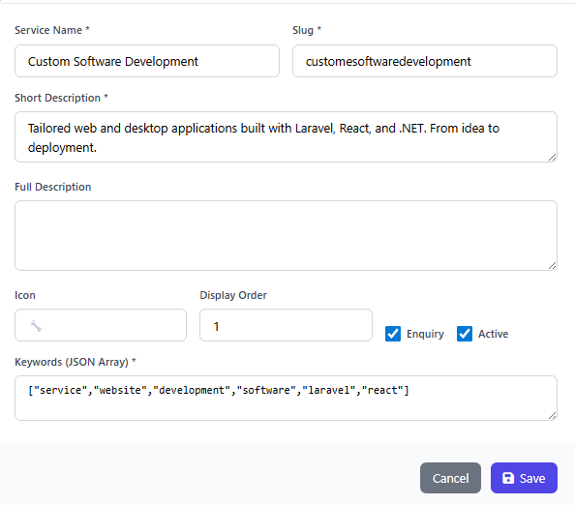

Service 2 — IT Consulting & Strategy
Field | Value to Enter
Service Name | IT Consulting & Strategy
Slug | it_consulting_strategy
Short Description | Technology roadmap planning, digital transformation consulting, and vendor selection support for growing businesses.
Full Description | (Optional) Leave blank.
Icon | 📊
Display Order | 2
Enquiry | ✅ Checked
Active | ✅ Checked

Keywords (JSON Array) — copy and paste this:
["consulting", "strategy", "digital", "transformation", "it", "advisory"]

Service 3 — Annual Maintenance & Support (AMC)
Field | Value to Enter
Service Name | Annual Maintenance & Support (AMC)
Slug | annual_maintenance_support
Short Description | Dedicated support plans with guaranteed SLA response times. Covers bug fixes, updates, and performance monitoring.
Full Description | (Optional) Leave blank.
Icon | 🛡️
Display Order | 3
Enquiry | ✅ Checked
Active | ✅ Checked

Keywords (JSON Array) — copy and paste this:
["amc", "support", "maintenance", "sla", "annual", "helpdesk"]

⚠️ Note: Enquiry checkbox — tick this if you want customers to be able to raise an enquiry for this service. Leave unchecked for informational-only services.

🔗 Step 8 — Integrations
Admin Panel → Companies → Setup Wizard → Integrations tab

Go to Admin Panel → Companies → Setup Wizard → Integrations tab → click “+ Add Integration”. Fill in the fields exactly as shown below.
Field |  | Value to Enter
Integration Key | danabook
🔒 Auth Service
Auth Base URL | https://userhub.zerobook.online
Auth Endpoint | /api/v1/login
Token Path | data.access_token
Identifier Field | email
Token TTL (seconds) | 3600
🔧 Microservices (click “+ Add Service” for each row)
Service Key | Base URL
dashboard | https://dashboardhub.zerobook.shop

Tip: After filling all fields, click Save. The integration will appear in the Integrations list with status Active. The “dashboard” microservice key is used in flow Data Configuration JSON (base_url for cash_balance and today_expense services).

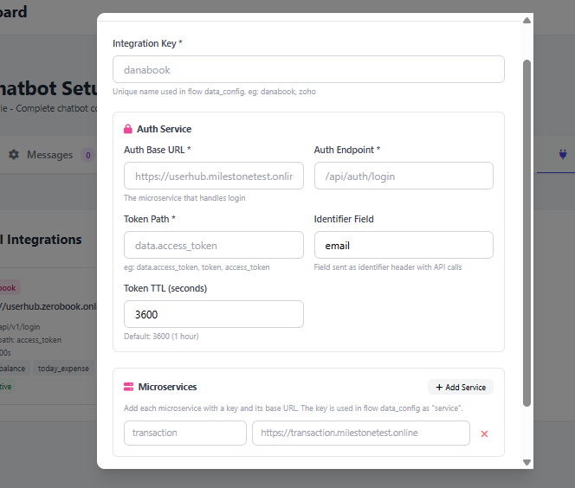

After completing all steps, open the chatbot at:
https://yourdomain.com/nexgen/chat

Test each of the following:

Type this in chatbot | What you should see
hi | Welcome message + 6 buttons (Products, Services, Contact, Demo, Support, FAQ)
products | List of 3 products with icons and descriptions
services | List of 3 services with icons and descriptions
contact | Phone numbers and email addresses
demo | Flow starts — bot asks for your name
support | Flow starts — bot asks for your name
faq | Full FAQ message is displayed
exit | Goodbye message is shown
hello | Returns to welcome message
What do you do? | AI gives a response about NexGen Solutions (uses your description)

⚠Note: If any button does not trigger the right flow, double-check that the button Value exactly matches one of the flow Triggers or a built-in keyword.

Tip: After testing the demo flow, check your email at leads@nexgensolutions.in to confirm you received the email notification.

📋 Setup Checklist
Use this to track your progress

# | Task | Status
1 | Company profile filled in with slug 'nexgen' | ☐ Done
2 | SMTP mail settings saved | ☐ Done
3 | Groq API key saved | ☐ Done
3a | Danabook API key saved | ☐ Done
4 | welcome_message added | ☐ Done
5 | goodbye_message added | ☐ Done
6 | error_message added | ☐ Done
10 | 'default' button template created (6 buttons) | ☐ Done
10 | 'default' button template created — 6 buttons (main menu) | ☐ Done
10b | 'navigation' button template created — 2 buttons (cancel/menu) | ☐ Done
10c | 'products' button template created — 3 buttons (Demo, Services, Main Menu) | ☐ Done
10d | 'services' button template created — 3 buttons (Support, Demo, Main Menu) | ☐ Done
10e | 'contact' button template created — 3 buttons (Demo, Products, Main Menu) | ☐ Done
11 | 3 Products added (ERP Suite Pro, MobileApp Builder, CloudConnect) | ☐ Done
12 | 3 Services added (Custom Dev, Consulting, AMC) | ☐ Done
7 | Flow 1: demo_request created (5 steps) | ☐ Done
8 | Flow 2: support_ticket created (4 steps) | ☐ Done
9 | Flow 3: faq created (1 step) | ☐ Done
14 | Chatbot tested — all triggers working | ☐ Done
15 | Email notification received after demo test | ☐ Done

Setup complete! Your NexGen Solutions chatbot is ready. 🚀
For technical assistance, contact your system administrator.

