Analytic Regime Maps for M0 and M1
Masking, Authenticity, and Peer Adaptation: Lecture Notes
Prepared as an article-ready technical note

Executive summary
M0 is analytically solvable for objective and subjective optimality. The objective boundary separates worlds in which masking has higher expected payoff from worlds in which authenticity has higher expected payoff. A loss-aversion parameter moves the subjective boundary and creates characteristic error regions: risk-averse over-masking and risk-taking over-authenticity.
M1 is also analytically tractable, but the answer is subtle. Under the objective expected-value model used here, disclosure has a linear expected payoff. Therefore, the static optimum is almost always an endpoint: full masking or full authenticity. Intermediate disclosure is not an objective static optimum except at exact indifference. Its protective role is dynamic: it lowers the risk of exploration and creates safer sampled paths through the learning process.
With loss aversion, M1 subjective value becomes quadratic in disclosure whenever rejected disclosure is experienced as a loss. This allows a more nuanced map: risk-averse subjective optima remain endpoint-dominated, while risk-taking or loss-discounting learners can have interior subjective optima over disclosure.

Shared notation
Symbol | Meaning | Default
b | Belonging reward when behavior is accepted | 1.0
a | Intrinsic authenticity reward | 0.6
c | Suppression cost paid when masking | 0.25
r | Rejection penalty after failed authenticity | 2.0
p | Peer receptivity: probability authentic behavior is accepted | swept 0 to 1
lambda | Loss-aversion multiplier for negative realized rewards | 0.5, 1.0, 2.5

Part I: M0 analytic solution

1. M0 payoff structure
M0 has two actions: mask and authentic. Masking is deterministic; authenticity is stochastic.
E[M] = b - c
A = b + a with probability p
A = a - r with probability 1 - p
E[A] = p(b+a) + (1-p)(a-r)
= a + p b - (1-p) r
Define the authenticity advantage:
Delta = E[A] - E[M]
= a + p b - (1-p) r - (b-c)

2. Objective indifference boundary
Set E[A] = E[M] and solve for r:
r*(p) = (a+c)/(1-p) - b
Equivalently, for fixed r, solve for p:
p*(r) = (b - c - a + r)/(b + r)
At the default r = 2.0:
p* = (1.0 - 0.25 - 0.6 + 2.0)/(1.0 + 2.0)
= 2.15/3
= 0.7167
Receptivity p at r=2 | Objective optimum
p < 0.7167 | Mask
p = 0.7167 | Indifferent
p > 0.7167 | Authentic

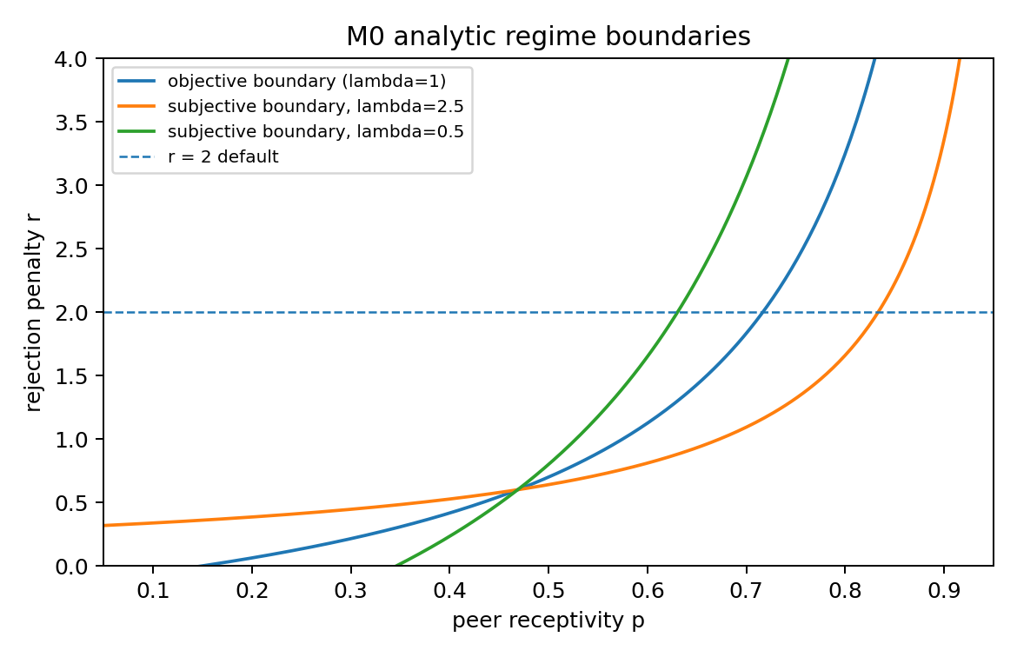
Figure 1. M0 objective and subjective regime boundaries. The objective boundary is the lambda=1 case; risk aversion shifts the subjective boundary toward requiring higher receptivity, while risk-taking shifts it toward authenticity.

3. Subjective loss-averse boundary
Loss aversion transforms realized rewards before updating the learner. If R is the realized reward:
v = R if R >= 0
v = lambda R if R < 0
When rejected authenticity is negative, i.e. r > a, subjective expected authenticity is:
E_lambda[A] = p(b+a) + (1-p) lambda (a-r)
The subjective indifference boundary is:
r_lambda*(p) = a + [p(b+a) - (b-c)]/[lambda(1-p)]
For fixed r:
p_lambda*(r) = [b-c - lambda(a-r)]/[b+a - lambda(a-r)]
Type | lambda | Threshold p* at r=2 | Interpretation
Risk-taking | 0.5 | 0.6304 | Switches to authenticity earliest
Baseline | 1.0 | 0.7167 | Matches objective threshold
Risk-averse | 2.5 | 0.8333 | Requires high receptivity

4. M0 regime map
Regime | Condition | Interpretation
Correct masking | Delta < 0 and Delta_lambda < 0 | Masking is objectively and subjectively favored
Correct authenticity | Delta > 0 and Delta_lambda > 0 | Authenticity is objectively and subjectively favored
Risk-averse over-masking | Delta > 0 and Delta_lambda < 0 | Authenticity pays, but the learner experiences it as too dangerous
Risk-taking over-authenticity | Delta < 0 and Delta_lambda > 0 | Masking pays, but the learner underweights rejection
Learning lock-in | Delta > 0, Delta_lambda >= 0, but final mask rate is high | Sampling history locks the learner into masking despite the analytic boundary
Mixed or bistable zone | Near boundaries or high seed dependence | The same parameters can produce different learned fates

Analytic M0 provides the normative map. Simulation remains necessary for the finite-time Q-learning lock-in probability because the softmax policy changes after every realized sample.

Part II: M1 analytic solution

5. M1 setup
M1 replaces the binary action with a disclosure level d in [0,1]. Full masking is d=0; full authenticity is d=1; intermediate values represent partial disclosure.
q(d) = P(accepted | d) = 1 - (1-p)d
P(rejected | d) = (1-p)d
The realized rewards are:
R_success(d) = a d - c(1-d) + b
= b - c + d(a+c)
R_reject(d) = a d - c(1-d) - r
= -c - r + d(a+c)

6. Objective expected value
The objective expected payoff is:
E[d] = q(d) R_success(d) + [1-q(d)] R_reject(d)
= b - c + d [a+c - (1-p)(b+r)]
This is linear in d. Define the slope:
S(p,r) = a+c - (1-p)(b+r)
Therefore the objective optimum over d in [0,1] is:
if S(p,r) > 0: d* = 1 full authenticity
if S(p,r) < 0: d* = 0 full masking
if S(p,r) = 0: every d is objectively tied
The objective boundary S(p,r)=0 is identical to the M0 objective boundary:
r*(p) = (a+c)/(1-p) - b
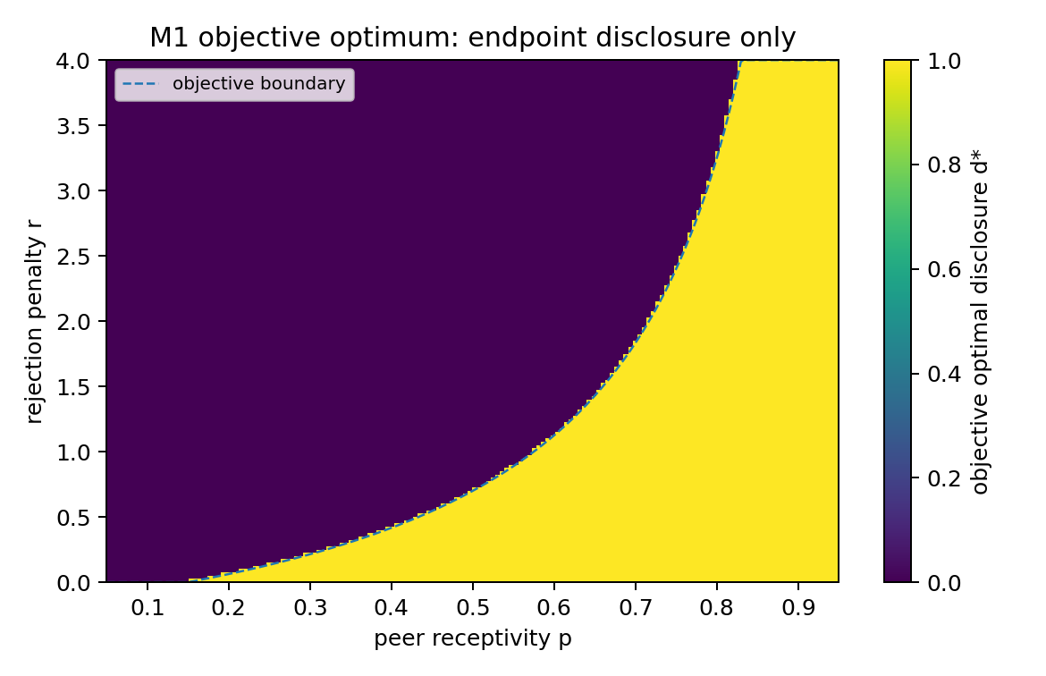
Figure 2. M1 objective optimum over disclosure. Under the linear objective expected-value model, M1 does not create a new static interior optimum: the optimum is full masking or full authenticity except on the indifference boundary.

7. What M1 adds despite the same objective boundary
The fact that M1 has the same static boundary as M0 is not a defect. It clarifies what M1 contributes. M1 is not primarily a static optimality story; it is a learning and exploration story.
Quantity | Formula | Interpretation
Probability of rejection | (1-p)d | Partial disclosure reduces the chance of a bad sample
Rejected payoff | -c-r+d(a+c) | Partial disclosure changes the loss severity; with defaults it remains negative through d=1
Reward gap between success and rejection | b+r | The success-versus-rejection spread is constant in d
Variance | [1-(1-p)d](1-p)d(b+r)^2 | Intermediate disclosure changes the sampled risk profile

This is the analytic reason M1 can reduce lock-in in simulations even though the objective expected-value optimum is an endpoint. Partial disclosure reduces the probability of catastrophic early samples and lets the learner gather information with lower exposure.

8. Subjective loss-averse M1 value
Now apply loss aversion to realized rewards. Assume the rejected-disclosure payoff is negative over the disclosure range being considered. This is true at the defaults because -c-r+d(a+c) remains negative for all d <= 1.
Let:
M = b - c
A = a + c
L = c + r
h = 1 - p
Then:
R_success(d) = M + A d
R_reject(d) = A d - L
q(d) = 1 - h d
The subjective expected value is:
E_lambda(d) = [1-hd](M+Ad) + hd lambda (Ad-L)
Expanding:
E_lambda(d) = M + B_lambda d + C_lambda d^2
B_lambda = A - h[M + lambda L]
C_lambda = h A (lambda - 1)

9. Subjective optimum over disclosure
Case | Shape of E_lambda(d) | Implication
lambda = 1 | Linear | Same as objective M1; endpoint optimum except at indifference
lambda > 1 | Convex | Maximum over [0,1] occurs at an endpoint; risk-averse subjective choice is usually full mask or full authenticity
0 < lambda < 1 | Concave | An interior subjective optimum can exist if the derivative is positive at d=0 and negative at d=1

For lambda < 1, the unconstrained interior optimum is:
d_int = -B_lambda / (2 C_lambda)
The constrained optimum is:
d* = clip(d_int, 0, 1) if lambda < 1 and the concave interior condition holds
otherwise choose the better endpoint, d=0 or d=1
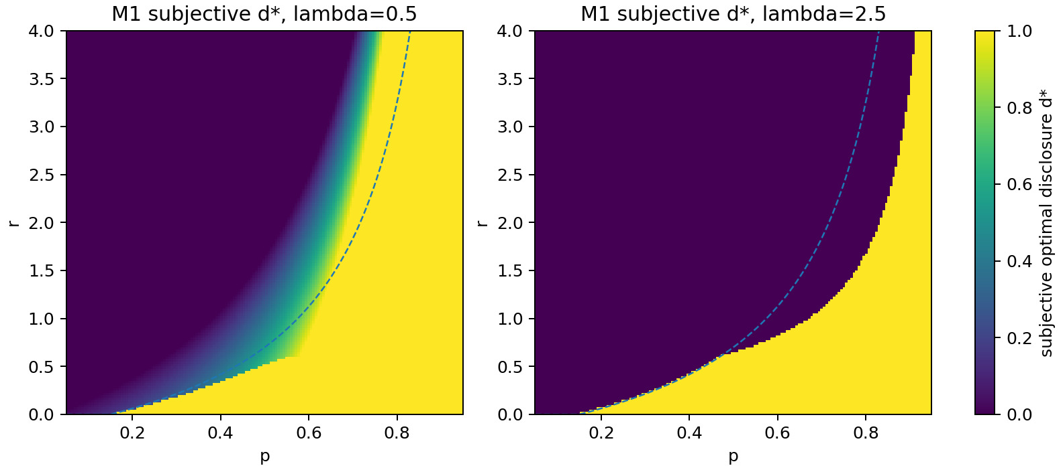
Figure 3. M1 subjective optimal disclosure under loss aversion. Risk-taking/loss-discounting learners can have interior subjective disclosure optima; risk-averse learners remain endpoint-dominated in the standard region.

10. M1 regime map
Regime | Condition | Meaning
Objective full masking | S(p,r) < 0 | Static expected value favors d=0
Objective full authenticity | S(p,r) > 0 | Static expected value favors d=1
Objective all-disclosure tie | S(p,r) = 0 | Every d has the same objective expected value
Risk-averse endpoint over-masking | lambda > 1 and subjective endpoint is d=0 while objective d=1 | Loss aversion shrinks the subjective authenticity region
Risk-taking interior disclosure | lambda < 1 and 0 < d_int < 1 | Partial disclosure can be a subjective optimum
Learning-protective disclosure | Objective endpoint optimum but simulations favor lower lock-in with intermediate arms | M1 changes exploration risk rather than static optimality

11. Example at default r=2
Using b=1.0, a=0.6, c=0.25, r=2.0:
M = b-c = 0.75
A = a+c = 0.85
L = c+r = 2.25
For p=0.60 and lambda=0.5:
h = 0.40
B = A - h[M + lambda L]
= 0.85 - 0.40[0.75 + 0.5(2.25)]
= 0.10
C = h A (lambda - 1)
= 0.40(0.85)(-0.5)
= -0.17
d_int = -B/(2C) = 0.294
So a risk-taking/loss-discounting learner can subjectively prefer partial disclosure in a region where the objective endpoint solution would not. This is not because the environment has an interior objective optimum; it is because the subjective transform changes the curvature of the value function over disclosure.

12. What is analytically solved, and what still requires simulation
Question | Analytic? | Answer
Objective M0 regimes | Yes | Exact boundary r*(p)
Subjective M0 regimes | Yes | Exact boundary r_lambda*(p), piecewise when losses change sign
Objective M1 regimes | Yes | Same boundary as M0; endpoint optimum because E[d] is linear
Subjective M1 optimum | Mostly yes | Quadratic under negative rejection payoff; piecewise if rejection payoff can become nonnegative
Finite-time Q-learning lock-in probability | No simple closed form | Requires simulation or approximations because action probabilities evolve after each sample

13. Article-ready takeaway
M0 supplies an exact analytic skeleton: objective optimality, subjective optimality, and temperament-specific error wedges. M1 does not alter the objective skeleton; its expected payoff is linear in disclosure, so the static optimum remains an endpoint. The contribution of M1 is dynamic. By introducing partial disclosure arms, the learner can sample authenticity with lower rejection probability and smaller early exposure, reducing hot-stove lock-in. Under loss aversion, M1 also produces a quadratic subjective value over disclosure, allowing interior subjective optima for risk-taking or loss-discounting learners. Thus M1 should be described as a learning-risk and action-granularity mechanism, not as a new static expected-value optimum.

Source note
This note builds on the user-provided technical report, Masking, Authenticity, and Peer Adaptation in Gifted Children: A Reinforcement-Learning Model Ladder, and on the subsequent robustness discussion in this conversation. Equations are presented as plain text for portability across DOCX/PDF renderers.

