Masking, Authenticity, and Peer Adaptation in Gifted Children
A Reinforcement-Learning Model Ladder: Specification, Simulation Methodology, and Outcome Maps
Technical research report — June 13, 2026

Contents
1. Introduction and Research Question
2. Grounding in the Empirical Literature
3. Glossary of All Terms
4. The Learning Agent
5. The Model Ladder (M0–M4)
6. Simulation Methodology
7. Results (Figures 1–7)
8. Risk-Averse versus Risk-Taking Children (Figures 8–9)
9. Consolidated Outcome Map
10. Limitations and Future Work
11. References

1. Introduction and Research Question
Gifted children frequently report feeling different from age peers, and the empirical literature documents a wide repertoire of adaptive responses: hiding or downplaying ability, deliberate underachievement, managed speech and self-presentation, humor, prosocial helping, withdrawal, and selective friendship. The central tension running through this repertoire is between masking (concealing the true self to secure belonging) and authenticity (revealing the true self at the risk of rejection, jealousy, or stigma). Masking often succeeds as a short-term social strategy but is associated with stress, identity costs, loneliness, and deliberate underachievement; authenticity supports identity and confidence but is socially risky outside supportive settings.
This report formalizes that tension as a sequence of reinforcement-learning (RL) games. The child is modeled as a learning agent who repeatedly chooses how to present themselves to peers, receives social and intrinsic payoffs, and updates their behavior from experience. The research questions are: (1) under which combinations of person type and environment does the learning child converge to a suboptimal state — most importantly, persistent masking in environments where authenticity would objectively pay; (2) how does the dimensionality of the problem (granularity of the action space, number of social contexts, presence of internal states and feedback loops) affect the outcome map and the danger of suboptimal lock-in; and (3) how do these answers differ between risk-averse and risk-taking children.
The methodological commitment is parsimony in both directions: each model in the ladder adds exactly one mechanism to its predecessor, the ladder starts with the simplest game that still contains the conflict, and a mechanism is admitted only if it changes the outcome map qualitatively. All models share a single learning core and a single payoff vocabulary, so differences between rungs are attributable to the added mechanism alone.

2. Grounding in the Empirical Literature
Every payoff primitive in the models corresponds to a documented construct. The mapping below anchors the formalism to the source literature (citations refer to the underlying literature review).
Model primitive | Empirical construct and source
b — belonging reward | Acceptance and 'normal social interactions' that gifted students actively seek (Carter et al., 2025); the basic social payoff of fitting in.
a — authenticity reward | Intrinsic value of expressing the true self: pride in one's work and abilities, e.g., Gross's case of Anastasia, who felt 'fake, lonely, and unhappy' when concealing it (R et al., 2020).
c — suppression cost | Hiding giftedness is 'stress generating' and inhibits ego/identity development (Alexopoulou et al., 2020; Cross & Cross, 2015); paid whenever the child masks.
r — rejection penalty | Peer jealousy, exclusion, bullying, and upward-comparison resentment triggered by visible outperformance (Cross et al., 2019; Kara et al., 2025).
p — peer receptivity | Probability that an authentic act is accepted. Varies with school culture and country (hiding common in US/Europe, open ability display valued in South Korea; Tourreix et al., 2023) and with the availability of similar-ability peers (Alelyani, 2021; Khalil et al., 2016).
Sticky stigma state | The 'stigma of giftedness' (Coleman & Cross): once ability becomes known, students are treated differently and manage information to avoid this; stigmatized students show weaker peer support and belonging (Carter et al., 2025).
Multiple peer groups | Selective friendship and the search for similar-ability 'ponds' where interests can be shared naturally (Horvat, 2019; Silverman's 'support of others like themselves').
bf — comparison cost | Big-Fish-Little-Pond Effect: placement among equally able peers lowers academic self-concept via social comparison (Zeidner & Schleyer, 1999; Fang et al., 2018 meta-analysis).
Endogenous receptivity | Persona entrenchment and reputation dynamics: prolonged masking solidifies the 'normal' identity (Sisk's 'protective mask'), while successful authentic contact lets peers acclimate; failed reveals damage reputation.

3. Glossary of All Terms

3.1 Environment parameters
Symbol | Default | Definition
b | 1.0 | Belonging reward received when peers accept the child's behavior (masking is always accepted; authenticity is accepted probabilistically).
a | 0.6 | Intrinsic authenticity reward: received whenever the child acts authentically (scaled by disclosure level in M1), independent of peer reaction.
c | 0.25 | Suppression cost: subtracted whenever the child masks (scaled by 1 − d in M1). Represents the chronic stress of self-concealment.
r | 2.0 | Rejection penalty: subtracted when an authentic act is rejected. Net rejected-authentic payoff is a − r = −1.4 at defaults.
p | swept 0–1 | Peer receptivity: probability that one authentic act is accepted. The principal environment axis.
p0 | swept (M4) | Initial receptivity in the endogenous model M4, before the child's own history reshapes it.
eta (η) | swept (M2) | Stigma escape rate: per-step probability that a stigmatized child returns to the neutral state (a fresh start: new class, new school).
b2 | 0.5 | Reduced belonging available while stigmatized, even when masking (stigmatized students show weaker peer support).
r2 | 2.5 | Harsher rejection penalty for authentic acts attempted while stigmatized.
delta (δ) | 0.02 | Peer-turnover rate: per-step probability that the accepted-as-self state resets to neutral (peers change; acceptance must be re-earned).
K | swept (M3) | Number of distinct peer groups (contexts) available to the child.
p_good / p_bad | 0.85 / 0.20 | Receptivity of the single 'good pond' group versus all other groups in M3.
bf | swept (M3) | Big-Fish-Little-Pond comparison cost subtracted from accepted-authentic payoffs inside the good pond.
ka | 0.12 | Acclimation rate (M4): after an accepted authentic act, receptivity moves up by ka·(p_max − p).
kr | 0.04 | Reputation-damage rate (M4): after a rejected authentic act, receptivity moves down by kr·(p − p_min).
km | swept (M4) | Entrenchment rate (M4): every masked step erodes receptivity by km·(p − p_min) — the 'normal' persona solidifies, making later reveals land worse.
p_min / p_max | 0.05 / 0.95 | Floor and ceiling of endogenous receptivity in M4.

3.2 Learner ('person type') parameters
Symbol | Default | Definition and psychological reading
alpha (α) | 0.1 | Learning rate: weight given to the newest experience when updating a value estimate. High α = recency-driven child whose beliefs swing with the latest event; low α = slow, evidence-accumulating child.
temp (τ) | 0.25 | Softmax temperature: randomness of action choice. High τ = exploratory, tentative behavior; low τ = decisive, exploitative behavior that commits to whatever currently looks best.
lambda (λ) | 1.0 | Loss aversion: multiplier applied to negative outcomes before learning. λ > 1 = risk-averse child for whom rejections sting disproportionately; λ < 1 = risk-taking child who discounts rejections. λ = 2.5 and λ = 0.5 define the two stratified types.
q0 | 0.0 | Initial value estimate for every action: an optimism/self-esteem prior. High q0 makes all options look promising at first, encouraging early sampling.
gamma (γ) | 0.9 (M2 only) | Discount factor in the stateful model: how much the child values future consequences of today's action. Needed only where actions change states.

3.3 Concepts and derived quantities
Term | Definition
Q-value, Q(s, a) | The agent's running estimate of the value of taking action a (in state s). All behavior derives from comparing Q-values.
Softmax policy | Action-selection rule: probability of choosing a is proportional to exp(Q(a)/τ). Smoothly interpolates between random (large τ) and greedy (small τ) choice.
Loss-averse value | The subjective reward fed to learning: v = r if r ≥ 0, v = λ·r if r < 0.
Final window | The last 20% of each simulated trajectory; all outcome statistics (mask rate, modal arm, lock classification) are computed there, after learning has largely settled.
Mask rate | Fraction of final-window steps on which the child chose the masking action.
Mask-lock / auth-lock / mixed | Per-child classification of the final window: mask rate > 0.8, < 0.2, or in between. 'Lock' denotes a behaviorally committed state.
Hot-stove effect | Denrell & March (2001): a learner who samples a risky option, gets burned, and stops sampling it can never correct its estimate. Produces persistent avoidance of objectively superior high-variance options. Here: authenticity is the risky arm.
Objective indifference curve | The locus in (p, r) space where expected payoffs of masking and authenticity are exactly equal: r*(p) = (a + c)/(1 − p) − b. Authenticity is objectively optimal below/right of it.
Subjective indifference curve | The same locus computed with loss-averse payoffs: r = a − [(b − c) − p(b + a)] / [λ(1 − p)]. The boundary as a given temperament experiences it; behavior tracks this curve, not the objective one.
Characteristic error region | The wedge between a type's subjective curve and the objective curve: the parameter region where that temperament systematically chooses the objectively worse action.
Bistability / bistability index | Coexistence of both lock outcomes at identical parameters. Index = min(P(mask-lock), P(auth-lock)) over the simulated population; large values mean 'same child, same world, different fates'.
Basin of attraction | The set of early experiences (and, in M4, receptivity trajectories) that funnel a child into one particular lock outcome.
Modal arm | In M3, the single (group, behavior) combination the child used most often in the final window; used to classify outcomes into authentic-in-good-pond, authentic-elsewhere, or masking.
Structural lock-in | Suboptimality enforced by the environment's state dynamics (sticky stigma, entrenched receptivity) rather than by the learner's beliefs; persists even for an optimal learner.
Learning-induced lock-in | Suboptimality created purely by the interaction of sampling and belief-updating (the hot-stove effect); curable in principle by more exploration.
Hysteresis | Path dependence in M4: the system's final state depends on the order and timing of early events, not only on parameters; once a spiral closes, returning to the old parameters does not restore the old behavior.
BFLPE | Big-Fish-Little-Pond Effect: lowered academic self-concept among able students placed in high-ability groups, modeled as the comparison cost bf.
Seed / population | Each simulated child is an independent random seed; n = 300–600 children are run in parallel per parameter cell, so reported quantities are population statistics.
Regret | Difference between the expected payoff of the optimal policy and the payoff the child actually obtains; suboptimal lock-in is sustained positive regret.

4. The Learning Agent
All five games share one agent. The agent maintains a table of Q-values, one per available action (per state, where states exist). On each time step it selects an action with the softmax rule:
P(choose a) ∝ exp( Q(a) / τ )
It then experiences a reward, transforms it through the loss-aversion filter,
v = r if r ≥ 0 ; v = λ · r if r < 0
and updates the chosen action's value by an exponential moving average (stateless models M0, M1, M3, M4):
Q(a) ← Q(a) + α · ( v − Q(a) )
In the stateful model M2 the update is standard Q-learning, which propagates the value of future states back through the discount factor γ:
Q(s, a) ← Q(s, a) + α · ( v + γ · max_a' Q(s', a') − Q(s, a) )
This agent is deliberately simple. It has no model of the environment, no memory beyond its Q-table, and no foresight other than (in M2) the one-step bootstrapped value. The claim defended by the results is that this minimal apparatus already reproduces the qualitative phenomenology of masking: nothing about the lock-in findings requires sophisticated cognition, only ordinary experience-driven learning under asymmetric risk.
Person types are coordinates in the agent-parameter space (α, τ, λ, q0). Five named personas are used in the figures: baseline (defaults), loss-averse / emotionally intense (λ = 2.5), bold explorer (τ = 0.6), optimistic prior (q0 = 1.5), and recency-driven (α = 0.5). Section 8 collapses these onto the single most consequential axis, λ, defining the risk-averse and risk-taking types.

5. The Model Ladder
Each rung is specified by its state space, action space, reward function, and transition rule, together with the single mechanism it adds and the question it isolates.

5.1 M0 — Two-armed bandit (the minimal conflict)
States: none. Actions: mask, authentic. Rewards: masking yields b − c with certainty (= 0.75 at defaults). Authenticity yields b + a (= 1.6) with probability p, and a − r (= −1.4) otherwise. Expected values are E[mask] = b − c and E[auth] = a + p·b − (1 − p)·r, which cross at the objective indifference threshold p* ≈ 0.72 at defaults. Mechanism contained: a safe-mediocre option versus a risky-rich option with an always-on intrinsic dividend. Question isolated: can ordinary learning alone, in a stationary world, produce persistent masking where authenticity is objectively better? (Yes — the hot-stove effect.)

5.2 M1 — Graded disclosure (action granularity)
States: none. Actions: disclosure level d on an evenly spaced grid in [0, 1], with 2, 5, or 11 levels. Acceptance probability of one act is 1 − (1 − p)·d, so full masking (d = 0) is always accepted and full disclosure is accepted with probability p. Reward: a·d − c·(1 − d), plus b if accepted, minus r if rejected. M0 is the special case of two levels. Mechanism added: intermediate self-presentation. Question isolated: is the masking trap an artifact of the binary in-or-out framing — do partial reveals act as low-variance stepping stones out of it?

5.3 M2 — Stigma MDP (sticky information)
States: neutral, accepted-as-self, stigmatized. Actions: mask, authentic. From neutral, an authentic act is accepted with probability p (transition to accepted) or rejected (transition to stigmatized). In accepted, authenticity reliably yields b + a, but peer turnover resets the state to neutral with probability δ per step. In stigmatized, belonging is degraded even when masking (b2 < b), rejected authenticity costs r2 > r, redemption attempts succeed only with probability p/2, and the state escapes back to neutral with probability η per step. Masking never changes the state. Learning is discounted Q-learning (γ = 0.9). Mechanism added: irreversibility of information — revealing cannot be undone. Question isolated: how much suboptimal masking is enforced by the environment's memory (structural lock-in) rather than by the child's beliefs?

5.4 M3 — Peer-group selection (context multiplicity)
States: none. Actions: 2K arms — (group g, mask) or (group g, authentic) for each of K groups. Group 0 is the receptive good pond (p_good = 0.85); all others have p_bad = 0.20. Masking pays b − c in any group; authenticity in group g is accepted with probability p_g. An optional comparison cost bf is subtracted from accepted-authentic payoffs inside the good pond (BFLPE). Mechanism added: the social world must be searched — masking is available everywhere, but authenticity-that-works must be found. Question isolated: how does context dimensionality K scale the exploration burden and the probability of settling suboptimally, and at what comparison cost does the good pond stop being worth it?

5.5 M4 — Endogenous receptivity (the feedback loop)
States: the child's own receptivity p_t, continuous in [p_min, p_max], private to each child. Actions and rewards as in M0, but p_t evolves: an accepted authentic act raises it by ka·(p_max − p) (peers acclimate; resonant peers are found); a rejected authentic act lowers it by kr·(p − p_min) (reputation damage); and every masked step lowers it by km·(p − p_min) (entrenchment of the 'normal' persona). Mechanism added: the environment responds to the child's history, creating two self-reinforcing spirals. Question isolated: when does the race between acclimation and entrenchment produce hysteresis — a closing window after which no environment quality rescues authenticity?

Rung | States | Actions | Mechanism added | Lock-in type exposed
M0 | — | 2 | risk asymmetry | learning-induced (hot stove)
M1 | — | 2–11 | graded disclosure | tests escape via granularity
M2 | 3 | 2 | sticky stigma | structural (environment memory)
M3 | — | 2K | context search | search-burden lock-in
M4 | p_t ∈ [0,1] | 2 | endogenous feedback | hysteresis (closing window)

6. Simulation Methodology
Populations, not single runs. Every parameter cell simulates n = 300–600 independent children (random seeds) in parallel for T = 1,500–2,000 interaction steps. A step is one peer interaction; T therefore spans roughly a school year or more of daily social episodes. All learning is online: no resets, no batch phases.
Measurement. Outcome statistics are computed exclusively over the final window — the last 20% of each trajectory — so they describe settled behavior, not transients. The primary statistic is the mask rate; per-child classification into mask-lock (> 0.8), auth-lock (< 0.2) and mixed supports the basin and bistability analyses; in M3 the modal arm of the final window classifies each child's social destination.
Sweep designs. M0: a 19 × 17 grid over receptivity p ∈ [0.05, 0.95] and rejection penalty r ∈ [0, 4], plus persona curves at r = 2. M1: lock-in probability versus p for 2, 5, and 11 disclosure levels. M2: a 15 × 13 grid over p and stigma escape rate η ∈ [0, 0.2]. M3: K ∈ {1, 2, 4, 8, 16, 32} at two temperatures, and a BFLPE sweep bf ∈ [0, 1] at K = 4. M4: a 15 × 13 grid over initial receptivity p0 and entrenchment km ∈ [0, 0.003], plus trajectory bundles at a bistable point. Risk stratification repeats the M0 grid, the M3 dimensionality curve, and an M4 tipping-point curve at λ ∈ {2.5, 1.0, 0.5}.
Analytic overlays. Two closed-form curves anchor the simulations: the objective indifference curve r*(p) = (a + c)/(1 − p) − b, and its subjective (loss-averse) counterpart r = a − [(b − c) − p(b + a)] / [λ(1 − p)]. In M3, the analytic BFLPE crossover bf* = [p_good(b + a) + (1 − p_good)(a − r) − (b − c)] / p_good ≈ 0.47 marks where masking becomes objectively optimal.
Implementation. A single Python file (~515 lines, NumPy-vectorized across the population axis) implements the shared agent core, the five environments, all sweeps, and all figures; runs are deterministic given the recorded seeds. The full source accompanies this report (masking_rl.py).

7. Results

7.1 M0: the trap exists in the simplest possible world (Figure 1)
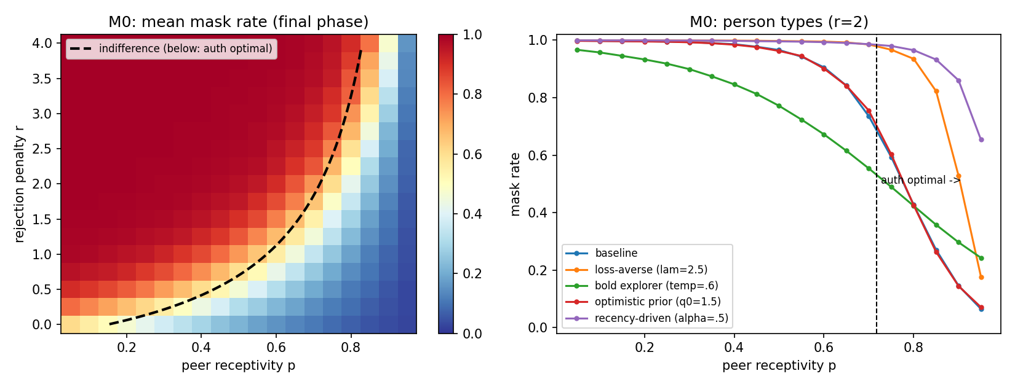
Figure 1. Left: mean final mask rate over (p, r); dashed curve = objective indifference. Right: persona curves at r = 2.
A wide band of heavy masking persists to the right of the objective indifference curve, where authenticity is strictly better in expectation: that band is the hot-stove lock-in region, present already in the stateless two-armed game. The persona panel maps temperament onto fate at r = 2: the loss-averse and the recency-driven child still mask at p ≈ 0.85, deep in authenticity-optimal territory, while the bold explorer escapes earliest. Notably, an optimistic prior barely helps — initial confidence is eroded by the same early bad draws, so durable exploration, not initial self-esteem, is what breaks the trap.

7.2 M1: action granularity is protective (Figure 2)
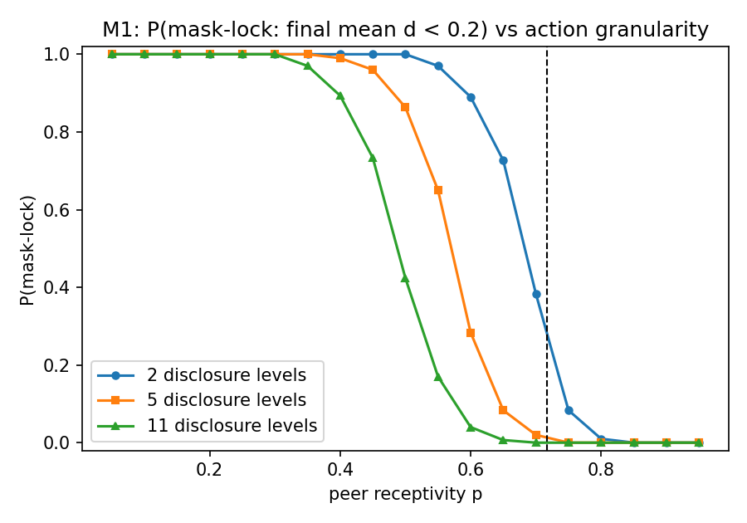
Figure 2. Probability of mask-lock versus p for 2, 5, and 11 disclosure levels.
Finer disclosure grids shift the lock-in transition left by roughly Δp ≈ 0.2 relative to the binary game. Intermediate disclosure levels are punished less when they fail, so estimates of 'showing more of myself' remain alive and the child can climb the disclosure ladder stepwise. Substantive prediction: settings that permit graded self-presentation (clubs, one-to-one contact, partial reveals) should show measurably less masking lock-in than settings that force a binary in-or-out choice.

7.3 M2: sticky stigma is a separate, environment-side trap (Figure 3)
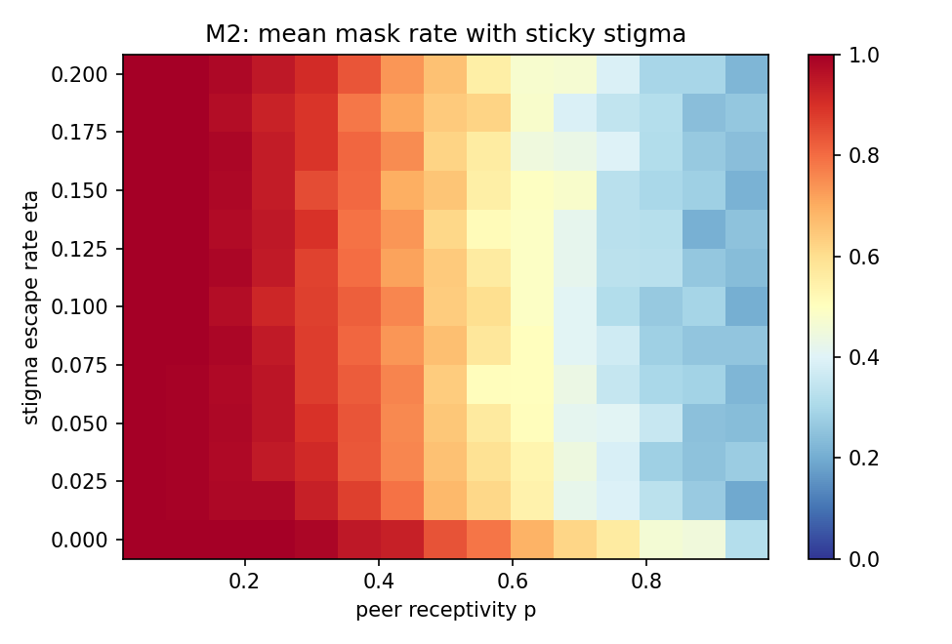
Figure 3. Mean mask rate over receptivity p and stigma escape rate η.
Masking stays high even at large p when η is small, and the contours bend so that escape rate matters most at intermediate receptivity. Structural lock-in is therefore not redundant with the learning trap: at p = 0.6, moving from η = 0 to η = 0.05 — occasional genuine fresh starts such as a new class or school — cuts masking substantially, an effect no learner parameter in M0 can replicate. The intervention lever here belongs to the environment, not the child.

7.4 M3: context multiplicity is harmful (Figure 4)
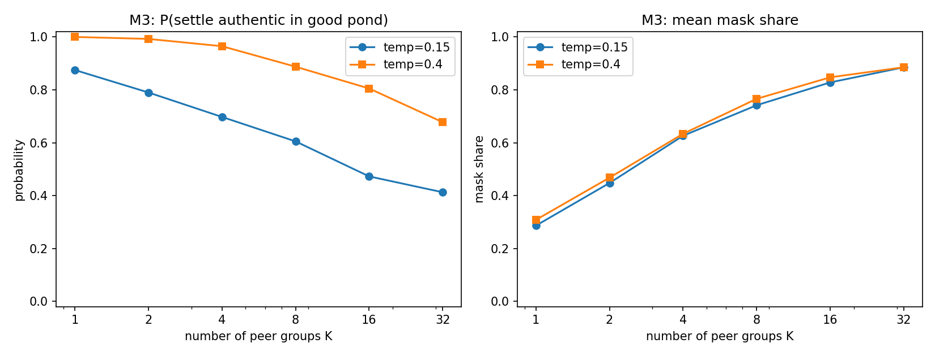
Figure 4. Left: probability that the modal final behavior is authenticity in the good pond, versus K. Right: mean mask share versus K.
The probability of settling authentically in the good pond falls roughly linearly in log K, and mean mask share climbs from about 0.3 at K = 1 to about 0.9 at K = 32. The asymmetry driving this is that masking works everywhere while working authenticity must be found, so the safe arm's advantage compounds with the size of the social world. Higher exploration improves pond-finding but barely reduces masking along the way — search costs are paid in masked time.

7.5 Bistability: same parameters, different fates (Figure 5)
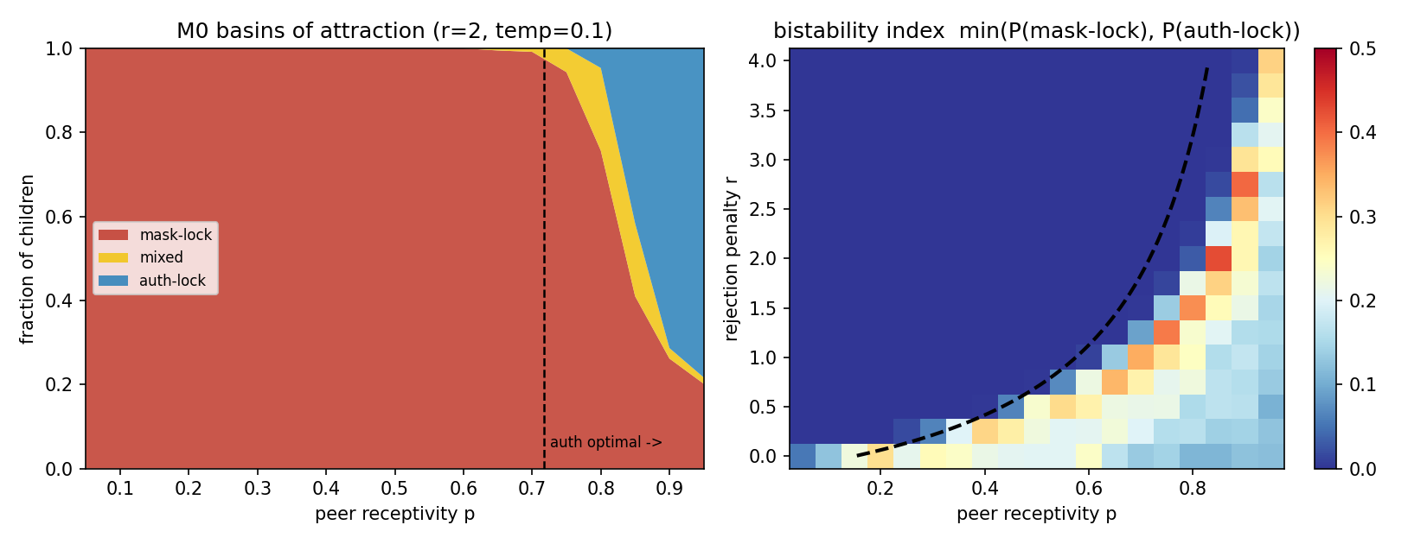
Figure 5. Left: basin fractions along r = 2 at τ = 0.10. Right: bistability index min(P(mask-lock), P(auth-lock)) over (p, r).
Hard bistability requires a decisive (exploitative) policy: at the baseline temperature the two basins dissolve into persistent mixed behavior, while at τ = 0.10 the population at p = 0.85, r = 2 splits roughly 45/40 into mask-locked versus authenticity-locked children with almost no one in between. The bistable ridge hugs the authenticity-optimal side of the indifference curve: divergent fates concentrate exactly where the objectively right choice is the risky one. A testable corollary: decisive, commitment-prone children should display more divergent social outcomes than tentative ones in identical environments.

7.6 BFLPE: anticipatory retreat from the good pond (Figure 6)
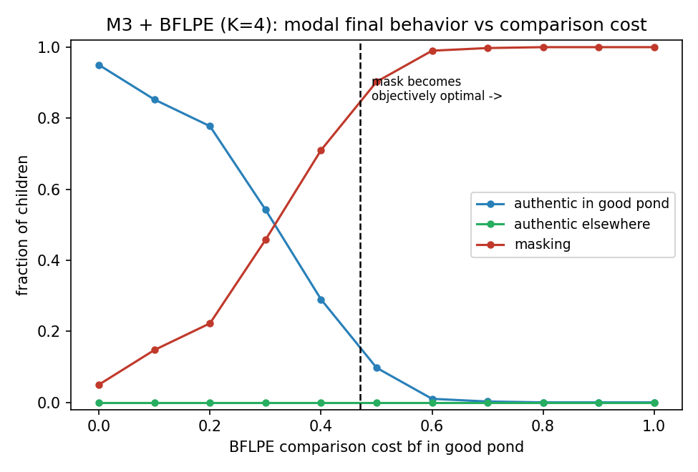
Figure 6. Modal final behavior versus comparison cost bf at K = 4; dashed line = analytic crossover bf* ≈ 0.47.
The behavioral migration from good-pond authenticity to masking is already half complete at bf ≈ 0.3, well before the crossover at which masking actually becomes optimal. The hot-stove asymmetry shaves the perceived value of the risky arm, so a modest comparison cost tips learned behavior while authenticity is still objectively worth it. 'Authentic elsewhere' never occurs: the model produces no children who are authentic in unreceptive groups — the realistic alternatives are good-pond authenticity or masking, consistent with the selective-friendship literature.

7.7 M4: spirals, hysteresis, and the closing window (Figure 7)
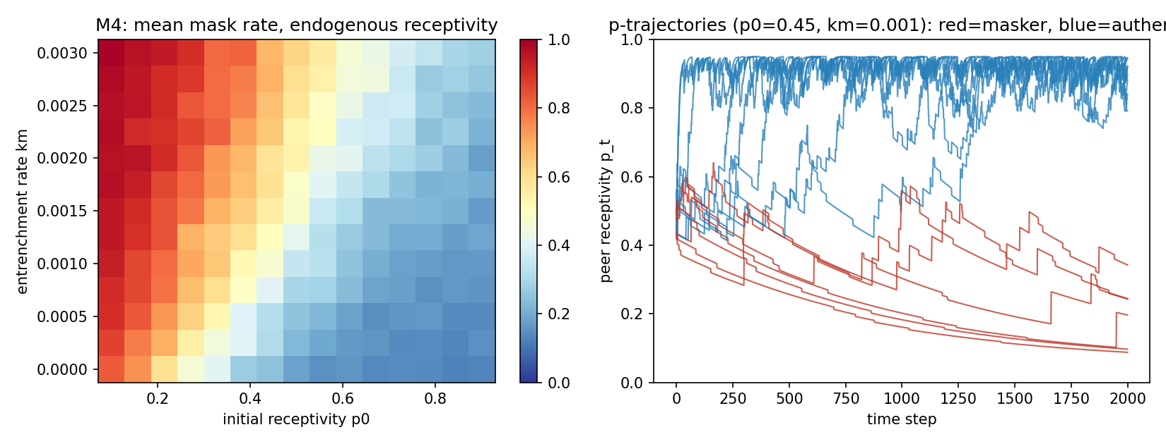
Figure 7. Left: mean mask rate over (p0, km). Right: receptivity trajectories from identical starts (p0 = 0.45, km = 0.001); red = final maskers, blue = final authentics.
With acclimation faster than reputation decay (ka = 0.12 versus kr = 0.04), the trajectories show true hysteresis: from identical starting conditions, some children string together early authentic successes, receptivity compounds toward 0.9, and they become robustly authentic — surviving occasional rejections once high. Others mask early, receptivity erodes, and each later authentic attempt lands in a worse world than the last; the small upward blips that decay are failed coming-out attempts. The basin boundary in the heatmap runs diagonally in (p0, km): higher entrenchment demands higher starting receptivity. Timing therefore matters more than environment quality — the same environment reached late, after entrenchment, behaves like a worse one. An earlier calibration in which entrenchment outpaced acclimation produced universal collapse regardless of learner parameters, a diagnostic boundary case: if the world entrenches faster than peers acclimate, no temperament saves the child.

8. Risk-Averse versus Risk-Taking Children
Risk attitude enters through the loss-aversion parameter λ: the risk-averse child (λ = 2.5) experiences rejections at two and a half times their face value; the risk-taking child (λ = 0.5) discounts them by half. Because λ acts only on the subjective value fed to learning, the stratification reuses every environment unchanged, and the analytic subjective indifference curve predicts where each type's behavior should flip.

8.1 Static mirror-image errors (Figure 8)
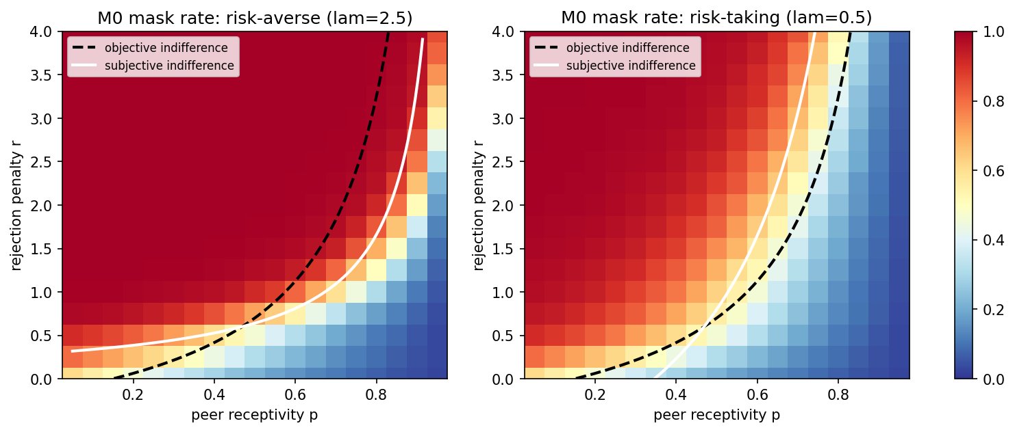
Figure 8. M0 phase maps by risk type. Black dashed = objective indifference; white = that type's subjective indifference. The wedge between them is the type's characteristic error region.
Each type's behavior tracks its own white curve, not the black one. For the risk-averse child the white curve sits right of the objective one, and in the wedge between them the child masks where authenticity is objectively better — the classic gifted-masking failure, widened, with a sharper and more committed transition, and compounded by hot-stove lock-in pushing in the same direction. For the risk-taking child the picture mirrors: the white curve sits left of the objective one, and in that wedge the child remains authentic where masking would objectively pay, repeatedly absorbing rejection costs that fail to deter — a second, qualitatively different suboptimal equilibrium: not the hidden child but the one who keeps getting burned and does not withdraw. Neither temperament is calibrated; they err on opposite sides of the boundary, so an intervention that simply pushes children toward boldness trades one error region for the other.

8.2 Dynamic worlds break the symmetry (Figure 9)
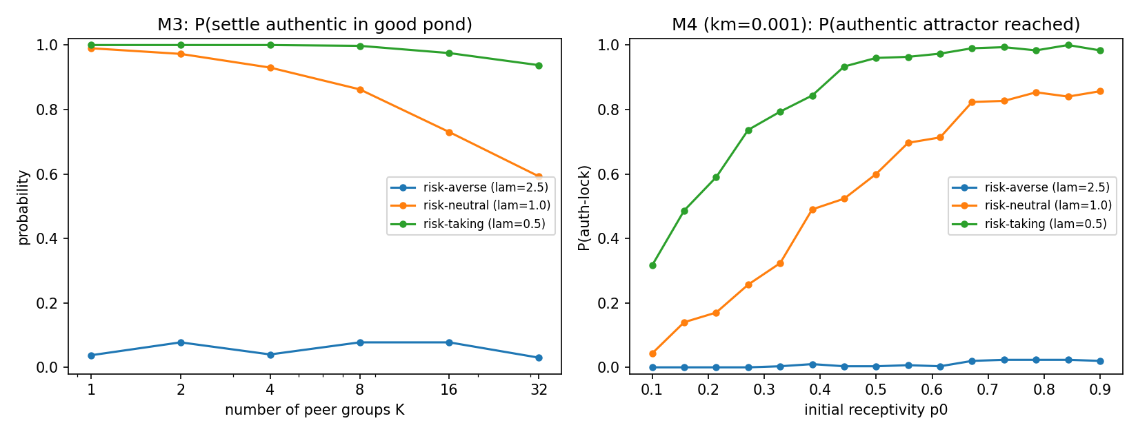
Figure 9. Left: M3 good-pond settlement versus K by risk type. Right: M4 probability of reaching the authentic attractor versus initial receptivity p0 (km = 0.001).
In the static game the two types make mirror-image errors of comparable size; in any dynamic world the symmetry breaks decisively. In M3 the risk-averse child essentially never settles authentically in the good pond at any K — including K = 1 — because a couple of early rejections, weighted 2.5×, close the authentic arms before the good pond's statistics can emerge; the risk-taker holds roughly 95% settlement even at K = 32, nearly immune to dimensionality. In M4 the risk-averse curve is flat at zero across all p0: even a maximally receptive starting environment cannot carry the child through the inevitable early-failure phase before entrenchment closes the window, while the risk-taker's tipping point sits near p0 ≈ 0.15–0.2.
The headline asymmetry: wherever authenticity must be discovered (M3) or built (M4), risk-taking is strictly protective and risk-aversion is close to fatal, because the payoff structure makes authenticity the arm whose value can only be learned by surviving its losses. The highest-leverage intervention for risk-averse children is therefore not more opportunity — raising p0 does nothing on the flat curve — but reducing the subjective cost of a failed reveal (adult framing of rejection, low-stakes venues), which moves λ rather than the environment.

9. Consolidated Outcome Map
The ladder identifies four mechanistically distinct routes into suboptimal persistent masking. They respond to different interventions, which is the practical payoff of separating them.
Route (rung) | Mechanism | Who is most exposed | What helps
Hot-stove lock-in (M0) | Early rejections freeze sampling of the high-variance authentic arm; estimates never correct. | Loss-averse (λ high) and recency-driven (α high) children; decisive (low τ) children split into divergent fates. | Sustained exploration; reducing the subjective sting of rejection (moves the white curve toward the black one).
Structural stigma (M2) | Revealing is irreversible; the stigmatized state degrades all options and traps even optimal learners. | Children in environments with long social memory and no turnover (low η). | Environment-side fresh starts: new classes, schools, contexts. No learner parameter substitutes.
Search burden (M3) | Masking works everywhere; working authenticity must be found among K contexts and loses the race as K grows. | Risk-averse children (never find the pond at any K); everyone as K grows. | Shrinking or structuring the search: placing the child near a similar-ability pond rather than leaving them to find it.
Entrenchment / hysteresis (M4) | Masking erodes future receptivity; the authentic option decays while unused, closing a time window. | Risk-averse children (window closes before first successes); anyone starting at low p0 under high km. | Early action, before entrenchment: timing dominates environment quality.

Dimensionality conclusions. The two dimensionality axes pull in opposite directions: finer action spaces (graded disclosure) protect against lock-in, while larger context spaces (more peer groups) aggravate it; endogeneity (M4) then converts the entire static phase diagram into a time-critical one, in which identical parameters yield different fates depending on early history. The danger of ending in a suboptimal equilibrium is therefore not a monotone function of 'problem complexity': it depends on whether added dimensions enlarge the child's expressive repertoire or merely enlarge the haystack.

10. Limitations and Future Work
Quantitative locations of boundaries — the bistable ridge, the size of the BFLPE anticipation gap, the Δp ≈ 0.2 granularity shift — depend on the exploration budget (T, α, τ) and should be reported as functions of it; the qualitative structure (existence and ordering of the regions) is robust across the calibrations tested. The loss-aversion parameter conflates risk tolerance with loss insensitivity; a mean-variance agent that penalizes payoff variance separately would disentangle them at the cost of roughly twenty lines of code. Peers are passive statistics rather than learning agents — a multi-agent extension would let receptivity itself be a population-level learned response and could model classroom-culture formation. Disclosure in M1 is one-dimensional, whereas the literature distinguishes domains (ability, interests, intensity) that could be masked independently. Finally, the models are not yet fitted to data; the natural empirical bridge is the Social Coping Questionnaire literature, whose subscales (denying giftedness, social interaction, humor, helping) map onto regions of the outcome maps and onto M1/M3 strategy mixtures.

11. References
Alexopoulou, A., et al. (2020). Stress, anxiety and mental health problems in gifted adolescents.
Alelyani, S. (2021). Special educational need of the gifted and talented students in Saudi Arabia: A review paper.
Carter, N., et al. (2025). School experiences of gifted adolescents and their peers.
Coleman, L. J., & Cross, T. L. (1988/2014). The stigma of giftedness and information management among gifted students.
Cross, J. R., et al. (2019). A cross-cultural study of the social experience of giftedness.
Demir, S., et al. (2021). Examining the relationship between the sense of humor and the social exclusion perceived by gifted and talented students.
Denrell, J., & March, J. G. (2001). Adaptation as information restriction: The hot stove effect. Organization Science, 12(5), 523–538.
Fang, J., et al. (2018). The Big-Fish-Little-Pond effect on academic self-concept: A meta-analysis.
Freeman, J. (2014). A 35-year comparison of children labelled as gifted, unlabelled as gifted and average-ability.
Gaerlan-Price, E. (2015). Meet, prey, like: A study of gifted girls' interactions with social media.
Horvat, M. (2019). Sociometric status of gifted students in classroom and subject teaching in elementary school.
Kara, A., et al. (2025). Cyber victimization and subjective well-being: Protective roles of self-esteem and social support among Turkish gifted youths.
Khalil, M., et al. (2016). Identifying 'good' teachers for gifted students.
Korneeva, S. (2021). Gifted children in the educational space.
Papadopoulos, D. (2021). Examining the relationships among cognitive ability, domain-specific self-concept, and behavioral self-esteem of gifted children aged 5–6 years.
R, et al. (2020). How can we better understand, identify, and support highly gifted and profoundly gifted students? A literature review.
Rokach, A. (2018). Children's giftedness and its determinants.
Sisk, D. (2021). Managing the emotional intensities of gifted students with mindfulness practices.
Sutton, R. S., & Barto, A. G. (2018). Reinforcement Learning: An Introduction (2nd ed.). MIT Press.
Tourreix, E., et al. (2023). Non-cognitive specificities of intellectually gifted children and adolescents: A systematic review of the literature.
Zeidner, M., & Schleyer, E. J. (1999). The big-fish-little-pond effect for academic self-concept, test anxiety, and school grades in gifted children.

