Learning, concealment, and objective benchmarks: a computational model cascade
Authority-reconciled Stage 3 working manuscript | Scientific consistency review draft
Stage 3 working manuscript. This authority-reconciled draft is for the
scientific consistency audit and contains only the models and experiments in the fixed Article V1 scope.

Abstract
Some gifted young people manage the visibility of their ability across social settings, but observed lower visibility does not establish whether concealment is currently advantageous, learned from adverse experience, or sustained by restricted information. We develop a cascade of reinforcement-learning models that compares finite learned behaviour with explicit full-information benchmarks. In E01, an initially rejected authentic action reduced later authentic sampling, although a persistent final-window masking difference was not detected. In E02, independently learned graded-disclosure actions increased nonzero disclosure but reduced discovery and use of the objectively optimal full-authentic endpoint. In E03, aggregate final-window Neutral actions favoured masking in 243 of 357 tested persistent-state cells where the dynamic oracle favoured authenticity; this is tested-grid coverage, not prevalence. In E04, the full-information value of a receptive context was K-invariant while its final-window use varied across finite-learning representations. In E05, the flat learner's operational comparison-cost crossing (.313, 95% bootstrap interval .308–.317) preceded the exact objective crossover (8/17≈.471). Together, the models show that immediate value, dynamic value, discoverability, and learned behavioural boundaries are distinct within the specified environments. They do not estimate human prevalence, diagnose gifted learners, or establish intervention effects. Instead, they provide explicit mechanisms and benchmarks for testing why lower-visibility strategies can persist when a more authentic alternative remains objectively valuable.

1. Introduction

1.1 Ability visibility as a sequential-learning problem
Giftedness is not a uniform social-emotional condition. Reviews and community-sample evidence caution against treating high cognitive ability as a general deficit or assuming that all high-ability young people encounter the same peer difficulties (Lavrijsen and Verschueren, 2023; Tourreix et al., 2023). At the same time, a substantial giftedness literature documents that some young people manage how visible their ability, interests, or performance is in social settings. The stigma-of-giftedness tradition describes conditional concerns about being treated differently when exceptional ability becomes known, while social-coping studies identify strategies including denial, conformity, helping, selective disclosure, and changes in social interaction (Coleman and Cross, 1988; Cross et al., 1993; Swiatek, 1995). These strategies vary across settings, social groups, and developmental circumstances rather than constituting a single trait.
We use concealment or lower-visibility behaviour as a bounded operational term for the low-visibility end of that strategy family. It does not equate privacy, strategic self-presentation, or temporary conformity with pathology, and it does not import clinical meanings of masking. The substantive question is narrower: how might a lower-visibility response remain learned when more authentic expression would have greater value in the specified social environment? This question concerns the temporal relation between action, social feedback, and later action—not whether a person is inherently risk averse or whether any observed concealment is maladaptive.
The available literature describes strategies and context dependence more readily than it identifies the sequential process that sustains one strategy. The same visible endpoint can arise because an environment remains unreceptive, because early adverse feedback discourages further testing, because an individual lacks a useful intermediate action, because a receptive setting is hard to identify, or because the immediate and future values of a response differ. Cross-sectional observations of low visibility cannot distinguish these possibilities. They also cannot establish whether a response is objectively advantageous under a defined environment.

1.2 Why observed masking is insufficient to establish objective optimality
Reinforcement learning provides a compact way to formalize this identification problem. In hot-stove learning, an early negative sample from a variable action can reduce subsequent sampling of that action; the resulting absence of corrective evidence can preserve avoidance even without a fixed aversion to risk (March, 1996; Denrell and March, 2001). This is established generic learning theory, not a new explanation unique to giftedness. Its relevance here is methodological: the outcome of a learner's choice changes the information available for later learning.
Observed action, however, is not itself a value function. In a static environment, an action may have lower estimated value because it has been sampled unfavourably despite a greater expected environmental reward. In a stateful environment, a seemingly costly action may improve later state and therefore have higher dynamic value. In a heterogeneous environment, a good option can exist while remaining difficult to identify and use. These are different propositions. Conflating them turns either low masking or high masking into an unsupported conclusion about adaptation.
This article therefore compares finite learned behaviour with an explicit full-information benchmark in each environment. The benchmark is an oracle relative to stated rewards and transitions; it is not a claim about human welfare, moral desirability, or what a learner could know at the moment of choice. The comparison allows the analysis to measure a learned–objective divergence where one is defined, and to distinguish that divergence from an environment in which lower visibility is itself the objective policy.

1.3 Contribution and model progression
The contribution is an existence-and-structure model cascade, not a calibrated psychological model. M0 is a two-action risky-authenticity bandit that isolates history-dependent sampling. M1 adds graded disclosure while preserving the static endpoint geometry. M2 adds Accepted and Stigmatized social states, so the relevant objective becomes a dynamic policy. M3 adds heterogeneous contexts that must be discovered and, within that environment, a comparison-cost axis. The sequence is logical rather than developmental, and no model step is mapped to a fixed unit of human time.
Five frozen experiments instantiate this progression. E01 asks whether an initial rejection changes later authentic sampling. E02 asks whether independently learned disclosure levels change discovery of an objectively best endpoint. E03 compares aggregate final-window action patterns with an exact full-information dynamic policy in the persistent-state model. E04 asks whether an objectively favourable context is equally discoverable across action architectures. E05 compares the environmental comparison-cost crossover with a learner's operational behavioural crossover. Figure 1 summarizes the formal progression and the benchmark assigned to each rung.
The intended synthesis is deliberately bounded. Immediate reward, dynamic value, discoverability, and a learned behavioural boundary are not interchangeable. The experiments do not estimate the prevalence of masking, establish an empirical causal mechanism in gifted populations, or evaluate an educational intervention. Instead, they make several candidate explanations for persistent lower visibility separable enough to state what evidence would be needed to distinguish them empirically.
The comparison also establishes a reporting discipline. An analytic statement can hold for every value in a formula's stated domain, whereas a simulated contrast supports only the axes, learner settings, horizons, and estimands that were executed. A full-information best action is not an instruction to a learner without the oracle's information. Conversely, an end-of-episode learner pattern is not evidence that the environmental payoff structure makes the same action best. We use “objective” only in this conditional model-relative sense: not as a moral recommendation, psychological welfare claim, or instruction to reveal more than one judges safe.
This perspective makes a practical ambiguity explicit. A low-visibility action can reflect current adaptation to an unreceptive setting, restricted learning after earlier feedback, or difficulty identifying a favourable alternative. These accounts require different empirical measurements despite producing a similar observed endpoint. Explicit benchmarks cannot determine which account describes a person, but they prevent a single behavioural observation from being treated as if it had already done so.

2. Model framework and Methods

2.1 Modelling objective and common learner
We use a sequence of deliberately simplified reinforcement-learning environments to ask when a finite learner can reduce authentic expression even though a full-information benchmark favours it. The numerical parameters define a normalized reference scale; they are not estimates of psychological utility, social transition rates, or the prevalence of any response in gifted learners. The models are therefore existence-and-structure analyses. They isolate relations among feedback, representation, persistent social state, and context discovery that can be evaluated exactly within their stated environments.
Three quantities are distinguished throughout. Environmental reward is the payoff generated by an environment and defines the objective comparison. Learned value is a finite learner's estimate based on selected experience. The full-information benchmark is an oracle that knows the relevant payoff and, for the stateful model, transition structure. It is not an information-matched optimum, a welfare prescription, or a claim about what a person should do.
All learners start with action values of zero and use a constant learning rate alpha=0.1, softmax temperature tau=0.25, and loss-neutral reward transform lambda=1. A realized reward R is transformed only before the learning update: v_lambda(R)=R for nonnegative outcomes and lambda R otherwise. Thus, at the reported baseline, the learner update and environmental reward coincide; loss aversion does not explain the headline results. For a selected stateless action x,
Q_{t+1}(x)=Q_t(x)+\alpha[v_\lambda(R_t)-Q_t(x)].
At each step the learner samples available actions with a numerically stable softmax,
P(X_t=x)=\frac{\exp\{Q_t(x)/\tau\}} {\sum_{x'}\exp\{Q_t(x')/\tau\}}.
The row maximum is subtracted before exponentiation in implementation. The finite horizon is an operational number of model steps, not a calendar unit. Final-window summaries use the last 20% of a run; they describe end-of-episode behaviour, not asymptotic convergence. Standard E01, E02, E04, and E05 runs use n=500 learners, T=2000, and five independent master seeds. E03 uses n=160 and T=1000 per grid cell because its outcome is a fixed-grid classifier. Student-t intervals across the five master estimates are reported for applicable contrasts; E05 uses a master-curve bootstrap described below.

2.2 M0 and E01: adverse-history environment
M0 offers masking M and authenticity A. Masking has deterministic reward R_M=b-c; authenticity is accepted with probability p and otherwise rejected:
R_A=\begin{cases}b+a,&\text{accepted},\\a-r,&\text{rejected}.\end{cases}
With the common reference values (b,a,c,r)=(1.0,0.6,0.25,2.0), masking returns 0.75, authenticity has expectation -1.4+3p, and the static objective boundary is p=43/60. E01 conditions on an initially accepted or rejected authentic outcome in the tested p=.75/.85 domain, then compares later authentic sampling. It also evaluates two information-restoring model manipulations within the rejected stratum: 5% forced authentic exploration and counterfactual authentic feedback. The primary E01 estimand is later sampling; the related normalized objective pseudo-regret is an action-count translation, not an independent result.

2.3 M1 and E02: graded disclosure/endpoints
M1 replaces the two actions with independent tabular values for disclosure levels d on a grid containing zero and one. Here d=0 is the masking endpoint and d=1 is full authenticity. Acceptance is 1-(1-p)d, yielding
Expected reward is therefore affine in disclosure. Except at exact indifference, a strict static optimum is an endpoint; intermediate disclosure is not made objectively optimal by the linear specification. E02 compares the binary architecture with five independent disclosure arms after an initial rejection, using matched random-number streams within master seed and receptivity. It measures continued nonzero disclosure, final-window selection of d=1, and whether d=1 is the unique modal final-window arm.

2.4 M2 and E03: persistent social state and a dynamic comparator
M2 makes the environment stateful. The explicit states are Neutral, Accepted, and Stigmatized. Authentic acceptance from Neutral moves to Accepted, whereas rejection moves to Stigmatized; masking does not itself change state. Accepted authenticity has reliable reward unless turnover returns the system to Neutral. Stigmatized outcomes use the specified b2, r2, and reduced redemption probability, with escape governed by eta. Reward is generated before the next-state transition. The learner stores Q(s,a) and updates the selected state-action pair with
Q(s,a)\leftarrow Q(s,a)+\alpha\{v_\lambda(R)+\gamma\max_{a'}Q(s',a')-Q(s,a)\},
where gamma=.9. The objective comparator is value iteration over the known reward and transition model, not a static M0 threshold.
E03 spans a frozen 21-by-17 receptivity-by-escape grid. For each cell, the reported classifier compares aggregate final-window Neutral-state action counts with the full-information dynamic policy, subject to a prespecified Neutral visit-adequacy rule. A cell is labelled learned–objective disagreement only when aggregate Neutral counts favour masking and value iteration favours authenticity. This is an action-level aggregate classifier; it is not an individual policy label, an ordering of Q values, or an estimate of a human or learner prevalence.

2.5 M3 and E04: heterogeneous-context discovery
M3 contains K contexts: one receptive context with probability p_good and K-1 unreceptive contexts with p_bad. In the reference design, p_good=.85, p_bad=.2, and bf=0 for E04. Masking has the common payoff across contexts. Authenticity uses the context-specific acceptance probability; comparison cost bf is subtracted only from accepted authenticity in the good context. With one fixed good context, increasing K changes the multiplicity of bad alternatives but not the distinct objective payoff classes or their maximum. The full-information objective is consequently K-invariant.
E04 compares four representations: flat_2k, a single softmax over joint context–behaviour arms; hierarchical, a context softmax followed by a behaviour softmax with both value tables receiving the realized reward; global_mask, one shared masking action plus context-specific authentic arms; and fixed_known_good, a two-arm problem without context choice. The primary outcome is the mean, across learners, of an indicator that the argmax of a child's final-window action counts is an authentic action in a good context. Ties are permitted by this defined argmax procedure. This is called final-window argmax classification below; it is not convergence or a literal model of human relocation between peer groups.

2.6 E05: objective and learned comparison-cost crossings
E05 holds K=4 and one good context fixed while varying bf. At the reference parameters, masking has expected reward .75 and accepted good-context authenticity has expected reward 1.15-.85bf; their exact objective equality is therefore bf*=8/17=0.470588. This is a static environmental boundary, not a learned threshold. The reported learned response is the across-child fraction whose final-window modal arm is the good-context authentic arm in the flat eight-action architecture. Equal-weight nonincreasing pooled-adjacent-violators (PAVA) fits are calculated on the dense .30 to .65 cost grid, and the reported value is the fitted 0.5 crossing. Five complete master curves are resampled for its 10,000-resample bootstrap interval. The monotonic fit is an estimator constraint, not a proof that each learner or master curve is monotonic. The hierarchical response is reported as left-censored when it is already below .5 at the lower fitted boundary; no crossing is extrapolated.
Full equations, transition kernels, parameter tables, grid definitions, stream construction, tie mechanics, sensitivity conditions, PAVA details, and provenance records are routed to Supplementary Methods and repository documentation.
All reported effect estimates preserve their experiment-specific inferential unit. E01, E02, and E04 summarize five independent master-seed estimates rather than treating individual learners as independent experiment replications. E03 preserves a fixed grid per master, and its stable-cell rule prevents inadequate Neutral-state exposure from being silently classified. E05 resamples complete master curves so uncertainty in the fitted crossing reflects run-level response curves rather than merely the number of simulated children. These choices do not convert a reference configuration into a population estimate; they make the uncertainty statement match the preserved design.

3. Results

3.1 Early rejection reduced subsequent authentic sampling (E01)
E01 provides the minimal restricted-feedback result. Across the five master seeds, learners assigned an initially rejected authentic outcome sampled authenticity less often over subsequent steps than learners assigned an initially accepted outcome (rejected minus accepted -0.025837, 95% CI [-0.035753,-0.015922]; Figure 2A). In the stated M0 environment, authenticity is objectively preferable at the tested receptivities. The result therefore documents a finite learning-history difference in sampling, not a change in the environmental payoff comparison.
The normalized objective pseudo-regret contrast was +0.025824 [+0.015914,+0.035735], but it is not a second corroborating outcome. In this design it is exactly linked to the sampling contrast, Delta R_norm=-(1999/2000)Delta A; it restates the same action-history difference in objective-loss units. Importantly, the final-window masking contrast was -0.000343 ([-0.011605,+0.010918]). Thus the experiment did not detect an increase in final-window masking after a single initial rejection; the interval crossing zero is not evidence of equivalence.
The two model information manipulations were directionally consistent with the sampling account. Within the rejection stratum, 5% forced authentic exploration reduced final-window masking by 0.046590 ([0.033230,0.059951]), and counterfactual authentic feedback reduced it by 0.118135 ([0.109683,0.126587]). These are manipulations of the model's information channel, not estimates of human intervention effects. E01 is consequently a supporting hot-stove demonstration: early adverse feedback can reduce later sampling and delay correction, without establishing a persistent final-mask effect in the tested conditions.

3.2 Independent graded actions reduced optimal-endpoint discovery (E02)
E02 asks what changes when the visibility continuum is represented as five independently learned actions rather than binary endpoints. Following initial rejection, the graded architecture increased continued nonzero disclosure by 0.255040 (95% CI [0.253004,0.257077]) relative to binary resampling of full authenticity (Figure 2B). This is an exposure-distribution result: more learners continued some nonzero disclosure. It does not show that an intermediate level was objectively preferable.
The same graded representation reduced full-authentic final-window selection by 0.328692 ([-0.342037,-0.315348]) and reduced the probability that the objectively optimal endpoint was the unique modal final-window arm by 0.221740 ([-0.288755,-0.154724]; Figure 2C). The analytic comparison is decisive for interpretation. Because M1 expected reward is affine in d, full authenticity is the strict objective endpoint whenever the corresponding binary environment favours it; intermediate actions are not an unmodelled compromise optimum.
The graded arms instead change how finite experience is allocated. An outcome at one disclosure level does not update neighbouring levels, so partial actions can receive experience while the full-authentic endpoint remains relatively under-sampled. E02 therefore complements E01 rather than replicating it. E01 changes the history of information about one risky action; E02 changes the action representation through which information is acquired. The normalized regret statistic is disclosure distance 1-d in authenticity-optimal cells and is not treated as a second welfare result. The result is representation conditional: it does not establish a disclosure-specific psychological mechanism or predict the same behaviour for a learner that generalizes across ordered disclosure levels.

3.3 Aggregate learned Neutral actions disagreed with the dynamic optimum (E03)
E03 introduces a different question: when authentic action changes future social state, what should count as the relevant objective comparison? The answer is not the static M0 reward threshold. In M2, authentic acceptance can move the environment into an Accepted state with reliable authentic reward, whereas rejection can move it into a Stigmatized state; the value of a Neutral choice consequently includes future rewards and transitions. Figure 3 compares finite learner behaviour with the exact full-information discounted MDP policy computed by value iteration under the same rewards and transition equations. The comparison is an oracle benchmark: it knows environmental contingencies that the learner must sample to estimate.
At n=160 learners and T=1000 steps per cell, the frozen 21-by-17 receptivity-by-escape grid produced 243 of 357 cells in which aggregate final-window Neutral-state action counts favoured masking while the full-information dynamic policy selected authenticity. The fraction, 243/357=0.680672, was identical across the five master seeds. It is a count of cells satisfying a jointly defined classification, not a frequency of individual learners. Specifically, a cell enters the count only when the aggregate Neutral final-window action count favours masking, value iteration favours authenticity, and the maintained visit-adequacy criterion is met.
The classifier was stable in 350 of 357 cells under the prespecified four-of- five-master rule. Seven low-receptivity, eta=0 cells were inconclusive because Neutral visits did not meet the adequacy criterion. They were not forced into a masking or authenticity category. The map should therefore be read as a tested-grid summary of this learner, horizon, classifier, and M2 environment. It is not human prevalence, learner prevalence, a natural phase-space volume, or a Q-value classifier. Nor does it establish that the learner failed relative to an information-matched optimum; it shows a divergence from a known-model, full-information dynamic policy.
For a general reader, the central contrast is between an action's immediate outcome and its role in changing future opportunity. In Neutral, masking can provide a predictable immediate payoff, while authentic action can have a negative immediate realization but also a chance to create an Accepted state with later benefit. Value iteration incorporates that future branch directly. A finite Q learner must encounter, remember, and propagate those contingent outcomes through its state-action values while its own earlier choices affect which states it revisits. The result does not identify which component—finite sampling, state visitation, constant-step learning, or the oracle information advantage—accounts for a given cell. It establishes the disagreement under the specified joint design.
The frozen sensitivity results delimit rather than generalize the map. Dynamic objective thresholds varied with the escape parameter, and selected changes to gamma, alpha, or tau reclassified named sentinel cells. At gamma=.5, some reclassifications reflected a change in the objective policy itself, not better learner performance. No learned Neutral transition threshold was estimated from the preserved data. A separately labelled harsh boundary demonstrates that masking can be dynamically objective in a different M2 configuration; it does not turn the reference-grid result into a universal structural-lock-in region. E03's supported conclusion is consequently narrow but important: in a persistent-state environment, observed end-of-run action counts can differ from the relevant dynamic objective benchmark.
The distinction is easiest to see by asking what a final-window Neutral count does and does not summarize. It reports which action was more frequent during the observed tail of the finite episode among those moments classified as Neutral. It does not report the probability that every learner uses masking, the action chosen in Accepted or Stigmatized states, the value of an unobserved policy, or the amount of discounted loss relative to the oracle. The visit criterion matters for the same reason: a cell with too little Neutral exposure cannot support a reliable statement about its Neutral action pattern. Keeping this classifier explicit makes the map interpretable without turning a useful model comparison into a stronger population claim.
The M2 result also supplies a caution for the surrounding literature. A longitudinal observation that an adolescent becomes less visibly authentic after a negative response could reflect changing beliefs in a fixed environment, changing opportunities caused by social state, or a combination. The present model cannot identify those processes in people, but it shows that they imply different formal benchmarks. A study designed to discriminate them would need repeated actions, responses, state-relevant contextual measures, and a clear account of what information was available at each decision.

3.4 A favourable context was not equally discoverable across representations (E04)
E04 asks whether objective availability of a receptive context is sufficient for a finite learner to use authentic behaviour there. The one-good-context M3 environment supplies an exact baseline: increasing K creates additional bad contexts but leaves the distinct payoff classes and the full-information best expected reward unchanged. Any K response therefore cannot be attributed to a reduced maximum objective opportunity. The empirical question is whether a finite learner identifies and repeatedly selects authentic action in the good context under the representation through which it learns.
The primary outcome is final-window argmax classification as authentic in a good context: for each learner, final-window action counts are compared by argmax, and the indicator is one when the resulting action is authentic in a receptive context. It is neither an asymptotic convergence statement nor a claim that a person has permanently chosen a social group. In the flat 2K architecture, increasing the number of contexts from one to 16 changed this outcome by -0.2340 (95% CI [-0.246417,-0.221583]; Figure 4A). Under the hierarchical architecture, in which context and behaviour are represented in separate but jointly rewarded tables, the corresponding contrast was -0.4704 ([-0.511031,-0.429769]). These are architecture-specific estimates; the larger hierarchical decline must not be read as a general ranking of learning architectures.
The control set constrains the interpretation. In fixed_known_good, there is no context choice and the structural K effect is exactly zero. In global_mask, one masking action is shared across contexts while authentic actions remain context-specific; its K contrast was +0.0088 ([0.002090,0.015510]), statistically distinguishable from zero but practically near zero under the prespecified band. These controls show that the result is not simply a change in the objective maximum and is sensitive to how joint actions are represented. They do not isolate a single duplicate-mask or normalization mechanism because global masking also changes cardinality, initial mass, competition, and reward allocation.
Randomising the good-context identity did not materially change the K decline: the random-minus-fixed slope contrasts were -0.00292 ([-0.012269,0.006429]) for flat and +0.00140 ([-0.012620,0.015420]) for hierarchical learning. Adding receptive contexts weakened the decline: with two good contexts the change relative to one good was +0.05064 for flat and +0.02524 for hierarchical; in the tested proportional-25% design the corresponding changes were +0.06044 and +0.11224. Together, these results support a bounded conjunction: representation-dependent finite discovery burden is most evident in the tested scarce-receptivity design. The one-good-context manipulation alone confounds increasing K with reducing the good fraction to 1/K, so it does not separately establish a causal effect of “more contexts” or scarcity alone.
E04 thus separates two propositions that can otherwise be conflated. A good authentic option may remain objectively available under full information while its discovery and final-window use by a finite learner vary with the action architecture and distribution of receptive contexts. The model does not represent literal student movement between classrooms, friendship groups, or educational placements. Its contribution is the more limited formal claim that the structure of alternatives and their discoverability can matter even when a favourable option remains in the environment.
The contrast between the four architectures is informative precisely because it changes the learner's representation while holding the frozen environmental payoffs fixed. flat_2k requires a learner to acquire a value for each joint context-behaviour arm. hierarchical separates context and behavioural selection but updates both selected representations from the same outcome. global_mask makes the low-visibility option share evidence across contexts, and fixed_known_good removes context identification entirely. None is claimed to be a literal cognitive architecture. Together they instead show that the apparent K effect is not a consequence of the objective maximum falling with K, and that it cannot be reduced to the number of arms alone. The observed patterns remain conditional on the specified learner and scarce receptivity configurations.

3.5 Learned and objective comparison-cost boundaries separated (E05)
E05 varies a comparison cost within M3 to compare an exact environmental boundary with an operational behavioural boundary. At the reference payoffs, masking returns .75, while accepted authenticity in the good context returns 1.15-.85bf. The full-information objective crossover is therefore exactly bf*=8/17=0.470588 (Figure 4B): below that value, good-context authenticity has the higher expected reward; above it, masking does. This is a property of the stipulated payoff equation, not an estimate of learner preference or a human comparison-cost threshold.
The learned quantity is different. In the flat eight-action (K=4) model, we calculated for each cost the across-child fraction whose final-window modal arm was the good-context authentic action. We pooled the five master curves and used a nonincreasing PAVA fit over the dense .30–.65 range. The fitted response crossed .5 at bf=0.312852, with a 10,000-resample master-curve bootstrap interval [0.307836,0.316918]. Thus the reported .5 crossing occurs well before the objective indifference point. At the learned point crossing, good-context authenticity still retained an objective advantage of about 0.134076; the transformed bounds inherited from the crossing were about [0.130620,0.138340].
This contrast should not be collapsed into a familiar two-action softmax statement. The response is an across-child final-window modal-classification fraction, not a per-trial softmax probability, a direct policy probability, or a binary Q-value equality. The PAVA constraint summarises the observed population response; it does not prove monotonicity of individual histories or identify the mechanism of the shift. The objective line was a tested analytic anchor, not a target provided to the fitting procedure.
The hierarchical response was already below .5 at the lower dense-boundary value bf=.30: its isotonic response there was .1176, and none of 10,000 bootstrap resamples yielded an in-range crossing. Its crossing is therefore left-censored below the resolved range, not absent globally and not comparable as a point estimate with the flat crossing. The endpoint contrast from bf=0 to .80 provides supportive context but does not replace the dense transition estimator.
E05 establishes a learned–objective crossover displacement in this learner and reference configuration. It does not apportion that displacement among temperature, multi-action normalization, finite sampling, endogenous under-sampling, context discovery, constant-step learning, or representation. Those factors remain possible contributors, and the frozen evidence does not identify their quantitative shares. The result is consequently neither a universal behavioural threshold nor a calibrated claim about social comparison in gifted populations.

4. Cross-experiment synthesis and Discussion

4.1 History, information, and action representation
The five experiments distinguish several reasons why an observed low-visibility action can persist without establishing that it is the best environmental choice. E01 is the minimal information-history case. A rejected authentic outcome lowers subsequent sampling of the action that could correct the estimate, a familiar hot-stove pattern in which choice alters later evidence (March, 1996; Denrell and March, 2001). Its information-restoring manipulations show that changing the model's evidence channel can improve correction. Yet E01 does not demonstrate a stable final-window masking difference. Its value in the article is therefore foundational: it separates a trajectory-level learning consequence from a claim about a persistent behavioural endpoint.
E02 provides a complementary, rather than confirmatory, manipulation. It leaves the static endpoint logic intact but expands the learner's independent action representation. More nonzero disclosure after rejection coexists with less discovery and use of the full-authentic endpoint. The two results should not be translated into a mechanism-independent recommendation to increase or decrease access to authenticity-related actions. E01 restores missing information about an existing risky alternative; E02 divides finite evidence across several actions that do not generalize to one another. Their shared lesson is that behaviour can change through information acquisition and action representation even while the objective comparison remains fixed. Their different designs are a cross-mechanism dissociation, not statistically independent replications of the same treatment effect.

4.2 Immediate and dynamic value
M2 changes the mathematical object to be evaluated. The M0 and M1 comparisons are static expected rewards; M2 requires a policy that values state-dependent future consequences. Consequently, describing masking as “suboptimal” in E03 is meaningful only relative to the stated full-information dynamic-programming oracle. The 243/357 map does not say that a corresponding share of learners or people masks irrationally. It demonstrates that, under a precisely specified classifier and tested region, aggregate end-of-run Neutral choices can favour masking where the known-model dynamic policy favours authenticity.
This distinction matters substantively. The same immediately safer choice can be adaptive in an environment with persistent adverse consequences and non-optimal in one where authentic success opens valuable future states. Indeed, the harsh M2 sentinel preserved in the supplement shows that masking can be dynamically objective in another parameter configuration. The model therefore resists both symmetric overinterpretations: a high observed masking rate does not itself establish maladaptive avoidance, but a more favourable immediate authentic payoff does not settle a dynamic question either. Empirical work inspired by this distinction would need repeated information about action, response, later context, and persistence—not only a cross-sectional measure of concealment.

4.3 Availability and discoverability
E04 extends the identification problem from time to alternatives. The full-information objective is K-invariant in the one-good-context design, but finite learners' final-window argmax classifications change as the context structure and representation change. This is not evidence that real students literally search a menu of peer groups or that one learning architecture is a psychological process. It is a formal demonstration that the structure of available alternatives and the cost of discovering them can matter separately from whether a favourable alternative exists.
This abstraction is relevant to giftedness because social coping and visibility management are documented as context-sensitive rather than uniform (Coleman and Cross, 1988; Cross et al., 1993; Swiatek, 1995). The model suggests a testable hypothesis: when social receptivity is uneven and information about contexts is local, opportunities for authentic expression may be harder to identify or use than their objective availability alone would imply. It does not identify a literal search mechanism, a school-placement intervention, or a causal pathway in any gifted population. The E04 controls further caution against a single-factor story: its supported result is representation-dependent finite discovery burden under scarce receptivity in the tested environments.

4.4 Behavioural and objective boundaries
E05 makes the distinction between environment and learned response visible at a single reference configuration. The objective 8/17 line is a payoff indifference result. The earlier flat learned crossing is an estimator-defined summary of across-child end-of-run modal classifications. Their difference shows that a finite learner's behavioural transition need not occur where a fully informed environment changes its optimal action. That is the article's most direct boundary-displacement result.
The difference should not be made cleaner than the evidence permits. Because the response is multi-action and population-level, the binary-softmax half-probability identity cannot attribute or exclude a temperature effect. Neither the existing curves nor the analytic result quantify contributions from exploration, action competition, representation, finite horizon, or learning rate. The hierarchical result is left-censored, adding an explicit reason not to generalize a single flat crossing across architectures. E05 therefore supports a configuration-specific learned–objective displacement, not a causal decomposition or a human threshold.

4.5 Implications for ability visibility
Taken together, the models provide a bounded mechanism-level hypothesis for understanding persistent concealment-like strategies in high-capability individuals. A low-visibility response can be learned even when an alternative has greater objective value within a stipulated environment, because early history can restrict information, an action representation can dilute endpoint learning, current choice can have dynamic consequences, receptive alternatives can be difficult to discover, and an operational behavioural boundary can differ from environmental indifference. This proposition concerns the constructed environments, not a diagnosis, prevalence estimate, or claim that gifted people instantiate the models literally.
The giftedness literature supplies the substantive motivation and the necessary restraint. Some gifted young people report managing the visibility of ability, conformity, or disclosure across social settings, but giftedness does not imply a uniform social-emotional profile or a universal need to conceal (Cross et al., 2014; Cross et al., 2019; Tourreix et al., 2023). The appropriate empirical next step is to measure sequences of visible action, perceived and observed response, later sampling of related actions, and changing opportunities across contexts. Such data could distinguish current adaptation to an adverse environment from restricted information, dynamic consequences, or discovery constraints—mechanisms that look similar in a single end-point observation.

5. Limitations
Several limitations are integral to the interpretation. First, the models are stylized and use a normalized reference payoff scale. Their parameters are not calibrated estimates of the social value of authenticity, the cost of concealment, the probability of acceptance, comparison costs, or psychological time. The model actions are constructs for analysing visibility management, not direct measures of behaviour, identity, privacy, or clinical masking. Accordingly, the results do not estimate prevalence in gifted populations, diagnose individuals, or establish educational intervention effects.
Second, the full-information static and dynamic benchmarks are oracles. They provide a clear reference for the specified environments, but they are not information-matched optima that a finite learner could necessarily attain. Learner–oracle differences are not decomposed into separately identified contributions from observation, exploration, state uncertainty, finite horizon, or update efficiency. The learner family is also narrow: tabular values, constant learning rate, fixed-temperature softmax choice, and the stated action representations. E02 in particular is conditional on independent disclosure arms and does not establish what a learner with structured generalization would do.
Third, simulation claims are conditional on executed grids, horizons, and inferential units. E03's 243/357 result is tested-grid coverage under a specific aggregate classifier, not a prevalence estimate or a full parameter characterization. E04's K response depends on scarce receptivity and action architecture. E05's crossing is based on five master curves and an estimator-defined PAVA response; its mechanism decomposition is unresolved, and its hierarchical transition is left-censored below the fitted range. A model limitation is allowed to remain a limitation rather than being repaired by unexecuted sensitivity analyses.
Finally, the frozen result artifacts are preserved and hash-validated, but the exact historical generator-source worktree for E01–E03 was not fully recovered from Git alone. E04 and E05 have fingerprint-exact archived generator bundles. This provenance limitation constrains exact historical source reconstruction; it does not authorize replacement runs or change the scope of the frozen evidence.

6. Conclusion
This model cascade separates learned behaviour from the relevant objective benchmark rather than treating observed concealment as evidence that concealment is objectively preferable. Across the E01–E05 progression, early adverse feedback altered later sampling, independent graded actions altered endpoint discovery, persistent state changed the relevant dynamic optimum, context structure changed discoverability, and an operational learned boundary preceded environmental indifference. The central lesson is therefore structural: immediate value, dynamic value, discoverability, and a learned behavioural boundary are distinct quantities.
The article does not claim a calibrated account of gifted students or a universal mechanism of masking. Instead, it offers explicit environments and comparators that generate testable hypotheses about how visibility-management strategies may persist. Empirical work can build on this distinction by observing behaviour, social feedback, subsequent sampling, and contextual opportunities over time, while retaining the possibility that lower visibility is sometimes a current adaptation rather than a learning error.

Figures included for draft review

Figure 1
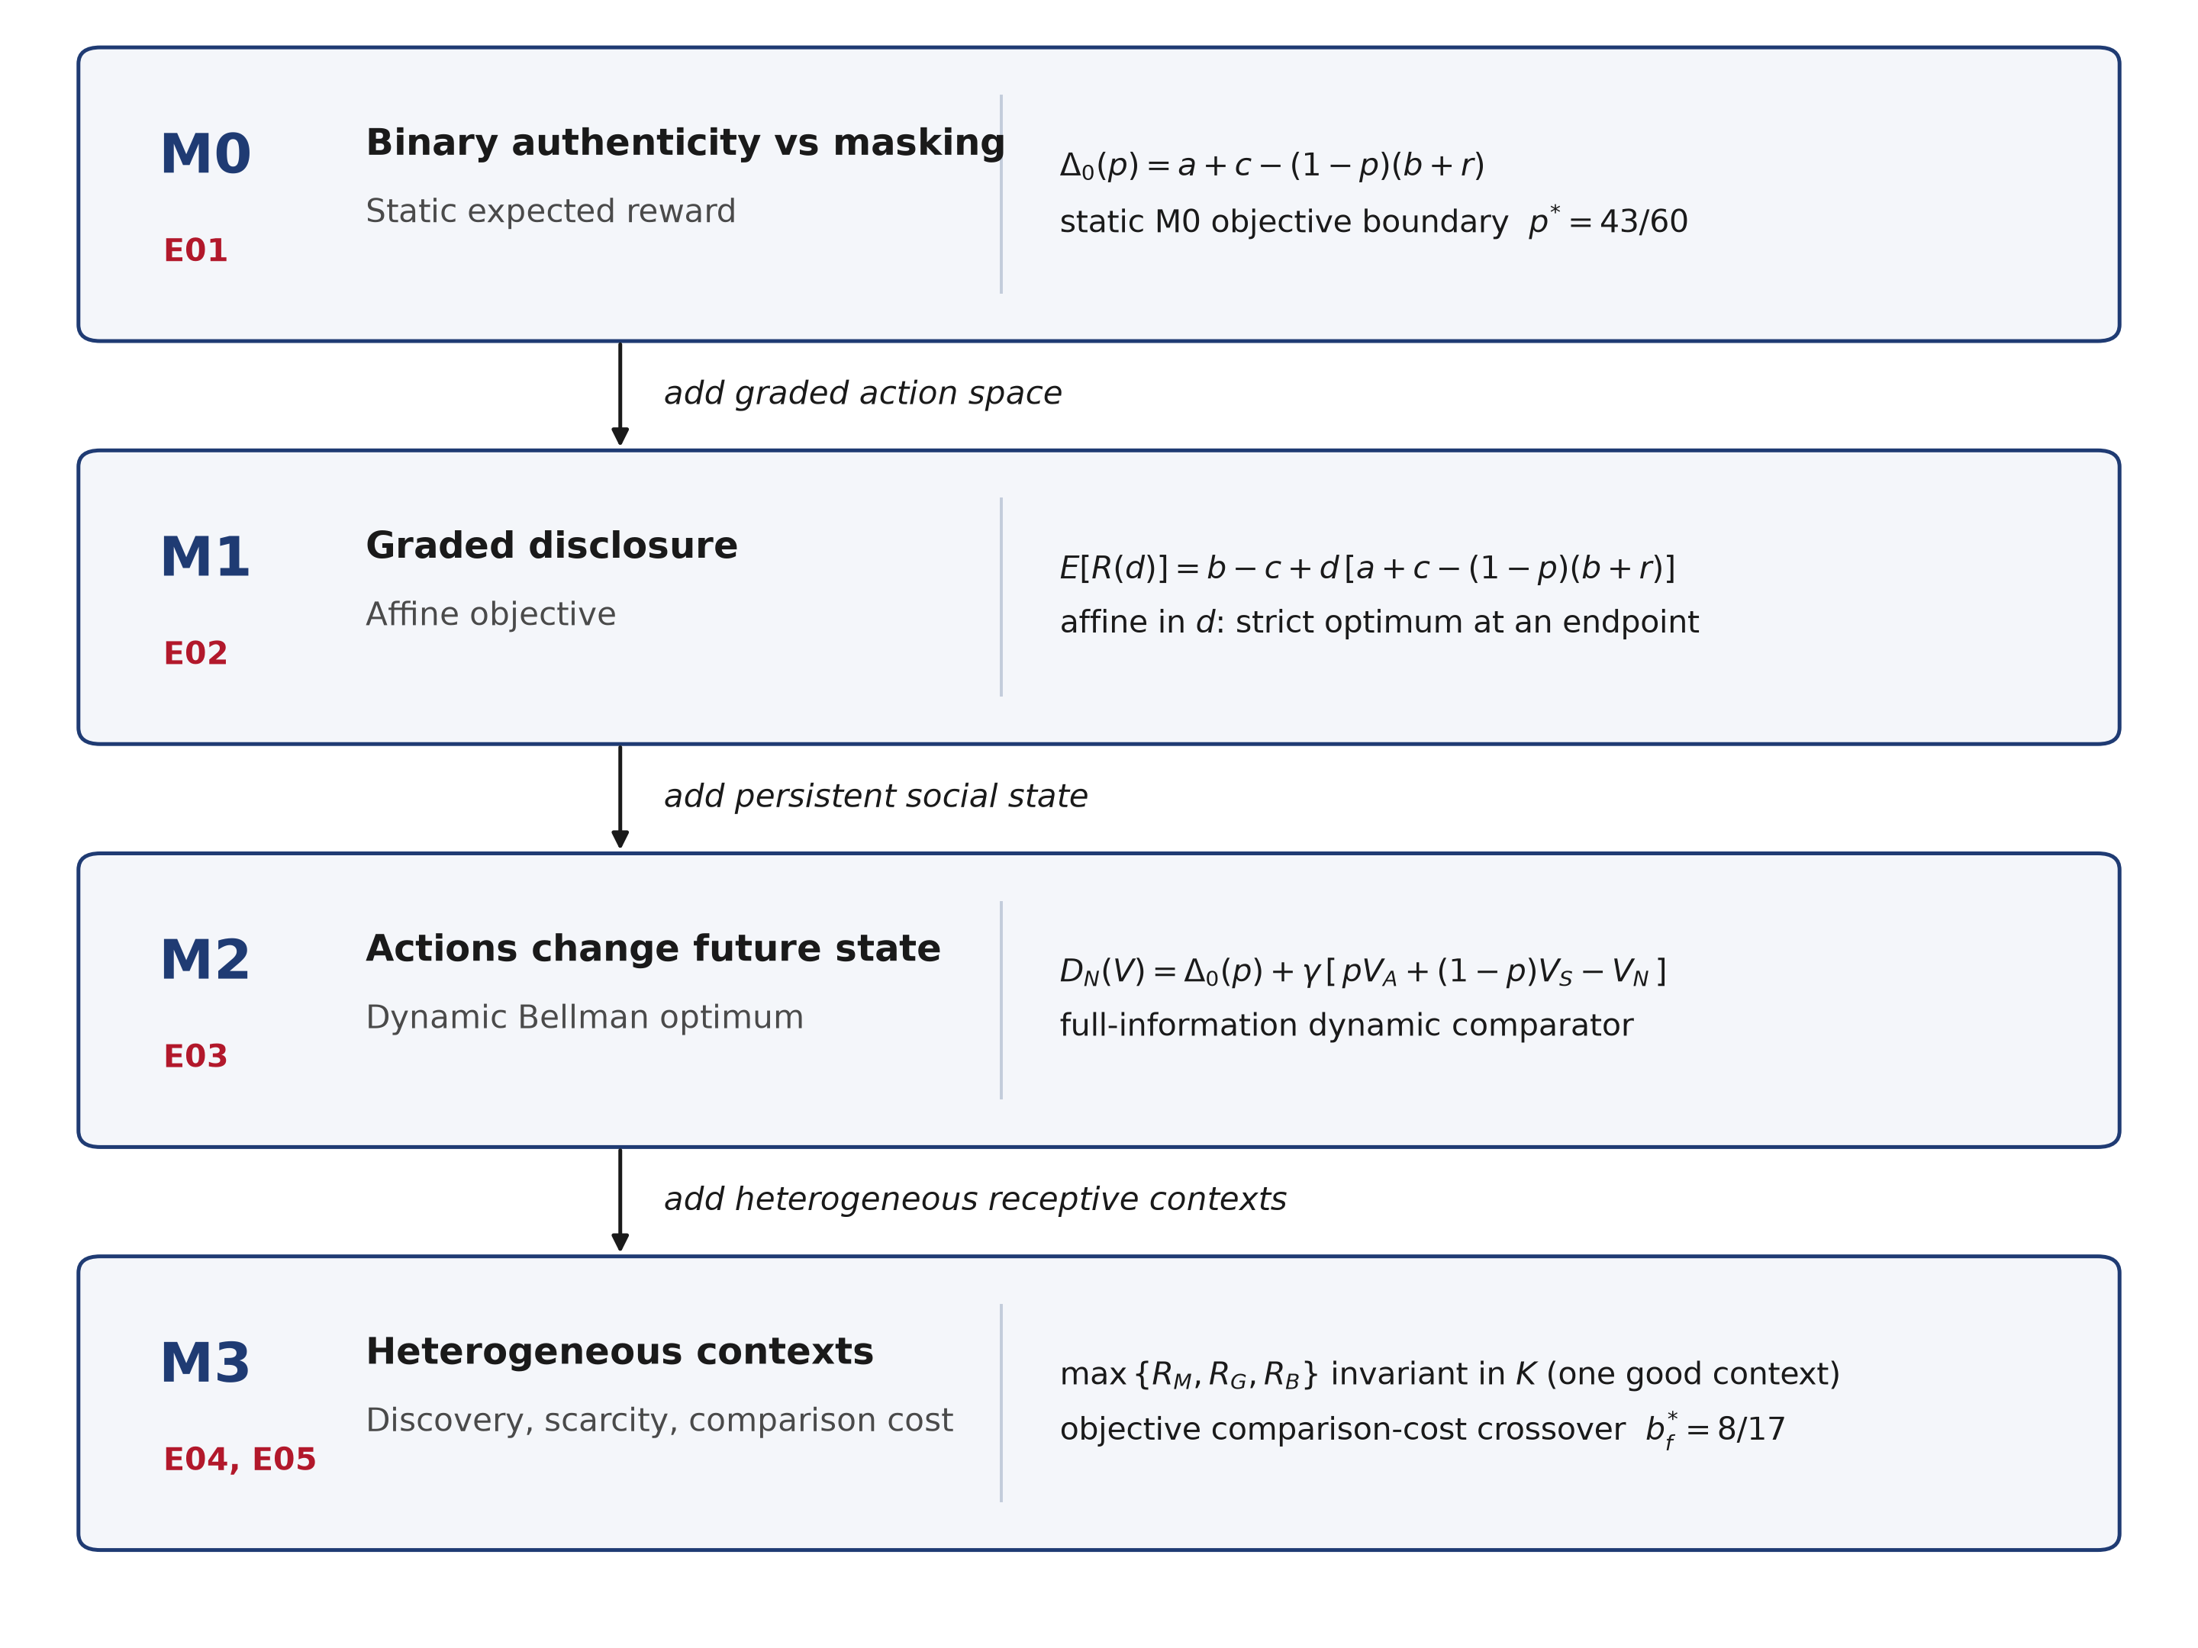
Existing deterministic publication figure; included for manuscript review.

Figure 2
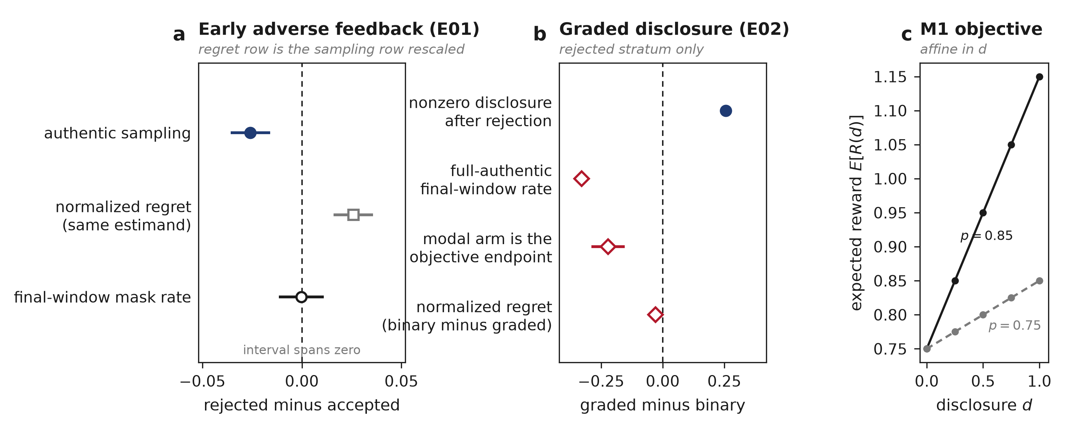
Existing deterministic publication figure; included for manuscript review.

Figure 3
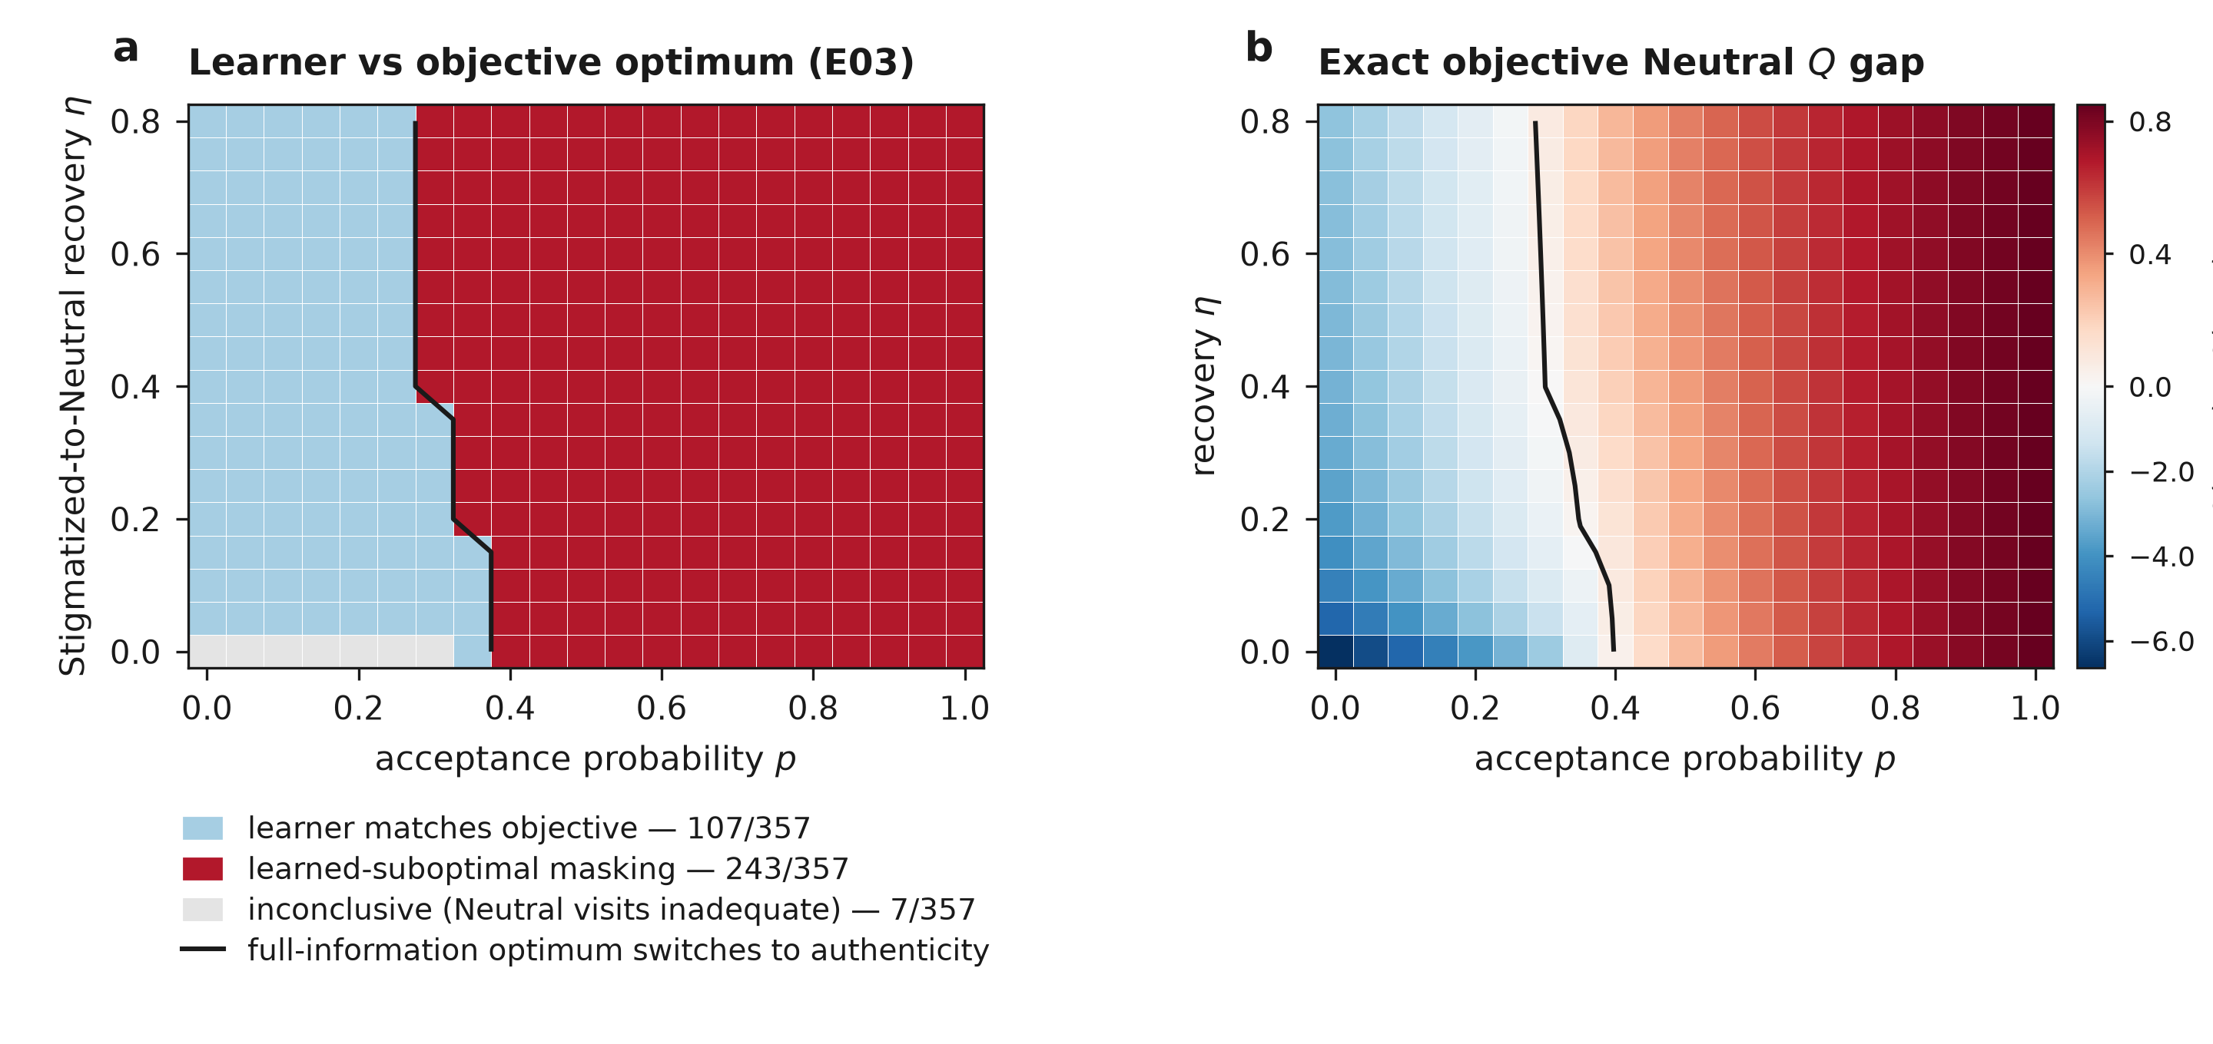
Existing deterministic publication figure; included for manuscript review.

Figure 4
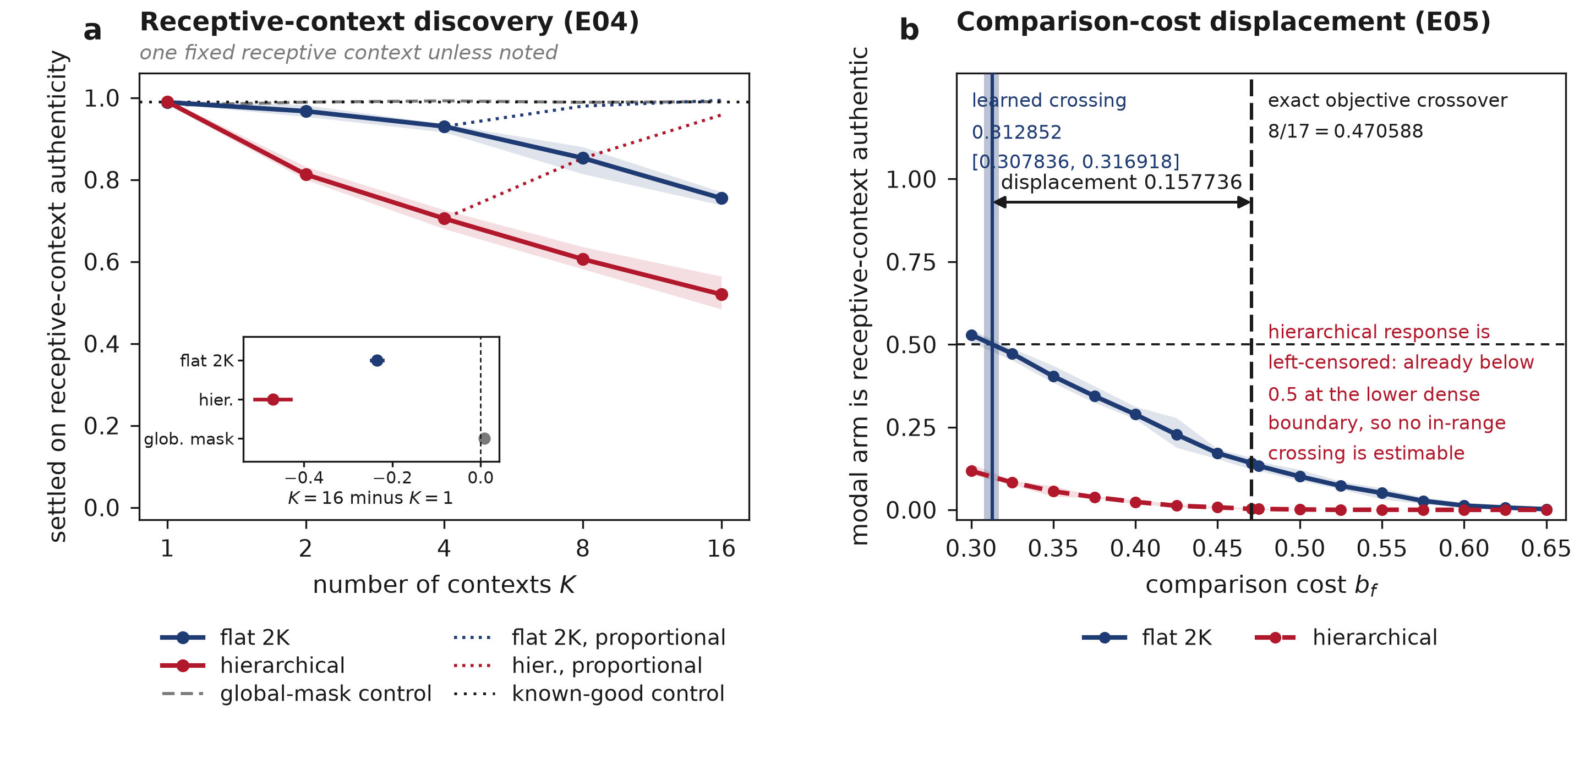
Existing deterministic publication figure; included for manuscript review.

Selected references cited in this working draft
Coleman, L. J., and Cross, T. L. (1988). Is being gifted a social handicap? Journal for the Education of the Gifted, 11, 41-56.
Cross, T. L., Coleman, L. J., and Stewart, R. A. (1993). The social cognition of gifted adolescents. Roeper Review, 16, 37-40.
Cross, T. L., Coleman, L. J., and Terhaar-Yonkers, M. (2014). Managing the stigma of giftedness. Journal for the Education of the Gifted, 37, 30-39.
Cross, J. R., et al. (2019). A cross-cultural study of the social experience of giftedness. Roeper Review, 41, 224-242.
Denrell, J., and March, J. G. (2001). Adaptation as information restriction: the hot stove effect. Organization Science, 12, 523-538.
Lavrijsen, J., and Verschueren, K. (2023). High cognitive ability and mental health. Journal of Intelligence, 11, 38.
March, J. G. (1996). Learning to be risk averse. Psychological Review, 103, 309-319.
Swiatek, M. A. (1995). Social coping strategies used by gifted adolescents. Gifted Child Quarterly, 39, 154-160.
Tourreix, E., Besancon, M., and Gonthier, C. (2023). Non-cognitive specificities of intellectually gifted children and adolescents. Journal of Intelligence, 11, 141.

