Ability Concealment Does Not Uniquely Reveal the Environment: Learning and Social Opportunity in Gifted Learners

Abstract
Gifted learners may reduce the visibility of ability in social settings, yet similar concealment need not reflect the same learner–environment relationship. Observed behaviour alone may therefore underidentify whether lower visibility reflects current social conditions, learned expectations, the available action representation, or difficulty recognizing receptive alternatives.
We used five controlled reinforcement-learning experiments with finite learners to separate the effects of social-feedback history, independently learned disclosure options, persistent social consequences, contextual discoverability, and learned versus environmental decision boundaries. Each experiment compares learned actions with the stipulated payoff structure or, where relevant, a full-information dynamic benchmark.
An adverse initial authentic outcome reduced subsequent authentic sampling without a detected persistent final-window masking effect. Independently learned graded options sustained non-zero disclosure but reduced selection of the full-authentic endpoint. When actions changed future social state, learned masking diverged from the full-information dynamic optimum in some tested conditions. An available receptive context became less discoverable as the contextual search problem expanded under particular action representations. In the comparison-cost experiment, the learned behavioural crossing was 0.313, below the stipulated environmental crossover of 0.471.
These controlled models show why concealment cannot uniquely identify current adaptation, learned expectation, or the discoverability of receptive opportunities. Empirical studies should measure current social conditions, feedback history, expectations, behavioural expression, subsequent sampling, and contextual access separately rather than infer them from concealment alone.
Keywords: giftedness; ability concealment; reinforcement learning; social feedback; individual differences

1. Introduction

1.1 Ability concealment as a heterogeneous educational phenomenon
Giftedness is not a uniform social or emotional condition. Evidence cautions against assuming that high cognitive ability generally entails poor adjustment or similar peer difficulties across learners (Lavrijsen & Verschueren, 2023; Tourreix et al., 2023). Yet some gifted young people report managing how visible their ability, interests, performance, or gifted identity is. The stigma-of-giftedness and social-coping traditions describe denial, conformity, selective disclosure, helping classmates, and modified social interaction (Coleman & Cross, 1988; T. L. Cross et al., 1993; Swiatek, 1995). These strategies vary across learners and settings rather than defining gifted learners as a class (J. R. Cross et al., 2019; Klimecká, 2023).
This literature establishes that visibility management occurs, but it does not supply a population prevalence or a single developmental pathway. Much of the evidence is cross-sectional, questionnaire-based, or retrospective, and reported peer experience differs across settings. Gifted social coping is also broader than concealment: denial of a label, conformity, selective participation, and reduced display of demonstrated ability are related but not identical behaviours.
We use ability concealment and lower-visibility behaviour for the narrow part of this strategy family represented in the models; model masking denotes the low-visibility action. This definition does not equate privacy, conformity, self-presentation, non-disclosure, underachievement, or clinical masking. Concealment is neither universal nor necessarily pathological. Its meaning depends on the current environment, learned expectations, and identifiable alternatives.

1.2 The inference problem: behaviour does not identify mechanism
The central question is not only why a gifted learner might conceal ability, but what can be inferred from observing it. Similar concealment may arise from different current reward structures, learning histories, action representations, persistent social dynamics, or contextual opportunities.
We call concealment an underidentified behavioural phenotype in this limited sense: behaviour does not uniquely reveal its generating process. Current social conditions, learned expectations, and observed behaviour are distinct variables. Masking alone establishes neither hostility, objective adaptiveness, a stable aversion to authenticity, nor the absence of a receptive alternative. Conversely, receptivity does not establish that the learner has sampled or recognized it, or revised expectations acquired elsewhere. Greater authentic expression is not assumed to be beneficial in every environment.
Equifinality supplies the established developmental principle that different pathways can reach a similar endpoint (Cicchetti & Rogosch, 1996). The present study applies that logic by specifying how current reward structure, learning history, action representation, persistent social dynamics, and contextual discoverability can create observational ambiguity in ability concealment.
Accordingly, an observation of lower visibility cannot identify whether intervention at the environment, information, action set, or expectation level would change behaviour. The required evidence is sequential: what conditions were present, what feedback was experienced, what the learner expected, and which alternatives were sampled afterward.
Behavioural heterogeneity therefore need not imply a stable person difference. Otherwise similar learners can acquire different action values after encountering and sampling different outcomes; they can also face different action representations, persistent consequences, or contextual opportunities. Conversely, similar masking can arise from different histories and environments. Cross-sectional behaviour cannot separate these possibilities.

1.3 Sequential learning and information restriction
Reinforcement learning formalizes one source of this ambiguity. In hot-stove learning, an adverse sample lowers an action’s estimated value; reduced resampling then limits corrective evidence (March, 1996; Denrell & March, 2001). Choice affects both reward and subsequent information. This sampling asymmetry can persist over a finite horizon without assuming a fixed aversion to risk (Denrell, 2005; Le Mens & Denrell, 2011).
Applied here, the conceptual sequence is adverse authentic outcome, reduced authentic resampling, less corrective information, and a continuing learned-value difference. This is established generic learning theory applied to an ability-visibility problem, not a gifted-specific mechanism. It does not imply that one rejection determines behaviour for years or creates irreversible concealment. The bounded proposition motivating E01 is that early adverse feedback can alter subsequent authentic sampling without establishing a persistent final-mask effect in the tested condition.
Information allocation also depends on action representation. If graded disclosure levels are independent, experience at one level does not update its neighbours. A broader repertoire can sustain non-zero disclosure while diffusing evidence about the full-authentic endpoint. This motivates E02 without treating graded disclosure as intrinsically helpful or harmful.

1.4 Objective value, learned value, and dynamic value
Three quantities must remain separate. Environmental or objective value follows from the stipulated environment under full information. Learned value is the finite learner’s estimate from sampled outcomes. Observed action reflects learned value and the choice rule, not objective value directly.
This distinction is straightforward in a static environment, where expected rewards can be compared action by action. It becomes more consequential when behaviour changes later opportunity: the action with the better immediate outcome need not be the action with the greater discounted value over future states.
When actions alter future social conditions, immediate reward is not the long-run quantity. Authentic action may have an adverse immediate outcome yet create a favourable future state; rejection may instead create persistent consequences that make concealment dynamically preferable. Dynamic value incorporates current and future consequences. E03 compares learning with an oracle that knows the stipulated rewards and transitions and is not information-matched to the finite learner.
Throughout, objective is model-relative: it follows from specified rewards, states, transitions, and full information. It does not denote moral desirability, psychological welfare, advice to disclose, or policy. Learner–oracle divergence does not establish human irrationality.

1.5 Availability, discoverability, and learned boundaries
A receptive option can be available without being discoverable to a learner with local information and finite experience. The number and representation of alternatives can change evidence acquisition even when the best full-information opportunity is fixed. E04 tests this bounded availability–discoverability problem across specified architectures and scarcity conditions. It implies neither literal peer-group search nor that more contexts generally cause more masking.
Availability is also distinct from the boundary at which behaviour changes. The environmental boundary is the parameter value at which the stipulated payoff comparison changes; a learned boundary is an operational summary of where the learner population’s behaviour changes under a particular architecture, horizon, and estimator. E05 asks whether those boundaries coincide. Their ordering is along a comparison-cost axis, not elapsed time, number of attempts, or a moment at which learners “give up.” A separation can establish learned–objective divergence without identifying a unique causal contributor or a human threshold.

1.6 Present study and research questions
We use simplified computational environments to separate explanations confounded in observed behaviour. This is an existence-and-structure analysis, not a calibrated psychological model or a frequency estimate. It distinguishes learning history, action representation, persistent-state dynamics, contextual discoverability, and learned–objective boundary separation.
Five experiments ask:
- E01: Does an initially adverse authentic outcome alter subsequent authentic sampling when the environment is unchanged?
- E02: Does independently representing graded disclosure increase continued non-zero disclosure while reducing discovery or use of an objectively optimal full-authentic endpoint?
- E03: Can finite learned behaviour disagree with a full-information dynamic optimum when current behaviour changes future social state?
- E04: Under the tested representations, does increased contextual search burden reduce discovery of an objectively available receptive context?
- E05: Does the learned behavioural crossover coincide with the exact environmental comparison-cost crossover?
Together, these experiments test whether different learning and environmental processes can generate similar observed concealment, and whether similar specified opportunities can yield heterogeneous learned behaviour. They also clarify what empirical work would need to measure jointly: current social contingencies, feedback history, learned expectations, subsequent action sampling, state persistence, and access to identifiable receptive contexts. To separate these quantities formally, the next section specifies reinforcement-learning environments in which environmental reward, learned value, future social state, and contextual availability can be manipulated or computed independently.

2. Model Framework and Methods

2.1 Common learner and evidential scope
We used deliberately simplified reinforcement-learning environments to separate feedback history, action representation, persistent social state, and context discovery. The models are existence-and-structure analyses, not calibrated psychological models: numerical parameters are normalized reference values, model steps are not calendar time, and simulated learners are not a sample of gifted children. Environmental reward is generated by the stipulated environment; learned value is estimated from selected experience; and an objective benchmark is the full-information value implied by the model. Objective value is therefore model-relative, not a welfare judgment or disclosure recommendation.
Learners began with $Q_{0}=0$ and used learning rate $α=.1$, softmax temperature $τ=.25$, and $λ=1$. For realized reward $R$,
$$v_{λ}(R)=\left\{\begin{matrix}R, & R≥0, \\ λR, & R<0.\end{matrix}\right.$$
Only the selected stateless action $x$ was updated:
$$Q_{t+1}(x)=Q_{t}(x)+α\{v_{λ}(R_{t})−Q_{t}(x)\}.$$
Actions were sampled by a numerically stable softmax after subtracting the row maximum. Neither the softmax nor its temperature was interpreted as a measured psychological trait. The primary configurations were loss-neutral, so $v_{1}(R)=R$ and the transform did not alter environmental payoffs. Final-window measures used the last $⌈.2T⌉$ steps and do not establish asymptotic convergence.

2.2 M0 and E01: feedback history
M0 offered masking ($M$) and authenticity ($A$). Masking returned $R_{M}=b−c$. Authenticity returned $b+a$ with acceptance probability $p$ and $a−r$ otherwise, giving
$$E[R_{A}]=p(b+a)+(1−p)(a−r)=a+pb−(1−p)r.$$
Hence the authentic-minus-mask advantage was $Δ_{0}(p)=a+c−(1−p)(b+r)$ and the static boundary was $p^{*}=1−(a+c)/(b+r)$. With $(b,a,c,r)=(1,.6,.25,2)$, $R_{M}=.75$ and $p^{*}=43/60=.7167$.
E01 fixed the first action as authentic and conditioned comparisons on its accepted or rejected outcome at $p∈\{.75,.85\}$. The primary estimand was the between-stratum difference in authentic-action rate over steps 1 through $T−1$. Normalized pseudo-regret was the exact action-count translation $Δ{\overline{Regret}}_{norm}=−(T−1)Δ{\overline{A}}_{1:T−1}/T$, not an independent outcome. Final-window masking was secondary. Within the rejected stratum, prespecified information manipulations supplied 5% forced authentic exposure or counterfactual feedback about authenticity. The finite-horizon design tests subsequent sampling, not permanent masking after one rejection.

2.3 M1 and E02: action representation
M1 represented disclosure by $d∈[0,1]$, where $d=0$ was masking and $d=1$ full authenticity. Acceptance probability was $1−(1−p)d$, and the expected reward was
$$E[R(d)]=b−c+d\{a+c−(1−p)(b+r)\}=b−c+dΔ_{0}(p).$$
The objective is affine: except at exact indifference, its strict optimum is an endpoint. E02 compared the binary action set with five independent arms $d∈\{0,.25,.5,.75,1\}$ at $p∈\{.65,.75,.85\}$ after an initial rejection. Updating one arm did not generalize to adjacent disclosure levels. Random streams were matched between architectures within receptivity and master seed. Estimands were post-initial non-zero disclosure, final-window full-authentic action rate, and unique modal classification at the objectively optimal endpoint. Intermediate disclosure was interpreted as sampled representation, not as a statically optimal compromise.

2.4 M2 and E03: persistent state and dynamic value
M2 used three states: Neutral ($N$), Accepted ($A$), and Stigmatized ($S$). Rewards were realized before the next-state transition. From $N$, masking returned $b−c$ and retained $N$; authentic acceptance returned $b+a$ and moved to $A$, whereas rejection returned $a−r$ and moved to $S$. In $A$, masking returned $b−c$ and authenticity $b+a$; either action was followed by turnover to $N$ with probability $δ$, otherwise $A$ persisted. In $S$, masking returned $b_{2}−c$, followed by escape to $N$ with probability $η$. Authenticity redeemed with probability $p/2$, returned $b+a$, and moved to $A$; otherwise it returned $a−r_{2}$, followed by escape to $N$ with probability $η$ or persistence in $S$. The reference values were $b_{2}=.5$, $r_{2}=2.5$, and $δ=.02$.
The selected state-action value followed
$$Q_{t+1}(s_{t},x_{t})=Q_{t}(s_{t},x_{t})+α\left[v_{λ}(R_{t})+γ\max_{x^{′}}Q_{t}(s_{t+1},x^{′})−Q_{t}(s_{t},x_{t})\right],$$
with $γ=.9$. The corresponding Neutral-state advantage for continuation values $V$ was
$$D_{N}(V)=Δ_{0}(p)+γ\{pV_{A}+(1−p)V_{S}−V_{N}\}.$$
Thus the dynamic boundary need not equal the static M0 boundary. The objective comparator used value iteration on the known, untransformed environmental rewards and transitions; it was a full-information, infinite-horizon discounted-MDP oracle, not information-matched to the learner.
E03 evaluated $p=0,.05,…,1$ by $η=0,.05,…,.8$ (21 × 17 cells). For each master and cell, final-window state-action counts were aggregated across 160 learners. Neutral exposure was adequate only with at least 160 total Neutral visits and at least 32 visiting learners. Inadequate exposure or equal Neutral mask/authentic counts yielded an inconclusive learned action. learned_suboptimal_masking required adequate aggregate Neutral counts favouring masking and an oracle Neutral action favouring authenticity. The label concerns a tested cell and aggregate action counts, not individual $Q$ ordering, human prevalence, or an information-matched regret comparison. Cross-master stability required the same non-inconclusive class in at least four of five masters.

2.5 M3 and E04: context representation
M3 contained $K$ contexts. In the primary one-good-context condition, $p_{good}=.85$ and the other $K−1$ contexts had $p_{bad}=.2$. The three distinct expected-reward classes were
$$R_{M}=b−c, R_{G}(b_{f})=p_{good}(b+a−b_{f})+(1−p_{good})(a−r),$$
$$R_{B}=p_{bad}(b+a)+(1−p_{bad})(a−r).$$
Masking was context-invariant, and comparison cost $b_{f}$ applied only to accepted authenticity in a good context. Increasing $K$ duplicated mask and bad-context reward classes but did not change this distinct set or its maximum.
E04 compared: flat_2k, one softmax over $2K$ joint context–behaviour arms; hierarchical, a context softmax followed by a within-context behaviour softmax, with both selected values updated from the same reward; global_mask, one shared mask and $K$ context-specific authentic arms; and fixed_known_good, two actions in a known good context. $K∈\{1,2,4,8,16\}$; random good-context identity and multiple-good-context conditions were controls. The primary learner indicator used deterministic argmax of final-window joint-action counts and equalled one when the selected arm was authentic in a good context. Non-unique modes were retained: ties resolved to the first indexed arm. The cell response was the across-learner mean. This operational classification is neither convergence nor literal movement among peer groups.

2.6 E05: learned and environmental boundaries
E05 fixed $K=4$, one good context, and varied $b_{f}$. At the reference values,
$$R_{G}(b_{f})−R_{M}=.40−.85b_{f},$$
so the exact environmental crossover was $b_{f}^{*}=.40/.85=8/17=.470588…$. The learned response was the across-learner fraction whose deterministic final-window argmax selected the single good-authentic arm in the flat eight-action architecture, again retaining first-index tie resolution. It was not a binary choice probability.
At each cost, five master-seed cell responses were averaged equally. A non-increasing, equal-weight pool-adjacent-violators fit was applied to the dense grid $b_{f}=.30,.325,…,.65$, augmented by the exact $8/17$ anchor. Its learned boundary was the fitted .5 crossing: a .5 plateau used its cost-range midpoint; otherwise adjacent fitted points were linearly interpolated. Crossings were estimable only strictly inside $(.30,.65)$; a curve already below .5 was no_crossing_below, treated as left-censored without extrapolation. Ten thousand bootstrap resamples drew five complete master curves with replacement, refitted and reinverted them; percentile limits were reported only when at least 95% produced valid in-range crossings. Monotonicity constrained the pooled estimator, not trajectories or individual master curves.

2.7 Simulation design, inference, and reproducibility
Standard E01, E02, E04, and E05 cells used $n=500$, $T=2000$, a 400-step final window, and five independent master seeds; E03 cells used $n=160$, $T=1000$, a 200-step window, and five masters. E01, E02, and E04 scalar contrasts used Student-$t$ intervals across the five master estimates (four degrees of freedom), rather than children as top-level replications. E03 retained fixed-grid classification and stability rules. E05 used the complete-curve bootstrap above.
Configurations, seed hierarchies, manifests, machine-readable artifacts, validation records, and hashes were archived per experiment. Detailed provenance and the unrecovered historical generator-state limitation for E01–E03 are reported in Supplementary Methods and Data and Code Availability. Because the exact historical generator states cannot be reconstructed, those results are supported by archived outputs, hashes, configurations, and verification records rather than by a claim of bit-identical regeneration from the current code.

3. Results
Across five experiments, the simulations separated three quantities that can be conflated when masking is observed directly: the objective value of authentic action, the information available to the learner, and the policy the learner acquires. The experiments varied learning history, action representation, persistent social state, contextual search, and comparison cost. Together, they show that authentic behaviour can remain objectively advantageous while finite learners sample it less, fail to identify receptive contexts, or shift toward masking at comparison-cost values below those required to make masking objectively preferable.

3.1 Early rejection reduced subsequent authentic sampling
E01 tested whether an adverse initial authentic outcome changes subsequent behaviour when the environment itself remains unchanged. Across five master seeds, learners assigned an initially rejected authentic outcome sampled authenticity less often than learners assigned an initially accepted outcome (rejected minus accepted −0.026, 95% CI [−0.036, −0.016]; Figure 2A).
At the tested receptivity, authenticity remained objectively preferable. The difference therefore reflects learning history rather than a change in environmental value. The normalized objective pseudo-regret contrast was +0.026 [0.016, 0.036], but this is algebraically linked to the sampling contrast and should not be treated as independent corroboration.
Crucially, E01 did not detect a persistent final-window masking increase after a single initial rejection: the final-window masking contrast was −0.000343 (95% CI [−0.011605, +0.010918]). The result is therefore bounded. Early rejection reduced later authentic sampling, but did not establish a lasting final-mask effect under the tested conditions.
Two information manipulations supported this sampling interpretation. Within the rejection condition, 5% forced authentic exploration reduced final-window masking by 0.047 [0.033, 0.060], while counterfactual authentic feedback reduced it by 0.118 [0.110, 0.127]. These manipulations restore information that avoidance can otherwise prevent the learner from observing.

3.2 Graded actions sustained partial disclosure but reduced optimal-endpoint discovery
E02 replaced the binary masking/authenticity choice with five independently learned disclosure levels. Expected reward remained affine in disclosure, so whenever the corresponding binary environment favoured authenticity, full authenticity remained the objectively optimal endpoint. Intermediate levels were not alternative static optima.
Following initial rejection, the graded architecture increased continued non-zero disclosure by 0.255 [0.253, 0.257] relative to binary resampling of full authenticity (Figure 2C). Learners therefore continued some expression more often.
However, the same representation reduced full-authentic final-window selection by 0.329 [−0.342, −0.315] and reduced the probability that full authenticity was the unique modal final-window action by 0.222 [−0.289, −0.155] (Figure 2C).
The two effects are complementary. Intermediate actions supplied lower-exposure routes for continued disclosure, but fragmented experience across independently learned arms. Experience at one disclosure level did not update neighbouring levels, allowing partial actions to accumulate evidence while full authenticity remained under-sampled.
E02 therefore identifies an action-representation effect: expanding the behavioural repertoire can sustain engagement while making discovery of the objectively optimal endpoint less likely. This conclusion is conditional on independently learned graded actions and does not imply the same effect for learners that generalize experience across neighbouring disclosure levels.

3.3 Learned neutral-state behaviour disagreed with the dynamic optimum
E03 introduced persistent social state. Authentic acceptance could move the environment into an Accepted state with favourable subsequent returns, while rejection could move it into a Stigmatized state. The relevant objective comparison was therefore no longer immediate expected reward but the discounted value of future state transitions.
Finite learner behaviour was compared with the exact full-information MDP policy obtained by value iteration under the same rewards and transition equations (Figure 3). At $n=160$ learners and $T=1000$ steps per cell, the archived $21×17$ receptivity-by-escape grid contained 243 of 357 cells in which aggregate final-window Neutral-state action counts favoured masking while the full-information dynamic policy favoured authenticity. The fraction, 243/357 = 0.681, was identical across the five master seeds.
This is a count of tested parameter cells, not a prevalence estimate. A cell qualified only when aggregate Neutral-state behaviour favoured masking, value iteration favoured authenticity, and the maintained visit-adequacy criterion was met. The classifier was stable in 350 of 357 cells under the prespecified four-of-five-master rule. Of the seven low-receptivity, zero-escape inconclusive cells, five had inadequate Neutral exposure in every master; two additional cells had classifications from only one or two adequately visited masters and therefore failed the four-of-five stability criterion.
The central result is therefore a learned–objective disagreement. In these cells, the learner favoured the immediately safer action while the full-information optimum favoured authenticity because authenticity could improve subsequent social state.
Formally, the relevant quantity is
$$Q^{*}(s,a)=E​\left[r_{t}+γV^{*}(s_{t+1})∣s_{t}=s,a_{t}=a\right].$$
Observed masking can therefore mean different things. Under some social dynamics it may be objectively adaptive; under others, finite learners may mask despite authenticity having higher long-run value.
The benchmark is deliberately strong: value iteration knows the environmental contingencies that the learner must discover through sampling. E03 demonstrates divergence from a known-model full-information optimum, not from an information-matched learner facing the same uncertainty.

3.4 Receptive contexts were available without being equally discoverable
E04 tested whether the existence of a favourable context guarantees that finite learners identify and use it. Increasing the number of contexts $K$ added bad contexts while preserving the same best full-information opportunity. The primary outcome applied deterministic first-index argmax to each learner’s final-window joint-action counts: a learner qualified when the selected indexed arm was authentic in a good context. Non-unique modes were retained because ties resolved to the first indexed arm; the outcome was not a unique-modal classifier.
In the flat $2K$-action representation, increasing $K$ from 1 to 16 reduced final-window argmax classification as authentic in a good context by 0.234 [−0.246, −0.222] (Figure 4A). In the hierarchical representation, the corresponding decline was 0.470 [−0.511, −0.430].
Controls constrained the explanation. When the good context was fixed and known, there was no context search and the structural $K$ effect was exactly zero. When masking was represented as one global action while authentic actions remained context-specific, the $K$ contrast was only +0.009 [0.002, 0.016], practically negligible relative to the primary effects.
Increasing the number of receptive contexts also weakened the decline. Relative to the one-good-context condition, two good contexts changed the estimated per-$\log_{2}K$ slope by +0.051 in the flat architecture and +0.025 in the hierarchical architecture; with 25% of contexts receptive, the corresponding slope changes were +0.060 and +0.112.
E04 therefore supports a distinction between availability and discoverability. A receptive context can remain objectively available while becoming harder for a finite learner to locate under particular representations and scarcity structures. The result does not support the generic claim that more contexts inherently cause more masking.

3.5 The learned masking boundary preceded the objective boundary
E05 compared an exact environmental crossover with an operational behavioural crossover by varying the comparison-cost parameter $b_{f}$.
At the reference payoffs, masking returned 0.75 and accepted authenticity in the good context returned
$$1.15−0.85b_{f}.$$
Their exact objective crossover is therefore
$$b_{f}^{*}=\frac{8}{17}=0.470588….$$
Below this value authenticity has the higher expected reward; above it masking does.
The learned transition occurred at a substantially lower comparison-cost value. In the flat eight-action model ($K=4$), the fraction of learners whose final-window modal action was good-context authenticity was pooled across five master curves and fitted with a non-increasing isotonic regression over $b_{f}=.30$–$.65$. The fitted response crossed 0.5 at
$$b_{f}^{learned}=0.312852.$$
with 95% bootstrap CI [0.307836, 0.316918] (Figure 4B).
The learned and objective boundaries were therefore separated by 0.157736. At the learned crossing, good-context authenticity still retained an objective expected-reward advantage of approximately 0.134076.
E05 thus identifies not merely isolated cases of suboptimal masking but a displaced behavioural boundary: learners shifted toward masking at comparison costs substantially below those required to make masking objectively preferable. Here, “preceded” and “below” refer only to position on the comparison-cost axis, not to elapsed time, attempts, or a chronological point of withdrawal.
The hierarchical response was already below 0.5 at $b_{f}=.30$ and yielded no in-range crossing in 10,000 bootstrap resamples. Its crossing is therefore left-censored below the resolved range, not absent.
E05 establishes the boundary displacement but does not identify a unique cause. Finite sampling, context discovery, action normalization, under-sampling, temperature, and representation may contribute. Nor is the result temporal: “earlier” refers to position along the comparison-cost parameter, not to elapsed time or number of attempts.

3.6 Overall pattern
The experiments identify complementary routes by which observed masking can diverge from a simple reading of current conditions. E01 shows that early feedback can alter subsequent exploration. E02 shows that action representation can sustain partial disclosure while impairing discovery of the optimal endpoint. E03 shows that persistent social consequences change the objective benchmark itself and can produce disagreement between finite learning and dynamic optimality. E04 shows that receptive opportunities can exist without being readily discoverable. E05 directly demonstrates that the learned transition toward masking can occur at a lower comparison-cost value than the objective environmental crossover.
Together, these findings make masking an underidentified behavioural phenotype: similar observed concealment can reflect an objectively adaptive response, restricted exploration, difficulty discovering receptive contexts, or a learned policy that diverges from the current objective optimum.

4. Discussion

4.1 Masking as an underidentified behavioural phenotype
The experiments show that ability concealment is an insufficient statistic for the social environment or learning process that produced it. The same low-visibility behaviour can express two fundamentally different relations to current conditions: masking may be objectively adaptive where adverse consequences persist, or it may be a learned response retained even though a more valuable alternative is available. Between these cases lie additional routes to the same endpoint: adverse feedback can restrict later sampling, independent action values can fragment experience, favourable future states can remain difficult to learn, and receptive contexts can exist without being identified.
This is an identification problem. Current social conditions, learned expectations, and observed behaviour are distinct quantities; reliable inference requires measuring each. Similar environments can produce different behaviour because finite learners encounter different outcomes and acquire different information. Different processes can converge on concealment, while the same opportunity structure can generate heterogeneous learned responses.
That distinction sharpens the relevance of individual differences. Gifted social coping and ability visibility vary across learners and contexts (J. R. Cross et al., 2019; Tourreix et al., 2023). The models add that behavioural heterogeneity can emerge without changing a stable learner trait. Person-level tendencies may matter, but history, environment, and decision structure can also produce variation. Observed masking therefore begins an explanatory inquiry.

4.2 Learning-history differences need not be stable trait differences
E01 isolates a minimal route from experience to behavioural heterogeneity. An adverse authentic outcome reduced subsequent sampling of authenticity even after the later environment was held constant. Because action choice determines which outcomes become observable, reduced sampling also reduces access to evidence that could revise the learner’s estimate. This recursive relation is the core hot-stove logic: experience changes choice, and choice changes later experience (March, 1996; Denrell & March, 2001; Le Mens & Denrell, 2011).
Two otherwise comparable learners can therefore enter the same later environment with different expectations and propensities to test them. Their behavioural difference need not originate in stable aversion, motivation, or social preference. It may be history-induced: a consequence of which outcome occurred and which evidence remained available. The information manipulations reinforce this interpretation because the trajectory changes when corrective evidence is supplied through another channel.
The result-defining boundary is equally informative. One initial rejection reduced later authentic sampling but did not produce a detectable persistent final-window masking difference in the tested conditions. E01 therefore supports a learning-history account of subsequent exploration rather than evidence that one adverse event fixes a lasting endpoint. Cross-sectional behavioural variation may combine stable person characteristics with acquired expectations, and study designs should separate them.

4.3 Action representation changes what finite learners discover
E02 shows that learning depends on how behaviour is represented, even when the environmental ordering of the endpoints is unchanged. Adding graded actions sustained more non-zero disclosure after rejection while reducing discovery and use of the objectively optimal full-authentic endpoint. The result is a learning-representation trade-off: intermediate actions can preserve some engagement, yet they also distribute finite experience across a larger set of estimates.
In the tested architecture, each disclosure level had an independent value. Evidence obtained at one level did not update adjacent levels, despite their ordered meaning. A learner could therefore accumulate relatively favourable experience with partial disclosure without improving its estimate of full authenticity. More behavioural flexibility changed the information allocated to each action and, consequently, what the learner discovered.
This finding challenges the assumption that a more gradual choice set must improve learning, without supporting the opposite conclusion that graded choice is inherently harmful. Its contribution is to identify action representation as a source of behavioural heterogeneity separate from objective reward. E02 suggests that choice structure can influence learning independently of the values attached to those choices. That inference remains conditional on independently learned arms; a learner that generalizes across neighbouring disclosure levels poses a different problem.

4.4 Persistent social consequences change what is objectively adaptive
E03 changes the benchmark from immediate reward to dynamic value. When authentic action changes later social state, the relevant question is not simply which action pays more now. Successful authenticity may open a favourable state with reliable later returns, whereas rejection may create a stigmatized state with persistent costs. The value of an action includes both its current outcome and the future conditions it helps create.
Disclosure theory already treats antecedent goals, disclosure events, and postdisclosure outcomes as a process that shapes later decisions (Chaudoir & Fisher, 2010). E03 applies that established dynamic logic to ability concealment by formalizing persistent social states and comparing finite learned behaviour with a full-information dynamic benchmark.
This structure separates masking as learned error from masking as current adaptation. In part of the tested model region, finite learners favoured masking in the Neutral state while the full-information dynamic oracle favoured authenticity. There, learned behaviour and the known-model optimum diverged because the learner had to discover a policy whose value depended on future states. Other parameter configurations make masking dynamically optimal: sufficiently persistent or severe adverse consequences can outweigh the future benefit of successful authenticity. The direction of the objective comparison is therefore itself conditional on the social transition structure.
The central implication follows directly. Behaviour alone cannot distinguish current adaptation from learned suboptimality, and immediate rewards cannot resolve the question when actions alter later opportunity. Empirical interpretation requires information about how long social consequences persist, whether successful expression changes subsequent acceptance or access, and whether expectations track those dynamics. E03 thereby connects behavioural variation to environmental persistence: similar concealment may reflect accurate adaptation in one setting and history-limited learning in another.

4.5 Availability is not discoverability
E04 extends the identification problem from outcomes over time to alternatives across contexts. A receptive setting that exists but is difficult to identify presents a different problem from one that is known. In the one-good-context design, the best full-information opportunity remained fixed while learned behaviour changed with the number, scarcity, and representation of alternatives. The controls show that opportunity must be characterized beyond availability alone.
We use environmental legibility as a model-derived descriptive term for how readily a learner can recognize where and when ability expression will be received favourably. Effective opportunity depends on both the existence of a receptive setting and the accessibility of information that marks it as receptive. A school can therefore contain supportive people or programmes without making the path to them equally visible, predictable, or credible to every learner.
This interpretation aligns with evidence that gifted social coping and visibility management vary by peer and school context (Coleman & Cross, 1988; T. L. Cross et al., 1993; Swiatek, 1995). E04 adds a formal distinction between having an alternative and discovering its value through finite experience. The effect remains conditional on the tested representation and scarcity structure, rather than a general law that adding contexts increases masking. Context structure and the legibility of receptivity can shape which opportunities become behaviourally usable.

4.6 Learned behavioural boundaries can diverge from environmental boundaries
E05 provides the clearest synthesis of the difference between environmental conditions and learned response. The objective boundary marks the comparison cost at which masking and good-context authenticity have equal environmental reward. The learned boundary summarizes where the finite learner population’s final-window modal classification crosses toward masking. In the tested flat architecture, the learned transition occurred while good-context authenticity still retained an objective advantage.
This displacement shows that behavioural withdrawal can arise before the environment reaches its own indifference point. An observed shift toward masking therefore offers no direct location of the environmental boundary. Estimates, sampling history, action competition, horizon, and representation stand between environmental reward and behaviour.
The boundary ordering is along the comparison-cost axis, not chronological time: it marks neither an early stopping point nor a need for more attempts. The cause of the displacement remains unidentified because the multi-action modal statistic does not isolate exploration, temperature, action competition, or finite-sample learning. Its contribution is the demonstrated separation itself. Together with E01–E04, it shows why behavioural thresholds should be treated as joint products of environment and learning architecture rather than direct measurements of environmental preference.

4.7 What empirical studies must measure
The modelling changes the empirical question from whether a learner masks to why masking occurs under the current conditions. Visible expression or concealment is necessary to measure but insufficient to distinguish the mechanisms separated here. Current conditions, learned expectations, behavioural choices, and learning history should be measured separately rather than inferred from one another.
Behavioural measurement should capture more than a binary masking indicator. Repeated observations could distinguish visible ability expression, lower-visibility behaviour, selective disclosure, and graded changes across settings. These observations should be paired with measures of current social response: acceptance and rejection by peers and teachers, the immediate consequences of visibility, and the duration of any change in reputation, access, or group position.
Expectation measures are equally important. Learners can be asked what they predict would happen if they offered an advanced answer, requested harder work, disclosed an interest, corrected a misconception, or entered a different setting. Comparing those predictions with observed responses would distinguish expectations that remain accurate from those acquired under earlier conditions. Learning history should therefore include prior acceptance and rejection, repeated feedback, environmental transitions, and the timing of changes in expected consequences.
Studies should also observe subsequent sampling. After feedback, does the learner repeat the action, try a lower-visibility variant, test another context, or stop sampling the relevant alternative? This sequence reveals whether behaviour restricts later information. Finally, context measures should distinguish whether receptive settings exist, whether the learner knows about them, and whether their receptivity is legible before costly testing. Longitudinal and context-linked designs could then separate stable person-level tendencies from history-induced variation, current adaptation from learned avoidance, and unavailable opportunities from undiscovered ones.
These distinctions provide a route from descriptive accounts of gifted concealment toward testable explanations of individual variation. They also organize the next practical and methodological questions: which part of the system—current conditions, information, expectations, action representation, persistent consequences, or contextual legibility—best explains a learner’s observed pattern?

5. Limitations
The models formalize stylized decision problems relevant to ability visibility and concealment; they are not calibrated psychological replicas of gifted learners. Reward, comparison cost, temperature, learning rate, and state persistence are design variables rather than measured psychological quantities. The resulting analyses establish structural possibilities and boundary relationships, not human prevalence or population effect sizes. Their value is to isolate how feedback, representation, persistent consequences, and context discovery can be separated empirically.
The headline learner is one finite, tabular reinforcement learner with constant-step updating and softmax sampling. Learners with different priors, memory, generalization, model-based reasoning, or learning algorithms may acquire different policies. This dependence is especially consequential for E02, where disclosure levels are learned independently, and for E04, where the representation of actions and contexts is part of the finding rather than a mere implementation detail.
Neutral, Accepted, and Stigmatized states abstract persistent social consequences; contexts abstract opportunity structures. In particular, E04 models repeated choice among contexts and behaviours, rather than observed movement between peer groups, classrooms, or schools. The distinction between availability and discoverability nonetheless remains informative. We use environmental legibility as a model-derived label for how readily a learner can identify receptive opportunities. Its relation to established educational or psychological constructs, and its empirical operationalization, require future work.
Throughout, objective refers to the reward and transition structure stipulated by the model. The E03 oracle has complete information about that structure, whereas the finite learner must acquire information through experience. This intentional asymmetry supplies a benchmark for asking whether learned behaviour matches the specified environment; it is neither a human-welfare measure nor a moral ranking of ability expression.
Parameter grids are experimental design spaces rather than population distributions: E03’s tested-cell coverage is consequently not prevalence. Simulation steps carry no direct calendar interpretation, and E05’s comparison-cost crossing is neither a time-to-withdrawal nor an attempts-required threshold. The educational implications identify model-derived assessment and intervention targets whose effectiveness requires empirical testing. Finally, exact historical generator states for E01–E03 are not fully recoverable; their archived artifacts, hashes, and verification records rather than reconstruction from current code govern the retained results. These constraints make measurement of expectations, feedback history, persistent consequences, and contextual discoverability the next test of the distinctions identified here.

6. Conclusion
Ability concealment is not self-interpreting. Similar masking can arise from a current adaptive response, learning history, action representation, persistent social consequences, or difficulty discovering receptive contexts. Observed behaviour therefore leaves its underlying cause underidentified.
The model series separates environmental reward, learned value, dynamic value, contextual availability, and contextual discoverability. Its central contribution is to show that learned behaviour and environmental opportunity can diverge: a receptive option may be available but undiscovered, and a learner’s behaviour may reflect accumulated expectations rather than the value of the current environment alone. This provides a framework for interpreting individual variation without reducing it to either stable disposition or a single social condition. Rather than treating visible restraint as evidence of one deficit or one environmental fact, the framework makes competing explanations explicit and testable.
Future empirical studies should measure current conditions, learned expectations, feedback history, behavioural expression, subsequent sampling, and contextual access separately. The central question is not simply whether a gifted learner masks, but which combination of environment, history, information, and learned expectation makes the behaviour intelligible. That question provides a route from descriptive accounts of concealment to mechanism-sensitive research on individual variation.

Educational Relevance and Implications
The following implications are model-derived hypotheses and assessment or intervention targets rather than validated educational or clinical protocols.

A. Start with mechanism, not masking
Observed concealment is insufficient on its own to identify either the current social environment or the appropriate response. A learner may be accurately responding to adverse conditions, acting on an expectation acquired in an earlier setting, avoiding further information after costly exploration, using partial expression because of the available action structure, or failing to identify a receptive alternative. The same visible pattern can therefore call for different educational responses.
Assessment should separate six questions: What happens now when ability is expressed? What does the learner expect will happen? Which experiences formed that expectation? What does the learner actually express or conceal? Which receptive alternatives exist? And can the learner identify them before taking a social risk? This framework treats masking as an outcome to explain rather than a diagnosis of either the learner or the setting.

B. Assess expectations as well as behaviour
E01 and E03 suggest that adults should ask about predicted consequences, not only observed participation. Useful questions include: What would happen if you gave the advanced answer, requested harder work, shared an interest, corrected a misconception, or joined another activity? Where did that expectation come from? Does the present setting still respond in the expected way? Are the costs immediate, or do they alter later acceptance, access, or group position?
This assessment can distinguish an expectation that is outdated from a response that accurately reflects persistent current costs. Prior feedback may also change what information a learner subsequently obtains: avoiding an action reduces opportunities to observe outcomes that could revise an expectation. Parents can compare present and earlier experiences; teachers can examine peer and classroom consequences alongside participation; counsellors can use differences between predicted and observed responses as diagnostic information.

C. Make receptive opportunities legible, not merely available
E04 suggests that effective opportunity depends on discoverability as well as availability: a learner must be able to identify which settings, people, or opportunities are likely to respond receptively. A school may offer enrichment, supportive adults, or compatible peer activities without making the route to them visible, predictable, or credible to a learner who expects social cost.
A practical target is therefore to make advanced interests and challenging opportunities easier to recognize and explore: communicate where they are welcomed, clarify likely forms of support, and provide identifiable contacts or settings in which expression can be tested at lower uncertainty.

D. Treat choice architecture as part of the learning environment
E02 suggests that more behavioural options are not automatically better or worse. Graded and partial-expression options may sustain engagement while also distributing experience across alternatives and slowing discovery of a better endpoint when each alternative is learned independently. The educational question is therefore how a choice structure organizes information: does experience at one level help a learner infer what would happen at another, or does it leave each option to be learned separately? This is a design question about learning opportunities, not a recommendation for either all-or-nothing or gradual disclosure.

E. Match the intervention target to the mechanism
The central practical principle is mechanism matching. Where concealment tracks current hostility, exclusion, or persistent social cost, the relevant target is the environment and its consequences. Where it reflects an expectation formed under earlier conditions, corrective information may be the more relevant target. Where sampling has contracted, adults can consider how the learner might acquire credible new evidence; where receptive options are hard to find, the target is environmental legibility. E05 reinforces this approach: observed withdrawal alone does not locate the environmental point at which expression ceases to be advantageous in the stipulated model.
Reduced masking is therefore not the universal objective. The aim is better correspondence between learned expectations, available evidence, and current conditions. Encouraging greater visibility while adverse social costs remain unaddressed may worsen the mismatch; treating all concealment as accurate adaptation may leave an outdated expectation unexamined. The practical task is to determine which process best accounts for the observed pattern, then align information, opportunity structure, and environmental change with that process.

Figure captions

Figure 1. Underidentification architecture and experimental mechanism map.
(A) Observed ability visibility or concealment is modelled as an outcome of learning history, current social conditions, action representation, persistent social consequences, and the availability and discoverability of receptive contexts. These inputs shape the learner’s information and expectations; distinct upstream configurations can therefore converge on similar observed concealment, while similar current conditions can yield different behaviour when histories and expectations differ. (B) E01–E05 decompose five such routes: restricted sampling after early feedback (E01), action representation (E02), persistent social state and dynamic value (E03), contextual discoverability (E04), and learned versus environmental boundaries (E05). The diagram is conceptual and contains no numerical simulation result.
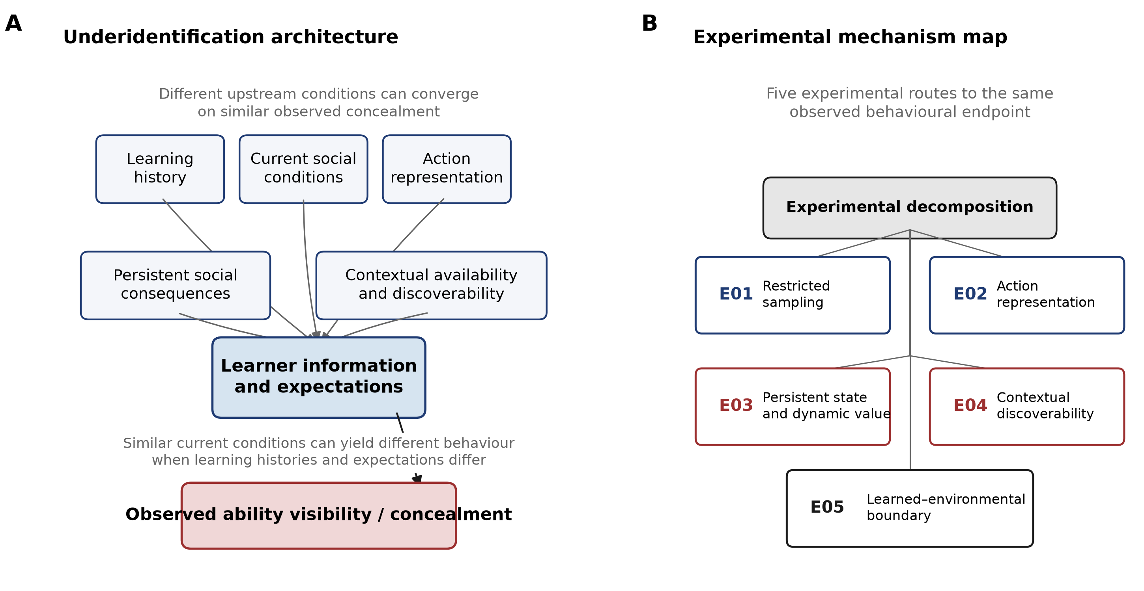

Figure 2. Learning history and action representation alter sampled and discovered actions.
(A) E01 compares learners whose forced initial authentic action was rejected versus accepted. Rejection reduced subsequent authentic sampling by −0.025837 (95% CI [−0.035753, −0.015922]), whereas the final-window mask-rate contrast was −0.000343 (95% CI [−0.011605, 0.010918]); the latter interval spans zero. (B) Within the rejected stratum, the model’s 5% forced-authentic-exploration and counterfactual-authentic-feedback manipulations reduced final-window masking by 0.046590 [0.033230, 0.059951] and 0.118135 [0.109683, 0.126587], respectively, relative to the rejection baseline. These are model information manipulations. (C) In E02’s rejected stratum, five independently learned graded disclosure arms increased continued non-zero disclosure relative to binary resampling (+0.255040 [0.253004, 0.257077]) but reduced full-authentic final-window selection (−0.328692 [−0.342037, −0.315348]) and unique-modal full-authenticity (−0.221740 [−0.288755, −0.154724]). Intervals are Student-t intervals across five master seeds.
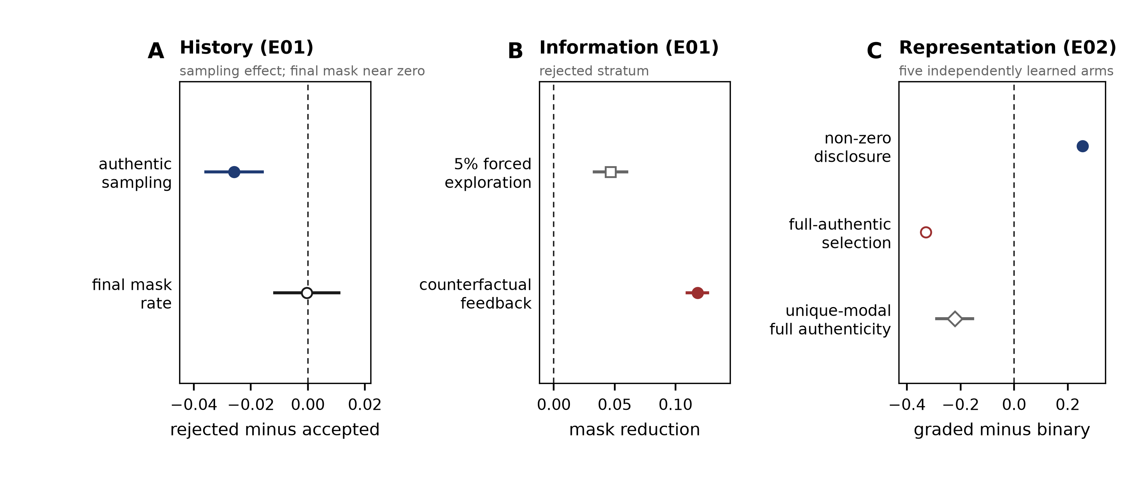

Figure 3. Persistent social state and learned–objective disagreement.
(A) In E03, authentic action from Neutral can lead to Accepted or Stigmatized social states; turnover and recovery can return the environment to Neutral. The relevant full-information objective therefore includes immediate reward and the continuation value of subsequent social state. (B) The frozen $21×17$ receptivity-by-recovery grid compares aggregate final-window Neutral-state action counts with the full-information dynamic oracle. Of 357 tested parameter cells, 243 are maintained learned–objective disagreement cells, 107 agree with the oracle, and seven are inconclusive: five had inadequate Neutral exposure in every master, while two had classifications from only one or two adequately visited masters and failed the four-of-five stability rule. Markers and gray levels distinguish the three categories; the contour marks the oracle’s switch to authenticity. Thus, 243/357 denotes tested parameter cells—not simulated learners, human prevalence, or a population frequency.
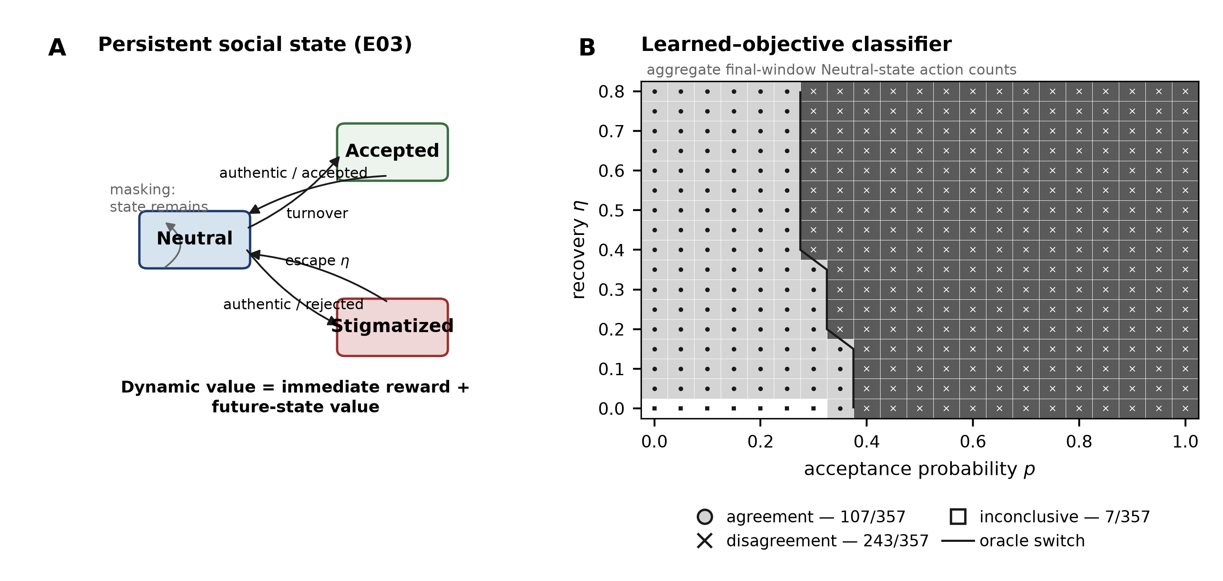

Figure 4. Context discoverability and learned–objective boundary displacement.
(A) E04 plots the primary one-good-context condition using each learner’s deterministic final-window first-index argmax classification of a good-context authentic action. The $K=16$ minus $K=1$ effects are −0.234000 [−0.246417, −0.221583] for the flat $2K$ representation and −0.470400 [−0.511031, −0.429769] for the hierarchical representation; the fixed-known-good control is exactly zero and the global-mask control is +0.008800 [0.002090, 0.015510]. Shaded regions are descriptive ranges across five master seeds; the inset uses the corresponding Student-t intervals across those masters. (B) E05 plots the frozen flat eight-action ($K=4$) pooled response against comparison cost $b_{f}$, its non-increasing PAVA fit, and the response threshold of 0.5. The learned behavioural crossing is $b_{f}^{L}=0.312852$ (95% complete-master-curve bootstrap CI [0.307836, 0.316918]), below the exact environmental/objective crossover $b_{f}^{*}=8/17=0.470588$; their displacement is 0.157736. The hierarchical response is already below 0.5 at the lower tested boundary ($b_{f}=0.30$), so its crossing is left-censored below the tested range rather than absent. The horizontal axis is comparison cost, not elapsed time or attempts.
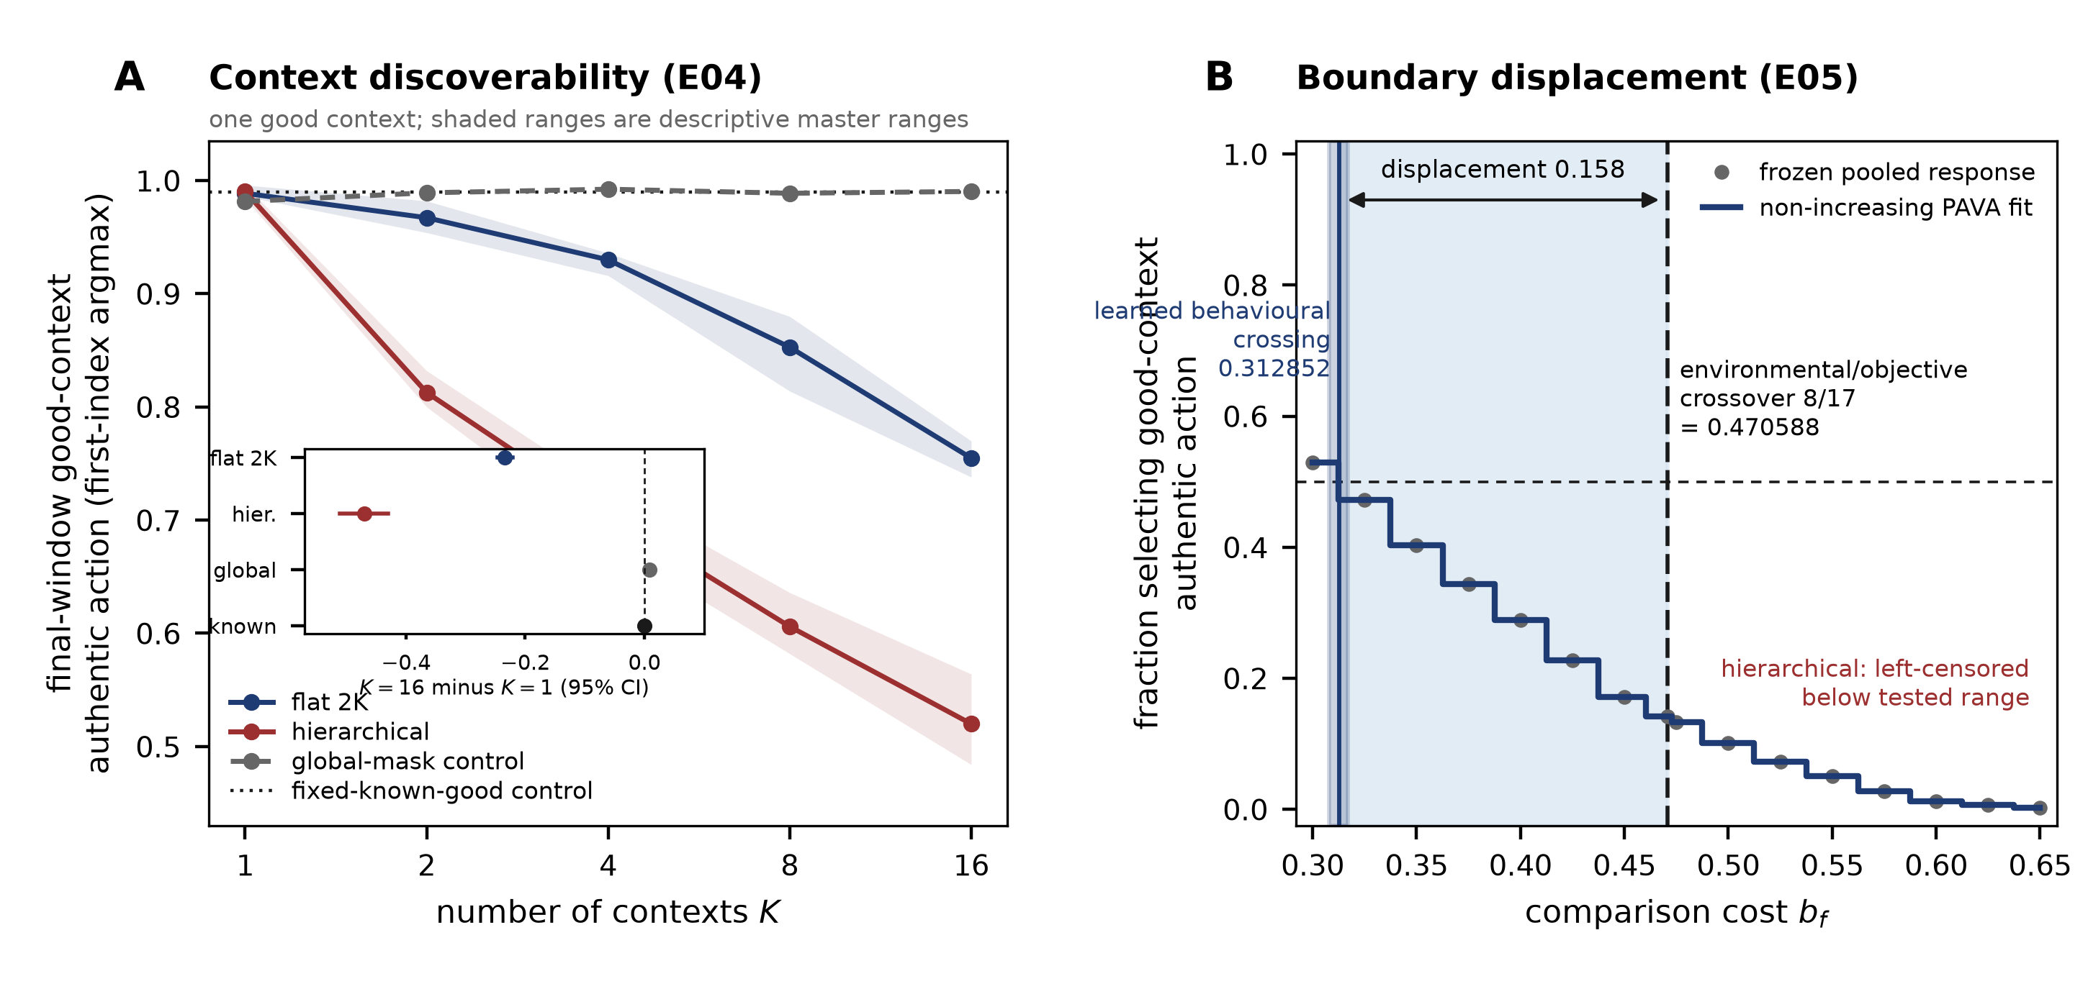

Data and Code Availability
The public source repository and persistent E01-E05 evidence archive are identified on the separate title page and will be restored here after double-anonymized review. The archived outputs are content-addressed and artifact-verified. The exact historical generator states for E01-E03 were not recovered; those results are supported by verified artifacts, configurations, manifests, and validation records rather than a claim of bit-identical regeneration from current code.

References
Chaudoir, S. R., & Fisher, J. D. (2010). The disclosure processes model: Understanding disclosure decision making and postdisclosure outcomes among people living with a concealable stigmatized identity. Psychological Bulletin, 136(2), 236–256. https://doi.org/10.1037/a0018193
Cicchetti, D., & Rogosch, F. A. (1996). Equifinality and multifinality in developmental psychopathology. Development and Psychopathology, 8(4), 597–600. https://doi.org/10.1017/S0954579400007318
Coleman, L. J., & Cross, T. L. (1988). Is being gifted a social handicap? Journal for the Education of the Gifted, 11(4), 41–56. https://doi.org/10.1177/016235328801100406
Cross, J. R., Vaughn, C. T., Mammadov, S., Cross, T. L., Kim, M., O’Reilly, C., Spielhagen, F. R., Pereira Da Costa, M., & Hymer, B. (2019). A cross-cultural study of the social experience of giftedness. Roeper Review, 41(4), 224–242. https://doi.org/10.1080/02783193.2019.1661052
Cross, T. L., Coleman, L. J., & Stewart, R. A. (1993). The social cognition of gifted adolescents: An exploration of the stigma of giftedness paradigm. Roeper Review, 16(1), 37–40. https://doi.org/10.1080/02783199309553532
Denrell, J. (2005). Why most people disapprove of me: Experience sampling in impression formation. Psychological Review, 112(4), 951–978. https://doi.org/10.1037/0033-295X.112.4.951
Denrell, J., & March, J. G. (2001). Adaptation as information restriction: The hot stove effect. Organization Science, 12(5), 523–538. https://doi.org/10.1287/orsc.12.5.523.10092
Klimecká, E. (2023). Advantages and disadvantages of being ‘gifted’: Perceptions of the label by gifted pupils. Research Papers in Education, 38(6), 902–923. https://doi.org/10.1080/02671522.2022.2065523
Lavrijsen, J., & Verschueren, K. (2023). High cognitive ability and mental health: Findings from a large community sample of adolescents. Journal of Intelligence, 11(2), Article 38. https://doi.org/10.3390/jintelligence11020038
Le Mens, G., & Denrell, J. (2011). Rational learning and information sampling: On the “naivety” assumption in sampling explanations of judgment biases. Psychological Review, 118(2), 379–392. https://doi.org/10.1037/a0023010
March, J. G. (1996). Learning to be risk averse. Psychological Review, 103(2), 309–319. https://doi.org/10.1037/0033-295X.103.2.309
Swiatek, M. A. (1995). An empirical investigation of the social coping strategies used by gifted adolescents. Gifted Child Quarterly, 39(3), 154–160. https://doi.org/10.1177/001698629503900305
Tourreix, E., Besançon, M., & Gonthier, C. (2023). Non-cognitive specificities of intellectually gifted children and adolescents: A systematic review of the literature. Journal of Intelligence, 11(7), Article 141. https://doi.org/10.3390/jintelligence11070141

