1. Installation de Visual Studio Code

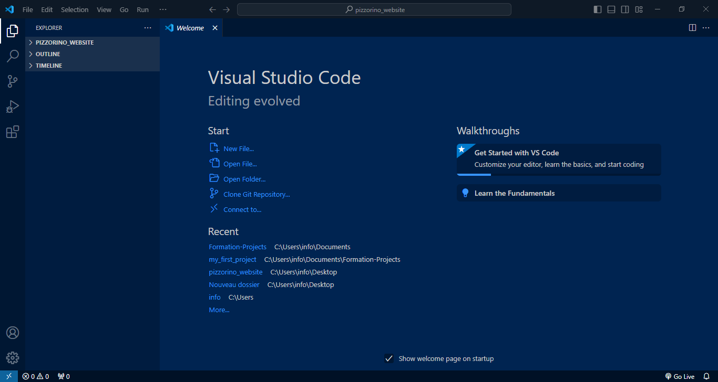

1. Installation of the following extensions (Prettier, LiveServer, CSS Peek, Regex Previewer)

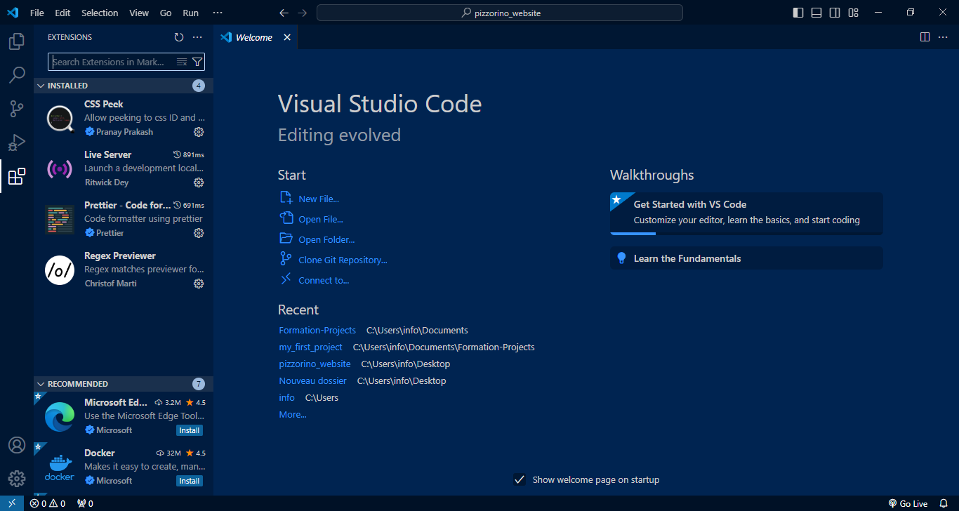

1. Installation of Google Chrome

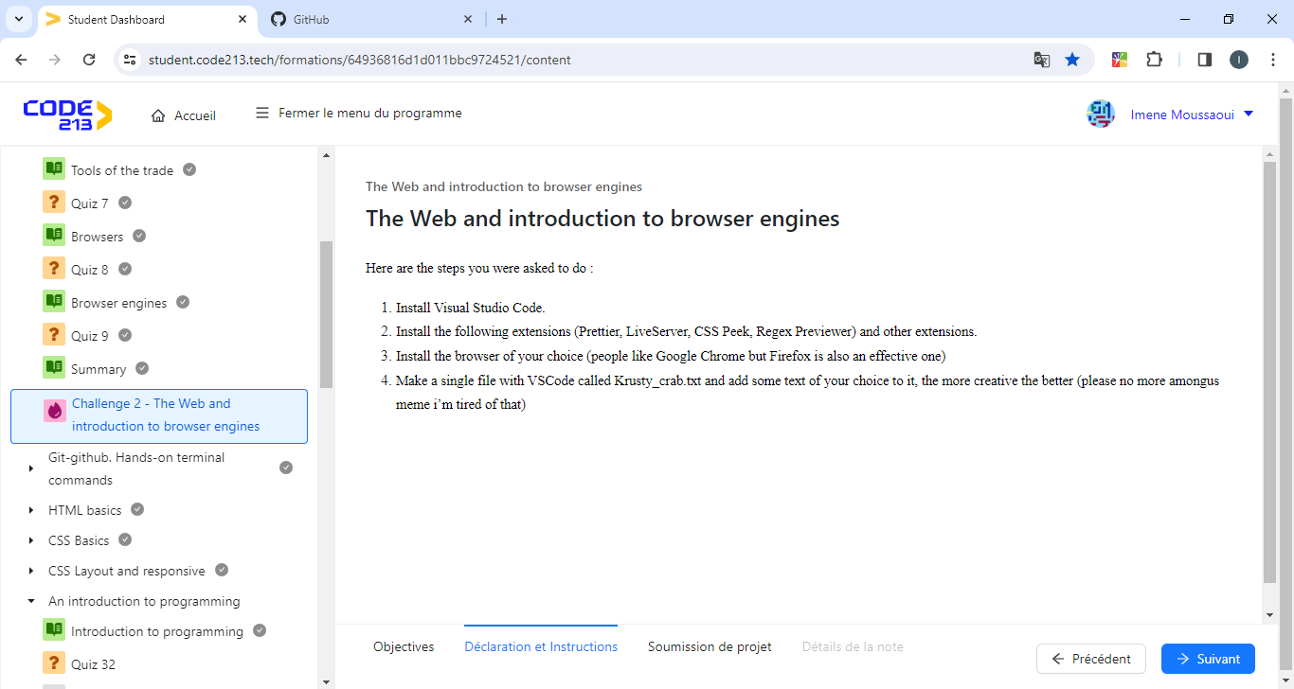

1. Make a single file with VSCode called Krusty_crab.txt and add some text

