Givens
$$Z_{o}=50Ω, f=9.5GHz$$

$$Copper thickness=1 oz/ft^{2}=34 μm$$
Substrate: Rogers RT/Duroid 5880
$$h=787.41 μm, ε_{r}=2.20±0.04, tanδ=0.0009 @ 10 GHz$$

npn type BJT BFG410W fabricated by NXP semiconductors
$$I_{c}=6mA, V_{ce}=2V$$

S parameters $@9.5GHz$ are Extracted from Spar_BFG410W_commonemitter2V6mA file
$$\left[S\right]=\left[\begin{matrix}0.608∠34.757° & 0.151∠-52.987° \\ 1.603∠-81.484° & 0.238∠49.648°\end{matrix}\right]$$

Matching Networks Microstrip TL — radial stub and $λ/4$ transmission line $\left(λ=λ_{g}=\frac{λ_{o}}{\sqrt{ε_{eff}}}\right)$

Specs
- Stability: stable over the entire useful bandwidth of the device
- $G=G_{T,max}$ at the design frequency
- ${\left.S11\right|}_{amp}, {\left.S22\right|}_{amp}$: minimize
- Only open-circuited shunt stubs should be used
- $BW$: maximize, based on a narrowband design (The pair of networks that are to be used in the end should be selected such that the bandwidth of the amplifier is maximized)
- Amplifier must be DC-isolated by blocking capacitors
- Layout has space between the launcher microstrip lines and the surface mount capacitors
- Layout must take into consideration the physical dimensions of the transistor, capacitors, and resistors. The capacitors and resistors are surface-mounted ones. You can use the dimensions of the 0603 package for the capacitors and resistors.

Stability
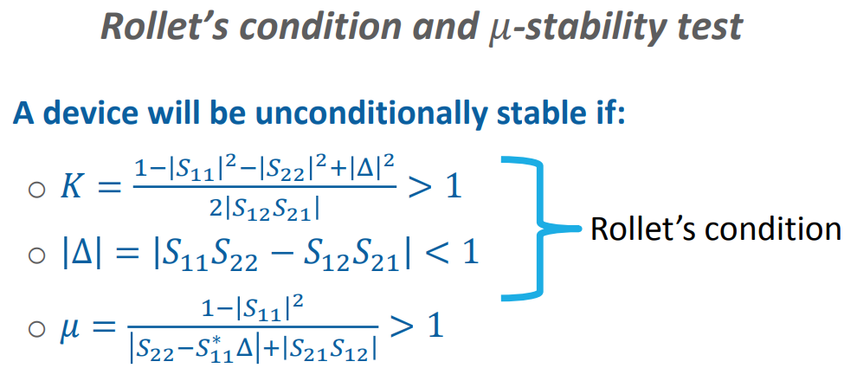

$$∆=0.366∠59.891°$$
$$\left|∆\right|=0.366<1$$
$$K=1.462>1$$
The device is unconditionally stable $@9.5GHz$

Another Solution
$$μ=1.849>1$$
The device is unconditionally stable $@9.5GHz$

Gain
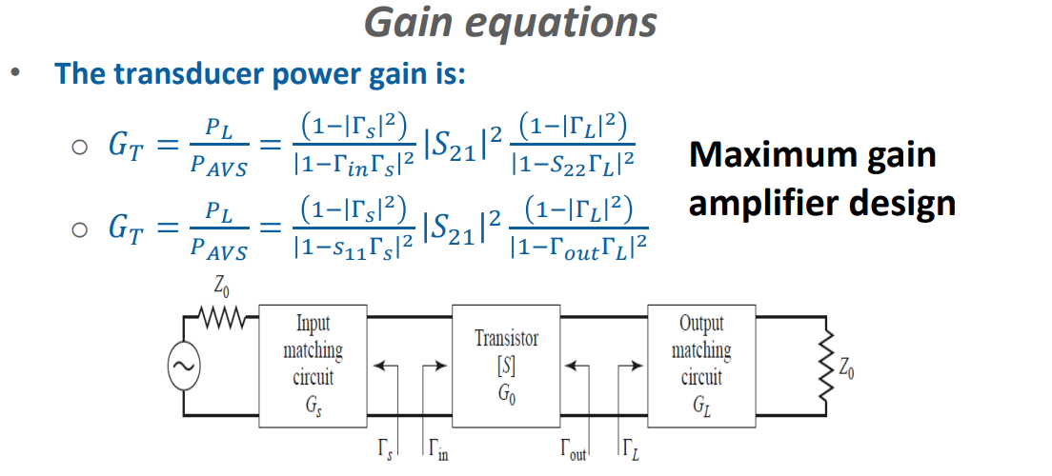
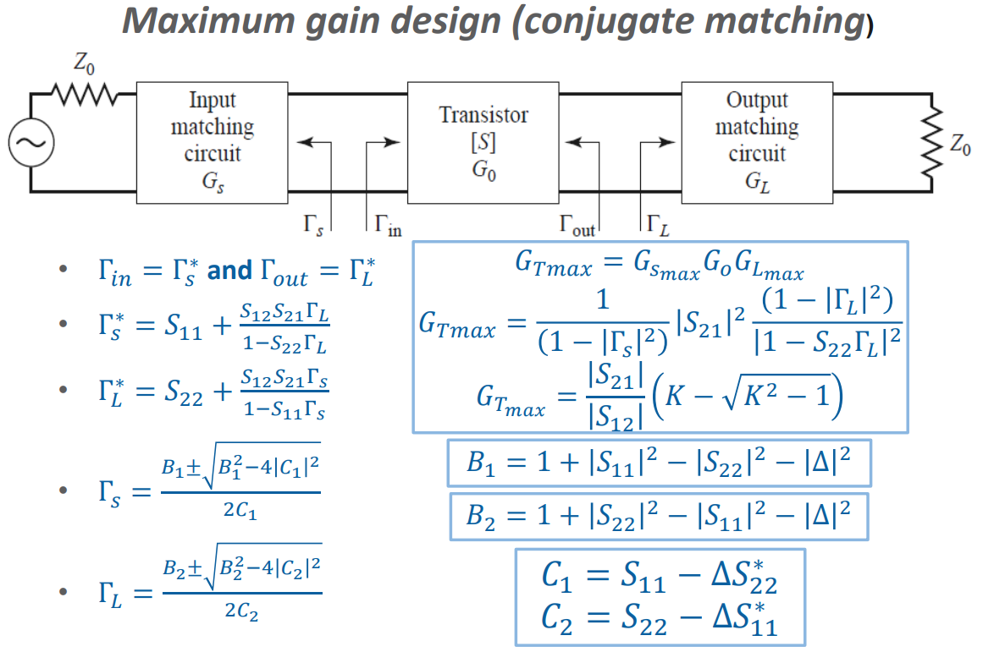
Law4
$$G_{T,max}=4.199=6.231 dB$$

Another Solution
$$B_{1}=1.179$$
$$B_{2}=0.553$$
$$C_{1}=0.53∠38.669°$$
$$C_{2}=0.099∠118.652°$$
$$Γ_{s}=1.599∠-38.669° \left(rejected\right), 0.625∠-38.669°$$
$$Γ_{L}=5.404∠-118.652° \left(rejected\right), 0.185∠-118.652°$$
$$Γ_{in}=0.625∠38.669°$$
$$Γ_{out}=0.185∠118.652°$$
Law1
$$G_{T}=4.199=6.231dB$$
Law2
$$G_{T}=4.199=6.231dB$$
Law3
$$G_{T}=4.199=6.231dB$$

Microstrip TL Design
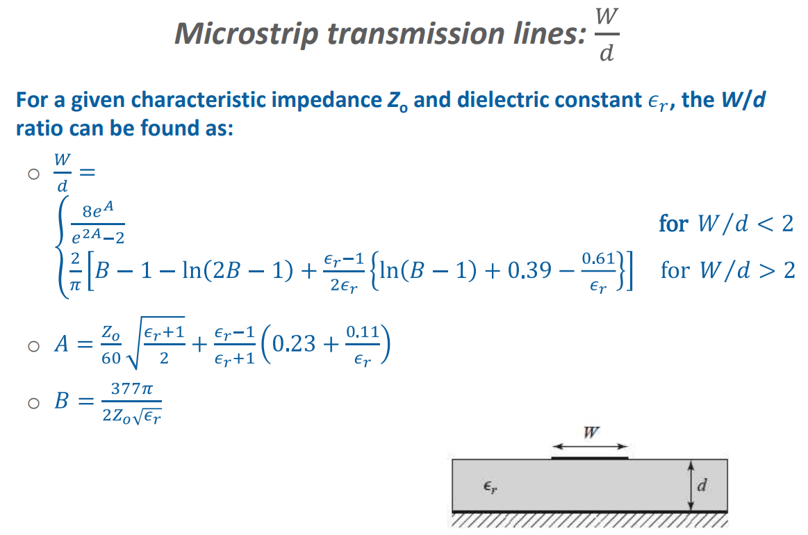

$$A=1.159→\frac{W}{d}=3.126≮2 \left(rejected\right)$$
$$B=7.985→\frac{W}{d}=3.081>2$$

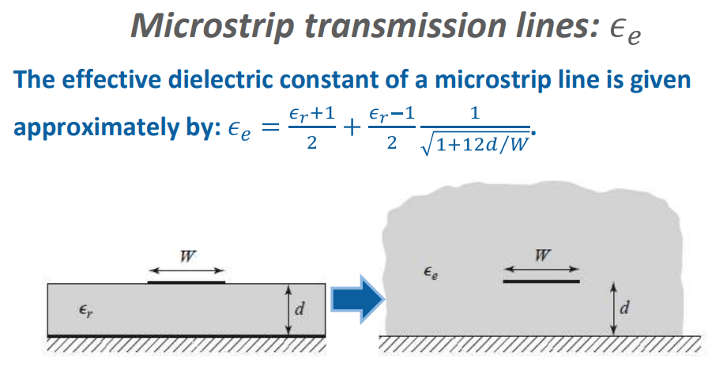

$$ε_{eff}=1.871$$
$$λ=λ_{g}=\frac{λ_{o}}{\sqrt{ε_{eff}}}=\frac{c_{o}}{f\sqrt{ε_{eff}}}=0.023069m$$
$$λ=23.069mm→\frac{λ}{4}=5.767mm$$

Input and Output Matching Network
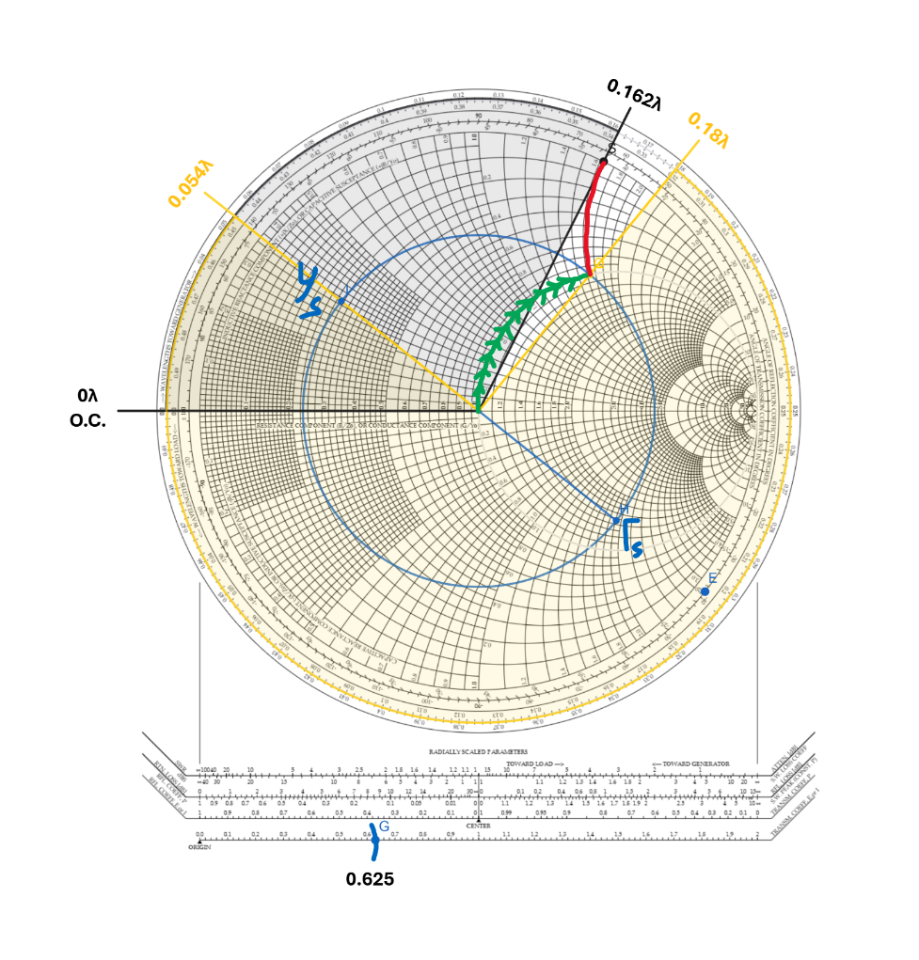 | Solution1  $$l=0.162λ-0λ$$  $$l=0.162λ+\frac{mλ}{2}, m=0, 1, 2, …$$  $$l=0.162λ=58.32°$$  $$l=3.737mm$$  $$d=0.054λ-0.18λ$$  $$d=-0.126λ$$  $$d=-0.126λ+0.5λ$$  $$d=0.374λ+\frac{mλ}{2},m=0, 1, 2, …$$  $$d=0.374λ=134.64°$$  $$d=8.628mm$$
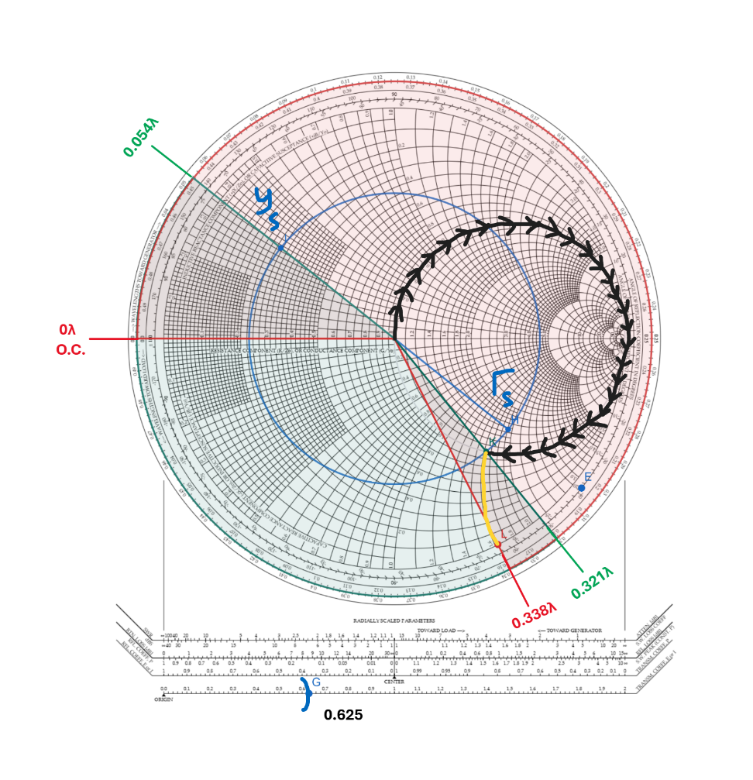 | Solution2  $$l=0.338λ-0λ$$  $$l=0.338λ+\frac{mλ}{2},m=0, 1, 2, …$$  $$l=0.338λ=121.68°$$  $$l=7.797mm$$  $$d=0.054λ-0.321λ$$  $$d=-0.267λ$$  $$d=-0.267λ+0.5λ$$  $$d=0.233λ$$  $$d=0.233λ+\frac{mλ}{2}, m=0, 1, 2, …$$  $$d=0.233λ=83.88°$$  $$d=5.375mm$$

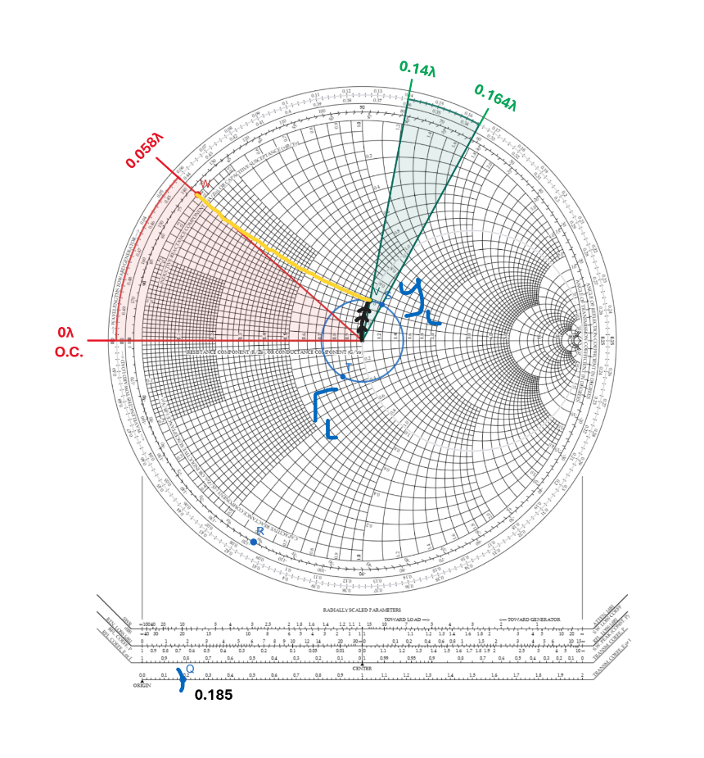 | Solution1  $$l=0.058λ-0λ$$  $$l=0.058λ+\frac{mλ}{2}, m=0, 1, 2, …$$  $$l=0.058λ=20.88°$$  $$l=1.338mm$$  $$d=0.164λ-0.14λ$$  $$d=0.024λ+\frac{mλ}{2}, m=0, 1, 2, …$$  $$d=0.024λ=8.64°$$  $$d=0.554mm$$
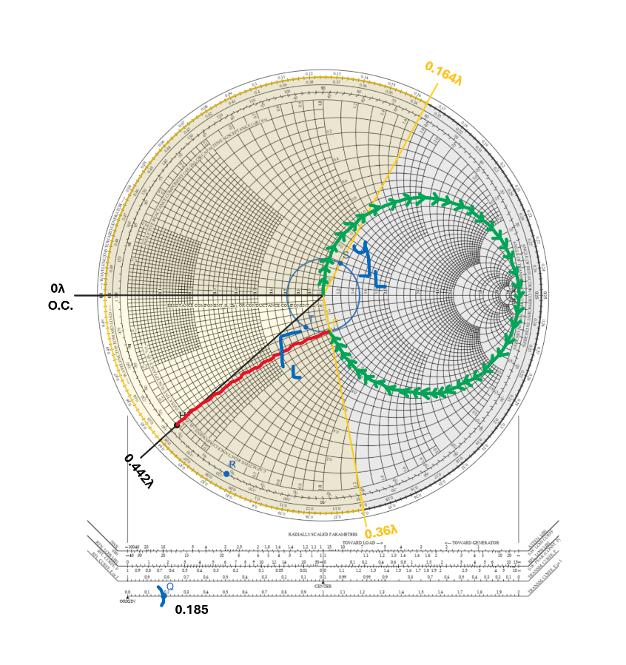 | Solution2  $$l=0.442λ-0λ$$  $$l=0.442λ+\frac{mλ}{2}, m=0, 1, 2, …$$  $$l=0.442λ=159.12°$$  $$l=10.197mm$$  $$d=0.164λ-0.36λ$$  $$d=-0.196λ$$  $$d=-0.196λ+0.5λ$$  $$d=0.304λ+\frac{mλ}{2}, m=0, 1, 2, …$$  $$d=0.304λ=109.44°$$  $$d=7.013mm$$

