Machine Learning Classification Project
Diabetes Prediction — Code Documentation

An end-to-end supervised-learning pipeline that predicts diabetes from
patient health records — covering data cleaning, preprocessing, class-imbalance
handling, dimensionality reduction, model training, tuning, and evaluation.
Dataset | diabetes_prediction_dataset.csv
Records | 100,000 patients (9 columns)
Task | Binary classification (diabetes / no diabetes)
Models compared | 7 classifiers
Best model | Gradient Boosting (Test F1 = 0.8098)

Table of Contents
1. Project Overview 4
1.1 Dataset 4
1.2 Workflow Summary 4
1.3 Libraries Used 4
2. Data Loading & Cleaning 6
2.1 Loading and Inspecting the Data 6
2.2 Removing Duplicate Rows 6
2.3 BMI Imputation and Outlier Capping 7
2.4 Cleaning the Gender Column 7
3. Feature Encoding 9
3.1 Consolidating Smoking History 9
3.2 Encoding Strategy 9
4. Data Splitting & Class Imbalance 10
4.1 Train / Validation / Test Split 10
4.2 Handling Class Imbalance with SMOTE 10
4.3 Feature Scaling 12
4.4 Preprocessing Summary 12
5. Model Training & Evaluation 13
5.1 Naïve Bayes 13
5.2 PCA Exploration 15
5.3 Logistic Regression 17
5.4 Multi-Layer Perceptron (MLP) 19
5.5 Support Vector Machine — Linear Kernel 21
5.6 Support Vector Machine — RBF Kernel 22
5.6.1 Grid Search 22
5.6.2 Particle Swarm Optimization 22
5.7 Random Forest 25
5.8 Gradient Boosting 27
6. Model Comparison & PCA Analysis 28
6.1 All-Model Comparison 28
6.2 PCA Applied to the Best Model 30
6.3 Final Summary 30
7. Results & Conclusion 32
7.1 Final Test-Set Results 32
7.2 Key Observations 32
7.3 Conclusion 32

1. Project Overview
This project builds and compares a suite of supervised machine-learning classifiers to predict whether a patient has diabetes from routinely collected health indicators. The notebook follows a complete, reproducible workflow: it cleans the raw data, engineers and encodes features, addresses the strong class imbalance in the target, splits the data into train/validation/test partitions, trains seven different models, tunes their hyperparameters, and finally evaluates each one on a held-out test set.

1.1 Dataset
The dataset (diabetes_prediction_dataset.csv) contains 100,000 patient records with nine columns. Eight columns are predictive features and one (diabetes) is the binary target. The features are:
- gender — patient gender (Female / Male / Other).
- age — patient age in years.
- hypertension — whether the patient has hypertension (0 / 1).
- heart_disease — whether the patient has heart disease (0 / 1).
- smoking_history — categorical smoking status.
- bmi — body mass index.
- HbA1c_level — glycated haemoglobin level.
- blood_glucose_level — blood glucose measurement.
- diabetes — TARGET: whether the patient has diabetes (0 / 1).

1.2 Workflow Summary
The pipeline is organised into the following stages:
- Data loading and quality inspection.
- Data cleaning — duplicate removal, BMI imputation and outlier capping.
- Feature encoding — label encoding and one-hot encoding of categoricals.
- Train / validation / test split (70% / 15% / 15%, stratified).
- Class-imbalance correction with SMOTE (applied to the training set only).
- Feature scaling with StandardScaler.
- Model training — Naïve Bayes, Logistic Regression, MLP, SVM (Linear & RBF), Random Forest and Gradient Boosting.
- Hyperparameter tuning — grid search and Particle Swarm Optimization.
- Dimensionality reduction with PCA, applied to the best model.
- Final comparison of all models and selection of the overall winner.

1.3 Libraries Used
The notebook begins by importing its core scientific-computing and machine-learning dependencies:
import numpy as np
import pandas as pd
import matplotlib.pyplot as plt
import seaborn as sns
from sklearn.preprocessing import StandardScaler, LabelEncoder
from imblearn.over_sampling import SMOTE
from sklearn.model_selection import train_test_split
Additional model-specific libraries (scikit-learn classifiers, imbalanced-learn pipelines, and metric utilities) are imported within their respective sections, described later.

2. Data Loading & Cleaning

2.1 Loading and Inspecting the Data
The raw CSV is loaded into a pandas DataFrame and immediately inspected for shape, missing values and duplicate rows.
df = pd.read_csv('diabetes_prediction_dataset.csv')

print("Shape:", df.shape)
print(df.head())
print("\nNull values:\n", df.isnull().sum())
print("\nDuplicates:", df.duplicated().sum())
OUTPUT
Shape: (100000, 9)
gender age hypertension heart_disease smoking_history bmi \
0 Female 80.0 0 1 never 25.19
1 Female 54.0 0 0 No Info 27.32
2 Male 28.0 0 0 never 27.32
3 Female 36.0 0 0 current 23.45
4 Male 76.0 1 1 current 20.14

HbA1c_level blood_glucose_level diabetes
0 6.6 140 0
1 6.6 80 0
2 5.7 158 0
3 5.0 155 0
4 4.8 155 0

Null values:
gender 0
age 0
hypertension 0
heart_disease 0
smoking_history 0
bmi 0
HbA1c_level 0
blood_glucose_level 0
diabetes 0
dtype: int64

Duplicates: 3854
The inspection confirms a dataset of 100,000 rows and 9 columns with no missing values, but 3,854 duplicate rows that must be removed.

2.2 Removing Duplicate Rows
Exact duplicate rows are dropped to prevent the same observations from being over-represented during training.
before = len(df)
df = df.drop_duplicates()
after = len(df)

print(f"Rows dropped : {before - after}")
print(f"Rows remaining: {after}")
OUTPUT
Rows dropped : 3854
Rows remaining: 96146

2.3 BMI Imputation and Outlier Capping
A specific BMI value of 27.32 was found to repeat unusually often, behaving like a placeholder for missing data. Leaving it in could distort models such as SVM, Logistic Regression, MLP, Random Forest and XGBoost. The notebook therefore replaces these placeholder values with a cohort-aware median: patients are temporarily grouped by gender and age band, and each placeholder BMI is replaced by the median BMI of its cohort (falling back to the global median when a cohort has no genuine values). Finally, extreme BMI values are capped at the 99th percentile to limit the influence of outliers.
PLACEHOLDER = 27.32
print(f"Rows with BMI = {PLACEHOLDER}: {(df['bmi'] == PLACEHOLDER).sum()}")

# Temporary age bins for cohort grouping
df['age_group'] = pd.cut(df['age'],
bins=[0, 18, 35, 50, 65, 100],
labels=['child', 'young', 'adult', 'senior', 'elderly'])

# Median BMI per cohort using only non-placeholder rows
cohort_medians = (df[df['bmi'] != PLACEHOLDER]
.groupby(['gender', 'age_group'])['bmi']
.median())
global_median = df[df['bmi'] != PLACEHOLDER]['bmi'].median()

def impute_bmi(row):
if row['bmi'] == PLACEHOLDER:
try:
return cohort_medians.loc[(row['gender'], row['age_group'])]
except KeyError:
return global_median # fallback if cohort has no real values
return row['bmi']

df['bmi'] = df.apply(impute_bmi, axis=1)
df.drop(columns=['age_group'], inplace=True)

# Handle outliers by capping extreme values at the 99th percentile
cap = df['bmi'].quantile(0.99)
df['bmi'] = df['bmi'].clip(upper=cap)
OUTPUT
Rows with BMI = 27.32: 21666

/tmp/ipykernel_4494/1431022144.py:15: FutureWarning: The default of observed=False is deprecated and will be changed to True in a future version of pandas. Pass observed=False to retain current behavior or observed=True to adopt the future default and silence this warning.
.groupby(['gender', 'age_group'])['bmi']

Rows still at 27.32: 0
BMI range after imputation: 10.01 – 95.69
BMI capped at 99th percentile: 48.97

2.4 Cleaning the Gender Column
The "Other" gender category contains too few examples to be statistically useful and is dropped so the gender variable is cleanly binary.
print("Gender distribution before:")
print(df['gender'].value_counts())

df = df[df['gender'] != 'Other']

print("\nGender distribution after:")
print(df['gender'].value_counts())
print(f"Rows remaining: {len(df)}")
OUTPUT
Gender distribution before:
gender
Female 56161
Male 39967
Other 18
Name: count, dtype: int64

Gender distribution after:
gender
Female 56161
Male 39967
Name: count, dtype: int64
Rows remaining: 96128

3. Feature Encoding
Categorical variables must be converted into numeric form before modelling. The smoking_history column is first consolidated, then the two categorical columns are encoded with two complementary strategies.

3.1 Consolidating Smoking History
The original smoking categories include several near-synonyms. The values "former", "ever" and "not current" all describe a patient who used to smoke and are merged into a single "former" category; "No Info" is treated as its own "unknown" category; "never" and "current" are kept unchanged.

3.2 Encoding Strategy
Gender is label-encoded (Female = 0, Male = 1) because it is binary. The smoking_history column is one-hot encoded with drop_first=True to avoid the dummy-variable trap.
smoke_map = {
'never': 'never',
'current': 'current',
'former': 'former',
'ever': 'former', # semantically the same as former
'not current': 'former', # semantically the same as former
'No Info': 'unknown' # treat as its own "missing" category
}
df['smoking_history'] = df['smoking_history'].map(smoke_map)

# Label-encode gender, one-hot encode smoking history
le = LabelEncoder()
df['gender'] = le.fit_transform(df['gender']) # Female=0, Male=1

df = pd.get_dummies(df, columns=['smoking_history'], drop_first=True)
OUTPUT
Smoking categories before:
smoking_history
never 34395
No Info 32881
former 9299
current 9197
not current 6359
ever 3997
Name: count, dtype: int64

Smokng categories after consolidation:
smoking_history
never 34395
unknown 32881
former 19655
current 9197
Name: count, dtype: int64

Gender encoded: {'Female': np.int64(0), 'Male': np.int64(1)}

Columns after encoding: ['gender', 'age', 'hypertension', 'heart_disease', 'bmi', 'HbA1c_level', 'blood_glucose_level', 'diabetes', 'smoking_history_former', 'smoking_history_never', 'smoking_history_unknown']
Shape: (96128, 11)

4. Data Splitting & Class Imbalance

4.1 Train / Validation / Test Split
The data is split into three stratified partitions — 70% training, 15% validation, 15% test. Stratification preserves the original class ratio in every partition. The split is performed in two steps: first a 15% test set is separated, then the remaining 85% is divided into training and validation.
X = df.drop(columns=['diabetes']).astype(float)
y = df['diabetes']

# 70% train | 15% val | 15% test - stratified to preserve class ratio
X_temp, X_test, y_temp, y_test = train_test_split(
X, y, test_size=0.15, random_state=42, stratify=y)

X_train, X_val, y_train, y_val = train_test_split(
X_temp, y_temp,
test_size=0.1765, # 0.1765 x 0.85 ~= 0.15 of total
random_state=42, stratify=y_temp)
OUTPUT
Class distribution before split:
diabetes
0 0.9118
1 0.0882
Name: proportion, dtype: float64

Train size : 67,286
Validation size : 14,422
Test size : 14,420

4.2 Handling Class Imbalance with SMOTE
The target is heavily imbalanced — roughly 91.5% of patients do not have diabetes versus 8.5% who do. Without correction, a model could predict "no diabetes" for everyone and still reach about 91% accuracy while being clinically useless. SMOTE (Synthetic Minority Over-sampling Technique) addresses this by synthesising new minority-class samples through interpolation between real ones. Crucially, SMOTE is applied to the training set only — never to the validation or test sets — so that evaluation reflects real-world class proportions.
smote = SMOTE(random_state=42)
X_train_res, y_train_res = smote.fit_resample(X_train, y_train)
OUTPUT
Train class distribution BEFORE SMOTE:
diabetes
0 61349
1 5937
Name: count, dtype: int64

Train class distribution AFTER SMOTE:
diabetes
0 61349
1 61349
Name: count, dtype: int64
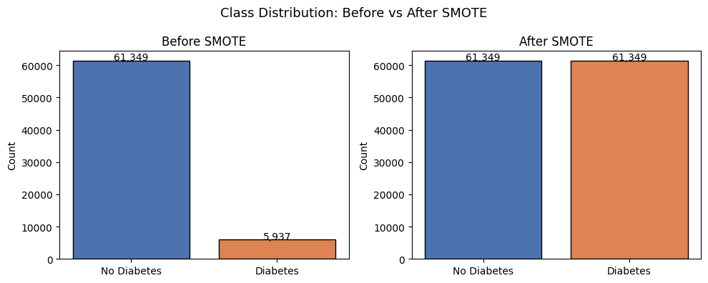
Figure 4.1 — Class distribution before and after SMOTE resampling.

4.3 Feature Scaling
Distance- and gradient-based models (SVM, MLP and Logistic Regression) require features on a common scale. A StandardScaler is fitted on the resampled training data and then applied — without re-fitting — to the validation and test sets. This prevents information from the evaluation sets leaking into the scaler.
scaler = StandardScaler()
X_train_scaled = scaler.fit_transform(X_train_res) # fit + transform
X_val_scaled = scaler.transform(X_val) # transform only
X_test_scaled = scaler.transform(X_test) # transform only
OUTPUT
Scaling done.
Train scaled shape : (122698, 10)
Val scaled shape : (14422, 10)
Test scaled shape : (14420, 10)

Post-scaling stats (train) — mean should ≈ 0, std ≈ 1:
gender age hypertension heart_disease bmi HbA1c_level \
mean 0.0 -0.0 -0.0 0.0 0.0 -0.0
std 1.0 1.0 1.0 1.0 1.0 1.0

blood_glucose_level smoking_history_former smoking_history_never \
mean 0.0 0.0 -0.0
std 1.0 1.0 1.0

smoking_history_unknown
mean -0.0
std 1.0

4.4 Preprocessing Summary
After all preprocessing steps the data is ready for modelling. The notebook prints a consolidated summary of the prepared datasets.
OUTPUT
PREPROCESSING COMPLETE:
=======================================================
Features : 10
Train samples (SMOTE) : 122,698
Validation samples : 14,422
Test samples : 14,420
Class balance (train) : {0: 0.5, 1: 0.5}
Feature names : ['gender', 'age', 'hypertension', 'heart_disease', 'bmi', 'HbA1c_level', 'blood_glucose_level', 'smoking_history_former', 'smoking_history_never', 'smoking_history_unknown']
=======================================================

Ready for modeling.
Variables available for next steps:
X_train_scaled, y_train_res → for model fitting
X_val_scaled, y_val → for hyperparameter tuning
X_test_scaled, y_test → for final evaluation only

5. Model Training & Evaluation
Seven classifiers are trained and evaluated. Each model is assessed with a consistent set of metrics — accuracy, precision, sensitivity (recall), specificity, F1-score and ROC-AUC — and visualised with a six-panel evaluation dashboard showing learning curves, an ROC curve, confusion matrices and a metric summary. To avoid data leakage, learning curves are computed with an imbalanced-learn Pipeline so that SMOTE and scaling are performed inside each cross-validation fold.

5.1 Naïve Bayes
A Gaussian Naïve Bayes classifier serves as a fast probabilistic baseline. It is trained on the scaled, SMOTE-resampled training data and evaluated on both the validation and test sets.
from sklearn.naive_bayes import GaussianNB

nb = GaussianNB()
nb.fit(X_train_scaled, y_train_res)

y_val_pred = nb.predict(X_val_scaled)
y_test_pred = nb.predict(X_test_scaled)
The evaluation produces the six-panel dashboard below.
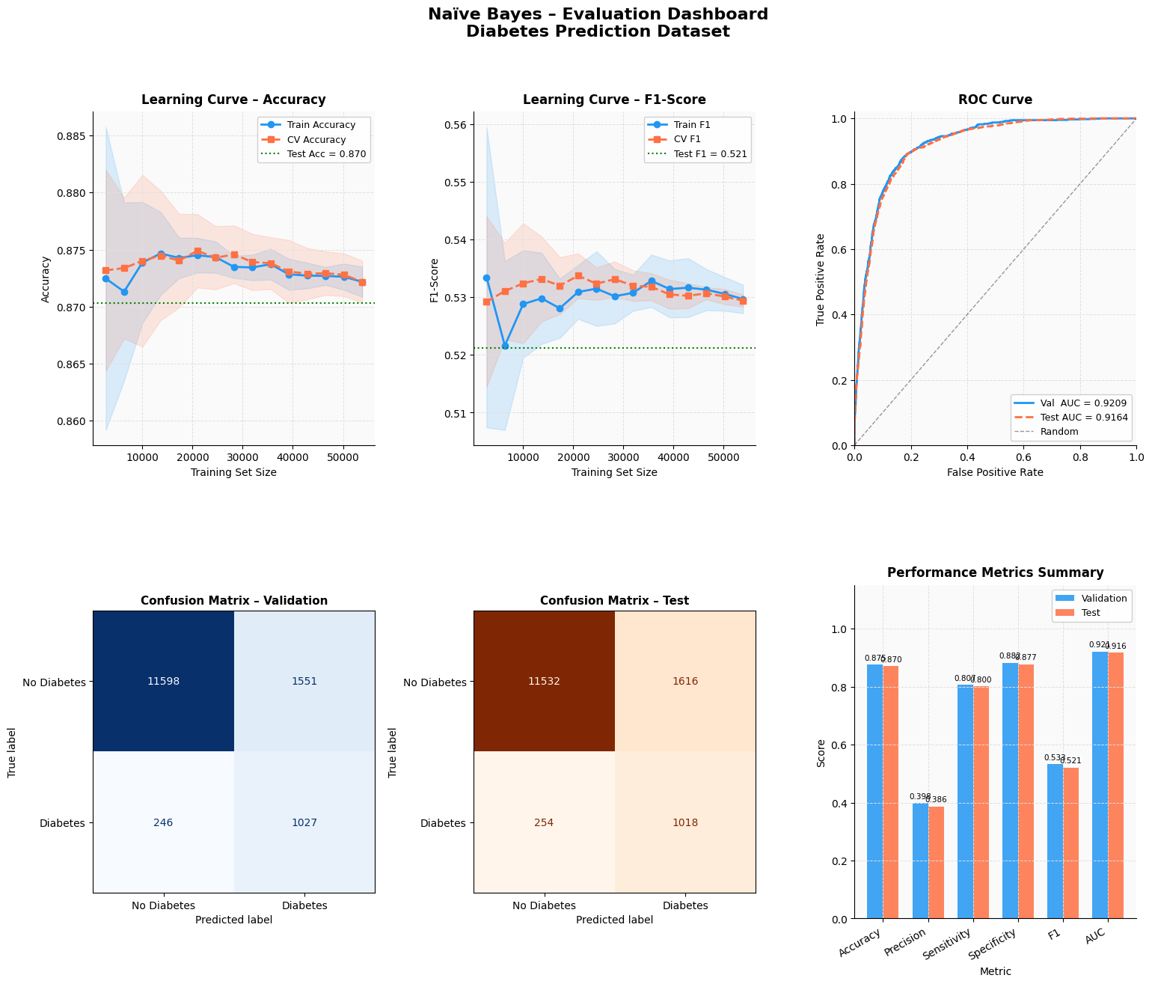
Figure 5.1 — Naïve Bayes evaluation dashboard: learning curves, ROC curve, confusion matrices and metric summary.

5.2 PCA Exploration
Before training the linear models, the notebook explores Principal Component Analysis (PCA) to understand how the feature variance is distributed. A full PCA is fitted to the scaled training data, and the number of components required to retain 90%, 95% and 99% of the variance is reported.
from sklearn.decomposition import PCA

pca_full = PCA(random_state=42)
pca_full.fit(X_train_scaled)

explained_var = pca_full.explained_variance_ratio_
cumulative_var = np.cumsum(explained_var)
OUTPUT
Total features : 10
Components for 90% var : 8
Components for 95% var : 9
Components for 99% var : 10

Explained variance per component:
PC 1: 23.66%
PC 2: 15.54%
PC 3: 11.44%
PC 4: 9.96%
PC 5: 9.25%
PC 6: 8.70%
PC 7: 7.60%
PC 8: 6.78%
PC 9: 5.66%
PC10: 1.42%
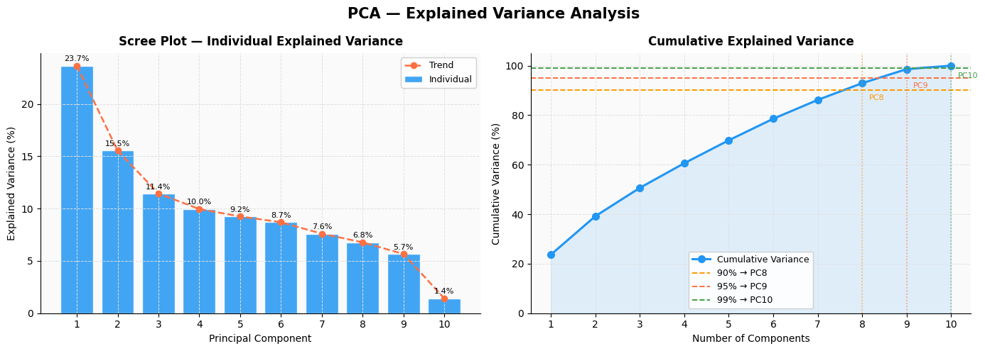
Figure 5.2 — Scree plot (individual variance) and cumulative explained-variance curve.
PCA retaining 95% of the variance is then applied, reducing the feature space, and a loading matrix shows how each original feature contributes to each component.
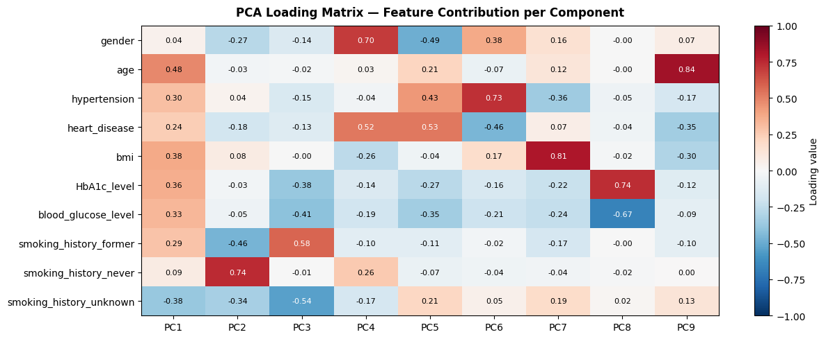
Figure 5.3 — PCA loading matrix: feature contribution per principal component.

5.3 Logistic Regression
Logistic Regression is tuned over the inverse-regularisation parameter C, with the best value chosen by validation F1-score.
C_grid = [0.001, 0.01, 0.1, 1, 10, 100]
for c in C_grid:
tmp = LogisticRegression(C=c, max_iter=1000, random_state=42)
tmp.fit(X_train_scaled, y_train_res)
# ... score on validation set, record accuracy / F1 / AUC

# best C selected by highest validation F1
lr_model = LogisticRegression(C=best_C, max_iter=1000, random_state=42)
lr_model.fit(X_train_scaled, y_train_res)
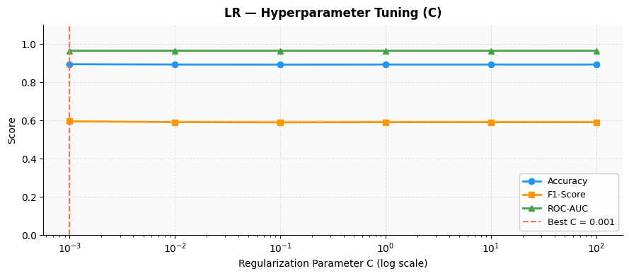
Figure 5.4 — Logistic Regression hyperparameter tuning: metrics versus the regularisation parameter C.
The final tuned model is evaluated with the same six-panel dashboard.
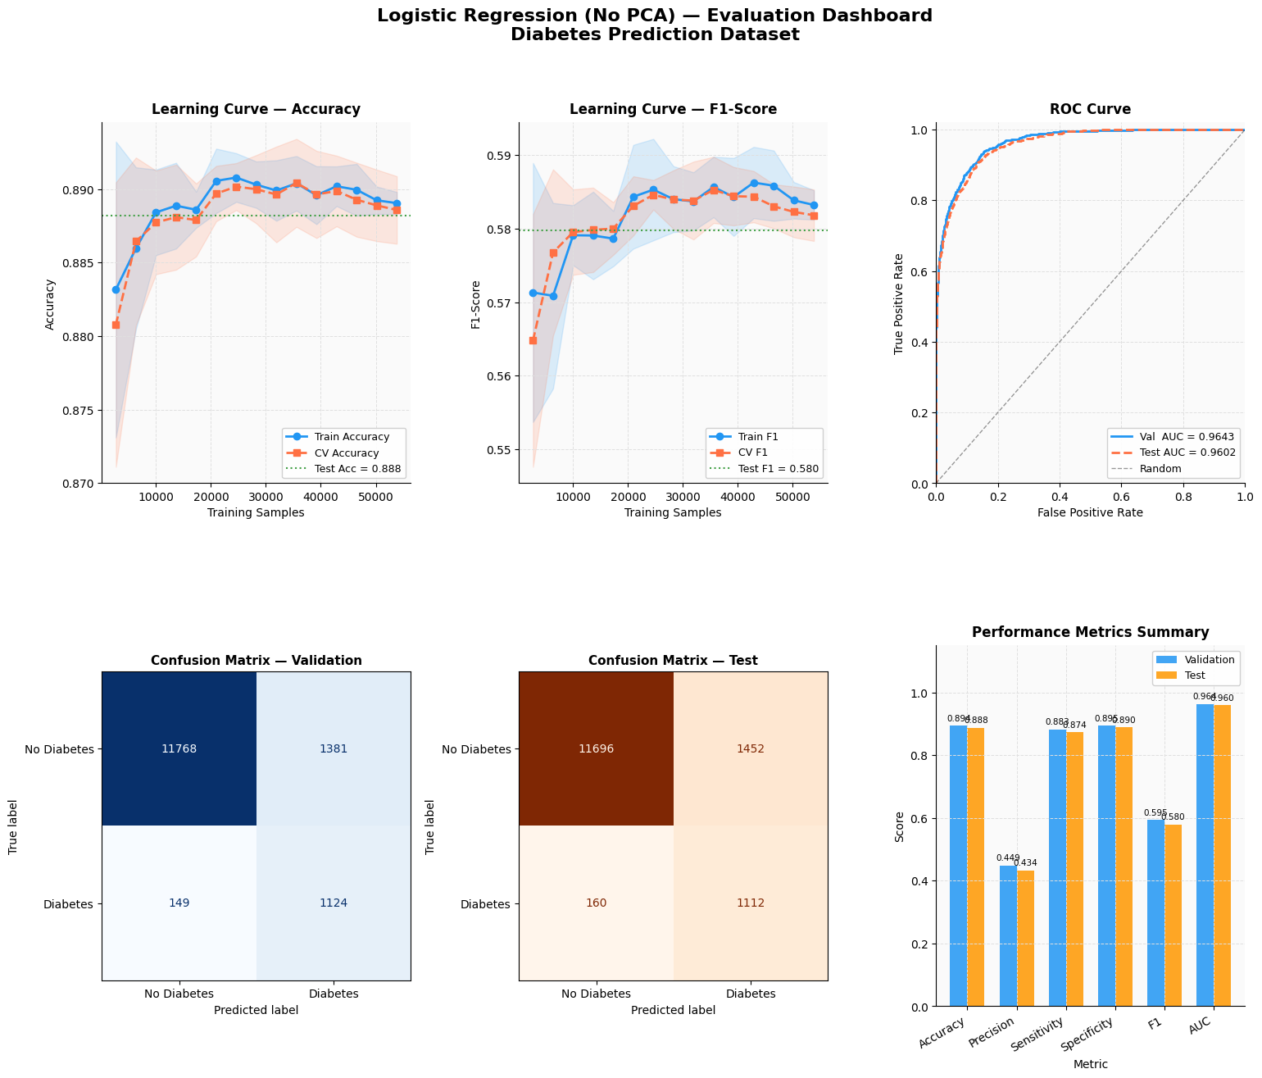
Figure 5.5 — Logistic Regression evaluation dashboard.

5.4 Multi-Layer Perceptron (MLP)
A neural-network classifier is tuned over several hidden-layer architectures. Each candidate uses ReLU activation, the Adam optimiser and early stopping; the architecture with the highest validation F1-score is retrained as the final model.
from sklearn.neural_network import MLPClassifier

mlp_grid = [
{'hidden_layer_sizes': (32,)},
{'hidden_layer_sizes': (64,)},
{'hidden_layer_sizes': (64, 32)},
{'hidden_layer_sizes': (128, 64)},
]
# each architecture is tuned on the validation set;
# the best one is retrained with early stopping
mlp = MLPClassifier(hidden_layer_sizes=best_mlp_arch,
activation='relu', solver='adam',
alpha=1e-4, learning_rate_init=1e-3,
max_iter=200, early_stopping=True,
random_state=42)
mlp.fit(X_train_scaled, y_train_res)
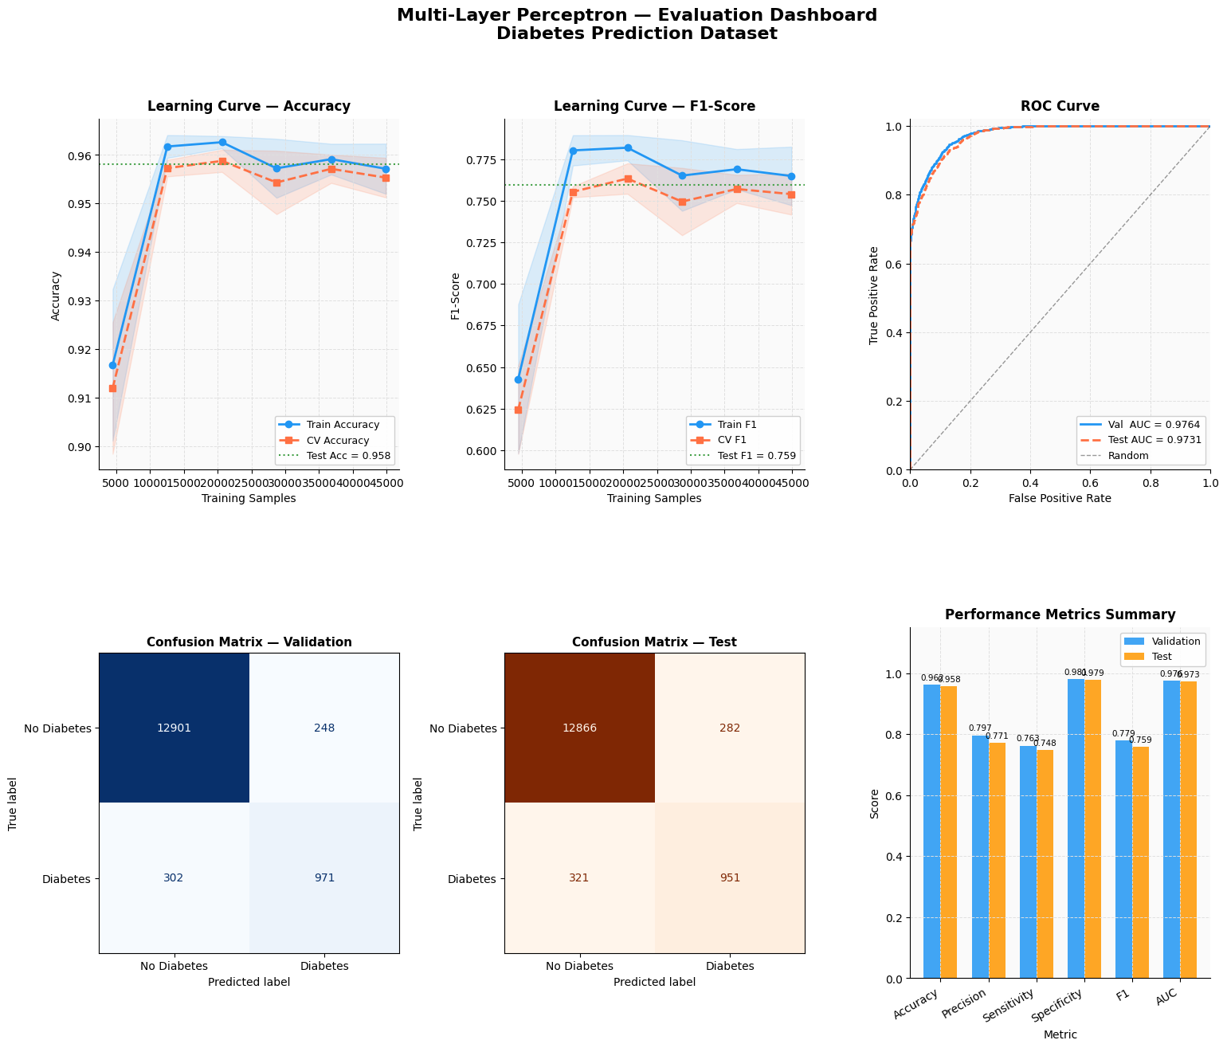
Figure 5.6 — Multi-Layer Perceptron evaluation dashboard.

5.5 Support Vector Machine — Linear Kernel
For the linear SVM the notebook uses LinearSVC, whose liblinear solver is far faster than a standard kernel SVM on 100k+ rows. Because LinearSVC does not produce probabilities, it is wrapped in CalibratedClassifierCV to recover calibrated probabilities for ROC-AUC computation. The regularisation parameter C is tuned on the validation set.
from sklearn.svm import LinearSVC
from sklearn.calibration import CalibratedClassifierCV

# tune C over [0.01, 0.1, 1, 10] on the validation set
base_svm = LinearSVC(C=best_C_svml, dual=False, max_iter=5000, random_state=42)
svm_lin = CalibratedClassifierCV(base_svm, method='sigmoid', cv=3)
svm_lin.fit(X_train_scaled, y_train_res)
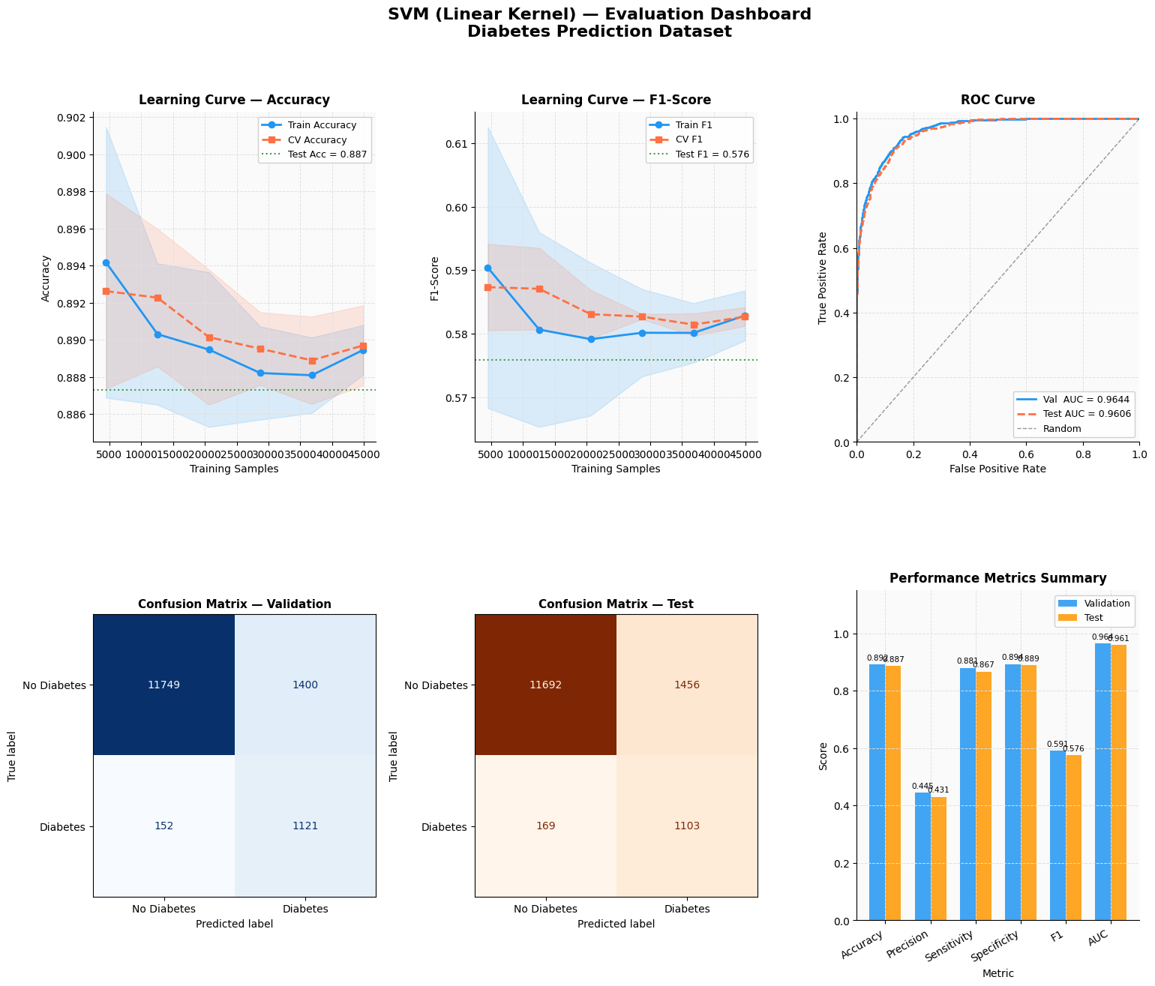
Figure 5.7 — SVM (Linear kernel) evaluation dashboard.

5.6 Support Vector Machine — RBF Kernel
The Gaussian (RBF) kernel SVM is the most computationally expensive model, scaling quadratically-to-cubically with the number of samples. To keep tuning practical, the (C, gamma) hyperparameters are optimised on a stratified 8,000-row subsample using two methods, and the final model is retrained on a larger 30,000-row stratified subsample. Predictions are still made on the full validation and test sets.

5.6.1 Grid Search
An exhaustive grid search evaluates every combination of C and gamma, selecting the pair with the best validation F1-score.
from sklearn.svm import SVC

C_grid_svm = [0.1, 1, 10, 100]
gamma_grid_svm = [0.001, 0.01, 0.1, 1]

for C_val in C_grid_svm:
for g_val in gamma_grid_svm:
clf = SVC(C=C_val, gamma=g_val, kernel='rbf', random_state=42)
clf.fit(X_sub, y_sub)
# score on validation set, record F1
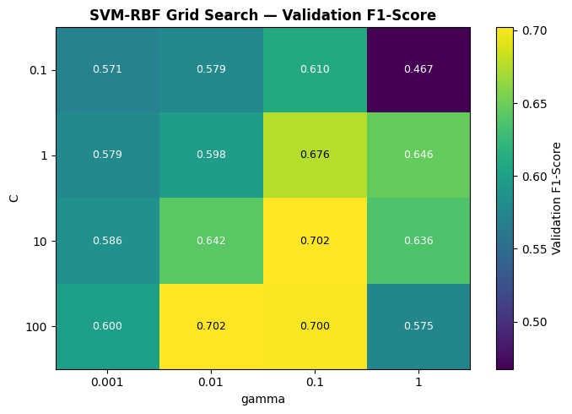
Figure 5.8 — Grid search heatmap of validation F1-score across the (C, gamma) grid.

5.6.2 Particle Swarm Optimization
As an alternative, the notebook implements Particle Swarm Optimization (PSO) from scratch. PSO is a population-based stochastic optimiser: a swarm of candidate solutions moves through log-scaled (C, gamma) space, with each particle pulled towards its own best-known position and the swarm’s global best, while inertia preserves momentum. The search optimises in log space because both parameters span several orders of magnitude, and minimises (1 − F1) by convention.
# PSO hyperparameters
N_PARTICLES = 8 # swarm size
N_ITERS = 6 # iterations
W = 0.6 # inertia
C1 = 1.5 # cognitive (personal-best pull)
C2 = 1.5 # social (global-best pull)

# velocity update for each particle:
velocities = (W * velocities
+ C1 * r1 * (pbest_pos - positions)
+ C2 * r2 * (gbest_pos - positions))
positions = np.clip(positions + velocities, bounds_lo, bounds_hi)
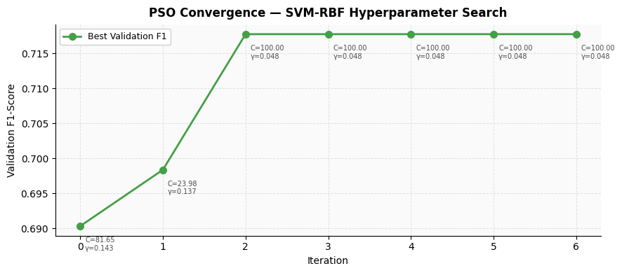
Figure 5.9 — PSO convergence: best validation F1-score per iteration.
The better of the two tuners (grid search vs PSO) is selected, and the final RBF-SVM is trained with the winning hyperparameters.
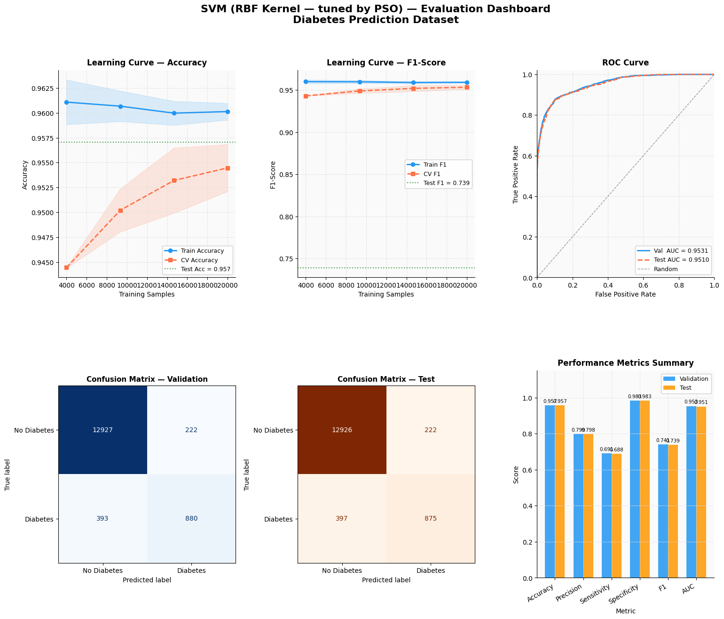
Figure 5.10 — SVM (RBF kernel) evaluation dashboard.

5.7 Random Forest
The first ensemble model is a Random Forest, tuned over combinations of the number of trees (n_estimators) and maximum tree depth (max_depth). A feature-importance plot reveals which clinical indicators drive the predictions.
from sklearn.ensemble import RandomForestClassifier

rf_grid = [
{'n_estimators': 100, 'max_depth': None},
{'n_estimators': 200, 'max_depth': None},
{'n_estimators': 200, 'max_depth': 10},
{'n_estimators': 300, 'max_depth': 15},
{'n_estimators': 300, 'max_depth': None},
]
# best params chosen by validation F1
rf = RandomForestClassifier(**best_rf_params, n_jobs=-1, random_state=42)
rf.fit(X_train_scaled, y_train_res)
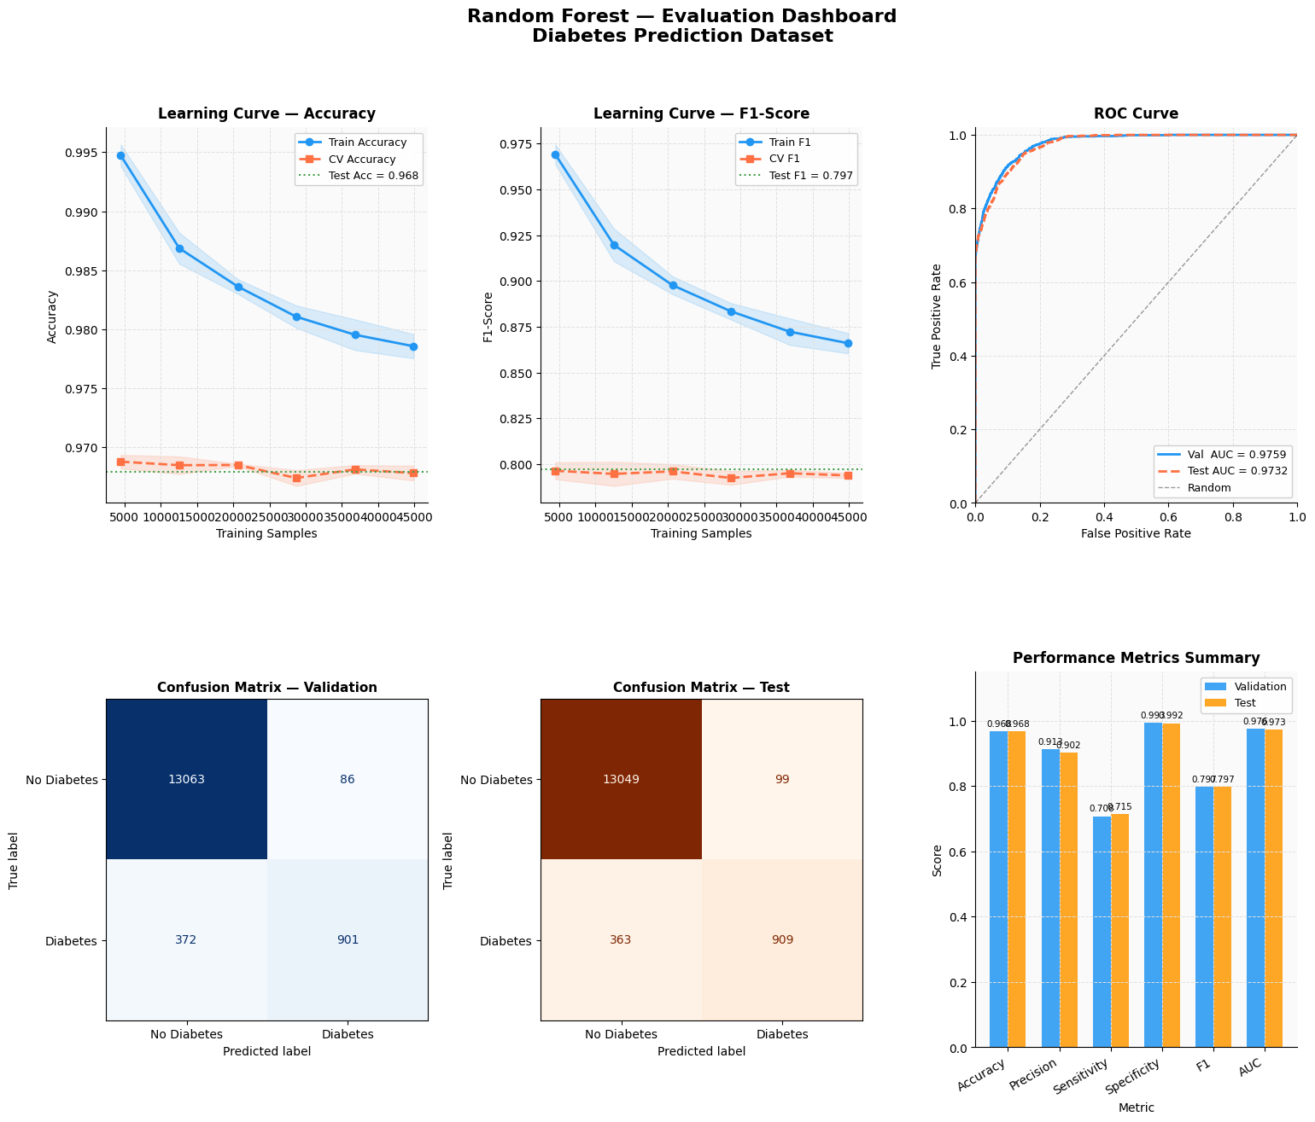
Figure 5.11 — Random Forest evaluation dashboard.
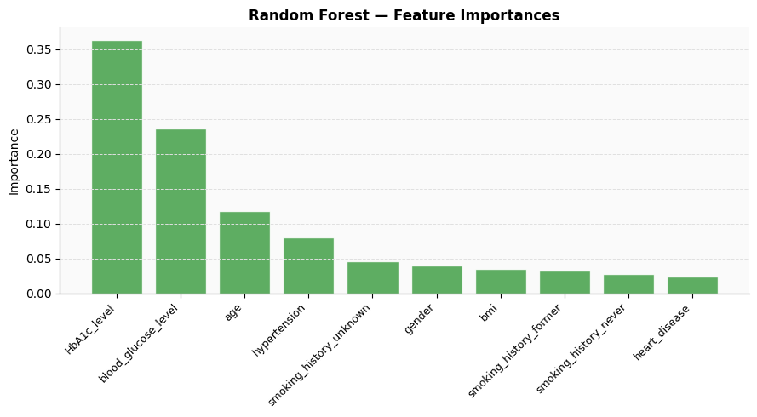
Figure 5.12 — Random Forest feature importances.

5.8 Gradient Boosting
The second ensemble model uses HistGradientBoostingClassifier — scikit-learn’s fast, histogram-based gradient-boosting implementation, which trains in seconds on a 100k-row dataset. It is tuned over the number of boosting iterations, learning rate and maximum depth.
from sklearn.ensemble import HistGradientBoostingClassifier

gb_grid = [
{'max_iter': 150, 'learning_rate': 0.1, 'max_depth': None},
{'max_iter': 200, 'learning_rate': 0.1, 'max_depth': 6},
{'max_iter': 300, 'learning_rate': 0.05, 'max_depth': None},
{'max_iter': 300, 'learning_rate': 0.05, 'max_depth': 8},
{'max_iter': 400, 'learning_rate': 0.05, 'max_depth': 6},
]
# best params chosen by validation F1
gb = HistGradientBoostingClassifier(**best_gb_params, random_state=42)
gb.fit(X_train_scaled, y_train_res)
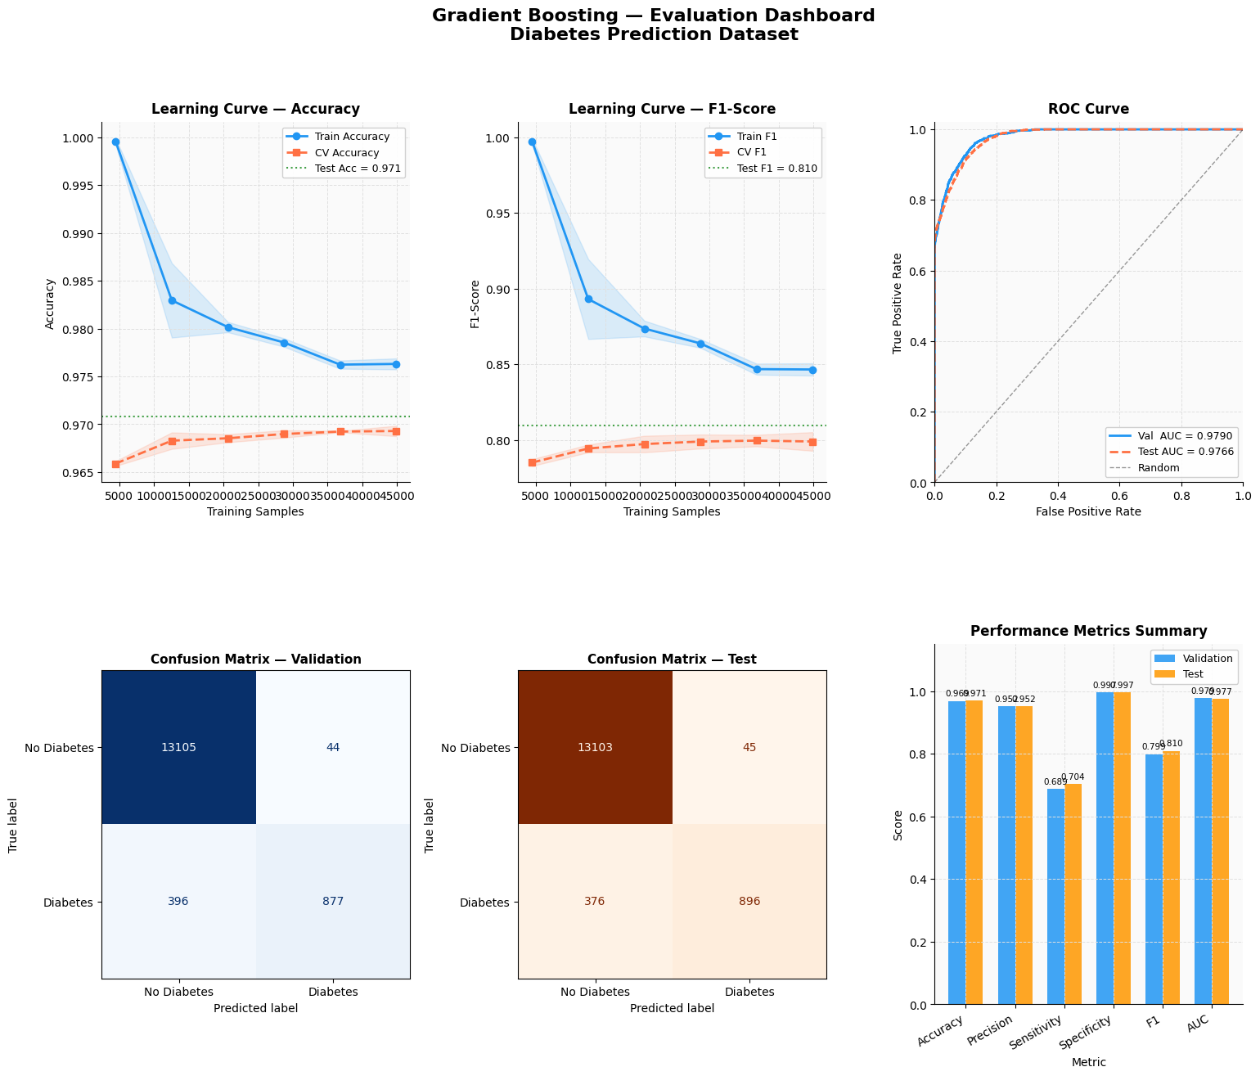
Figure 5.13 — Gradient Boosting evaluation dashboard.

6. Model Comparison & PCA Analysis

6.1 All-Model Comparison
With every model trained on the same scaled, SMOTE-resampled feature space, the notebook ranks all seven classifiers by their test-set F1-score. The F1-score is chosen as the ranking metric because the target is imbalanced and F1 balances precision against recall.
OUTPUT
══════════════════════════════════════════════════════════════════════════════
ALL MODELS — Test Set Comparison (sorted by F1)
══════════════════════════════════════════════════════════════════════════════
Model Accuracy Precision Sensitivity Specificity F1 AUC
Gradient Boosting 0.9708 0.9522 0.7044 0.9966 0.8098 0.9766
Random Forest 0.9680 0.9018 0.7146 0.9925 0.7974 0.9732
MLP 0.9582 0.7713 0.7476 0.9786 0.7593 0.9731
SVM RBF 0.9571 0.7976 0.6879 0.9831 0.7387 0.9510
Logistic Regression 0.8882 0.4337 0.8742 0.8896 0.5798 0.9602
SVM Linear 0.8873 0.4310 0.8671 0.8893 0.5758 0.9606
Naive Bayes 0.8703 0.3865 0.8003 0.8771 0.5212 0.9164
══════════════════════════════════════════════════════════════════════════════

→ BEST MODEL by test F1-score: Gradient Boosting

Saved → all_models_comparison.png

Saved → model_ranking_f1.png
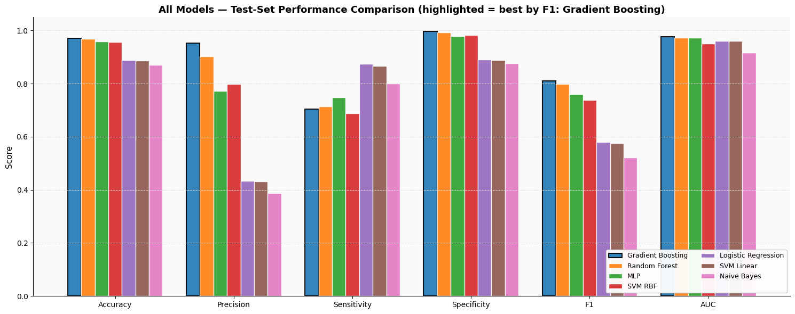
Figure 6.1 — All models compared across every test-set metric.
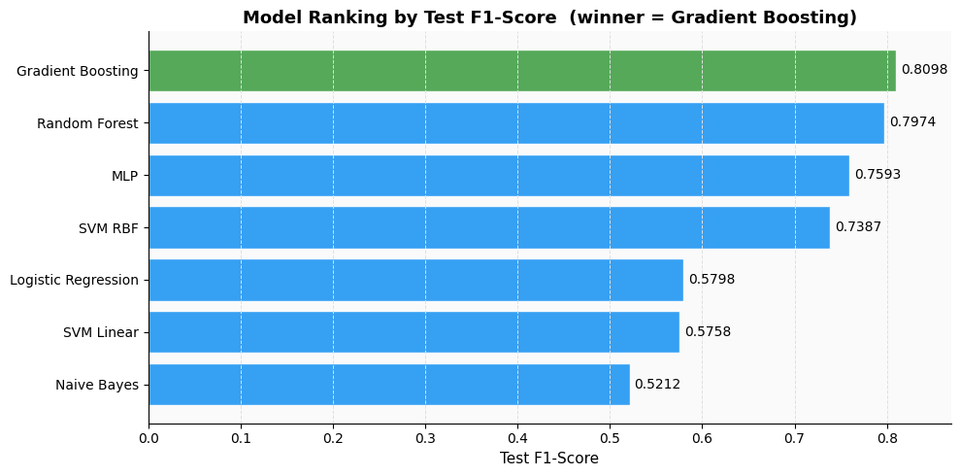
Figure 6.2 — Model ranking by test F1-score (winner highlighted).

6.2 PCA Applied to the Best Model
Following the project requirement to test dimensionality reduction on the strongest model, the best classifier — Gradient Boosting — is retrained on the PCA-reduced feature space (95% retained variance) and compared against its without-PCA version.
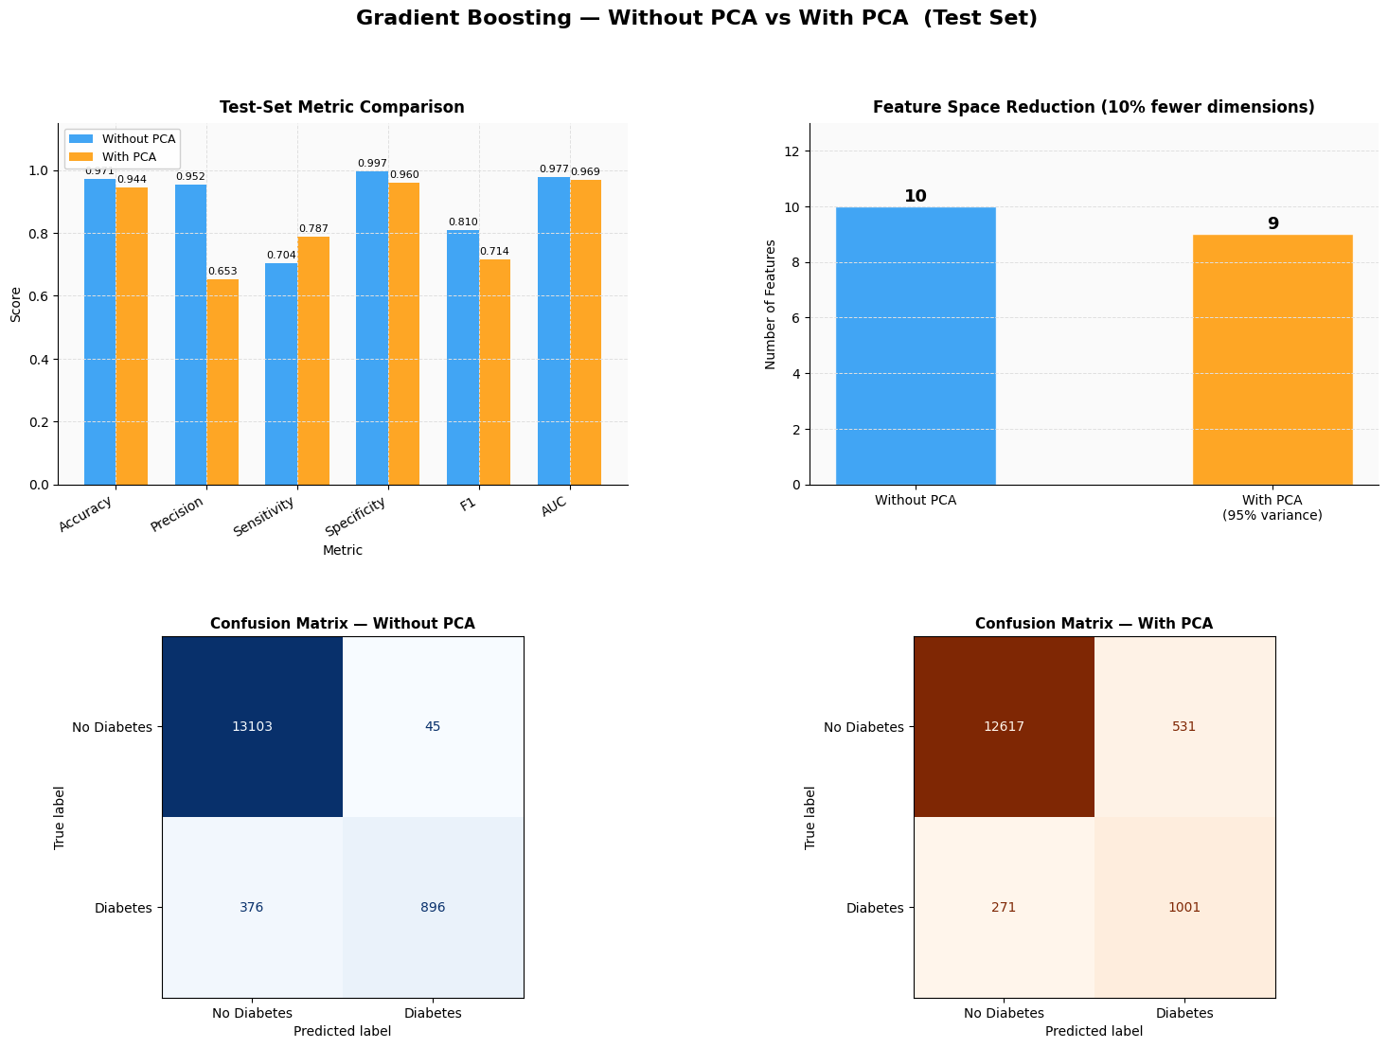
Figure 6.3 — Best model: without-PCA versus with-PCA comparison on the test set.
In this project PCA reduced the feature count but did not improve performance: the without-PCA Gradient Boosting model retained the higher F1-score, so it was kept as the final model.

6.3 Final Summary
The final summary table reports every model’s test-set performance, including the with-PCA variant of the best model, sorted by F1-score.
OUTPUT
════════════════════════════════════════════════════════════════════════════════════════════════════
FINAL SUMMARY — Test-Set Performance Across All Models
════════════════════════════════════════════════════════════════════════════════════════════════════
Model PCA Features Accuracy Precision Sensitivity Specificity F1 AUC
Gradient Boosting No 10 0.9708 0.9522 0.7044 0.9966 0.8098 0.9766
Random Forest No 10 0.9680 0.9018 0.7146 0.9925 0.7974 0.9732
MLP No 10 0.9582 0.7713 0.7476 0.9786 0.7593 0.9731
SVM RBF No 10 0.9571 0.7976 0.6879 0.9831 0.7387 0.9510
Gradient Boosting Yes (95% var) 9 0.9444 0.6534 0.7869 0.9596 0.7140 0.9686
Logistic Regression No 10 0.8882 0.4337 0.8742 0.8896 0.5798 0.9602
SVM Linear No 10 0.8873 0.4310 0.8671 0.8893 0.5758 0.9606
Naive Bayes No 10 0.8703 0.3865 0.8003 0.8771 0.5212 0.9164
════════════════════════════════════════════════════════════════════════════════════════════════════

🏆 OVERALL WINNER: Gradient Boosting (PCA = No)
Test Accuracy : 0.9708
Test Precision : 0.9522
Test Sensitivity : 0.7044
Test F1-Score : 0.8098
Test ROC-AUC : 0.9766
════════════════════════════════════════════════════════════════════════════════════════════════════

7. Results & Conclusion

7.1 Final Test-Set Results
The table below summarises the test-set performance of all seven models, ranked by F1-score.
Model | Accuracy | Precision | Sensitivity | Specificity | F1 | AUC
Gradient Boosting | 0.9708 | 0.9522 | 0.7044 | 0.9966 | 0.8098 | 0.9766
Random Forest | 0.9680 | 0.9018 | 0.7146 | 0.9925 | 0.7974 | 0.9732
MLP | 0.9582 | 0.7713 | 0.7476 | 0.9786 | 0.7593 | 0.9731
SVM RBF | 0.9571 | 0.7976 | 0.6879 | 0.9831 | 0.7387 | 0.9510
Logistic Regression | 0.8882 | 0.4337 | 0.8742 | 0.8896 | 0.5798 | 0.9602
SVM Linear | 0.8873 | 0.4310 | 0.8671 | 0.8893 | 0.5758 | 0.9606
Naïve Bayes | 0.8703 | 0.3865 | 0.8003 | 0.8771 | 0.5212 | 0.9164

7.2 Key Observations
- Gradient Boosting was the overall winner, achieving the highest test F1-score (0.8098) and ROC-AUC (0.9766), along with very high precision (0.9522) and specificity (0.9966).
- The two ensemble methods — Gradient Boosting and Random Forest — clearly outperformed the simpler linear and probabilistic models.
- Linear models (Logistic Regression and SVM Linear) and Naïve Bayes achieved higher sensitivity but much lower precision, meaning they caught more diabetic patients at the cost of many false positives.
- Applying PCA to the best model reduced the feature space but slightly lowered its F1-score, so the full-feature Gradient Boosting model was retained for deployment.
- Across all models, SMOTE and stratified splitting were essential — without them, the 91.5% / 8.5% class imbalance would have produced misleadingly high accuracy with poor minority-class detection.

7.3 Conclusion
This project delivered a complete, leakage-aware machine-learning pipeline for diabetes prediction. After thorough data cleaning, principled handling of class imbalance, and systematic hyperparameter tuning — including both grid search and a from-scratch Particle Swarm Optimization — seven classifiers were trained and rigorously compared. Gradient Boosting emerged as the strongest model, combining high overall accuracy with excellent precision and ranking ability (AUC). The pipeline is reproducible (fixed random seeds throughout) and evaluates all models on a genuinely held-out test set, making its reported performance a reliable estimate of real-world generalisation.

End of Documentation

