BACKWARD/FORWARD SWEEP (BFS) ALGORITHM
The backward/forward sweep (BFS) algorithm is one of the most common ways used for load flow distribution system because it is simple, fast and robust convergence and low memory requirement. The BFS algorithm involves mainly an iterative three basic steps based on Kirchhoff's current law (KCL) and Kirchhoff's voltage law (KVL). The three steps are named as the nodal current calculation, the backward sweep and the forward sweep and they are repeated until the convergence is achieved. In the nodal current calculation, all the current injection at different buses is determined. In the backward sweep, the section currents and powers are calculated starting from the last node and proceeds towards substation node. In the forward sweep, the voltage at each node is calculated starting from the substation node and proceeds towards last node. The input data required for this algorithm are the numbering of sending and receiving nodes, the branch data represented by resistance and reactance and the active and reactive powers at each node. The BFS utilizes a simple and flexible radial distribution system numbering scheme in order to numbering each branch in the feeder, lateral and sub-lateral [24].
The BFS algorithm can be applied to find the load flow results using the following steps:
Step 1: Initialization
Insert the following:
- The distribution system line and load data.
- The base power and base voltage.
- Calculate the base impedance.
- Calculate the per unit values of line and load data.
- Take the voltage for all buses flat voltage (1 p.u.).
- Set convergence tolerance Є=0.0001 and ΔV_{max} = 0.

Step 2: Radial distribution system numbering scheme
The numbering scheme aims to give a number to each section in the distribution system, where a section is part of a feeder, lateral or sub-lateral that connects two buses in the distribution system. The total number of sections (N_{Sec}^{Total}) of a distribution system can be calculated as:
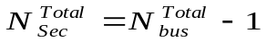 (B.1)
where, N_{bus}^{Total} is the total number of buses. Each section will carry a number which is one less than its receiving end bus number, e.g., the number of section that connects the sending end p and the receiving end q in Fig. 5.1 can be calculated as:
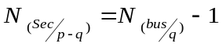 (B.2)
where, N_{(Sec} _{/p-q)} is the section number between buses p and q, N_{(bus /q)} is the number of bus q.
Now, the radial distribution system numbering scheme should be applied on the distribution system to give a number to each section in the system.
Step 3: Nodal current calculation
At iteration k, the nodal current injection at node i due to loads and any other shunt elements can be calculated as:
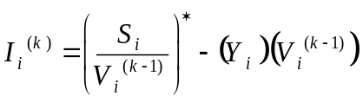 (B.3)
where, I_{i}^{(k)} is the current injection at node i, S_{i} is the specified power injection at node i, V_{i}^{(k-1)} is the voltage at node i at iteration k-1, Y_{i} is the sum of all shunt elements at node i.
Step 4: Backward sweep
At iteration k, start from the branches at the end nodes and moving towards the branches connected to the substation. Hence, all branch currents can be calculated by applying the KCL and then the powers through these branches can be determined. For the branch L, the current and power flows can be calculated as:
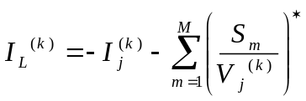 (B.4)
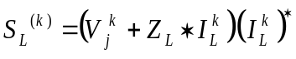 (B.5)
where, I_{L}^{(k)} is the current flow in branch L at iteration k, I_{j}^{(k)} is the current injected due to shunt elements at bus j, M is the number of branches connected to bus j, S_{m} is the complex power at the sending end of branch m, V_{j}^{(k)} is the voltage at bus j, S_{L}^{(k)} is the power flow in branch L and Z_{L} is the impedance of branch L.
Step 5: Forward sweep
At iteration k, the nodal voltages are updated in a forward sweep starting from the branches in the first section toward those in the last by applying the KVL. For a branch L connected sending end p and receiving end q, the voltage at receiving end at iteration k can be calculated as:
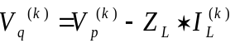 (B.6)
where, V_{p}^{(k)} and V_{q}^{(k)} are the voltages at sending and receiving ends, respectively.
Step 6: Check the voltage mismatches
After the previous steps have been computed, the voltage mismatches for all nodes are calculated, e.g., the voltage mismatch at bus i at iteration k can be calculated as:
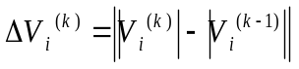 (B.7)
After calculating the voltage mismatches, check the convergence of the voltage as:
- If ΔV_{i}^{(k)}>ΔV_{max}, then make ΔV_{max}= ΔV_{i}^{(k)}.
- If ΔV_{max} ≤ Є, go to step 8, otherwise increment the iteration number and go to step 3.
Step 7: Check stopping criterion
The program will be terminated when the maximum iteration is reached or the convergence from the voltage mismatches is verified.
Step 8: Power loss calculation
After computing the node voltages and branch currents using the BFS algorithm, the total active and reactive power losses in the distribution system are calculated from Equations (4.3) and (4.4).
The steps of the BFS algorithm to find the radial distribution system load flow are shown in Fig. B.1.
Yes
No
Compute the total power losses in all branches for the distribution system using Equations (4.3) and (4.4)

Stop
Apply the nodal current calculation using Equation (B.3)
Apply the forward sweep using Equation (B.6)
If ΔV_{max} ≤ Є
or
The maximum iteration is reached
Apply the backward sweep using Equations (B.4) and (B.5)
Start
Read line and load data
Determine line and load per unit values
Set initial values of voltages to flat voltages (1 p.u.) for all nodes
Apply the numbering scheme using Equations (B.1) and (B.2)
Fig. B.1 Flow chart of backward/forward sweep load flow

