**Optimal capacitor placement in 34-bus system using Archimedes Optimization Algorithm (AOA) for power loss reduction and voltage profile improvement**

Supervisor Dr.Mohamed Mouwafi

**المشاركون في المشروع**

|  |  |  |  |
| --- | --- | --- | --- |
| **السكشن** | **الاسم** | **الرقم الأكاديمي** | **رقم** |
| 6 | محمد ربيع عبدالحميد محمد الشيخ | 161017 | 1 |
| 6 | محمد رجب عبدالمعطي خفاجة | 170598 | 2 |
| 6 | محمد الدسوقي احمد حليمه | 170562 | 3 |
| 6 | محمد خالد احمد سلطان | 161016 | 4 |
| 7 | محمد فكري محمد عبدالوارث زهران | 170691 | 5 |
| 9 | مصطفى محمد عبدالغنى عبدالله شاهين | 170860 | 6 |
| 7 | محمد على السيد عبد الجليل | 170666 | 7 |
| 7 | محمد عماد الدين عبدالنبى عبدالله | 160677 | 8 |
| 9 | مصطفى محمد عبدالغني ندا | 170861 | 9 |
| 8 | مصطفي أحمد صبري احمد العشماوي | 160805 | 10 |
| 3 | اسلام جمال حسين الاغا | 140183 | 11 |

**Table of contents**

1. Introduction 1

1.1. Distribution systems optimization 1

1.1.1. Complexity of Distribution systems optimization problems 1

1.2. What is metaheuristics? 2

1.2.1. Pseudo code of metaheuristics 2

1.3. Archimedes Optimization Algorithm (AOA) 2

1.3.1. Archimedes’ principle 2

1.3.2. Theory 3

1.3.3. Algorithmic steps 3

1.3.4. Pseudo code of AOA 4

2. Problem formulation for power system networks 5

2.1. Backward/forward sweep (BFS) algorithm 5

3. Results 6

4. conclusion 6

# Introduction

## Distribution systems optimization

Shunt capacitors and DGs installation on radial distribution feeders is commonly used to improve power flow control, system stability enhancement and power factor correction, managing voltage profile, and reducing active power and energy loss in distribution network.

### Complexity of Distribution systems optimization problems

Distribution systems optimizations problems are too complex that it is computationally impossible.

To get a sense of the complexity of this type of problems, consider a 34-bus distribution system like that in figure 1 and we are required to place 3 capacitors on those systems and the capacitors sizes must be within the boundaries 500: 1200 KVAR. If we considered bus 1 as the slack bus then for the first capacitor there is 33 possible location and the second there are 32 possible location and 31 possible location for the third. So in total we need to try possible locations.

If we considered only the integer values of the capacitors sizes (500 , 501,502,……,1198,1199,1200), then for each capacitor there are 700 possible value of its size. So there are (. So the search space with these assumptions would have candidate solutions.

We can get the mean time required to run the BFS algorithm in years and multiply it with the number of the candidate solutions to find the number of years of computations required to find the best solution (under the mentioned assumptions). The result is shockingly above 200 years.

If we considered values to 1 decimal number instead of integer sizes of the capacitors ( 500.1, 500.2,500.3,……, 1199.8,1199.9,1200). Then the result will be above 2000 years and in general the result would be .

Figure 1

## What is metaheuristics?

**Metaheuristics** is a subfield of **stochastic optimization**. They’re algorithms used to find solutions to problems which brute-force search algorithms (random search) is computationally impossible to use and you must be able to test these solutions and assess how good it is . Metaheuristics are independent of the problem which means that can implemented to solve different types of problems.

**Stochastic optimization** is the general class of algorithms and techniques which employ some degree of randomness to find optimal solutions to hard problems. Metaheuristics are the most general kind of these algorithms and applied to a wide range of problems.

**Brute-force search** means trying each possible solution and choosing the best of them

In our case, we are trying to optimally place DGs and capacitors in a 34-bus network to improve power flow and voltage regulation. It’s impossible computational to solve this problem using brute-force search as the space we search is too enormous. We can always check the candidate solution and assess that it improves the power flow and voltage regulation of our network. A metaheuristic algorithm will be suitable for our problem.

### Pseudo code of metaheuristics

## Archimedes Optimization Algorithm (AOA)

Archimedes optimization algorithm (AOA) generally emulates what happens when objects of different weights and volumes are immersed in a fluid.

### Archimedes’ principle

Archimedes’ principle states that “Any object, totally or partially immersed in a fluid or liquid, is buoyed up by a force equal to the weight of the fluid displaced by the object.”

Figure 2

### Theory

Objects in a fluid tries to reach equilibrium state. For an object to be in equilibrium state, the buoyant force must equal the object’s weight

Where is the density, is the volume, and is the acceleration. The subscripts and are referring to the fluid and immersed object, respectively.

If there is a collision between to objects the equilibrium state is reached when

### Algorithmic steps

AOA is a population-based algorithm. In the proposed approach, the population individuals are the immersed objects. Like other population-based metaheuristic algorithms, AOA also commences search process with initial population of objects(candidate solutions)with random volumes, densities, and accelerations. At this stage, each object is also initialized with its random position in fluid. After evaluating the fitness of initial population, AOA works in iterations until termination condition meets. In every iteration, AOA updates the density and volume of every object. The acceleration of object is updated based on condition of its collision with any other neighboring object. The updated density, volume, acceleration determines the new position of an object.

### Pseudo code of AOA

# Problem formulation for power system networks

## Backward/forward sweep (BFS) algorithm

# Results

# conclusion

|  |  |
| --- | --- |
|  | (1) |

|  |  |
| --- | --- |
|  | (2) |

# Code

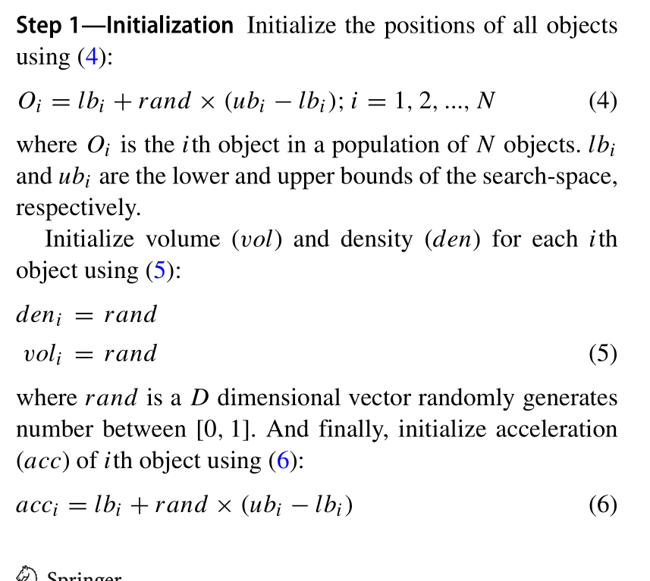

%==========================================================================

% Initial population and Initialization

%==========================================================================

%create the population

% for each device there are two objects: one for the bus and the other for

% the capacity

solutions{solutions_no,2*N_caps+2*N_DGs}=objecte(2,3);

for i=1:solutions_no

    for j=1:N_caps

        solutions{i,j} =objecte(2,Nb);

    end

    for j=(N_caps+1):(2*N_caps)

        solutions{i,j}=objecte(cap_min,cap_max);

    end

    for j=(2*N_caps+1):(2*N_caps+N_DGs)

        solutions{i,j} =objecte(2,Nb);

    end

    for j=(2*N_caps+N_DGs+1):(2*N_caps+2*N_DGs)

        solutions{i,j} =objecte(DG_min,DG_max);

    end

    for j=(2*N_caps+2*N_DGs+1)

        solutions{i,j} =result(Nb);

    end

end

classdef objecte

    %OBJECTE Summary of this class goes here

    %   Detailed explanation goes here

    properties

        x;

        den;

        vol;

        acc;

        acc_norm;

        acc_temp;

    end

    methods

        function m= objecte(lb,ub)

            %equ 4:6

            m.x= lb+rand*(ub-lb);

            m.den=rand;

            m.vol=rand;

            m.acc=lb+rand*(ub-lb);

            m.acc_norm=m.acc;

            m.acc_temp=m.acc;

        end

    end

end

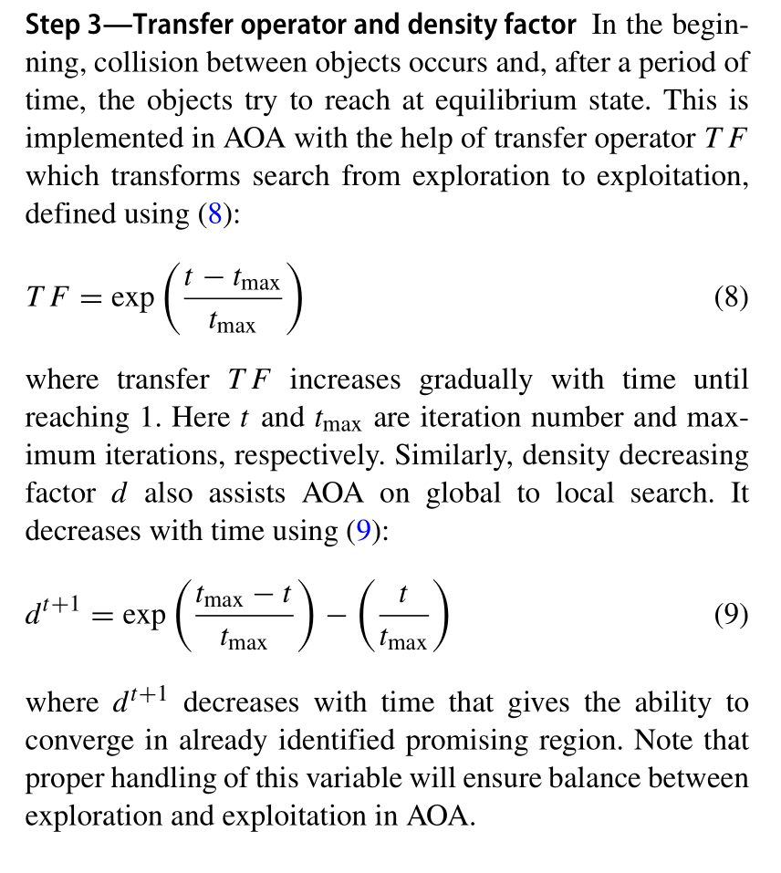

%==========================================================================

%              Start the iterations -- AOA

%==========================================================================

for t=1:Max_iter

    %======================================================================

    TF=exp(((t-Max_iter)/(Max_iter)));                            % Eq. (8)

    if TF>1

        TF=1;

    end

    d=exp((Max_iter-t)/Max_iter)-(t/Max_iter);

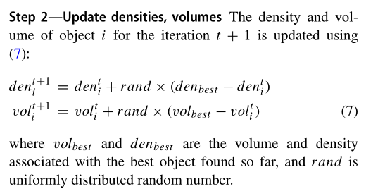

    for kk=1:solutions_no

        for mm=1:(2*N_caps+2*N_DGs)

            %eq 7

            solutions{kk,mm}.den=(solutions{kk,mm}.den)+rand*((best_obj{mm}.den)-(solutions{kk,mm}.den));

            solutions{kk,mm}.vol =solutions{kk,mm}.vol +rand*(best_obj{mm}.vol- solutions{kk,mm}.vol);

          %collision

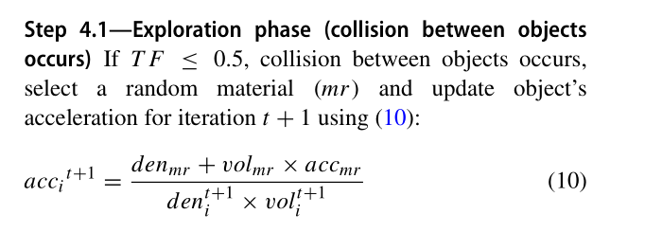

            if TF<.55

                mr=randi(solutions_no);

                % Eq. (10)

                solutions{kk,mm}.acc_temp=((solutions{mr,mm}.den+solutions{mr,mm}.vol*solutions{mr,mm}.acc)/(rand*solutions{kk,mm}.vol*solutions{kk,mm}.den));

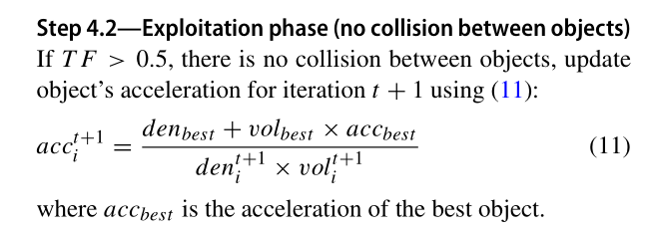

  else

                %eq 11

                solutions{kk,mm}.acc_temp=((best_obj{mm}.den+best_obj{mm}.vol*best_obj{mm}.acc)/(rand*solutions{kk,mm}.vol*solutions{kk,mm}.den));   % Eq. (10)

            end

        end

    end

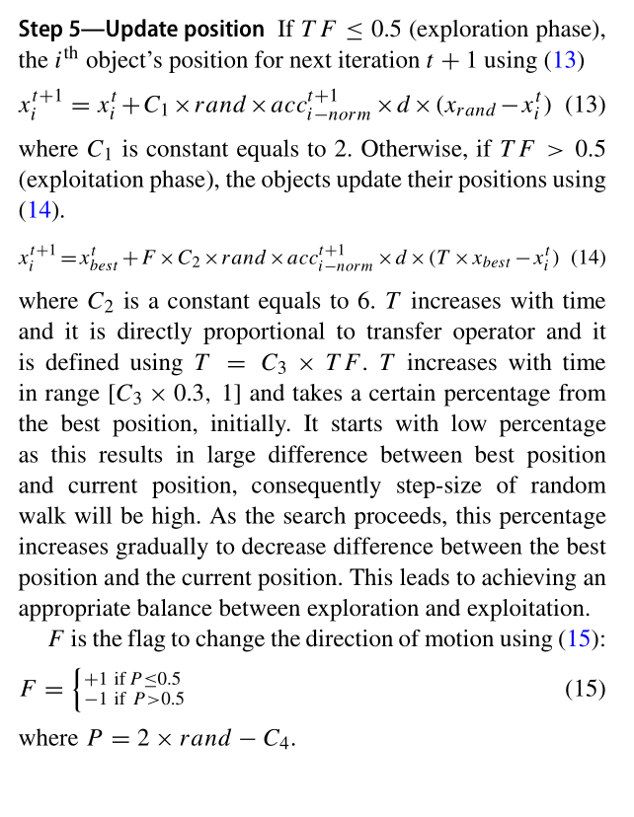

%==========================================================================

% update position

%==========================================================================

    for v3=1:solutions_no

        for vv3=1:(2*N_caps+2*N_DGs)

            if TF<.5

                mr=randi(solutions_no);

                % Eq. (13)

                solutions{v3,vv3}.x=solutions{v3,vv3}.x+C1*rand*solutions{v3,vv3}.acc_norm*(solutions{mr,vv3}.x-solutions{v3,vv3}.x)*d;

            else

                p=2*rand-C4;                                    % Eq. (15)

                T=C3*TF;

                if T>1

                    T=1;

                end

                if p<.5

                    % Eq. (14)

                    solutions{v3,vv3}.x=best_obj{vv3}.x+C2*rand*solutions{v3,vv3}.acc_norm*(T*best_obj{vv3}.x-solutions{v3,vv3}.x)*d;

                else

                    solutions{v3,vv3}.x=best_obj{vv3}.x-C2*rand*solutions{v3,vv3}.acc_norm*(T*best_obj{vv3}.x-solutions{v3,vv3}.x)*d;

                end

            end

        end

    end